Michael Dang – 16257750

MATH434

Lab5

1.

a,b and c

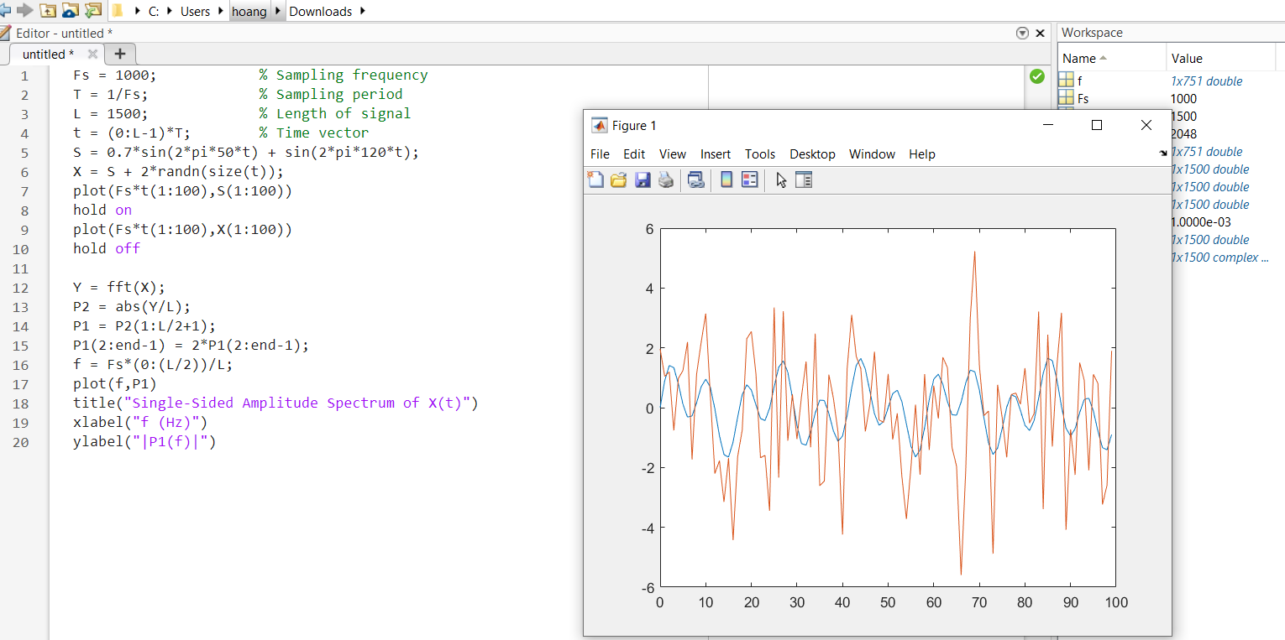

d.

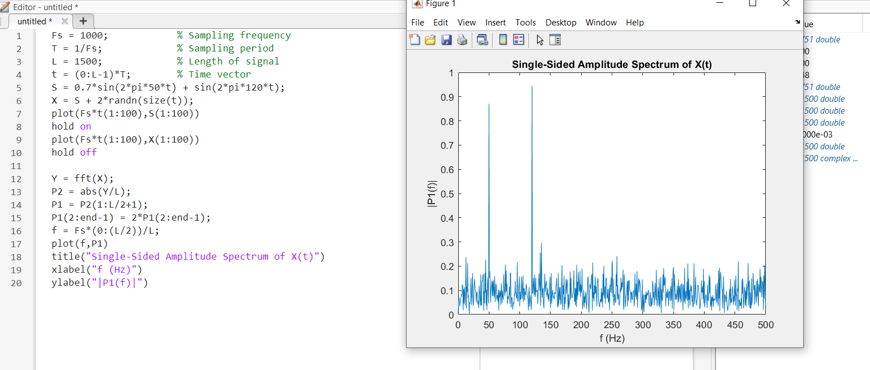

2.

a and b

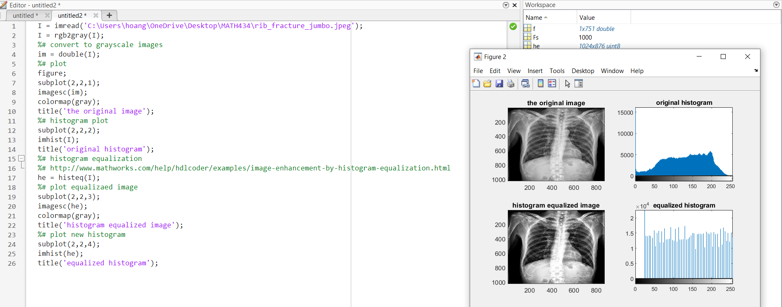

3.

It is showing a spectrum of color represent temperature distribution over time. This can be applied into data visualized. Really nice!

4.

a.

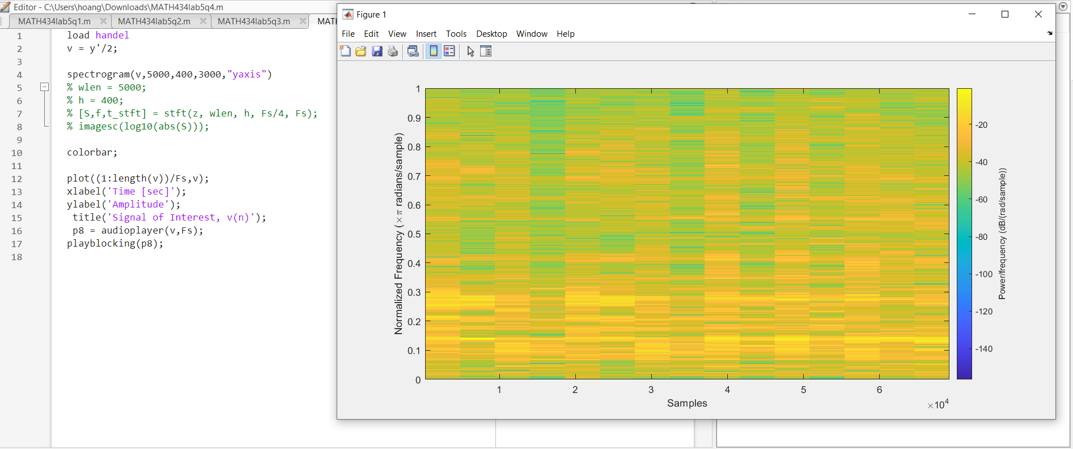

b.

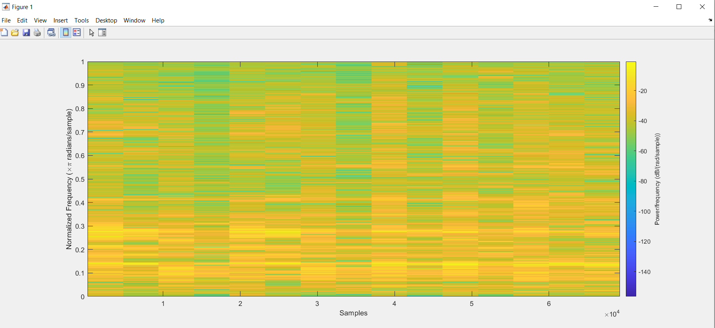

c.

Oversampling

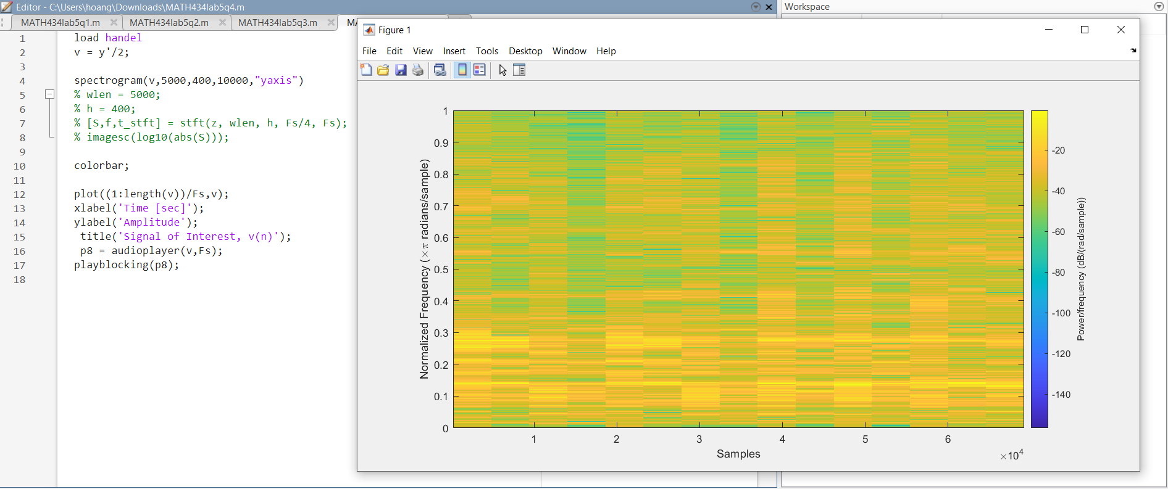

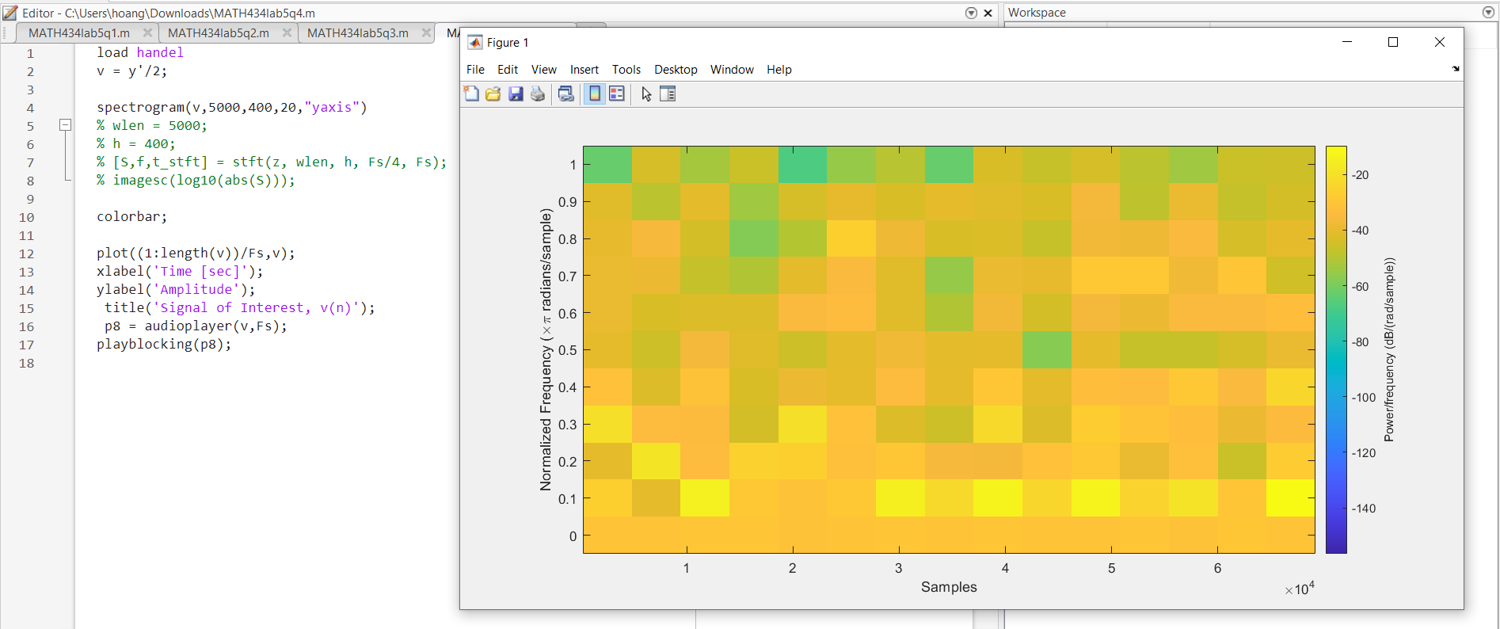Undersampling

d.

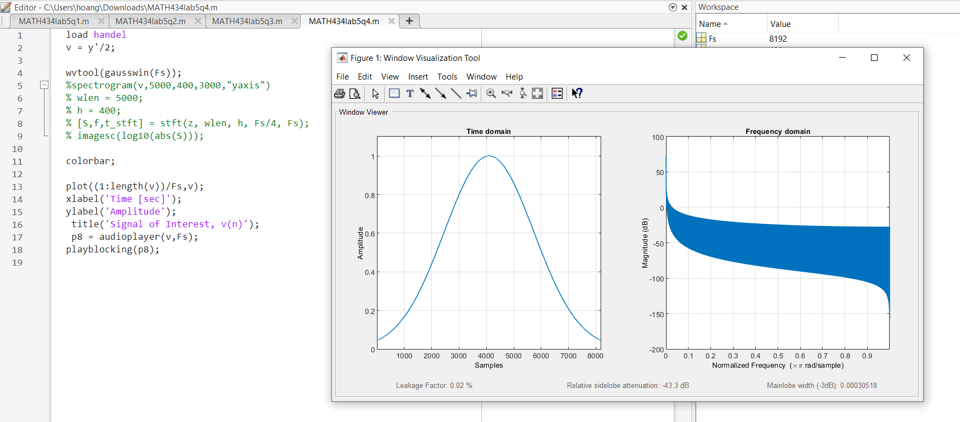

5.

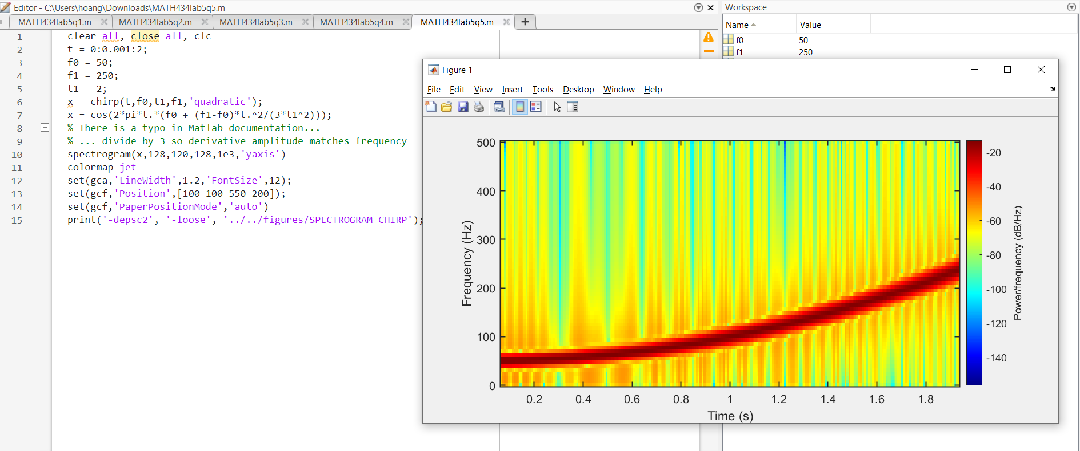

6.

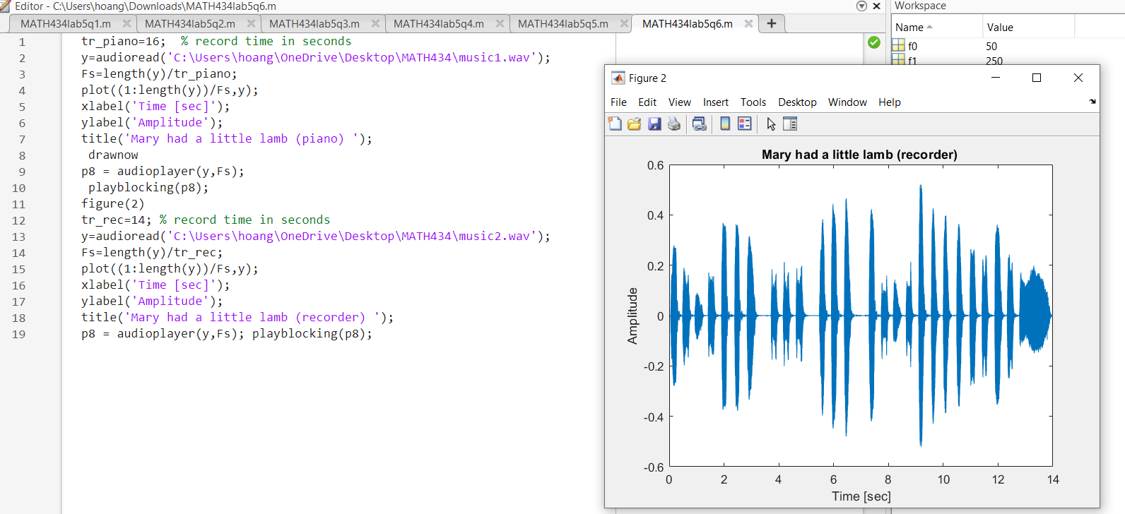a.

What do you mean by filter out overtones? It’s that remove those high notes. I can play the piano without those high notes.

b.

The record sound better because it can analysis and remove the noises.

Yes

7.

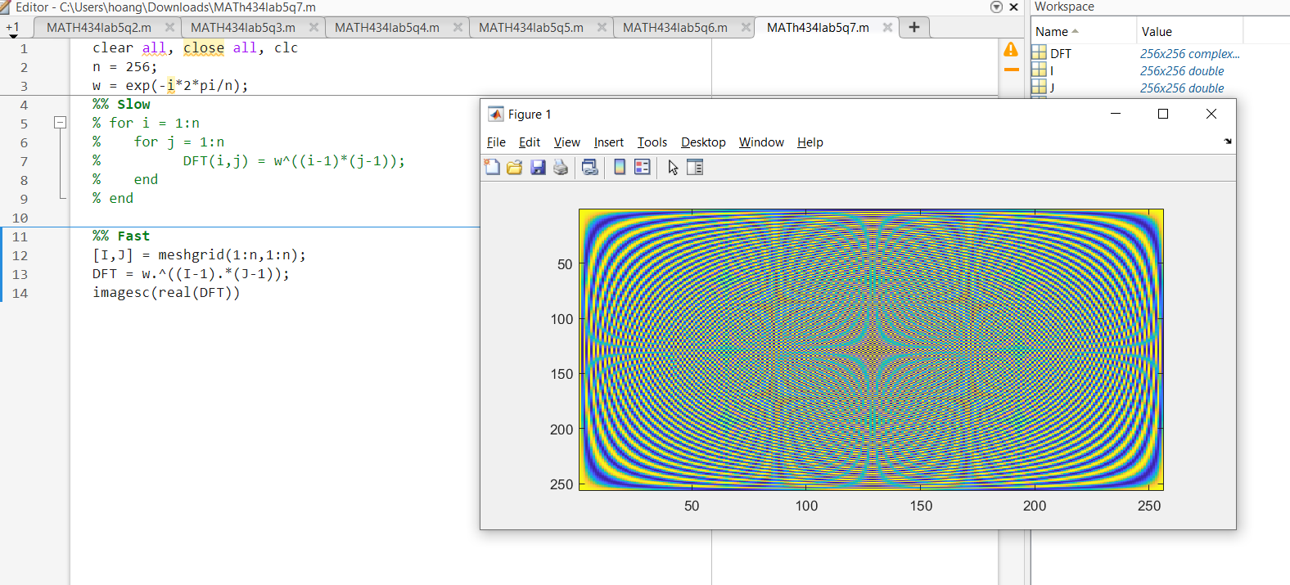

There are 4 stars surrounding the big star, however, when I manipulate the size the image itself updated.