Michael Dang – 16257750

MATH434

Lab6

1.

a.

The command sparse(A) will converts the matrix A to sparse form by get rid of the any zero elts. If matrix A contains many zeros, it will convert the matrix to sparse storage saves memory.

b.

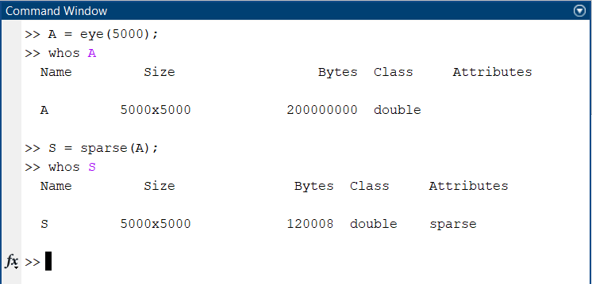

c.

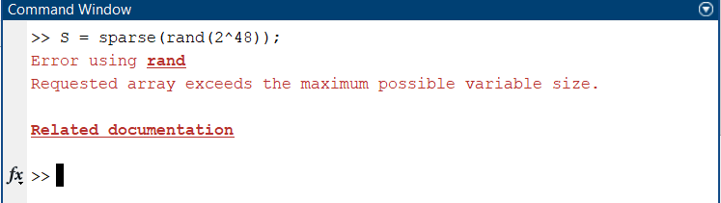

2.

a.

My laptop doesn’t have enough memory to process 100,000 x 100,000 data so I have to reduce it to 30,000 x 30,000.

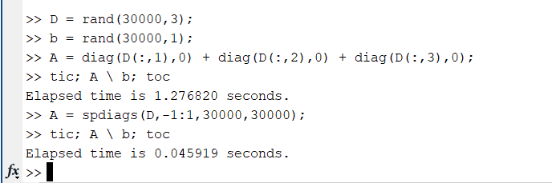

b.

With the spdiags() method can help to speed up the process of compute big data set.

c.

In case A, we are using multiple method of diag() so the elapse time take longer to compute. However, in case B, we are using only 1 method spdiags() so the elapse time is much faster.

3.

a. and b.

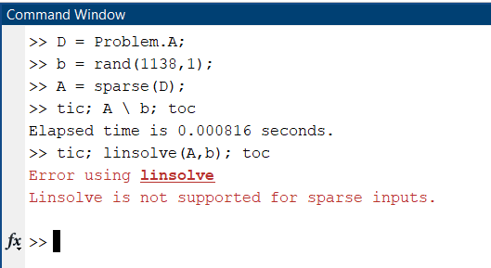

c.

By using sparse() method, the algorithm computes much faster then the spdiags() method. However, for my version the linsolve() is not apply to sparse data.

4.

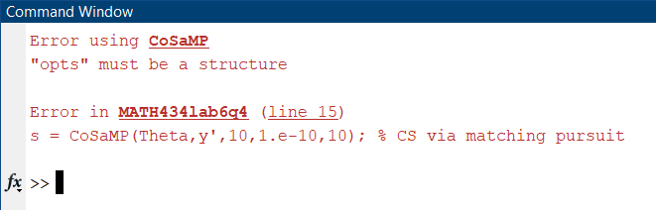I try to do this question for curiosity but cosamp() function is not defined.