**Software Design Specification (SDS)**

Revision History: (The server and client documents should be combined into one for a single project)

|  |  |  |
| --- | --- | --- |
| Date | Author | Description |
| 2020.10.09 | YuhangFU&XuHUANG | First Version |
| 2020.11.8 | Xu HUANG | Add some functions |
|  |  |  |
|  |  |  |
|  |  |  |
|  |  |  |

Contents

Software Design Specification (SDS) 1

1. Introduction 2

1.1. Intended Audience and Purpose 2

1.2. How to use the document 2

2. System Design 2

3. Module Interface Design 2

4. Detailed Design 3

4.1. Server Detailed Design 4

4.2. Client (Web/Desktop) Detailed Design 4

A.    Appendices 5

A.1    Definitions and acronyms 5

5

A.1.1    Definitions 5

A.1.2    Acronyms and abbreviations 5

A.2    References 5

## Introduction

## Intended Audience and Purpose

This document is written for interface designers, coders, relevant collaboration groups, and users.The aim is to enable stakeholders to have a certain degree of awareness of the work of the Web side, and to have specific design and implementation directions when working.

## How to use the document

<Describes the document organization. This section should answer for the reader: “Where do I find particular information about X?”>

## System Design

The Web system is on the use of total sever end demand, and face users directly.Therefore, the design of the system should not only meet the needs of customers, but also give consideration to the clarity and feasibility of the programmer in the implementation.The system has been determined to run on the browser. The design architecture is according to BS framework, and we apply JSP specification to achieve the relevant functions.

The programming languages：html5, css, javascript, java.

The operating system:windows, linux.

## Module Interface Design

1. Realize data transmission from page to server through input control and JavaBean.
2. Use the servlet corresponding interface to complete the operation of page transformation
3. Thesevlet is also responsible for the transmission of some data from the server to the page.
4. Ajax is used to realize local page refresh technology when image data is displayed to transfer image data string to obtain data.。

## Detailed Design

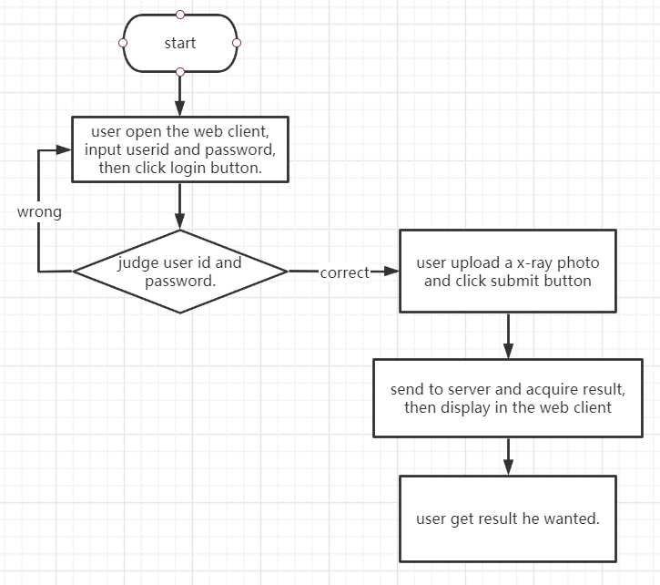

## Server Detailed Design

As a Web group, the server design mainly involves the design and implementation of sevlet which is strongly related to the page. There are seven main groups of objects.

1. Register

2. Login

3. Batch upload pictures

4. Picture upload and result display

5. Auxiliary line edit and upload results

6. Search history by one patient

7. Search information of a specific patient by the doctor

8.Support Chinese and English display

9.The evaluation of detect result upload

## Client (Web/Desktop) Detailed Design

The client mainly involves the module planning and design of the page.It is divided into four parts

1. Register page

2. Login page

3. Doctors use page

4. Patients and their family members page

5.Doctor change and evaluate the detect result page

The patient USES the same interface function as the doctor.Their common function is to upload individual images and display the results.The doctor's interface also has batch photo upload, display results can be edited and patient data search and other functions.The patient interface has a historical view of photos you have uploaded in the past.

## A.    Appendices

## A.1    Definitions and acronyms

## 

## A.1.1    Definitions

|  |  |
| --- | --- |
| **Keyword** | **Definitions** |
|  |  |
|  |  |
|  |  |
|  |  |

## A.1.2    Acronyms and abbreviations

|  |  |
| --- | --- |
| **Acronym or**  **Abbreviation** | **Definitions** |
|  |  |
|  |  |
|  |  |

## A.2    References

RA_GourdIsland