Testing Reports

Revision History:

|  |  |  |
| --- | --- | --- |
| Date | Author | Description |
| 2020.10.23 | Chang LIU | Complete the first version of TR. |
| 2020.11.10 | Chang LIU | Add unit test and function test |
|  |  |  |
|  |  |  |
|  |  |  |
|  |  |  |
|  |  |  |
|  |  |  |
|  |  |  |
|  |  |  |

Contents

1. Introduction 3

1.1. Intended Audience and Purpose 3

1.2    How to use the document 3

2. Testing Cases 3

2.1. Client 3

3. Testing Plan 6

3.1. Register 6

3.2. Sign in 6

3.3. Upload Single Pic 6

3.4. View History 6

3.5. Upload Multiple Pics 6

3.6. Edit Lines 6

4. Testing Results 7

## Introduction

## Intended Audience and Purpose

This document provides the testing method and results, corresponding to the requirement from the customer. It consists of 3 parts, the testing cases, the test plan, and the testing results.

## 1.2    How to use the document

You may refer to the content section for the structure of the document, in which Sec. Testing Cases collect the unit and module test information from each team; Sec. Testing Plan shows the steps and expected results of the integration test; Sec. Results describes the real world data out of the test, and the correspondence to the requirements.

## Testing Cases

Testing tools: Robot Framework

In this section, each team propose their testing cases on unit and module testing.

## Client

Unit testing:

In” doctor. jsp”,there is a function called loadResultImage( )

Case01:

Summary: Check whether the function can be executed correctly.

Steps:

1. Uploading correct x-ray photo when file select window has opened.
2. Clicking the submit button.

Expected results:

The web page can display and save the result picture.

In “modifyimg.jsp”,there is a function called strockline()

Case03:

Summary: Check whether the function can be executed correctly.

Steps:

1. Entering the coordinates of the two points. (2,5)……..(9,3)

Expected results: The webpage draws the straight line according to the coordinates.

Module testing:

Case1:

Summary: Check whether the registration function of the system is in good condition.

Steps:

1. Opening the browser and opens the website.
2. Clicking the register button.
3. Inputting personal information.
4. Clicking the submit button.

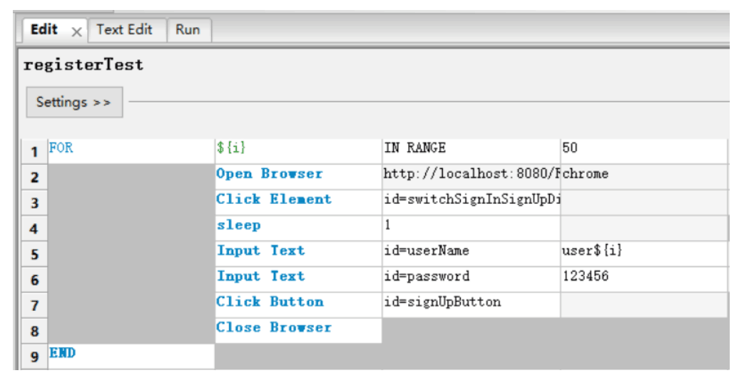

Expected result:

1. The user registration interface pops up.
2. The system will pop up the message "user registered successfully".

Case2:

Summary: Check whether the login function of the system is in good condition.

Steps:

1. Opening the browser.
2. Inputting the URL in the URL input area of the browser.
3. Choosing and clicks the login button.
4. Inputting user id and password, then clicks the enter button.

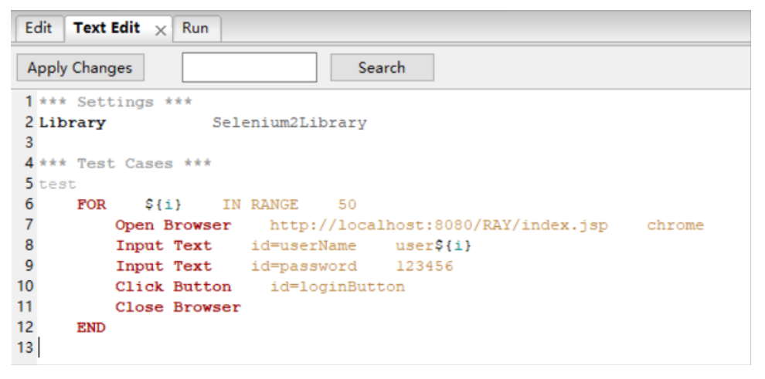

Expected result:

1. The user login interface pops up.
2. Successfully enter user interface.

Case3:

Summary: Check whether a single image can be uploaded by doctors.

Steps:

1. Choosing scoliosis detect algorithm engine 1.
2. Entering an account ID :1
3. Clicking the upload image button.
4. Uploading correct x-ray photo when file select window has opened.
5. Clicking the submit button.

Expected result: The web client can display result which from server.

Case4:

Summary: Check whether a single image can be uploaded by patients.

Steps:

1. Choosing scoliosis detect algorithm engine 3.
2. Clicking the upload image button.
3. Uploading correct x-ray photo when file select window has opened.
4. Clicking the submit button.

Expected result: The web client can display result which from server.

Case5:

Summary: Check to see if the patient can check the history.

Steps:

1. From the result records menu, selecting a record.

Expected result: The web client display correspondingly scoliosis detect result.

Case6:

Summary: Check if the doctor can upload multiple images.

Steps:

1. Choosing the correct page which is only opened to doctors.
2. Clicking the upload button.
3. Uploading a zip of new data.
4. Clicking the submit button.

Expected result: The web client display success message and acknowledge.

Case7:

Summary: Check if the doctor can edit the picture.

Steps:

1. Clicking the edit button to edit the image results.
2. Clicking the save button after editing.

Expected result: User can click the download button to download the image result after editing.

## Testing Plan

Here comes the complete testing plan for integration, referring to the workflows in the system design document.

## Register

1. The user opens the browser and opens the website.
2. The user clicks the register button.
3. The user inputs personal information.
4. The user clicks the submit button.
5. The web client displays result.

## Sign in

1. The user opens the browser.
2. The user inputs the URL in the URL input area of the browser.
3. The user chooses and clicks the login button.
4. The user inputs user id and password, then clicks the enter button.

## Upload Single Pic

1. The user chooses which scoliosis detect algorithm engine.
2. If user is a doctor, he must enter an account ID (ID can be empty).
3. The user clicks the upload image button.
4. The user uploads correct x-ray photo when file select window has opened.
5. The user clicks the submit button.
6. The web client display result.

## View History

1. From the result records menu, the user selects the which record he or she want to see.
2. The web client display correspondingly scoliosis detect result.

## Upload Multiple Pics

1. User chooses the correct page which is only opened to doctors.
2. The user clicks the upload button.
3. The user uploads a zip of new data.
4. The user clicks the submit button.
5. The web client display success message and acknowledge.

## Edit Lines

1. User clicks the edit button to edit the image results.
2. User clicks the save button after editing.
3. User clicks the download button to download the image result.

## Testing Results

The results of the integration are listed here and you may find the correspondence to the requirements in the requirement analysist document.

|  |  |  |  |
| --- | --- | --- | --- |
| **Test Case No.** | **Module** | **Result** | **Corresponding Requirement** |
| 1 | Register | The client shows that the registration is successful. |  |
| 2 | Sign in | The client shows that the login is successful. |  |
| 3 | Upload single Pic by doctors | The web client shows a warning message and user can upload photo again. | The image user upload isn’t qualified x-ray photo. |
| 4 | Upload single Pic  by patients | Successfully uploaded. |  |
| 5 | View history | The web page shows the history. |  |
| 6 | Upload multiple Pics | Successfully uploaded. |  |
| 7 | Edit lines | The picture was edited and saved successfully. |  |
| 01 | loadResultImage | The web page can display and save the result picture. |  |
| 02 | strockline | The webpage draws the straight line according to the coordinates. |  |

Some examples for testing results by robot testing (register, log in):

