IY4101 – Object Oriented Programming
Practical Programming Assignment 2
Report
Michael Tahiroğlu
304000037
I confirm that this assignment is my own work. Where I have referred to academic sources, I have provided in-text citations and included the sources in the final reference list.

Design
The shape management tool has three main classes: Shape, ShapeList, and ShapeManagement. Shape contains four sub-classes that define the supported types of shapes: Rectangle, Square, Circle and Triangle. All of these shapes can be defined, translated, and scaled. The area and perimeter can also be calculated. This information can also be displayed.
ShapeList contains an ArrayList of Shape instances. It supports commands to translate, scale, and display all Shape instances within it. ShapeManagement is the main class that creates a console interface for the user to create and view their shapes in.
Below is the UML Diagram for the tool:
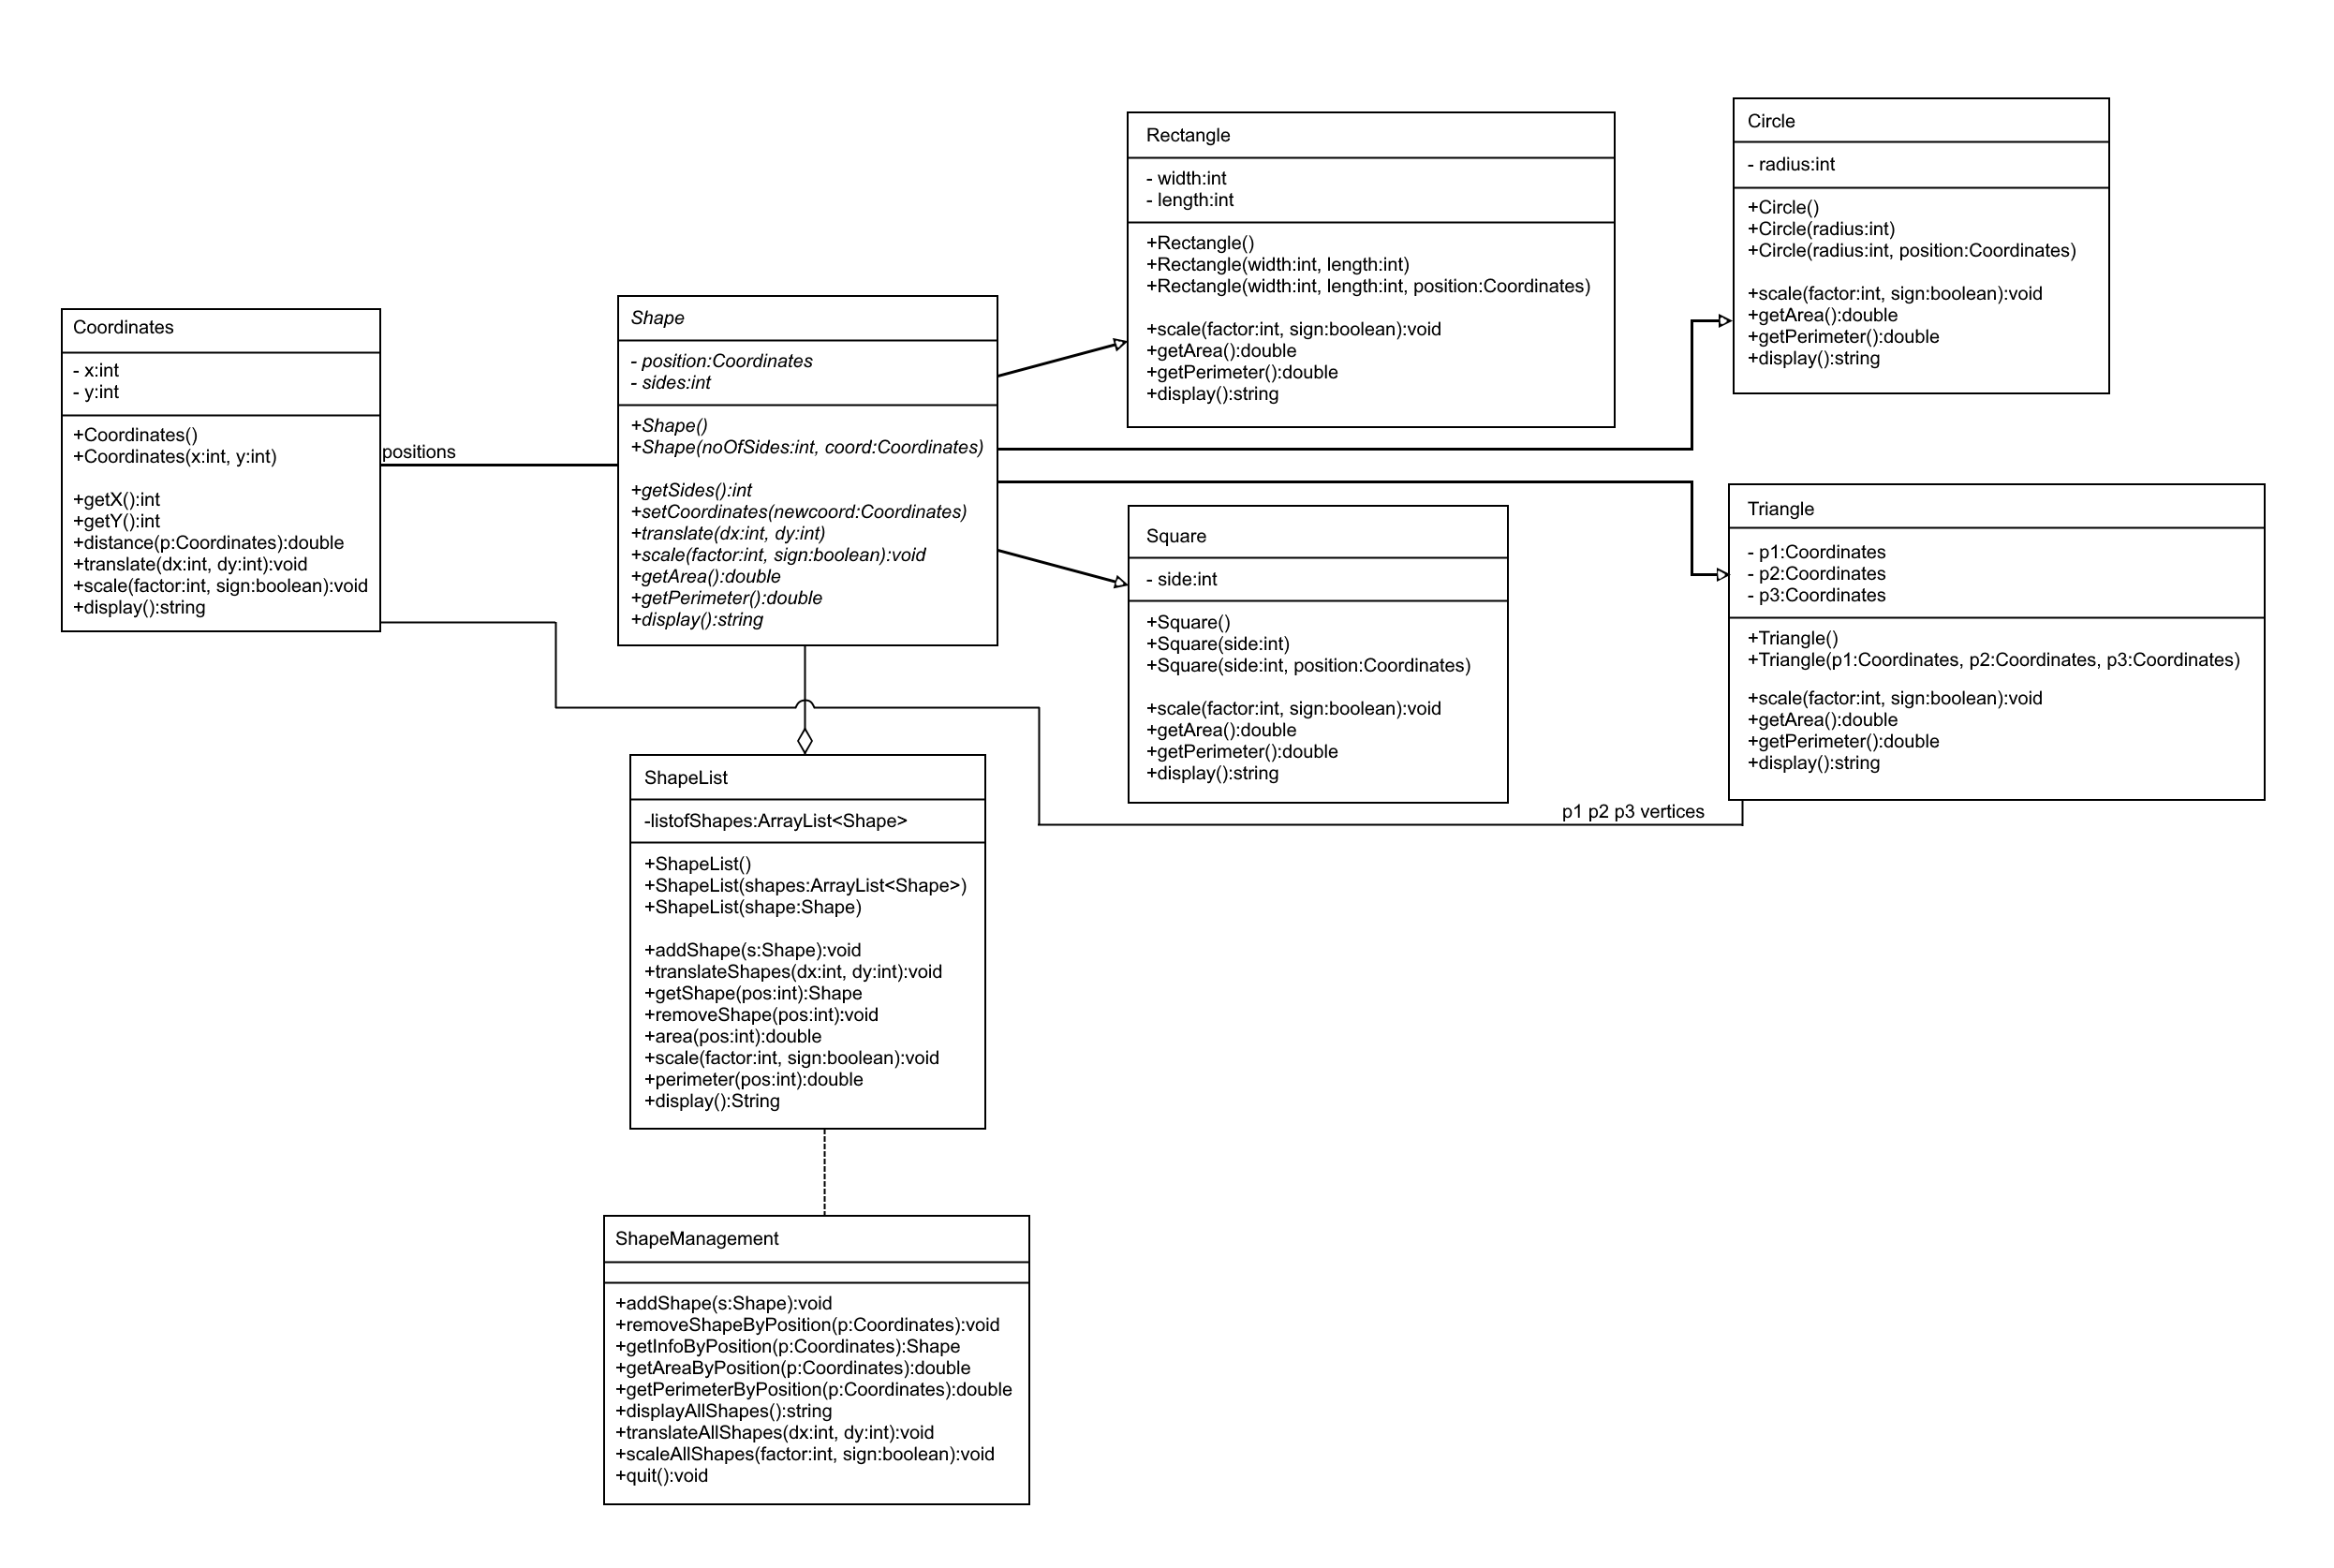

Testing
The required tests were run by applying the specified tests with the ShapeManagement class. Another common type of Shape was a unit shape (such as a triangle with vertices at (0, 0), (0, 1), (1, 0)). Below are the results of this test:
- Creating a triangle whose vertices are at (50, 50), (20, 70) and (70, 70), adding it to the list.
  - Expectation: The triangle will have an area of 500 and a perimeter of around 114.34. It will store it as the 0th indexed element of the ShapeList.
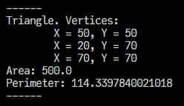
  - Results: The triangle’s coordinates show properly, the areas are indeed correct. It is the 0th indexed element of the ShapeList.
- Creating a rectangle at (100, 20), with width 10, length 15, adding it to the list.
  - Expectation: The rectangle is created at (100, 20). Has an area of 150 and a perimeter of 50. It should be the 1st indexed element of the ShapeList.
  - Results: The rectangle is at (100, 20). It has an area of 150 and a perimeter of 50, as expected. It is the 1st indexed element of the ShapeList.
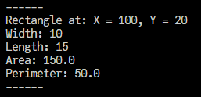
- Creating a circle in position (80, 100) and a radius of 25. Adding it to the list.
  - Expectation: A circle is created at (80, 100), with the radius set to 25. It should have an area around 1963.495, and a perimeter around 157.08. It should be the 2nd indexed element of the ShapeList.
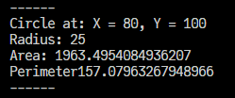
  - Results: The circle is at the correct location with the correct radius. It has the correct area and perimeter.
- Creating a square at (90, 40) with a side length of 20, adding it to the list.
  - Expectation: Square is created, with an area of 400 and a perimeter of 80. It should be the 3rd indexed element of ShapeList.
  - Results: The square is at the correct location and has the correct perimeter and area.
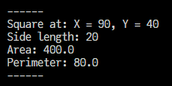
- Adding three other shapes: A circle at (0, 0) with a radius of 10 (4th shape), A triangle with points (0, 0), (0, 1), (1, 0) (5th shape), and a rectangle at (4, 4) with width 2 and length 4 (6th shape)
  - Expectation: The shapes are added and present at the correct index.
  - Results:
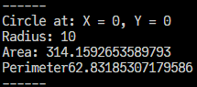
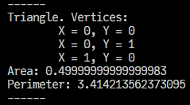
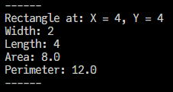
- Show the area and perimeter of the second object in the list.
  - Expectation: The second shape is the 1st index, so putting in 1 in there will give the rectangle at (100, 20), with width 10, length 15. The area then is 150 and the perimeter is 50.
  - Results: The area and perimeter are correct.
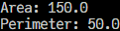
- Display information about all the shapes.
  - Expectation: The result will show each shape that we’ve seen so far in the order we’ve added them.
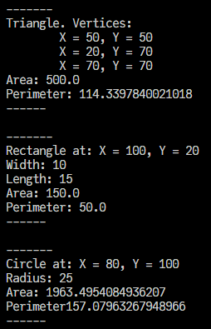
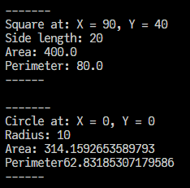
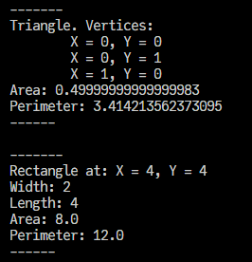
  - Results: Indeed the shapes appear in the correct order.

- Remove the third shape and check that no error occurs.
  - Expectation: The third shape, the circle at (80, 100) will get removed. Therefore when we check the third position, we should find our current fourth shape, the square at (90, 40) in its place. Keep in mind the third shape is at the 2nd index.
  - Result:
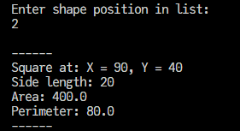
- Translate all the shapes by 10 for coordinate x and 15 for coordinate y.
  - Expectation: The X coordinate for the 4th shape, the circle at (0, 0) would be (10, 15) now.
  - Result: This is indeed the case.
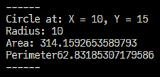
- Display information about all the shapes.
  - Expectation: We should see all the shapes, with their coordinates shifted accordingly.
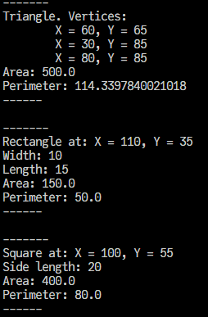
  - Result:
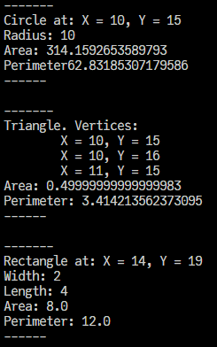
- Increase all the shapes by a factor of 2
  - Expectation: We should see the test triangle with points (10, 15), (10, 16), (11, 15) turn into the points (20, 30), (20, 32), (22, 30).
  - Result:
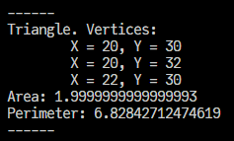
- Display all the shapes with the translation and scaling.
  - Expectations: The shapes should all be there, except for the one we removed, and they should all have the appropriate scaling.
  - Result:
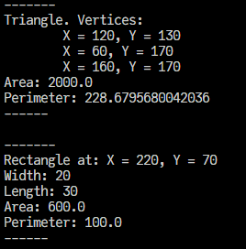
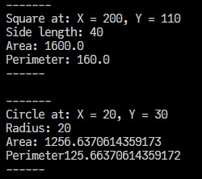
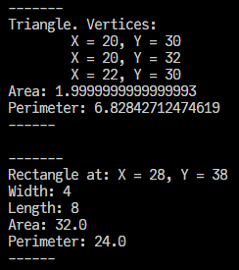
Further testing was also done to see if the program can handle common errors (such as an invalid index, trying to divide the scale by zero, or an invalid command number)
- Entering an invalid index to remove a shape from
  - Expectations: If I try to remove a shape at index 20, the program should let us know.
  - Result: it tells us by displaying “Invalid index.”
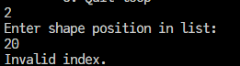
- Entering an invalid index to get information about a shape.
  - Expectations: The program should display the same error.
  - Result: It does.
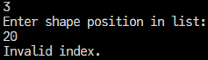
- Entering an invalid index to get area and perimeter.
  - Expectations: The program should display the same error again.
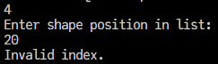
  - Result:
- Trying to divide the scale by zero.
  - Expectations: The program should raise a division by zero error, catch it, and display it.
  - Result:

