**The main goal of the thesis is to design and implement system that is using interactive evolutionary computation for generating haiku poems and recitation of the robot. It aims to contribute to social robotics research by allowing the user to completely adapt the pomes with their recitation according to their preferences.**

Web-based application for evolution of haiku poems

* + the emphasis is on human-computer interaction
  + uses interactive evolutionary computation for generating haiku poems that will be considered by human as pretty

Evolutionary algorithms are search-based optimization algorithms inspired by nature. They use biological phenomenon of evolution and ideas of natural selection, reproduction and heredity. Evolutionary algorithm is used when search of significantly big search space is required.

Interactive evolutionary computation uses evolutionary algorithms for problem optimization where the outputs of the optimized system should fit subjective user preferences. In this case, human is the fitness function. This approach is suitable e. g. for artistic applications or for industrial design.

# The system for haiku evolution

Haiku poetry was originally developed in Japan. Haiku poem is often inspired by nature and captures a feeling. Its modified form was adapted to English and other languages. In tradition English haiku consists of 5-7-5 syllable pattern of English words in three lines. A haiku in English follows the form and style of Japanese haiku. Generating haiku poetry was chosen because of its fixed form and simple idea of the content.

Interactive evolutionary computation is used for implementation of the system because the user’s subjective preference is the most important task in social robotics. Approach of interactive evolutionary computation is suitable also because of big search space of possible haiku poems and possible way of robot’s recitation.

## Representation of Haiku Poem

Haiku class is used to represent haiku poem. Natural representation was chosen- each line of a poem is represented by string variable. Random haiku poem is selected from haiku database in initial generation.

Genetic operator used for reproducing individuals in population is cross over. New individual is created from two parents by exchanging randomly chosen line of poem. The second parent is an input argument to cross over function.

## Representation of Population of Haiku Poems

Each population contains 10 individuals. The number of evaluations that IEC can receive from one human user is limited by user fatigue. For maintaining diversity in haiku poems, in each evolutionary cycle is population enlarged with new members.

Roulette method was chosen for selecting parents for reproduction. 4 parents are selected and each parent is then crossed over with other randomly chosen second parent. Reproduction again creates population of 8 individuals, other 2 are selected randomly from haiku database.

An integer variable is used to store fitness of each individual. At first, every poem in population has the same value. Later in evolutionary cycle, the fitness value is modified based on human evaluation.

# Evolution of haiku poems on web

Application for interactive evolution of haiku poems is web-based. An ASP .NET MVC application in C# and HTML was created for implementing web-based interface for interactive evolution of haiku poems. Visual Studio was used as developer tool. Local database for storing haiku poems was created with Microsoft SQL Server.

After opening website in a browser, introductory text with basic information about the thesis and application is shown.

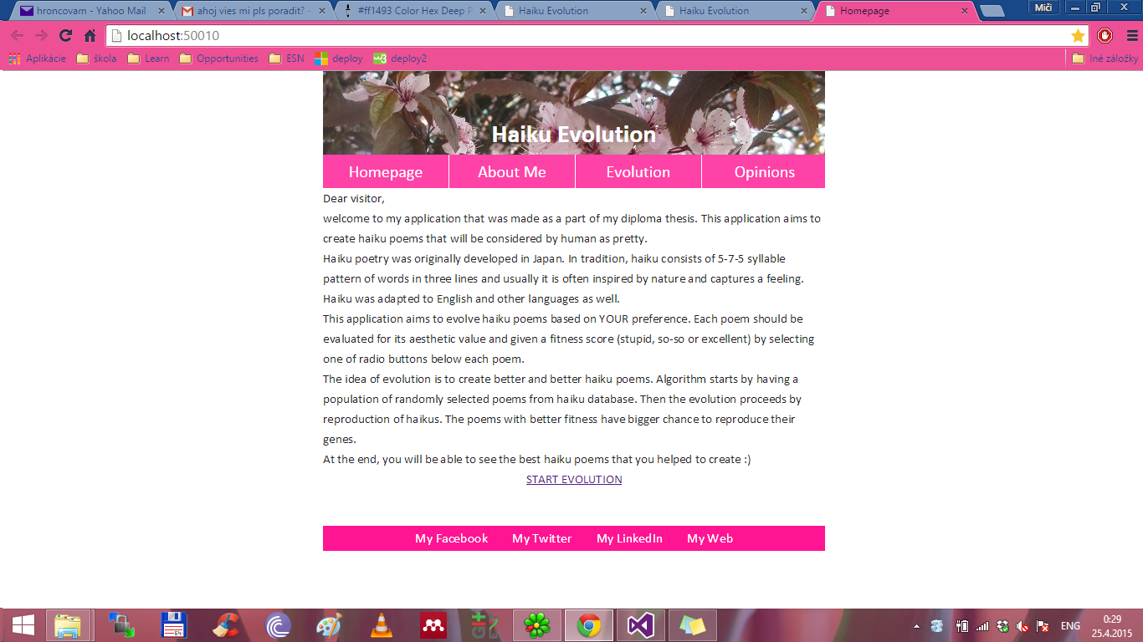

Figure 4 Web application for haiku evolution

After pressing button *Start Evolution* initial population chosen randomly from haiku database is displayed for evaluation. Radio buttons for evaluation are placed under each poem. Evaluation possibilities are 3:

* Excellent
* So-so
* Stupid

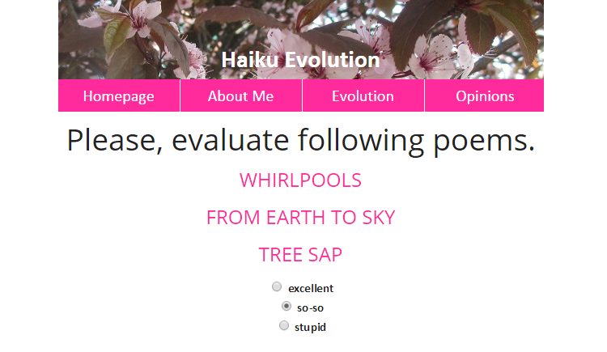

Figure 5 Web application for haiku evolution

New generation is computed after clicking on the submit button right below the table with poems. The total number of generations is 7.

The output of the application is a text file containing the best haiku poems according to user’s preferences.

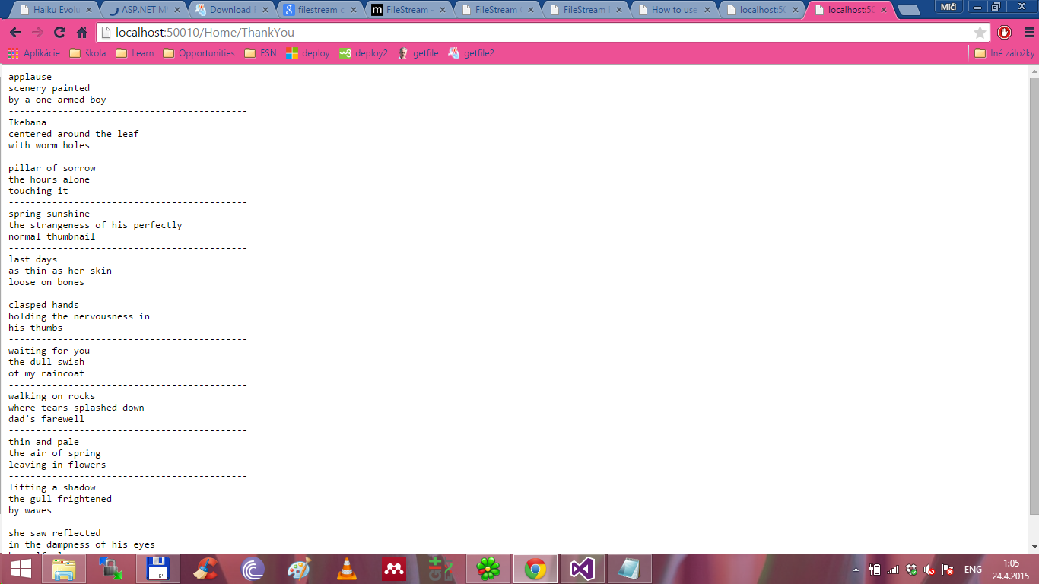

Figure 6 The output file with best poems

# Results of evolution

The experiments with real users trying the systems have shown following results:

6 users considered as better approach to evolve haiku poems the web-based application and only 4 of the users preferred evolution of haiku poem together with their recitation.

# Conclusion

This article describes a model of interactive evolution of haiku poetry and recitation as a state space search problem where a goal state is a poem that satisfies the preferences of human evaluating poems.