|  |  |  |  |
| --- | --- | --- | --- |
| Document filename: | **Send Federated Consultation Report** | | |
| Project / Programme | **GP Connect** | Project | **Send Document** |
| Document Reference |  | | |
| Project Manager | **Richard Phillips** | Status | **WIP** |
| Owner | **Jim Phelps** | Version | **1.3** |
| Author | **Jim Phelps** | Version issue date | **17/09/2018** |

GP Connect: Send Message

Send Federated Consultation Report Process Document

Document Control:

The controlled copy of this document is maintained in the NHS Digital corporate network. Any copies of this document held outside of that area, in whatever format (e.g. paper, email attachment), are considered to have passed out of control and should be checked for currency and validity.

Document management

Revision History

|  |  |  |
| --- | --- | --- |
| Version | Date | Summary of Changes |
| 1.0 | 03/09/18 | Original draft. Text updated from options paper. |
| 1.1 | 04/09/18 | Updated process and process map. Amendments to text. |
| 1.2 | 05/09/2018 | Updated based on feedback from clinical input group. |
| 1.3 | 12/09/2018 | Updated based on internal feedback |
|  |  |  |

Reviewers

This document must be reviewed by the following people:

|  |  |  |  |
| --- | --- | --- | --- |
| Reviewer name | Title / Responsibility | Date | Version |
| Mike Stacey | Lead Business Analyst |  |  |
| Brian Diggle | Technical Architect |  |  |
| Javed Fadal | Project Manager |  |  |
| Peter Short | Clinical Lead |  |  |
| Cath Johnson | Clinical Lead |  |  |
| Rob Jeeves | Clinical Lead |  |  |
| Neill Jones | Clinical Lead |  |  |

Approved by

This document must be approved by the following people:

|  |  |  |  |  |
| --- | --- | --- | --- | --- |
| Name | Signature | Title | Date | Version |
|  |  |  |  |  |
|  |  |  |  |  |

Glossary of Terms

|  |  |
| --- | --- |
| Term / Abbreviation | What it stands for |
| consultation | The interaction between patient and clinician and the notes taken by the clinician to record the interaction. |
| registered practice | The GP practice where the patient is registered. This practice receives the federated consultation report from the federated practice. |
| federated practice | The GP practice where the patient attends but is not registered at. This practice will be in the same GP federation (or a group of GP practices working together to deliver a service) as the registered practice. The federated consultation report is written and sent from this practice. |
| provider system | The principle GP system used in the federated GP practice. |
| consumer system | The principle GP system used in the registered GP practice. |
| ODS code | The Organisation Data Service (**ODS**) **code** is a unique identifying **code** used by the NHS for various purposes, relevant here as an identifier for GP practices |

Contents

1. Introduction 5

1.1. Project Introduction 5

1.2. Purpose of Document 5

2. Process 6

2.1. Description 6

2.1.1. Process map 7

2.1.2. Steps 8

# Introduction

## Project Introduction

**GP Connect** aims to support better clinical care by opening up information and data held within GP Practice IT systems for use across health and social care. The GP Connect vision will be achieved by standardising integration and simplifying the operating model, making medical information about patients available to the right clinician, across care settings.

Health and care data will be connected through:

* access to the detailed patient record of every practice, at the point of care
* quicker and more efficient appointment management between practices
* the ability to book an appointment at a practice from another care setting

GP Connect has initially focused on delivering HTTP FHIR® APIs. An additional set of capabilities, under the badge **GP Connect Messaging**, are focused on enabling updates to GP practice systems.

**Send Document** is one such capability being developed as part of GP Connect Messaging. It provides a simple and standardised means of sending a document, such as a PDF, an image, or HTML file to a GP practice system. It uses ITK3, MESH and Spine integration to deliver the message.

**Send Federated Consultation Report** is a specific use case for Send Document, arising when a patient attends a GP appointment outside their registered GP practice (for example an extended hours appointment in a federation). It will allow a clinician to send the details of that consultation back to the registered practice to be added to the patient GP record.

In the first phase of the project these details will be sent as a PDF (and any associated attachments that relate to the consultation) which will arrive in the workflow of the patient’s registered GP practice.

## Purpose of Document

This document will describe the business process for the Send Federated Consultation Report use case in order to help develop the business requirements.

# Process

## Description

This process describes the steps/actions involved in the Federated Consultation Report use case where a consultation is written within the provider system and is sent to the consumer system at the patient’s registered GP practice.

Two common requirements must be met for this process to proceed:

* The clinician writes a consultation for a patient; and
* The patient being treated is not registered at the practice where the consultation is written AND is registered at a GP practice within the same federation (or a group of GP practices working together to deliver a service).

Federated consultation reports will be sent three hours (locally configurable) after the consultation is saved and committed to the patient’s clinical record.

Where a clinician makes further updates to the consultation notes before the three hour gap, a single report is sent.

Where the consultation notes are edited after the report has already been sent, an updated version of the report is sent.

Additional reports are clearly marked with a version number.

### Process map

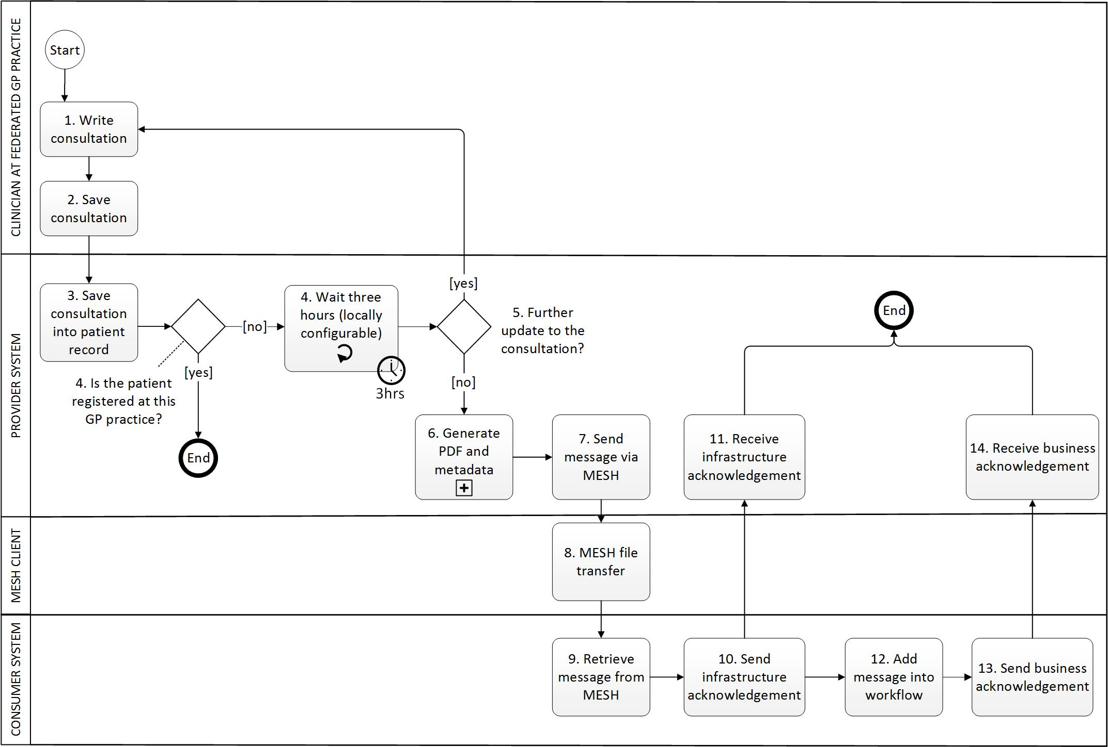

### Steps

1. **Write consultation**

Clinician inputs the details of the consultation into the GP provider system. Data inputted could be free text or clinical codes which may be entered manually or through the use of clinical templates. It could include adding attachments/documents (for example pain point diagram, ECG, photo). This is no different from the normal method of writing a consultation for a patient registered at the GP practice.

1. **Save consultation**

The clinician manually saves the consultation notes and commits them to the patient record.

1. **Save consultation into patient record**

The provider system saves the consultation notes into the patient’s electronic record at the federated GP practice.

1. **Wait three hours (locally configurable)**

The provider system waits three hours before the process moves on. This gives time for the clinician to make any necessary updates to the consultation to reduce the chance of the report being sent multiple times.

The period of time that the clinical system waits before sending a message can be configured by each GP practice to meet their local needs.

1. **Further updates to the consultation?**

If the user makes changes to the consultation notes in the patient record within three hours, the process moves back to step 1.

Otherwise, the process moves on to step 6.

There may be many reasons why the consultation is not completed when initially saved:

* + - The clinician may not have time to finish the consultation notes and must continue with treating other patients
    - The clinician may wish to ask a colleague for advice
    - The clinician may be offsite and will finish writing the consultation notes when they have returned to the GP practice
    - The results of a test may be required before the clinician can complete their notes
    - The clinician may have forgotten to add some important information when originally writing the consultation notes

1. **Generate PDF and metadata**

A FHIR message is generated which contains a PDF which contains all the information recorded in the consultation (including free text, clinical coding and other data entered relating to the consultation).

The ITK3 FHIR Message is generated, which must include:

* + - FHIR MessageHeader
    - FHIR STU3 task
    - PDF file, its contents and metadata
    - All attachments/documents recorded with the consultation

Further details on the message content can be found at:

https://developer.nhs.uk/apis/gpconnect-messaging-1-0/senddocument_payload.html

When the PDF is generated, the provider system checks for previous versions of the PDF linked to this consultation. A previous version will exist if the clinician updates the consultation more than three hours after it was initially saved and committed. If there are no previous versions, the PDF is designated as [version 1]. If there are previous versions, the PDF is designated [version 2/3/4…n]. The version number is displayed in the title of the PDF (“Federated Consultation Report Version x”) and version field within the document itself.

1. **Send message via MESH**

The provider system passes the message to the MESH client.

1. **MESH file transfer**

The MESH client transfers the message to the MESH inbox of the patient’s registered GP practice.

1. **Retrieve message from MESH**

The consumer system of the registered practice retrieves the message from their MESH inbox.

1. **Send infrastructure acknowledgement**

The consumer system sends an ITK3 FHIR Message to the provider system containing:

* + - FHIR MessageHeader
    - FHIR OperationOutcome (ITK3 response with response code 10001 to 20013)

1. **Receive infrastructure acknowledgement**

The provider system records the infrastructure acknowledgement. If no acknowledgement is received within a reasonable timeframe (to be defined by system supplier), the provider system notifies an appropriate end user.

1. **Add message into workflow**

The consumer system matches the message to a registered GP patient and presents the message to an appropriate user in a designated workflow.

1. **Send business acknowledgement**

The consumer system sends an ITK3 FHIR Message to the provider system containing:

* + - FHIR MessageHeader
    - FHIR OperationOutcome (ITK3 response with response code 30001 to 30003)

1. **Receive business acknowledgement**

The provider system records the business acknowledgement. If no acknowledgement is received within a reasonable timeframe (to be defined by the system supplier), the provider system notifies an appropriate end user.