**計算智慧於工程上的應用**

**HW1(GAHomework)**

**M11205314**

**張原嘉**

Programming Language : Matlab

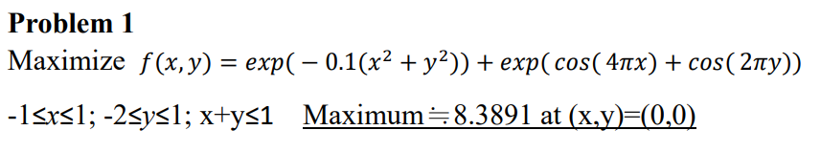

Step1 : Initialization

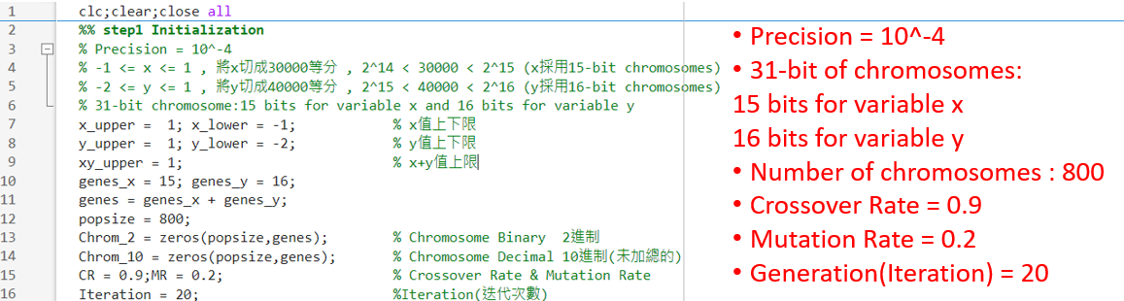Step2 : Evaluation

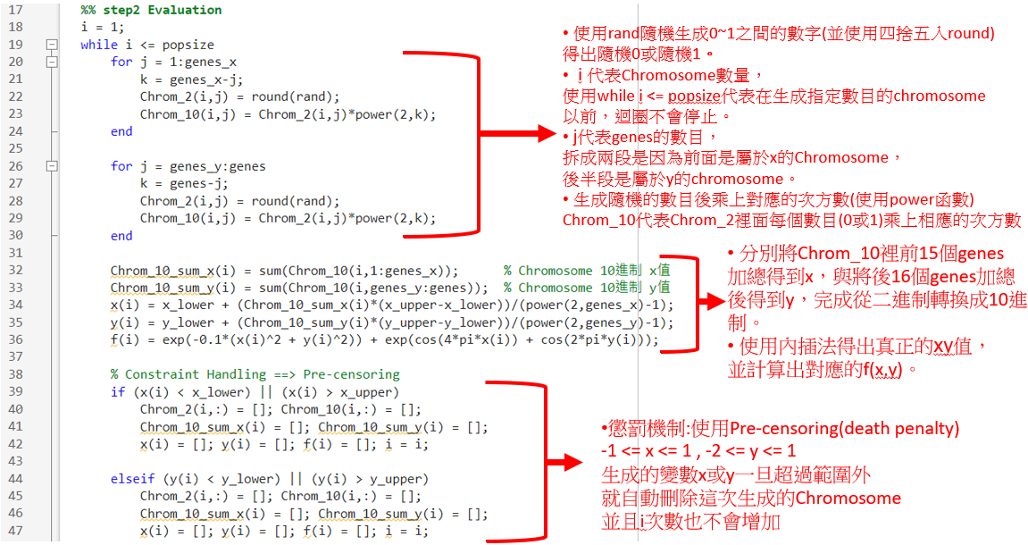

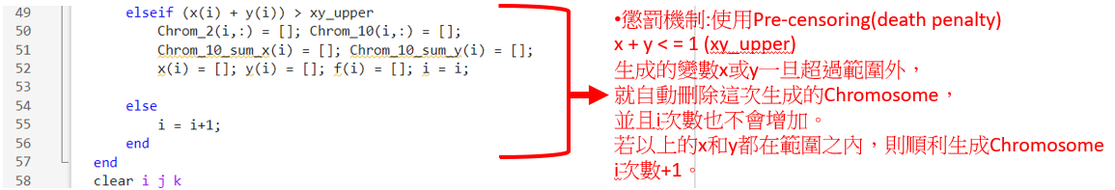Step3 : Selection (Roulette wheel)

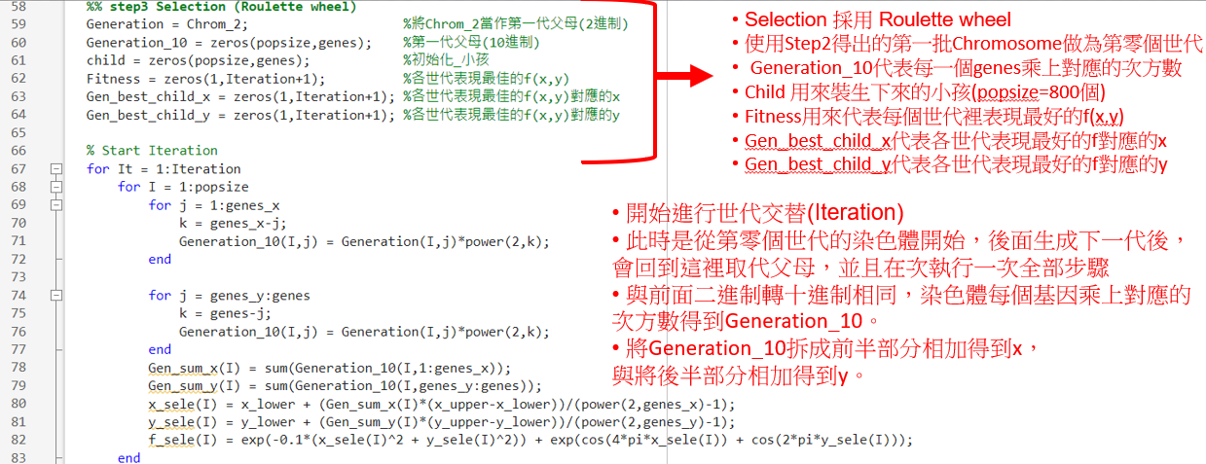

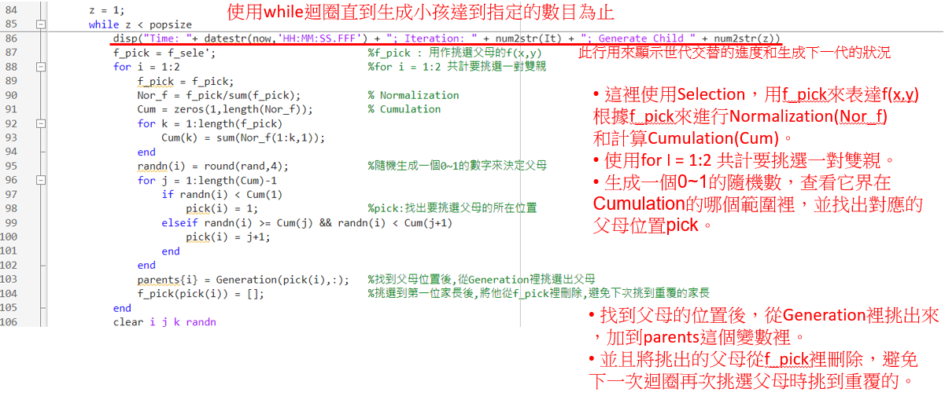

Step4 : Crossover (One-point crossover)

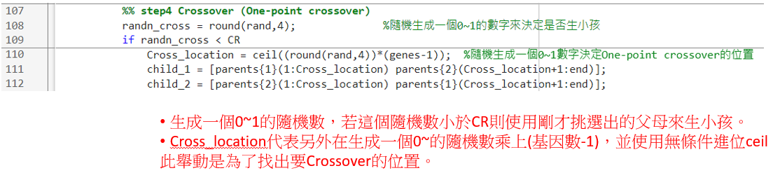

Step5 : Mutation (One-bit-mutation)

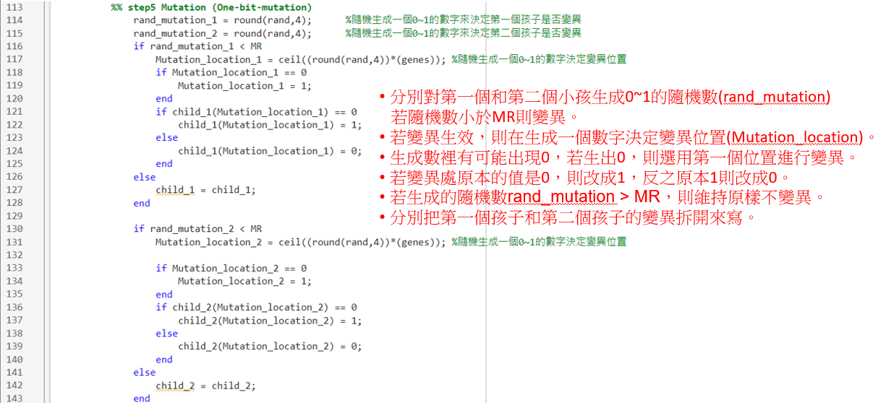

Step 6 : Constraint handling

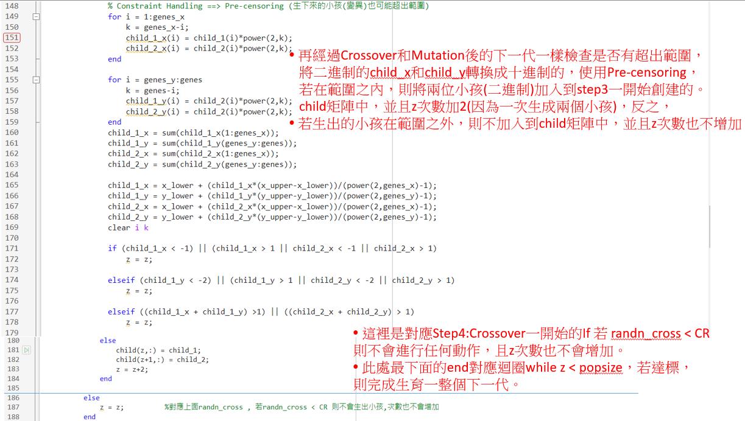

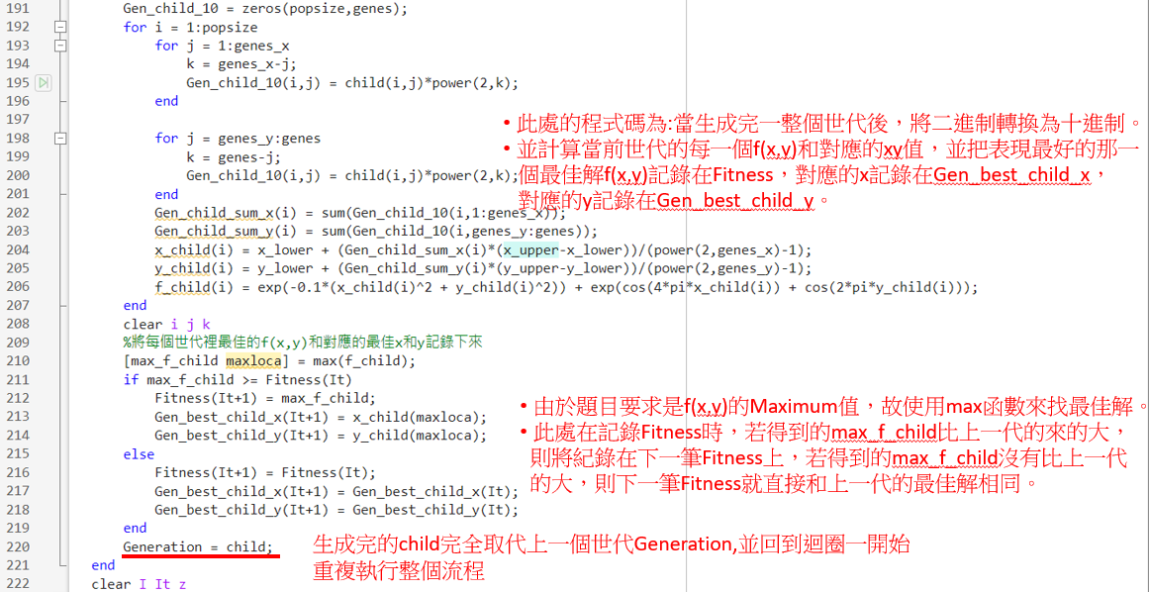

Final Optimization Result

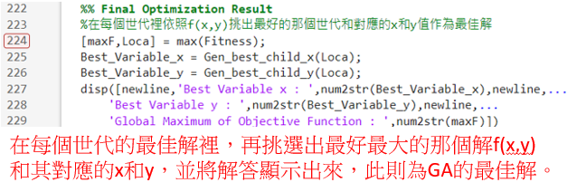

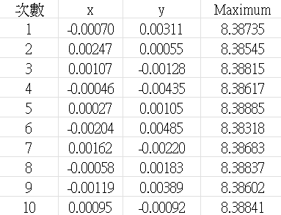



此為執行GA程式碼10次所得出的結果，與作業答案相比,精確度大概到小數點後第二位

Evolution History

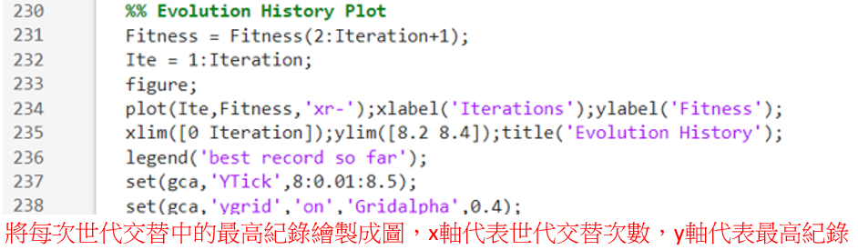

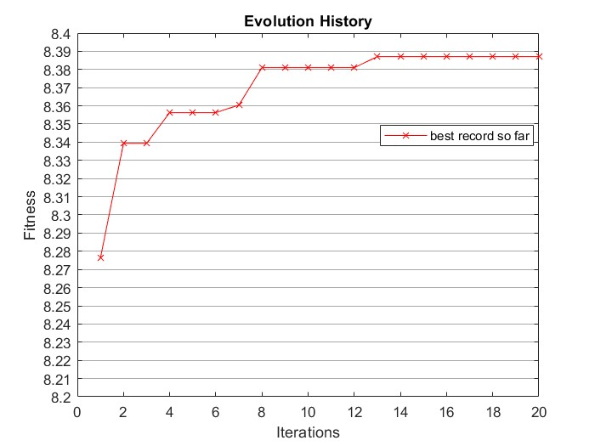

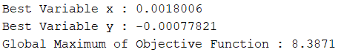

此為其中一次的執行結果，Evolution History得出的圖形會是一條單調遞增的線段。

Matlab Code:

clc;clear;close all

%% step1 Initialization

% Precision = 10^-4

% -1 <= x <= 1 , 將x切成30000等分 , 2^14 < 30000 < 2^15 (x採用15-bit chromosomes)

% -2 <= y <= 1 , 將y切成40000等分 , 2^15 < 40000 < 2^16 (y採用16-bit chromosomes)

% 31-bit chromosome:15 bits for variable x and 16 bits for variable y

x_upper = 1; x_lower = -1; % x值上下限

y_upper = 1; y_lower = -2; % y值上下限

xy_upper = 1; % x+y值上限

genes_x = 15; genes_y = 16;

genes = genes_x + genes_y;

popsize = 800;

Chrom_2 = zeros(popsize,genes); % Chromosome Binary 2進制

Chrom_10 = zeros(popsize,genes); % Chromosome Decimal 10進制(未加總的)

CR = 0.9;MR = 0.2; % Crossover Rate & Mutation Rate

Iteration = 20; %Iteration(迭代次數)

%% step2 Evaluation

i = 1;

while i <= popsize

for j = 1:genes_x

k = genes_x-j;

Chrom_2(i,j) = round(rand);

Chrom_10(i,j) = Chrom_2(i,j)*power(2,k);

end

for j = genes_y:genes

k = genes-j;

Chrom_2(i,j) = round(rand);

Chrom_10(i,j) = Chrom_2(i,j)*power(2,k);

end

Chrom_10_sum_x(i) = sum(Chrom_10(i,1:genes_x)); % Chromosome 10進制 x值

Chrom_10_sum_y(i) = sum(Chrom_10(i,genes_y:genes)); % Chromosome 10進制 y值

x(i) = x_lower + (Chrom_10_sum_x(i)*(x_upper-x_lower))/(power(2,genes_x)-1);

y(i) = y_lower + (Chrom_10_sum_y(i)*(y_upper-y_lower))/(power(2,genes_y)-1);

f(i) = exp(-0.1*(x(i)^2 + y(i)^2)) + exp(cos(4*pi*x(i)) + cos(2*pi*y(i)));

% Constraint Handling ==> Pre-censoring

if (x(i) < x_lower) || (x(i) > x_upper)

Chrom_2(i,:) = []; Chrom_10(i,:) = [];

Chrom_10_sum_x(i) = []; Chrom_10_sum_y(i) = [];

x(i) = []; y(i) = []; f(i) = []; i = i;

elseif (y(i) < y_lower) || (y(i) > y_upper)

Chrom_2(i,:) = []; Chrom_10(i,:) = [];

Chrom_10_sum_x(i) = []; Chrom_10_sum_y(i) = [];

x(i) = []; y(i) = []; f(i) = []; i = i;

elseif (x(i) + y(i)) > xy_upper

Chrom_2(i,:) = []; Chrom_10(i,:) = [];

Chrom_10_sum_x(i) = []; Chrom_10_sum_y(i) = [];

x(i) = []; y(i) = []; f(i) = []; i = i;

else

i = i+1;

end

end

clear i j k

%% step3 Selection (Roulette wheel)

Generation = Chrom_2; %將Chrom_2當作第一代父母(2進制)

Generation_10 = zeros(popsize,genes); %第一代父母(10進制)

child = zeros(popsize,genes); %初始化_小孩

Fitness = zeros(1,Iteration+1); %各世代表現最佳的f(x,y)

Gen_best_child_x = zeros(1,Iteration+1); %各世代表現最佳的f(x,y)對應的x

Gen_best_child_y = zeros(1,Iteration+1); %各世代表現最佳的f(x,y)對應的y

% Start Iteration

for It = 1:Iteration

for I = 1:popsize

for j = 1:genes_x

k = genes_x-j;

Generation_10(I,j) = Generation(I,j)*power(2,k);

end

for j = genes_y:genes

k = genes-j;

Generation_10(I,j) = Generation(I,j)*power(2,k);

end

Gen_sum_x(I) = sum(Generation_10(I,1:genes_x));

Gen_sum_y(I) = sum(Generation_10(I,genes_y:genes));

x_sele(I) = x_lower + (Gen_sum_x(I)*(x_upper-x_lower))/(power(2,genes_x)-1);

y_sele(I) = y_lower + (Gen_sum_y(I)*(y_upper-y_lower))/(power(2,genes_y)-1);

f_sele(I) = exp(-0.1*(x_sele(I)^2 + y_sele(I)^2)) + exp(cos(4*pi*x_sele(I)) + cos(2*pi*y_sele(I)));

end

z = 1;

while z < popsize

disp("Time: "+ datestr(now,'HH:MM:SS.FFF') + "; Iteration: " + num2str(It) + "; Generate Child " + num2str(z))

f_pick = f_sele'; %f_pick : 用作挑選父母的f(x,y)

for i = 1:2 %for i = 1:2 共計要挑選一對雙親

f_pick = f_pick;

f_pick = f_pick - min(f_pick);

Nor_f = f_pick/sum(f_pick); % Normalization

Cum = zeros(1,length(Nor_f)); % Cumulation

for k = 1:length(f_pick)

Cum(k) = sum(Nor_f(1:k,1));

end

randn(i) = round(rand,4); %隨機生成一個0~1的數字來決定父母

for j = 1:length(Cum)-1

if randn(i) < Cum(1)

pick(i) = 1; %pick:找出要挑選父母的所在位置

elseif randn(i) >= Cum(j) && randn(i) < Cum(j+1)

pick(i) = j+1;

end

end

parents{i} = Generation(pick(i),:); %找到父母位置後,從Generation裡挑選出父母

f_pick(pick(i)) = []; %挑選到第一位家長後,將他從f_pick裡刪除,避免下次挑到重覆的家長

end

clear i j k randn

%% step4 Crossover (One-point crossover)

randn_cross = round(rand,4); %隨機生成一個0~1的數字來決定是否生小孩

if randn_cross < CR

Cross_location = ceil((round(rand,4))*(genes-1)); %隨機生成一個0~1數字決定One-point crossover的位置

child_1 = [parents{1}(1:Cross_location) parents{2}(Cross_location+1:end)];

child_2 = [parents{2}(1:Cross_location) parents{1}(Cross_location+1:end)];

%% step5 Mutation (One-bit-mutation)

rand_mutation_1 = round(rand,4); %隨機生成一個0~1的數字來決定第一個孩子是否變異

rand_mutation_2 = round(rand,4); %隨機生成一個0~1的數字來決定第二個孩子是否變異

if rand_mutation_1 < MR

Mutation_location_1 = ceil((round(rand,4))*(genes)); %隨機生成一個0~1的數字決定變異位置

if Mutation_location_1 == 0

Mutation_location_1 = 1;

end

if child_1(Mutation_location_1) == 0

child_1(Mutation_location_1) = 1;

else

child_1(Mutation_location_1) = 0;

end

else

child_1 = child_1;

end

if rand_mutation_2 < MR

Mutation_location_2 = ceil((round(rand,4))*(genes)); %隨機生成一個0~1的數字決定變異位置

if Mutation_location_2 == 0

Mutation_location_2 = 1;

end

if child_2(Mutation_location_2) == 0

child_2(Mutation_location_2) = 1;

else

child_2(Mutation_location_2) = 0;

end

else

child_2 = child_2;

end

% Constraint Handling ==> Pre-censoring (生下來的小孩(變異)也可能超出範圍)

for i = 1:genes_x

k = genes_x-i;

child_1_x(i) = child_1(i)*power(2,k);

child_2_x(i) = child_2(i)*power(2,k);

end

for i = genes_y:genes

k = genes-i;

child_1_y(i) = child_2(i)*power(2,k);

child_2_y(i) = child_2(i)*power(2,k);

end

child_1_x = sum(child_1_x(1:genes_x));

child_1_y = sum(child_1_y(genes_y:genes));

child_2_x = sum(child_2_x(1:genes_x));

child_2_y = sum(child_2_y(genes_y:genes));

child_1_x = x_lower + (child_1_x*(x_upper-x_lower))/(power(2,genes_x)-1);

child_1_y = y_lower + (child_1_y*(y_upper-y_lower))/(power(2,genes_y)-1);

child_2_x = x_lower + (child_2_x*(x_upper-x_lower))/(power(2,genes_x)-1);

child_2_y = y_lower + (child_2_y*(y_upper-y_lower))/(power(2,genes_y)-1);

clear i k

if (child_1_x < x_lower) || (child_1_x > x_upper || child_2_x < x_lower || child_2_x > x_upper)

z = z;

elseif (child_1_y < y_lower) || (child_1_y > y_upper || child_2_y < y_lower || child_2_y > y_upper)

z = z;

elseif ((child_1_x + child_1_y) > xy_upper) || ((child_2_x + child_2_y) > xy_upper)

z = z;

else

child(z,:) = child_1;

child(z+1,:) = child_2;

z = z+2;

end

else

z = z; %對應上面randn_cross , 若randn_cross < CR 則不會生出小孩,次數也不會增加

end

end

Gen_child_10 = zeros(popsize,genes);

for i = 1:popsize

for j = 1:genes_x

k = genes_x-j;

Gen_child_10(i,j) = child(i,j)*power(2,k);

end

for j = genes_y:genes

k = genes-j;

Gen_child_10(i,j) = child(i,j)*power(2,k);

end

Gen_child_sum_x(i) = sum(Gen_child_10(i,1:genes_x));

Gen_child_sum_y(i) = sum(Gen_child_10(i,genes_y:genes));

x_child(i) = x_lower + (Gen_child_sum_x(i)*(x_upper-x_lower))/(power(2,genes_x)-1);

y_child(i) = y_lower + (Gen_child_sum_y(i)*(y_upper-y_lower))/(power(2,genes_y)-1);

f_child(i) = exp(-0.1*(x_child(i)^2 + y_child(i)^2)) + exp(cos(4*pi*x_child(i)) + cos(2*pi*y_child(i)));

end

clear i j k

%將每個世代裡最佳的f(x,y)和對應的最佳x和y記錄下來

[max_f_child maxloca] = max(f_child);

if max_f_child >= Fitness(It)

Fitness(It+1) = max_f_child;

Gen_best_child_x(It+1) = x_child(maxloca);

Gen_best_child_y(It+1) = y_child(maxloca);

else

Fitness(It+1) = Fitness(It);

Gen_best_child_x(It+1) = Gen_best_child_x(It);

Gen_best_child_y(It+1) = Gen_best_child_y(It);

end

Generation = child;

end

clear I It z

%% Final Optimization Result

%在每個世代裡依照f(x,y)挑出最好的那個世代和對應的x和y值作為最佳解

[maxF,Loca] = max(Fitness);

Best_Variable_x = Gen_best_child_x(Loca);

Best_Variable_y = Gen_best_child_y(Loca);

disp([newline,'Best Variable x : ',num2str(Best_Variable_x),newline,...

'Best Variable y : ',num2str(Best_Variable_y),newline,...

'Global Maximum of Objective Function : ',num2str(maxF)])

%% Evolution History Plot

Fitness = Fitness(2:Iteration+1);

Ite = 1:Iteration;

figure;

plot(Ite,Fitness,'xr-');xlabel('Iterations');ylabel('Fitness');

xlim([0 Iteration]);ylim([8.2 8.4]);title('Evolution History');

legend('best record so far');

set(gca,'YTick',8:0.01:8.5);

set(gca,'ygrid','on','Gridalpha',0.4);