Assetify

- Document Repository
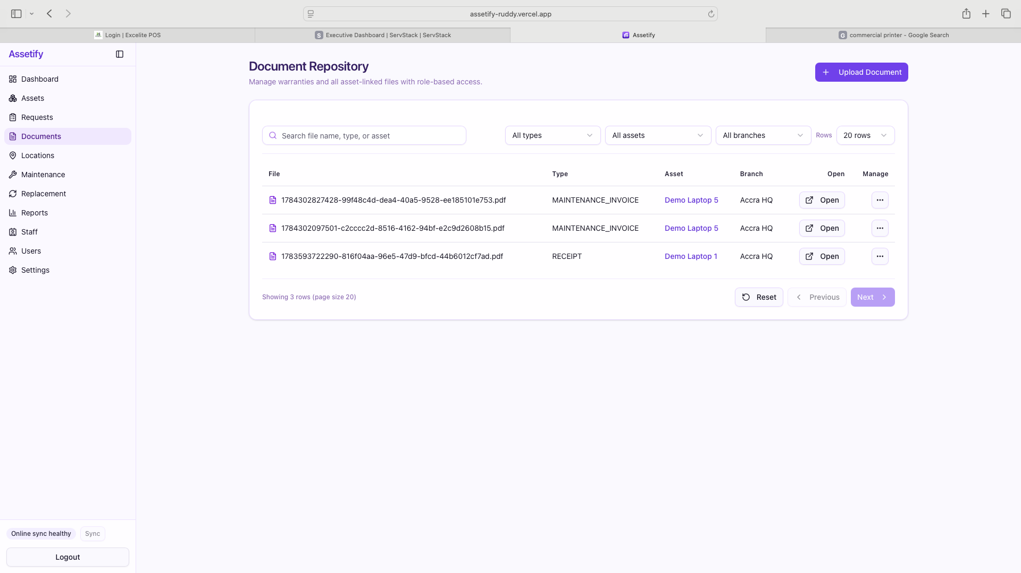

Add a “Document Name” field in the “Add documents” panel and show on panel
Rename “Open” to “Artifact”
Hide “File” from the display

When you select edit, allow user to replace the file

- Request
Show asset name field since category may not provide much info for request
Suggested flow
- User select the Asset Type
- System allows user to select the “Asset Name” from the asset name field. The asset names are filtered based on the category from the asset type field.

Add a “Custodian” field.
The person requesting the asset may not be the one who needs the asset. They may be requesting on behalf of another staff. This could happen if we do not grant access to all staff into Assetify. So the custodian will pull from the staff list.

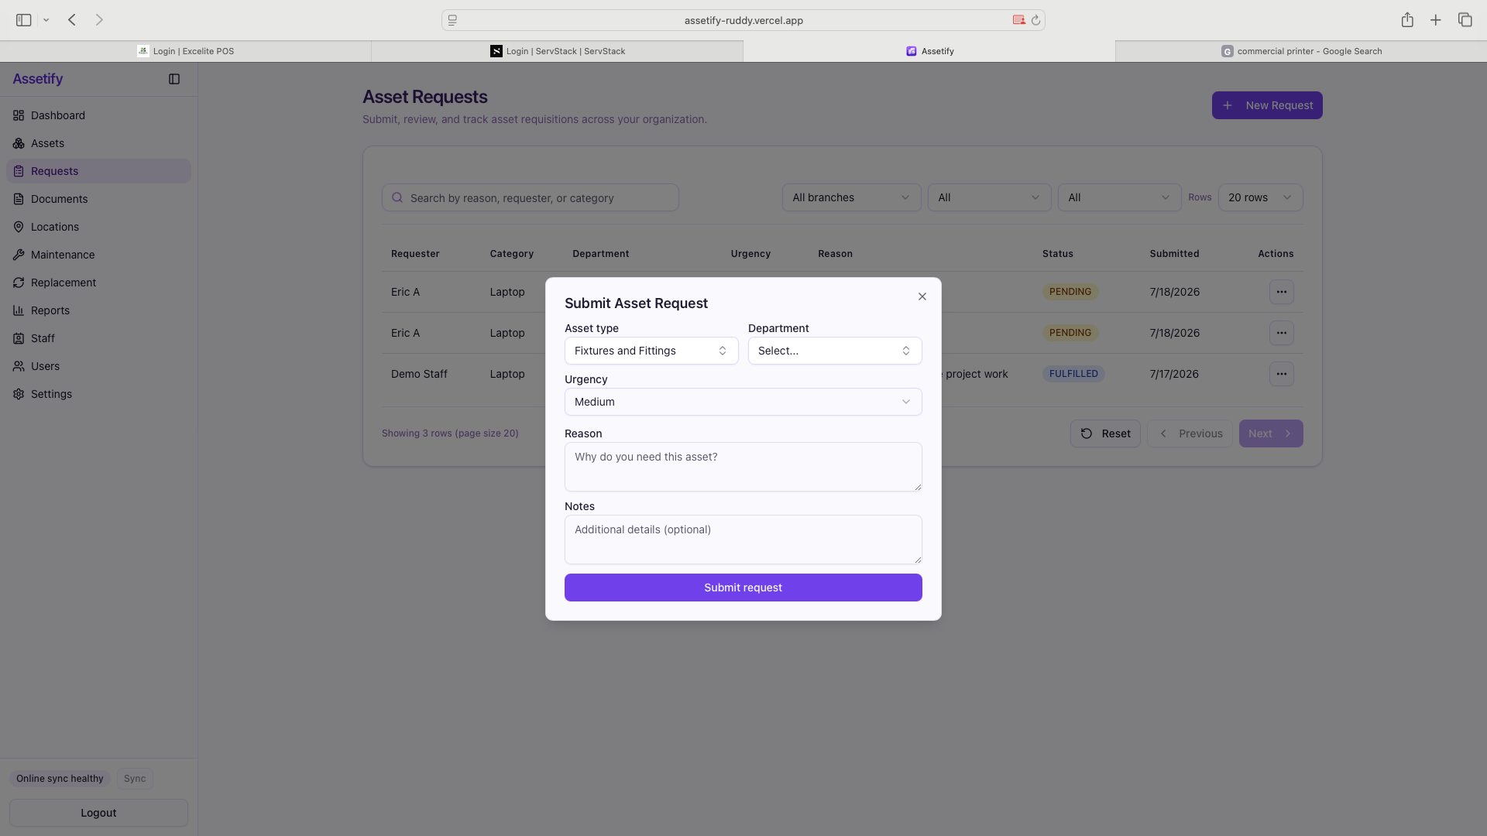

- Maintenance
The display is buggy..
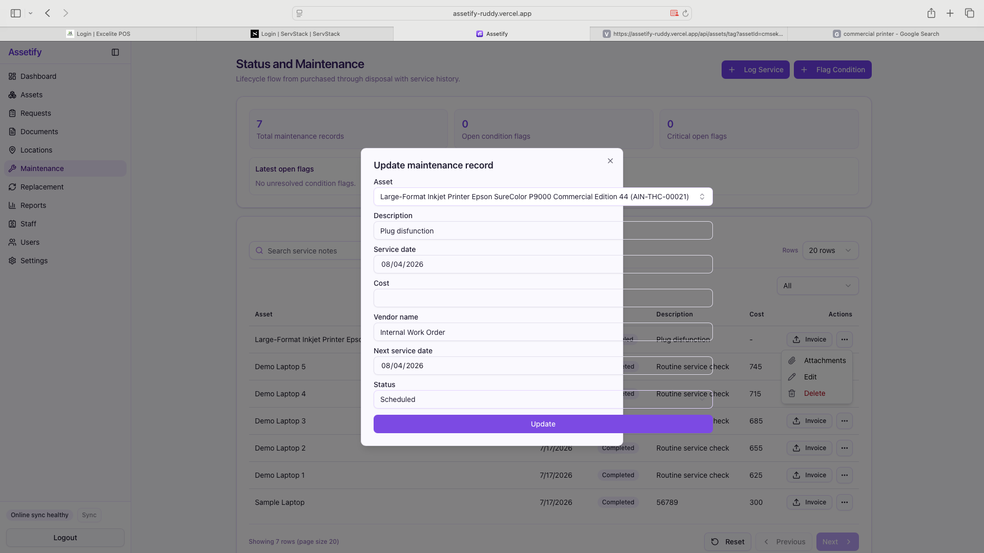

- Add notes field when creating a flag
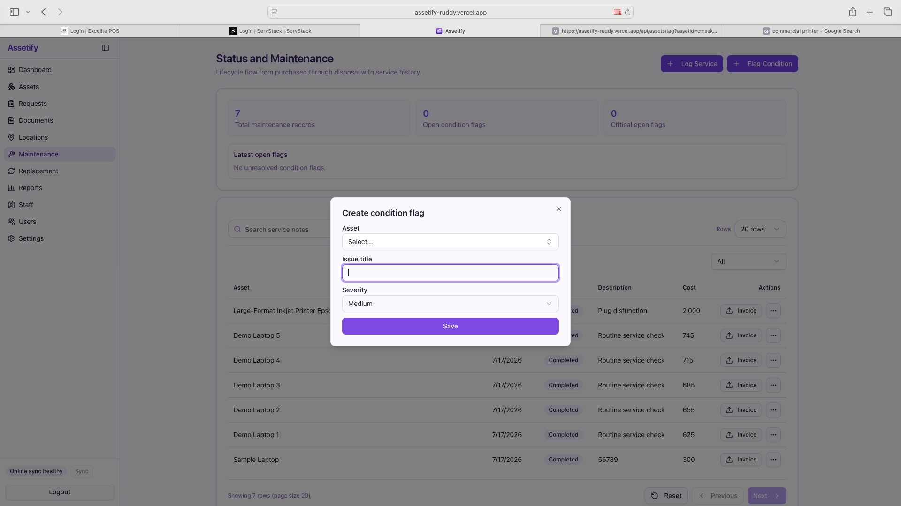

- Dashboard
Check Pie Chart - values or colors not displaying
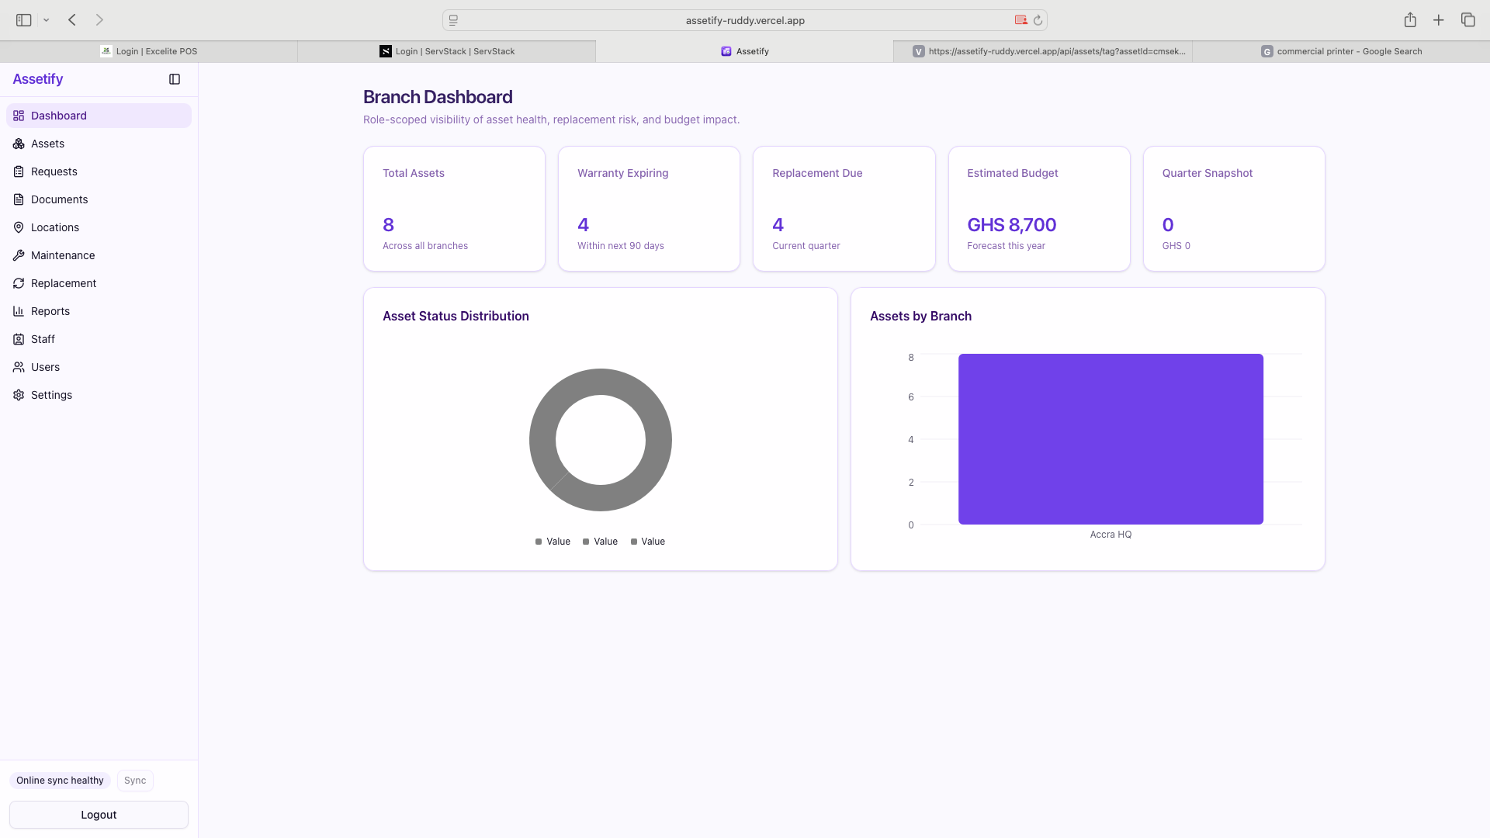

- Assets
Can we show the “Age” and Purchase Cost” of the asset

- Settings – Audits
Lets revise this so its easy to understand by non technical users.
Action | Page | Entity | Asset | User | Date/Time

- General
Add “pagination” to every page that displays rows

