docker build -t microservice-back-diabete .
docker run -p 9004:9004 microservice-back-diabete

docker build -t microservice-back-note .
docker run -e SP_USERNAME=root -e SP_PASSWORD=0241585915 -p 9003:9003 microservice-back-note

docker build -t microservice-back-patient .
docker run -e SP_USERNAME=root -e SP_PASSWORD=0241585915 -p 9001:9001 microservice-back-patient

docker build -t microservice-front .
docker run -p 9002:9002 microservice-front

docker build -t microservice-gateway .
docker run -p 9000:9000 microservice-gateway

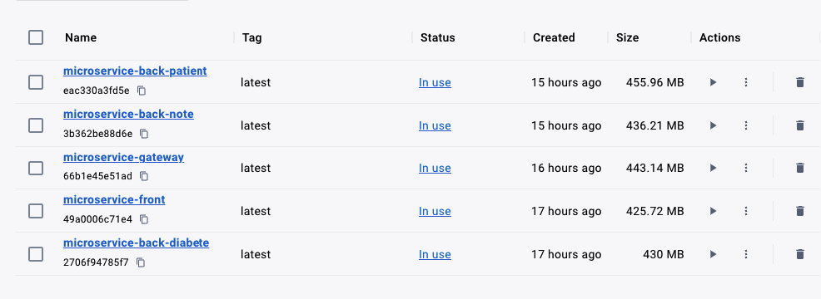
docker-compose up --build

