Tab 1

Executive Summary
The Port Gamble S’Klallam Tribe (PGST) administrative complex currently consumes about 25,000 gallons of propane per year, producing 140 tCO₂e annually. The shared boiler serving the Longhouse and Career Education Center (CEC) is the largest single emissions source on campus, accounting for approximately 41% of all propane-related emissions on campus. Although this share is uncertain because submetered data was not available, the boiler is clearly the highest-priority target for near-term decarbonization.

This report evaluates three replacement pathways for that boiler: an electric boiler, high-temperature air-to-water heat pumps (HT-AWHPs), and standard air-to-water heat pumps (AWHPs). The main technical constraint is that the Longhouse radiant floor system can operate with lower-temperature water, while the CEC fan coil units currently receive about 195 °F water. This creates the key tradeoff: standard AWHPs are more efficient but may require some CEC retrofit, while HT-AWHPs better preserve existing CEC conditions at lower efficiency.

Under the modeled assumptions, standard AWHPs paired with rooftop solar panels, or photovoltaic (PV) provide the strongest electrification pathway for the Longhouse and CEC. This scenario reduces campus propane emissions by about 58 tCO₂e per year and is the only electrification case evaluated that financially produces savings over the propane boiler baseline under the full-capital, net-metered case. The electric boiler is not recommended as its higher electricity use produces the highest long-term operating and life-cycle costs. HT-AWHPs remain technically viable, but standard AWHPs are preferred where the required CEC retrofit is feasible.

Rooftop PV materially improves project economics by offsetting added electric load. Results are sensitive to Puget Sound Energy rate structure and solar export compensation, and grant or incentive funding makes the AWHP + solar pathway especially favorable under either compensation structure. Battery storage is not recommended as part of the core electrification project: under the modeled cases, it does not improve economics enough to justify its cost, though it may still warrant separate consideration for resilience. Based on these results, PGST should prioritize a standard AWHP + rooftop PV package while confirming the final CEC retrofit scope, pursuing grant funding, and monitoring utility rate and solar export policy changes before final design.

Acknowledgements
We thank Rachel Gates, Energy Manager for PGST and our primary point of contact, for providing site data and collaborating with us throughout the design process. We also thank Dr. Daniel Schwartz, Director of the Clean Energy Institute and Professor of Chemical Engineering, and Dr. Bosong Li, Senior Staff Scientist at the Washington Clean Energy Testbeds, for their guidance and support over the duration of this project.

1. Introduction

1.1 Project Background and Scope
The University of Washington Department of Chemical Engineering and Clean Energy Institute partnered with PGST to evaluate decarbonization options for the administrative complex. This report focuses on the Longhouse and CEC because their shared propane boiler is the largest single emissions source on campus and offers the largest near-term reduction opportunity.

A site visit on February 3, 2026 confirmed that the Longhouse and CEC share a propane boiler but require different supply temperatures: about 195 °F at the CEC and 135 °F at the Longhouse. This temperature split is the main technical constraint on replacement options. The site visit revealed a heating/cooling controls conflict at the CEC. To keep scenarios comparable, results are reported against a hypothetical fixed-controls baseline. This assumption propagates through the final results (details in Appendix C). Additional site observations can be found in Appendix B.

1.2 Project Overview
The analysis evaluated three ways to replace the Longhouse/CEC boiler: an electric boiler, high-temperature air-to-water heat pumps (HT-AWHPs), and standard air-to-water heat pumps (standard AWHPs). Rooftop solar, also referred to here as photovoltaic (PV) systems, were evaluated with each electrification pathway because electrification increases campus electric demand and PV can offset part of that increase. The project design statement can be found in Appendix A.

The pathways were compared using three decision metrics: emissions reduction, 25-year life-cycle costs, and 10-year operating costs. Battery storage was also explored to determine whether it improved project economics. Detailed modeling methods and input assumptions are documented in the Technical Appendix.

2. Campus Energy Use: Where Emissions Come From Today
Figure 2.1 summarizes propane use and emissions estimated from billing records, weather data, and site observations. Detailed methods are documented in Appendix C.

Propane billing records from 2023-2025 show that the administrative complex consumes an average of 24,505 gallons of propane per year, producing about 140 tCO₂e annually. The Longhouse/CEC boiler is estimated to be the dominant source at 58 tCO₂e per year, or 41% of total campus propane emissions. After the boiler, the next largest propane loads are the three CFS furnaces at 32 tCO₂e per year, followed by the Elder’s Center Stoves and Gym Furnace at about 16 tCO₂e each. The ECC stove and ECC domestic hot water load are smaller but still material. The administrative kitchen stove is negligible in comparison.
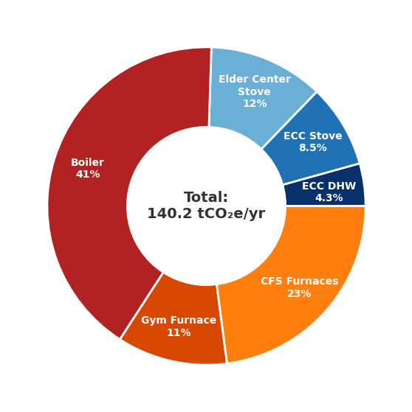 | Propane unit | Propane usage  [gal] | CO₂ emissions  [tCO₂e]
 | Boiler | 10000 | 58
 | CFS Furnaces | 5600 | 32
 | Elder’s Center Stove | 2900 | 16
 | Gym Furnace | 2700 | 16
 | ECC Stove | 2100 | 12
 | ECC DHW | 1100 | 6.1
 | Kitchen Stove | 34 | 0.20
 | Total | 24505.4 | 140.2
Figure 2.1 Annual propane emissions allocation by unit. Left: share of total emissions. Right: estimated annual propane use and emissions. Unit values are rounded to reflect uncertainty; totals come from delivery records.

3. Campus Electrification Options
The shared Longhouse/CEC boiler is the main electrification target. We compare three replacement pathways: an electric boiler, high‑temperature AWHPs, and standard AWHPs. The Longhouse is already compatible with standard AWHPs because its radiant floor operates at about 135 °F. The Career Education Center (CEC) is the main design constraint because its fan coil units (FCUs) currently receive 195 °F water. Figure 3.1 shows the existing system configuration.
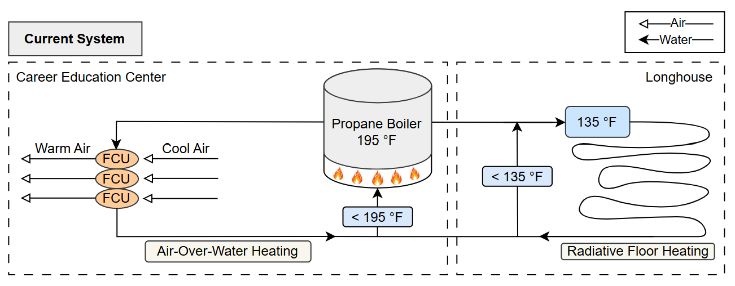
Figure 3.1 Existing shared hydronic heating system. A propane boiler at 195 °F serves the CEC FCUs and the Longhouse radiant floor through one loop. The CEC temperature requirement is the key replacement constraint.

3.1 Electric Boiler
An electric boiler is the simplest like-for-like replacement. It can meet the existing water-temperature requirement without modifying the hydronic distribution system, and it has the lowest estimated upfront capital cost of the three pathways. Its major drawback is operating cost. With a coefficient of performance of approximately 1, the electric boiler uses substantially more electricity than either heat-pump option and drives higher long-term energy and demand charges. It therefore performs poorly in economic comparisons relative to the AWHP pathways. Detailed sizing and cost assumptions for the electric boiler case are provided in Appendix D and Appendix G.

3.2 Air-to-Water Heat Pumps
AWHPs reduce electricity use relative to an electric boiler, but their feasibility depends on the output temperature each building requires. Figure D1 in Appendix D compares how HT-AWHP and standard AWHP efficiency changes with temperature relative to an electric boiler. Standard AWHPs are the more efficient heat-pump option because they deliver lower-temperature water. That aligns well with the Longhouse radiant floor system, but requires CEC distribution upgrades. Calculations in Appendix D suggest that the CEC may need larger or additional FCUs. Figure 3.2 shows the proposed standard AWHP configuration.
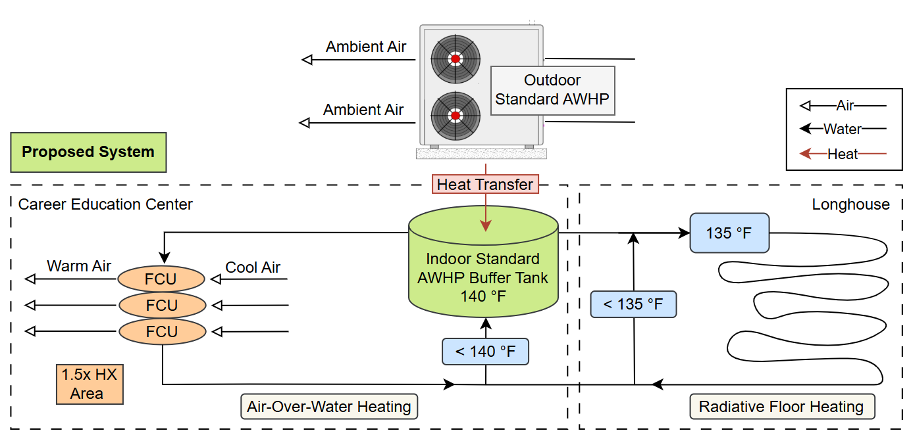
Figure 3.2. Proposed standard-AWHP configuration. An outdoor AWHP charges an indoor buffer tank to 140 °F to serve the CEC FCU loop and the 135 °F Longhouse radiant floor loop. The lower supply temperature may require up to 1.5x FCU area at the CEC.

The retrofit scope at the CEC is the main difference between the two heat pump pathways. HT-AWHPs preserve higher-temperature service and are more likely to fit the existing CEC distribution system with minimal changes, but they do so at lower efficiency. Standard AWHPs may require FCU upgrades, but they remain the preferred pathway if that retrofit is feasible. If the CEC retrofit adds about $12,000, standard AWHP capital cost will rise to about $110,000, still only about $15,000 more than the HT-AWHP case. Given its higher efficiency and greater electricity savings, standard AWHPs are therefore the preferred option unless retrofit constraints make installation infeasible.

3.3 Additional Electrification Considerations
The boiler is the highest-priority target, but meaningful decarbonization opportunities remain across the rest of the campus. The three CFS furnaces and the gym furnace together account for about 34% of total propane consumption and are well-suited for cold-climate air-source heat pump replacement. The Elder's Center and ECC gas ranges account for another 20%, though fuel-switching decisions there should involve kitchen staff and tribal leadership given operational and cultural considerations. The ECC domestic hot water load is smaller but addressable with a direct electric replacement. Detailed analysis of each of these options is in Appendix E.

4. Scenario Comparison
Scenarios were modeled in NLR’s software tool, REopt, a platform used to optimize energy systems. Information on the REopt reference-case setup and constant REopt inputs can be found in Appendix F.

4.1 Technology Packages Evaluated
Three heating pathways were evaluated as replacements for the existing propane boiler: an electric boiler, HT-AWHPs, and standard AWHPs. Table 4.1 summarizes the capital cost of each alongside the propane boiler replacement baseline. The standard AWHP carries the highest upfront cost due to the anticipated CEC fan coil retrofit, but the $15,000 premium over the HT-AWHP is modest given the efficiency advantage documented in Appendix D.

Table 4.1 Heating system capital costs. Costs are order-of-magnitude estimates based on online catalogue pricing and installation benchmarks; see Appendix G for full methodology.
Equipment | Estimated capital cost
Propane boiler replacement | $28,000
Electric resistance hydronic boiler | $25,000
High-temperature air-to-water heat pumps | $95,000
Air-to-water heat pumps | $110,000

Rooftop PV and battery storage were evaluated as optional additions to each heating pathway, not as standalone alternatives. An 80 kW PV array was sized based on available roof area across the CEC and Elder's Center roofs; battery storage was tested at three fixed sizes (10, 20, and 40 kWh at 10 kW discharge). Table 4.2 summarizes the capital costs for these add-ons.

Table 4.2 PV and battery capital costs. Costs are order-of-magnitude estimates based on provided data and REopt estimates; see Appendix H for full methodology.
Equipment | Estimated capital cost
80 kW PV array | $180,000
10 kWh battery | $23,000
20 kWh battery | $35,000
40 kWh battery | $53,000

4.2 Financial and Policy Cases
Each scenario was evaluated under two financial lenses. The 25-year full-cost case includes capital and operating costs and is the primary measure of long-term value. The 10-year capital-excluded case removes upfront capital cost to approximate grant- or incentive-funded implementation over a shorter planning horizon.

Within each lens, results are reported under both net metering and net billing compensation structures. Under PSE's current net metering policy (Schedule 150), exported solar generation offsets grid purchases at the retail rate. Under net billing, exports are compensated at $0.0671/kWh, a lower rate that reduces the optimal PV size in several scenarios and shifts the relative performance of each pathway. The difference between outcomes under the two structures is the largest single policy variable in the analysis.

Utility rate schedule adds a further dimension. The site currently bills under Schedule 24, which has no demand charges. Electrifying the boiler increases peak demand enough that several scenarios cross into Schedule 25 territory, where demand charges apply but the energy rate is lower.

5. Key Findings: Which Options Are Most Favorable
Of all scenarios evaluated, standard AWHPs paired with rooftop PV represent the strongest long-term pathway in terms of emissions reduction, operating savings, and financial viability. The electric boiler is not recommended under any self-funded scenario.

5.1 Financial Performance
Under full-cost assumptions, the standard AWHP with net-metered PV is the only electrification pathway that beats the replacement propane boiler baseline over 25 years, reducing life-cycle cost by about $13,000 (Figure 5.1). The electric boiler has the highest life-cycle cost because its lower upfront cost is outweighed by higher electricity use.
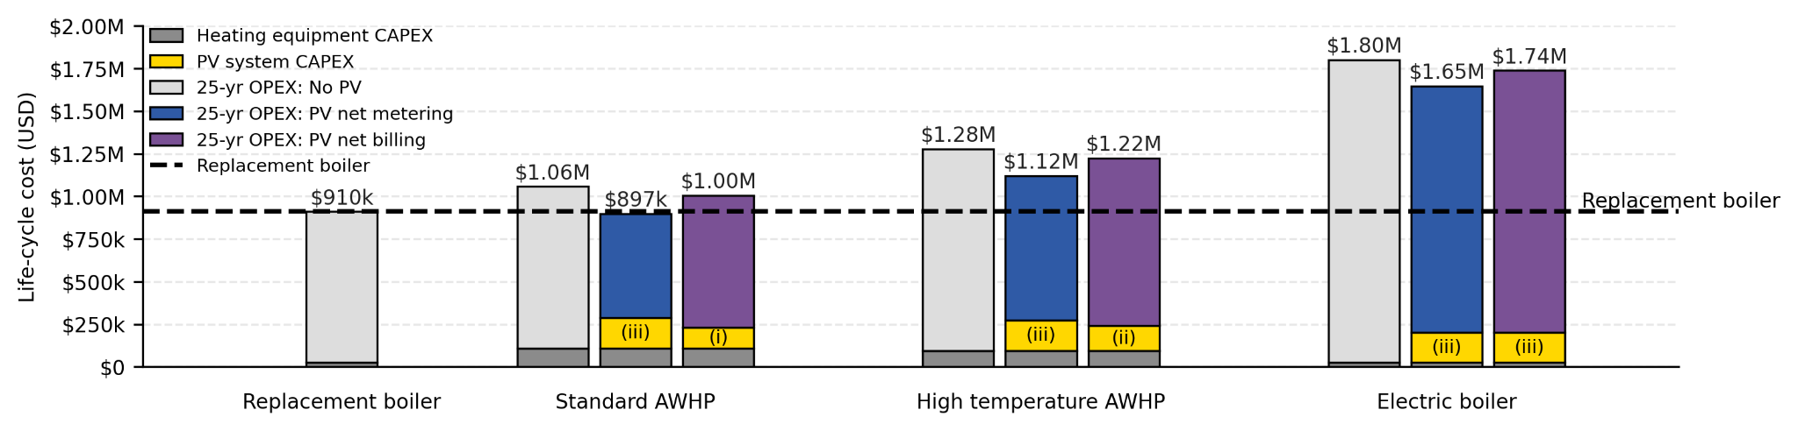
Figure 5.1 25-year life-cycle cost comparison across electrification scenarios. Standard AWHP with net-metered PV is the only full-cost pathway that costs less than the propane baseline. PV system sizes selected by the model are marked: (i) 55 kW, (ii) 66 kW, (iii) 80 kW. Net-metering cases select the full 80 kW array; net-billing cases select smaller systems because exported generation has lower value.

When capital costs are removed to reflect grant- or incentive-funded implementation, the picture shifts materially (Figure 5.2). Both standard AWHP and HT-AWHP with PV generate savings relative to the replacement boiler, and the standard AWHP saves money even without solar. PV system size also expands: under full-cost net-billing assumptions, the model selects smaller arrays (55–66 kW) because exported generation has limited value; under grant-funded assumptions, all scenarios expand to the full 80 kW because additional solar capacity no longer carries an upfront cost penalty. Access to capital grants can therefore change the preferred PV size even when export compensation remains weak.
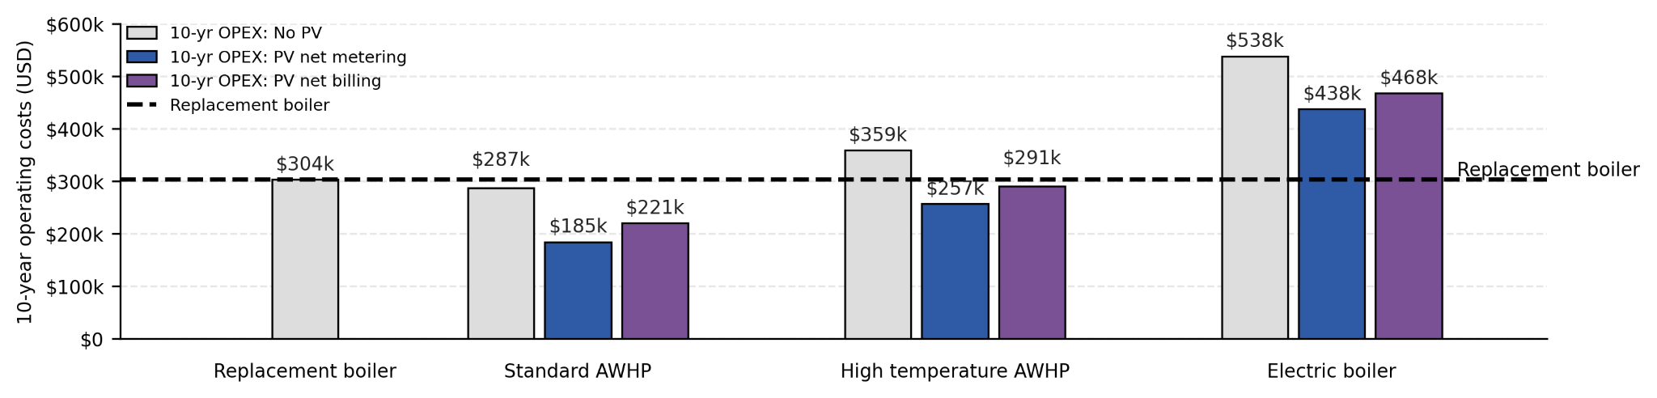
Figure 5.2 10-year operating cost comparison across electrification scenarios. Grant funding shifts economics from break-even to clearly favorable, where all standard AWHP cases fall below the baseline. Removing upfront capital costs expands all PV scenarios to 80 kW.
Rate structure and solar compensation are the two largest cost drivers outside equipment choice. Net metering yields approximately $108,000 in 25-year savings over net billing for the standard AWHP + PV scenario. PSE's net metering policy (Schedule 150) is in place indefinitely pending a replacement tariff, but PGST should monitor rate proceedings closely.
Rate schedule effects are more nuanced: Schedule 24 has higher energy charges but no demand charges, while Schedule 25 has lower energy charges but adds demand charges and higher fixed costs. For the standard AWHP with PV under net metering, these differences largely offset one another: solar generation reduces exposure to Schedule 24’s higher energy rates, while the AWHP’s peak demand (~51 kW) keeps Schedule 25 demand charges modest. Without PV, or under net billing where exported energy is less valuable, Schedule 25’s lower energy rates provide greater savings. Figure 5.3 illustrates these effects across scenarios.
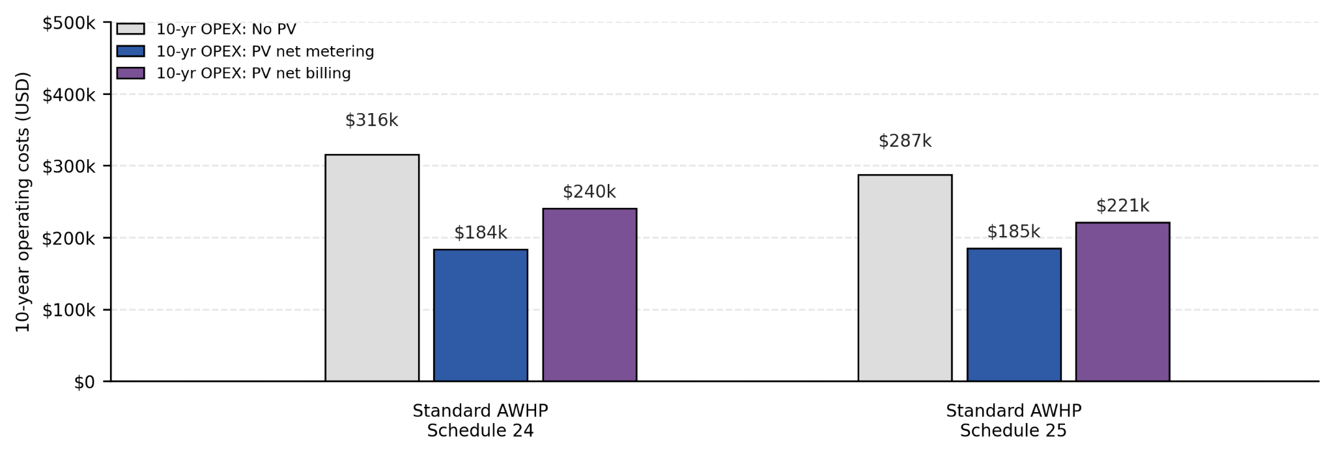
Figure 5.3 10-year operating cost comparison for standard AWHP scenarios under PSE Schedules 24 and 25. Net metering makes the two rates broadly comparable, while Schedule 25 is more favorable when exported PV energy has lower value.

5.2 Battery Findings
Battery storage is not recommended as part of the core electrification project because sustained winter heating loads limit recharge opportunities and the demand-charge savings do not cover hardware costs. Figure 5.4 shows the 25-year life-cycle cost of adding battery storage to the standard AWHP scenario; every battery case sits above the no-battery baseline regardless of compensation structure, with the 40 kWh battery adding roughly $50,000–$75,000 in life-cycle cost over the net-billing and net-metering cases respectively.
.
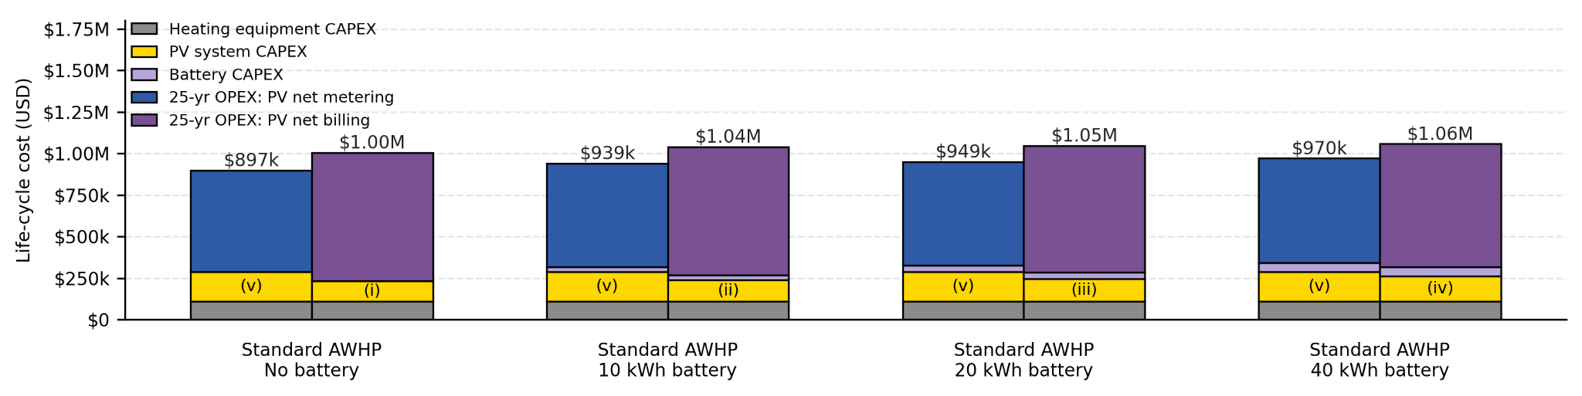
Figure 5.4 25-year life-cycle cost comparison across battery scenarios. Adding battery storage increases life-cycle cost in all cases; larger batteries favor larger PV systems.

Even when capital costs are excluded to represent a grant-funded battery, the financial benefit is negligible (Figure 5.5). Under net metering, 10-year operating costs are essentially flat across all battery sizes. Under net billing the savings are slightly larger but still modest— a fully grant-funded 40 kWh battery saves less than $10,000 over ten years. This result reflects a structural constraint: the PV system is sized for on-site load offset, not export arbitrage, so there is little stored energy value for the battery to capture.
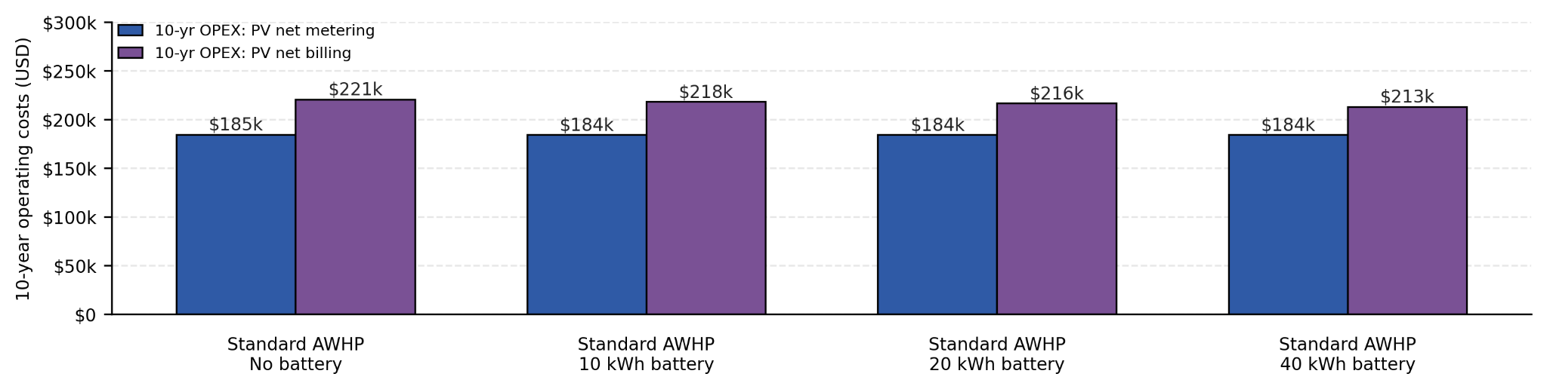
Figure 5.5 10-year operating cost comparison across battery scenarios. A grant-funded battery delivers negligible operating savings over 10 years. Net metering bars are nearly flat; net billing shows modest improvement at larger battery sizes.

Battery storage may still be justified on resilience grounds independent of the life-cycle economics. If PGST pursues storage for resilience, sizing should target the minimum heating load needed during an outage rather than demand optimization. The study also reviewed the PSE Flex Battery Program using the existing 120 kWh battery at the Health Center as a reference case. The $500 annual compensation cap is reached after just 11 Flex Events, while the remaining 89 events per year would increase battery wear without compensation. Further investigation of the commercial-scale Flex Battery program is being pursued separately by Dr. Bosong Li of the Washington Clean Energy Testbeds and is outside the scope of this report.

5.3 Sensitivity and Key Risks
Standard AWHPs with rooftop PV remain the preferred pathway across the full range of assumptions tested, and no combination of inputs makes the electric boiler competitive. Three factors most influence the magnitude of the cost advantage: electricity price escalation, PV capital cost, and net metering policy. Full sensitivity results are in Appendix I.

Electricity cost escalation is the largest source of uncertainty. At the estimated 6%/yr assumption, the net-metered standard AWHP with an 80 kW PV array saves roughly $160,000 over 25 years relative to the same system without PV, and about $13,000 relative to the propane boiler baseline. At a lower 3%/yr rate, PV savings narrow to $20,000–$30,000 and the optimal array falls to about 37 kW, but the net-metered AWHP still beats no-solar in every case tested. At 8–10%/yr, the spread widens to $285,000–$460,000. Propane price moves the baseline in the same direction: each $0.25/gallon increase adds roughly $65,000 to the 25-year boiler replacement cost.

Capital cost estimates also produce significant uncertainty before contractor quotes are in hand. Under net metering, REopt selects the full 80 kW array at all installed costs below about $3,900/kW-DC, well above the $2,220/kW-DC estimate. Under net billing, the optimal size declines more gradually and reaches zero near $4,800/kW-DC. A 50% increase in AWHP capital cost reduces 25-year net savings by roughly $55,000, but does not change the technology recommendation.

Net metering policy is the largest variable outside PGST's control. The gap between net metering and net billing outcomes is approximately $108,000 over 25 years, driven entirely by how exported solar is compensated. PSE's current net metering policy (Schedule 150) is in place indefinitely pending a replacement tariff. Under net billing, the standard AWHP remains the preferred pathway with a longer but still sound payback. PGST should proceed with the standard AWHP design while monitoring PSE rate proceedings before finalizing PV system size.

6. Final Design Recommendations
Standard AWHPs paired with a rooftop PV system are the recommended electrification pathway for the Longhouse and CEC. This combination eliminates approximately 58 tCO₂e per year — a 41% reduction in campus propane emissions — and produces the lowest 25-year life-cycle cost of any scenario evaluated. Before committing to major equipment purchases, PGST should confirm the final CEC distribution retrofit scope and monitor utility rate and solar export policy details that materially affect long-term economics.

Beyond the boiler, the furnaces at the CFS and gym represent the largest remaining decarbonization opportunity, together offsetting an additional 48 tCO₂e per year. PGST should plan to replace all four with cold-climate air-source heat pumps as a near-term follow-on project, after the boiler electrification is underway. Cooking range replacement at the Elder's Center and ECC should be evaluated in consultation with kitchen staff before any equipment decisions are made. Detailed analysis and recommendations can be found in Appendix E.

Table 6.1 Recommended implementation timeline for the boiler electrification pathway.
Timeline | Actions | Rationale
Immediate  (0-6 months) | 1. Address the HVAC controls issue identified on site  2. Obtain contractor quotes for standard AWHP and rooftop PV system  3. Complete FCU inventory | 1. Fixing controls improves system operation and reduces uncertainty in baseline performance assumptions  2. Reduces the CAPEX uncertainty in this report and is required for grant applications  3. Informs feasibility of standard AWHP retrofit
Near-term (6-18 months) | Apply for grants and other funding  options for new equipment | Converts the standard AWHP + PV scenario from marginally cost-saving to clearly favorable under both net metering and net billing
Long-term (18-36 months) | Install standard AWHP and PV array | Monitor PSE rate proceedings before committing.

Bibliography
AC Units for Less (2026). “Daikin 20 Ton Light Commercial Packaged Air Conditioner 460V 3PH R32 DSC2404D000001S.” Shopify [catalogue]. https://www.acunitsforless.com/products/daikin-20-ton-light-commercial-packaged-air-conditioner-460v-3ph-r32-dsc2404d000001s?variant=54775698260259
AF Supply Corp. (2026). “IBC Technologies 010-087 SL 399 Input MBtu - 96% AFUE Condensing Liquid Propane Gas Boiler - Direct Vent.” AF Supply. https://www.afsupply.com/ibc-sl-40-399-condensing-boiler-399-input-mbh-afue-96-direct-vent-propane-gas.html
Angi (2026). “How Much Does Propane Boiler Installation Cost? [2026 Data].” https://www.angi.com/articles/propane-boiler-installation-cost.htm
Center for Corporate Climate Leadership (2023). “Emission Factors for Greenhouse Gas Inventories.” EPA. https://www.epa.gov/system/files/documents/2023-03/ghg_emission_factors_hub.pdf.
Doctor Heat Pump (2025). “How Much Does Commercial Heat Pump Installation Really Cost?” Ramsey Media. https://doctorheatpump.com/how-much-does-commercial-heat-pump-installation-really-cost/
El Kontar, R., & Jin, X. (2020). “A Framework for Optimal Placement of Rooftop Photovoltaic: Maximizing Solar Production and Operational Cost Savings in Residential Communities." ASME. J. Eng. Sustain. Bldgs. Cities, 1(4), 41006. https://doi.org/10.1115/1.4049135
Energy Saving Products Ltd. (n.d.). Specification for hi-velocity fan coil systems: HE-Z engineering specs (Section 15740). Energy Saving Products Ltd.
Ferrell Gas (2026). “Port Gamble Ferrell Gas Consumption.” https://www.ferrellgas.com/.
HPAC Magazine (2016). Low ambient air-to-water heat pumps [Image]. Heating Plumbing Air Conditioning (HPAC). https://www.hpacmag.com/features/heat-pumps-in-hydronic-systems/attachment/siggy_2016-fig-5/
GoodHeat (2025). “Air to Water Heat Pump vs Air to Air Heat Pump: Key Differences.” GoodHeat. https://www.goodheatglobal.com/Air-to-Water-Heat-Pump-vs-Air-to-Air-Heat-Pump-Key-Differences-id40383106.html
Lawrence Berkeley National Lab (LBNL) (2024). “Replace Conventional Boiler with Electric Boiler.” U.S. Department of Energy: Office of Manufacturing and Energy Supply Chains. https://industrialapplications.lbl.gov/sites/default/files/pdf-embeds/IAC%20Decarb%20Tipsheet%203.pdf
MBtek (2026a). “APOLLO Commercial Air to Water Heat Pump.” MBtek [catalogue]. https://www.mbtek.com/products/apollo-commercial-air-to-water-heat-pump?variant=46706547589297
MBtek (2026b). “Pump High Efficiency 3" - 150F VFD Tango Pump.” MBtek [catalogue]. https://www.mbtek.com/products/pump-high-efficiency-3-vfd-tango-pump
MBtek (2026c). “APOLLO Commercial Custom Tank.” MBtek [catalogue]. https://www.mbtek.com/products/apollo-commercial-custom-tank
Mortenson (2025). “Cost Index - Seattle Q4 2025.” https://www.mortenson.com/content/dam/mortenson/global-assets/archive/files/campaigns/recurring/cost-index/2025-q4/construction-cost-index-seattle-q4-2025.pdf
National Laboratory of the Rockies (1999). PVWatts. U.S. Department of Energy. https://pvwatts.nlr.gov/
National Laboratory of the Rockies (2022). REopt. U.S. Department of Energy. https://www.nlr.gov/news/detail/program/2022/reopt-is-not-lite-anymore
Nyle Water Heating Systems, Inc. (2026). “Submittal: Alectro Heat Pump Boiler.” Nyle. https://portal.heatwater.com/document/submittal-alectro/?_gl=1*14brb12*_gcl_au*MTMwODYzMDU4OC4xNzc4NjI4MDA1LjY4NDg5MzgzNi4xNzgxMTE4MzUwLjE3ODExMTgzNDk.*_ga*MjExNzQ0MjU0My4xNzc4NjI4MDAy*_ga_0YLKVHGGHK*czE3ODEyOTIxMjUkbzEwJGcwJHQxNzgxMjkyMTI1JGo2MCRsMCRoMA..*_ga_9VQQG6SS4N*czE3ODEyOTIxMjUkbzEwJGcwJHQxNzgxMjkyMTI1JGo2MCRsMCRoMA..*_ga_CC4RG24GTV*czE3ODEyOTIxMjckbzkkZzAkdDE3ODEyOTIxMjckajYwJGwwJGgw
Puget Sound Energy (2026a). “Customer Connected Solar & Net Metering FAQs.” https://www.pse.com/en/green-options/Renewable-Energy-Programs/customer-connected-solar/Customer-Connected-Solar-FAQ
Puget Sound Energy (2023). "GRC Stipulation O Updated Decarbonization Study." Puget Sound Energy. Dockets UE-220066, UG-220067, UG-210918. https://www.pse.com/en/regulatory/gas-rate-case
Puget Sound Energy (2026b). “Solar Energy Credit.” https://www.pse.com/en/green-options/solar-energy-credit
Rahn Industries, Inc. (2025). “Heat Exchanger Replacement Cost Guide.” Rahn Industries Blog. https://rahnindustries.com/2023/03/24/heat-exchanger-replacement-cost-guide/
Rocky Ridge Geo Distributors (2026). “High Temp WH-Series Large 12-65Tons.” Rocky Ridge Geo Distributors. https://rockyridgegeo.com/product/high-temp-wh-series-large/
Säzän Group (n.d.). “Final Report: Port Gamble S’Klallam Tribe Microgrid Feasibility Study.” p. 22-24.
SolaX Power (2026). “Air to Air vs Air to Water Heat Pump: Complete Comparison Guide.” SolaX Power. https://www.solaxpower.com/blogs/air-to-air-vs-air-to-water-heat-pump.html
U.S. Department of Energy (2026). “Air-Source Heat Pumps.” https://www.energy.gov/energysaver/air-source-heat-pumps
U.S. Department of Energy (2026). “Solar Rooftop Potential.” https://www.energy.gov/cmei/systems/solar-rooftop-potential
U.S. Energy Information Administration (EIA) (2023). “Updated Buildings Sector Appliance and Equipment Costs and Efficiencies.” U.S. Department of Energy. https://www.eia.gov/analysis/studies/buildings/equipcosts/pdf/full.pdf

Technical Appendix

Table of Contents
Appendix A. Design Statement
Appendix B. Site Observations and System Documentation
Appendix C. Propane Disaggregation Methodology
Appendix D. Heating System Sizing and Distribution
Appendix E. Additional Electrification Considerations
Appendix F. REopt Input Summary Tables
Appendix G. Capital and Operating Cost Breakdown
Appendix H. Battery Analysis
Appendix I. Sensitivity Results
Appendix J. Campus-Wide Decarbonization Survey

Appendix A: Design Statement
Design Statement
Decarbonizing the Port Gamble S’Klallam Tribe
April 13th, 2026
By: Mick Deines, Hannah Chavla, Marion Garabedian, Naudia Watkins, Samantha Kravitz Edited by: Daniel Schwartz

Project Overview
The Port Gamble S’Klallam Tribe released a “Comprehensive Climate Action Plan” (CCAP) in July of 2025 which outlines the Tribe's mission to reduce greenhouse gas (GHG) emissions. Propane usage on the administrative campus is a large source of greenhouse gas emissions that is controlled by the Tribe’s infrastructure decisions. The University of Washington Clean Energy Institute and Department of Chemical Engineering are working collaboratively with our project partner, the Port Gamble S’Klallam Tribe (PGST) liaison Rachel Gates, to explore options for decarbonizing the administrative complex.

The primary design will focus on reducing emissions from the propane boiler that serves the Longhouse and Career Education Center. More than a year of 15 minute electric meter data for the Career Education Center and Longhouse was provided, as well as a decade of propane purchasing data. Because propane use is not sub-metered, key equipment plate data from propane heating and domestic hot water units was provided to estimate individual unit usage. For the Longhouse and Career Education Center, considerations will include the capital and operating costs of various design options for decarbonizing the site, as well as the expected operational disruptions of different options. A broader site survey will explore opportunities for emission reductions available by replacing other propane fired heating and domestic hot water infrastructure across the campus. The report will also survey the scale of roof-top solar opportunities across the campus.

A site visit on February 3, 2026 involved a walk-through of the Longhouse and Education Center--including the utility room, common-spaces, and several individual rooms–as well as a survey walk around the broader campus. The Longhouse and Education Center include award-winning architecture and art that reflect the community’s heritage, with exposed wood and beam interiors and exteriors. Several key issues identified at the site visit will influence the technology choices and opportunities for emission reduction and lowering energy bills. The Longhouse and Education Center share a propane-fired hydronic heating system with a lower temperature zone (135 ˚F set point) circulating water to the radiant floor system in the Longhouse and higher temperature zone (195 ˚F set point) circulating water to air handlers in the Education Center. The Education Center also has several auxiliary heat pump systems providing local heating and cooling in the building. Thermostat set points in the Education Center were 70 ˚F but actual temperatures exceeded the set point. In at least one room, a heat pump was cooling at the same time the hydronic system was heating the space. The Tribe has engaged a specialist to address the (apparently long-standing) control issues with the hydronic system. Additional site observation and review included that the Longhouse has structural issues and cannot bear additional loading on the roof. Lighting appeared to mostly have been upgraded to efficient LEDs in the Education Center. Additional clean energy infrastructure at the site includes an existing solar PV system and SolArk 60 kW/120 kWh battery energy storage system at the clinic, reducing energy costs and providing outage resiliency. There is also a solar PV system at the waste treatment plant.

Technical Scope
Data Analysis and Synthesis. Because propane use is not sub-metered by building or device, the cornerstone of the energy analysis—and the greatest source of uncertainty—is the disaggregation of the propane use by device. Disaggregation of heating propane versus domestic hot water propane across the campus (the two main propane-using categories) is readily assessed based on correlation with average outdoor temperature over the propane use-period (monthly, typically). Within each major category of use, individual device consumption will be estimated in two ways: based on face-plate capacity and a metric of building use intensity, or for the heating category, by the area of buildings being served along with use intensity. Recognizing the uncertainty of these methods, a range of expected propane use by building and device will be determined to encompass the expected values. For the more detailed design associated with electrification of heating in the Longhouse and Education Center, typical use profiles derived from the 15 minute electricity data for the buildings will be used as the basis for estimating hourly electricity loads in the future, following heating electrification designs.

Converting estimated monthly and annual propane use by individual devices into GHG emissions is the basis for prioritizing emission reductions across the campus by electrification. Use of propane in kitchens and back-up generation are expected to be small.

Eliminating propane use in the Education Center and Longhouse heating. Electrification of the propane-fired hydronic boiler is the pathway to decarbonizing heating in the Education Center and Longhouse, since PSE is systematically eliminating carbon from their electricity supply. We will evaluate the impact and feasibility of two electrification options: Electric hydronic boiler and air-to-water hydronic heat pump. In the analysis, no significant building envelope efficiency improvements are considered owing to the culturally significant architecture of the two buildings.
- A high turn-down electric hydronic boiler represents a drop-in decarbonization solution for the propane boiler because it can produce 195 ˚F hot water for the Education Center high temperature zone while also serving the low temperature 135 ˚F zone used in the Longhouse. In addition to the boiler replacement, an electrical service upgrade is likely to be needed. This option is expected to be the low capital cost choice for decarbonization, but also the highest annual operating cost option owing to the system’s low electricity-to-heat conversion efficiency vs. the heat pump option. No chilled water can be produced by an electric hydronic boiler, so any cooling demand will continue to be met by the individual heat pumps in the Education Center. Engineering heuristics will be used to estimate the capital and operating costs as detailed below, based on the range of heating demand we estimate from the propane data.
- An air-to-water hydronic heat pump is the high efficiency electrification option, but may require additional HVAC system retrofit. A hydronic heat pump will use roughly 1/3rd the annual energy of an electric hydronic boiler but will likely have higher capital and installation cost. A key feature driving the design is that the system has a maximum water output temperature of about 140 ˚F which is well matched to the Longhouse low temperature loop, but is approximately 55 - 60 ˚F below the temperature currently input into the Education Center air handlers. Thus, the design will consider the need and possible cost for air handler retrofit. The hydronic heat pump can also produce chilled water for cooling the Longhouse and Education Center in summer, potentially making the existing individual heat pump units in the Education Center redundant. While electrical demand will be approximately 1/3rd that of an electric hydronic boiler, electrical service may still require upgrading.

Currently, the meter serving the Longhouse and Education Center is billed under a PSE Schedule 24 rate, with flat energy usage charges (per kWh) and no demand charges (peak kW), indicating annual peak loads are under 50 kW. The transition to an electric boiler or hydronic heat pump will increase electricity usage and peak demand appreciably, potentially moving the electricity service into a Schedule 25 rate, where both energy usage and peak demand is charged monthly. This has technology implications, as Schedule 24 incentivizes behind-the-meter solar, whereas Schedule 25 potentially incentivizes behind-the-meter solar and battery energy storage. We discuss this in greater detail in the Economic Scope section.

Survey study of whole campus decarbonization and approach for electric bill reduction. With estimated propane use across campus, it is straightforward to estimate the emission reductions and increased electrical demand in each building when propane heating and domestic hot water is replaced by an efficient air-sourced heat pump system. This efficient electric decarbonization strategy will likely save money overall, compared to propane purchases, but it will significantly increase electricity bills. Increased electricity usage and demand can be offset by solar energy production. Thus, the report will also survey the solar potential of various buildings on campus to see how much of the decarbonization load growth can be offset by roof top solar. Additionally, the SolArk battery energy storage system (BESS) installed at the clinic is expected to receive software upgrades for participation in the “Flex” program offered by PSE. Flex can generate revenue, but at the potential cost of the additional degradation caused by more frequent charge/discharge cycles. In the Economic Scope section, we describe software tools and approaches for evaluating the hour-by-hour performance of the technologies described here and the quantification of economic benefits under various incentive structures.

Economic Scope
Economic modeling for Electrified Education Center and Longhouse. As noted, the Education Center and Longhouse currently operate under Schedule 24 rates, but are likely to move into Schedule 25 rates when the heating system is fully electric. Under Schedule 25, electricity is charged based on energy usage ($/kWh) and peak demand each month ($/peak kW). Depending on our hourly estimates for metered load profile of the future electrified Longhouse and Education Center, one must do a full economic optimization over the 8760 hours of a year to determine the likelihood of moving to Schedule 25, and if so, the value of adding a battery energy storage system to lower building peak loads and save on bills. Adding solar on the Longhouse is not deemed feasible owing to structural concerns, but we will also consider solar additions behind the meter on the Early Childhood Center, using both Net Metering and Net Billing economic models in our optimizations, since the PGST has examples of both billing structures.

REopt software will be used to run economic scenarios for our estimated hourly building loads under the electric boiler and hydronic heat pump scenarios vs. the “Business as Usual” (BAU) case of the propane boiler operations. Appropriate rate schedules will be used based on the additional electric load for each case. For any potential Schedule 25 rates, we will also consider optimization with or without a BESS. For each BAU or electrified scenario, the expected first year and 10 year NPV operating costs will be estimated assuming electricity cost escalation of 6% per annum and future-fund discounting at an inflation rate of 2.5%.

Costs and Benefits of Enrolling in PSE Flex. As noted, the existing BESS system at the clinic is expected to be eligible to participate in the PSE Flex Battery program, as would any storage associated with demand management for the Education Center and Longhouse if operating under Schedule 25, possibly stacking value on a BESS system. Flex Battery offers a one-time flat-rate rebate $0.75 per kWh of storage enrolled in the program (max $1,000), plus a payment of $0.50/kWh delivered during as many as 100 “Flex Events” (max $500 per year). “Flex Events” are coordinated by Uplight to serve as a Virtual Power Plant (VPP) that can be activated at a fixed $0.50/kWh price during periods when the real-time wholesale settlement price is higher. The UW team will use historic real-time pricing data from the PNW to identify how many hours per year the price exceeds $0.50/kWh to develop a REopt-compatible pricing signal for estimating Flex events. The impact of Flex on the degradation rate of battery assets will be computed to estimate the 10 year NPV associated with enrolling in Flex. Flex modeling will be guided by Dr. Bosong Li, Senior Power Systems Scientist at the Washington Clean Energy Testbeds.

Appendix B: Site Observations and System Documentation
B1. Longhouse and Career Education Center (CEC):
The Longhouse and CEC are served by a shared propane boiler but operate very different hydronic distribution systems. The Longhouse uses a three-zone radiant floor system designed around approximately 135°F water. The CEC uses air-to-water fan coil units that currently operate with approximately 195°F entering water. This temperature split is the main technical constraint on any shared electrified heating strategy.

The Longhouse is a large single-volume space of approximately 6,000 ft². The slab-heating system has slow thermal response and runs 24/7 to maintain comfort. The building also exhibits an extremely poor energy envelope. Visible gaps under doors and no insulation on the walls and roof all contribute to substantial heat loss.

The roof also appears to be supported by sagging beams, and is not viable for rooftop PV. The cultural significance and structural concerns of the Longhouse significantly constrains retrofit options, as stated in the Port Gamble S’Klallam Tribe Microgrid Feasibility Study (Säzän Group, n.d.). Care will be taken not to recommend alterations to any culturally-significant buildings, spaces, or designs.

In the CEC, heating and cooling units were observed to be operating concurrently due to a lack of communication between the systems. These HVAC control issues introduce uncertainty to the project’s estimates and highlight potential energy savings through improved controls. The Tribe has hired a specialist to address these long-standing control issues so it is out of the scope of this project to provide a solution.

B2. Other propane-using buildings and equipment
Other propane use on campus includes the CFS furnaces, the gym furnace, industrial cooking stoves at the Elder’s Center and ECC, an ECC domestic-hot-water heater, and a small kitchen stove in the main administrative building. These loads are smaller and more modular than the Longhouse/CEC boiler load. These are covered in detail in Appendix E.

B3. Field data gaps and other constraints affecting design recommendations
- The study relied on bulk propane deliveries rather than end-use metering. While an hourly propane load profile was constructed for each unit, these profiles and the subsequent results should be treated as rough approximations.
- A complete FCU inventory for the CEC was not available during the site visit. Final low-standard AWHP retrofit design should verify unit count, model numbers, airflows, coil dimensions, and piping configuration.
- Observed control conflict at the CEC reduces confidence in any baseline inferred solely from current fuel use.
- Several cooking loads serve community functions, so fuel-switching decisions should consider operational and cultural acceptability in addition to energy savings.

Appendix C: Propane Disaggregation Methodology
C1. Source data & cleaning
Table C1 summarizes the three datasets used to disaggregate propane use and develop the load profiles.

Table C1. Input datasets used for propane-use disaggregation and load-profile modeling.
Dataset | Resolution / Date Range | Source | Use in Model
Outdoor air temperature | Hourly ERA5; used for 2015-2026 context and 2024 review | ECMWF ERA5 | Common weather basis for regression and hourly duty-cycle model
Electricity interval data | 15-minute intervals used for 2023-2025 context and 2024 review | Puget Sound Energy | Baseline electric load profile for Longhouse/CEC meter
Propane delivery records | Bulk deliveries, 2005-2025 provided, used for 2016-2025 context and 2024 review | Ferrell Gas billing and delivery records | Annual propane totals and delivery-window regression

Delivery records were screened before modeling. Negative-gallon line items associated with billing adjustments or returns were removed, together with any matching offsetting entry. Deliveries below 200 gallons were excluded because they are more consistent with fills to auxiliary tanks or non-study equipment than to the primary campus tank. Electricity interval data were aggregated from 15-minute to hourly resolution for compatibility with REopt load-file requirements and with the hourly propane-allocation model. ERA5 temperature data were sampled at the PGST site coordinates and converted to a single hourly weather record.

Each cleaned propane delivery defines the end of a consumption window. The start of that window is the prior delivery date. For each window, delivered gallons were divided by the number of days in the interval to create a normalized propane-use rate in gallons per day. Average outdoor temperature over the same interval was then used as the independent variable in regression.

C2. Weather record & balance point
Outdoor temperature was used as the primary explanatory variable for space-heating demand, sourced from the ERA5 reanalysis dataset sampled at the PGST site coordinates. The balance point temperature (60°F) is the outdoor temperature below which space heating is assumed to be active — above it, the building is assumed to require no heating and propane consumption reflects only weather-independent loads like cooking and domestic hot water. The design minimum temperature (20°F) represents the coldest outdoor condition the heating system is sized to handle at full capacity; below this threshold, the duty-cycle model is capped at 1.0.

Both values are consistent with engineering practice for commercial buildings in the Pacific Northwest maritime climate. The 2015–2026 ERA5 record confirms that outdoor temperature at the PGST site fell below 20°F only once over the full review period (Figure C1), supporting the use of 20°F as a conservatively low design minimum rather than an arbitrary floor. Daily average temperatures stayed below 60°F for the majority of the year, consistent with space heating being the dominant propane end use across all three billing years analyzed.
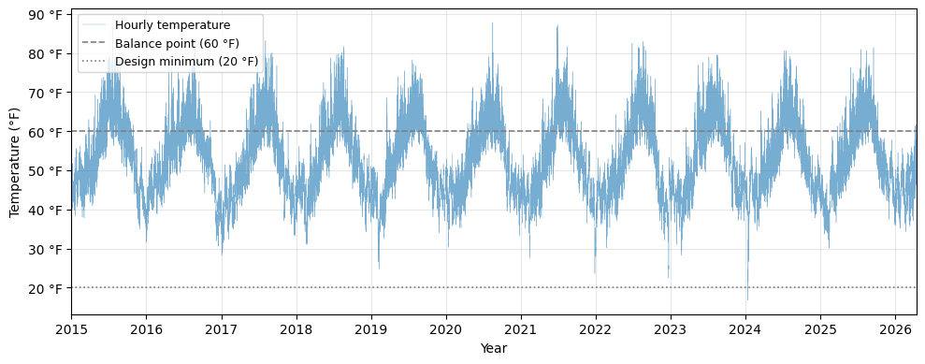
Figure C1. ERA5 daily average temperatures at the PGST site, 2015–2026. The 60°F balance point and 20°F design minimum are shown as dashed reference lines. Temperature fell below 20°F just once over the full period.

C3. Top-down regression model
Each cleaned propane delivery defines the end of a consumption window, with the window beginning on the date of the prior delivery. Dividing the delivered gallons by the number of days in the window yields a normalized consumption rate in gallons per day (gal/day), which represents average demand during that interval. The interval-average outdoor temperature was computed from the ERA5 daily mean record over the same window. This approach converts irregular monthly deliveries into a consistent time normalized dataset suitable for regression analysis.

These delivery-window data points, derived from the 2023–2025 period, were then regressed against interval-average temperature using a piecewise linear model with a balance point temperature (T_{b}) of 60°F (see Figure C3). Below T_{b}, a linear relationship captures the temperature-sensitive heating demand:
$gal/day = m T_{avg}+b (T_{avg}<60°F)$
Above T_{b}, propane consumption is approximately constant, representing the weather independent base load from domestic hot water heaters and cooking stoves:
$gal/day =baseline_{gpd} (T_{avg}>60°F)$
This is consistent with engineering practice for commercial buildings in the Pacific Northwest. Two delivery windows with the largest absolute residuals were removed before the final fit.

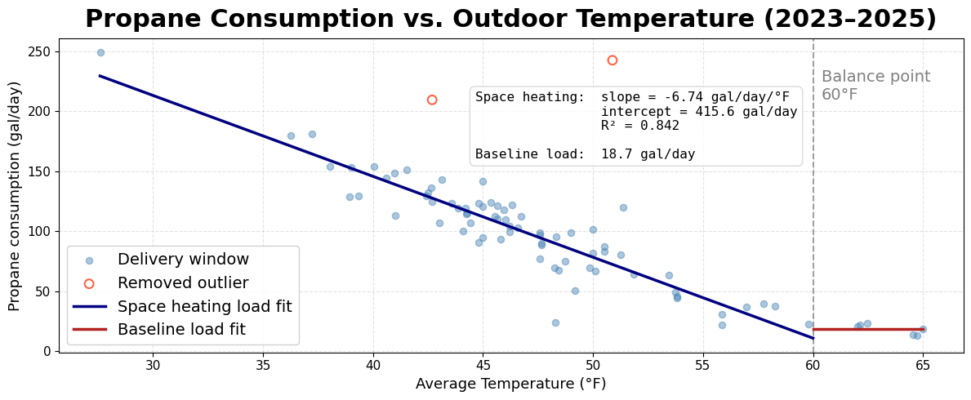
Figure C3. Propane consumption rate (gal/day) vs. average outdoor temperature (°F).

The upper, blue line represents the propane consumption that is temperature dependent, as there is a visible linear relationship. The lower, red line represents the propane consumption that is temperature independent, and can be considered the weather-independent baseline load.

C4. Bottom-up per-device allocation
With the top-down annual heating and non-heating totals established, a bottom-up equipment model distributes propane consumption across individual devices on an hourly basis. Each propane-consuming unit on the campus is characterized by its nameplate rated input capacity (BTU/hr), operating efficiency, and an assumed weekly schedule derived from site visit observations and facility records (see Tables C4-C5). The model is organized into two categories of equipment:
- Space heating equipment— the boiler and all furnaces, whose propane demand varies with outdoor temperature.
- Non-space heating equipment— domestic hot water heaters and cooking stoves, whose propane demand is temperature-independent and driven entirely by occupancy schedule and utilization factor.

Table C4: Space heating propane-consuming units rated input capacity (BTU/hr), thermal efficiency, and assumed schedule derived from site visit and facility records.
Propane Units | Propane input [Btu/hr] | Energy Output [Btu/hr] | Thermal Efficiency | Assumed Schedule
Longhouse / CEC Boiler | 378,000 | 314,000 | 83% | 7:00–6:00 PM, 7 days a week
CFS Furnace 1 | 74,000 | 59,200 | 80% | 7:00–6:00 PM, 7 days a week
CFS Furnace 2 | 74,000 | 59,200 | 80% | 7:00–6:00 PM, 7 days a week
CFS Furnace 3 | 74,000 | 59,200 | 80% | 7:00–6:00 PM, 7 days a week
Gym Furnace | 400,000 | 324,000 | 81% | Spanning 3 total hours, 5 days a week
Table C5: Non-space heating propane-consuming units rated input capacity (BTU/hr), utilization factor, and assumed schedule derived from site visit and facility records.
Propane Units | Propane input [Btu/hr] | Energy Output [BTU/hr] | Utilization Factor | Assumed Schedule
Elder’s Stove | 302,000 | 181,200 | 60% | 7:00–9:00 AM, 11:00 AM–1:00 PM, 7 days a week
ECC Stove | 302,000 | 181,200 | 20% | 7:00–8:00 AM, 11:00 AM–12:00 PM, 5 days a week
Kitchen Stove | 60,000 | 36,000 | 60% | 11:00 AM–12:00 PM, 5 days a week
ECC DHW | 60,000 | 36,000 | 60% | Spanning 5 total hours, 5 days a week

Hourly propane demand is computed using a linear duty cycle (DC) that maps outdoor temperature to fractional firing rate:
DC = (T_{b} − T_{outdoor}) / (T_{ᵇ} − T_{min})
where T_{b} = 60°F and T_{min} = 20°F. The duty cycle is clipped to [0.0, 1.0], so that units neither exceed full rated capacity nor operate below zero during mild weather. Hourly BTU demand for each unit equals its rated input capacity multiplied by the duty cycle, by an indicator of whether the unit is within its scheduled operating hours, and by an annual scale factor (see calibration below).
The boiler serving the Longhouse and CEC receives two additional modeling treatments that reflect the unique operational conditions observed during the site visit. First, the model includes a minimum “always-on” load by applying a 30% duty-cycle floor during all operating hours. This represents the persistent control conflict observed on site—CEC heat pumps cooling spaces while the hydronic system is heating—so the boiler rarely fully shuts off during mild weather. Second, the model includes a warm-weather shutdown/restart logic to reflect how facilities staff manually cycle the boiler. If the outdoor temperature stays above 60°F for 12 continuous hours, the boiler is assumed to be shut off. It is assumed to restart only after the temperature drops below 54°F and remains there for 12 continuous hours. While the boiler is in the shutoff state, both the weather-driven load and the minimum “always-on” load are set to zero.
The gym furnace (rated at 400,000 BTU/hr input) is modeled with a 70°F effective balance point during the first three hours of each occupied block—higher than the campus-wide 60°F—to capture the cold-soak recovery load that builds up while the building sits unoccupied through the morning. Once the thermal mass has been brought to set-point, the balance point reverts to 60°F for the remainder of the session.
For stoves and domestic hot water heaters, hourly demand is modeled as the unit’s rated input capacity multiplied by (1) a utilization factor (to reflect that not all burners or elements operate at once) and (2) an hourly schedule flag indicating when the unit is in use. Unit-specific schedules and utilization factors are summarized in Table C5. The Elder’s Center stove, for example, is modeled at 60% of its 302,000 BTU/hr rated capacity from 7:00–9:00 AM and 11:00 AM–1:00 PM each day, consistent with the breakfast and lunch service pattern observed on site.

C5. Calibration & Results
Separate space heating and non-space heating scale factors are applied for each calendar year (2023–2025) so that the modeled annual output for each category aligns with the corresponding regression-based target. To ensure the scaled profiles remain physically realistic, the model includes a cap-and-redistribute step: if scaling causes any hourly value to exceed a unit’s nameplate rated input capacity, that hour is capped at the nameplate maximum, and the excess energy is reallocated across other hours that still have available headroom. This preserves the annual total while respecting equipment limits. Table C6 summarizes the resulting annual scale factors; values are close to 1.0, indicating the bottom-up model needs only minor adjustment to match top-down delivery totals.

Table C6: Annual heating and non-heating propane scaling factors with post-scaling redistribution adjustments by major heating unit (2023–2025).
Calendar Year | Heat Scale Factor | Non-Heat Scale Factor | Boiler | Gym Furnace | CFS Furnace 1, 2, & 3
2023 | 1.2752 | 0.9922 | Redistributed 0.1 gal excess | No excess (clean) | Redistributed 0.1 gal excess
2024 | 1.1828 | 0.9801 | Redistributed 28.1 gal excess | Redistributed 5.6 gal excess | Redistributed 16.5 gal excess
2025 | 1.2329 | 0.9936 | No excess (clean) | No excess (clean) | No excess (clean)

Appendix D: Heating System Sizing and Distribution
D1. Electric boiler sizing and cost range
The replacement electric boiler rating (kW) would need to be a minimum of ~92 kW, corresponding to the 314,000 Btu/hr DOE heating capacity of the existing propane boiler.

D2. AWHP Efficiency with Temperature
The existing system requirements are that the Longhouse needs only 135°F water and the CEC uses 195°F water. To determine the effectiveness of AWHPs in replacing the propane boiler, we must consider the energy efficiency of AWHP technology in comparison to both the existing system and the proposed electric boiler. AWHP efficiency depends on both ambient air temperature and the desired output water temperature, since both affect the thermodynamic lift the system must achieve. The first stage of the analysis was to examine how temperature impacts AWHP coefficient of performance (COP). For this comparison, an electric boiler was assumed to have a COP of 1, regardless of temperature. Two contrasting AWHP technologies were investigated: a lower-efficiency unit producing 170°F leaving water (HT-AWHP), and a higher-efficiency unit producing 140°F leaving water (standard AWHP). Figure D1 displays the heat pump and electric boiler efficiencies across a range of outdoor temperatures.

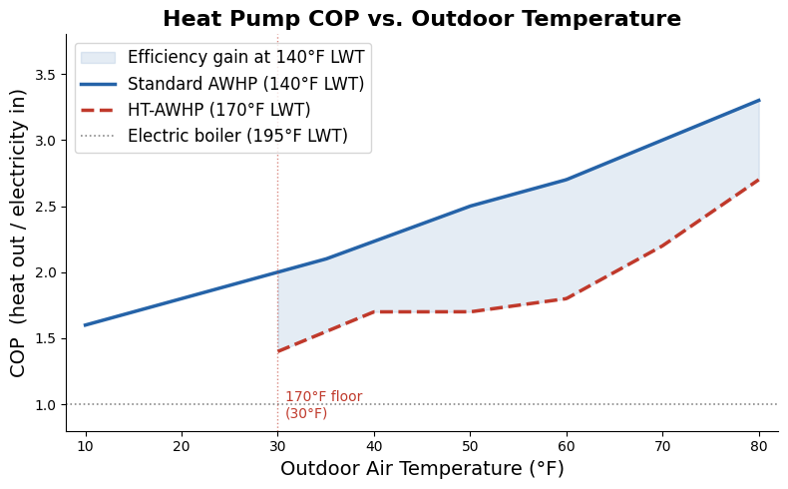
Figure D1: COP comparison between standard AWHP, HT-AWHP, and an electric boiler.

The electric boiler exhibits the lowest energy efficiency across ambient air temperatures. Although the HT-AWHP can achieve a leaving water temperature closer to the CEC’s current system, its lower efficiency and higher electricity demand make it less attractive than the standard AWHP, whose COP exceeds 3.0 during warmer months. Subject to the FCU compatibility findings in Appendix D4 and confirmation that the standard AWHP can meet the CEC’s peak heating demand, the standard AWHP appears to offer the stronger engineering and economic case relative to the less efficient HT-AWHP.

D3. CEC and Longhouse Space Heating Fraction
The CEC and Longhouse share a propane boiler that consumes an estimated 10,140 gallons of propane annually. To approximate the split between the two buildings, each building's heat-loss surface area (walls and roof, neglecting the floor) was used as a proxy for relative heating demand. Figure D2 highlights the key assumptions made to determine the building split fraction. The Longhouse was estimated to have a 12,700 ft² envelope and the CEC was estimated to have a 7,000 ft² envelope.

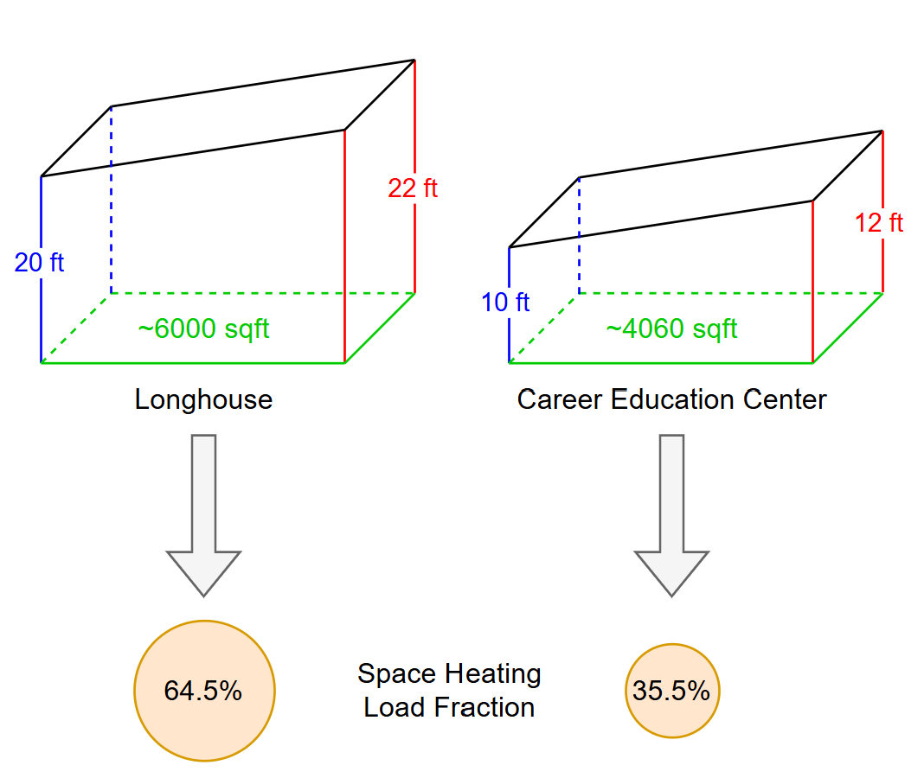
Figure D2: CEC and Longhouse heating split fraction based on floor and wall areas to approximate heat loss areas.

The resulting space heating load fraction is 64.5% for the Longhouse and 35.5% for the CEC. Applying this fraction to the boiler's annual load profile yields the CEC-specific space heating load profile shown in Figure D3.

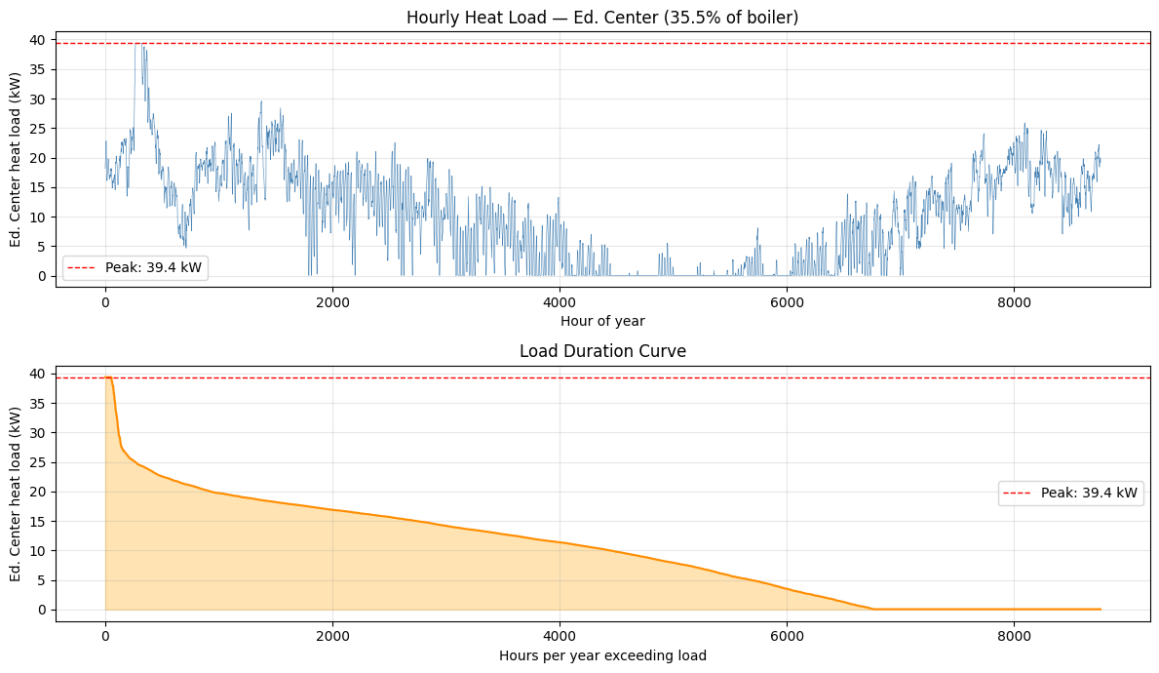
Figure D3. CEC hourly heat load profile from boiler load and space heating split fraction.

Based on this profile, the peak heating demand of the CEC in the winter is 39.4 kW. To determine whether the standard AWHP is sufficient to meet this peak, the existing FCUs had to be examined further, since reducing the entering water temperature (EWT) from 190°F to 140°F reduces the heat each FCU can deliver.

D4. FCU and Standard AWHP Compatibility Study
The heat output of each FCU was determined from its rated capacity [Btu/hr], flow rate [ft³/min], and the temperature differentials between entering and leaving water [K] and entering and leaving air [K]. For the 190°F EWT case, the difference between entering and leaving water temperature was determined using counter-current heat exchanger theory. For the 140°F EWT case, a 10°F approach was assumed, representing a practical lower limit for reasonably-sized fan coil units. Table D4 shows the resulting outputs for both entering water temperatures.

Table D4. Power output across four FCU models at two different entering water temperatures.
FCU Model | 190॰F Power [kW] | 140॰F Power [kW] | Power Reduction | Scaling Factor
HE-Z 50/RPM-50 | 16.5 | 11.4 | 31% | 1.45
HE-Z 70/RPM-70 | 23.4 | 15.5 | 34% | 1.51
HE-Z 100/RPM-100-4 | 32.9 | 22.7 | 31% | 1.45
HE-Z 100/RPM-100-5 | 39.3 | 25.8 | 34% | 1.52
 | Average |  | 33% | 1.48

Each FCU loses an average of 33% of its rated capacity when EWT drops from 190°F to 140°F, meaning the new system would need approximately 1.48 times the FCU area to deliver equivalent heat at the lower water temperature. Whether the existing FCU array can meet the 39.4 kW peak demand at 140°F EWT—and therefore whether the standard AWHP can serve the CEC without additional FCUs—depends on the number and model of FCUs currently installed, which was not fully documented during the site visit.

To translate the per-unit derating into a practical sizing question, the number of FCUs required to meet the CEC's 39.4 kW peak demand was evaluated for each model at both 190°F and 140°F EWT. Figure D4 shows the total heating capacity of several configurations, with each segment representing one FCU unit. At 190°F EWT, the existing system could meet peak demand with as few as two HE-Z 70 (Energy Saving Products Ltd., n.d.) units (46.7 kW) or two HE-Z 100 units (65.8–78.5 kW depending on the model). At 140°F EWT, the same models require one additional unit each to clear the 39.4 kW threshold: three HE-Z 50s become four, two HE-Z 70s become three, and the smaller HE-Z 100 configuration moves from two to a borderline three. Notably, the larger HE-Z 100 model still meets peak demand with only two units at 140°F EWT (51.6 kW), suggesting that depending on which FCU models the CEC currently has installed, the standard AWHP scenario may require either no retrofit or the addition of one FCU per zone. In practice this corresponds to adding one FCU per zone for most models, consistent with the 1.48× area scaling factor identified in Table D4.
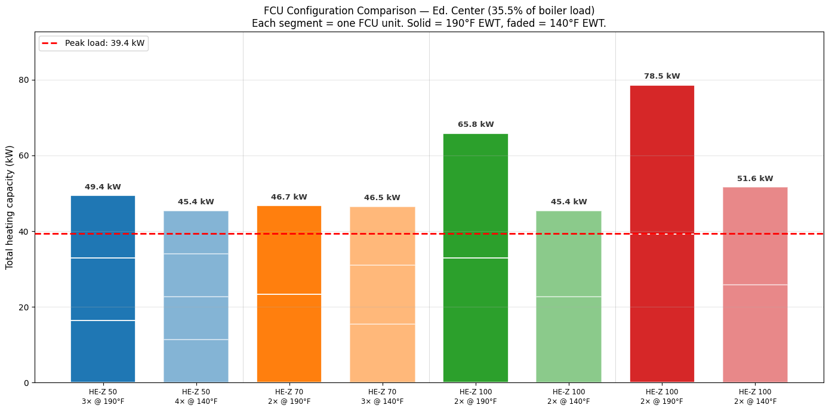
Figure D4. FCU configuration comparison for CEC. Total heating capacity of candidate FCU configurations at 190°F EWT (solid) and 140°F EWT (faded), relative to the CEC peak demand of 39.4 kW (dashed). Dropping to 140°F EWT requires one additional FCU unit in most configurations to maintain adequate capacity, except the HE-Z 100 (larger model), which clears peak demand with only two units at either temperature.

In practice this corresponds to adding one FCU per zone for most models, consistent with the 1.48× area scaling factor identified in Table D4.

Appendix E: Additional Electrification Considerations
Brief analysis was performed for some of the remaining propane-consuming units. Methodology for the heating load profiles is documented in Appendix C. As no CAPEX has been determined for these implementations, further detailed analysis is advised before pursuit of any of the following recommendations.

E1. CFS and Gym Furnace Replacement
Hourly heating load profiles for the Gym and CFS furnaces were derived from the overall campus heating model using occupancy-weighted splits (summarized in Table C4). These profiles were then divided by cold-climate air-source heat pump (CC-ASHP) COP values to estimate the additional electrical demand a heat pump replacement would induce. Table E1 presents results across three COP scenarios.

Table E1. Estimated annual electricity demand if furnaces are replaced by CC-ASHPs.
Average COP | Gym Furnace Replacement Estimated Electricity [MWh/yr] | CFS Furnaces Replacement Estimated Electricity [MWh/yr] | Total Estimated Electricity [MWh/yr]
COP 2.0 | 29.2 | 58.5 | 87.7
COP 2.5 | 23.3 | 46.8 | 70.1
COP 3.5 | 16.7 | 33.4 | 50.1

Electrifying the Gym and CFS furnaces with CC-ASHPs would substantially increase campus electricity demand, particularly in winter months. Figure E2 shows estimated monthly grid draw under the proposed electrification scenario, stacked against current campus electricity baseline.

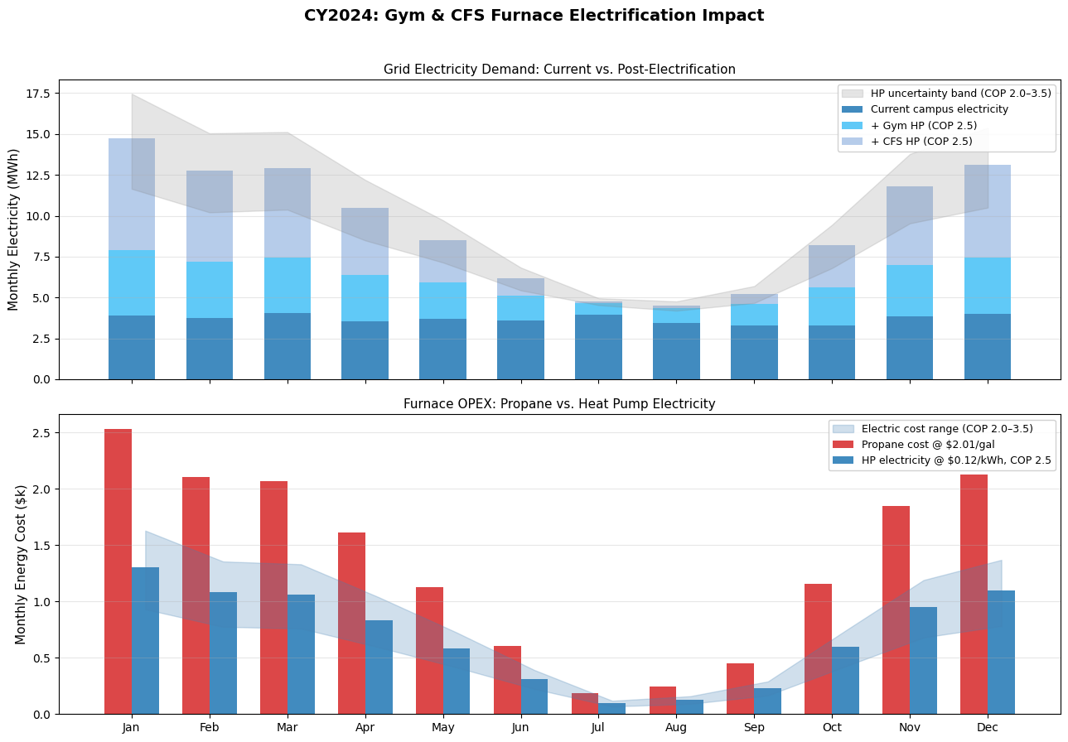
Figure E2. Estimated monthly campus electricity demand before and after Gym and CFS furnace electrification. Current electricity consumption is supplemented by estimated heat pump draw for the Gym and CFS furnaces.

Replacing the Gym and CFS furnaces with CC-ASHPs would more than double campus electricity consumption, increasing annual grid demand from 44 MWh to approximately 113 MWh. The effect is heavily seasonal (winter months from January to March, and November to December seeing the largest additions). Monthly demand rises from a roughly constant 4 MWh to 13–15 MWh, driven by the higher heating loads at low outdoor temperatures. Summer months require comparatively little additional electricity, as heating demand drops off. The gray uncertainty band reflects COP variability between 2.0 and 3.5, which has a meaningful effect in peak winter months but does not change the overall conclusion that a service capacity conversation with PSE would likely be warranted prior to implementation. Figure E3 shows the estimated monthly OPEX under the proposed electrification scenario, stacked against the current campus electricity baseline. Propane costs are calculated at $2.01/gal and heat pump electricity costs assume COP 2.5 at $0.12/kWh (PSE Schedule 25).


Figure E3. Monthly OPEX comparison for Gym and CFS furnaces. Current propane cost vs. estimated heat pump electricity cost. Heat pump operation is cheaper than propane in every month of the year.

Despite the significant increase in electricity consumption, heat pump operation is substantially cheaper than the propane it displaces. The furnaces currently cost an estimated $16,000/yr in propane at $2.01/gal, with costs peaking at roughly $2,000 to 2,500/month in winter. The equivalent heat pump electricity cost at COP 2.5 is approximately $8,200/yr: a savings of around $7,800/yr. The cost advantage holds in every month of the year, with winter months showing the largest absolute savings even accounting for COP uncertainty. PSE Schedule 25 carries a seasonal demand charge (with approximately $13/kW from October to March, and approximately $9/kW from April to September) in addition to the energy charge used here. However, given the campus's modest peak draw, estimated at roughly 25–30 kW added load from the heat pumps, the demand charge contribution would be on the order of $300–400/month in peak winter months, small relative to the $1,500/month propane cost it displaces. The cost advantage is therefore robust to this omission.

To support PGST decarbonization, PGST should plan to replace all four furnaces with CC-ASHPs. This is a well-supported technology for the Pacific Northwest climate and represents the single largest remaining electrification opportunity after the boiler, with full replacement offsetting approximately 34% of total propane consumption.

E2. Cooking Ranges Replacement
The Community Kitchen, Elder’s Center, and ECC currently use propane stoves for various cooking purposes. Both the Elder’s Center and the ECC currently have the 60” Imperial Gas Range Pro Series with a griddle and broiler, with the Elder’s Center stove estimated to be the highest consumer of propane due to its frequency of use. Replacing both industrial gas ranges with electric stoves would lead to an emissions decrease of approximately 28 tCO₂e per year. While replacing gas stoves across the tribal campus with electric stoves would decrease GHG emissions, there is a noticeable difference between these types of stoves while cooking. For this reason, further discussion amongst users of these stoves and tribal leadership will be necessary to determine if this switch would be beneficial for the overall community.

Table E2 compares the current gas range with its closest electric equivalent. The most significant difference is the plate heat output. The gas range delivers 9 kW per burner versus 2 kW for the electric, meaning each electric element produces less than a quarter of the heat of its gas counterpart. To compensate, the electric model adds two additional plates (8 vs 6), which also increases the unit footprint from 60" to 72", which is an important consideration for existing kitchen layouts. The griddle output is comparable at 6 and 8 kW. The one meaningful feature loss is the broiler, which the electric model does not include, and which may affect certain cooking workflows depending on how the kitchen currently uses it.

Table E2. Current stove model and comparable electric model
Parameter | Imperial Gas Range Pro Series | Imperial Electric Range Pro Series
Model | IR-6-RG-24 | IR-8-G24T-E
Plates | 6 | 8
Plate Rate | 9 kW | 2 kW
Range Width | 60" | 72"
Griddle Width | 24" | 24"
Griddle Burner Rate | 6 kW | 8 kW
Standard Ovens | 2 | 2
Broiler | Yes | No

The next step is to consult with kitchen staff to assess operational requirements and potential disruption before deciding whether to replace the existing equipment. The carbon and cost impacts are meaningful, but they should be weighed against possible effects on kitchen operations.

Appendix F: REopt Input Summary Tables
This appendix details the REopt input parameters used across all electrification and PV scenarios evaluated in this report. REopt requires inputs spanning site characteristics, utility rate structures, load profiles, financial assumptions, emissions factors, and technology-specific parameters for PV, battery storage, and AWHPs. Tables F1-F8 document each input value alongside the reasoning behind its selection, including REopt defaults retained, values derived from PSE rate schedules and site data, and assumptions specific to the Tribe's tax-exempt status.

Table F1: Step 1-5: Use Case, Technologies to Evaluate, and Site Data Input Data
Variable | Value | Reason
Single Site | On | PGST Campus is a single site
Grid-tied | On | The site is Grid-tied
Cost Savings | On | Financial analysis is more critical than resiliency per the campus Energy Manager
ASHP  Battery  PV | On/Off | Varies with design matrix
ASHP water heater to serve the domestic hot water load | Off | Did not evaluate using REopt
ASHP configuration | 2: Full replacement heating | Used to evaluate full replacement of the boiler heating load
Evaluation Name | (varies) | Vary this to properly label all simulations
Site Location | Use Latitude & longitude | Location of the site
Latitude | 47.85212 | Location of the site
Longitude | -122.56923 | Location of the site
PV & wind space available | Roofspace only | Evaluating rooftop solar
Roofspace available (ft2) | 8,000 | Measured ~8,600 sqft on the two roofs using PVWatts. Rounded down to 8,000 to account for existing HVAC equipment.
Sector | Commercial/Industrial | Tribal buildings are not considered Federal: https://www.ecfr.gov/current/title-10/chapter-II/subchapter-D/part-436/subpart-A
Advanced Inputs (Solver settings) | REopt default | Simulations were optimizing properly

Table F2: Utilities Input Data
Variable | Value | Reason
Electricity Rate | Puget Sound Energy Inc: 25 (Small Demand General Service) | When peak demand is greater than 50 kW, must use Schedule 25
Compensation type | Net metering  Net billing | Varies
Net metering system size limit (kW) | 100 | PSE limit for net metering participation
Technologies that can net meter | PV | Evaluating PV net metering
Compensation for excess export beyond annual grid purchases ($/kWh) | $0 | $0 for PSE
Net billing compensation for all exports ($/kWh) | $0.06713 | PSE Solar Energy Credit:  https://www.pse.com/en/green-options/solar-energy-credit
Technologies that can participate in net billing | PV | Evaluating PV net billing
Existing heating system fuel type | propane | Current heating system uses propane
Annual existing heating system fuel cost ($/gal) | $2.01 | CY2025 Average propane cost  (See Appendix I)

Table F3: Load Profiles Input Data
Variable | Value | Reason
Typical electrical load | Upload custom load profile | Uploaded 2024 hourly electric load from given PSE data after processing (see Methodology)
Year of electric load profile | 2024 | Year of uploaded profiles
Electrical load adjustment | 100.0% original consumption | Construction is assumed to leave the baseline electricity load unchanged, it will only add a heating load
Typical Heating system fuel load | Upload custom heating system fuel load profile | Uploaded 2024 hourly boiler load derived from deliveries  (see Methodology)
Space Heating load percent of total heating load (%) | 100% | Did not evaluate domestic hot water using REopt
Year of heating load profile | 2024 | Year of uploaded profiles
Existing heating system efficiency (% HHV-basis) | 83.07% | Efficiency of existing boiler
Total installed cost for existing boiler ($) | $0 | For full cost runs, this number will be added outside of REopt  (see Methodology)

Table F4: Financial Input Data
Variable | Value | Reason
Analysis period (years) | 25  10 | Client requested 25 years for full capital scenarios  10 year horizon for free capital scenarios useful for grant funding and quote comparisons
Host discount rate nominal (%) | 2.50% | Set to 2.5% to offset inflation. This report is not focused on investment so the discount rate is kept minimal.
Electricity cost escalation rate nominal (%/year) | 6.00% | Reflects anticipated rate increases driven by growing electricity demand. Difficult to estimate accurately, may decide to perform sensitivity analysis later.
Existing heating system fuel escalation rate, nominal (%/year) | 7.80% | PGST propane purchasing cost [$/gal] was plotted over time from 2016 to 2025. A linear trendline was used to estimate the average change in propane price per year.  (See Appendix I)
Host effective tax rate (%) | 0% | The Tribe is a tax-exempt sovereign entity
O&M cost escalation rate (%/year) | 2.50% | REopt default, aligned with federal inflation numbers from DOE economic analyses.
Minimum capital cost, before incentives ($) | None | We are not considering a minimum spend
Maximum capital cost, before incentives ($) | None | We are not considering a maximum budget

Table F5: Emissions Input Data
Variable | Value | Reason
- | REopt defaults | We are not setting emissions targets in REopt

Table F6: PV Input Data
Variable | Value | Reason
Size class | Small Commercial (12 - 100 kW)
System capital cost ($/kW-DC) | $2,220  $0 | Based on solar cost data provided by client  ($0 for free capital runs)
Existing PV system? | Off | No current PV system on meter of interest
Minimum new PV size (kW-DC) | 0 | We do not need a minimum PV size
Maximum new PV size (kW-DC) | Unlimited | We let REopt determine PV size based on roofspace/economic optimization
O&M cost ($/kW-DC per year) | $26 | REopt default, includes cleaning, administration costs, replacing broken components, and inverter replacement
PV Production | Estimate using system characteristics | Do not have a custom generation profile
Array type | Rooftop, Fixed | We are interested in implementing roof-mounted solar
Module type | Standard | REopt default, assumes typical efficiency and performance
Array azimuth (degree) | 335.4 | Based on CEC/EC roofs
Array tilt (degree) | 10.7 | Based on CEC/EC roofs
DC to AC size ratio | 1.2 | REopt default, typical range is 1.10 to 1.25
System losses (%) | 14% | REopt default, accounts for soiling, shading, mismatch, wiring, connections, light-induced degradation, nameplate rating, and availability
PV Station Search Radius (mi) | Unlimited | We have no reason to constrain nearby solar resource data sites
Rooftop power density (kW-DC per square foot) | 0.01 | REopt default, affects system size on constrained roofspace
PV Incentives and Tax Treatment | 0% Federal capital cost incentive  0%, $0 for rest | 30% investment tax credit is being phased out due to recent legislation
MACRS schedule | No MACRS | The Tribe is a tax-exempt sovereign entity
MACRS bonus depreciation | 0% | The Tribe is a tax-exempt sovereign entity

Table F7: Battery Input Data
Energy capacity cost ($/kWh) | $450  $0 | Interpolated between residential and large commercial scale pricing from NLR data, rounded to two significant figures  ($0 for free capital runs)
Power capacity cost ($/kWh) | $600  $0 | Interpolated between residential and large commercial scale pricing from NLR data, rounded to two significant figures  ($0 for free capital runs)
Constant cost ($) | $8,700  $0 | Interpolated between residential and large commercial scale pricing from NLR data, rounded to two significant figures  ($0 for free capital runs)
Annual O&M cost as a percent of upfront cost (%) | 2.50% | REopt default, covers administrative costs, insurance, fees, labor, taxes, maintenance, replacement costs
Allow grid to charge battery | Yes | Financial incentive to allow this, no incentive not to
Minimum energy capacity (kWh) | (varies) | We will vary this depending on desired battery capacity to test several scenarios (details in design matrix)
Maximum energy capacity (kWh) | (varies) | We will vary this depending on desired battery capacity to test several scenarios (details in design matrix)
Energy capacity replacement cost ($/kWh) | $315  $0 | NLR forecasts that battery costs will be 30% cheaper every 10 years
Energy capacity replacement year | 10 | REopt default, assumes current technology lasts ~10 years and future battery will last remaining ~15 years. Depends on SOC
Power capacity replacement cost ($/kWh) | $420  $0 | NLR forecasts that battery costs will be 30% cheaper every 10 years
Power capacity replacement year | 10 | REopt default, assumes current technology lasts ~10 years and future battery will last remaining ~15 years. Depends on SOC
Constant replacement cost ($) | $6,090  $0 | NLR forecasts that battery costs will be 30% cheaper every 10 years
Constant replacement year | 10 | REopt default, assumes current technology lasts ~10 years and future battery will last remaining ~15 years. Depends on SOC
Minimum power capacity (kW) | (varies) | We will vary this depending on desired battery capacity to test several scenarios (details in design matrix)
Maximum power capacity (kW) | (varies) | We will vary this depending on desired battery capacity to test several scenarios (details in design matrix)
Minimum battery duration (hours) | 0 | We do not need a minimum battery duration
Maximum battery duration (hours) | Unlimited | We do not need a maximum battery duration
Rectifier efficiency (%) | 96% | REopt default, typical for 100 kW/50 kWh lithium-ion system
Round trip efficiency (%) | 97.50% | REopt default, typical for 100 kW/50 kWh lithium-ion system
Inverter efficiency (%) | 96% | REopt default, typical for 100 kW/50 kWh lithium-ion system
Minimum state of charge (%) | 20% | REopt default, achieves optimal performance of battery
Initial state of charge (%) | 50% | REopt default, battery charge at Hour 0 of simulation
Total percentage-based incentive (%) | 0% | 30% investment tax credit is being phased out due to recent legislation
Total power capacity rebate ($/kW) | $0 | No available rebate
MACRS schedule | No MACRS | The Tribe is a tax-exempt sovereign entity
MACRS bonus depreciation | 0% | The Tribe is a tax-exempt sovereign entity

Table F8: ASHP Input Data
Variable | Value | Reason
Total installed cost ($/ton) | $0 | For full cost runs, this number will be added outside of REopt  (see Methodology)  ($0 for free capital runs)
Incremental O&M cost increase over existing HVAC system ($/ton/yr) | $0 | REopt default, can input O&M costs here if higher/lower than existing boiler
ASHP performance (COP and CF) table | Custom ASHP performance table | AWHP table obtained from Nyle Alectro manual. For electric boiler, COP and CF set to 1.0 for all temperatures
Heat pump capacity sizing factor | 1 | Uploaded heating load profile captures worst-case conditions corresponding to full propane boiler plate capacity of 314,000 Btu/hr.
Avoided HVAC upgrades | $0 | REopt default, can input HVAC replacement costs here if AWHP retrofit helps avoid HVAC replacement costs
Resistive heating back-up temperature threshold (°F) | 10°F  30°F | Equipment manuals:  10°F for electric boiler and standard AWHP  30°F for HT-AWHP
MACRS schedule | No MACRS | The Tribe is a tax-exempt sovereign entity
MACRS bonus depreciation | 0% | The Tribe is a tax-exempt sovereign entity

Appendix G: Capital and Operating Cost Breakdown
G1 Capital Cost Estimates.
See Table G1 for the summarized capital costs of each heating system scenario (excluding PV costs). Unless otherwise noted, Table G1 reflects order-of-magnitude installed equipment costs and excludes design/engineering, permitting, commissioning, contingency, contractor overhead and profit, and any taxes or financing costs.

Table G1. Summarized Capital Cost Breakdown for Each Longhouse and CEC Heating System Technology.
Cost Type | Propane Boiler Replacement | Electric Boiler | HT-AWHPs | Standard AWHPs
Unit cost | $16,000 | $18,000 | $62,000 | $64,000
Installation cost | $12,000 | $7,000 | $33,000 | $34,000
Distribution system upgrade costs | $0 | $0 | $0 | $12,000
Controls upgrade costs | Considered negligible | Considered negligible | Considered negligible | Considered negligible
Total capital cost | $28,000 | $25,000 | $95,000 | $110,000

Below is a full explanation of the methodology for developing each estimate.

Propane boiler:
The current propane boiler model on campus is the Buderus Logano G334X/92, with an input capacity of about 378,000 Btu/hr at an efficiency of 83%, corresponding to an output heating capacity of about 314,000 Btu/hr. This model is no longer manufactured, so keeping the existing propane boiler system (which is nearing the end of its life) would require replacement with an alternative model.

One example model for replacement is the IBC Technologies 010-087 SL Liquid Propane Gas Boiler, which is slightly oversized at an output capacity of about 383 MBtu/h corresponding to its 399 MBtu/h input capacity and 96% AFUE. The boiler unit costs approximately $16,000 at full price (AF Supply Corp, 2026). Capital costs also include the cost of installation, which is around $8,000-$12,000 for a propane boiler with a rating >120,000 Btu/hr (Angi, 2026). Using the upper limit due to the boiler’s large size, installation costs are estimated to be about $12,000.

Since the propane boiler is a direct replacement, no distribution system changes should be required. The cost of addressing the conflicting heating and cooling controls was assumed to be negligible with respect to the cost of buying and installing heating system equipment.

Electric boiler:
The replacement system needs to produce an output capacity equivalent to the 314,000 MBtu/hr of the existing propane boiler. This is an electric boiler size of at least 92 kW, assuming 100% boiler efficiency (which is typical of electric boilers). This follows from 314,000 Btu/h ÷ 3,412 (Btu/h per kW) ≈ 92 kW. One example model that meets this criterion is the VoltMax Electric Three Phase Boiler, with a voltage of 480V and capacity of 99–180 kW. Like the propane boiler model, this is slightly oversized and may result in an overestimate of the unit capital cost. This model alone (without installation) costs approximately $18,000 (PlumbEstore, 2026).

The installation and setup costs for a medium-sized electric boiler (100-500 kW) are approximately $3,000-$8,000 (FangKuai, 2025). Estimating this to be on the higher end due to the need for additional changes in the system when switching to a new energy source (i.e., electrical panel upgrades), the installation and setup costs were estimated to be about $7,000.
Because the electric boiler is capable of producing water at the desired temperature, the distribution system will not see any changes and will not incur additional cost.

HT-AWHP:
REopt optimizes a 38 ton size for the HT-AWHP based on its COP and the heating profile of the current boiler. This is similar to the optimized standard heat pump size of 35 tons. Unfortunately, there is a lack of available data on pricing for high temperature AWHPs at this commercial size. The Nyle Alectro model used to develop COP heating curves for REopt is not available at this size (Nyle Water Heating Systems, Inc., 2026). A high temperature heat pump model that is available online, however, is the High Temp WH-Series Large, at sizes of 12-65 tons (Rocky Ridge Geo Distributors, 2026). It is important to note that this model is a water-to-water heat pump, which differs from the air-sourced AWHPs explored in this report and is used only as a pricing proxy and may over- or under-estimate installed costs. When the 40 ton, non-reversible option is selected, the unit cost is approximately $62,000.

Additionally, installation costs account for approximately 35-45% of the total cost of installing a heat pump unit (Doctor Heat Pump, 2025). Installation is assumed to be on the low end of cost since most of the system is expected to be installed outdoors and connects to existing infrastructure. Therefore, assuming the $62,000 in equipment accounts for 65% of the cost, the remaining 35% in installation costs is approximately $33,000 for a total of about $95,000 in unit cost capital expenditures.

The high temperature achieved by the HT-AWHP should not result in the need for distribution system upgrades. While HT-AWHPs cannot typically achieve the 195°F temperature output of the propane, the Nyle Alectro (and others) are capable of reaching 170°F supply temperatures, which may reduce or eliminate the need for distribution upgrades (Nyle Water Heating Systems, Inc., 2026). This should be confirmed against the CEC fan coil specifications and required supply temperature under design conditions.

Standard AWHP:
Based on the optimization in REopt, the required heat pump size for a standard AWHP is about 35 tons. This is a commercial-sized heat pump, so finding estimates of the cost online was challenging. However, a listing for the outdoor APOLLO Commercial AWHP (50 tons) puts the price at about $51,000 (MBtek, 2026a). This is an oversized heat pump, but was one of the few commercial-sized pumps with costs available online. This is excluding the cost of buying an additional commercial storage tank (to store water indoors) and a circulating pump for the indoor hydronic system. If these components are included, they would cost approximately an additional $5,000 and $8,000, respectively, for a total unit cost of around $64,000 (MBtek, 2026b; MBtek, 2026c). Again it will be assumed that installation costs account for approximately 35% of the total cost of installing the heat pump unit, assuming it is on the lower end since the APOLLO system is mostly outdoors and connects to existing infrastructure (Doctor Heat Pump, 2025). Therefore, assuming the $64,000 in equipment accounts for the other 65% of the cost, the remaining 35% in installation costs is approximately $34,000 for a total of about $98,000 in capital expenditures. This estimate includes major equipment components (outdoor unit, buffer/storage, and primary circulation) but excludes piping modifications, controls integration beyond baseline assumptions, and any electrical service upgrades.

To accommodate the lower leaving water temperature that a standard heat pump would produce, the existing fan coil units need to be sized up to a heat exchange area of approximately 1.5x the previous area. This estimate assumes two additional FCUs are required; actual needs depend on the existing FCU models, coil performance at lower entering/leaving water temperatures, and the confirmed peak load. A complete FCU inventory should be completed prior to final design. A commercial fan coil unit costs approximately $2,000-4,000 (Rahn Industries, Inc., 2025). Using the $4,000 on the upper end and the approximately 35% cost of installation from earlier, this is a total of approximately $6,000 per unit ($4,000 unit cost and $2,000 installation cost). If two fan coil units need to be added, the distribution system capital cost is about $12,000. See Appendix D4 for additional information on fan coil sizing.

Summing these costs, this option will cost approximately $110,000 in upfront capital expenditures.

G2. Operating Cost Estimates
See Table G2 for the summarized operating costs of each heating system scenario over 25 years (excluding PV costs).

Table G2. Summarized 25-Year Operating Cost Breakdown for Each Longhouse and CEC Heating System Technology (excluding PV)
Cost Type | Propane Boiler Replacement | Electric Boiler | HT-AWHPs | Standard AWHPs,  Schedule 24 | Standard AWHPs,  Schedule 25
Fuel cost | $526,480 | $0 | $0 | $0 | $0
Electricity cost | $355,438 | $1,774,216 | $1,183,586 | $1,040,295 | $946,792
Maintenance cost | Assumed negligible | Assumed negligible | Assumed negligible | Assumed negligible | Assumed negligible
Total operating cost | $881,918 | $1,774,216 | $1,183,586 | $1,040,295 | $946,792
Table G2 presents the 25-year electricity cost outputs from REopt for each heating technology, excluding PV. Propane costs were based on the propane consumption profiles developed in Appendix C. REopt calculates electricity cost based on the specified PSE rate schedule, simulated heating system consumption, and the electricity escalation rate. Heat pump COP curves were developed from the Nyle Alectro manual, as described in Appendix D2, and form the basis for the electricity profiles of both heat pump technologies (Nyle Water Heating Systems, Inc., 2026). The HT-AWHP used the Nyle Alectro COP curve at 170°F LWT; the standard AWHP used the 140°F LWT curve. Because both curves derive from the same low-efficiency HT-AWHP unit, the 140°F curve understates the COP of a purpose-built standard AWHP. Standard AWHP operating cost estimates should therefore be treated as conservative upper bounds. Maintenance costs were assumed negligible relative to utility costs on the basis that no major equipment replacement is expected within the 25-year analysis horizon.

Table G3. 25-Year PV O&M Cost by Scenario. O&M costs sourced directly from REopt output at $26/kW-DC/yr.
Compensation Structure | Heating Technology | PV Size (kW-DC) | 25-Year O&M Cost
Net Metering | All scenarios | 80 | $52,000
Net Billing | Electric Boiler | 80 | $52,000
Net Billing | Standard AWHP (Schedule 24) | 71 | $45,848
Net Billing | HT-AWHP | 66 | $42,903
Net Billing | Standard AWHP (Schedule 25) | 55 | $35,735

Under net metering, REopt selects the full 80 kW array for all heating technologies, producing a uniform 25-year O&M cost of $52,000. Under net billing, the lower export compensation reduces the optimal array size for heat pump scenarios, with the standard AWHP under Schedule 25 selecting the smallest system at 55 kW and $35,735 in O&M. The electric boiler retains the full 80 kW array under net billing because its higher electricity consumption makes on-site solar offset more valuable.

Table G4. 25-Year Battery O&M Cost by Battery Size. Values calculated from REopt input assumptions (Table F7); not sourced directly from REopt output.
Battery Size | Heating Technology | Annual O&M | Total 25-Year O&M
10 kWh | $16,400 | $13,400 | $29,800
20 kWh | $20,200 | $16,600 | $36,800
40 kWh | $27,900 | $22,900 | $50,800

Annual battery O&M is modeled at 2.5% of upfront installed cost per year, escalated at 2.5%/yr over the 25-year analysis horizon, consistent with the REopt default for systems in this size range. A battery replacement event is assumed at year 10, reflecting NREL's estimated end-of-life for current lithium-ion technology. Replacement costs apply a 30% reduction from initial values per NREL's projected cost trajectory ($315/kWh, $420/kW, $6,090 fixed), as documented in Table F7. The year-10 replacement accounts for roughly 45% of total 25-year battery O&M in all three size cases.

Appendix H: Battery Analysis
H1. Battery sizing assumptions used in REopt
Instead of allowing REopt to size the battery freely, the study evaluated explicit battery cases with fixed power and duration. Power was set to 10 kW. Energy capacity was then defined by duration.

Table H1. Battery Cases
Case | Power rating | Duration | Energy capacity
Battery-1h | 10 kW | 1 hour | 10 kWh
Battery-2h | 10 kW | 2 hours | 20 kWh
Battery-4h | 10 kW | 4 hours | 40 kWh

H2. Battery cost inputs
REopt models battery cost using a three-component structure: an energy capacity cost ($/kWh), a power capacity cost ($/kW), and a fixed constant cost ($). These inputs were interpolated between NREL's published residential and large commercial cost benchmarks and rounded to two significant figures. The resulting values — $450/kWh, $600/kW, and $8,700 fixed — reflect installed system costs at small commercial scale. A 10-year replacement is assumed, consistent with NREL's default lifetime estimate for current lithium-ion technology. Replacement costs apply a 30% reduction from initial values per NREL's projected cost trajectory, yielding $315/kWh, $420/kW, and $6,090 fixed. All incentive inputs (ITC, MACRS) are set to zero because the Tribe is a tax-exempt sovereign entity. Efficiency parameters follow REopt defaults for a system in this size range: 96% rectifier, 97.5% round-trip, and 96% inverter efficiency, with a 20% minimum state of charge. These are summarized in Table F7.

H3. Full-cost results across all scenarios
Table H2 presents the change in 25-year life-cycle cost from adding battery storage relative to the no-battery baseline, for each heating technology and compensation structure. All values are negative, indicating that storage increases life-cycle cost in every case evaluated.

Table H2. Change in 25-year life-cycle cost from adding battery storage relative to no-battery baseline. Positive values indicate cost increase.
Heating Equipment | Net Metering |  |  | Net Billing
 | 1 hr | 2 hr | 4 hr | 1 hr | 2 hr | 4 hr
Standard AWHP | $41,845 | $52,457 | $73,716 | $36,059 | $41,437 | $52,785
HT-AWHP | $75,850 | $101,167 | $153,542 | $62,314 | $75,304 | $111,334
Electric Boiler | $119,482 | $164,980 | $263,205 | $95,772 | $126,508 | $212,489

H4. PSE Flex Battery Program
The PSE Flex Battery Program was reviewed using the existing 120 kWh BESS at the Health Center as a reference case. The program offers a one-time enrollment bonus of $1,000 (capped at $0.75/kWh enrolled), plus $0.50/kWh discharged during Flex Events, with a $500 annual compensation cap and up to 100 events per year.

Assuming near-full discharge of usable capacity per event (approximately 96 kWh for a 120 kWh battery with a 20% minimum state of charge) each event generates roughly $48 in compensation ($0.50 × 96 kWh). The $500 annual cap is therefore reached after approximately 10–11 events. The remaining up to 89–90 events per year would continue to discharge and recharge the battery without compensation, accelerating battery degradation.

Appendix I: Sensitivity Results
I1. PV Cost Sensitivity
Figure I1 shows how REopt's optimized PV system size changes as a function of installed PV capital cost ($/kW-DC) for the standard AWHP under Schedule 25. Under net metering, the model selects the full 80 kW array at all costs below roughly $3,900/kW-DC, then falls sharply. Because exported generation is compensated at the full retail rate under net metering, the PV system retains high value even as upfront costs rise—until the break-even point is crossed, at which point the model steps down rapidly. Under net billing, where exports earn only $0.0671/kWh, the optimal size declines more gradually beginning around $2,100/kW-DC and reaches zero near $4,800/kW-DC.

At the default installed cost of $2,220/kW-DC, net metering selects the full 80 kW array while net billing selects 55 kW. The 25 kW gap between the two structures at the default cost illustrates that the value of high export compensation is a primary sizing driver: a switch from net metering to net billing at current installed costs would render roughly one-quarter of the optimal net-metered array financially unattractive.

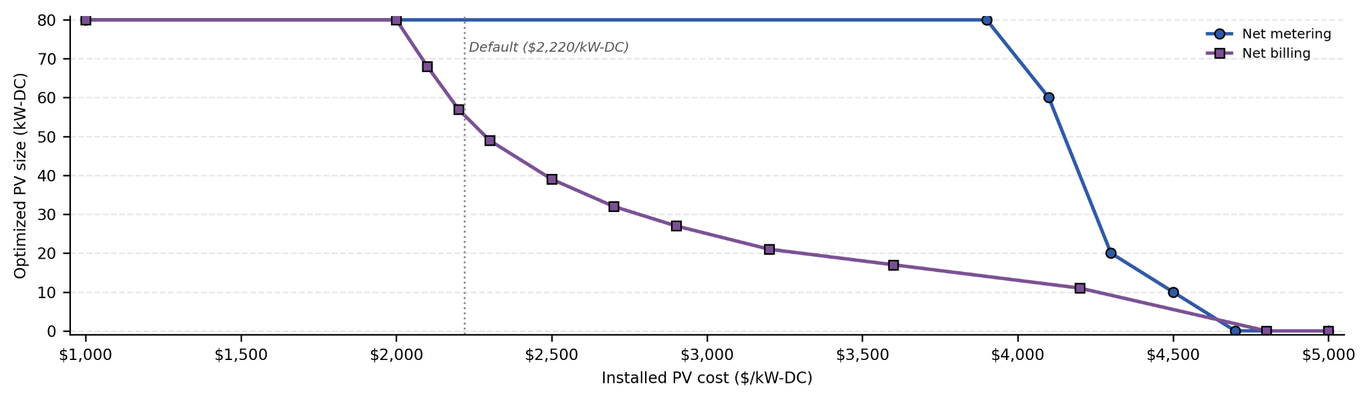
Figure I1. Optimized PV size as a function of installed PV capital cost. Net metering retains the 80 kW maximum across a wide cost range before dropping steeply above ~$3,900/kW-DC. Net billing reduces optimal size more gradually. Vertical dashed line: default assumption of $2,220/kW-DC.

I2. Electricity escalation rate sensitivity analysis
Figures I2 and I3 jointly examine sensitivity to the nominal electricity cost escalation rate for the standard AWHP under Schedule 25—the single largest driver of long-run operating cost uncertainty. Figure I2 shows that PV is not selected under either compensation structure when electricity prices are assumed flat (0%/yr). Under net metering, the model begins selecting PV at approximately 2%/yr and reaches the 80 kW maximum at about 4%/yr. Net billing requires a higher threshold before PV is selected at all and does not reach the 80 kW ceiling until approximately 8%/yr. At the default assumption of 6%/yr, net metering already selects the full 80 kW array while net billing selects approximately 55 kW—consistent with the base-case results reported in Section 5.

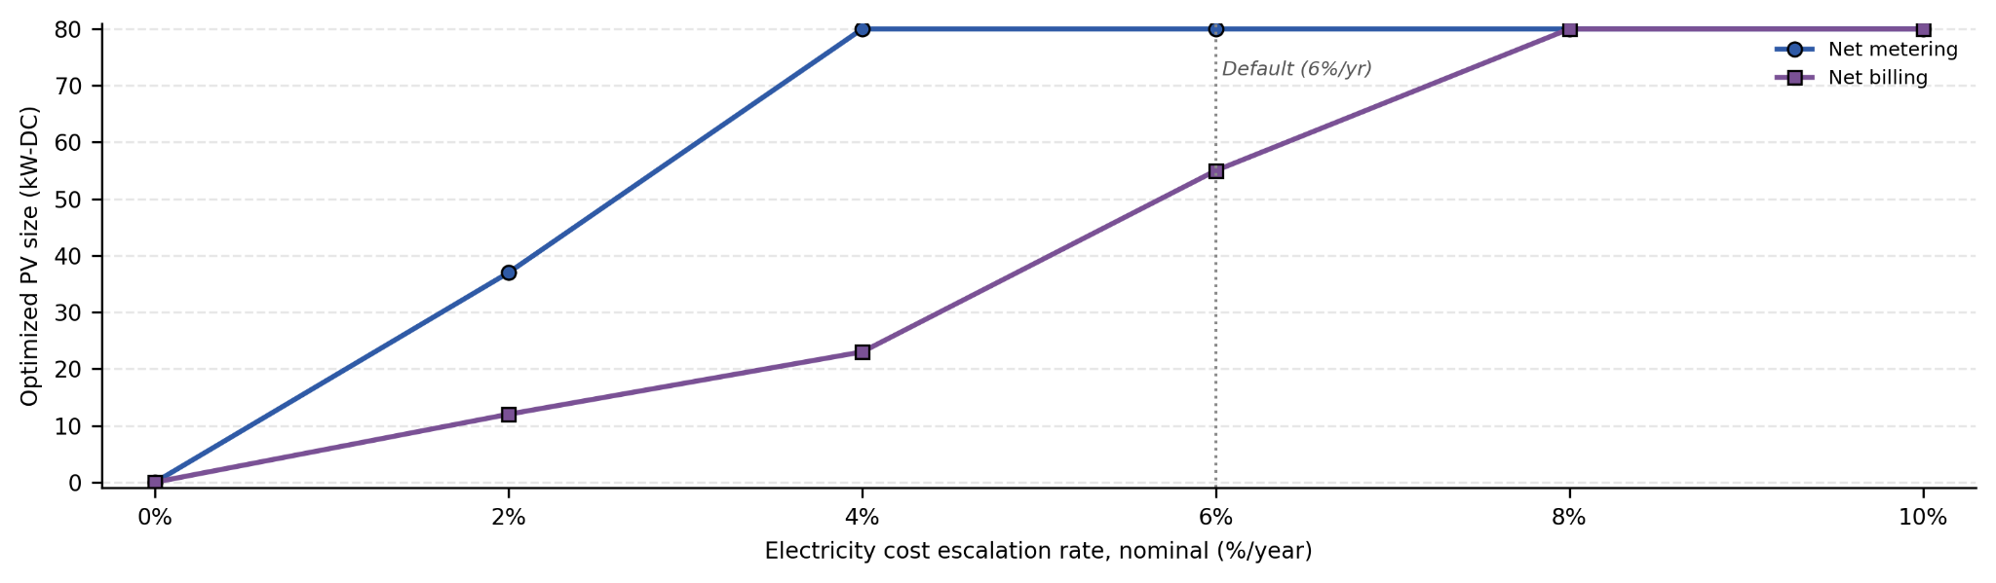Figure I2. Optimized PV size as a function of electricity cost escalation rate. PV is not selected at low escalation rates under either structure. Net metering reaches the 80 kW ceiling at lower escalation than net billing. Vertical dashed line: default assumption of 6%/yr.

Figure I3 shows the corresponding 25-year life-cycle costs for the no-PV, net-metered, and net-billed standard AWHP scenarios under Schedule 25 across the same escalation range. All three rise with escalation rate, reflecting higher cumulative electricity expenditure. The no-PV baseline grows fastest because it bears the full electricity cost without any on-site offset. Net metering grows most slowly and provides the strongest hedge against rising prices: the spread between the net-metered and no-PV cases widens from near zero at 0%/yr to approximately $460,000 at 10%/yr. Net billing occupies an intermediate position throughout.

At the default 6%/yr escalation rate, the net-metered standard AWHP saves roughly $160,000 in 25-year life-cycle cost relative to the no-PV baseline and approximately $108,000 relative to the net billing case—consistent with the values reported in Section 5.1. Even at a low 3%/yr escalation rate, the net-metered AWHP scenario saves money relative to operating without PV, indicating that the PV recommendation is not contingent on historically high electricity escalation.

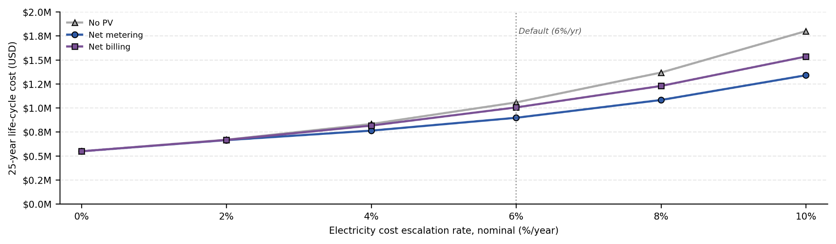
Figure I3. 25-year life-cycle cost as a function of electricity cost escalation rate. The no-PV baseline grows fastest with escalation rate. Net metering provides the strongest cost hedge. Vertical dashed line: default assumption of 6%/yr.

I3. Propane escalation rate sensitivity analysis
Figure I4 examines the 25-year life-cycle cost of the propane boiler replacement baseline as a function of assumed propane price. The relationship is nearly linear: each $0.25/gallon increase in propane price adds approximately $65,000–$66,000 to the 25-year baseline cost. At the default price of $2.01/gallon, the replacement boiler baseline totals approximately $910,000. Propane prices at the PGST campus have historically ranged from roughly $1.50 to above $2.50/gallon over the 2016–2025 billing period, placing the full plotted range within plausible experience.

This sensitivity provides context for the absolute life-cycle cost comparisons in Section 5.1. The net-metered standard AWHP scenario under Schedule 25 has a 25-year life-cycle cost of approximately $897,000 at the default escalation assumptions—roughly $13,000 below the propane baseline at $2.01/gallon. If propane prices rise toward $2.25/gallon or higher, the cost advantage of electrification widens to $75,000 or more. Declining propane prices narrow the gap but do not reverse the recommendation under the default electricity escalation assumptions: even at $1.50/gallon for propane, the net-metered standard AWHP case remains within roughly $120,000 of the boiler baseline in life-cycle cost while delivering the full emissions reduction benefit.
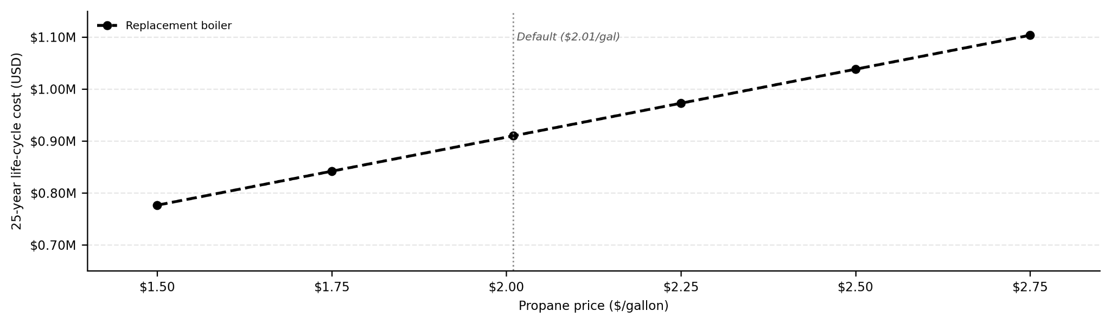
Figure I4. 25-year life-cycle cost of the propane boiler replacement baseline as a function of propane price. Each $0.25/gallon increase in propane price adds approximately $65,000 in 25-year life-cycle cost. Vertical dashed line: default assumption of $2.01/gallon.

Appendix J: Campus-Wide Decarbonization Survey
The current campus business as usual (BAU) operations call for a decrease in propane usage to limit the emission of GHGs. The campus uses approximately 25,000 gallons of propane annually, which equates to annual carbon emissions of 140 tCO₂e. Propane usage and GHG emissions are broken down by building in Figure J1. The highest propane consumer is the propane boiler used to heat the Longhouse and CEC, followed by the furnaces in the CFS, Police, and Courts building.
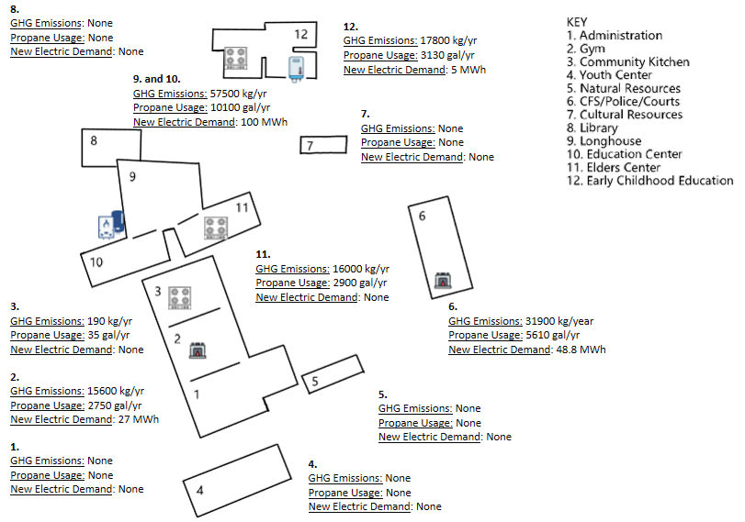
Figure J1. Campus Propane, GHG, and Electric Demand Survey

To offset the increase in electrical demand, solar was investigated for all buildings that have the structural stability to support solar installations. A site survey was conducted with annual emissions, solar potential for roofs, and the increased electricity demand if an electric alternative were implemented for each propane-using device on the campus. Detailed analysis of each building's solar capacity can be found in Appendix E. Campus wide electricity demand can be offset entirely by installations on a few different buildings to reach approximately 180 MWh annually. Replacing propane powered devices would lead to an increase in the electrical demand of the campus.

Using the physical roof parameters as inputs to REopt, the optimal PV system size for the CEC building alone is 44 kW-DC. Since the CEC and Elder’s Center share a roofline, these were combined in the analysis. Spanning the PV system across both the CEC and the Elder’s center would provide more space, allowing for an 80 kW PV unit to be installed. A range of average annual serving load is provided based on Net Metering or Net billing compensation. A serving load of 27,300 - 30,400 kWh, with 23,800 - 34,200 kWh being exported to the grid.

The annual solar potential for each roof was calculated by inputting key physical characteristics (area, azimuth, and tilt) into PVWatts, a web-based tool created by NLR (Table J1). These key characteristics were found using pictures from the site visit and Google Maps imagery. Other REopt inputs can be found in Appendix F to further model a PV system. Each solar potential was further used to evaluate solar capacity requirements to offset the electricity load of the longhouse and CEC’s boiler in two different roof scenarios.

Table J1. Solar Potential Parameter Data and PVWatts Outcome
Building | Roof Area [m²] | Azimuth  [degree] | Tilt [degree] | Capacity [kWdc] | Annual [MWh]
Administration | 460 | 155.4 / 335.4 | 17.1 | 90 | 110
Gym | 440 | 155.4 / 335.4 | 17.1 | 80 | 105
Community Kitchen | 300 | 155.4 / 335.4 | 17.1 | 60 | 80
Youth Center | 500 | 155.4 / 335.4 | 16.3 | 106 | 110
Natural Resources | 160 | 155.4 / 335.4 | 22.6 | 32 | 30
CFS/Police | 430 | 71.6 / 251.6 | 16.7 | 90 | 100
Cultural Resources | 150 | 0 / 180 | 28.4 | 29 | 30
Library | 290 | 180 | 9.2 | 63 | 70
CEC | 410 | 335.4 | 10.7 | 80 | 91
Elder's Center | 390 | 335.4 | 10.7 | 75 | 79
ECC | 814 | 0 / 90 / 180 / 270 | 21–24 | 155 | 150

Figure J2 presents a campus-wide overview of the solar PV potential for each building, summarizing the modeled system capacity and estimated annual generation as determined through PVWatts analysis. Buildings are labeled by number consistent with the site key, and asterisks denote systems exceeding the 100 kW-DC threshold for a small commercial system with net metering exports.
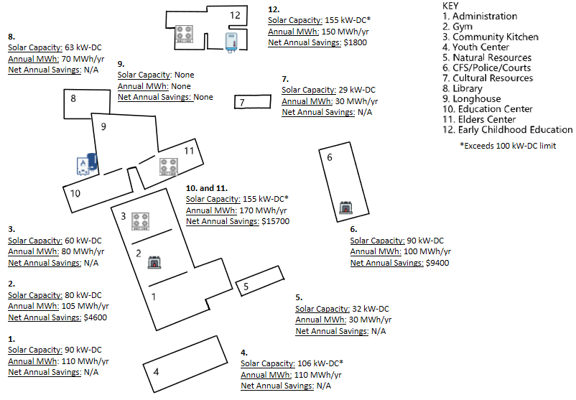
Figure J2. Campus-wide solar PV summary showing modeled system capacity (kW-DC) and estimated annual generation (MWh/yr) for each building.

As shown in Figure J2, solar installations are feasible across the majority of campus buildings, with a total modeled capacity of approximately 860 kW-DC and an estimated combined annual generation of ~955 MWh/yr. The largest contributors are the Administration Building (90 kW-DC, 110 MWh/yr), the Youth Center (106 kW-DC*, 110 MWh/yr), and the Early Childhood Education building (155 kW-DC*, 150 MWh/yr), which benefits from roof faces spanning all four cardinal orientations. The Longhouse (Building 9) was determined to have no viable solar capacity. Buildings 10 and 11 — the Career Education Center and Elder’s Center — share a roofline and are shown combined on the site plan at 155 kW-DC* and 170 MWh/yr.

An important note: the 80 kW-DC system used in the final design for the CEC and Elder’s Center was sized using REopt's default PV density of 0.01 kW-DC/ft², applied to a combined rooftop area rounded down to 8,000 ft² to account for existing HVAC equipment.

