Establish Scope of Site and Document Site Visit
- Current hydronic system configuration (temperature limitations, zones)
  - A hydronic system serves the Longhouse, with three separately thermostatted zones - each side of the bleachers and the main floor
    - The main floor is set to a constant slab temperature, heated through the main floor slab. Hydronic zones run under the bleachers.
      - On a typical 56°F day, the heating in the Longhouse keeps a 135°F cooling down temperature
      - The optimal running temperature is 195°F
      - The water loop is at a 106°F minimum high temperature
  - The Career Education Center uses an air-over-water hydraulic boiler system with redundant pumps and individual air handlers (using water to heat air and blow it into certain spots in the building).
    - Note that the boiler system operates separate from building heating in the Career Education Center because of the air-over-water component.
  - Note that no effort will be made to change the appearance of buildings (i.e., insulation).
- Which buildings are covered: site map
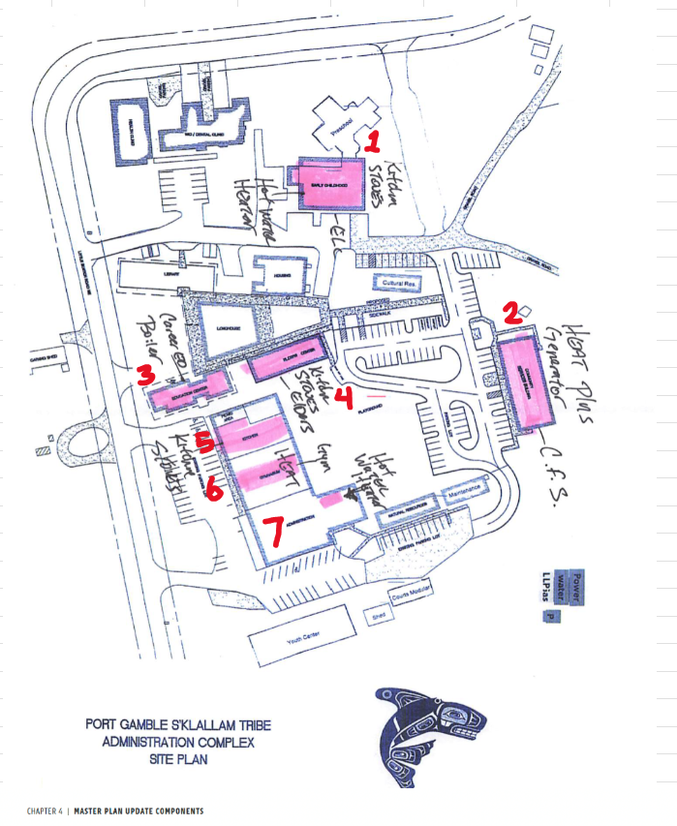
- Brief info on existing systems
  - Boiler-based air-over-water heating at the Career Education Center
  - Hydronic system at the Longhouse
  - Three CFS furnaces
  - Gym Furnace
  - Kitchen stoves in Kitchen, Early Childhood Center, and Elder’s center
  - Hot water heater in Early Childhood Center
- Simultaneous heating/cooling issue in Career Education Center and redundant heat pump system
  - Would be better with zone valves or dampers.
  - Inadequate integration of thermostats to control heating vs. cooling - should probably consider this when moving into electric heating scenarios.

Document existing PV/BESS systems
- Document existing clinic solar PV system specs (kW rating, orientation)
  - 66.2 kW-DC; 60 kW-AC (which is the usable kW after conversion)
  - South facing
- Document clinic SolArk 60kW/120kWh BESS specs
  - 2 batteries at 30 kW each, 61.4 kWh each (~120 kWh total)
- Document wastewater treatment plant solar PV system specs - proposals
  - System sizes proposed were ~60-67 kW
  - Average cost per watt for proposals was ~$2.22 (per Rachel’s email):
