**Network Directory Services Name: ____________________________**

**OpenLDAP and phpLDAPadmin Installation**

**Instructions**: This activity is intended to get you up and running with OpenLDAP, which is a common technology used in industry for organizing information in a standardized way. You will also configure a web-based admin tool called phpLDAPadmin, which will help you manage things visually.

**Section 1: Perform configuration and installation of both, OpenLDAP and phpLDAPadmin.** Follow the instructions indicated on this website:

http://www.techrepublic.com/article/how-to-install-and-configure-ldap-and-phpldapadmin/

**Section 2: Getting a feel for the web-based admin tool.** Inside of phpLDAPadmin, complete the following tasks:

1. Create a posix group using a group ID of 9300.
2. Create the following users using the group created in the previous step:
   1. Marvin Berry (mberry)
   2. Loraine McFly (lmcfly)
   3. Biff Tanon (btanon)

Note: Be sure to assign users to the group ID you created.

1. Continue exploring the tool.

**Section 3: For a moment, try thinking about how a business may use it.** Using the provided organizational chart, try setting up the organization, departments, and user accounts. Supply as much information as you feel is relevant.

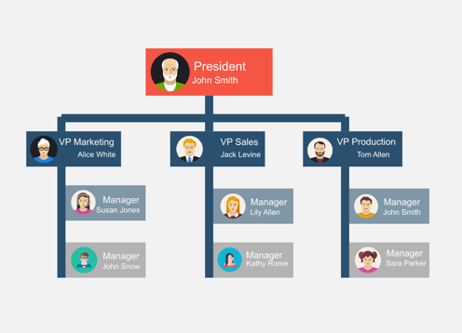

**Section 4: Done!** Once completed, please verify with instructor for sign-off: ____