UNIVERSIDAD NACIONAL AGRARIA LA MOLINA FACULTAD DE AGRONOMIA 

PROYECTO DE TESIS FERTILIZACION FOLIAR CON ZINC EN EL CULTIVO DE AJI ESCABECHE (*Capsicum baccatum* L. var. *pendulum* (Willd) Eshbaugh), EN CONDICIONES DE AGRICULTURA ORGANICA

EJECUTOR PONCE ASESOR RAÚL BLAS SEVILLANO

LIMA-PERU 2019-09-30

# INDICE GENERAL

I

# INDICE DE TABLAS

T

# INDICE DE FIGURAS

F

# RESUMEN

Class aptent taciti sociosqu ad litora torquent per conubia nostra, per inceptos himenaeos. Curabitur sodales ligula in libero. Sed dignissim lacinia nunc. Curabitur tortor. Pellentesque nibh. Aenean quam. In scelerisque sem at dolor. Maecenas mattis. Sed convallis tristique sem. Proin ut ligula vel nunc egestas porttitor. Morbi lectus risus, iaculis vel, suscipit quis, luctus non, massa. Fusce ac turpis quis ligula lacinia aliquet. Mauris ipsum. Nulla metus metus, ullamcorper vel, tincidunt sed, euismod in, nibh. Quisque volutpat condimentum velit. Class aptent taciti sociosqu ad litora torquent per conubia nostra, per inceptos himenaeos. Nam nec ante. Sed lacinia, urna non tincidunt mattis, tortor neque adipiscing diam, a cursus ipsum ante quis turpis. *Nulla facilisi* Ut fringilla. **Suspendisse potenti** Nunc feugiat mi a tellus consequat imperdiet. Vestibulum sapien. Proin quam. Etiam ultrices. Suspendisse in justo eu magna luctus suscipit. Sed lectus. Integer euismod lacus luctus magna. Quisque cursus, metus vitae pharetra auctor, sem massa mattis sem, at interdum magna augue eget diam.

**Keywords:** Lorem, ipsum, dolor, sit amet, consectetur.

# Introduction

Lorem ipsum Lozano-Isla et al. (2018) dolor sit amet, consectetur adipiscing elit. Integer nec odio. Praesent libero. Sed cursus ante dapibus diam. Sed nisi. Nulla quis sem at nibh elementum imperdiet. Duis sagittis ipsum. Praesent mauris Fusce nec tellus sed augue semper porta. Mauris massa. Vestibulum lacinia arcu eget nulla Class aptent taciti sociosqu ad litora torquent per conubia nostra, per inceptos himenaeos. Curabitur sodales ligula in libero. Sed dignissim lacinia nunc (Maluszynski et al. 2009, Pompelli et al. 2012).

Curabitur tortor (Avenot et al. 2009, Zárate y Gianina 2017) Pellentesque nibh. Aenean quam. In scelerisque sem at dolor. Maecenas mattis. Sed convallis tristique sem. Proin ut ligula vel nunc egestas porttitor. Morbi lectus risus, iaculis vel, suscipit quis, luctus non, massa. Fusce ac turpis quis ligula lacinia aliquet. Mauris ipsum. Nulla metus metus, ullamcorper vel, tincidunt sed, euismod in, nibh. Quisque volutpat condimentum velit. Nulla facilisi. Ut fringilla. Suspendisse potenti. Nunc feugiat mi a tellus consequat imperdiet. Vestibulum sapien. Proin quam. Etiam ultrice. Suspendisse in justo eu magna luctus suscipit. Sed lectus. Integer euismod lacus luctus magna.

# Materials and Methods

The data was analyzed in the statistical software R (R Core Team 2019). The germination analysis and graphics was carried out with the package GerminaR (Blum 2005). Each variable was submitted at analysis of variance (ANOVA) and the mean comparison test used was Student-Newman Keuls (P<0.05)(Müller y Wickham 2019). For the multivariate analysis, the principal components analysis (PCA) and cluster hierarchical classification analysis (HCPC) will be used (Gutierrez et al. 2018).

The vertical bars represent the means (±SE). The mean differences between the groups are represented by different capital letters and into the group different lowercase letters (SNK, p = 0.05) (Gutierrez et al. 2018).

## Nulla metus metus

Curabitur tortor. Pellentesque nibh. Aenean quam. In scelerisque sem at dolor. Maecenas mattis. Sed convallis tristique sem. Proin ut ligula vel nunc egestas porttitor. Morbi lectus risus, iaculis vel, suscipit quis, luctus non, massa. Fusce ac turpis quis ligula lacinia aliquet. Mauris ipsum. Nulla metus metus, ullamcorper vel, tincidunt sed, euismod in, nibh. Quisque volutpat condimentum velit. Class aptent taciti sociosqu ad litora torquent per conubia nostra, per inceptos himenaeos. Nam nec ante (Table ??).

# Results

## Sed convallis tristique sem

Lorem ipsum dolor sit amet, consectetur adipiscing elit. Integer nec odio. Praesent libero. Sed cursus ante dapibus diam. Sed nisi. Nulla quis sem at nibh elementum imperdiet. Duis sagittis ipsum. Praesent mauris. Fusce nec tellus sed augue semper porta. Mauris massa. Vestibulum lacinia arcu eget nulla. Class aptent taciti sociosqu ad litora torquent per conubia nostra, per inceptos himenaeos .

Curabitur sodales ligula in libero. Sed dignissim lacinia nunc. Curabitur tortor. Pellentesque nibh. Aenean quam. In scelerisque sem at dolor. Maecenas mattis. Sed convallis tristique sem. Proin ut ligula vel nunc egestas porttitor. Morbi lectus risus, iaculis vel, suscipit quis, luctus non, massa. Fusce ac turpis quis ligula lacinia aliquet. Mauris ipsum.

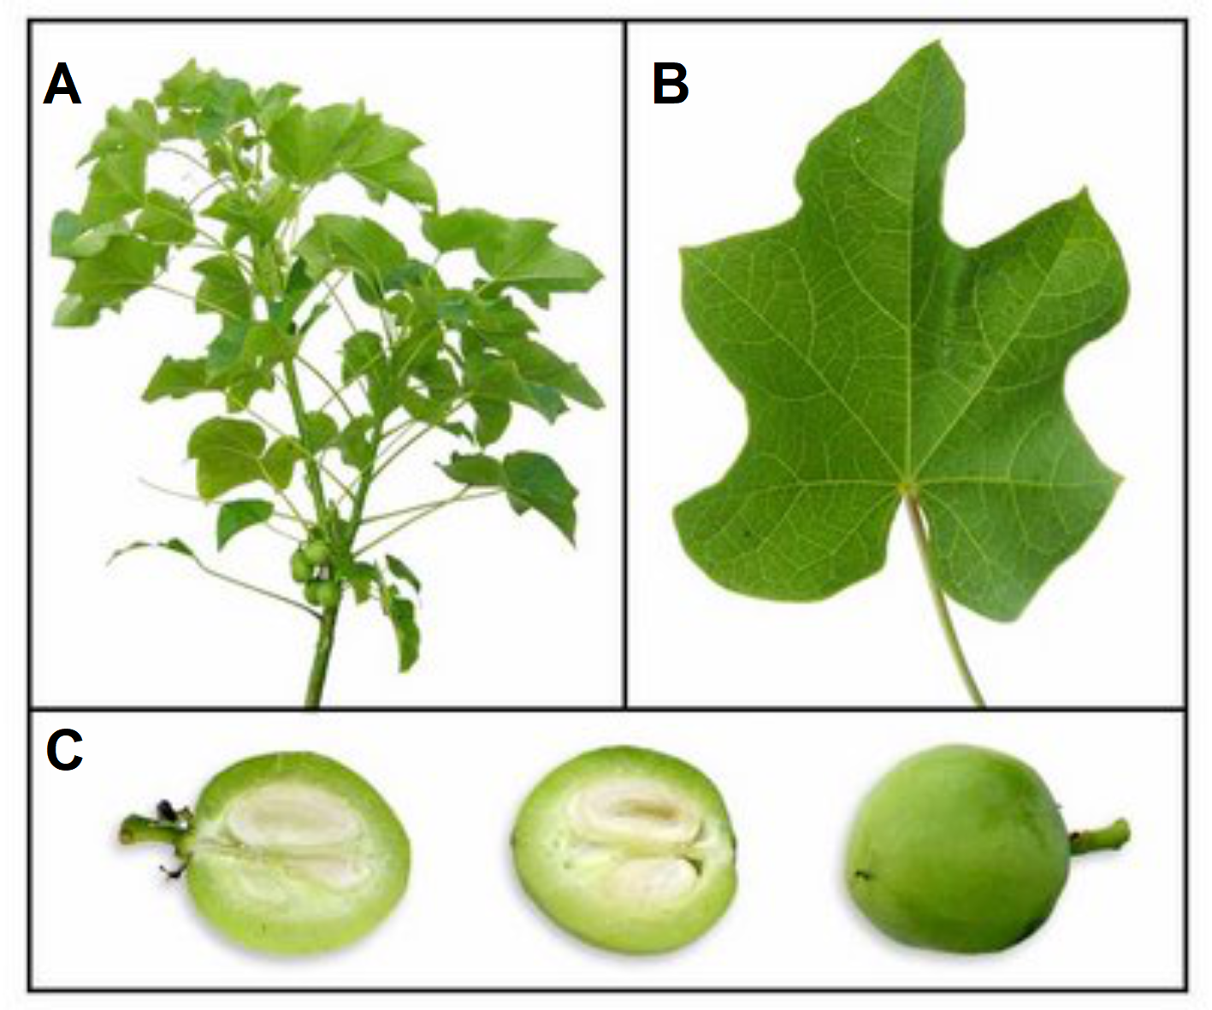

Figura 1: Plant of *Jatropha curcas*. A) Foliage, B) Leaf, C) Fruit.

## Class aptent taciti

Nulla metus metus, ullamcorper vel, tincidunt sed, euismod in, nibh. Quisque volutpat condimentum velit. Class aptent taciti sociosqu ad litora torquent per conubia nostra, per inceptos himenaeos. Nam nec ante. Sed lacinia, urna non tincidunt mattis, tortor neque adipiscing diam, a cursus ipsum ante quis turpis. Nulla facilisi. Ut fringilla. Suspendisse potenti. Nunc feugiat mi a tellus consequat imperdiet. Vestibulum sapien. Proin quam. Etiam ultrices. Figure: 1.

Tabla 1: Clasificación taxonómica del ají escabeche (*Capsicum baccatum* L. var. pendulum (Willd) Eshbaugh)

|  |  |
| --- | --- |
| Reino | *Plantae* |
| División | *Magnoliophyta* |
| Clase | *Magnoliopsida* |
| Subclase | *Asteridae* |
| Orden | *Solanales* |
| Familia | *Solanaceae* |
| Subfamilia | *Solanoideae* |
| Tribu | *Capsiceae* |
| Género | *apsicum* |
| Especie | *Capsicum baccatum* |

**Nombre común:** Ají escabeche, ají amarillo (fresco), ají mirasol (seco)

# Discussion

Curabitur tortor León et al. (2018) and Dixit (2015), Pellentesque nibh. Aenean quam. In scelerisque sem at dolor. Maecenas mattis. Sed convallis tristique sem. Proin ut ligula vel nunc egestas porttitor. Morbi lectus risus, iaculis vel, suscipit quis, luctus non, massa. Fusce ac turpis quis ligula lacinia aliquet. Mauris ipsum. Nulla metus metus, ullamcorper vel, tincidunt sed, euismod in, nibh. Quisque volutpat condimentum velit. Class aptent taciti sociosqu ad litora torquent per conubia nostra, per inceptos himenaeos. Nam nec ante (Table 1).

Sed lacinia, urna non tincidunt mattis, tortor neque adipiscing diam, a cursus ipsum ante quis turpis. Nulla facilisi. Ut fringilla. Suspendisse potenti. Nunc feugiat mi a tellus consequat imperdiet. Vestibulum sapien. Proin quam. Etiam ultrices. Suspendisse in justo eu magna luctus suscipit. Sed lectus. Integer euismod lacus luctus magna. Quisque cursus, metus vitae pharetra auctor, sem massa mattis sem, at interdum magna augue eget diam. Vestibulum ante ipsum primis in faucibus orci luctus et ultrices posuere cubilia Curae; Morbi lacinia molestie dui. Praesent blandit dolor (Blum 2005).

# Conclusions

Class aptent taciti sociosqu ad litora torquent per conubia nostra, per inceptos himenaeos. Curabitur sodales ligula in libero. Sed dignissim lacinia nunc. Curabitur tortor. Pellentesque nibh. Aenean quam. In scelerisque sem at dolor. Maecenas mattis. Sed convallis tristique sem. Proin ut ligula vel nunc egestas porttitor. Morbi lectus risus, iaculis vel, suscipit quis, luctus non, massa. Fusce ac turpis quis ligula lacinia aliquet. Mauris ipsum. Nulla metus metus, ullamcorper vel, tincidunt sed, euismod in, nibh. Quisque volutpat condimentum velit. Class aptent taciti sociosqu ad litora torquent per conubia nostra, per inceptos himenaeos. Nam nec ante. Sed lacinia, urna non tincidunt mattis, tortor neque adipiscing diam, a cursus ipsum ante quis turpis. Nulla facilisi. Ut fringilla. Suspendisse potenti. Nunc feugiat mi a tellus consequat imperdiet.

# Referencias

Avenot, H; Sellam, A; Michailides, T. 2009. Characterization of Mutations in the Membrane-Anchored Subunits AaSDHC and AaSDHD of Succinate Dehydrogenase from Alternaria Alternata Isolates Conferring Field Resistance to the Fungicide Boscalid. Plant Pathology 58(6):1134-1143. DOI: <https://doi.org/10.1111/j.1365-3059.2009.02154.x>.

Blum, A. 2005. Drought Resistance, Water-Use Efficiency, and Yield PotentialAre They Compatible, Dissonant, or Mutually Exclusive? Australian Journal of Agricultural Research 56(11):1159. DOI: <https://doi.org/10.1071/AR05069>.

Dixit, A. 2015. Adaptación al cambio climático: aumento de la producción de quinua mediante técnicas nucleares..

Gutierrez, P; Vega, R; Garc’ıa, S; Casas, A. 2018. Contribution from Vermicompost to Trace Element Uptake in *Capsicum* *Baccatum* L. Var. *Pendulum* Grown under Organic Management at La Molina, Peru. Acta Horticulturae (1217):327-334. DOI: <https://doi.org/10.17660/ActaHortic.2018.1217.41>.

León, D; Gutierrez, P; Riojas, R; Casas, A. 2018. Nitrogen, Phosphorus and Potassium Levels in Asparagus Production. Acta Horticulturae (1223):81-87. DOI: <https://doi.org/10.17660/ActaHortic.2018.1223.12>.

Lozano-Isla, F; Campos, ML; Endres, L; Bezerra-Neto, E; Pompelli, MF. 2018. Effects of Seed Storage Time and Salt Stress on the Germination of *Jatropha* *Curcas* L. Industrial Crops and Products 118:214-224. DOI: <https://doi.org/10.1016/j.indcrop.2018.03.052>.

Maluszynski, M; Szarejko, I; Bhatia, CR; Nichterlein, K; Lagoda, PJL. 2009. Methodologies for Generating Variability. Part 4: Mutation Techniques. Plant breeding and farmer participation:159-194.

Müller, K; Wickham, H. 2019. Tibble: Simple Data Frames (en línea). s.l., s.e. Disponible en <https://CRAN.R-project.org/package=tibble>.

Pompelli, M; Antunes, W; Ferreira, D; Cavalcante, P; Wanderley-Filho, H; Endres, L. 2012. Allometric Models for Non-Destructive Leaf Area Estimation of *Jatropha* *Curcas*. Biomass and Bioenergy 36:77-85. DOI: <https://doi.org/10.1016/j.biombioe.2011.10.010>.

R Core Team. 2019. R: A Language and Environment for Statistical Computing (en línea). Vienna, Austria, R Foundation for Statistical Computing. Disponible en <https://www.R-project.org/>.

Zárate, C; Gianina, M. 2017. Respuesta de 100 Accesiones de Quinua a La Infección Natural de Mildiu (Peronospora Variabilis Gäum) En El Valle Del Mantaro..