Random Taco Cookbook

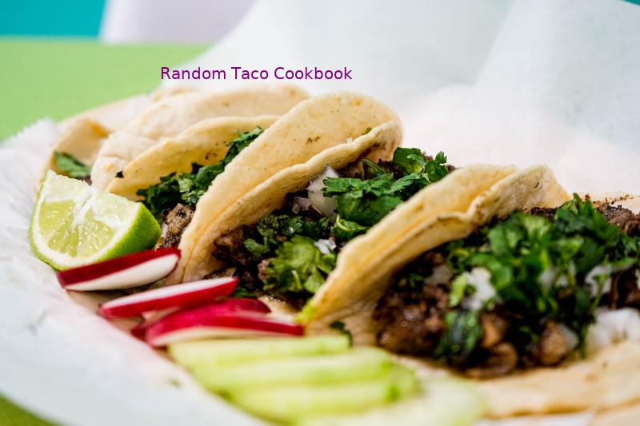

Tai's Captures

first last

https://taco-1150.herokuapp.com/random/?full_taco=true

# Zaatar

Zaatar  
======  
  
_A.k.a. za‘tar, za’atar, zattr, etc._  
  
Zaatar is a thyme-based Middle Eastern seasoning that adapts well to tacos. It has a pleasantly dry, faintly sour/bitter flavor. It goes well on savory bases like squash and lamb, and combines with other sour seasonings like lemon juice and radish.  
  
There are many kinds of zaatar, some quite different; this recipe is representative, not definitive.  
  
* 4 units thyme  
* 2 units oregano  
* 2 units sesame seeds  
* 0–1 unit salt  
* 1 unit sumac (to be found at a Lebanese or Syrian market, or at a yuppie grocery; in a pinch, lemon zest can substitute)  
* Other herbs to taste: fennel pollen, marjoram, cumin, etc.  
* Optional: trace olive oil or lemon juice as a binder (but not if you plan to store it)  
  
Toast the sesame seeds. Grind all ingredients together using any method, stopping when the mixture is not too fine to pick up by pinching.  
  
May be added to meat during cooking, or sprinkled over a finshied taco.  
  
The latest theories have not ruled out the possibility of a zaatar mole.

Guacamole (Simple)  
=========  
  
If you're not in the mood to be fussy, this could be considered a minimum-viable guacamole recipe.  
  
* 2 ripe avocados  
* 2-4 limes, depending on juiciness, delivering 2-4T of lime juice  
* 1 diced tomato (seeded if it's a big one)  
* salt (to taste)  
* hot sauce (to taste; Frank's Red Hot is a standard, but go with what you like)  
  
1. Scoop the avocado meat into a bowl and mash them with a fork. Leave it a bit lumpy as we will do more stirring in a bit and we don't want to over-work them.  
2. Add the chopped tomato.  
3. Add the lime juice; hold some back for later adjustment).  
4. Add ½t salt.  
5. Add 2T hot sauce.  
6. Stir with the fork again.  
7. Taste.  
8. Adjust salt/lime/hot sauce as desired.  
  
This recipe will support one average-size bag of chips, so adjust quantities based on expectations.

Drunken Green Beans  
===================  
  
Green beans are fine. Green beans cooked in beer are better. Maybe even the best.  
  
* 1 Surly fist full of green beans  
* half a beer  
* quarter cup vegetable broth  
* 2 cloves garlic  
* 1 Tbsp olive oil  
* some salt, whatever  
  
First peel and dice the garlic and sauté it in the olive oil. Before it gets all burned and ruined, add the beer and vegetable broth.   
   
As the liquid comes to a boil, cut the green beans up. Add the green beans and a pinch of salt and let them simmer for about five minutes. If you like your beans on the softer side you can let it go a little longer. But the trick is to pull them right after the color starts to turn and you've just made a delicious addition to any taco.

Marinated Portobello Mushroom  
=============================  
  
Sometimes you're throwing a taco party and you need a vegetarian option. Sometimes you just don't feel like eating meat.  
  
Since a proper taco is never overstuffed, one decent-sized portobello should be enough for three servings. Multiply accordingly, and drop your mushrooms into a big Ziploc bag with enough [salsa verde](/condiments/simple_salsa_verde.md) to cover. Let everything sit in your fridge for a couple of hours.  
  
Remove, season with just a touch of salt and cracked black pepper, then lay onto a grill (or a grill pan on your stovetop) over medium to medium-high heat for a few minutes on each side. Cut into thick slices, and you'll have a nice, earthy taco base.

# Quick and Dirty Spice Mix

Quick and Dirty Spice Mix  
=========================  
  
I’m not going to make a lot of big assumptions here. You own a skillet of some sort. You have some jars of jankity-ass spices from who-knows-when. You want to eat some tacos within the next, like, fifteen minutes. I got you covered, bachelor(ette).  
  
* 2 Tbsp all-purpose flour  
* 2 1/2 tsp. chili powder  
* 3/4 tsp. onion powder (or 1 1/2 tsp. minced yellow onion)  
* 1 1/4 tsp. salt  
* 1 tsp. paprika  
* 3/4 tsp beef bouillon powder  
* 1/4 tsp. granulated sugar  
* 1/4 tsp. cayenne pepper  
* 1/4 tsp. garlic powder  
* 1 tsp. cumin  
  
Put all this in something with a lid, add 3/4 cup of water, and shake it. Brown a pound of ground beef, then pour the whole situation in there. Stir. Cook it down until it looks like you only put in half a cup of water. You have tacos now.  
  
Vegetarians  
-----------  
  
I’ve made this with that soy protein “ground beef” and it does not _surprisingly_ taste like someone put spices on a stack of cheap bar coasters and ran it all through a blender. (Vegetable) oil the skillet when you’re dealing with that stuff, unless you’re looking for excuses to buy a new one.  
  
If you leave out the bouillon for the sake of doing things vegan-style you’ll probably want to nudge up the salt a little.

Guacamole  
=========  
  
This is pretty canonical stuff right here.  
  
* 1-2 ripe Hass avocados  
* half a lime  
* a clove or two of chopped garlic  
* some chopped white or yellow onion  
* salt  
* pepper  
* dry cayenne or red chile pepper powder  
* a jalapeño, if that's your thing  
* a small chopped tomato  
* a handful of chopped cilantro  
  
Look, here's how this works: First, you squeeze the lime juice into your nice little ceramic bowl. Then you add the garlic, onion, spices, peppers if you're heating it up, and then **walk away**.  
  
Seriously, walk away for a minute. Crack open a nice Negra Modelo and use a wedge of the other half of the lime in it. Back in your bowl, let the strong stuff marinate in that lime juice for a few minutes. It's cooking.  
  
OK, now that you're back, mix in the rest of the non-avocado ingredients. If you have a pestle, now's it's time to shine. If not, use a small wooden spoon, or failing all else, a fork, you miserable lout.   
  
Mash up everything but the avocado. Get it pasty if you can. Squish it all up.  
  
Now you can add your avocado or two, dude. I usually go with about 1.5 avos to condiment tacos or taco-like structures for four humans of varying sizes.  
  
Just in case no one ever taught you how to deal with an avocado correctly, here's a quick lesson:  
* Cut it in half, longways.  
* Smack the pit with the sharp edge of your knife and give it a sensible 90-degree twist.  
* Voila, the avocado pit is on your knife.  
* Dispose of it, unless you're not going to finish all that guac now, in which case, hang onto it and put it in the bowl with the guac before you put it in the fridge.  
* Now that your knife is free, use it to carve long slices into the flesh of your avocado, one half at a time. Cross-hatch that sucker a bit. Don't cut through the flesh.  
* Finally, get your avocado half above your nice bowl full of deliciousness, and use the skin to gently push your nice slices into the spicy soup below. Turn it inside-out, if you must, but know that you can minimize the amount of avocado that gets all over your hands if you do this just right.  
  
To finish up your guacamole, mash your avocado up a bit and gently mix it into the magical citric-spice-tomato concoction. We're done here.  
  
_Thanks to [The Awl](http://www.theawl.com/2010/02/half-baked-guacamole-by-the-ceviche-method) for limited inspiration regarding the limey and drinky parts._

Veggies for Fish Tacos  
======================  
  
Fish tacos are a special breed, requiring different vegetable options.  
  
__Assemble your veg from the following options:__  
  
* Cabbage, purple, shredded  
* Cabbage, other shades, shredded  
* Radishes, sliced into thin slices  
* Red peppers, diced  
* Cherry tomatoes, sliced (if you're a heathen)  
* Cilantro, if it doesn't taste like soap to you  
  
And one requirement:  
* Limes, sliced for juicing over tacos.  
  
Place out your selections and assemble into your taco. Then squeeze a lime over the top.

Marinated Portobello Mushroom  
=============================  
  
Sometimes you're throwing a taco party and you need a vegetarian option. Sometimes you just don't feel like eating meat.  
  
Since a proper taco is never overstuffed, one decent-sized portobello should be enough for three servings. Multiply accordingly, and drop your mushrooms into a big Ziploc bag with enough [salsa verde](/condiments/simple_salsa_verde.md) to cover. Let everything sit in your fridge for a couple of hours.  
  
Remove, season with just a touch of salt and cracked black pepper, then lay onto a grill (or a grill pan on your stovetop) over medium to medium-high heat for a few minutes on each side. Cut into thick slices, and you'll have a nice, earthy taco base.

# Mahi Mahi Rub

Mahi Mahi Rub  
==============  
  
A rub for Mahi Mahi, if fish tacos be what you're fancying:  
  
* 1 Part spicy chili powder  
* 1 Part salt  
* 1 Part ground cumin  
* 1/2 Part chopped cilantro  
* 1/2 Part cayenne  
* 1/2 Part pepper  
* 1/2 Part oregano  
* 1/2 Part onion powder  
* 1/2 Part garlic powder  
  
You choose your measurements and enjoy!

Salsa de chile de árbol  
=======================  
  
This is a go-to taco sauce in western Mexico and probably elsewhere. You can  
mix and match the techniques in the two variants presented here, and substituting  
or adding chiles is a ramp onto the combinatorial superhighway of Mexican food and  
can demystify the salsa bar at the local taquería.  
  
# Red  
  
* dried whole *chiles de árbol*  
* tomatoes  
* onion  
* *optionally*, garlic  
  
Take between .3 and 1 chiles per tomato, remove the stems and put them in a  
saucepan with a tablespoon or two of oil (olive, soy, etc.) The pan and oil should be very  
hot and the chiles should seem to be at risk of burning. Rotate the  
chiles around and let them get dark brown to black without actually burning them —  
this can happen quickly, which is good because your eyes, nose, and lungs  
may reach their maximum vaporized chile tolerance during this step.  
  
Add a bunch of chopped onion and garlic and lower the heat. Cut the tomatoes  
in half and throw them in with salt to taste. Cook until the tomatoes look stewed.  
If you have one of those blender wands that you can put directly in a saucepan,  
you can blend everything now (you may end up making this sauce frequently enough  
to justify the purchase of a blender wand.) Otherwise wait until the mixture  
is not hot and blend it in a standard blender.  
  
# Green  
  
* dried whole *chiles de árbol*  
* green tomatillos  
* onion  
* cilantro  
  
Take between .1 and .5 chiles per tomatillo, remove the stems and put them in a bare, hot saucepan.  
Toast the chiles without oil until they are dark. Add halved or quartered tomatillos, salt, and a  
tablespoon or two of water to prevent burning the chiles before the tomatillos release  
their juices. When the mixture has cooked for as long as you can stand to wait, remove  
the heat and let it cool. Blend and place in a little salsa bowl and heap with finely  
chopped onion and cilantro.  
  
One non-obvious little point is that skipping the oil in the chile roasting-toasting  
step seems to increase the spiciness of the final product.

Lettuce (Traditional; US)  
======================  
  
In a traditional American taco, lettuce serves to add extra crunch and coolness. Favor the bulkier lettuces over leafier fare such as Bibb lettuces or mesclun.  
  
* Iceberg Lettuce (shredded)  
* Romaine Lettuce (shredded; maintain the stalks)

Red Cabbage Filling  
===================================  
  
* 1/2 head of red cabbage, shredded  
* 3 chopped green onions  
* 1/2 bunch of finely chopped cilantro  
* 2-3 squeezed limes  
  
1. Mix all ingredients in large bowl