Random Taco Cookbook

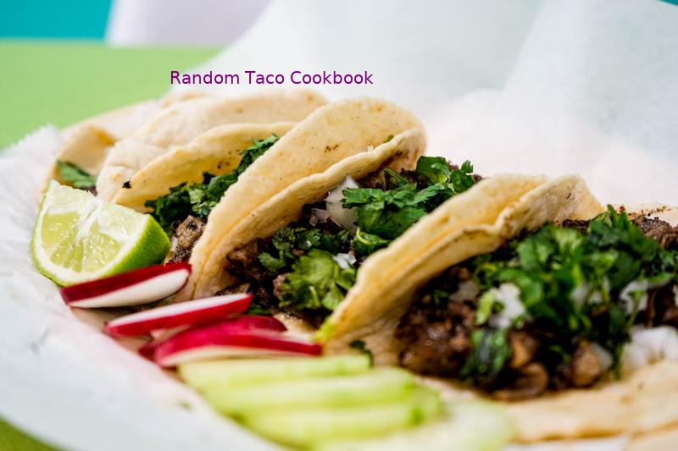

Tai's Captures

first last

https://taco-1150.herokuapp.com/random/?full_taco=true

# Universal Taco Seasoning

Universal Taco Seasoning  
========================  
  
I got tired of buying packets of store-bought taco seasoning, so I experimented with various spices and ratios until I landed on this recipe. I keep a jar of it in the cupboard at all times.  
  
* 6 tbsp chili powder  
* 4 tbsp cumin  
* 4 tbsp corn starch  
* 3 tbsp onion powder  
* 1 tbsp salt  
* 1 tbsp garlic powder  
* 4 tsp oregano (Mexican oregano, if you've got it)  
* 2 tsp crushed red pepper  
  
Combine in Mason jar and shake well to combine.  
  
This mix works well for chicken, pork and beef, destined for the grill, oven, slow cooker or stovetop. You could tweak it a bit to target a specific meat, but I like to have a base, universal mix around. Makes it super easy to turn leftover anything into delicious taco filling: Just chop up whatever it is, toss it into a skillet, sprinkle generously with seasoning, then add a bit of water and simmer to impart flavor.

Pickled Red Onions  
==================  
  
My wife made this recipe up, after eating something similar, but if you are making brisket tacos, it is the most wonderful accessory:  
  
__Ingredients__  
  
* Vinegar  
* 2 chopped red onions  
* 1 tablespoon of sugar  
* a dash of chili powder  
  
Chop the red onions into rings and put them into a container of vinegar. Add the sugar and store the mixture in your refrigerator to marinate and pickle, the longer the better.  
  
Pick out the rings and place them on your brisket taco. Eat.  
  
Variations  
----------  
  
Pickled onions are a favorite in the Von Doom house, too. [@littlewhirl](http://twitter.com/littlewhirl) played around with a similar starting point and we use this brine instead:  
   
* 1/2 cup apple cider vinegar  
* 1 T Sugar (I usually use coconut palm sugar because I'm a hippie I guess)  
* Water  
* 1 1/2 tsp salt  
* 1 sprig fresh oregano and/or cilantro (optional)  
  
Slice 1 red onion on a mandolin (WORTH IT). In a bowl melt the sugar and salt with some warm/hot water. Add vinegar and 1c of filtered water.  
Add in onion, top off w/ water so that the onion is just covered.   
VERY IMPORTANT: Let sit at room temp for at least an hour. Trust me.   
  
The apple cider vinegar is a tangier but also more subtle, keeping more of the onion flavor there. And using a partial salt water brine lets it work nice for quick pickles, but also for slightly longer engagements. Leading to the most important aspect:   
  
PICKLE ALL THE THINGS  
---------------------  
  
Seriously. All the things. Pickle your fridge. Pickle your waffles. Make. Lots. Of. Pickles.   
  
* __Cabbage__ — red or green work. You only need an hour or so (like onions)  
* __Jalepeños__ — seriously GTFO these are good. Add dill for a twist. Add parboiled carrots if you want to cut the spice  
* __Greenbeans__ — because greenbeans are goddam delicious  
* __Toy cars — kid with an attitude? Pickle their favorite toy car. Let's see them try to cop a tude when their matchbox cars are soggy and briney  
* __Cauliflower__ — personal favorite. Pickles in an hour, super delicious  
* __Baby corn__ — baby corn is gross, but if you pickle it you can make jokes about how big all the other things you pickled are

Cheese (Traditional; US)  
======================  
  
A major flavor component of a traditional American taco, select a cheese that's firm and sharp.  
  
* Cheddar (shredded)  
* Jack/Pepper Jack (shredded)

Chorizo  
=======  
  
_Adapted from [Aredridel's Lightly Seasoned Beef](aredridel_lightly_seasoned_beef.md)_  
  
* 20 oz chorizo  
* 20 g black cumin seed, ground  
* 2 cloves garlic  
* 15 ml white wine  
* 4 g salt if wine is unsalted  
* 1/2 small white onion, diced  
* Oil to coat the pan  
  
__Directions__  
  
1. Heat oil in the pan.  
2. Add in onions, stirring occasionally until onions become translucent.  
3. Toss in the garlic, and the chorizo on top of that.  
4. Add the cumin. Brown the chorizo.  
5. Use the splash of wine to loosen anything stuck to the pan.  
  
Perfect, lightly seasoned taco meat.

# Mahi Mahi Rub

Mahi Mahi Rub  
==============  
  
A rub for Mahi Mahi, if fish tacos be what you're fancying:  
  
* 1 Part spicy chili powder  
* 1 Part salt  
* 1 Part ground cumin  
* 1/2 Part chopped cilantro  
* 1/2 Part cayenne  
* 1/2 Part pepper  
* 1/2 Part oregano  
* 1/2 Part onion powder  
* 1/2 Part garlic powder  
  
You choose your measurements and enjoy!

Phoning it in Pico de Gallo  
===========================  
  
_Super Quick & Easy Pico_  
  
  
* 1 pint grape tomatoes, quartered (make your kids do this part)  
* 3 tablespoons finely chopped white onion  
* Coarse salt  
* Squeeze of lime  
* As many finely chopped red (or green) jalapeños as you want (optional)  
  
Combine the tomatoes, cilantro and onion together in a bowl. Season to taste with salt and lime.  
  
Reserve some of this mixture for kids, and then add as much jalapeño as you like to the remaining mixture for the non wimps.

Sweet Potato and Apple Hash  
===========================  
  
Sweet potatoes are my go-to taco punch-up. I was going my normal route of making small (1/4" or so) cubes of sweet potatoes when I thought: Hey, it's fall, I'm going to add an apple in there. Fuck yes.  
  
* 2 Small sweet potatoes (you'd be amazed how little sweet potato you need for tacos)  
* 1 Small apple  
* One can diced green chilis  
* A couple pinches of chili powder  
* A queeze of honey  
* Pat o' butter  
  
Mix this all into a pan, with about 1/4 cup of water, and boil it all up until the water goes away, toss in the butter, and continue to pan-fry until things get a little browned.

Crock Pot Pulled Pork  
=====================  
  
This is the base of my very favorite tacos. Added bonus is by cooking these all day in a slow cooker, your house smells _amazing_.  
  
Note: Unless you're cooking for a dozen people, you're going to end up with a lot of leftover pork, but that's about the best problem you can possibly have.  
  
GET GOING EARLY–in a perfect world, you're gonna give this thing at least eight hours on low.  
  
* 2-3 pound hunk of pork shoulder.  
* chili powder  
* mexican oregano (dried)  
* ground cumin  
* medium-sized onion (or, a couple shallots)  
* can of green chilies, diced  
* pepper & salt  
  
Chop up your onion or shallot into small bits–you don't want big loops of onion, dice it.  
  
Rub your hunk of pork generously with chili powder, oregano, pepper, salt, and a pinch or two of cumin. I tend to try and have a very light crust of this stuff on the outside of the pork.  
  
Toss the hunk of pork, the onions, and the green chilis into the crock pot, set that sucker to LOW, and let it slow cook. I try to get mine in by 9am so I can eat around 6pm. If you're pressed for time, you can do this in about four hours on high, but the deliciousness factor is lowered.  
  
Once the time is up, either shred the thing up in the crock pot or, if you can actually get it out without it falling apart, get it into a bowl and shred from there. That way, you're getting it out of what ends up being a GIGANTIC AMOUNT of juices. But again: oh no, your pork ended up sitting in a big vat of juice–we all weep for you.

# Zaatar

Zaatar  
======  
  
_A.k.a. za‘tar, za’atar, zattr, etc._  
  
Zaatar is a thyme-based Middle Eastern seasoning that adapts well to tacos. It has a pleasantly dry, faintly sour/bitter flavor. It goes well on savory bases like squash and lamb, and combines with other sour seasonings like lemon juice and radish.  
  
There are many kinds of zaatar, some quite different; this recipe is representative, not definitive.  
  
* 4 units thyme  
* 2 units oregano  
* 2 units sesame seeds  
* 0–1 unit salt  
* 1 unit sumac (to be found at a Lebanese or Syrian market, or at a yuppie grocery; in a pinch, lemon zest can substitute)  
* Other herbs to taste: fennel pollen, marjoram, cumin, etc.  
* Optional: trace olive oil or lemon juice as a binder (but not if you plan to store it)  
  
Toast the sesame seeds. Grind all ingredients together using any method, stopping when the mixture is not too fine to pick up by pinching.  
  
May be added to meat during cooking, or sprinkled over a finshied taco.  
  
The latest theories have not ruled out the possibility of a zaatar mole.

Pickled Vegetables  
==================  
  
__Whisk:__  
  
* 1/4 cup rice vinegar  
* 2 teaspoons sugar  
* 1 teaspoon soy sauce  
* 1 teaspoon fish sauce  
* Some red pepper flakes  
  
__Then toss in some sliced vegetables. Suggestions include:__  
  
* cucumbers  
* carrots  
* onions  
* radishes  
  
Mix, cover and chill in fridge for at least 30 minutes before using.

Tomatoes (Traditional; US)  
======================  
  
Adding a bit of coolness and moisture, tomatoes are a staple ingredient of the American taco. The better the tomato the more flavor they will impart, but even a sub-sandard grocery store tomato has a place in a traditional taco.  
  
* Tomatoes (diced)  
* Cherry Tomatoes (quartered)  
* Grape Tomatoes (sliced)

Crock Pot Pulled Pork  
=====================  
  
This is the base of my very favorite tacos. Added bonus is by cooking these all day in a slow cooker, your house smells _amazing_.  
  
Note: Unless you're cooking for a dozen people, you're going to end up with a lot of leftover pork, but that's about the best problem you can possibly have.  
  
GET GOING EARLY–in a perfect world, you're gonna give this thing at least eight hours on low.  
  
* 2-3 pound hunk of pork shoulder.  
* chili powder  
* mexican oregano (dried)  
* ground cumin  
* medium-sized onion (or, a couple shallots)  
* can of green chilies, diced  
* pepper & salt  
  
Chop up your onion or shallot into small bits–you don't want big loops of onion, dice it.  
  
Rub your hunk of pork generously with chili powder, oregano, pepper, salt, and a pinch or two of cumin. I tend to try and have a very light crust of this stuff on the outside of the pork.  
  
Toss the hunk of pork, the onions, and the green chilis into the crock pot, set that sucker to LOW, and let it slow cook. I try to get mine in by 9am so I can eat around 6pm. If you're pressed for time, you can do this in about four hours on high, but the deliciousness factor is lowered.  
  
Once the time is up, either shred the thing up in the crock pot or, if you can actually get it out without it falling apart, get it into a bowl and shred from there. That way, you're getting it out of what ends up being a GIGANTIC AMOUNT of juices. But again: oh no, your pork ended up sitting in a big vat of juice–we all weep for you.