1.....Can happen with ( **Twillio & Edison Arduiuno**)

http://martinkronberg.com/blog/2015/7/16/nodejs-twilio-api-on-intel-edison-texting-your-house

http://geek-mag.com/posts/263274/ ```````````````````````````````````````````````````````````````````````````````````````not working -->- - -(crypto, curl, twillio, uttill)_ Libraries not installed

http://allaboutee.com/2015/03/23/esp8266-and-arduino-phone-calls-with-twilio-api/``````````````````````to be done directly- - ->>- - - -

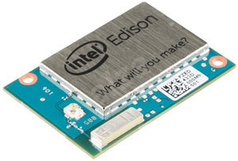

* Messages on twillio Working, only, sent (9:00AM- - 9:00PM)
* Paid - - -5$
* Arduino code c/c++
* Arduino Internet <Brdige.h> not supported in Edison

2.......Can happen with**(- - - GSM module & Arduino ONLY- - - )**

3......Can happen with ............(**EDISON + + +Ubidots*new account)**

* ULtrasonic code in C++
* UbIDOTS Code in node.js, May by avaialble in C++ Too
* Edsion Crash



https://www.hackster.io/pooja_baraskar/burglar-alarm-with-sending-sms-and-email-from-iot-device-9a9917

http://www.c-sharpcorner.com/UploadFile/f55fd9/sending-sms-and-email-from-your-iot-device/

* Thus have to separtely do - **- - Edsion Only JS** - - -**Arduino C++ by ESP 8266**

Can be done by Pooja Bhaskar ways..............................

1....get the (**LED blinking program**) Run @ Edison

# 2.....get the (ultrasonic code/Offsets) hookup, fixup, wrk, [#GALILEO] Using non #Grove sensors with Grove, ie: #UltraSonic Ranger

# *https://elbruno.com/2015/02/23/galileo-using-non-grove-sensors-with-grove-ie-ultrasonic-ranger/*

3......Get the (Pooja bhaskar) program to Ubidots,

4......Test it, Run it...!!

5......**Works Live (9:00AM- - -9:00PM)**

4........Can happen with .............(**Arduino- - - >>-- - -tembo- - ->> - - -twillio))**

https://temboo.com/arduino/others/send-sms

https://temboo.com/support/using-any-api

https://www.survivingwithandroid.com/2015/09/iot-arduino-push-message-android-2.htm``````````````````````````````````````````````````````````````````````````````````(How to use tembo)

* ---Temboo library easy to Install in Arduino

**temboo library Examples , not working)**

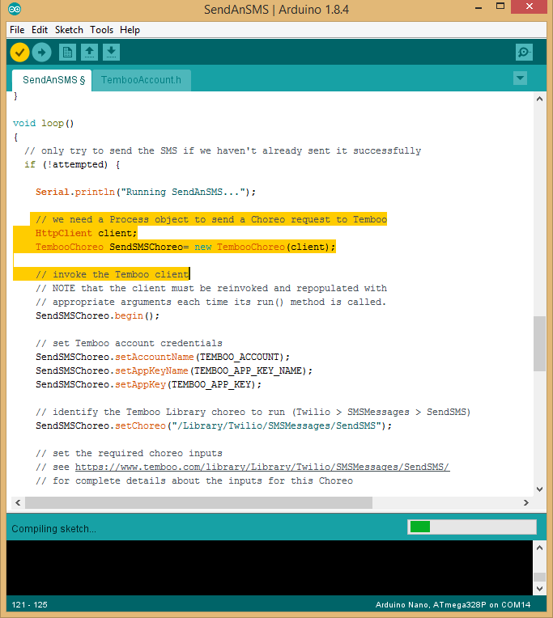

**[ Error: no matching function for call to**

**@Onlyy works for Arduino- -Yun ]**

Try: installing the new - - - -Arduino IDE 1.8.5- - - >>- - - - -temboo Examples Builtin- - ->>- - -If not Download from Below- - - ->>- - - - https://temboo.com/library/Library/Twilio/SMSMessages/SendSMS/- - - - ->>- - -- -Select your board/relevant To get itp-- - ->>- - - - -- Compare Arduino MEGA code vs - - - >>- - - - - Code failing Earlier one ------->>------------? ?- - -- - ->>- - - -Congrats Compiled Successfully.

* http://www.arduinolibraries.info/libraries
* https://temboo.com/library/Library/Twilio/SMSMessages/

5..............Can happen with **(Arduino Nano- - ->>- - -ESP8266- - ->>- - - -Twillio)**

https://www.twilio.com/docs/guides/how-to-send-sms-mms-messages-in-cpp#prerequisites-for-this-c-mms-and-sms-guide

https://www.twilio.com/blog/2012/08/diy-home-automation-using-twilio-powerswitch-arduino-and-pusher.html

https://www.twilio.com/blog/2014/06/garduino-phone-using-twilio-arduino-and-sinatra.html

https://create.arduino.cc/projecthub/temboo_official/send-an-sms-using-twilio-with-temboo-305530

http://allaboutee.com/2015/03/23/esp8266-and-arduino-phone-calls-with-twilio-api/

6............Arduino on (Edsion/Esp8266/Shield)- - - ->>- - - -PHP page Or Server Page- - - ->>- - - - -Twillio- - - >>- - - - - - SMS get It-