Requirements Report

Project title: Online Encryption Device

By Mickeyas Yonas
W1501335

ECSC697 Computer Science and Software Engineering Project

Department of Computer Science

University of Westminster

Contents

1. Introduction...................................................................................................................Page 3

2. Problem statement.........................................................................................................Page 3
  - Stakeholders....................................................................................................Page 3
  - Project scope....................................................................................................Page 3
  - Project Goals of the application and the stakeholder......................................Page 3

3. Elicitation Techniques...................................................................................................Page 4 3.1 Requirements Gathering..................................................................................Page 4 3.2 Similar sites.....................................................................................................Page 4 3.3 Table of features........................................................................................Page 6 – 7 3.4 Features and Descriptions..........................................................................Page 7 – 8

4. Designs..........................................................................................................................Page 8 4.1 Use Case Diagrams..................................................................................Page 8 – 16 4.2 Class Diagram................................................................................................Page 17

5. Requirements...............................................................................................................Page 17
5.1 Reliability......................................................................................................Page 18 5.2 Security..........................................................................................................Page 18 5.3 Performance...................................................................................................Page 18 5.4 References.....................................................................................................Page 19

1. Introduction
In this report I will describe and explain the requirements of the project I will be building. These requirements include encryption standards as well as some non-functional usability requirements.

2. Problem statement
Encryption has become a vital part of business with any and all entities choosing to protect all data regarding customers and or products. This, where necessary, includes the encryption of sales information such as the quantity of a product bought, sold etc. Encryption is a term used to describe the process of deliberately scrambling and or changing a file in order to render it unusable, unreadable and invaluable to any and all entities other than the original owner. This method has been created as there is no guarantee that a system can or will ever be completely secure or free of attacks and or violation.
This online encryption device will be utilising the best available methods for encryption and be made to function widely available over the internet as a web based application. As an online service this application would be widely available to anyone with internet access.

2.1 Stakeholders
For this project stakeholders can be easily identified as those with internet access and or know of it are potential stakeholders and those who have interests in and or may be using the application are stakeholders.
Stakeholders: “A stakeholder is a party that has an interest in a company, and can either affect or be affected by the business”. As defined by: “http://www.investopedia.com/terms/s/stakeholder.asp#ixzz4RUgASEJ0”

2.2 Project scope
The project scope is to create a device to encrypt and decrypt a file and to extend to provide a means of storage, retrieval and management of such files. This application may include provision of access to encrypted storage drive.

2.3 Project Goals of the application and the stakeholder
The goal of this project is to create an application that will enable the user to protect precious files. With cloud computing it can allow the user to upload and retrieve even encrypted files and as well as files this application can encrypt text. These functions and features have design considerations for anybody unfamiliar with encryption and familiar with encryption.
The user (stakeholders) of this application will be able to store and retrieve privately stored files and or protect files anonymously without storage. Registered users will be able to store as much files as they want as long as file storage space is available.

3. Elicitation Techniques
Elicitation techniques are a form of any means of data collection techniques. The techniques can be used in many fields including education, anthropology and cognitive science among others. These techniques are important as they can include a variety of means of information gathering techniques including and not limited to utilizing questionnaires and or searching through for examples.
For my research I have used search engine to find similarly developed applications in search of functions and features I could use and include in the encryption device.

3.1 Requirements Gathering
As part of my research for this project I searched for ideas of features that can be included for this application however what helped the most during the design and requirements stages was to search through and find examples of similar sites that performed similar features. During such research periods I took into account the importance of selecting useful tools and programming options. As my research developed I found useful information regarding web development in python with a framework.

3.2 Similar sites
Initially I struggled to find ideas but once I began my search for similar sites I came across varying sites that had similar functions. I searched online using the 'google' web browser and found sites relevant to my research, this inspired me to continue. The following sites are similar in what functions they have available to the user as what is the intended purpose of my encryption application;
http://aes.online-domain-tools.com/
https://encipher.it/
http://vmola.com/
These websites all have in common the features to encrypt and decrypt files and text online. Where they differ are in features such as more encryption variables and even providing access to encrypted storage space.
All three of these sites posses their own unique designs and features. The first of these 'http://aes.online-domain-tools.com/' may contain advertisements however it features an easy to use form with the options to encrypt text. This is what the website looks like.

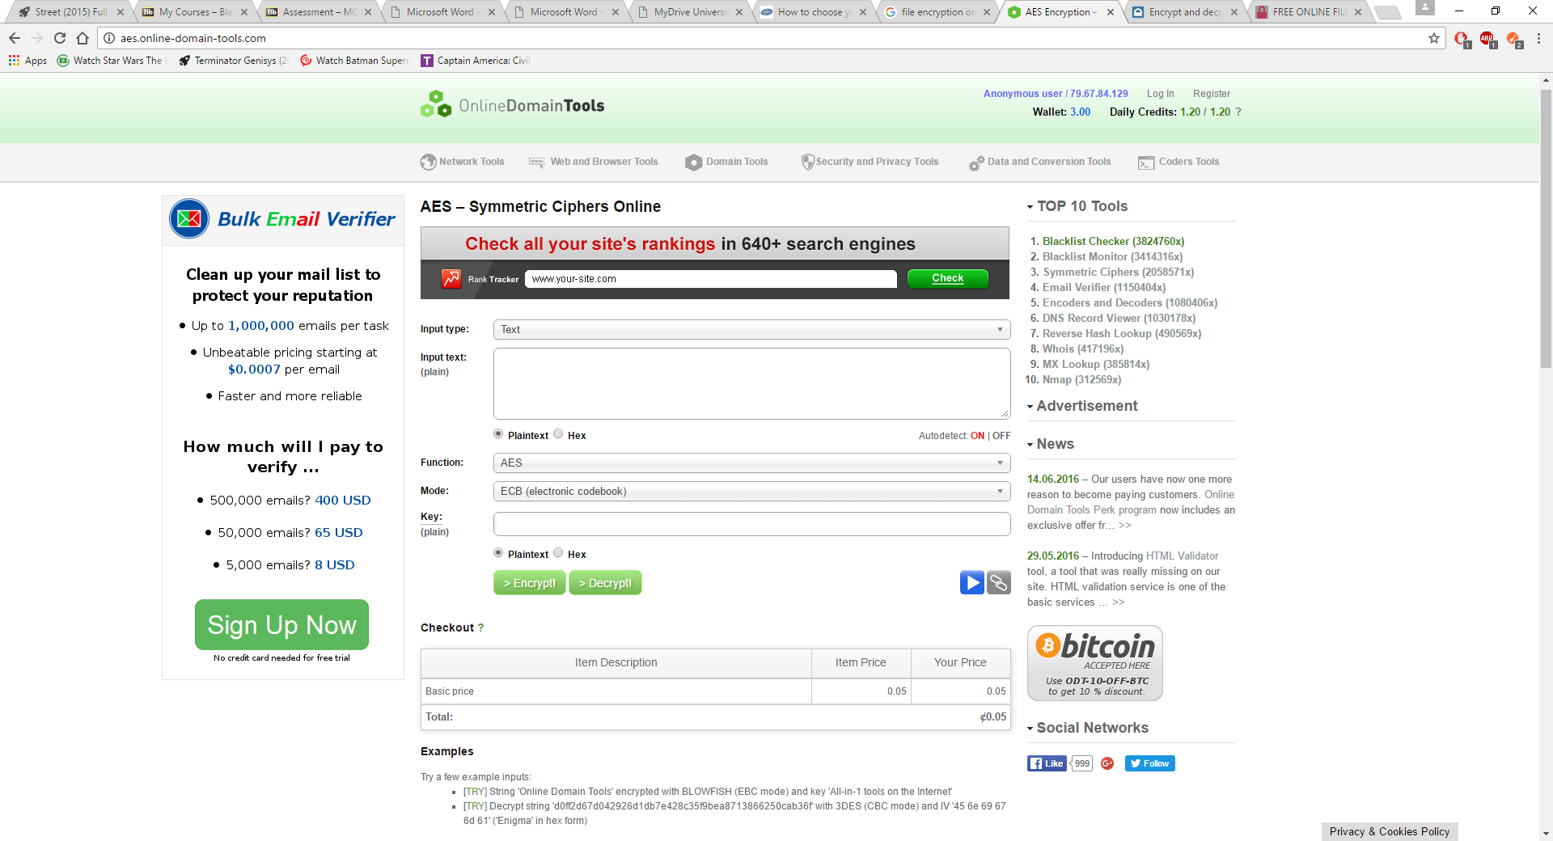
Img 1 :'http://aes.online-domain-tools.com/'
In just the area shown in the image above there are many options including to encrypt text or files, register or login, further options to encrypt other than AES and such options to encrypt and display hexadecimals.
The site listed 'https://encipher.it/' also has a means of encryption however this one offers a client available for download to encrypt the files while offline. It features brief yet descriptive instructions on how to use the encryption features available online. Another feature available on this website allows the user to encrypt web emails. The image below displays the website.
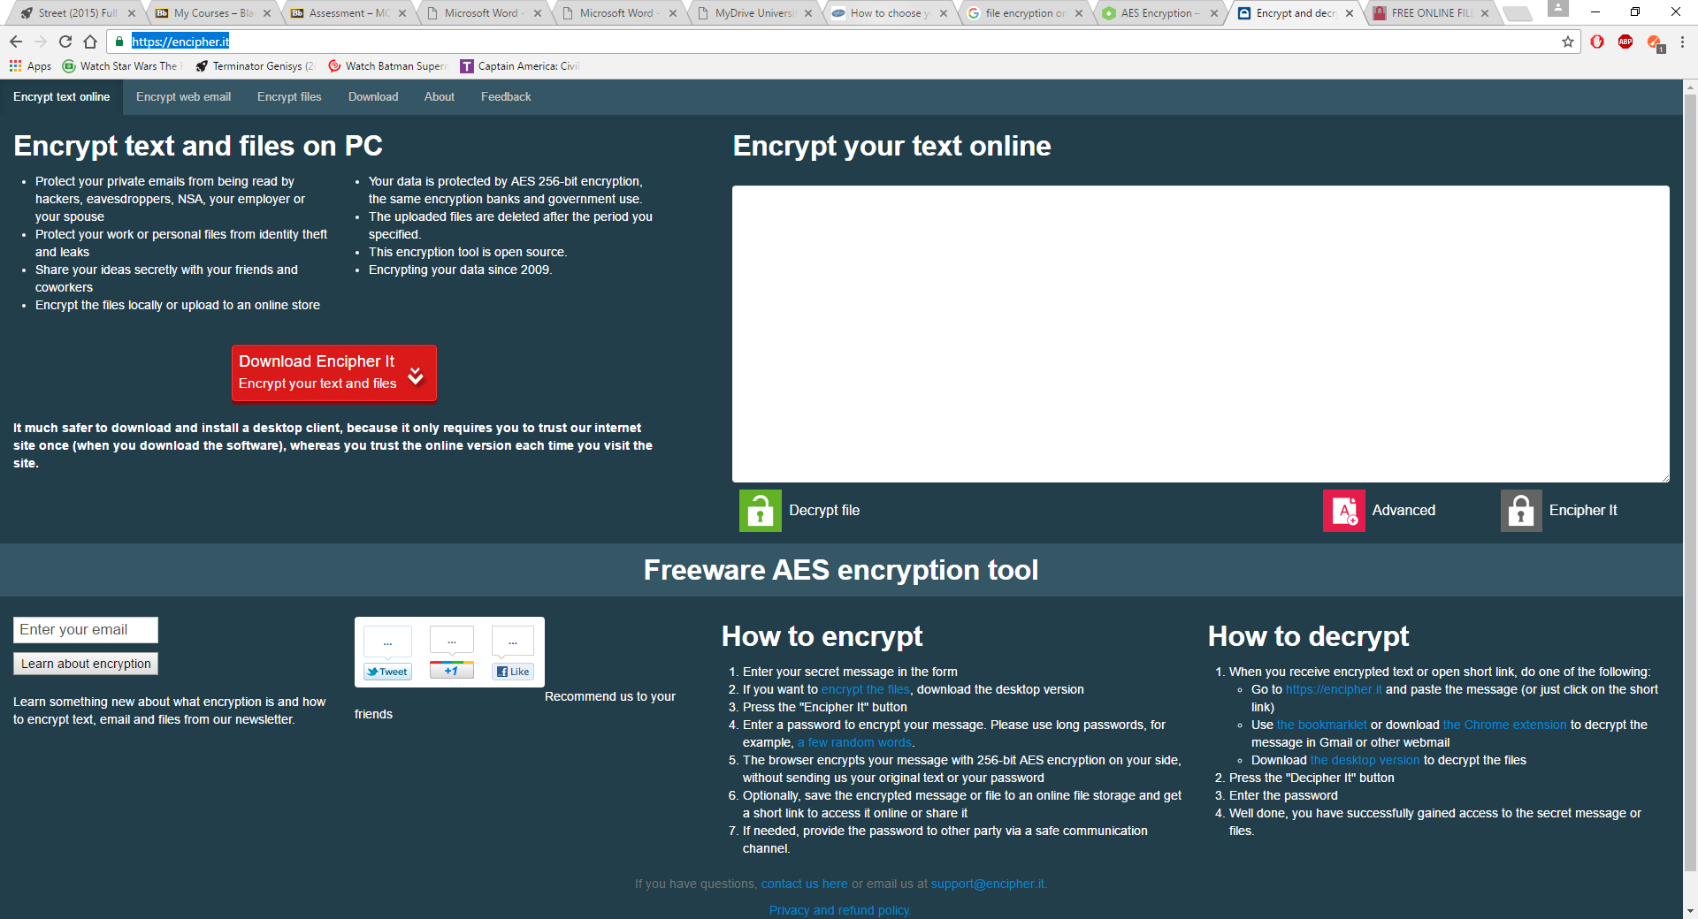
Image 2 :'https://encipher.it/'
Navigation on this website is also very clear and easy as there are tabs the user can selected depending on the task. There is also a feedback page available.

The third example listed on the previous page 'http://vmola.com/' is perhaps more easier to navigate and even has simpler yet sophisticated visuals. This website does not contain advertisements which imply a more professional and sophisticated feel.
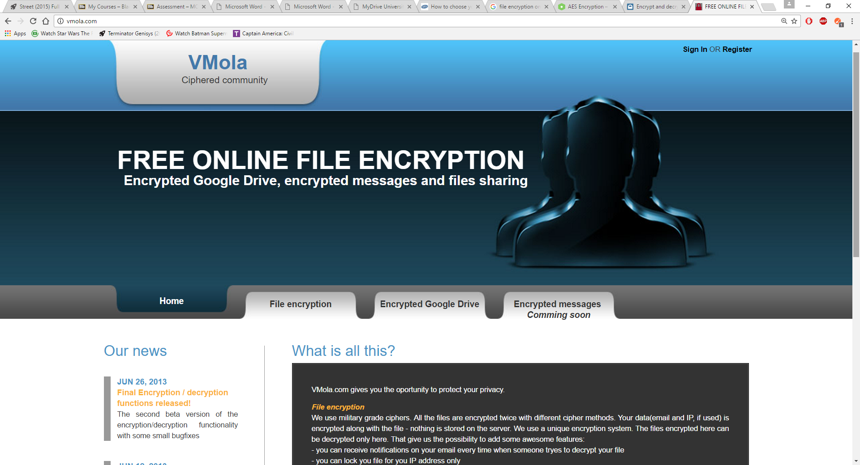
Image 3 :'http://vmola.com/'
Unlike the other two 'http://vmola.com/' offers users access to an encrypted drive while still offering the features to encrypt files. The tabbed views make it easier to navigate and it is still developing more features, which implies some superiority over the others, despite already offering most of what is available in the other two examples.

3.3 Table of features
Below is a table of features developed for the purpose of comparing the three similar examples and their features in a clear format and describe which features can be in my encryption application. The key is as follows; 'X' to signify the function or feature is not available on this website, 'O' is to signify that the function of feature is available on the website.
Function or Features | aes.online-domain-tools.com/ | encipher.it | vmola.com | My Encryption Device
Register / Log in | O | X | O | O
Text encryption | O | O | X | O
File encryption | O | O via client application | O | O
Downloadable Client Application | X | O | X | X
Store / Retrieve files | O | X | O | O
Encrypted drive | X | X | O | O
Guest / Anonymous login | X | X | O | O
Table1: Examples and features

3.4 Features and description
Descriptions of the functions mentioned above are as follows, most of these functions are to be included in the end product of the implemented encryption device.
Register / login
To use the system the user must either register prior to logging in or use a guest account. In the example websites above the user can in most cases register and provide details the system can authenticate to allow further access, 'encipher.it' however does not need a form of registration or login as it has available its client for download.
Text encryption
The three example sites all have forms for the user to input text and redisplay it in encrypted form. The user decides the encryption variables and once encrypted the websites display encrypted text.
File encryption
All but 'encipher.it' have available, pages or areas in their sites relating to and providing a means of encrypting a file. 'encipher.it' however offers this feature in the downloadable client available on the website. Where this feature is online the user only needs to upload the file from the directory it is located and then select the relevant encryption method and such variable and to click a form submit button.
Downloadable client application
This is not much a feature as it is a utility available as part of a system. Only 'encipher.it' offers this form of system but the others have their functions online.
Store / Retrieve files
Online storage of files is a method of both keeping files safe and finding somewhere to keep important files somewhere from which they can be easily retrieved.

Encrypted drive
This is similar to the drive above however this is with the added functionality to have a storage drive encrypted.
Guest / anonymous login
This feature enables users to have access to some of the websites features without completing the registration process. It can be used to gain temporary access via a temporary or guest account to use the system.

4. Designs

In the designs of my application I have utilised many of the available design tools and methodologies including use case, class diagrams etc. The designs also take into account operating system and available frameworks and software tools.

4.1 Use Case Diagrams

Use cases are a steps or actions a user can take while interacting with a system. My use case diagrams include a login and register use case and the website navigation with functions use case. The image below is of the user authentication part of the application, this part describes the events and the interactions between the user and the system.
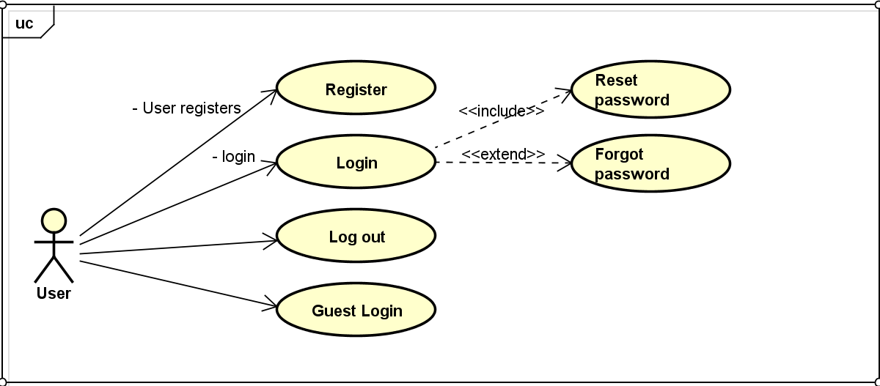
Fig1: Login_register

The use cases in this diagram include:
- Register
- Login
  - Reset password
  - Forgot password
- Log out
- Guest Login

The user can first register or choose to login as a guest using a temporary automatic generated guest id. This will give temporary and limited access to the website and its features. After registration is complete the user can login and have full access to the website and available features including file and text encryption. The login function includes the function to reset the user's password and also extends to allow the user to have access to password recovery options.

Use case 1.1 | Register
Primary actors | Users can be single, group or any organised entity.
Preconditions | None
Description | The user can register an account and gain access to more functions.
Flow of events
Normal flow of events | 1. The user enters their credentials and a suitable password.
Alternate flow of events | None
Exceptions | The user can login as guest.
Post conditions | The user will have an account with credentials they can authenticate at any time to gain access to the website and available features.

Use case 1.2 | Login
Primary actors | Users can be single, group or any organised entity.
Preconditions | User must have registered.
Description | The user can login and gain access to more functions and features than a guest.
Flow of events
Normal flow of events | 1. The user enters their credentials and a suitable password.
Alternate flow of events | None
Exceptions | The user can login as guest.
Post conditions | The user will be transferred to the homepage which declares welcome to the user using a personalised format such as 'welcome user'.

Use case 1.2.1 | Reset password
Primary actors | Users can be single, group or any organised entity.
Preconditions | User must have registered.
Description | The user can login and choose to reset their password.
Flow of events
Normal flow of events | 1. The user enters their credentials and a suitable password.  2. The user can then choose to reset their password.  3. The user enters a valid new password and confirms this password by re-entering the same new password.  4. The new password can now be used to login.
Alternate flow of events | The user can choose not to reset their password, although not recommended.
Exceptions | The user can login as guest, or choose not to reset password.
Post conditions | The user will be notified of the changes in their credentials and be able to login using their new password.

Use case 1.2.2 | Forgotten password
Primary actors | Users can be single, group or any organised entity.
Preconditions | User must have registered.  The user must have forgotten their password.
Description | The user can regain access to their website and change their password.
Flow of events
Normal flow of events | 1. The user enters their recovery information such as a back up email or phone number.  2. This information is validated.  3. A new password is sent.  4. The user can change their password.
Alternate flow of events | None
Exceptions | The user can login as guest.
Post conditions | The user will be transferred to the homepage which declares welcome to the user using a personalised format such as 'welcome user'.
Use case 1.3 | Logout
Primary actors | Users can be single, group or any organised entity.
Preconditions | User must have logged in first for which the user must have previously registered.
Description | The user can logout to end the session of use.
Flow of events
Normal flow of events | 1. The user can choose to logout.  2. The user is transferred to a page notifying them that the session has ended.
Alternate flow of events | None
Exceptions | None
Post conditions | The user is transferred to a page declaring the session has ended.

Use case 1.4 | Login as guest
Primary actors | Users can be single, group or any organised entity.
Preconditions | User must have logged in first for which the user must have previously registered.
Description | The user can login as a guest to have access to some of the features available. This is temporary.
Flow of events
Normal flow of events | 1. The user can choose to login as a guest.  2. The user is given an automatic generated id.
Alternate flow of events | The user can register and login
Exceptions | None
Post conditions | The user is transferred to the homepage welcoming the guest user 'Welcome guest123456ID'.

This next use case diagram describes the interactions between the user and the system after the login process is complete.
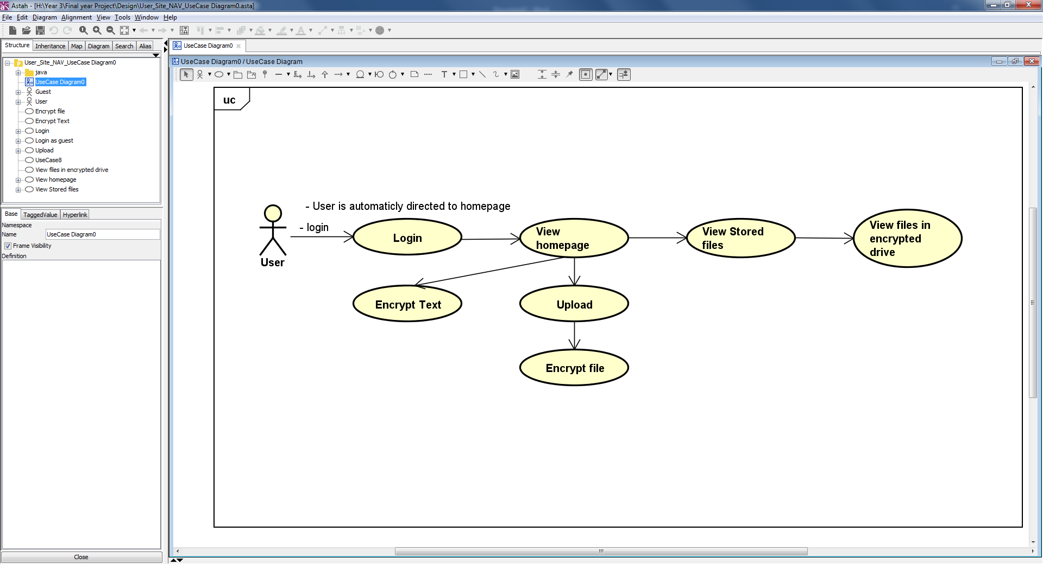
Fig1.2 : Site_Nav_features

The use cases in this diagram include:
- Login (this use case is already described)
- View homepage
- Encrypt Text
- Upload
- Encrypt File
- View stored files
- View files in Encrypted Drive

Initially the user is transferred to the homepage of the website and allowed further access to the website through links available on the page. From the homepage the use case describes the user being able to navigate to the other areas of the page including the functions to upload, encrypt and access storage areas.

Use case 2.1 | View homepage
Primary actors | Users can be single, group or any organised entity.
Preconditions | User must have logged in first as a registered account holder or a guest.
Description | The user is welcomed and can then navigate through the rest of the website.
Flow of events
Normal flow of events | 1. The user can login and is automatic transferred to this page.  2. The user can navigate the website.
Alternate flow of events | None
Exceptions | None
Post conditions | The user can navigate the website.

Use case 2.2 | Encrypt text
Primary actors | Users can be single, group or any organised entity.
Preconditions | User must have logged in first as a registered account holder or a guest.
Description | The user is shown a form where text can be entered and then encrypted.
Flow of events
Normal flow of events | 1. The user can login and is automatic transferred to this page.  2. The user can enter text and select to encrypt it.  3. Once encryption is complete the user is shown the text in encrypted form.
Alternate flow of events | None
Exceptions | None
Post conditions | The user can navigate can view the text in encrypted form.

Use case 2.3 | Upload
Primary actors | Users can be single, group or any organised entity.
Preconditions | User must have logged in first as a registered account holder.
Description | The user is can upload a file to store online.
Flow of events
Normal flow of events | 1. The user can selects the file from the directory.  2. The user can then submit the file.  3. The user is notified of the submission.
Alternate flow of events | None
Exceptions | None
Post conditions | The user has submitted a file to be stored online.

Use case 2.4 | Encrypt
Primary actors | Users can be single, group or any organised entity.
Preconditions | User must have logged in first as a registered account holder.
Description | The user selects the relevant file and selects to perform the encryption.
Flow of events
Normal flow of events | 1. The user locates the file.  2. Select to encrypt the file.  3. The file is encrypted.
Alternate flow of events | None
Exceptions | None
Post conditions | The user can can download the file in its encrypted form.

Use case 2.5 | View stored files
Primary actors | Users can be single, group or any organised entity.
Preconditions | User must have logged in first as a registered account holder.
Description | The user is able to view the files they have stored online, the user can also download these files.
Flow of events
Normal flow of events | 1. The user can navigates to the relevant page on the stored files.  2. The user can navigates the the file.
Alternate flow of events | None
Exceptions | None
Post conditions | The user can download and or encrypt the file.

Use case 2.1 | View files in encrypted drive
Primary actors | Users can be single, group or any organised entity.
Preconditions | User must have logged in first as a registered account holder. The user must encrypt their drive.
Description | The user can view the contents of the encrypted drive.
Flow of events
Normal flow of events | 1. The user can navigate to the page regarding encrypted drive, if the user has an encrypted drive or if the user encrypts the drive.  2. The user can search this drive in search of their files.
Alternate flow of events | None
Exceptions | None
Post conditions | The user can view contents of the encrypted drive.

4.1 Class Diagram

The following is my class diagram, I have developed this diagram with the model view controller design pattern as priority. This application will be developed using the Django MVC framework, a tool that allows for development of websites using the python language. Django is available on windows, the most widely used operating system available.

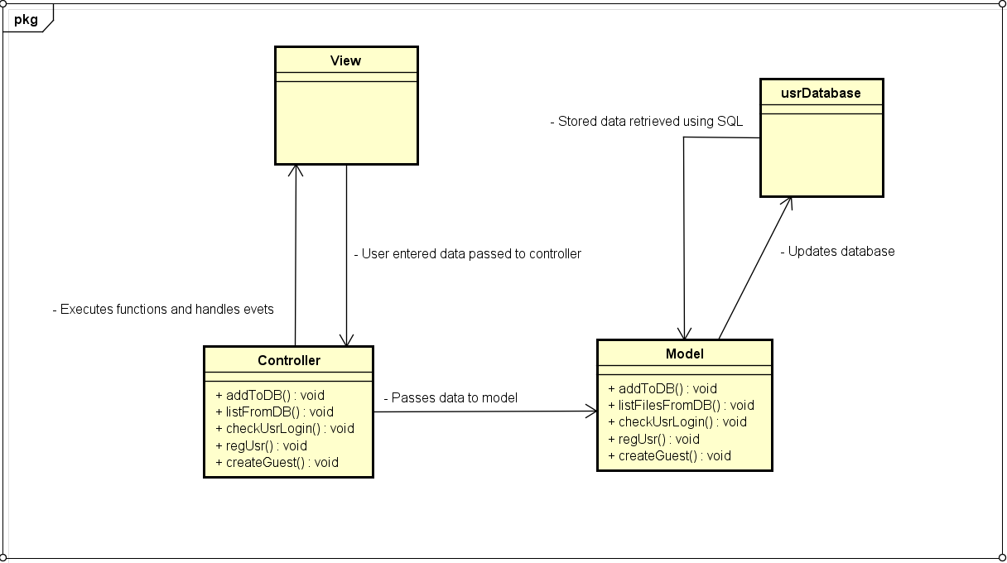
Fig 2: MVC_class_diagram

The controller class will be accessed to perform and handle user input data and functions initialised by the user to allow navigation through the website and access to functions. The model class will be accessed to add and retrieve data using SQL queries from the database while the view will display information to the user. This is only an initial design for the software, and is likely to change vastly as implementation and code develops but this is to emphasise the fact that this application will be utilising the MVC design pattern.

5. Requirements
In regards for the functional requirements of my project I have chosen to include the possibility of more than one type of algorithm. This is to ensure that all, if not most stakeholders have the best method of encryption available to them or another which they might want. I have included a key to the following lists of bullet points to state the importance of each requirement.

- AES (Advanced Encryption standard) encryption. Essential
- Most if not all the variables included. Essential
- Private key. Essential
- Cloud services (upload and download). Essential
- Encrypted drive (google) Luxury
- Text encryption Desirable
- File encryption Essential
- Register / Login Essential

My non-functional requirements can include the following.

- Anonymous login / guest access Desirable
- Generate hash numbers Luxury
- Passwords must be with at least one number and at least one capital character. Essential

5.1 Reliability

Provided the internet connection is stable and of good quality and signal strength the application is to be available at any hours of night or day and is not scheduled for down time without advanced notice. It also depends on the reliability of the host should the application be made available via a different host.

5.2 Security

The encryption application shall be implemented and will be utilising an user login system, where by the user is granted access if they can provide authenticated credential information such as a combination of username and password. Guest users will not be granted access to storage areas as this requires some means of recognising the user in order to ensure protection of submitted files.

5.3 Performance

The encryption device is designed with the user in mind, different users have different requirements for example not all users might be familiar with encryption. For this, some explanations may be in place to aid less experienced users. File sizes will also be limited when submitting them to improve all round functionality, reduce usage time and improve usability.

5.4 References

Three example similar web applications, last accessed 8/12/2016.

http://aes.online-domain-tools.com/
https://encipher.it/
http://vmola.com/

“http://www.investopedia.com/terms/s/stakeholder.asp#ixzz4RUgASEJ0”

