2010 Third Professional Year Project

Report Guidelines

Steven M. Durbin & Peter J. Smith

Supervisor: Andrei Kolmogorov
Abstract

This document provides a template and guidelines for students preparing final project reports for the Third Professional Year Project. Instructions within this document should be adhered to closely. Excluding title page, abstract page, references and any appendices, the maximum page limit is 15 pages. This limit may not be exceeded. Appendices are for additional background material and are NOT to be used as a place to extend the report and avoid the page limit. A penalty schedule applies for reports which do not fall within the guidelines as presented in this paper.

1. INTRODUCTION

This document provides a template and guidelines for the final project report. It has been modified from the previous year, so close attention should be paid to the instructions. Deviation from this template will result in penalties being assessed. It is strongly recommended that each student sit down and discuss the proposed content with her/his supervisor prior to beginning; an outline can be invaluable to bring to such a meeting. Each report will be marked by the project supervisor(s), and at least one other member of the academic staff.

2. THEORY OF OPERATION

The report must be typed on A4 paper, with 2 cm margins on all sides. A3 pages for large schematics, etc. should be placed in the appendix. All text must be 12.0 point Times Roman or equivalent font. Paragraphs must be single-spaced, not indented, and with a single space separating them. Double space after the last line of a section, and single space after a section heading.

The cover page should include the project title, the student name, and the project supervisor. Do not include any additional material such as University logos or graphics on this page.

The abstract must be placed on its own page, which should be numbered page 1 at the bottom centre of the page. The abstract is limited to 250 words, but should be at least 50 words in length. No table of contents is needed, nor should one be included. Begin the introduction on page 2.

  - A Secondary Heading

All primary section headings should be in all caps, numbered, and bold font. Secondary headings should be in bold, mixed case, with a single blank line above and below.

  - Colour

The default report is black and white. All reports will be printed in black and white and distributed to the markers. Colour figures may only be included in your report if they are ESSENTIAL to convey information or improve clarity. In this case, let Peter Smith know in advance or the examiners will only have the black and white version. Note that the use of colour simply to separate multiple curves on a figure is not a good reason for the use of colour. For this case, simply use different plotting characters or line types.

  - References

An example reference style is provided in Section 5 [1]. References should be numbered in the order called out in the report and referred to in brackets as illustrated [2]. Any work referred to must be included in the references [3]. Any source consulted for your project must be disclosed. Failure to do so may result in a failing grade.

  - Figures

Figures should be numbered consecutively, include a figure caption, and be placed as close to the referring text as possible (Fig. 1). Figure headings/titles are only appropriate in PowerPoint presentations. Tables do not have captions; rather, each table has a number and a heading.

2.5 Penalties (Maximum possible score is 100 marks)

The following penalties can be assessed against any report failing to keep to within guidelines:
1. Exceeding page limit 10 marks/page
2. Not meeting margins, page size, or font size limits 50 marks

3. DISCUSSION

A well-written report has several key characteristics. First, the abstract is written for the person who has no time or inclination to read the remainder of the report. The key points as well as a brief overview must be conveyed in a relatively small number of lines. The introduction should not include a cut-and-paste version of the abstract, but neither should the writer assume the reader of the introduction has bothered to read the abstract. In many ways, they are two separate documents.

The examiners will expect a good overview of your project, beginning with appropriate background material. Do not assume the reader is an expert in the narrow field of your work, but do assume the reader is an electrical engineer by training. Acronyms should be spelled out at their first usage. After reading the introduction, the reader should be left with an understanding of the scope of your project as well as its motivation.
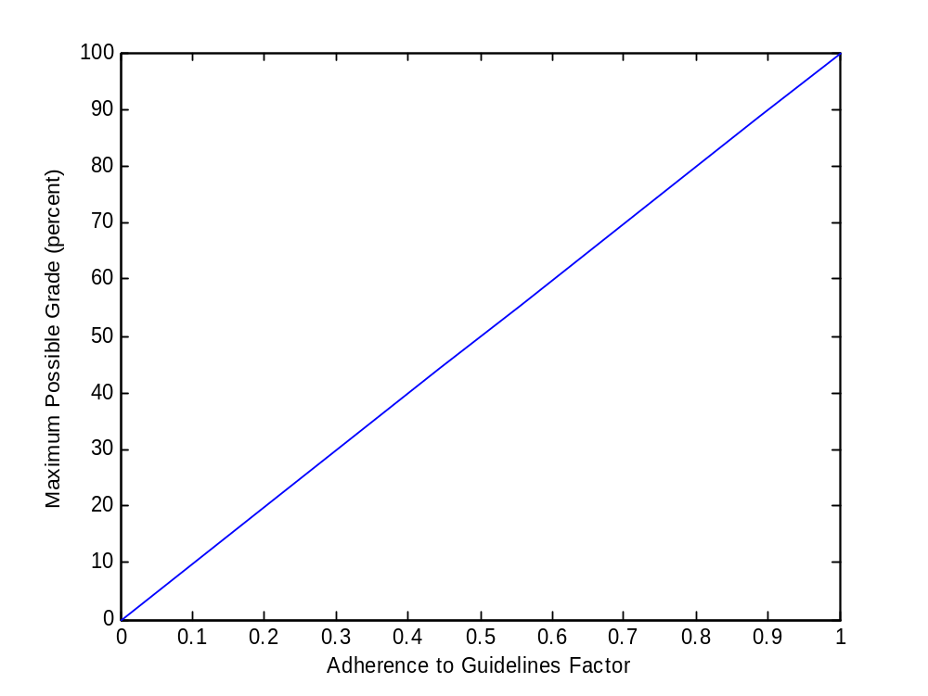

Figure 1 Plot depicting relationship between maximum possible grade and adherence to report guidelines.

The theory section of your report is important, but no more than perhaps 3 to 5 pages should be dedicated to it as a general rule. Examiners will expect a reasonable depth of development for whatever theory or principles you describe. Equations, schematics, and diagrams should be used as required. In some cases, it will seem more natural to include the theory behind your basic approach in this section, and then discuss the detailed operation of your final design in the Discussion section.

The most important section of your report is a discussion of results. This includes measured performance of your project, testing results, and data collected. A well-thought-out discussion relates these factors to the theory upon which you based your work. If several iterations were required, the thinking behind each stage or phase of the project is appropriate to describe.

Finally, a few words regarding writing style are warranted. Unlike this template document, a good paragraph typically has 5 to 8 sentences. Longer paragraphs are probably too diverse in their focus, and shorter paragraphs represent fragmented topical development. Punctuation and spelling should be carefully checked, and it is good practice to print out the PDF document prior to emailing in order to proof check formatting.

4. CONCLUSIONS
The conclusions section should not merely represent a summary of the report, although a brief summary is permissible as one component. Under no circumstances should nonsense statements such as “I learned a lot” or “I really enjoyed this project” be included. Written by an engineer, the report should reflect careful thinking and a measurable degree of professionalism. Conclusions regarding the suitability of the approach chosen, the quality of the data collected, the performance of the final product and any possible future directions the project can be taken should be included.

5. REFERENCES

[1] P.Q. Smith, A Handy Solution, 3rd Professional Year Project Report. Christchurch, New Zealand, 1895.

[2] Y.Q. Smith, “A simple circuit for all applications,” IEEE Transactions on Ohm’s Law 45, 1932, 980-987.

[3] I.Q. Smith, “Your Third Pro Project,” Reports-for-free.com, 2005.

[4] J. Smith, “How to cite the world wide web,” www.citethis.com, accessed 2 Feb 2006.
APPENDIX (OR APPENDICES)

Appendices may include tables of data, source code, procedures or other information suggested or required by the project supervisor. Its presence will be noted by the examiners, but the content will not be graded.

