Dear Sir or Madam,

My name is Michael Braverman, and I am candidate for the full stack developer role at Southern Cross.

First of all, thank you for this opportunity and I have enjoyed to work on this small assignment.

I have decided to use .NET Core razor page because I really like to work with MS technologies and use C# as a language.

I limited myself for 3 hours of development and that was my biggest challenge because I haven’t dealt with creation of web sites from the ground up for a while and spent some time for small tweaks fixing, however, ASP.NET is very intuitive framework to work with.

I focused on important matters first to be able to implement the main requirements within the time limitation, because the deadline is the deadline.

I have decided to make the UI a little bit different, however, it fits the requirement.

I found a small challenge in the requirement: What if more than 1 record found according to the search inputs? How can show it in the result page?

As a BA, QA and Developer in one person I had a “3 amigo” session with myself and decided to load all members in to the main page with option to filter it out to show all members that match the search conditions. It looks for me as more useful than just give the item that fits the conditions.

For instance, we can search by these parameters

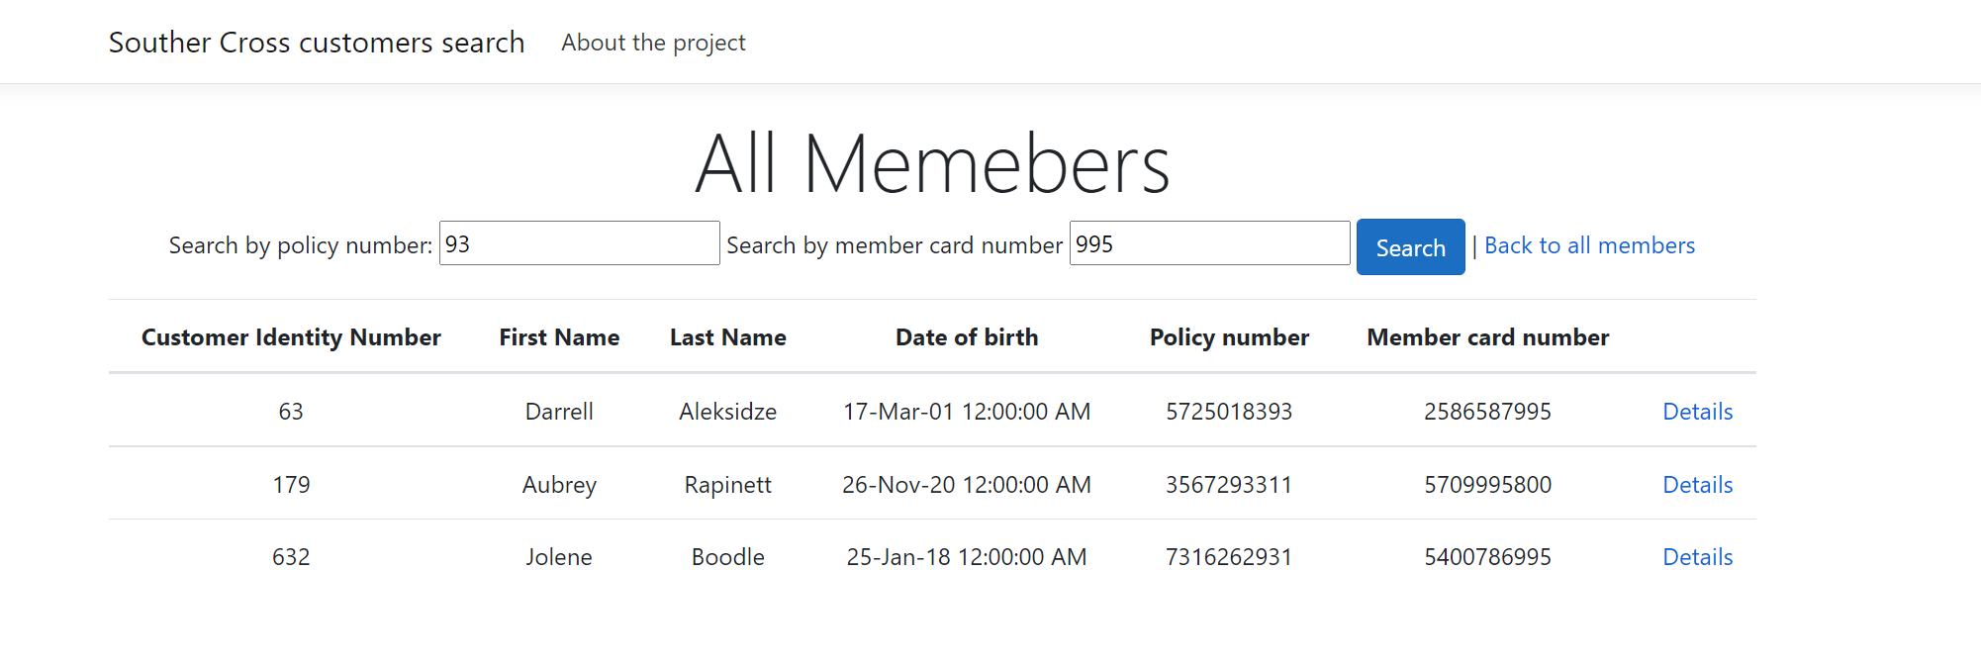

And then see the search details:

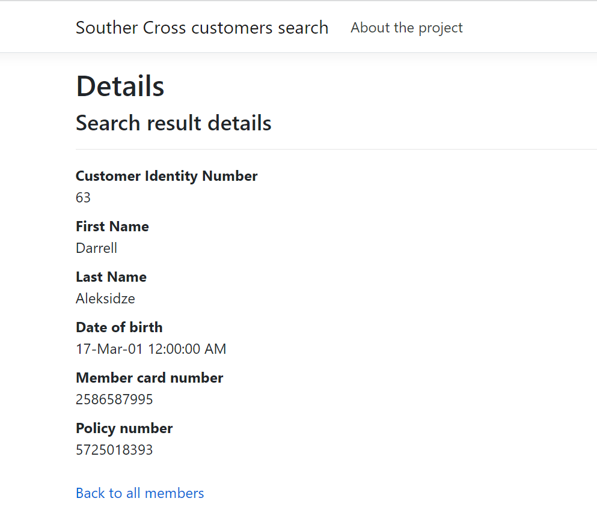

I used interfaces rather than specific type to be able to create more flexible implementation. Such as factory pattern in the case we have different customers or another data source like excel, xml, mongo DB, SQL etc.

What would I improve?

As I mentioned, I have focused on robust implementation that fits the requirements in given 3 hours range.

1. I did not have enough time for validation in search. If the input is empty, we have just all records and if the input is not a number – we have an empty result.
2. I would separate the data access layer from business logic layer. Even though the business logic is simple, it is good to use dependency injection as an interface to be able to
   1. Separation of concerns
   2. Mock for unit tests. In that case I would be able to unit test this logic: 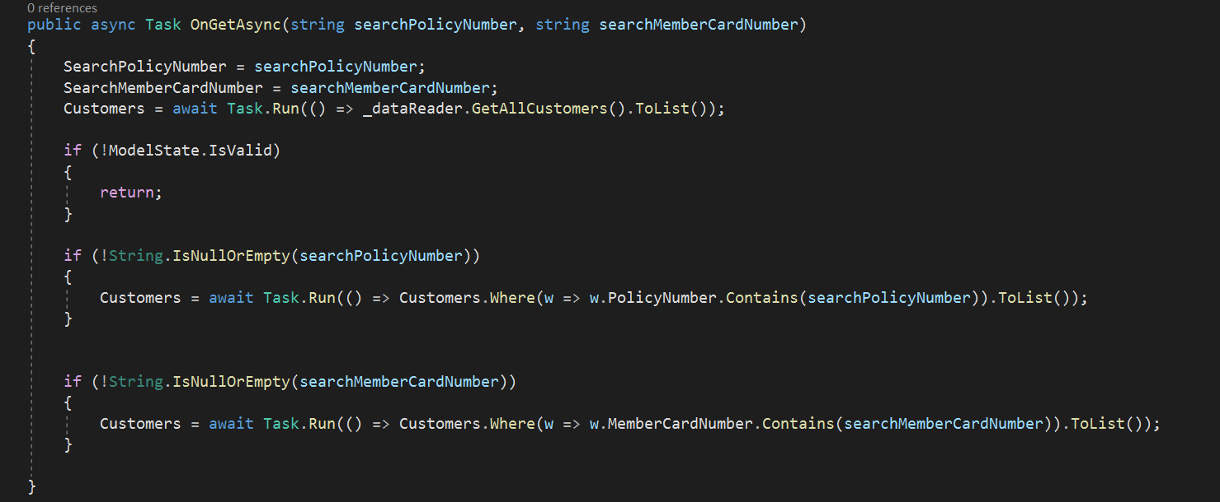
3. I would also upload into the clouding hosting, however, I could not find any free for the given time.
4. I would create the “hamburger” menu as was in the screenshot

To be able to run this project, please, just open it in Visual Studio (I work with 2019 version) and run it.