Roboflow usage tutorial

Website
https://roboflow.com/

- Sing in your account or have to register a new account first.
- Create a new project.
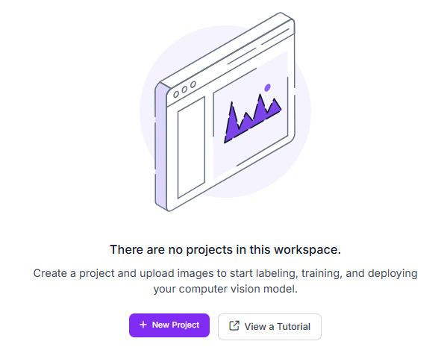

- Select Instance Segmentation and enter the information requested.
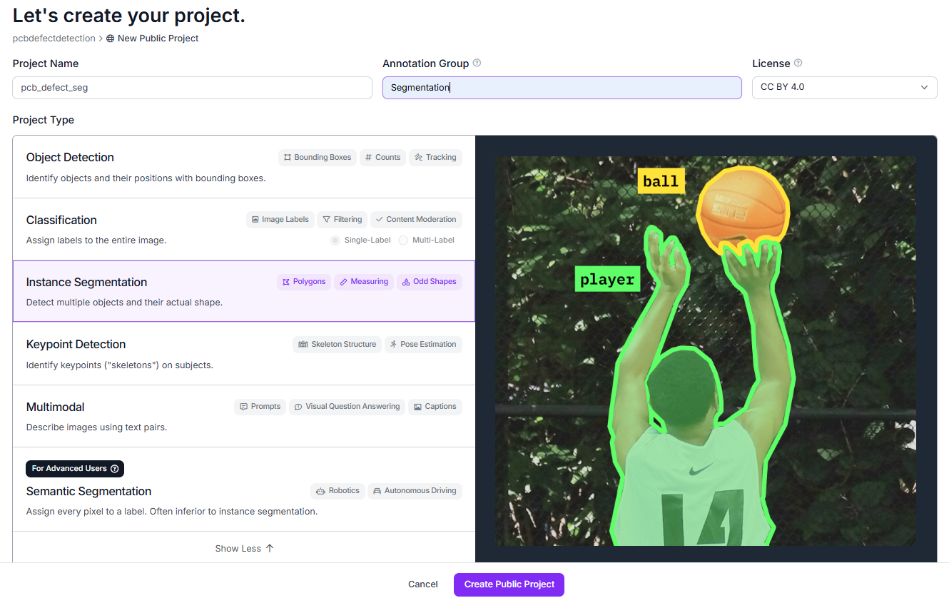
- Upload your dataset.
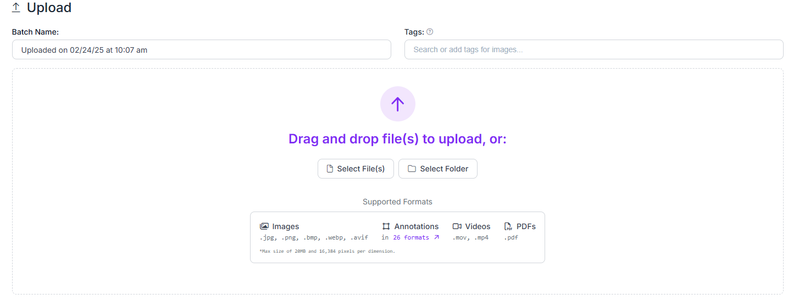
- Click save and continue.
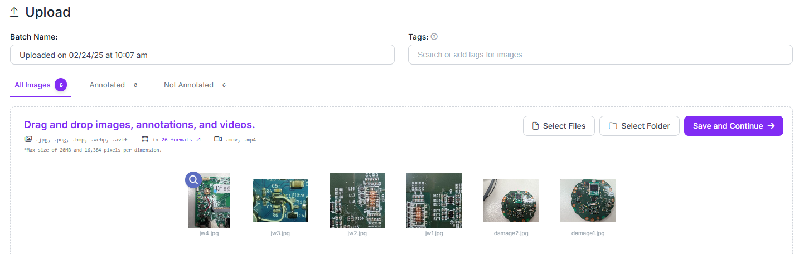

- Select start manual labeling
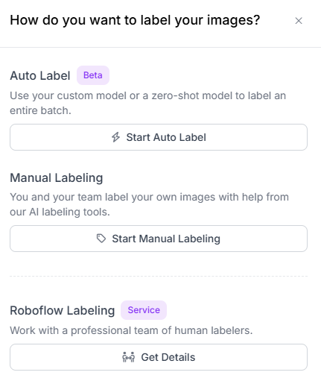
- Click Assign to myself to next step or invite teammate to labeling together
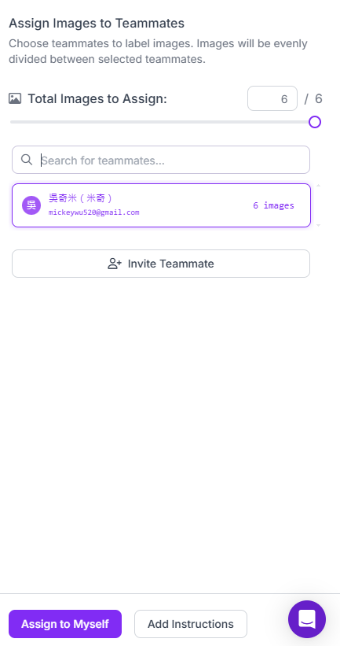
- Click start annotating.
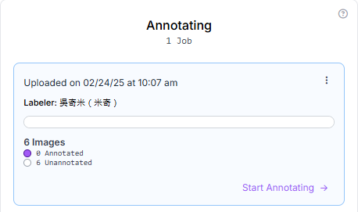
- Selected the labeling toolbar as right site.
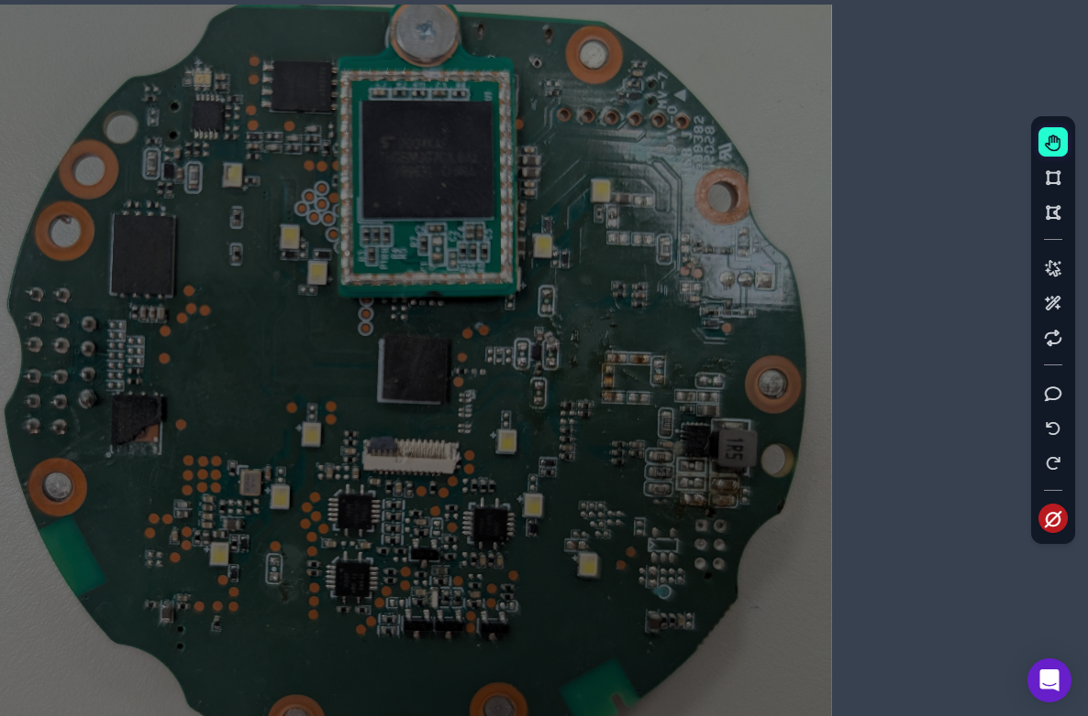

- Label the target and specify the category.
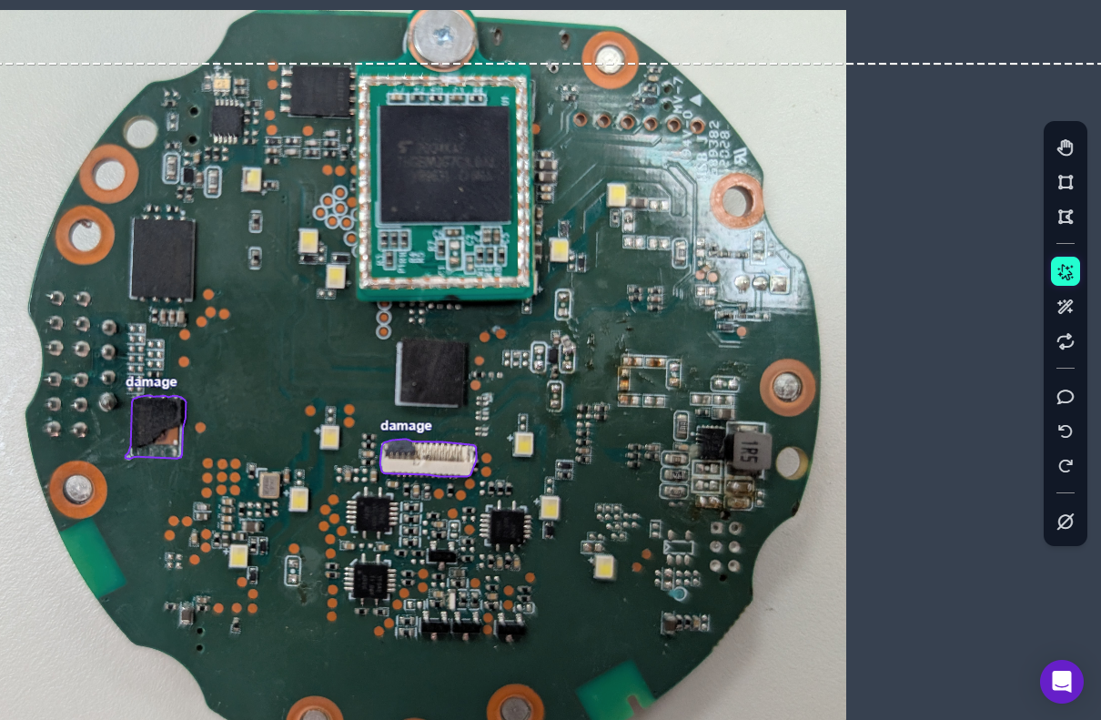
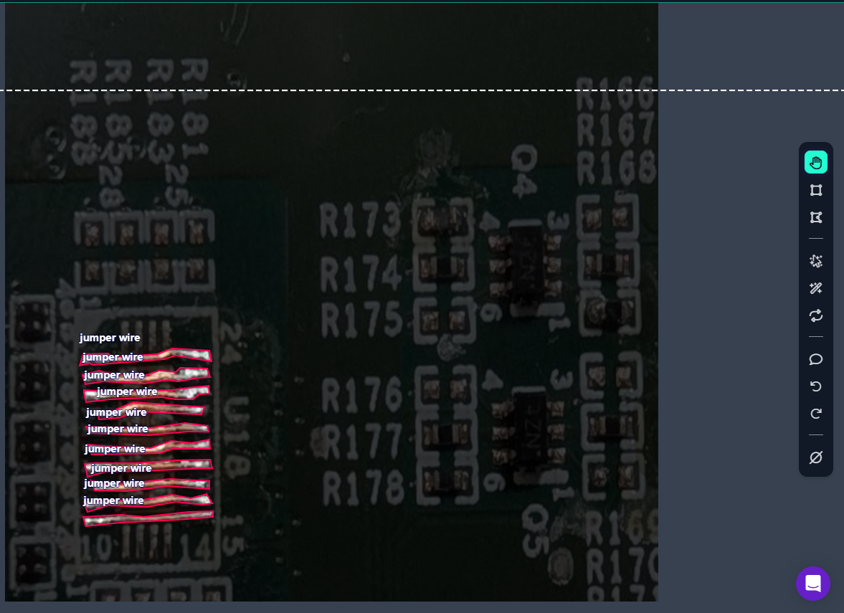

- After annotated all picture, click Add image to dataset
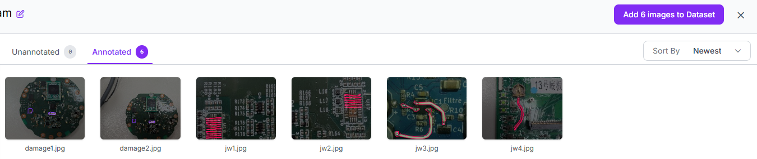
- You can change the percentage, or keep the default setting then click add images
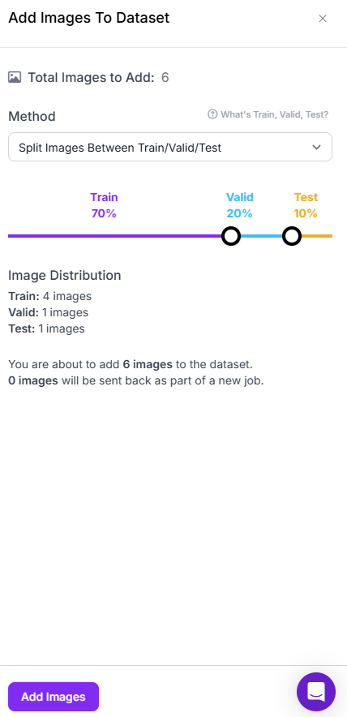
- Click the Version control button.
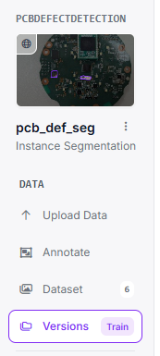

- Deploy the dataset
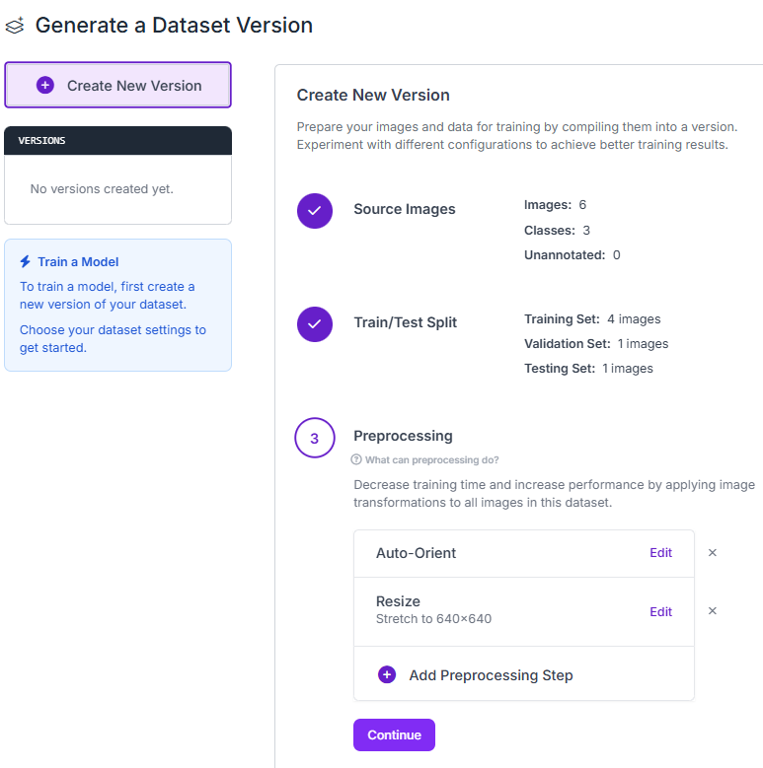

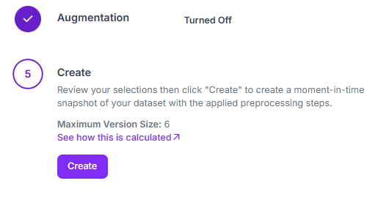

- Download the dataset that you annotated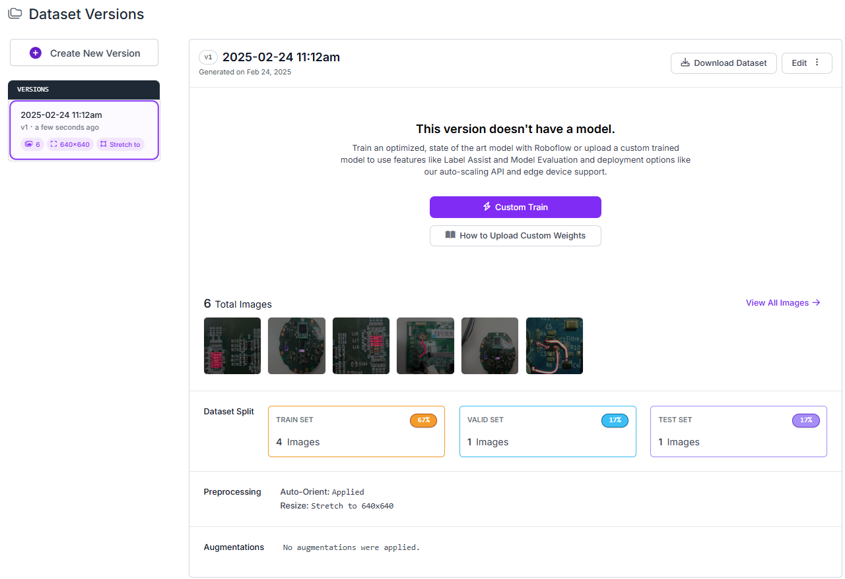
- Select YOLO model format.
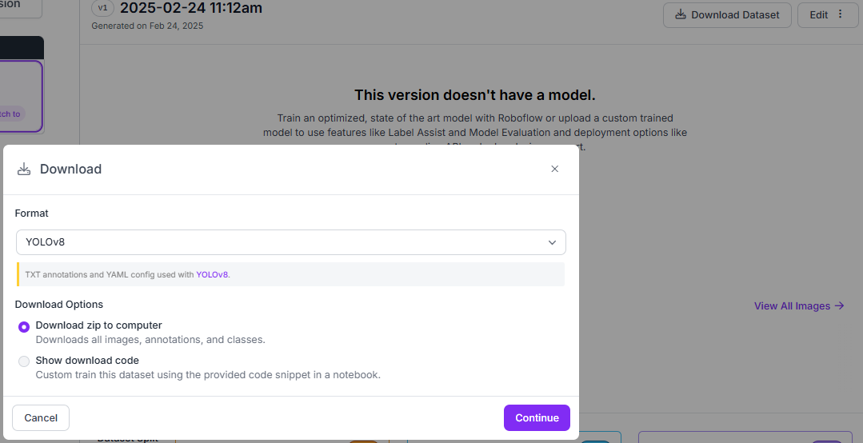

- After downloaded the dataset of YOLO format, then you can train a custom model via YOLO SDK(Ultralytics)

The structuration like below.
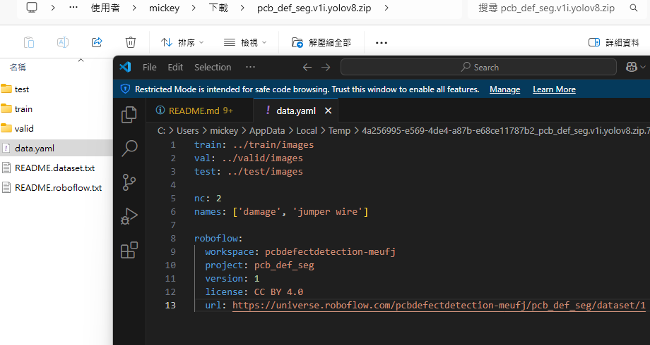
Tree.
