**Pop art Andy Warhol Creative Craft**

Step by step instructions:

1. Gather children into groups of 4.

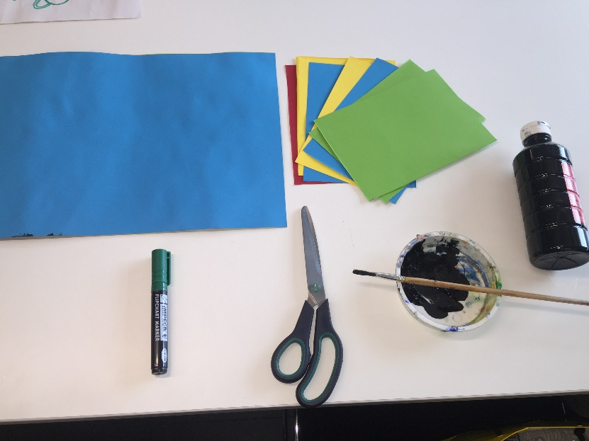

1. Then Gather equipment.

This includes:

* A3 card
* Black paint
* Paint pot
* Paint brush
* Scissors
* Pen to draw round hand
* Glute sticks
* A5 paper

1. Get each child to select a piece of coloured A5 card to go in one corner of the large A3 card. This will create a college of bright colours which will be the background of the picture.
2. Then get the child to select a different coloured piece of card.
3. Once chosen get a black felt tip pen and get the child to draw round there hand.
4. Once done then cut out the shape.
5. Stick the cut out hand print on to the child’s selected colour card.
6. Get a paint brush and black paint for them to then paint there hand over the colour card hand print.
7. This will then create an Andy Warhol style of art. 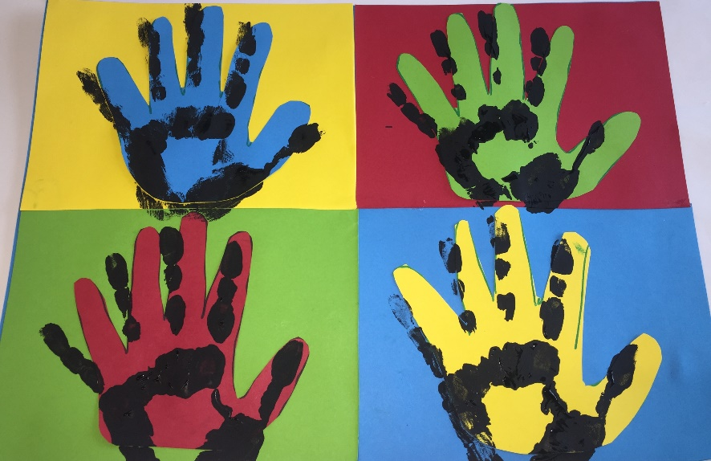
8. It would be a great idea after to create a Big college of the pupils crafts on the wall. This would look really effective and colourful for everyone to see.

Alternative option:

If you did not want to the children to draw round there hand and cut out, then they could paint there hand with another colour and press it on the paper. Followed by the Black Hand print to give it the Andy Warhol effect.