3. Theoretical Framework

* Theoretical Framework
  + Research Questions - Nov 2024
  + Introduction
    - (Why not use constructionism) - REMOVEd SO INTEGRATE ideas
  + The foundational concepts of activity theory
  + Further developments in activity theory
    - 3GAT and Expansive learning
    - Applying 3GAT via formative interventions
    - Theoretical concepts emerging from the LCHC and the Fifth Dimension interventions
    - Funds of knowledge and third space
    - Third spaces and repertoires in the context of this study
    - Design based research approaches - INSERTED
  + Putting AT to work, variations and synthesis in interventionist CHAT research
    - DBR as an applied research process
    - Change Lab and Living labs
    - Social design-based experiments (SDBEs)
  + Concepts of agency within CHAT
    - Instrumental and relational agency
    - Dynamically emergent agency
    - (Authorial and) transformative agency
      * Transformative activist stance (TAS)
      * Transformation agency through double stimulation (TADS) - On double stimulation and agency
    - Relational agency
      * Feedback and relational agency and specialism in context of making
  + Conclusion / Synthesis.

# Theoretical Framework

### Research Questions - Nov 2024

1. What contradictions arose in participation in this research’s game coding processes and how were they addressed?
2. How can game design patterns support the development of computational fluency in novices?
3. How can learners build agency in an evolving community of game makers?

## Introduction

The focus of this study is on the construction of shared meaning and practices as part of an emerging community of game makers. As such, the research questions address cultural factors which act as barriers to participation in digital making, and therefore require a method of research which allows the detailed analysis of complex, emergent learning environments. To achieve this, I adopt cultural historical activity theory (CHAT) as a guiding framework, which is operationalised through a formative intervention approach, incorporating adaptations from design-based research (DBR). This chapter explores these theoretical frameworks and key concepts relevant to the development of the thesis.

Activity Theory (AT) emerged as part of a movement known as the social turn in psychology (Sugiman et al., 2008), marking a shift from a purely psychological approach towards a more social understanding of learning and human behaviour. While this shift has influenced various disciplines, the focus here is on its impact on learning. The rationale behind moving away from the assumption that human mental activity should be studied in isolated, context-free settings (Stetsenko, 2005), concerns not only the validity of results (Brown, 1992), but also the relevance of the research for both designers and participants (Barab et al., 2019). This perspective transcends traditional transmission models of learning and embraces the value of group-based, participatory processes. The work of Brown (1992), a prominent psychology researcher advocating the importance of context within experimental design, helped legitimise this focus and facilitated its broad adoption across diverse fields. The growing work in these varied fields, sometimes grouped by the term *learning sciences*, reflects a move away from randomised control trials and their attempt to sever context, shifting from a behaviourist view of learning as an internal psychological process to a more interdisciplinary approach. This new approach draws on cognitive and cultural psychology (Hoadley and Van Haneghan, 2011). While this fragmentation promotes pluralism and knowledge-sharing across fields as diverse as education, anthropology, and computer science, it has also been criticised for lacking conceptual coherence in understanding learning and human activity on a deeper level (Hoadley and Van Haneghan, 2011).

This chapter outlines the theoretical frameworks that shape the methodology and underlying ethos of this study. It begins by introducing the foundational concepts of AT and then explores its evolution into CHAT and third-generation activity theory (3GAT), developed by Engeström and the Helsinki school. In order to enhance the 3GAT approach, several key concepts from the work of the Laboratory of Comparative Human Cognition (LCHC) in San Diego are discussed. To demonstrate how CHAT is applied in research, the chapter also examines DBR and various forms of formative interventions. While AT forms the basis of this study, elements from other theoretical approaches within the learning sciences, particularly DBR, are incorporated to address the utility and practical application of the research (Hoadley, 2002; Barab et al., 2019). To address the study’s focus on designing an intervention aimed at fostering participant agency within the game-making process, the final section of the chapter explores key conceptions of agency within CHAT, specifically in the form of activist and transformative approaches. The chapter concludes by justifying the synthesis of these theoretical choices and provides a brief description of how these concepts are operationalised within the context of this study.

#### (Why not use constructionism) - REMOVEd SO INTEGRATE ideas

## The foundational concepts of activity theory

Before outlining the core concepts driving Activity Theory (AT), a brief historical overview helps to contextualise them. For Marx, human endeavour and change are based on activity, with the subject of that activity being the individual or group driving it (Marx and Engels, 1975; Blunden, 2009). Vygotsky built upon Marxist ideas, emphasising the importance of human activity as a socially mediated process, and applied these core concepts to the broader understanding of learning (Blunden, 2010). While Vygotsky’s student Leontiev developed Vygotsky’s work into a prototypical Activity Theory (AT), AT had stagnated in the repressive context of the USSR (Blunden, 2010) and saw limited uptake in Western academia until Cole translated Vygotsky’s work (Vygotsky, 1978). Cole’s efforts brought these foundational ideas into the realm of educational psychology during the broader *social turn* in the discipline.

In this emerging field of cultural psychology, scholars such as Wertsch (1985) and Cole (1996) explored the critical role of cultural mediation in human development, particularly in relation to learning communities and contexts. They positioned learning pedagogies as forms of mediational strategies. Before turning to Cole’s work and others in this context, it is valuable to examine the core concepts of Activity Theory. Nardi and Kaptelinin outline AT as a series of foundational principles that underpin broader theories (Wertsch, 1981; Kaptelinin and Nardi, 2009), specifically: object-orientedness, tool mediation, hierarchical structure of activity, the ongoing development of activity, and the psychological processes of internalisation and externalisation.

A useful starting point to explore key concepts in AT is Vygotsky’s formulation of the relationship between subject, object, and tools. Activity Theory is object-oriented, meaning that human behaviour and learning are driven by the goals or objectives of the individual or collective subject (Engeström, 1987). Kaptelinin and colleagues (1995) note that while the materialist roots of AT, stemming from Marxist theory, have led some interpretations to focus on the object as the physical entity being worked on and transformed by activity, conceptual objects are also included in Leontiev’s conception of Activity Theory (Leont’ev, 1974). Thus, the term object is best understood within the context of a broader motivation or objective. To represent the subject-object relationship in a way that addresses Vygotsky’s resolution of the subject-object, mind-body, and Cartesian dualism problems (Still and Costall, 1991), this relationship was developed by Leontiev into a triadic model that includes tools which mediate the activity (Engeström, 1987). See fig 3.x below.

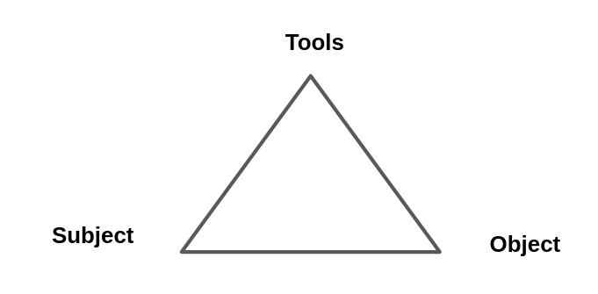 Fig. 3.x essential conception of Activity

Turning to mediation via tools, Vygotsky’s concept of tools is broad (1978), encompassing language, physical tools, and representational concepts. Mediation is particularly relevant to this study, as the learning environment involves diverse and dynamic forms of tool use. Physical, digital, and conceptual tools evolve as products of the experiences of others in society, containing evidence of cultural adaptation and evolution. This study positions pedagogies as forms of mediational strategy that can be employed by both facilitators and learners (Donato and MacCormick, 1994; Gutierrez et al., 2009).

For Vygotsky, mediation via conceptual tools involves the interconnected processes of internalisation and externalisation of activity (Kaptelinin, Karl Kuutti, et al., 1995). Learners are actively processing and make sense of the world by both appropriating cultural learning from cultural practices and then by contributing back into shared cultural understandings of the world. This reciprocal process is well described in learning context by Rogoff via a personal process she calls participatory appropriation (Rogoff, 1995). This reciprocity is crucial as it challenges traditional transmission-based models of learning. Rogoff further identifies this appropriation as consisting of three key planes, of *personal, interpersonal, and cultural processes* (Rogoff, 1995:154), the analysis of which is essential for understanding community activity, a topic that will be explored in a later section of this chapter.

To describe activity systems with greater granularity, Leontiev (2009) employed the concepts of actions and operations, which together constitute a vertical hierarchy of activity structure. At the highest level, activity is driven by an overall motive, while actions represent smaller sub-goals necessary to achieve this broader objective. As we move down this hierarchy, we encounter a series of unconscious operations that are performed fluently during the execution of actions. See the figure below from (Daniels, 2001:87).

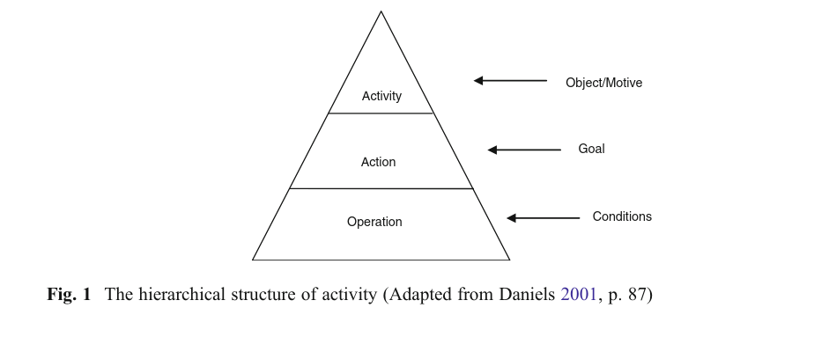

Figure 3. x - hierarchical structure of activity adapted from (Daniels, 2001:87).

The concept of fluency is key to this study, making it essential to locate and describe the chains of operations and actions involved in the activity. Kuutti (1995) articulates the transition from actions to operations as follows:

*Initially each operation is a conscious action, consisting of both the orientation and execution phases, but when the corresponding model is good enough and the action has been practiced long enough, the orientation phase will fade and the action will be collapsed into an operation, which is much more fluent.* (Kuutti, 1995)

Additionally, activity systems can be viewed as nested within broader activity systems. For instance, the development and teaching of a series of lessons may occur within the larger activity of a school or university (Barab, Barnett, Yamagata-Lynch, et al., 2002; Lewin et al., 2018a). Therefore, the process of selecting which activity system to analyze in depth involves identifying an appropriate unit of analysis (Blunden, 2014).

For example, in Barab et al.’s (2002) research on changes to a university course, the use of varied scopes and different framings of activity are used, at times focusing in on the specifics of evolving tool use or participant interaction as an object of activity, to build up a detailed examination of the tensions and processes within a complex educational environment. This level of detail not only enhances replicability but also provides utility to other practitioners, illustrating and justifying the use of a smaller activity system than what is typically represented in Engeström’s approach (Engeström, 1987, 1993; Barab, Barnett, Yamagata-Lynch, et al., 2002). Similarly, in this thesis, while game making is studied as a community project within a larger system, interpersonal activity is also examined through an activity system of a smaller scope. This aspect is explored in more detail in Chapter 4.

In terms of development, activity theory perceives activity as constantly evolving within its context. The theory is rooted in Marxist dialectical materialism, which posits that activity is a dynamic system best understood through its transformations (Ilyenkov, 1960). A significant driver of transformation in activity is the emergence and resolution of contradictions and conflicts that arise from the accumulation of tensions within the activity itself (Ilyenkov, 1960; Blunden, 2023a). Engeström’s work on what he termed the third generation of activity theory includes the theory of expansive learning, which traces the changes and growth of the object being worked on. This transformation often occurs as tensions extend beyond a single activity system to involve multiple systems, acknowledging the influence of actors moving between them (Engeström, 2001). Alongside Cole’s contributions, this framework is essential for broadening the understanding of activity and engaging with cross-cultural perspectives on learning (Cole, 1988). These concepts are explored further in the section on expansive learning below.

## Further developments in activity theory

As activity theory (AT) has been adopted and developed beyond its Soviet origins, researchers have developed new concepts within varied schools of practice. Given the variation in the use of terms, the following disambiguation aims to clarify their meanings in the context of this study. Activity theory (AT) refers to the core principles of the approach discussed earlier. The cultural-historical approach and cultural-historical activity theory (CHAT) denote the broader application of these principles, which may also integrate related concepts from sociocultural frameworks. These include approaches like communities of learners (Rogoff, 1994), communities of practice (Lave and Wenger, 1991), and social design experiments (Gutiérrez et al., 2020). When a distinction is necessary, the term third generation activity theory (3GAT) will be used to refer specifically to Engeström and the Helsinki school’s interpretation of AT. This section begins by exploring key concepts in third generation activity theory (3GAT) and their application through formative interventions. It then examines concepts derived from CHAT, as articulated by Michael Cole and his colleagues, such as funds of knowledge, idiocultures, and legitimate peripheral participation, which are especially relevant to this study.

### 3GAT and Expansive learning

Addressing the first strand, third generation activity theory (3GAT) represents an important development of conceptual tools for applying activity theory to authentic learning settings. Engeström’s concept of the activity system model extends Leontiev’s work through a triangular representation that highlights key cultural aspects of the activity in question. Engeström adds a new tier to the model to visually represent Leontiev’s focus on issues of cultural factors (Engeström, 1987). Specifically, these cultural factors include the wider community, which encompasses those involved in the activity beyond the subjects themselves, the division of labour, which may occur through either the distribution of tasks among community members or a more vertical power structure, and the emergence of rules or norms that guide evolving community behaviours (Sannino and Engeström, 2018).

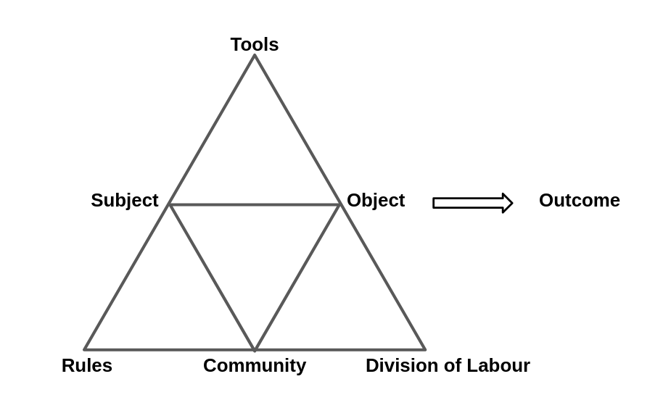 Figure 3. x - Engeström’s representation of community concepts an activity system

While these visual representations are novel, the main advances of third generation activity theory (3GAT) lie in its expanded focus on the role of interacting activity systems, the movement of subjects between systems, and the potential for collaborative work on a shared object. The recognition of broader activity systems and the transfer of motivations and practices of actors into new systems encapsulates Engeström’s perspective on activity theory (Spinuzzi, 2020). This shared, or expanded, object being worked on by more than one activity system is illustrated in Figure 3.x below.

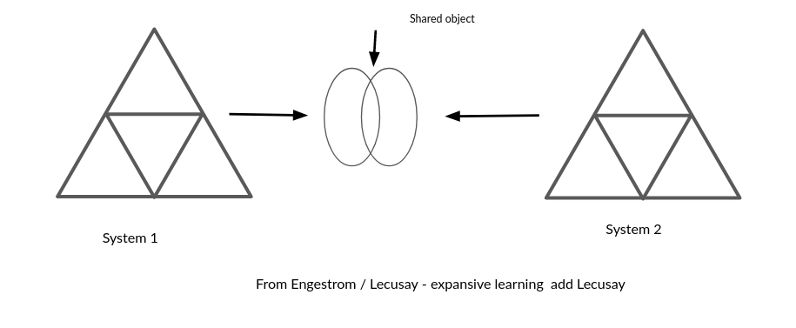

Figure 3. x - Engeström’s concept of expansive learning via a shared object, from (Sannino et al., 2016) (Engeström et al., 2014)

To clarify this relationship further, an example in context is beneficial. In research on a joint activity involving schools, Cakir and colleagues (2022) depict the joint activity as an objective shared between the school, family, and researchers.

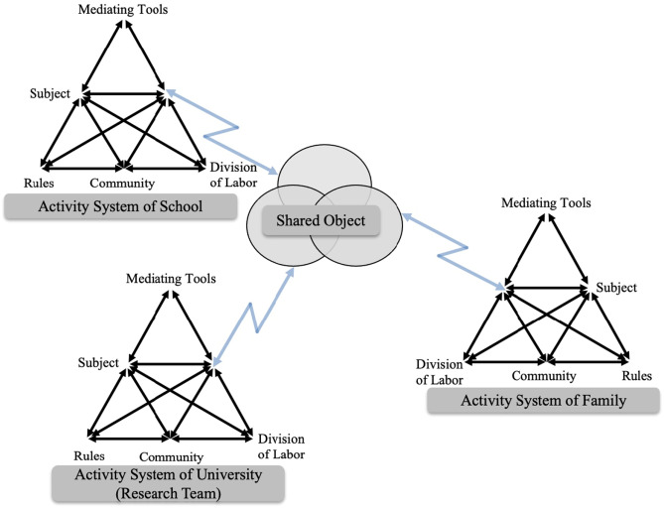 Figure 3.cakir - An object shared between different activity systems

This conception emphasises the importance of the roles of researchers and other stakeholders within these interventionist and participatory processes. Analysing activity through its transformation, particularly in relation to the contradictions and tensions among system elements, draws on Marxist conceptions of dialectics and forms the foundation for the concepts of expansive learning. In 3GAT, this view of transformation through collaborative work between activity systems on a new, expanded object is termed expansive learning (Engeström, 2011).

Drawing on concepts of tensions and contradictions existing in foundational concepts of dialectal materialism, the 3GAT allows for a granular exploration of tensions and contradictions are a vital source of change and evolution of new and ongoing activity systems (Engeström, 2001). 3GAT achieves this through careful of description, analysis, and representation of system elements, the interaction between systems, and the resulting contradictions. Some tensions arising between participant motives and different parts of activity system may be resolved quickly through change, while others may persist and can be referred to as conflicts (Sannino and Engeström, 2018). These unresolved contradictions which develop into impasses or conflicts which may serve as motivational factors driving agentic responses from participants. A later section explores Sannino’s perspective on such conflicts as a source of transformative agency in greater depth.

In this study, rather than analysing larger workplace systems over extended periods, the focus is on the analysis of systemic tensions within the context of shorter interventions, as seen in diverse research (Barab, Barnett and Squire, 2002; Barab, Barnett, Yamagata-Lynch, et al., 2002; Lewin et al., 2018b). Following Kuutti’s approach (1995), this study adopts the term contradictions to encompass concepts of tensions, barriers, and misalignments. Engeström states that such sub-terms can be “understood as manifestations of contradictions” (Engeström and Sannino, 2011:340). Additionally, Kamanga emphasises the value of identifying system congruencies or strengths within activity systems (Kamanga and Alexander, 2021). For a comprehensive analysis of systemic contradictions, see the work of Engeström and Cakir (Engeström and Sannino, 2011; Cakir et al., 2022).

### Applying 3GAT via formative interventions

The term formative intervention (FI) has its roots in Cole and Engeström’s exploration of two models of CHAT based interventionist research (Cole and Engeström, 2007), namely Change Laboratory (from Helsinki school) and 5th Dimension (Cole’s intervention carried out in partnership with wider sociocultural researchers). More recently, Engeström has defended its specific application against more flexible interpretations (Engeström et al., 2014). In this section, I explore the Helsinki school’s narrower interpretation of formative interventions as an application of 3GAT theory.

Cole and Engeström (2007) contend that while formative interventions align with key principles of CHAT, there are practical challenges in aligning with perceived rigour of social science, given the variation in environmental factors in the research process [EXPLAIN]. They also note the challenges of financing lengthy and repeated interventions within the experimental process, as well as the potential to disrupt the status quo of research settings by developing the agency of workers and learners. This disruption may, in turn, impact the direction of the research, steering it away from the objectives initially supported by the funders.

Cole highlights the need to align research interventions with the ongoing aims of educational or community partners to maximise their sustainability beyond the research period (Cole, 2006; Cole and Engeström, 2007). Penuel (2014) proposes the *formative intervention research* as a useful term to encapsulate a variation of FI closely aligned with CHAT, including those drawing on elements of design-based research. In reply, Engeström (2014) initially resists this proposition, insisting that formative interventions should contain a clear articulation of *double stimulation* and the process of *rising to the concrete* within the framework of Engeström and Sannino’s understanding of these concepts (Engeström and Sannino, 2011; Engeström et al., 2014; Sannino et al., 2016). The following sections explain and addresses the importance of these terms.

The concept of rising to the concrete through a germ cell of activity (or unit of analysis) can be traced through the works of Vygotsky and Leontiev back to Hegelian and Marxist ideas of holistic understandings of phenomena (Blunden, 2023a). Forms of activity are viewed as concrete instances and iterations of underlying germ cell concepts, which exist in an abstract form. For example, Marx’s analysis identifies complex and diverse patterns of economic activity within the capitalist system as stemming from an underlying, prototypical concept of commodity exchange in pre-industrial economies. The works of Blunden and Davydov (Davydov, 2008; Blunden, 2010, 2014, 2023a) provide comprehensive justification for the utility of identifying a germ cell or unit of analysis in relation to collaborative and learning projects. Blunden describes the germ cell of activity and the unit of activity as two similar concepts with slightly different foci.

*… the germ-cell and the unit of analysis are one and the same thing, but in one case the developmental aspect is emphasised and in the other case the analytical aspect is emphasised.* (Blunden, 2020)

In this thesis, my role as both researcher and practitioner makes both aspects relevant. Examining the analytical dimension, the process of seeking and defining key activities as units for analysis helps to delineate the boundaries of what to analyse in depth. One challenge in applying this approach is the duration and relative stability required to identify these germ cells. In their critique of Penuel, Engeström and Sannino (2014) provide no suggestions for adapting their models to more rapidly changing situations where actors come from different activity systems. The developmental aspect will be addressed in the following chapters, which explore the evolution and analysis of the learning design, highlighting the process of applying of game design patterns by participants as a germ-cell concept that both shapes and facilitates practice.

Double stimulation refers to a process involving the use of tools to overcome contradictions that emerge in joint activity. Engeström’s early work on formative interventions frames the first stimulus as “the problem itself”, while a potential series of secondary stimuli can be introduced as part of the intervention (Cole and Engeström, 2007:492). Engeström and Sannino (2014) explain that the process of double stimulation is active and goes beyond simple mediation via existing tools. The stimuli, whether presented by researchers as suggested tools or discovered in the environment by participants, are actively imbued with meaning and transformed by the participants through their use.

“Most likely the initially given potential second stimuli are rejected or reshaped by the participants, and the participants typically pick up or invent devices of their own, often as if behind the back of the interventionist.” (Engeström et al., 2014:121)

LINK TO BELOW

### Theoretical concepts emerging from the LCHC and the Fifth Dimension interventions

The work of Michael Cole and colleagues at the Laboratory of Comparative Human Cognition (LCHC), in particular the previously mentioned after-school intervention Fifth Dimension (5D) (Cole et al., 1997), provides useful concepts related to the development and analysis of culture through joint activity (Cole and Engeström, 2007) which are explored in this section. Cole’s approach in this area The programme emphasised sustainability, mutuality, and a utopian ideal of creating a new activity system, insulated from some of the more debilitating aspects of mainstream schooling and broader societal forces (Blunden, 2023b). The following theoretical concepts, beneficial to this thesis, have been developed or utilised by various researchers associated with LCHC: design based approaches, mutual appropriation, third spaces, idiocultures, funds of knowledge, and communities of learners.

Turning first to mutual appropriation, the concept has been utilised by Cole to explain and explore the development of the practicalities and structure of the research programme The setting of 5D interventions predominantly consisted of after-school clubs run by community partners, guided by university researchers and supported by undergraduate student volunteers. The main activities were playful tasks aimed at providing fun, along with additional objectives of building literacy. Cole noted that for an activity to be sustainable, the goals of researchers, student volunteers, funders, and local partners needed, as much as possible, to align (Cole, 2006). To achieve this, Cole and colleagues describe a mutual process of adaptation in joint activities between institutions, which not only reforms activities to make them suitable for ongoing partnership but also leaves a historical trace of evolving activities that serve as a valuable basis for cultural analysis (Downing-Wilson et al., 2011). A key distinction between the 5D approach and that of Change Laboratories is that, in the early stages of the 5D intervention, activity goals are not fully formed and are still in a state of evolution. I will return to this point later in this chapter.

Cole describes the value of researchers being involved in early evolution of interventions in their observations in adaptations of the 5D programme based on the culture of the host partners and young participants. Following Fine (Fine, 1987), Cole employs the term *idioculture* (Cole, 2006:32) to highlight the evolution of a novel, micro culture within the 5D programme. In line with Downing-Wilson (2011), novel idiocultures do not emerge from thin air; rather they encompass the traits of the diverse cultural systems of stakeholders (Cole, 2017). Cole describes the utility of idiocultures as concrete ways of studying the dynamics of cultural variability between different sites, as well as practical means to shape the programme’s activities based on participants’ previous experiences (Cole, 2017).

INSERT Repertoires AS A MORE APPLIED CONCEPTS OF USE IN THE OBSERVATION OF AND DESIGNING FOR BUILD OF idiocultureS

This interpretation of the practical utility of idiocultures resonates with the concepts of third spaces and funds of knowledge. Funds of knowledge (FoK), a term popularised by one of the research partners of the 5D, Luis Moll (Moll et al., 1992), locates home discourses and practices as resources that can be drawn upon by teachers and participants to facilitate learning in school or other environments, thereby achieving more equitable and inclusive learning experiences. This approach is particularly valuable for learners whose home life is culturally distant from school discourses. Moje and colleagues (Moje et al., 2004) explore the use of FoK in the context of interventions outside of school, aiming to develop content literacy. The process of blending the knowledge and discourses of the first space (home life) with the motivations of the second space (school or institution) into a new third space has been explored in various studies (Moje et al., 2004; Gutiérrez, 2008, 2008; Bryant et al., 2009). Rajala and colleagues (2023) problematise the use of FoK in third spaces. They critique the superficial application of FoK, which may perpetuate cultural stereotypes and thus maintain the existing negative status quo (Rajala et al., 2023). Additionally, the practical challenge of gathering sufficient relevant data on home cultures to inform a more nuanced use of FoK would be very time-consuming. To address these issues, they advance the concept of funds of identity, which allows for an exploration of home cultures within the scope of the intervention through the creation of identity artefacts with participants (Subero et al., 2018).

The work of Rogoff and Gutiérrez on linguistic and cultural-historical repertoires (Rogoff, 2003) also aims to prevent cultural-historical practices of participation from being misrepresented as innate behaviours, a misrepresentation they identify as particularly problematic in relation to race. They emphasise that both educators and researchers should avoid designing interventions based on assumed traits of learners. Instead, they advocate for researching and verifying existing repertoires of practice that may be incorporated and then extended within joint work. This perspective builds on Rogoff’s pioneering approach to analysing complex group activities through three planes of observation: personal, social, and community activity. A key motivation driving the analysis of behaviours on the social plane is Rogoff’s desire to transcend the dichotomy between learner-led and teacher-led approaches (Rogoff, 1993; Mascolo, 2009). Rogoff’s concept of guided participation and the role of emerging repertoires of practice within that process, serving as a middle ground between instruction and discovery, are explored in more detail, through the lens of participants use of game design patterns, in Chapter 6.

### Funds of knowledge and third space

The concept of funds of knowledge (FoK) emerged from research within United States Latino communities. FoK refers to knowledge that household members have gained as part of their lived experience and social practices (Moll et al., 1992).

In the original study home visits were carried out to better inform design of after-school activities.

However there limits to this approach, including only some families were visited, and adult focused nature of process (Rajala et al., 2023).

The term addresses the use of knowledge and skills from participation in activities outside school that teachers can build on to help classroom work and to support the motivation of learners. Researchers found that Latino home cultures, skills and traditions were hardly visible in mainstream school cultures. This resulted in a form of deficit thinking about the performance of these communities (Moll et al., 1992).

Look at how Moje opertationalised third spaces too. See dissertation on third space here (Bellocchi, n.d.)

Rogoff and Gutierrez’s initial motivation in their exploration of repertoires was to challenge simplistic, overgeneralising approaches regarding learning styles especially if applied to non-dominant communities (Gutiérrez and Rogoff, 2003). The researchers highlight the value of identifying potential funds of knowledge framed as “linguistic and cultural-historical repertoires” that learners bring to learning environments (Gutiérrez and Rogoff, 2003:22).

### Third spaces and repertoires in the context of this study

The concept of third space is helpful in the context of this study in particular as a space between home life and formal education rooted in a sociocultural understandings of learning.

PROBABLY DROP THIS BIT Rogoff and Gutierrez’s initial motivation in their exploration of repertoires was to challenge simplistic, overgeneralising approaches regarding learning styles especially if applied to non-dominant communities (Gutiérrez and Rogoff, 2003). The researchers highlight the value of identifying potential funds of knowledge framed as “linguistic and cultural-historical repertoires” that learners bring to learning environments (Gutiérrez and Rogoff, 2003:22).

### Design based research approaches - INSERTED

5thD interventions and related LCHC approaches incorporate, and have contributed to design based approaches in research.

From a source of Brown’s provocation on the importance of context (Brown, 1992), the evolution in the conceptual complexity and practical application of what has become known as design based research (DBR).

While starting from similar roots, and sharing key concerns regarding ecological validity, there has been a degree of contestation in attempts to compare formative intervention with design based research.

The process of comparing formative intervention (FI) and design-based research (DBR) is complicated by the wide application of DBR and its diverse interpretations, which extend beyond a set of generally agreed principles (Penuel, 2014; McKenney and Reeves, 2021). Easterday and colleagues (2014) characterise the core elements of DBR as: research as a form of intervention, iteration, involvement of participants in the evolution of designs, and flexibility in research outcomes based on how events unfold . Cobb and colleagues (2003:13) summarise the characteristics of design-based approaches as “extended (iterative), interventionist (innovative and design-based), and theory-oriented enterprises whose ‘theories’ do real work in practical educational contexts” . For more detailed definitions of DBR, see Sandoval (2014) and Hay (2001:3).

While these broad approaches are in alignment with CHAT, Penuel (2014), in an attempt to summarise differences between DBR and CHAT interventions, notes that DBR is more common in the domain of learning sciences, particularly in advancing practice and theory related to innovative learning tasks. In contrast, CHAT interventions concentrate more on transformations in activity and the increasing agency of those involved. initially outlined several criticisms of DBR when compared to CHAT in educational contexts: it is vague in its description of systemic elements in analysis, and it tends to be overly focused on a linear approach to refining the researcher’s learning design, which limits the input and agency of participants. O’Neill (2016) echoes these concerns and extends them, urging DBR researchers to apply CHAT methodology to address the limitations of current DBR practices in the learning sciences community. He emphasises that DBR researchers often fail to invest sufficient time in familiarising themselves with the existing learning practices of the contexts they study, an oversight that runs counter to the more contextually focused approaches encouraged by CHAT.

Bakker (2018) challenges Engeström’s characterisation of DBR as having closed goals, particularly critiquing Engeström’s portrayal of the work of Collins and colleagues (2004) as a misrepresentation. Bakker (2018:17) argues that these researchers did “not want to fix variables or educational goals upfront” . He echoes the call of Cole, Penuel and O’Neill for more dialogue and greater recognition of the shared traditions between CHAT and design research (2018). Penuel (2014) emphasises the eclectic methodological approach in design-based research as a necessary means of responding flexibly to context. Bakker also views this flexibility as a strength of DBR, resisting calls for greater formalisation of the design process (Ormel et al., 2012; McKenney and Reeves, 2013).

Engeström’s view of DBR (2009) is that it lacks rigorous examination of the dynamic and historic nature of context with CHAT conceptions of activity. O’Neill, in advocating for great use of CHAT approaches within DBR, offers contextual factors which help explain this deficit, including the time scales and wider priorities of using DBR within the funded research environment of the learning sciences (O’Neill, 2016). The result is a challenge for DBR in producing in-depth analyses of context, which are often required in CHAT-based approaches.

An additional challenge is the context in which formative interventions are often applied. These interventions are frequently used in stable, institutional work environments, particularly in European contexts, where stakeholder roles and systemic structures are more predictable. In contrast, learning environments associated with DBR, especially in less formal or rapidly evolving contexts, do not share the same stability (Spinuzzi, 2020). This difference may limit the utility of formative interventions like the Change Laboratory in more fluid settings.

Recent work by Engeström, Sannino, and colleagues suggests a shift toward a more collaborative stance on DBR, recognising its value rather than critiquing it outright. In particular, they acknowledge that formative interventions can enrich DBR by offering a robust framework for systemic transformation, collective agency, and expansive learning (Cakir et al., 2022). This shift highlights a growing consensus on the potential benefits of incorporating cultural-historical concepts into DBR approaches. The study in this thesis, which applies CHAT principles to a novel and relatively unstable learning context, presents a useful case study in this ongoing endeavour to integrate the strengths of both formative interventions and DBR.

Barab and Squire (2004) describe the inherent *messiness* of design-based research which presents a challenge for researchers when attempting to present results in a coherent manner that is useful for other practitioners. There is an ongoing tension between staying closely aligned with the specific, rich context of the research, and stepping back to generalise findings without becoming lost in abstraction. This balance is crucial to ensure that the research is both contextually meaningful and practically applicable to broader settings. Hoadley and Campos (2022) further explore the outcomes of DBR, including the development of design processes, the creation of domain theories, the formulation of design principles or patterns, the introduction of ontological innovations, the generation of new hypotheses, and the transformative learning experienced by researchers themselves. These varied outcomes highlight the broad applicability of DBR and the importance of ensuring that design processes and theoretical insights are communicated clearly to enhance the utility of research findings.

## Putting AT to work, variations and synthesis in interventionist CHAT research

This section

While there is broad agreement among researchers regarding the theoretical understanding of concepts in activity theory, there is greater disparity in their application within research settings. This section explores the variations between key approaches, relevant to this thesis. Specifically it describes applications of DBR, Change Labs and Living Labs, and social design based experiments (SDBEs).

<!-- "Formative interventions can contribute to the new generation of DBR by providing a robust theory and methodology for systemic transformation, collective agency, and expansive learning". [@cakir_contradictions_2022] -->

### DBR as an applied research process

This section outlines key techniques used in DBR which I draw on in later chapters namely, the challenge of overcoming the tension between the rich context and generalisation of results (moved up), design narratives, and the process of rapid iterations of learning designs.

One solution to the challenge of balancing utility and generalisation, as well as representing the research process in an accessible format, is through the use of *design narratives*. Bakker (2018) notes the difficulties of conveying the richness of the design process within the constraints of traditional journal formats, where space restrictions may hinder detailed explanations. Design narratives, as proposed by Hoadley (2002), address these limitations by providing a detailed account of the learning design process. They document the problems encountered during the intervention, the iterative changes made, and the rationale behind those revisions (Hoadley, 2002; Bell, 2004; Brase, 2024).

In this study, a design narrative is particularly valuable in conveying the intricate details of the learning design. This thesis format allows for a fuller exploration of these aspects, notably in Chapter 5 where I use the depth of description possible to illuminate evolving tensions in the learning activity. I argue that design narratives can further enhance the alignment between DBR and Cultural-Historical Activity Theory (CHAT) interventions. By incorporating systemic and analytical concepts from activity theory, design narratives can provide a more holistic account of the intervention process. An example of such a narrative, using CHAT techniques, is found in Cole’s (2006) work on the Fifth Dimension.

A key aspect of DBR is its emphasis on the rapid iteration of educational resources based on continuous feedback rooted in practice. This process helps produce pedagogies and resources that respond to the needs of learners (Cobb et al., 2003). This emphasis on rapid iteration aligns with the aims of this thesis, where the ongoing feedback from participants informed the development of a novel learning design via phases of delivery. The iterative nature of DBR, with its focus on refining learning materials in response to feedback, supports the dynamic, practice-based approach explored in the following chapters. By integrating these DBR concepts, this thesis leverages the strengths of design-based approaches while aligning them with the systemic insights offered by CHAT. This flexible approach addresses both the complexities of real-world learning contexts and the need for practical, and ideally replicable outcomes.

### Change Lab and Living labs

The Change Laboratory (CL) is Engeström’s key implementation of expansive learning in workplace environment (Engeström, 2007). CL interventions take the form of a series of workshops involving stakeholders important to the workplace setting, with researchers acting as facilitators of the process. The structural model of 3GAT is used as a tool to identify, analyse, and provoke reflection on current workplace practices and dynamics, facilitating discussion on possible actions to enact change. The CL processes suit formal, relatively stable workplaces where existing concepts of community, division of labour, and norms can be readily identified. Another form of FI relevant to this study is that of the Learning Lab (Bal, 2011; Cakir et al., 2022), the overall environmental structure of which is represented above in Fig.3.x. While the Learning Lab takes place in a school environment, interventions retain the form of stakeholder workshops. For more on formative interventions that have taken other forms used or endorsed by Engeström’s team in Helsinki, see (Engeström et al., 2022).

Returning the concept of double stimulation….

For example, in the Change Laboratory model, the first stimulus would be data derived from ethnographic video recordings, which if *mirrored* back to participants to help to identify a problem that needs addressing. The second stimulus, more accurately a series of stimuli, comprises techniques designed to provoke, shape, record, and reflect on the emerging discussion (Engeström, 2007). Sannino’s work on the volitional aspect of the double stimulation process views auxiliary stimuli as triggers for will and agency in participants (Sannino, 2015). The exploration of these concepts, as discussed by Hopwood (Hopwood and Sannino, 2023), is addressed in greater detail later in this chapter.

### Social design-based experiments (SDBEs)

THE ORDER MAY NEED TO BE DIFFERENT - PUT DBR BEFORE SDBEs

The work of 5D has led Gutiérrez to develop a methodology called Social design-based experiments (SDBEs). SDBEs draw on FI and DBR and extend it with several useful techniques and perspectives.

* A focus on equality
* diversity
* historical actors and movement between spaces
* linked with transformative agency [guti and jurow, p3]
* non hierarchical - horizontal concepts of institutional and everyday knowledge [guti and jurow, p4]

For shadows work on abstract and concrete in the future.

## Concepts of agency within CHAT

Before addressing Research Question 2, which asks how participants develop agency in an evolving community of game makers, it is important to clarify the concept of agency, particularly in the context of learning environments. The question of who or what has agency is a philosophical one with practical applications in designing learning settings. Agency and autonomy are often either vaguely defined or have contested, interconnected definitions in studies (Huang and Benson, 2013; Matusov et al., 2016). For this thesis, in line with a cultural-historical approach, agency is viewed as a cultural phenomenon experienced by individuals in relation to their peers and their learning environment.

DROP THIS - IT DOESN’T MATCH To situate this view within the varied and evolving concepts of agency in educational settings, I draw on the work of Matusov and colleagues (2016) who categorise agency into several genres: instrumental agency focused on developing capacities, effortful agency related to motivation and commitment, dynamically emergent agency involving affordances and actor-network theory, and authorial agency, which entails agentic changes to the learning environment. Matusov and colleagues’ critique effortful agency in education, which primarily focuses on achieving goals predefined by educational institutions.

CHANGE THIS - SIMPLIFY BASED ON WHAT IS NEEDED. Thus the following outlin e begins an analysis of instrumental, dynamically emergent, and authorial agency within the framework of Activity Theory. These forms of agency offer a broad perspective on how individuals navigate and transform their learning environments which extends beyond merely fulfilling institutionally set objectives.

### Instrumental and relational agency

Instrumental agency reflects a concept of agency as the ability to get things done, thus, a view of agency as a set of capacities (Edwards and Mackenzie, 2005). Matusov and colleagues (2016) highlight an often technological view of educational environments where educators seek to increase instrumental agency by building the individual capacity of learners to achieve relevant tasks. Many DBR studies which aim to develop and study the use of new tools especially in the area of education technology, would aim to increase instrumental learner agency, designing away problems.

Within a CHAT framework, this type of agency can be seen as enhancing the fluidity of practice, with learners using both objects and people as tools within mediated activities. According to Leontiev, actions that initially require concentration and effort may evolve into fluid operations through practice. Thus, understanding these dimensions of agency within an AT framework should be grounded in a solid comprehension of mediation principles.

### Dynamically emergent agency

CAN THIS BE LINKED WITH RELATIONAL AGENCY -

Matusov and colleagues’ interpretation of a dynamically emergent dimension of agency is complex and diverse allowing agency to be recognised in distributed forms such as ‘emerging collective agency, agency of bureaucracy, non-human agency of animals, agency of distributed machine-human network, agency of Internet, and so on’ (Matusov et al., 2016:432). The authors recognise the value of this framing of agency to explore and address constraints and designing support in the form of affordances in the learning environment. As this study involves the use of computer systems to learn computer coding, there is value in exploring agency in this context. Work by Bærentsen and Trettvik (2002) linking the use of affordances in human computer interaction (HCI) to a foundation in activity theory highlights, following Gibson (1979), that affordances exist as opportunities provided by the environment and objects within it, either natural or culturally created, to organisms within that environment. The authors also note that the distinction between the intended (designed) use of affordances and their possible use, an important distinction in the field of HCI, is one best explored via activity theory’s study of the interaction of humans and artefacts as joint activity, thus preventing the view that that affordances have magical powers outside of a cultural context.

HOW CAN THE FOLLOWING BE FRAMED AS RELATIONAL AGENCY OR WHAT IS THE LINK TO RA IN TERMS OF THE RELATION TO MATERIAL AFFORDANCES ?

The work of Nardi and Kaptelinin (2012a) is also helpful here to examine the concept of designed affordance in learning environments through a lens of activity theory. The authors (2012b) also reframe Gibson’s concept of affordances as possibilities in line with activity theory concepts of mediated action. They situate the creation of affordances in designed systems as a form of delegated agency (Kaptelinin and Nardi, 2012a). Artefacts or tools used in mediated activity may be given a form of delegated agency through designed affordances, e.g. a phone may prompt its user to charge its battery via notifications. However, unlike Latour’s (2013) concept of agency in actor network theory, objects would not delegate agency to a human (Kaptelinin and Nardi, 2012a:42). This is not to say that non-human objects have no impact on others as once the artefacts are placed in context they may have unintended consequences creating what Engeström calls *runaway objects* (Spinuzzi, 2011). This interpretation acknowledges the agentic like impact of these objects but attributes the original volition or motivations to human-initiated activity. In the following section, an authorial interpretation of agency is explored as one that is not experienced as delegated but rather created.

### (Authorial and) transformative agency

NOTE DROP AUTHORIAL?

Matusov and colleagues (2016) propose authorial agency as the concept of agency, as the most active and best aligned with an ideal form of education, in doing so drawing on existing work from CHAT researchers on transformational concepts of agency. This section exemplifies this through the work of Stetsenko in the form of transformative activist stance (TAS) (2014, 2015) and Sannino in the form of transformative agency by double stimulation (TADS) (2022)

#### Transformative activist stance (TAS)

While there is a wealth of research which discusses and applies concepts of affordances and dynamic agency, often in the field of HCI, the focus is often skewed towards individual rather than on collective action (Kaptelinin and Nardi, 2012b). Additionally, Stetsenko’s (2020b) critique of relational approaches to agency, both outside and within CHAT circles, invites us to resist the marginalisation of the role of the individual. Stetsenko (2020) critiques both conceptions of human agency an individual attribute or a negation of human agency which views individuals as helpless bodies in wider cultural phenomenon. Instead, agency involves both contextual tensions and human volition. Thus, Stetsenko proposes a transformative activist stance (TAS) to address the societal urgency of agency with a direct focus on political dimensions. For Stetsenko the stakes are high given ecological and military crises caused by neo-liberal capitalist economic, but there is still everything to play for (Stetsenko, 2023). Thus, Stetsenko advocates a *flagrantly partisan* approach for researchers, as a reaction to a perceived pose of neutrality or distancing present post-modern and post-human approaches (Anna Stetsenko, 2020a; A Stetsenko, 2020).

While the overall focus is societal change, TAS has been applied to smaller scale concrete explorations, including play (Stetsenko and Ho, 2015), transformation in the setting of adolescents looked after in residential care (Vianna and Stetsenko, 2011). In TAS aspects of conceptual understandings of agency and specifics of methodology are less explored than the motivational dimensions, the methods of auto-ethnography and case studies are used in several studies which draw on this concept (Vianna and Stetsenko, 2011).

#### Transformation agency through double stimulation (TADS) - On double stimulation and agency

The Helsinki school’s focus on transformative agency also advocates the importance of intervention and transformation as a desirable aspect of research, (Engeström, 2006; Haapasaari et al., 2016; Sannino et al., 2016). The vehicle for this in recent years has been the concept of transformation agency through double stimulation (TADS). Similarly to TAS, the objective of TADS is increased agency of participants in research interventions. In addition, TADs researchers articulate a desire to understand a broad picture of agency from a CHAT perspective. As outlined above double stimulation describes additional stimuli beyond the first stimulus understood as the motivation of the activity. In the Change Lab (CL) interventions for example, the active use of secondary stimulus can both analyse and facilitate agency by provoking reflection (Sannino, 2015).

Studies of transformative agency, for example within CL, often involve a significant longitudinal aspect. However, the TADS concepts has been applied in research over much shorter time frames and in more naturalistic settings such as hospital practice (Hopwood and Gottschalk, 2022; Hopwood et al., 2022), higher education (Grant, 2022), and digital education (Aagaard et al., 2022). The concept of volitional action by subjects as a foundation for transformation is used in these shorter term studies to explore the processes of decision forming and implementation (Virkkunen, 2006; Sannino and Laitinen, 2015). Here the secondary stimuli are used by participants as a spur and then as leverage in volitional acts. To address this aspect, Sannino augments the concept of transformative agency by double stimulation (TADS) with a metaphor of a sea vessel warping using kedging anchors.

*We may think of the second stimulus as an anchor. Anchors are commonly understood as stabilising devices to prevent a vessel from moving. However, not all anchors have this function. Beside the heavy-weight anchors, there are also kedge anchors serving the purpose of* ‘*warping,*’ *that is, pulling the anchor once it has settled on the ground, for moving the vessel away from a problem area.* (Sannino, 2022:4)

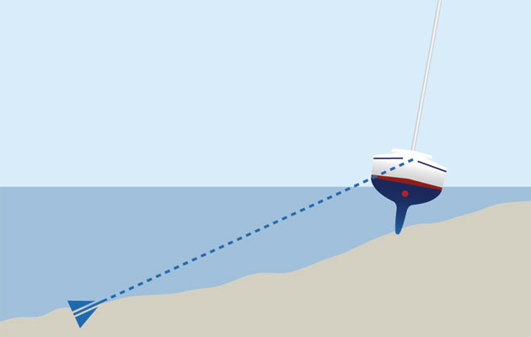

Figure 3.warping - Warping using a kedging anchor

This metaphor highlights the active effort of participants to overcome tensions and dilemmas in their activities, which can leave them stuck, much like being stranded on a sandbank. In an educational intervention, learners might “throw a kedge anchor” into the learning environment, symbolizing an intentional action to pull themselves out of the impasse they are facing.

While not all attempts, such as directly asking a peer or teacher for help, will succeed, some will take hold and lead to transformation for the student. This may also trigger a broader shift in the educational environment itself. This idea is particularly relevant to the setting of this study, where the learning environment is co-created by both participants and researchers.

### Relational agency

Edwards and Mackenzie’s concept of relational agency builds on instrumental agency, extending it to include a social dimension that enables learners to request and offer support within a community context (Edwards and Mackenzie, 2005). While applying this relational, instrumental agency in school settings is commendable, the authors (2005) note that this application is often limited by institutional and curricular constraints.

#### Feedback and relational agency and specialism in context of making

TO ADD - Within relational agency, a call back to 3rd spaces and emerging repertoires is needed to introduce exploration in Chapter 7.

The work of DiGiacomo and Gutiérrez exploring making and tinkering in a 5D context explored the role of:

1. feedback to increase relational agency
2. feedback increases relational expertise in

The additional focus of equity, and diversity rather than agency of Gutierrez should be noted here also.

From (2016)

We argue that these relational and material feedback elements of the activity helped to create an environment with relational agency—a “capacity for working with others to strengthen purposeful responses to complex problems” [@edwards_building_2011] (Edwards, 2011, p.34). According to Edwards (2011), relational agency arises from (a) working with others to expand the object of activity and (b) aligning one’s own responses to new interpretations being made by the others while acting on the expanded object.

## Conclusion / Synthesis.

In this chapter I have outlined the foundational concepts and current strands of interest of CHAT and explored how the field is becoming increasing aligned with that of design-based research. The complementary elements identified can be operationalised by utilising both CHAT’s comprehensive framework for understanding human activity and DBR’s practical focus on more rapidly iterative cycles of designed interventions.

To situate the reader at this stage, concepts related to an activity systems approach explored in this chapter are briefly outlined in the context of this study. Figure 3.broad below presents a broader picture of the activity within the context of other activity systems as seen in the work of Cakir and colleagues represented above in Fig 3.cakir (2022).

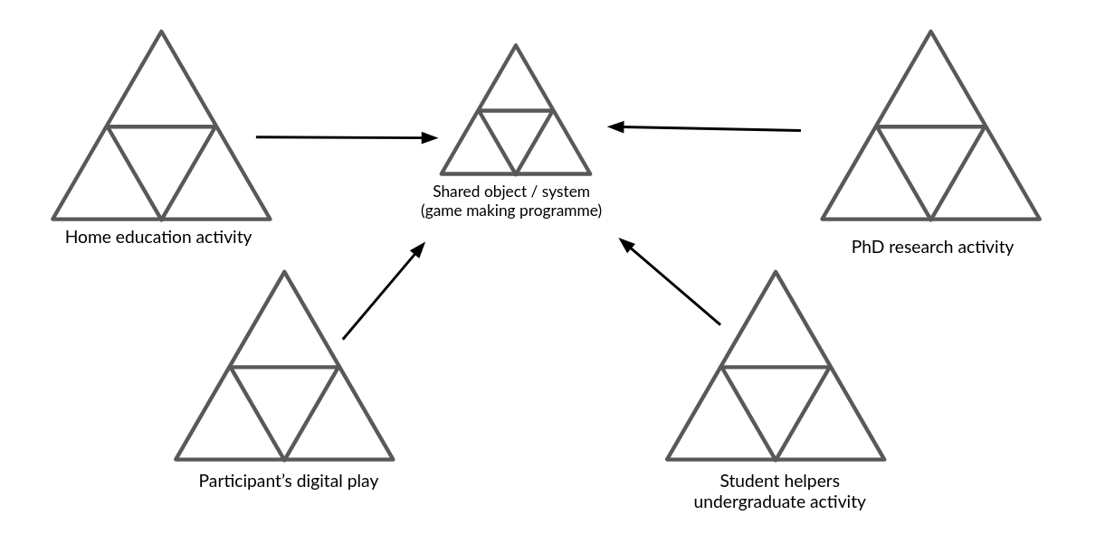

Fig 3.broad - environmental positioning with game making activity mediating the interactions between stakeholders.

The representation above shows a relation between systems which allows transmission of funds of knowledge and existing repertoires of communication from the existing activity systems of different stakeholders and learning contribution to a new, emerging system. Following an approach taken by Lecusay (2015), the processes at work in the emerging shared object merits examination as an activity system in their own rights a process tackled in chapter five.

The use of concepts from both of CHAT and DBR is particularly valuable for this study, as it allows exploration of the contextual factors and influences from other activity systems contributing to the new shared object of activity. These include the ongoing development of cultural artefacts used, home interests and repertoires, as well as my own motivations.

MOVE THIS UP OR DROP IT? While TAS can be seen primarily as a conceptual approach in comparison to TADS which more closely linked to an applied approach of formative interventions, I am encouraged by the activist stance advocated by Stetsenko (2020), which rejects the abstraction of oneself from the processes participants engage in and promotes immersion in the struggle. This aligns with my own motivations in this study, resonating with my past experiences, as I position myself as an activist advocating for improved access to game-making through computer coding, a process currently hindered by educational contexts and classroom practices as explored in Chapters 1 and 2.

KEEP THIS? To achieve this, rather than following an established applied CHAT methodology like the Change Laboratory, I synthesise different concepts outlined in this chapter. Chapter 4, which describes the methodology in more detail, will explain how I draw on CHAT, DBR, and Rogoff’s concept (1995) of the three foci of analysis. In the analysis, I focus on the tensions between system elements, the iterative processes used to address these tensions, and transformational concepts of agency.

In chapter 5 particular attention is paid to the development of the artefacts and processes developed as part of the learning design as a form of evidence of these transformations. The more rapid iterations of design align to a greater extent to DBR process of than that of Change Laboratory. Despite this, this study does aim for a full application of the stricter interpretation of the term formative intervention as outlined by Engeström and Sannino (2014). This hybrid approach addresses a key critique of the Helsinki school’s implementation of third-generation activity theory (3GAT) via formative interventions such as the Change Laboratory, specifically that it is time-consuming and requires stable stakeholders (Spinuzzi, 2020). However, while this hybrid process has proven fruitful in some areas, it has also posed challenges during the analysis stage. The implications of both successes and challenges are explored in the thesis conclusion.

Turning to a similar issue regarding conceptions of agency, TADS (transformative agency by double stimulation) is most commonly explored in relation to Change Laboratory and professional settings. Despite its potential in less structured contexts, there is a paucity of studies in the area of “student-centered contexts of learning” (Isaac et al., 2021:93). However, the broader concept of participants actively overcoming blockages caused by contradictions is well-explored in the fields of Human-Computer Interaction (HCI) and DBR. These fields often focus on revising educational tool designs to address conflicts, while still recognising the agency and input of participants (Karanasios et al., 2021) In line with Hopwood (2022), I see significant potential in the application of TADS in varied, real-world learning environments, using a diverse range of in-situ data sources as learning practices evolve.

To conclude this chapter, it is helpful to situate this synthesised theoretical framework as one that has the potential to make a valuable contribution through an applied case study. This case study aims to engage with current theoretical advances in the field of agency studies, particularly within the implementation of smaller-scale formative interventions. The framework outlined in this chapter informs the specific methodology described in the following chapter, where methods of data collection and stages of data analysis evolve in an iterative process, while remaining structured to incorporate the underlying concepts of CHAT and DBR.