Process - Emerging Learning Designs
- Outline
- Chapter Introduction
  - Contextual factors from practitioner perspective influencing design
  - Short vignette illustrating shifts in scope of activity
  - Description of the nested levels of activity via analysis of tools used.
- Overview of 3M pedagogical model
  - Methods (Inclusive)
  - Missions (Main Missions)
  - Maps - more detailed in this chapter
- Evolution of Design
  - Description of Phases
- Exploring tensions emerging in design
- Evolving design of Support Materials and Documentation
- Learning Dimensions Map
  - Overview -
  - Limits to this map
  - Including Coding Concepts in the Learning Map and including Code Cards with links to online Concepts
- Using Physical Maps of Missions as Game Design Patterns
  - Overview - Physical Maps
  - Emerging Findings & Discussion on use of Physical Maps
- Link to next chapter
- List of appendices for this chapter
  - Tensions of the 3M design evolution

Outline
- Recap of context and specifics of designing for informal learning
- Vignette showing shifts between scopes
- Identifying units / scopes of activity
- Overview of 3M pedagogical model
- Learning design in stages
- Analysis of Tensions in design and how this guided Evolution
- Docs and Tools
- maps - learning dimensions
- maps - physical
Missing?

Chapter Introduction
This chapter charts the evolution of the learning design. It draws on immediate analysis of participants reactions and contributions from journal notes, participant interviews and analysis of changes in the learning resources created.
The first section is a short summary of the phases of the design.

Contextual factors from practitioner perspective influencing design
NOTE - move some of this to a discussion section?
Recap of context and specifics of designing for informal learning
- design based experiments - some factors
- informal learning - recap rogoff and similar - issues of designing for informal settings
Cultural influences on my choice of learning design
I set up the working pattern based on my professional experiences and my own academic and cultural interests. As mentioned in the introduction, DIY culture, remix culture, repair culture, TAZ events are strong influences to the learning design based on the ideals of an autonomous community.
- a desire to increase engagement based on my experiences in classroom and out of classroom - Home Ed / coder dojo experiences
- the link to cultural practices of code patching and remixing - the example of the plumber coder potentially being someone who finishes the job rather than elegant coder.
- other experiences of social coding being important being part of a community working on a joint project (add a quote from Dave?)
- Other examples from the interviews with practitioners are relevant to include here.
Practical factors
It is important to address contextual factors that facilitated and shaped development of some initial creative practices.
- Research and teaching practices, the location at the university and being part of a research project. Eliza effect? If so how relevant?
Availability of resources potentially novel. For example, the ability to have that number of identical computers for this audience in particular, and using this shape of working which was determined by technical reasons but which had an impact nevertheless on the ability for students to move around the room and the absence of a front for the teacher to teach from. After attempts in previous sessions I abandoned attempts to use the screen in the space to do explicit teaching. The process was very disruptive to the emerging group behaviours and practices.
Key questions / motivations in creating a new learning community
The game making community is not authentic or mature in the practices they are undertaking, the kind of community practices which we can undertake are focused partly on building connections to existing knowledge and practice. One of my roles as designer here was to uncover and to help participants explore knowledge that they were unaware they possessed.

Summary of design evolution
Summary Table of Stages
This is introduced to ground the reader by giving a brief overview of the stages and a link to examples of resources in the appendices and links to online examples.

Short vignette illustrating shifts in scope of activity
The following vignette, consisting of extracts of participant activity over 20 mins of a session, is presented as an summary of different scopes of activity. The participant is the child Toby who in this session has been working independently.
Change to markdown? https://docs.google.com/document/d/1vYeVxYaRMTWPDOHwC4DEGYAkGPRIDX7wLiz0l8b7LWc/edit

Commentary on Vignette - including a brief description of the nested levels of activity & tools used
Activity Theory allows researchers to identify intersecting or nested systems of activity with varied goals. Taking a holistic view of goals of the game making activity, we can identify the larger and smaller scale objectives of systems of varied scale.
These include:
- Larger-scoped objective: creating a game which is fun to play and communicate an environmental theme.
- Mid-level objectives: identifying and implementing key game features to add to the game.
- Lower-level objectives: creating, changing and transporting game assets or changing code constructs to enact or change game elements.
While these are the chief objectives other high level objectives are present but much less dominant in this setting. Other objectives include: research goals on the part of the researcher/ participant; desire to create a useful learning experience on the part of student helpers; learning computing skills and concepts as a home education project; and participating with other home educators in a creative environment and thus building team and communication skills.
A short description of the activity systems follows will illustrative diagrams / table
eg
Subject | Objective | Tools / Processes
Whole community | creating a game which is fun to play and communicate an environmental theme | Code playground - glitch.
 |  | Piskel
Subject | Objective | Tools / Processes
Medium-scope | Implementing game elements | Overall mission
Higher-level objective
Students picked missions from a choice of printed resources. There were four colour themed categories of missions. Game mechanics are features to do with the actions of the game. Game space patterns address the layout of the game. Game polish patterns involve adding music, backgrounds, graphics and story elements. Finally System and Challenge patterns look at how different elements interact to create challenge in the game.

Overview of 3M pedagogical model
The process of developing the learning design happened in tandem with the data gathering. The model was guided by reflection and feedback from ongoing game making sessions.
In summer 2020 I began early dissemination of results and wanted to be able to present the essence of the learning resources and design to fellow practitioners and participants as well as researchers.
To do this I created the frame of a 3M model, the aim being to simplify a complex set of resources and teaching processes.
The resources have been created under an open licence (CC-BY-SA) which allows them to be freely used and adapted.

Figure 1.3. Synthesising diagram of 3M Game Making Model
Missions | Maps | Methods
Simple code changes yield quick feedback | A map of learning dimensions flexibly linked to main missions/patterns can be used by both learners and facilitators | Play Testing in each session aids short term motivation. Showcase events help longer-term motivation and aid project prioritisation
Free choice of Patterns increases learner engagement and ownership | Tracing the learner pathway on an attractive physical map in the learning space can help integrate navigation and reflection into the creative process | Drama and fictional scenarios can help explore issues and reduce learner anxiety though coding in a role
Restrict Game Type and number of Patterns to reduce Facilitator stress |  | Adding electronics to control the game via arcade buttons and cabinets increases engagement and perceptions of project authenticity
Limit complexity of patterns. Some are simple but cause a large change in the game
Side missions which explore and celebrate different ‘maker types’ (from Bartle’s player types)
Table 1.2. Key Features of 3M Game Making Model
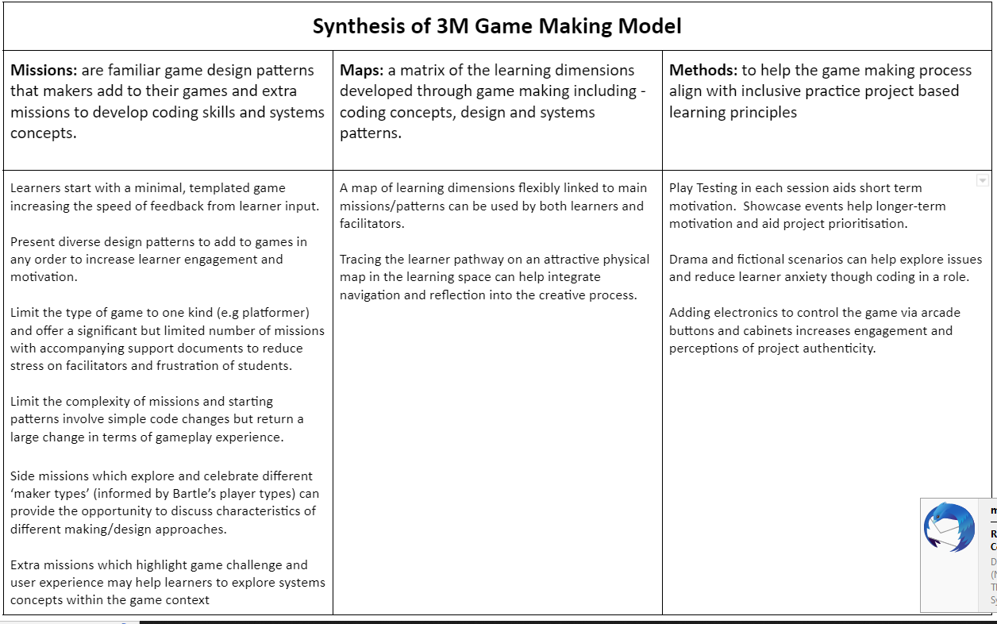
Figure 1.4. Synthesising table of 3M Game Making Model

Methods (Inclusive)
NOTE - CHECK NEXT CHAPTER - Revise this to prep for next chapter
Explore other research that builds on lit review concepts and has a game making context.

Missions
The main challenge of the 3M model is to create a playable game around a theme for a real or imagined audience with learners given the choice to add many optional features to the game.
In addition, side missions encourage social and playful coding approaches which help develop a community of coders. The purpose of mirroring the language of adventure game experience is to create a playful environment, a theme explored in the following chapter.
In the 3M model rather than following a step-by-step tutorial learners start with an incomplete game template and add new features as they choose. Each feature or pattern is described as a mission.
In my final implementation of the 3M model students picked missions from a choice of printed cards or online resources. There were colour themed categories of missions. Game mechanics are features to do with the actions of the game. Game space patterns address the layout of the game. Game polish patterns involve adding music, backgrounds, graphics and story elements. Finally System and Challenge patterns look at how different elements interact to create challenge in the game. An example of a game mechanic design pattern follows.
Your mission is to apply the following pattern to your game. There are supporting step-by-step resources available if you need them. When you finish be sure to reflect on how adding this pattern helps your understanding of the computing concepts and similar patterns listed. This concludes your mission.
* **Name of Game Design Pattern:** Jumping on Enemies to Zap them

* **Type Pattern:** Game Mechanic

* **Description:** If the player is descending from a jump when they touch the enemy the player is zapped and in this case disappears.

* **Need for Pattern:** Enemies create challenge and being able to jump on an enemy is a good way of clearing the area you want to explore.

* **Coding Concepts involved:** Arrays[^8], Change Listener[^9]

* **Links to other Computing Patterns:** Systems Dynamics[^10]

* **Related Game Patterns:** You'll need to have added the **Add Enemies** pattern to your game before you can add this one.

Maps - more detailed in this chapter
Move some of the below here? if it sits right?

Evolution of Design

Description of Phases
As outlined in the table above I carried out four stages of workshops and development with home educator families.
I will outline decisions behind the design activities at key stage of activity - AND INCLUDE TENSIONS IN EACH STAGE.
NOTE - NOT SURE WHERE TO PLACE THIS IN THE CHAPTER. Table of Tensions & resolutions of 3M design - also should reference the resources - in appendix and online. https://docs.google.com/document/d/1DRgpgIUfq5XIktYy-lX4WlviUDnffNc0v8SOeLGgHho/edit
https://docs.google.com/document/d/1tBoXJWw-aZUcc8EsAvT195CtHLSM468YOCD0sGzOuoA/edit# CREATE THE SUMMARY TABLE FIRST THEN REVISE THE BELOW

Phase One
This phase took place before the official start of this research and relevant ethics application. As such, this stage was initially aimed not at collecting user data rather than building my own background knowledge and competency. Some of methods emerged from the start including play testing of other games, a final public showcase, and the use of drama / warm up games.
The first phase of delivery in late 2018 was based on initial research stage; I drew on literature to identify factors to consider when designing for collaboration. I adopted an open project based approach which integrated drama games to aid group bonding and reflection.
Playing games, and game filled laptops.
I chose a tool set which drew on relevant design principles explored earlier (Resnick and Rosenbaum, 2013).
The tools allow participants to create games using a combination of a free to use online tools.
an online coding environment using the phaser javascript game library (glitch.com), a pixel art editor (piskelapp.com), and a sound effect generator (sfbgames.com/chiptone).
One of the principles that I prioritised in the choice of tools was that of immediate feedback for participants. For example, in the code editing interface of glitch.com shown in Illustration 1, changes made to the code on the left section take immediate effect in the resultant game on the right side of the screen.
In terms of supporting resources, stage one was exploratory and responsive; I had no pre-existing supporting materials and created a starting code framework of a platform game and code examples to add extra functionality to the game as the programme developed.
At the end of this stage participants showed their games to students in the foyer of the MMU Brooks building and gave me feedback on their participation in the programme.

Phase Two
As per Rogoff’s analysis of informal learning in museaums [], the process of finding a medium between structured activity and authentic activity can be challenging.
The kinds of exhibits which invite extended play are of interest to this study. Such design indicates that there are affordances that invite revised design, tinkering and ongoing play.
My design pivoted to this stage after introducing design patterns based challenge cards and inviting participants into game playing via older arcade games.
This was in response to tension of teaching PGCE students in a smaller time scale but wanting to capture the essessce of the pedagogy. And in the process of preparing for Mozilla conference.
NOTE MOVE ANALYSIS LATER This approach follows the Use-Modify-Create model to limit learner anxiety for novice coders and to scaffold the acquisition of coding and computational thinking concepts <Do Zotero Refresh: [@lee_computational_2011]>. I worked with learners to create a wish list of game features to create a 2D platform game. These features included moving hazards, jumping on enemies, finding a door or flag to progress to the next level. We can describe these features as game design patterns. Driven by the requests of learners, I developed tutorials to support students implement these patterns. This approach aligns with inclusive education principles in that it increases the choices of students, scaffolds the way they can access resources and allows them to keep a track of their own progress.

Phase Three
Delivery
The delivery of the second phase in early 2019 drew on this participant feedback and detailed reading of relevant literature to bring substantial changes to the programme. While still driven by participant interests, it took a more structured approach. The resources included small scale starting challenges as A5 hand-outs, step-by-step tutorials as print outs, and code examples as online projects illustrating key additions to the game.
I have brought the workshops resources together a book published on the FLOSS Manuals documentation platform (Chesterman, 2019) and an online project-hub linking to all resources (Chesterman and Potts, 2019).

Phase Four
Second iteration in May 2019 I drew on previous work with the MMU Faculty of Education drama department <Do Zotero Refresh: [@caldwell_drama_2019]> to create a simple drama process to give a simple external motivation and narrative to the creation of games for a fictional audience of visiting aliens.
I revised the an online project-hub to link to the project chapters rather than the code examples.

Phase Five - MakeCode Arcade
(Jan 2020 - July 2020)
I ran two iterations of game making course of 5-6 weeks using MakeCode Arcade tool. The template, resources and facilitation approach was based closely on the previous stages using glitch.com.
However, there were some additional changes in the way that design patterns were presented to learners. In addition, material which mapped and explained learning dimensions including design skills and computational concepts were included in the participant support resources.
Learning Map design and expression of patterns in modified traditional GDP form.
Addition of a Game Challenge section
I wanted to explore the possibility to use this model to explore systems thinking. There is precedent to do this in GSM.
It was driven in a response to meaningful missions which helped guide a focus on game play.
I created such missions (outlined in Methods chapter) Added game design patterns based on challenge - find source Schnell & GSM literature (their terminology is Game elements) And then updated the learning map to highlight potential concepts to be learned.

Exploring tensions emerging in design
NOTE - SOME OF THESE TENSION MAY BE BETTER EXPLORED IN OTHER CHAPTERS IF THERE IS OVERLAP - and some in the final discussions - Select 2 or 3 most relevant to this chapter
The following are a list of tensions observed in early game making experiments that I recorded in journal form. More likely have some starting tensions from early design stages, that are then analysed in relation to other sources and data, and other resolutions that are more general or sophisticated emerge.
- for a more polished table see here

Tensions related to different learning approaches
Facilitators may have a more linear and limited view of ‘progress’ than learners:
Side missions which explore and celebrate different ‘maker types’ (informed by Bartle’s player types) can provide the opportunity to discuss characteristics of different making/design approaches.
Systems concepts are embedded in many games but the process of direct teaching of such systems can be complex and interrupt and distract from other design activities.
Extra missions which highlight game challenge and user experience may help learners to explore systems concepts within the game context
Learner disengagement if game coding is taught in an instructionist / from first principles (especially in younger ages)
Find evidence
In journal notes, I reflect on avoiding stopping making to share points.
- Facilitator avoids demonstrations on the screen.
- Learners start with a minimal game to improve. Using a template to increase speed of feedback from learner input.

Tensions related to choice of pathways
Learner frustration if they are not able to choose what feature they add to the game next:
- Challenge of personal expression. 3d bee design of one participant which happened when there was no framework.
Present a wide range of different kinds of design patterns that learners can add to their game in the order they choose (with some exceptions).
This facilitates engagement and motivation.
Teacher stress if they are not able to support a very diverse set of features demanded by students working on diverse kinds of games.-
Limit the type of game to one kind. Offer a significant but limited menu of missions that users can add. Offer written and visual support documents which learners can access independently of facilitators
Learners take on features which are too advanced or complex for their current coding level Limit the maximum complexity of missions and present patterns to encourage learners to start with ones that involve simple code changes but return a large change in terms of gameplay experience.
Tension choosing patterns - resolve via a pattern collection
In PBL, UDL and other models - learner choice and building agency is shown to be of value in increasing engagement and ownership over learning.
Howver, in starting experiments I observed that the long time in building the relevant knowledge to identify, agree on and implement game patterns negatively impacted motivation.
In order to accelerate the process of making a game to fit into contextual expectations of an acceptable project timeframe, I pre-chose the genre of game to be made and based on my previous teaching experience, analysis of literature and knowledge of platform games, I pre-prepared a set of coded example and tutorials to implement a range of game design patterns.

Tensions related to funds on knowledge / culture
Parents may feel a lack of confidence in taking part in coding activities which they have little cultural connection to. Side missions which explore and celebrate both Bartle player types and
Facilitators may need to justify learning happening and struggle to see this in-situ if unfamiliar with the game making process. This may restrict openness of activities to better assess and support learning. A map of learning dimensions flexibly linked to main missions/patterns can be used by both learners and facilitators.
If it is not recorded, learners and facilitators may lose track of what has been covered in the process of making a game. Thus reducing opportunities for project reflection. However, stopping activity to record formally interrupts the enjoyment of game making. Tracing the learner pathway on an attractive physical map in the learning space can help integrate navigation and reflection into the creative process.
Learners may not find coding a project a motivating project if it is only a private activity with no end audience. Play Testing - each lesson can help with short term motivation of having a game product ready for others to play. Showcase events help longer-term motivation towards and aid prioritisation as learners near the end of their project.
Learners may feel alienated from coding as a practice and need a way into the process. Drama and fictional scenarios can help explore issues and reduce learner anxiety though coding in a role.
Learners interact with code primarily using the mouse keyboard and screen which does not take advantage of benefits of physical computing for learner engagement. Connecting arcade buttons to the computer via simple electronics is a project which can be completed quickly. The process of students building their own arcade cabinets for a games showcase increased their perception of the authenticity of their end goal
Online resources vs Print outs Also a tension of moving online with resources, via having them available in the class. Try to resolve with a summary as a laminated card, and then online as well - this tension is partly to do with the data gathering process, as it is easier to follow if it is visible on the screen.

Evolving design of Support Materials and Documentation
Use of a non-linear menu of Gdp
Learning resources were presented in a menu format with graphics focused on the player experience rather than underlying coding constructs. The purpose was to;
- increase learner engagement through accessible design
- make documentation relatable to existing gameplay experience
- develop use of common GPD terminology
There were two main ways of approaching adding a new pattern. One to examing a code example which was built around the same code base. This would involve searching for new code constructs and notes in the code designed to orientate the learner, alerting them to the location and purpose of the relevant code. The other was longer form step by step help.
Use of simple code examples which demonstrate the pattern in isolation
Code examples were initially the starting resource. The idea being it was quick to see the behaviour in context. This was changed after this iteration based on the difficulty of finding the relevant section on step-by-step resources.
These code example are a staple of professional sharing and problem solving practice. They exist on the Phaser website, however their use there is not consistent and sometimes, as with many developer created documentation, focused on demonstrating the code constructs in isolation rather than in context.
Non-linear step-by-step instructions
Longer form step by step tutorials are common in computing education. Examples can be found in Code Academy, and in the education resources of RPi foundation. Many examples talking learners through steps to build a game can be found online with varied amount of explanation of underlying constructs and concepts. I started my journey learning JS games using some provided by Mozilla and the Phaser developers.
The approach used in the step based documentation I created varies from many in that rather than choosing a defined order users can choose which order they want to add game elements. The use of GDP aids the learner navigation of this process. This does add challenges however to the documentation authouring process.
An example of parent Sh interaction with long form tutorial follows. Sh engaged with the long form resources. While this process did not involve dialogue, the recording of her screen allows for a detailed description of how the resources was used.
Sh opens browswer to see list of code Examples, navigates to page, sees list of chapters, selects GDP pattern name, then follows along. FIND THIS EXAMPLE AND WRITE IT UP / SEE WHAT IT ADDS TO THIS SECTION.
Interestingly, the online menus was not used by participants in any regular or consistent way. However, it did have a trickle down effect. Kay participants did either browse it, use it to try to solve problems or were referred to it my the facilitators. The patterns that those learners implemented were then remarked upon and taught in via peer to peer propagation.
A linear / step-by-step resource
While a manual was available, few participants worked their way through it chapter by chapter.
While I created this for the planners suited to this way of working and in response to feedback from parents in early designs that foundation knowledge would be useful, in practice, once their template game was up and running, there was little incentive to do use this resource. In terms of the objectives of making a playable game or adding particular patterns to the game the step by step resources would have involved backtracking. The process would have value to reinforce computing concepts present in the design.
The foundational concept here was that after making the game from a template. The linear resources would explain all underlying concepts that the starting template had initially abstracted away from the participants.
In my journal I named this concept meeting yourself in the middle to represent the possibility of retracing the process of learning from first principles. Narratively the equivalent of a prequel.

Learning Dimensions Map
The results of this chapter are drawn from journal entries and from the reflection on resources design which happens over several iterations of the game making design.
One of the aims of adapting and extending resources to facilitate the use of key techniques that emerged in the early design stages in more restricted and structured environments, e.g. a computing classroom in secondary school. DEVELOP MOTIVATION - OPEN THIS TO RETURN TO IT LATER IN DISCUSSION.

Overview -
In learning environments where there is a lot of choice assessing learners via observation is beneficial. Rather than deciding what you want to teach and testing students on that area, you can map the learning happening in an authentic activity. When researching hands-on tinkering in Science museums Bevan and Petrich <Do Zotero Refresh: [-@petrich_it_2013]> worked with educators to examine video footage of families interacting with exhibits to make a structured list of the learning they observed. The resulting map of learning dimensions included underlying science concepts but also contained more general skills and helping behaviours involved in exploratory learning processes.
// REWRITE FOLLOWING Another chapter in this collection identified concept maps and observation as methods for teachers and researchers to identify key learning suited to particular computing projects. One of the outcomes of my research was to extract some of the concepts and practices that learners engaged with when making games from hours of recorded material. While some are common to existing Computational Thinking frameworks others, including systems thinking concepts, are more unique to game making. Table 1.1. shows my resulting map of learning dimensions for the 3M game making model.
Coding Concepts | Systems Patterns | Design Practices
Sequences | Systems Elements | Goal Setting
Variables | Systems Dynamics | Being Incremental and Iterative
Logic | Reinforcing Feedback Loops | Developing Vocabulary
Loops | Balancing Feedback Loops | Web Navigation
Arrays |  | Problem Solving
Creating Functions |  | Version Control
Change Listener |  | Debugging
Input Event |  | Reusing and Remixing
Table 1.1. Learning Dimensions of the 3M Game Making Model
This process of mapping such frameworks may be overly time-consuming for many full-time teachers. However, teachers may also use and adapt existing maps and frameworks based on their own classroom experience to help their observation of students. Because these frameworks can also help students to navigate their own learning journey the effort serves a double purpose.

Limits to this map
This map was designed to link with particular conceptions of learning whilst still retaining a sense of the uniqueness of the affordances of this design. The settings are, CT in school curriculums, systems thinking, design approaches. These align broadly with a STEM approach. The rationale behind this is that Game Making commonly aligns with these curriculum areas and they are particularly suited to explore via iterative game making. NOTE - EXPLAIN WHERE THAT IS EXPLORED IN MORE DETAIL.
However, there are a broad range of other skills and literacies also relevant with evidence emerging in video data.
My own work in this area has been informed by work developing teaching materials for the Mozilla Foundation as part of the Teach the Web programme. This programme introduced a broad set of competencies name Web Literacies <Do Zotero Refresh: [@noauthor_learning/webliteracystandard/legacy/webliteracieswhitepaper_nodate]> <Do Zotero Refresh: [@mozilla_foundation_webmaker_2014]>.
- digital literacy - broad overview
- web literacy - narrower
- webmaker - and more specific affordances of key web based coding and exploring tools
Note - while the use of these skills is not unique to game making and common to pick up on many making situations, the use of external image and sound asset creation tools which then creates production pipeline process does engender key navigation and importing and exporting skills which are very valuable in online environments.
NOTE - The map could easily be changed to reflect this or other foci of teachers / researchers.

Including Coding Concepts in the Learning Map and including Code Cards with links to online Concepts
Recap here the choice of coding concepts rather that CT in more abstract terms.
- Make Code cards which contained links to game design patterns and the different component concepts
- (see Eriksson and Bjork)
- Draw on material and critique in chapter on semantic profiles / waves.

Using Physical Maps of Missions as Game Design Patterns
Maps in the 3M model were explored partly as a way of representing the personal dimension of learning.

Overview - Physical Maps
To support younger coders unsure what to do next or who struggle to stay on task, I sought to create another kind of map to help them navigate their game making journey. I printed out a large-scale colour map of a coastal landscape stylised in a way that mirrored a map used for navigation in a quest-themed computer game.
The game pattern missions were represented as different islands . Learners took time to create and personalise a movable marker representing themselves. When learners selected their next mission, they moved their counter to the relevant island. Thus learners had to be intentional about their next goal and were implicitly encouraged to stick to it. They also kept a track of the missions that they had completed by tracing a trail as they progressed. In addition the colourful, physical and visual representation served to encourage a sense of community and peer learning. When moving the counter on the map I prompted them to reflect on the coding concepts or other learning dimensions that they had been working with. As learners traced a trail between the different island/missions they had visited, the map provoked learners to reflect on their journey and progress. However, this approach may be too labour and time intensive for many class environments. I am currently investigating replicating this process using online tools to reduce complexity and preparation time.

Emerging Findings & Discussion on use of Physical Maps
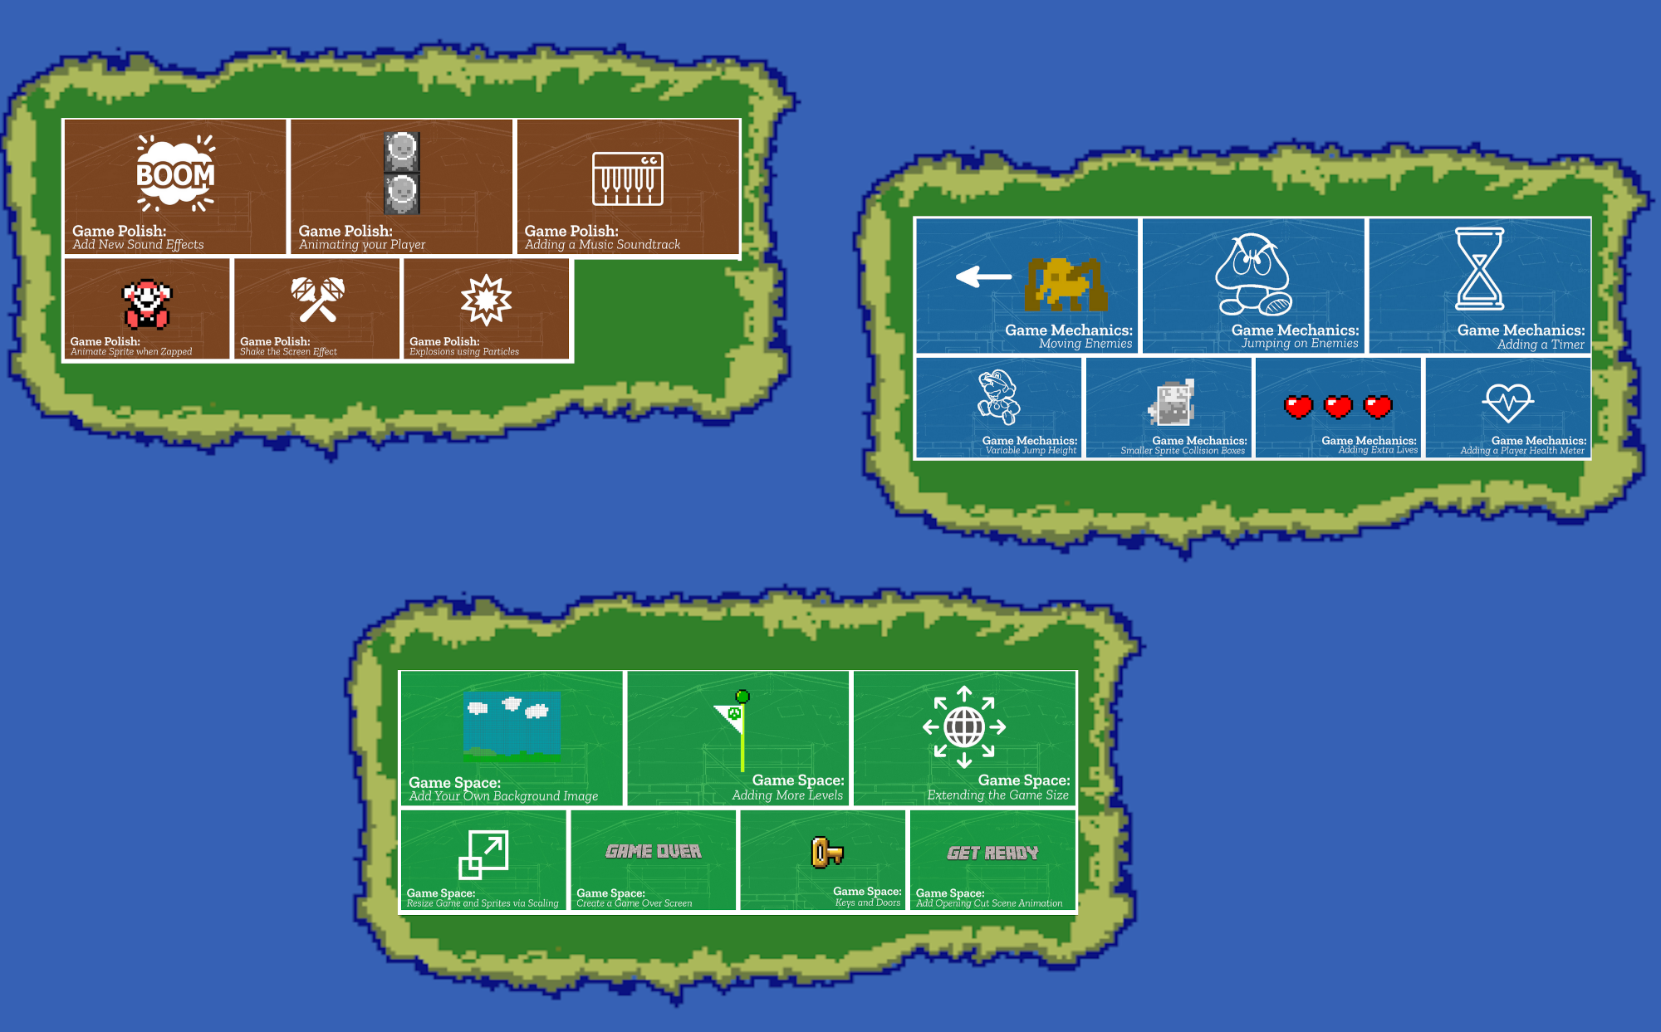 learning islands Missions as Islands
Working with learner stress and confusion was something that I struggled with for some time. One source of frustration started from giving learners clear pathway. The freedom to choose what game to create was liberating but then conversations about what was possible with the time and technical ability we had were hard and we did lose some families in this process.
Starting with a template and creating resources to help common patterns helped resolve this tension. However having this menu of choices also created another issue. Increased confusion.
EXAMPLE - ma & fi
Having GDP mapped out had some of the following possibilities.
Maps as an area seems to be the weakest point in this process. I may have neglected this plane as it is normally well explored in other research based in formal settings, and I was particularly interested in nurturing an organically forming game making community.
This section highlights key tensions in the design that still need to be overcome.
It explores these tensions in relation to existing research and contains further discussion to inform possible future directions of research.

Link to next chapter
This chapter has dealt with the evolution of design in initial phases and responses to learner experience to resolve tensions.
Due to the complexity and many moving parts of the design it has been mostly descriptive.
While CHAT provides the technique of highlighting emerging tensions and resolutions, to undertake deeper analysis I will an analytical process proposed by Rogoff which examines learning communities using 3 foci.
This process begins in this chapter with a focus on evolving design and continues in with three following chapters with a greater focus on the learner response to challenges of game making in the recorded sessions.

List of appendices for this chapter

Tensions of the 3M design evolution
https://docs.google.com/document/d/1DRgpgIUfq5XIktYy-lX4WlviUDnffNc0v8SOeLGgHho/edit
<Bibliography: Do Zotero Refresh>

