6. Findings - Game Design Patterns
- Findings: Gam

Introduction
Software design patterns are a grouping of a description of target project behaviour, with a suggested community solution of code structure often accompanied with worked examples (see Chapter 2). While existing research explores the use of game design patterns in educational settings, for instance to aid the transfer of science simulation concepts to other contexts (Basawapatna, Koh and Repenning, 2010; Repenning et al., 2015) or as a foundation for co-design work (Eriksson et al., 2019), there is limited work addressing their role in overcoming challenges faced by emerging communities of game creators using text coding. In the previous chapter, I outlined the evolution of tool use, emphasising emerging tensions in activity. The importance of gameplay design patterns (GDPs) emerged from participant input in P1 and were then integrated by myself into various forms of scaffolding within and graded step of practice including: quick-start activities, instructional tutorials, and code snippet examples. This chapter shifts focus to the perspectives of participants, using recorded data to interpret their varied uses and adaptations of GDP use. In doing so, it addresses the research question: How does CHAT theory help us understand how game design patterns can be used in an evolving community of novice game makers? I describe the use of GDPs as diverse mediational strategies to overcome some of the tensions explored in the previous chapter, not only addressing the use of facilitator-provided resources but also as part of emerging community practices and interpersonal repertoires.
INSERT SUMMARY TABLE HERE (From start of Vignettes document)
Table 6.1: Summary of varied GDP use within the activity of this research
The above table summarises the principal different uses of GDPs in the data analysed. In this table and the structure of this chapter, I employ Rogoff’s three planes of analysis (Rogoff, 1995), as introduced in Chapter Four. This chapter’s sections examine how gameplay design patterns are utilised broadly by parents, children and facilitators, each through the lens of a respective analytical plane. Recognising that these observations do not neatly align with the three planes, I discuss the use of GDPs across cultural activities, interpersonal activity and personal knowledge in three distinct sections.
INCLUDE A MERGED DIAGRAM IF THIS IS REALLY HELPFUL BELOW.
An analogy can be drawn between these three planes of analysis and the examination of activity systems at varying scopes. Specifically, the cultural plane aligns with the community scope of activity described in Figure 5.x in the previous chapter, while the interpersonal and personal planes correspond to smaller scopes depicted in Figure 5.x. A discussion section explores the implications of these findings in relation to existing research and theoretical concepts.

The role of GDPs in the personal appropriation of concepts and processes
Rogoff’s interpretation of personal appropriation is complex communicating the bi-directional nature of the process where individual interpretations of community gained knowledge is remediated and fed back into the community. To avoid duplication with community processes and given the overall focus on social and cultural domains in thesis given the deficit in this aspect compared to studies exploring , this section follows the framing of Kafai and Burke’s (2015, p. 4) review of CGD&P as “knowledge appropriation and transformation that is instantiated in the process of making games”. While in this informal learning context, the overall motivation of participant had a greater alignment with making an engaging game compared to learning knowledge within the computing curriculum. Despite this, the evolving design process resulted in activities which did allow the exploration of computational thinking, systems concepts and other computing concepts.
Kafai and Burke’s review (2015) in its identification of the greater number of studies focus on personal dimensions of learning programming and curricular knowledge compared to the deficit regarding social and cultural aspects, justifies my approach of explore this dimension in less depth. I focus on a limited aspect of personal appropriation in this section to observable novel skills: namely the code patching, debugging and the development of digital literacy skills. WHY THIS?
I am inspired by the the process and rationale of Bevan and Petrich’s (2013; 2015) work to create a map of learning dimensions to a seemingly chaotic tinkering and making process in museum contexts. As such, during early data analysis, with the potential to adapt this learning design to a more formal environment in mind, I mapped out curriculum-oriented concepts that suited exploration via in the game making process of this research. This process resulted in a learning map of curricular concepts included here as Table 6.x. For brief definitions of these terms see the Glossary of this thesis.
Computational Thinking | Coding Concepts | Systems Patterns | Design Practices
Abstraction | Sequences | Systems Elements | Goal Setting
Decomposition | Variables | Systems Dynamics | Being Incremental and Iterative
Pattern Recognition | Logic | Reinforcing Feedback Loops | Developing Vocabulary
Algorithmic Thinking | Loops | Balancing Feedback Loops | Web Literacy
 | Arrays |  | Problem Solving
 | Creating Functions |  | Version Control
 | Change Listener |  | Debugging
 | Input Event |  | Reusing and Remixing
Table 6.x. Learning dimensions facilitated by this study’s game making process
The map of learning dimensions above includes a balance of skills, concrete and more abstract aspects of coding concepts (Appendix.learningmap explores in more detail the evolution of this map). It aims to address tensions in the integration of concepts into an informal context, specifically, a tension or paradox common in project-based approaches in more formal settings, between the an exploratory learning approach and a possibility or need to align with curricular concepts (Hoyles and Noss, 1992). I propose that the play paradox (Hoyles and Noss, 1992) is addressed by orienting the leading/motivational activity of the learning design to be one aligned with the underlying goals of the participants. In this case to add features to their game. I return to this subject in Chapter 7.

The interrelationship of GDPs and the development of personal appropriation of skills and processes
While the above learning map is relevant to the overall process of game making. The main focus of this chapter is the exploration of diverse uses of GDPs within this activity, as such I now explore the motivational and mediational uses of GDPs in this personal plane. The implementation of GDPs can encourage participants to adopt or share technical processes in various ways. These processes were sometimes introduced in a basic form through scaffolded activities, supporting documentation, or informal interactions between peers. The following observations illustrate how introduced processes were adapted and modified by the community.
Code Patching as a guided technical process and the use of GDPs to nurture tactical responses to coding errors
Code patching is a professional technical process to scaffold the application of new features in computer programming (see Glossary and Chapter 2). This patching process became an important element of documentation. Although code was provided, mistakes occurred in practice and additional customisations were introduced. Video evidence and observational journal notes highlight the potential of coupling code implementation with target behaviour, structured within a framework of GDPs. The following extract from Vignette 1 shows an example of code patching in practice. Toby’s careful copying and pasting of different lines of code from supporting materials into his game project (see V1a and Appendix.patching).
V1.5 | Veronica: What was that website called?  Toby: Glitch.  Veronica: With the key on?  Toby: The what?  Veronica: We’re trying to work out how to make the game work. How to get that key and make it unlock that door. | Toby is still playtesting his game and tries to chip in to help Veronica who is seated next to him.  Mick also hears Veronica’s request and attends to demonstrate how to access two different forms of help in the form of code examples and step by step tutorials.
V1.6 | 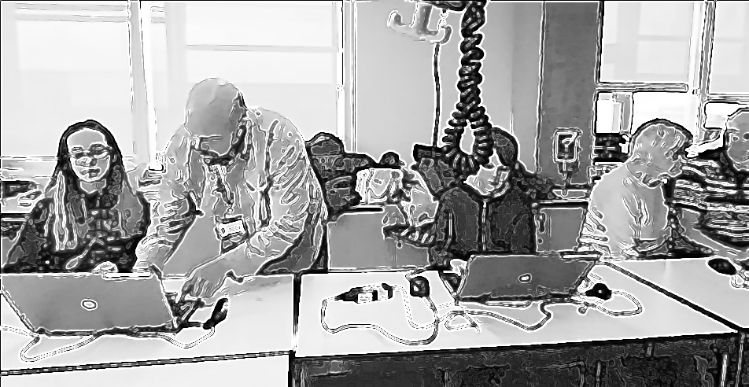
V1.7 | Mick: So we’ve got two ones. Here’s the tutorial and there’s the examples of code so you can compare what you are doing and see where the new code should be placed. | Mick shows different sources of documentation on the screen. The tutorials mentioned at https://en.flossmanuals.net/phaser-game-making-in-glitch/_full/  And a menu linking to code snippet examples at  https://ggc-examples.glitch.me  Meanwhile Toby is playtesting his game.
V1.8 |  | Toby finishes playtesting and navigates to the page containing a menu of game design patterns at https://ggc-examples.glitch.me  He clicks on the image of Game Mechanics - Moving Enemies
V1.9 | 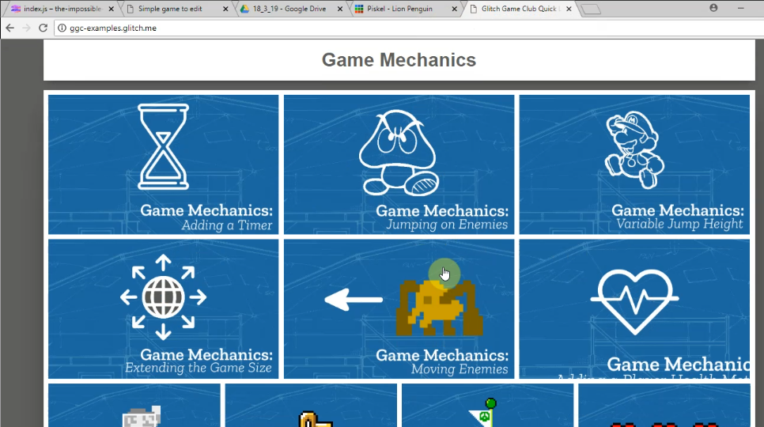
V1.10 |  | This opens up a code project using the same code base as Toby’s existing project.  He takes time to examine the start of code carefully.
V1.11 | 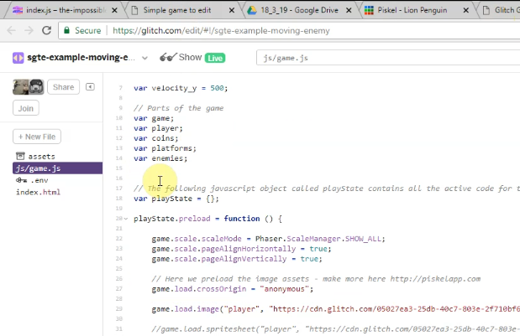
V1.12 |  | Toby then clicks on the tab of his own game code and examines how it is different. He deletes a redundant line in his code.  He returns to the example code and scrolls down and examines the code needed to patch into his game. He hovers over it. He selects half of it and then hesitates. He then rapidly clicks on the Show Live button.
V1.13 | 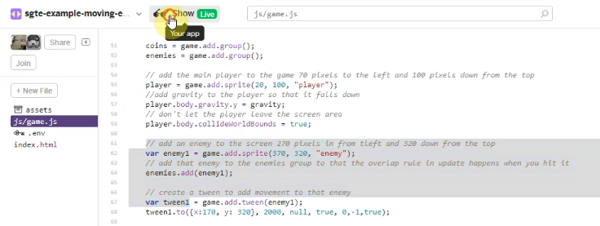
V1.14 |  | When Toby clicks on Show Live this opens up a live preview of the example code in a new browser. Toby plays this example game and avoids the moving red block as he navigates around the screen away from and back into the danger zone of the patrolling enemy (red square).
V1.15 | 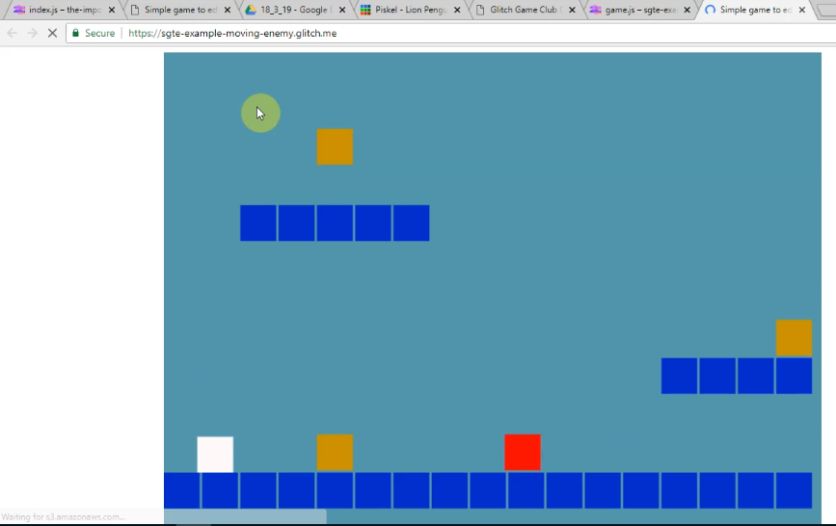
V1.16 |  | When Toby dies in the game he navigates away from this screen and returns to copy the full code needed from the example. He then navigates to the same section of his own code project template. He seems to check this, as indicated by mouse movements checking what was above and below the space he has created. He then pastes the code into this space and then navigates to the live preview of his game to check the result.  The game now shows a new enemy moving back and forth. Toby check his game by playtesting it and struggles to get past this new enemy, failing multiple times.
V1.17 | 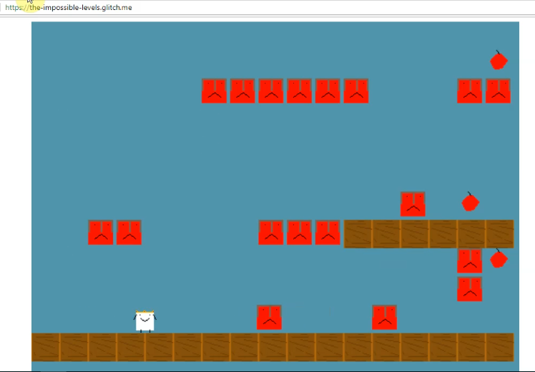
V1.18 | Helper1: How is your game going? Have you got anything else you want to add to it?  Toby: I’m just adding this moving enemy. It’s so much harder. (laughs)  Helper1: You’ve got a lot of enemies going on here. What is it? Is it a sheep?  Toby: I’ve no idea my cousin designed it?  Helper: Has it got a crown on?  Toby: I think it does. My cousin designed it? I’m not that sure. (both laugh) | Toby is approached by a student helper.  As they begin to talk. Toby’s grandmother Pearl turns her attention away from her and Clive’s screen and looks over and looks at what is happening on the Toby’s screen and at the helper.

Toby’s success in using the code patching technique was supported by the UMC based structure of the game template in line with the UMC principles explored in the previous chapter and the high level of contextualisation provided by GDPs as a guiding framework in the learning design. This is illustrated in V1 when Toby alters the imported code producing a type of programming error I refer to as a glitch. This specific error occurs when the game continues to function but exhibits an unintended effect (see V1a). The glitch triggered an initial investigation prompted Toby to seek my assistance and required an iterative process of revision and cross-referencing with the original code snippet. From this and similar observations I propose that the tight coupling between code implementation and target behaviour in this case structured within GDPs scaffolds the debugging process and can be a valuable tool for facilitators.
Additionally the key affordances of the learning design including the starting template code snippets and the resulting code patching process appear to encourage the creation of glitch errors. The data in this section is further supported by observations on the growing diversity of helping strategies in response to different types of errors discussed in Appendix Debugging. I also explain the patching process in greater depth to participants in an extract from Vignette 9 (V9a). In the commentary (V9b) I propose that noticing celebrating and exploring the sources of unintended behaviours may function as an inclusive strategy to mitigate the potentially frustrating process of debugging. Considering the bi-directional process aspects of personal appropriation can also be inferred from the interpersonal interactions explored in the following section.
Digital / Web Literacy
Belshaw?
To integrate new gameplay design patterns or adapt existing ones in their games, participants needed to develop unfamiliar technical processes associated with computer coding, as well as foundational digital skills related to using a desktop personal computer. See Appendix: Digital Literacy for further details. One example of a skill developed by many participants was proficiency in keyboard and mouse use. Combined with the ability to navigate internet browser tabs, this facilitated movement between computer code, game prototypes, and supporting web-based documentation. Such personal appropriation and increasing fluidity are well illustrated in Toby’s repeated, solo, incremental changes to level design, as seen in Vignette 1.a. Most participants demonstrated increased fluency, particularly in areas such as creating, uploading, and integrating graphical assets, adjusting game challenges by modifying GDP elements, and engaging in coding processes such as debugging and code patching, which is explored in later sections. In line with CHAT theory, this can be interpreted as the gradual operationalisation of actions that initially required more explicit guidance, as discussed by Leontiev (Leontiev, 2009).
While the use of new techniques was driven by the implementation of GDPs, the following observations reveal a complex, interdependent relationship between GDP concepts and emergent technical processes. In line with Rogoff’s understanding of personal appropriation as a bi-directional process, where the appropriation of personal knowledge is shaped by and contributes to a broader sociocultural context, participants actively contributed their interpretations of knowledge back into the communities they belonged to.
In this case, the community in question was the game-making community. In this process, GDPs functioned as both conceptual tools and structured project stages, facilitating interpersonal knowledge exchange, as explored in the following example. In Vignette 5 (sections V5.a and V5.c), Madiha(p) seeks assistance from her daughter Nasrin to format and export graphical files for use in the game code project. The implementation of her chosen GDPs drives the development of these technical processes, as she must either learn them herself or draw on peer knowledge to complete the task. For instance, changing pen colours in the graphical tool is a process that Nasrin has already internalised and performs effortlessly, whereas Madiha is still deliberately working to build her competency. Nasrin has fully operationalised the process, incorporating it into her repertoire of practices. Similarly, in section V5.d, Madiha receives help from a peer, Ed, in using the cropping tool to remove redundant space at the edges of sprite characters after he playtests her game.
There is a cross over here with guided participation, and this aspect is explored in a later section on this chapter.

A SORT OF CONCLUSION / LINK.
It is of value to compare the observational process of creating the learning map to the more intentional, concept-driven design approach described in research on Microworlds, which foregrounds the role of learning designers in shaping the affordances of (playful) learning environments to steer learners toward exploring curricular concepts. In much of the Microworlds research, these are often scientific or mathematical concepts: take, for example, geometry in Turtle computing with the LOGO language (Ernest, 1988).
There are similarities between this design and the structural constructionist techniques involved in designing Microworlds [Laurillard], However, as the leading motivation of this study is the creation of and acculturation to a game-making community, the process can be seen differently. Take code patching for an example, the design is oriented to support this practice which is taken on, however this is a procedural skill rather than more abstract knowledge. This is not to say future iterations of this design could not facilitate the exploration of abstract concepts more explicitly. For example, there is significant potential to explore systems thinking concepts (see appendix.map). Indeed, similar work using the Game Start Mechanic software takes such an approach.
LINK ?

GDPs used in the process of guided participation
This section examines data on the use of GDPs from the perspective of interpersonal interaction. Here, the process of being guided into planned activities or peer collaboration is exploratory, contributing to interpersonal processes that facilitate the completion of tasks. As outlined in the previous section, personal understandings of knowledge can be observed within these interpersonal interactions, particularly in exchanges between parents and children. Based on observations of video data, I describe how GDPs are employed in diverse mediational strategies. I focus on three key categories of interaction that incorporate GDPs: the use of a provided menu of GDPs and supporting documentation, the role of GDPs in project ideation and prioritisation, and their function within the division of labour.

Use of a menu of GDPs to assist project navigation and resource organisation
Chapter 5 introduced my provision of a curated collection (menu) of gameplay design patterns to address the tension between participants’ choice and the need for documentation to support the technical implementation of code structures. Appendix.themeing outlines the evolution of how the sub-categories of patterns developed and the rationale guiding them. In Vignete 9, I address the whole group, describing the webpage presenting the menu of GDPs as a hub to help choose project goals and locate tutorials and code examples. “It’s almost like this is our control panel. You decide what you want to do next and we jump off from there.” In this section, I summarise data on the use of the menu of GDPs, focusing on interpersonal interactions.
Toby, in Vignette 1 (see V1.8–V1.17), engages in independent work, copying code from a snippet example of the game design pattern he selected from a graphical menu of patterns. His ability to choose and implement new features using supporting documentation enables him to take on the role of a mentor, inspiring and assisting others in adding the same GDPs to their games (see V1.b). Toby’s independence and effectiveness in this process align with existing concepts, including the use of shorter, just-in-time tutorials to reduce barriers associated with more extensive instruction-based approaches, particularly those related to literacy (Resnick and Rusk, 2020; Dietz et al., 2021).
Vignette 2 (V2.a) observes parent Susanna (p)‘s use of a tutorial to address the goal of implementing her child’s chosen GDPs. Susanna, who is limited in her programming skills, leverages the concept of GDPs, particularly to access written step-by-step instructions to make progress. She prefers to avoid seeking facilitator help (see V2.b). The participants’ choice over which GDPs they tackle can create a personal connection to these goals, a process that may help reduce feelings of alienation from coding or game-making culture (see Tehillah’s positive reaction in V2.a and V11).
While the evidence supports the potential of a menu of GDPs to address the tensions between choice-based approaches and the danger of a lack of relevant scaffolding, there are some important clarifications to make at this point. Firstly, not all participants engage with this menu: a later section shows how GDPs picked up by one learner, via provided documentation (e.g., Toby), are propagated in other ways. For example, in Vignette 3 (V3.a), Ed cedes this aspect to his father in a way explored in the section below on division of labour. Secondly, there are potential issues concerning the validity of observations on the use of the GDP menu (and concepts) as navigational and organisational tools by participants, due to their nature as being introduced for that purpose. The danger here is of circular reasoning in methodology. At this early stage, this study acknowledges the potential of circular reasoning but observes the potential of GDP adoption and, in particular, the evolution of practices by participants. In addition, this process of using GDPs in this way was also discovered via an exploratory DBR approach, and thus its introduction is also significant and cannot be divorced from the aspect of participant reaction. Additionally, the potential of GDPs as a germ cell concept (as explored in Chapters 3 and 5) is explored in greater depth in the following chapter.

GDPs used to scaffold ideation and prioritisation processes
Addressing the tension between participant choice and scaffolding via menu of GDPs, my journal notes on the shift from P1 to P2, I noted that the provision of this menu of GDPs significantly decreased in time spent in the ideation phase by providing scaffolding and restricting choice. Beyond this immediate impact, this section outlines how the use of GDP concepts and supporting tools were used in ideation and project organisation, specifically: as a lingua franca, as a visual prototyping tool, and within participant gestural interaction.
Video data surfaced frequently use of GDPs terms as a lingua franca to organise and prioritise game making activity. An exchange from Vignette 3 between participants Ed and Mark shows the use of GDP concepts to help resolve a tension between a more chaotic style of working jumping from one goal to another and a parental motivation to prioritise work. The pair’s initial listing of features is a brainstorming technique using the approximate names of game design patterns (get the person animated, get an enemy in, changing the platforms, make a theme tune). The vignette analysis sees the parent overwhelmed with the child’s lack of focus on one pattern “that’s what I mean, you can’t just skip around like that.”
In Vignette 7 (see V7.a), home-based knowledge of GDP mechanics is utilised on an interpersonal plane, with Dan(p) helping Toby(c) via guided facilitation to provoke and shape new design ideas. Dan(p) draw on the game playing experiences to promote innovation in the design of the existing template: “the previous style of game was a platform (makes shape with hands) game wasn’t it? You went along and there was gravity pushing down. There are other types of games aren’t there?” The pair use their knowledge of game play patterns and genre conventions to break out of the genre constraints of starting template. Here they are charting new territory beyond the curated choices of GDPs and as such may not have vocabulary to express concepts. Both Dan and Toby make extensive use of gestures in their interaction reinforces their spoken references to GDP concepts.
In the same vignette (see V7.12-16), Toby uses the code based tilemap tool to design a maze game instead of a platformer game drawing on existing knowledge of tools and home knowledge of the target game genre to rapidly make revisions without extensive planning. This use of GDPs to allow the spacial exploration of design in a visual and intuitive way suits being mapped onto paper, or onto graphical software which allows for a similarly rapid prototyping. By way of contrast, other pairs take advantage of paper prototyping (see Appendix.prototyping). For example, Susanna(p) notices the child’s difficulty in using cursor and delete/backspace keys to edit a matrix allowing level design. The parent provides a book with grid paper to allow the child to replicate the matrix. The parent is then able to transcribe the design to the code example while engaging the child by checking she has interpreted the design correctly. The use of GDPs to support visual prototyping is also undertaken by Mark and Ed explored in more detail in Appendix.tech.prototyping
To end this section, it is of value to link this use of GDP terminology and visual prototyping techniques to existing research on the development of shared language to support joint work and guided participation. While much research on teaching coding addresses the benefits of collaborative approaches (see Chapter 2), fewer studies outline strategies to facilitate such joint attention (Brennan, 2009). The work of Stahl and others (Stahl, Koschmann and Suthers, 2006) within the fields of technology use and collaborative learning is relevant here to highlight the importance of language development and the intersubjective interpretation of visual prototypes and gestures as tools in building mutual understanding in the kind of joint problem space we see in this study. Returning to Kynigos’s interpretation of the half-baked game as a boundary object facilitating communication (Kynigos, 2007), we can locate the diverse forms of GDPs as such boundary objects at a scope of greater granularity.

GDPs aiding the process of division of labour (1400)
Addressing division of labour on an interpersonal plane, participants worked mostly as pairs or individuals, alternating between community playtesting and pair/individual design work. Turning to the use of GDPs specifically in DoL as an organisational strategy, structuring work processes through implementing modular sub-projects in the form of GDPs can aid division of labour. GDPs feature in processes division of labour in a variety of ways: working knowledge of different types of GDPs can help participants to divide work by working on different patterns or taking on project elements within patterns.
In Vignette 3 (V3.a), Mark(p) repeatedly steers his son Ed to pick one GDP for them to carefully work through the associated documentation together, a process he later refers to in interview data as plodding . Early in that session Mark takes a significant amount of time puzzling over documentation on how to add animation to a character. This results in Ed being blocked from progressing and to address this tension child proposes dividing their labour and workig on two separate computer (see V3.9 “Why don’t you go there for a computer and you can do that?”). Ed appears to make a tactical decision allowing the father to specialise in GDPs that involve deciphering technical instructions, whilst he engages with a pattern that involves creating audio and graphical assets in a less technical, more exploratory process.
While in this case, a decision was made to work side-by-side on the same game using different computers, data uncovered other ways in which the participant divided the process of game making, in ways which uncovered traces of home collaboration practices. For example, In Vignette 2, Susanna(p) and Tehillah(c) relied on the parent to do the majority of code implementation but shared one computer. The parent took a lead on many activities but took care that they alternated between use of keyboard and mouse to give the child hands on experience when possible, particularly in level design activities and playtesting (see V2.7). In interview data (see V2.b), the parent notes “I resist the urge to fix things immediately when she struggles.” In another exchange (see), Tehillah (c) uses the name of a GDP within a request for her parent to take on a specific task within their making process, “Go on then. Key-Door person.” When the parent expresses confusion Tehillah gestures with her hands to indicate that her mother is the person she is referring to. The child appears to consider the level of complexity needed to add a new pattern into the code to be beyond her ability and thus directly delegate the task to her mother. At times Susanna(p) asked Tehillah(c) to seek help from facilitator (V2.1). On another occasion when the child appeared bored of waiting for parent to solve a code problem, she approached the facilitator to ask for help on behalf of the adult without prompting. At other times Tehillah(c) engages more peripheral activities such as watching older children playtest each others games, or observing community activity from under the table.
Madiha’s(p) family Nasrin(c) and Zidane(c) are all working on separate games on different computers. While Madiha sits next to Zidane who needs closer support, Nasrin often sits close by but next to a friend. In Vignette 5, as part of her process of building an emerging identity as a graphical asset designer (see V5.b), Madiha calls across the room to draw on Nasrin’s help to correct a design mistake. Nasrin affects reluctance in her support of her mother (see V5.a), but at other times shows that she enjoys her status of technical supporter (see V5.d). Nasrin appears reluctant to explain the technical processes she uses to help her mother:
“Madiha (to Nasrin): What are you doing? You have to tell me what you are doing so I can do it myself.” This may be driven by a desire to preserve this specialist status and utility to her mother.
Toby adopts different working arrangements dependent on which family members he attends with. While in P2 when supported by grandparents Toby had worked mostly alone (see V1), in P3, he works as a pair with his father (Dan) in closely guided practice (see V7.b). In several interchanges, the father starts as a facilitator, taking a lead from the direction of the child. As the child reaches the limits of their ability, he begins to be more directive, by asking leading questions and testing existing knowledge. Finally, in order to complete the programming or research tasks beyond the child’s knowledge, the father is more direct in instruction, directing the research and proposing a coding solution for their new game design pattern. Dan’s experience as a software engineer and volunteer at Coder Dojo (see glossary) is relevant as a fund of knowledge he draws on (see V7.a and later section).
While the context of the participants as families involved in home education makes any general claims difficult, these observations support findings in other research in this domain. For example, research shows that children have the potential to help parents as technology brokers (Correa et al., 2015). In joint technology work, parents can fulfil several reciprocal roles including collaborator, resource provider, learner, non-technical consultant, and emotional support (Barron et al., 2009). Thus, in response to the creative support that parents and siblings provide, facilitators should design learning environments to facilitate these possibilities. The work of Roque provides guidance for helpers in the process to support parents to value and feel confident in these roles (Roque, Lin and Liuzzi, 2016) in a way which mirrors the use of helpers in this phase of my study (see Chapter 4). While these examples involve GDPs, others are explored in relation to the development of agency in the following chapter. The examples above illustrate part of some of the varied strategies to divide labour adopted by participants at times involving complex tensions in activity. For example, Madiha and Nasrin reversed the traditional helping relationship, and the child would reluctantly implement the parent’s requested technical elements of GDPs but would pointedly not explain the changes made, seemingly taking pride in knowing something that her mother didn’t.
Similarly, while Tehillah’s activity away from the screen while non-productive within the scope of technical progress, can be characterised as legitimate peripheral activity of observation of community activity (Lave, 1991 ; Rogoff, 2014). Indeed the possibility for children to not engage in community activities is seen by Rogoff (2003; 2016) as an important characteristics in participation based models of learning.
The variety of repertoires of helping practice depends in part on the different funds of knowledge the parent has access to. Toby and Dan’s pair process is more guided and focused than many other participants and includes accessing professional documentation and exploration of computational thinking concepts. While the helping pattern of researching and accessing technical documentation is available to all pairs, due to the level of skill and experience involved, other technical processes are developed by most participants and are explored in the next section.

Discussion of GDPs not aligning with design cycles
A possible existing framework on CGD&P to address the process of organising or scaffolding guided participation is that of design cycles. However, observations of participant design behaviour did not align with common design thinking concepts or advocated in design cycle frameworks (Resnick, 2007; Wi̇Narno et al., 2020; Dam, 2024). The stages were instead fragmented and sometimes happened in parallel. In many interactions, I observed improvisational approaches which incorporated ideation, planning, implementation, and testing in the space of a minute or so. As typified in vignette 1 and 5, some younger participants, in particular, developed impressively fluid practices, demonstrating extremely rapid shifts between code editing, game testing, authoring assets in online tools, and migrating files, often while talking with peers. Some older participants also showed rapid, responsive creativity. Grandad Clive quickly incorporated a boost to player health after a level after being given feedback during playtesting. If I had encouraged participants to follow prescribed design stages, this may have restricted this flexibility in practice (Kuby, 2016).
In Vignette 4 (see 4.c in particular), we see Ed(c) break out of the more restrictive approach of plodding that Mark(p) advocated for to engage in experimental, improvised design processes with no clear end goal. Mark (p) later joins in Ed(c)’s exploration of sound-making software. They start a process of tinkering and messing about with the capability of music-making tools in a way that spurs creativity. In this case, the joint improvised process sparks a new proposal to incorporate the two soundtracks they create in distinct levels.
Other pairs often adopted a similar spirit of collaborative improvisation. In V7 Dan(p) makes a suggestion - “Use paper to design?” - to which Toby(c) replies, “I’m just going with it.”
These examples and many observations in this chapter show a variety of ways that GDPs assist division of labour, and Thus, rather than design cycles a more flexible understanding is needed.

Use of GDPs in the cultural plane / community level of activity
Following Rogoff’s (Rogoff, 1995) three planes approach to analysis, the following section explores the use of GDPs at the community plane of activity. While Rogoff’s earlier analysis of activity on a cultural plane emphasised the metaphor of apprenticeship, focusing on an already existing community, her later work with Gutiérrez (Gutiérrez and Rogoff, 2003) places greater emphasis on cultural activity as dynamic. This perspective examines existing and emerging norms and repertoires, adapted from participants’ engagement in other communities and contexts.

The role of GDPs to facilitate learners to design for others
The use of GDPs, particularly during playtesting, can support the process of imagining end-user experiences. This section examines how the concept of, and experience with, implementing GDPs encouraged participants to envision the experience of end users of their games. Chapter two explored the proposition from professional and participatory design processes that design should be informed by end-user experience (Redström, 2006), as well as the challenges involved in undertaking such an “operationalization of empathy” (Surma-aho and Hölttä-Otto, 2022, p. 1). From a CHAT interpretation, this process involves shifts in perspective by participants as they engage with objectives across different scopes of activity.
For instance, in the vignette below, Tehillah (child) pursues a quirky design goal during her paired design work, which Susanna (parent) resists. Imagining a shift in perspective to the intended audience at a community level of interaction, the parent aims to ensure a sense of challenge for the imagined player.
THIS IS EXPLORED ABOVE - MOVE THIS TABLE?
Dialogue | Activity
Susanna Are you putting one in your third level as well?
Tehillah: Yes and then I’m going to make more levels | Tehillah Smiles at Susanna and then looks away for a short while
Tehillah: You do this bit
Tehillah: And then delete those H’s. And in there.
Susanna No. No.
Tehillah: Then, let me do it. | (off screen) Tehillah takes over the keyboard
Susanna It’s no fun having a game with any hazards to avoid.
Tehillah: It is for me!How do you go that way back?So sorry for deleting…They just… | (on screen) Tehillah deletes hazards in Level 3 of game
Back Back BackO O O.Back O (giggles) | (laughs) replaces another)(on screen) Tehillah adds three coins to Level 3 by inserting o in the matrix
Susanna: Goodness me what was the point of designing our car with fumes if we’re not going to use it?Tehillah: I don’t know (sighs)
Susanna(p)’s alarm at the child’s deletion of all elements of hazard shows she has too keen a sense of game balance to ensure a sense of challenge for the imagined player. “It’s no fun having a game without any hazards to avoid.” The child seems determined to remove all hazards. My understanding is that she is also aware of implications for game balance but is taking pleasure in this act of creative transgression of convention. In contrast other participants created extremely challenging or impossible game levels that frustrated other players.
Susanna shares “Must be quite hard to get through that door.” when Tehillah places the exit door high above a platform. She then continues, “It’s no fun having a game without any hazards to avoid.” Tehillah (child) seems determined to remove all hazards. “It is for me!” she counters. She may be aware of the implications for game balance but takes pleasure in this destruction of the key challenge of the game as an act of disruptive play. However, a later interaction with a peer shows that Tehillah (child) is indeed imagining the experience of the immediate audience of fellow game makers and supporting students. “I like making it frustrating. That other people find it frustrating!” Tehillah (child) notes the persistence of a student helper who pushes past her frustration to complete the game. Her remark, “If people tried hard they would get to my level,” shows her awareness that not all players will persist in the same way to reach her final level, which has only rewards and no hazards. This being a “secret, special” experience, which plays against the norms of platform game design, is thus intended to provoke player surprise.
The examples explored above serve to highlight two dimensions of the use of GDP concepts to facilitate the process of designing for others. The first is the influence of making in a cultural setting where regular playtesting by peers occurs on the making process. The second is through either direct advice by pair partners and peers in playtesting to imagining others’ user experience, or indirectly by gameplay feedback or suggesting alterations to GDP implementations. This research is in line with other studies which explore the potential of tangible, public digital products as both a motivating and focusing factor in computer-supported collaborative learning (Fields, Vasudevan and Kafai, 2015; Xambó et al., 2017). The results here help address a deficit of results in this area (Silva, Mendes and Gomes, 2020).

GDPs can facilitate the use of wider funds of knowledge and interest
Existing research outlines the motivations for social making incorporating gaming cultural elements (Gee, 2003; Itō et al., 2010) and the ability to make personalised game assets and narratives, which sustain engagement in digital making projects (Sefton-Green, 2013). GDP concepts allow participants to share and explore funds of knowledge and interest (Esteban-Guitart and Moll, 2014; Fasso and Knight, 2020) related to gaming culture (Itō et al., 2010; Livingstone et al., 2018) in the emerging learning community. Research related to project based learning (PBL) benefits of working with participants’ home interests with project work include to motivate participants in initial stages (Swirski, Baram-Tsabari and Yarden, 2018; Penuel et al., 2022), sustain activity and overcome problems in order to share the personalised object created (Barron, 2006, 2010).
Given the gap in research for appropriate frameworks to facilitate the process of allowing participants to explore FoK cited in Chapter 2, I propose that GDPs are a suitable framework to facilitate a choice based approach in this domain. In addition, the subdivision of GDPs using the MDA mechanics, dynamics, and aesthetics) framework (see Ch.2 and Glossary) as a way of providing varied learning pathways and thus align with characteristics of inclusive pedagogy (UDL) (Sanger, 2020).
The different types of GDPs available to participants to choose from in the menu of GDP documentation and code snippets allowed for a choice in participant making paths, enabling alignment with home interests. This point is well illustrated via the domain of polish/aesthetics in Vignette 5, where Madiha and Nasrin show identification with the graphical-making process and the process of bringing that aspect of creativity into their games. Beyond their internal family interaction, they share this artistic flair and attention to detail with the emerging learning community.
In another example, Mark and Ed designed a game around the character of a train driver that needed to collect coal. In subsequent post course interview Mark describes the impact of the child feeling like they could bring their own identity and interest into the project. “I know just your eyes lit up when you realised you could expand your interests into gaming.” See Appendix 4.x (Mark and Ed working with home interests)
Another pair Clive and Pearl, the grandparents of Toby, included a narrative message at the start of their game surfacing the interest and expertise of the family as beekeepers (see V6). This sparked interesting conversations with other participants.
In addition to issues of aesthetics, home knowledge of game mechanics and dynamics (the M and D of the MDA framework) also contributed to emerging cultural repertoires.
As explored in the previous section, Vignette 4 gives several examples of participant feedback on the dynamics of Madiha’s game in the level of the challenge experienced by players.
ADD TRANSCRIPT EXTRACT? Peers shared their experience of what makes a good game to bear in the feedback they shared. Turning to the area game mechanics, In see V1.b Bertie(c) comments on Toby(c)’s game, which has a dominant game experience of timed jumping: “It’s like parkour in Minecraft but timed. It’s like playing the game Wipeout. Have you ever played Wipeout?”. Parkour in Minecraft and Wipeout are both game experiences whose main gameplay mechanic is about judging jumps and landing accurately. Bertie makes links to his existing experience of games, making comparisons between Toby’s game, commercial games, and his own. In doing so, Bertie is able to show his knowledge and analysis of gameplay patterns. Additionally, the guidance of Dan(p) for Toby(c) explored above in Vignette 7, saw the parent explicitly drawing out the child’s home knowledge of games to enable an exploration of a different set of game mechanics. Thus, the tacit knowledge of GDPs of children and adults as game players serves them in knowledge-brokers roles in the process of feeding back and ideation (Wenger, 1998).
The previous examples have outlined how participants used GDPs in incorporating graphical, audio assets, and narrative elements into their games. In Chapter 5 and Appendix.tech.gameframework I outlined the use of the MDA (mechanics, dynamics, and aesthetics) framework to theme the presentation of GDPs. I propose that this subdivision of GDPs scaffolds participants to elect to follow varied learning pathways based on their home interests in a way which align with characteristics of the inclusive pedagogy universal design for learning (UDL) (Sanger, 2020). Specifically, providing resources which allow exploration of providing multiple means of engagement with the learning process
The MDA framework can be profitably examined from the perspective of superficial and underlying characteristics of game elements. Thus those less intrinsically interested in the game play feel or challenge can engage with aspects of the game more aligned to other media projects in terms of the cast of characters the narrative of the game or the aesthetics of the graphical or audio design of the work.
DVELOP THIS A BIT OR LINK TO ANOTHER BIT EXPLORING THIS
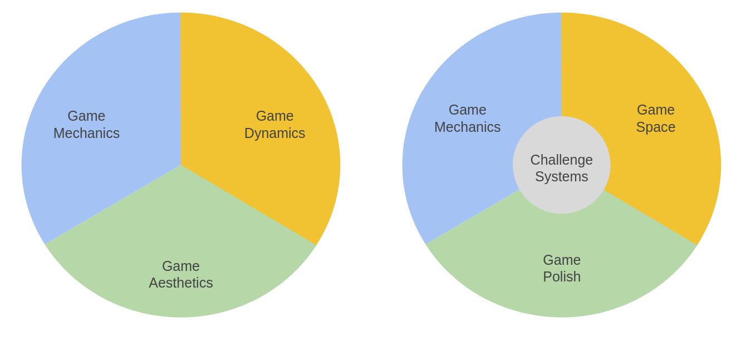
Illustration 6.x - MDA as an additional framework promoting multiple means of engagement - mapped to an grouping of GDPs
These findings align with existing constructivist research which highlight the motivating potential of incorporating home interests in games, coding and media projects (Papert, 1980; Resnick, 2012); (kafai_constructionist_2015?), and socio-cultural research on the tactical use of FoK to overcome barriers to technical environments (Moje et al., 2001; Gutiérrez et al., 2019). While existing work on computational design patterns by Repenning et al. (Repenning et al., 2015) addresses the value of progressive scaffolding to support the engagement of learners, it does not address any aspect of choice when of drawing on FoK when creating games.
As such, the use of GDPs collection here and within that a careful structuring of patterns using and adapted MDA framework () facilitating participants to follow different strands of home interests is a significant contribution to the design knowledge with in CGD&P.

Evolution and propagation of GDPs concepts
The implementation of popular or novel GDPs by participant pairs or individuals is often spread through peer activity. Both documented (those part of provided resources) and novel GDPs (those introduced by participants) were transmitted between participants, enriching the games of participants. At times, participants were influenced by playing the games of others, and at times, they would request the direct help of peers to implement GDPs in their own games.
ADD TRANSCRIPT EXTRACT? In Vignette 1B, Toby’s work adding 21 levels to his game is noticed by Bertie who then asks Toby, “Can you show me how you add more levels onto yours?” The full exchange shows an example of the propagation of GDPs emerging from the process of community playtesting through a direct request. It is possible that Bertie’s request to Toby is prompted by Bertie noticing Toby helping Nasrin and Harper add levels to their games. Toby’s emerging role as a specialist that the community can draw on for practical help, and similar examples (see also that of Nasrin in Vignette 5), were welcomed by me as a way to reduce dependence on myself as a facilitator, or to provide an alternative to the instruction-based support documents.
Turnign to evolution of patterns, the concept of a safe zone in the game of Pearl and Clive arrived as a direct result of adding many moving enemies in a way that it became essential for players to quickly identify and use ‘safe zones’ where enemies did not reach. This novel is concept, became used frequently in the playtesting of that game and that of others.
Once concepts like safe zone or bonus level enters the linguistic and coding repertoire of this community of game makers, either from documentation, home gaming knowledge or genuine innovation, it became available for propagation for take up by other participants.
As explore previously in Ch.5, to prioritise participant engagement, I avoid a principles-first instruction approach (either to the whole group or to individuals). The use of documentation followed just in time principles or was not needed as participants engaged in the kind of peer learning described in this section.
The data shows other examples of organic emergence of novel GDPs and related design concepts beyond those offered in the menu of supporting documentation. Tehillah’s concept of a level that eschews challenge and offers only rewards (see Vignette 2 and table above) emerged through playful experimentation. While this idea was experimental and novel for the child and was not included in the scope of presented patterns, the idea exists in popular platform games (see Flicky and Super Mario Brs). ANY COMMENT?
In contrast other participants created extremely challenging or impossible game levels that frustrated other players.
DEVELOP THIS OR MOVE They seem to take pleasure from ignoring concepts of what should be done to maintain game balance and from the sense of shock from their current audience her parent. Going against this convention is a type of playful destruction in this context. The process mirrors play theory concept of playing against the game or dark play (Sutton-smith, 2001).
The preferences shown by some for peer learning and convention breaking became a part of the emerging culture of the game making sessions.

GDPs as components of emerging repertoires in an evolving idioculture
This section uses the term idioculture (Cole and Packer, 2016), a local, non-geographical, non-demographic community where culture emerges via valued behaviours (Lecusay, 2015), to examine the role of GDPs as component parts in the emergence of a community culture.
Aspects of idioculture stemming from GDP use have already been described above, in aspects of peer learning, use of home interests, etc.
evolving culture of playfulness and social interaction
To creating a relaxed environment I led by warm up games at the start of sessions in P1 regularly and at the start of P2. Regular playtesting which was open in scope allowed for natural play to emerge. For many younger participants, the game making time involved may playful interactions and was an important, perhaps even primary, motivation to attend. Playtesting was also used as a social time for adults, conversations about x and y.
Community norms of gameplay began to develop, some of which were influenced by home experience of game playing. The discussion of game challenge, specifically comments about how ‘hard’ participant games were, was a particularly common interaction during playtesting. Vignette 4 (V4.a) outlines the community norming of Madiha(p)’s game to conform to expected standards of a platform game. The vignette shows varied attempts to influence Madiha to change the game variables to make controlling her player avatar less frustrating. There is an apparent tension in play here between encouraging individual agency of expression within the game and an evolving community tendency to norm peoples games to be more playable. The indirect norming behaviours described in Vignette 4 (V4.a) mirror observations seen in the work of Rogoff and colleagues (Rogoff, 2003) on learning in community settings. DEVELOP THIS VIA LINK?
LINK This section is short as this aspect is explored in more depth in Chapter 7. These examples are emerging process where cultural concepts are mutually constituted by different actors involved in the game making activity system. While the concepts of hardness and challenge that emerge and not concrete examples of GDPs used as mediation, rather an examples of blending of users FoK about gaming norms meeting feedback processes. The next chapter explores similar concepts of blending of practices to create new aspects of the emerging idioculture.

Discussion
This discussion section discusses the complexity of the exanded object of activity and the diverse mediational uses of GDPs using a 3GAT framework. Bearing in mind the challenge of communicating the diverse motivations and forms of activity involved, it returns to concepts of proximal flow and computational fluency present in CGD&P research to begin an analysis of how this research can contribute to understandings in this domain.

Addressing the use of GDPs in relation to theoretical understandings of processes of mediation and expanded objects of activity -
This chapter has also addressed the complexity of activity by focusing on the germ cell concept of GDPs used in a variety of ways, a summary of which has been represented in table form at the start of this chapter.
As such a fuller table summarises interpretation of the diverse roles of GDPs in the game-making activity using CHAT concepts. The right column lists example behaviours and notes vignettes or appendices where the behaviour can be found in situ with more detailed analysis.
Chapter 5, via a design narrative of the pedagogical design used, exposed tensions where existing mediational strategies or tools were insufficient, and thus innovative forms of mediation were needed.

GDP usage in game making | Description (using CHAT concepts) | Examples in data – click links to move to evidence in vignette
Personal appropriation:
GDPs used in appropriation of personal knowledge. | Facilitators can use existing and planned GDPs to surface computational, design and systems concepts embedded in games.  Beyond curicular knowledge, participants demonstrate concrete and varied design knowledge.  Careful template design can aid experimentation with game dynamics via rapid prototyping techniques.  The implementation of GDPs can stimulate participants to adopt or to share technical processes. | Personal appropration of learning map concepts: Error: Reference source not found, Appendix.learningmap  Fluidity of design operations: Error: Reference source not found, Error: Reference source not found,  Use of code patching and code snippets in V1  Debugging in Vignettes 2, 1,  Present in x out of y coded sessions.
Guided Participation / Interpersonal focus

GDPs as a framework for supporting resources and navigation | The restricted set of GDPs can serve as a framework for code examples and step-by-step tutorials. Presentation of documentation of GDP implementation as a menu or collection can facilitate flexibility of learner pathway and diversity of end design and without restricting access to resources beyond programme based support | Use provided of step-by-step docucmentation  V.2 , Error: Reference source not found  Use of code snippet examples: V1  Utility of a graphical menu and map of GDPs: App.theming  Present in x out of y coded sessions.
GDPs used to scaffold ideation and prioritisation processes | GDP concepts can guide ideation processes in diverse ways including: use of GDP terms as shortcuts in ideation and prioritisation, the use of visual code structures | Use of GDPs concepts by participants during ideation: V2,3 ,Error: Reference source not found  GDPs altered via visual prototyping: Appendix.prototyping, Error: Reference source not found  Discussion of GDP dynamics facilitated by template game structure:  Present in x out of y coded sessions.
GDPs used to aid the process of division of labour | Participants can split work and resolve working blockages by allocating different GDPs or parts thereof.  The use of GDP concepts as a lingua franca and the sometimes modular structure of GDPs help the division of labour as participants to divide work by working on different patterns or taking on project elements within patterns, sometimes building specialisms in the process. | Dividing work between pairs by pattern based on difficulty or aptitude: Error: Reference source not found, Error: Reference source not found  Alternating between coding tasks and other non-coding tasks in Vignette 2.  Parents shifting from facilitating role to a more directive role: Vignette 7  Present in x out of y coded sessions.
Cultural activity focus
GDPs can encourage learners to design for others | Referring to the impact of implementing or changing GDPs can help scaffold the process of imagining the end user experiences. | GDPs used to stimulate awareness of designing for others: Error: Reference source not found  Present in 8 out of 12 coded sessions.
GDPs facilitate tPERHAPS DO A SUMMARY TABLE AT START OF THE CHAPTER AND A FULL TABLE HERE? he use of wider funds of knowledge (FoK) | Three dimensions of GDPs (mechanics, dynamics and aesthetics) can be used by participants to share and explore FoK and other interest within the emerging learning community. | Via incorporation of home interests and FoK in game narratives: Error: Reference source not found  and assets: V6.b  Coding and documentation practices: Error: Reference source not found  Bertie’s sharing of knowledge of game mechanics in Vignette 1b  Present in x out of y coded sessions.
GDPs are propagated into the community through playtesting | New GDPs emerge often from the merging of home knowledge, technical processes and existing patterns.  The implementation of popular or novel GDPs by participant pairs or individuals is often spread through peer activity. | A popular GDP implementation becomes a subject of community activity: V1b  Present in x out of y coded sessions.
GDPs as components of emerging repertoires in an evolving idioculture

The examples in this table show GDPs are used in diverse ways by participants, peers and facilitators, as principle or supporting parts of mediational strategies including as as a lingua franca, as a motivational element, or as a way of structuring the learning experience and supporting resources.
The findings expose complex activity which presents challenges in terms of graphical representation using 3GAT methods. The uses of GDPs within the quick-start activities, tutorials, and code snippets as supporting tools, if viewed in isolation, can be seen as a triangular form of mediation involving subject, tool, and object mediation .
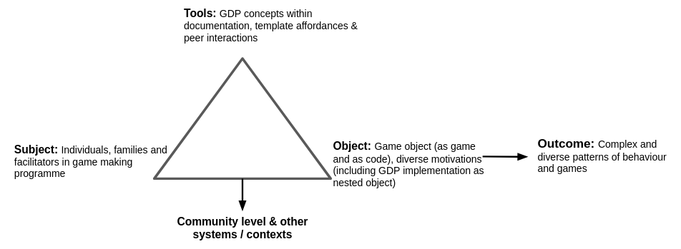
Figure 6.x - Diverse mediational strategies and complex object of activity
While this diagram helps represent a general picture of the pattern mediation it may be too general to be useful. In particular, there is complexity in terms of the role of GDPs here which act sometimes as mediational strategies and at other times as motivational components of the object at hand. In addition, it fails to communicate interplay with community level of activity and wider systems.
Given the complexity of the expanded object and it would be unwieldy to try to represent in a 3GAT diagram form. As Engestrom noted in discussing challenges of representing new generations of AT, you can’t keep adding triangles.
At the larger scale, (see Figure.5.x) the activity system of games code and process can be seen as a boundary objects. Additionally, each game instance, can also be interpreted as a boundary object for complex, and expanded interacting processes of activity. Take for example findings showing participant draw some of their home gaming knowledge of GDPs in varied ways in the new setting including: goal formation, as a lingua franca in design processes, and to provide feedback in playtesting.

Expanded object in terms of motivation - fluency towards agency
Given the complexity of the object being worked on in this research, and the disparate sometimes chaotic nature of the emerging activity, (Cormier, 2008; de Freitas, 2012; Biffi, Bissola and Imperatori, 2017), it is of value to return to existing research on CGD&P in terms of goal formation and motivation in a way which invites discussion on how best to conceptualise the diversity of motivational aspects and resulting impact on diverse goal formation ( & flexible design practices) present in the findings of this chapter.
One of these motivational factors is remaining engaged or in flow. Flow theory in my guiding motivations in terms of participant experience (Perttula et al., 2017). As a facilitator, my design decisions were often guided by the desire to not detract from participant experience of flow, and thus their coding fluency and engagement in and identification with the overall game-making process. The experience of flow is also a component of the concept of fluency in technology use explored in Chapter 2 in varied forms within constructionist research, technological, digital and computation. The guiding principle being technical proficiency with the relevant technology to share interests and identity within a community of peers. It is of value to now identifying manifestations of such fluency and identify the techniques used to design for this behaviour via in the mediational uses of GDPs outlined in this chapter. In other words, what can be observed about the interaction of participants use of GDPs and the experience of participant fluency?
Fluency and fluidity in practice
Younger participants in particular developed impressively fluid practice demonstrating extremely rapids shifts between code editing, game testing, authoring assets in online tools and migrating files often while talking with peers. Older participants also showed rapid, responsive creativity. Above Toby’s increased navigational proficiency was interpreted as transformation of actions into more fluent operations (Leontiev, 2009).
Clive quickly incorporated a boost to player health after a level after being given feedback during playtesting. In exploring sound making software Ed and Mark start a process of tinkering and messing about with the capability of the tools which spurs creativity. The joint improvisation created two different soundtracks. This sparks a new proposal to incorporate different soundtracks for different levels. Pairs often adopted a similar spirit of improvisation. For example parent Dan makes a suggestion - “Use paper to design?” - to which Toby replies “I’m just going with it.”
In Chapter 2 the value of a learning design using computational thinking patterns was explore through the concept of proximal flow (Basawapatna et al., 2013), with reponsive just in time documentation aligned with participants goal shown to be more engaging than principles based instruction. This research extends this technique by adding greater specificity in detail of use of patterns and most importantly choice of which patterns participants implement. The user-led process can be examined increased the experience of flow through possibilities for social identity development (Mao et al., 2016).
limitation of fluency as a concepts
Returning to the gaps in research outline in Chapter 2 in regarding CGD&P
The limitations here are on detail on how to enact identity formation via specific pedagogical strategies. While Chapter 2. explored the value of pair and peer programming, it also highlighted this area as one needed further development.
The work of the constructionist school is rich in a legacy of designing for fluency, notably including: software microworlds, affordance rich tools sets facilitating open-ended experimentations, accessible multi-media authoring software and community of Scratch. One idea which while present in part in online community of Scratch is that of constructopedia, an evolving resource of inspirational design elements, and accompanying instructions.
In addition, while the concept flow is well established in socio-cultural research, the more specific concept of technological fluency are less explored. Given its wider scope within CHAT, in Chapter 7 characterics and processes associated with fluency in this chapter are analysed using the lens of agency, in particular that of relational agency.

Conclusion
On a theoretical plane, this chapter has outlined the evolving use of GDPs as a meditational strategy to develop coding repertoires that are often shared. CHAT frames diverse use of shared resources and concepts, in this case GDPs, as meditational strategies.
On a cultural plane, using GDPs can aid the propagation of technical and social processes game making practices within an emerging community of learners. GDPs served both researchers and participants by providing a common language to clarify first learner expression and researcher’s analysis of gameplay experience.
The observations of this chapter show the diversity and flexibility of uses of GDP as an mediational tool. The next chapter builds on this to propose the potential of GDPs as a relatable navigational framework, occupying a the space between too concrete to be repeated and too theoretical to be grasped by novice game makers.
The findings identified a complex object with a diversity of motivation which pose challenges in communicating in simple terms in terms of what characteristics we are designing learning environments to develop. The candidates of proximal flow and computational fluency were explored in relation to existing research and gaps were identified in there coverage of the importance of learning agency and identify formation.
As such in the next chapter, this gap is addressed via the socio-cultural framing of learning.

