6. Findings - Game Design Patterns
- Findings: Game Design Patterns
  - Research Questions April 2025
  - Introduction
  - The role of GDPs in the personal appropriation of concepts and processes
    - The interrelationship of GDPs and the development of personal appropriation of skills and processes
  - GDPs used in the process of guided participation
    - Use of a menu of GDPs to assist project navigation and use of documentation
    - GDPs used to scaffold ideation and prioritisation processes
    - GDPs aiding the process of division of labour (1400)
  - Use of GDPs in the cultural plane / community level of activity
    - The role of GDPs to facilitate learners to design for others
    - GDPs can facilitate the use of wider funds of knowledge and interest
    - The propagation and evolution of GDPs concepts
  - Discussion
    - Addressing the use of GDPs in relation to theoretical understandings of processes of mediation and expanded objects of activity -
    - Expanded object in terms of motivation - fluency towards agency
  - Conclusion

Findings: Game Design Patterns

Introduction
Software design patterns are a grouping of a description of target project behaviour, with a suggested community solution of code structure often accompanied with worked examples (see Chapter 2). While existing research explores the use of game design patterns in educational settings, for instance to aid the transfer of science simulation concepts to other contexts (Basawapatna, Koh and Repenning, 2010; Repenning et al., 2015) or as a foundation for co-design work (Eriksson et al., 2019), there is limited work addressing their role in overcoming challenges faced by emerging communities of game creators using text coding. In the previous chapter, I outlined the evolution of tool use, emphasising emerging tensions in activity. The importance of gameplay design patterns (GDPs) emerged from participant input in P1 and were then integrated by myself into various forms of scaffolding within and graded step of practice including: quick-start activities, instructional tutorials, and code snippet examples. This chapter shifts focus to the perspectives of participants, using recorded data to interpret their varied uses and adaptations of GDP use. In doing so, it addresses the research question: How does CHAT theory help us understand how game design patterns can be used in an evolving community of novice game makers? I describe the use of GDPs as diverse mediational strategies to overcome some of the tensions explored in the previous chapter, not only addressing the use of facilitator-provided resources but also as part of emerging community practices and interpersonal repertoires.
Outer pipes Cell padding
GDP usage in game making | Description (using CHAT concepts)
Personal appropriation: | GDPs used in appropriation of personal knowledge.
Guided Participation / Interpersonal focus | GDPs as a framework for supporting resources and navigation
 | GDPs used to scaffold ideation and prioritisation processes
 | GDPs used to aid the process of division of labour
Cultural activity focus | GDPs can encourage learners to design for others
 | GDPs facilitate the use of wider funds of knowledge (FoK)
 | GDPs are propagated into the community through playtesting
Table 6.1: Summary of varied GDP use within the activity of this research
The above table summarises the principal different uses of GDPs in the data analysed. In this table and the structure of this chapter, I employ Rogoff’s three planes of analysis (Rogoff, 1995), as introduced in Chapter Four. This chapter’s sections examine how gameplay design patterns are utilised broadly by parents, children and facilitators, each through the lens of a respective analytical plane. Recognising that these observations do not neatly align with the three planes, I discuss the use of GDPs across cultural activities, interpersonal activity and personal knowledge in three distinct sections.
An analogy can be drawn between these three planes of analysis and the examination of activity systems at varying scopes. Specifically, the cultural plane aligns with the community scope of activity described in Figure 5.x in the previous chapter, while the interpersonal and personal planes correspond to smaller scopes depicted in Figure 5.x. A discussion section explores the implications of these findings in relation to existing research and theoretical concepts.

The role of GDPs in the personal appropriation of concepts and processes
Personal appropriation is described in of Kafai and Burke’s (2015, p. 4) review of CGD&P as “knowledge appropriation and transformation that is instantiated in the process of making games”. Rogoff’s interpretation of personal appropriation is more complex communicating the bi-directional nature of the process where individual interpretations of community gained knowledge is remediated and fed back into the community. In this informal learning context, the overall motivation of participants was on making an engaging game rather than explicitly developing to knowledge linked to the computing curriculum. Despite this, the evolving design process resulted in activities which did allow the exploration of computational thinking, systems concepts and other computing concepts and proceedures.
Kafai and Burke’s review (2015) notes the greater number of studies focus on personal dimensions of learning programming and curricular knowledge compared to the deficit regarding social and cultural aspects. To reflect the greater coverage of this area of research, this section is focused on limited aspects of personal appropriation: namely the code patching, debugging and the development of digital literacy skills. I have chose these areas as there were a subject of several observations provoked by the characteristics of the learning design of this research.
I was inspired by the the process and rationale of Bevan and Petrich’s (2013; 2015) work who created a map of learning dimensions to a seemingly chaotic tinkering and making process in museum contexts. As such, during early data analysis, with the potential to adapt this learning design to a more formal environment in mind, I mapped out curriculum-oriented concepts that suited exploration via in the game making process of this research. This process resulted in a learning map of curricular concepts included here as Table 6.x. For brief definitions of these terms see the Glossary of this thesis.
Computational Thinking | Coding Concepts | Systems Patterns | Design and Technical Practices
Abstraction | Sequences | Systems Elements | Goal Setting
Decomposition | Variables | Systems Dynamics | Being Incremental and Iterative
Pattern Recognition | Logic | Reinforcing Feedback Loops | Developing Vocabulary
Algorithmic Thinking | Loops | Balancing Feedback Loops | Web Literacy
 | Arrays |  | Code patching
 | Creating Functions |  | Version Control
 | Change Listener |  | Debugging
 | Input Event |  | Reusing and Remixing
Table 6.x. Learning dimensions facilitated by this study’s game making process
The map of learning dimensions above includes a balance of skills, concrete and more abstract aspects of coding concepts (Appendix.learningmap explores in more detail the evolution of this map). It aims to address tensions in the integration of concepts into an informal context, specifically, a tension or paradox common in project-based approaches in more formal settings, between the an exploratory learning approach and a possibility or need to align with curricular concepts (Hoyles and Noss, 1992). I propose that the play paradox (Hoyles and Noss, 1992) is addressed by orienting the leading/motivational activity of the learning design to be one aligned with the underlying goals of the participants. In this case to add features to their game. I return to this subject in Chapter 7.

The interrelationship of GDPs and the development of personal appropriation of skills and processes
It is of value to compare the observational process of creating the learning map to the more intentional, concept-driven design approach described in research on Microworlds, which foregrounds the role of learning designers in shaping the affordances of (playful) learning environments to steer learners toward exploring curricular concepts. In much of the Microworlds research, these are often scientific or mathematical concepts: take, for example, geometry in Turtle computing with the LOGO language (Ernest, 1988). This design has used several structural constructionist techniques involved in designing Microworlds (Laurillard, 2020), however, as the principal motivation of this study is acculturation within a game-making community, my focus has prioritised procedural skills that facilitate community participation over underlying subject related concepts. Due to limited scope of this section I prioritise an analysis here of the technical practices of web literacy,code patching and debugging. In addition to the use of new techniques being driven by the implementation of GDPs, the following observations reveal a complex, interdependent relationship between GDP concepts and emergent technical processes.
Addressing digital and web literacies first, to integrate new gameplay design patterns or adapt existing ones in their games, participants needed to develop not only technical processes associated with computer coding, as well as foundational digital skills related to using a desktop personal computer and use of internet browser and online tool ( see Chapter 1 and Appendix.digitalliteracy). most participants demonstrated increased fluency in these digital and web literacies, particularly in areas such as browser tab use, creating, uploading, and integrating graphical and audio assets, and proficiency in keyboard and mouse use for text manipulation. In line with CHAT theory, this can be interpreted as the gradual operationalisation of actions that initially required more explicit guidance, as discussed by Leontiev (Leontiev, 2009).
In this process, GDPs functioned as both a motivational and conceptual tools facilitating interpersonal knowledge exchange, as explored in the following example. In Vignette 5 (sections V5.a and V5.c), Madiha(p) seeks assistance from her daughter Nasrin to format and export graphical files for use in the game code project. In this section Madiha has just finished created a pixel art sprite of an alien in the Piskel graphical web app but is unsure of how to transfer the image from Piskel into the glitch coding environment, and and make the relevant coding changes to place the imported asset into her game.
Madiha(p): We’re finished. Right what’s next? Now I’m an expert pixel? Now I have to figure out how to get it in there don’t I? Without losing it I’ll be very upset.

Sonia(p): Have you saved it?
Madiha(p):– No I’ve not saved it.
Sonia(p):– Save there. (points to relevant button on screen)
...
Madiha(p): Nasrin! Nasrin! Nasrin!
Madiha(p): Do you know how to get it in the game?
Nasrin(c): Oh my god!

Madiha(p): Well . First of all save it to the gallery. How do you save it? Ah there you are. Save it. Is it saved? Right now export it.

Nasrin(c): Do you even know what export means?
Madiha(p): I know what export means!
Nasrin(c): Ok then smartie pants.
The implementation of Madiha(p) chosen GDPs drives the development of these technical processes, as she must either learn them herself or draw on peer knowledge to complete the task. She is clearly invested in her creative products, so much so that a fellow parent highlights out the process to saving images.
In another example, changing pen colours in the graphical tool is a process that Nasrin(c) has already internalised and performs effortlessly, whereas Madiha(p) is still deliberately working to build her competency. Nasrin(p) has fully operationalised the process, incorporating it into her repertoire of practices.
Code Patching as a guided technical process and the use of GDPs to nurture tactical responses to coding errors
GDPs also functioned a container for structured project stages, facilitating the initial use of procedures as illustrated in this section using the example of code patching. Code patching is a professional technical process to scaffold the application of new features in computer programming (see Glossary and Chapter 2). This patching process became an important element of documentation. Although code was provided, mistakes occurred in practice and additional customisations were introduced. Video evidence and observational journal notes highlight the potential of coupling code implementation with target behaviour, structured within a framework of GDPs. The following extract from Vignette 1 shows an example of code patching in practice. This vignette extract is included to show both the technical process of code patching explored here and the process of accessing documentation covered in the following section on guided participation.

Toby begins by playtesting his game. He plays through the many different levels of his game showing fluidity and skill. On Toby’s right Mick is helping Veronica’s request, demonstrating how to access two different forms of help in the form of code examples and step by step tutorials. On his left grandparents Pearl and Clive and working on their own game.
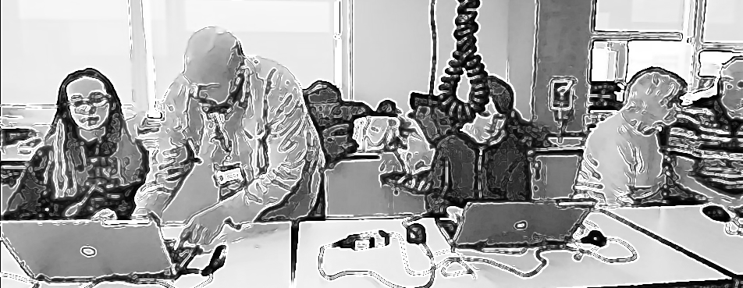
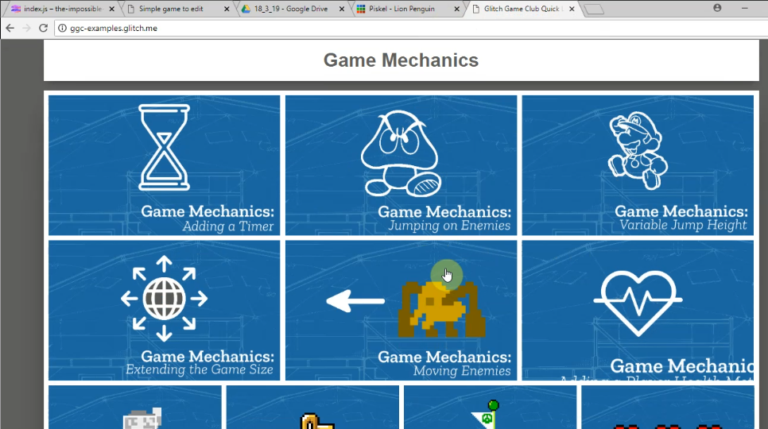 | Toby finishes playtesting and navigates to the page containing a menu of game design patterns at https://ggc-examples.glitch.me  He clicks on the image of Game Mechanics - Moving Enemies
This opens up a code snippet project which uses the same code base as Toby’s existing project.

He takes time to examine the start of code carefully.
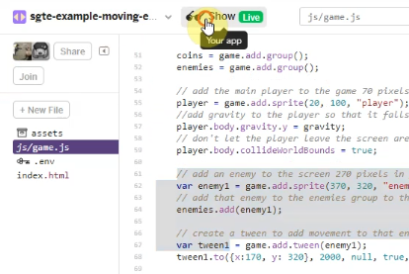 | Toby then clicks on the tab of his own game code and examines how it is different. He deletes a redundant line in his code.  He returns to the example code and scrolls down and examines the code needed to patch into his game. He hovers over it. He selects half of it and then hesitates. He then rapidly clicks on the Show Live button.
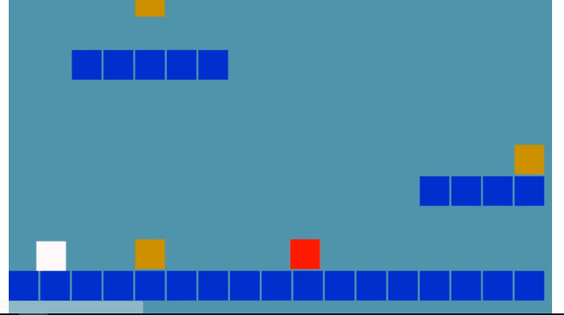 | When Toby clicks on Show Live this opens up a live preview of the example code in a new browser. Toby plays this example game and avoids the moving red block as he navigates around the screen away from and back into the danger zone of the patrolling enemy (red square).
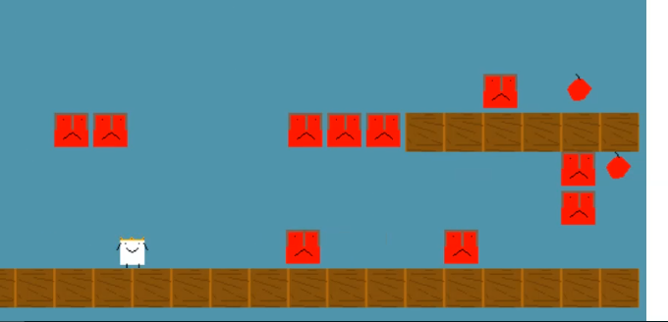 | When Toby dies in the game he navigates away from this screen and returns to copy the full code needed from the example. He then navigates to the same section of his own code project template. He seems to check this, as indicated by mouse movements checking what was above and below the space he has created. He then pastes the code into this space and then navigates to the live preview of his game to check the result.  The game now shows a new enemy moving back and forth. Toby check his game by playtesting it and struggles to get past this new enemy, failing multiple times.

Personal appropriation and increasing fluidity in terms of web literacies are well illustrated in Toby’s unaided incremental changes to level design, and the navigation of between code and game preview windows. By way of contrast his use of supporting documentation to undertake the code patching process is still hesitant and intentional. Toby’s eventual success in using the code patching and debugging technique was supported by the high level of contextualisation provided by the structuring of the process around GDPs. As a facilitator (see Appendix.patching), I made explicit the path between choosing a pattern to work on and the mechanics of accessing documentation and the code patching process. In the vignette we can see that debugging motivated was facilitated by the participants strong understanding driven of what the desired GDP should provoke in the target behaviour of the games. The need to get both the starting and ending position of the movement of the imported enemy provokes several iterations of debugging.
The process of code patching process often provoked such glitches. Glitches are errors which allow the game to continues to function but which provoke an unintended effect (see Appendix Debugging). As a facilitator I mobilised participants existing knowledge of GDP behaviour to compare erroneous behaviour with desired behaviour as an inclusive strategy to mitigate the potentially frustrating process of debugging.(Appendix Debugging)

GDPs used in the process of guided participation
This section examines data on the use of GDPs from the perspective of interpersonal interaction. Here, the process of being guided into planned activities or peer collaboration is exploratory, contributing to interpersonal processes that facilitate the completion of tasks. As outlined in the previous section, personal understandings of knowledge can be observed within these interpersonal interactions, particularly in exchanges between parents and children. Based on observations of video data, I describe how GDPs are employed in diverse mediational strategies. I focus on three key categories of interaction that incorporate GDPs: the use of a provided menu of GDPs and supporting documentation, the role of GDPs in project ideation and prioritisation, and their function within the division of labour.

Use of a menu of GDPs to assist project navigation and use of documentation
Chapter 5 introduced my provision of a curated collection (menu) of gameplay design patterns to address the tension between participants’ choice and the need for documentation to support the technical implementation of code structures. In the vignette extract above Toby uses the graphical menu of patterns to choose and implement a features. using supporting documentation. Later he is able to assisting others in adding the same GDPs to their games (see V1.b).As explored in Chapter 5, to prioritise participant engagement, I avoid a principles-first instruction approach (either to the whole group or to individuals). The use of shorter, just-in-time tutorials here reduces barriers associated with more extensive instruction-based approaches, particularly those related to literacy (Resnick and Rusk, 2020; Dietz et al., 2021). In this section, I outline findings on the use of the menu of GDPs, focusing on interpersonal interactions.

Dialogue | Activity
Suzanna: Thank you.  Did you see Olivia? | (Off Screen) Mick cedes computer to Suzanna.
Olivia: Did it do it?
Suzanna: Yes
Suzanna: I’ll reload it. Here you go | Suzanna presses refresh key to reload the game
Olivia: Laughs | Olivia moves laptop to point towards her and takes over using the keyboard
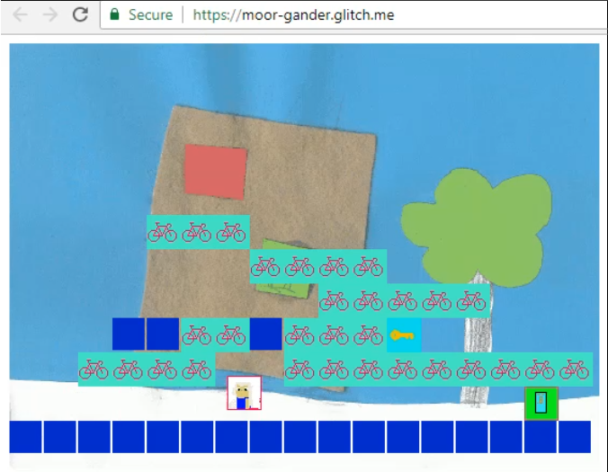
Olivia: (Makes excited cat noise) | Olivia is using arrow keys to control game and checks desired behaviour of player progressing to level 2 is working. T progresses to level 2 where there is not a door or key.
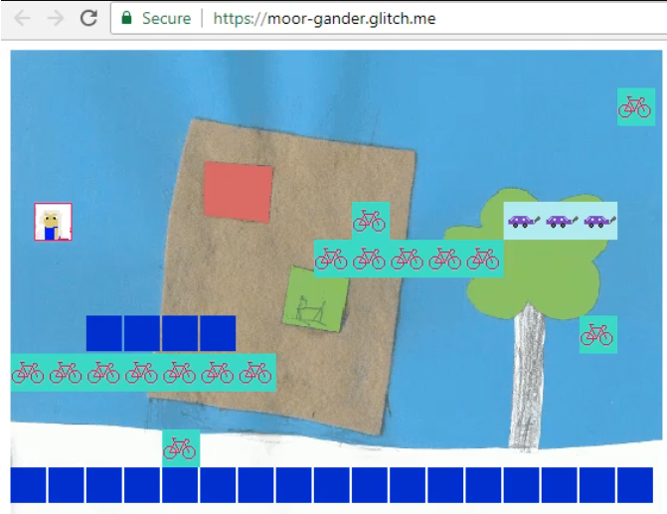
Olivia: We need a door in this one.  I want to make more levels now.  So you can put lots of doors and lots of keys  (in a rhythmic voice)  Key Door Key Door Key Door  (in a sing song voice)  Key Door Level. Key Door Level, Key Door Level | Suzanna moves computer back to take over the use of the keyboard. She changes browser tab and navigates to the section of the code which deals with the design of levels and placement of different game components.
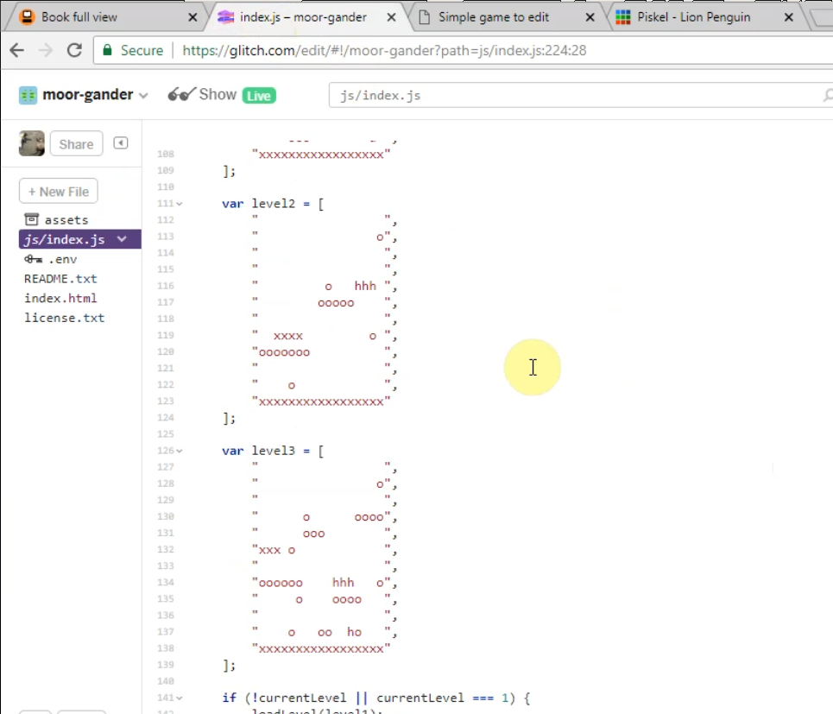
S. Well. Where are you going to put your door in level two?  Do you want to change the layout at all? | Suzanna gestures to screen
Olivia: What’s door? | Suzanna doesn’t move laptop but gets closer to take over keyboard
Suzanna: d
Olivia: Ok
Olivia: d . Door right there. | Inserts a “d” in an array high above a platform
Susanna And where’s the key going?
Must be quite hard through get to that door
Key is K
Vignette 2 (V2.a) observes parent, indicated by (p), Susanna(p)’s use of a tutorial to address the goal of implementing her child’s chosen GDPs. Susanna, who is limited in her programming skills but who avoiding seeking facilitator help (see V2.b), leverages the concept of GDPs, to independently access written step-by-step instructions. Tehillah(c)’s choice over which GDPs they tackle has helped create a personal connection to the game, see Tehillah’s positive reaction in the vignette above in her signing of the name of the key and door pattern.
While the evidence supports the potential of a menu of GDPs to address the tensions between choice-based approaches and the danger of a lack of relevant scaffolding, there are some important clarifications to make at this point. Firstly, not all participants engage with this menu. For example, in Vignette 3 (V3.a), Ed lets his father take the lead in accessing documentation. Other individuals lear to implement GDPs from peers, a process explored in later section. Secondly, becase the GDP menu (and concepts) were introduced by myself as navigational and organisational tool for use by participants, it seems logical that participant should use the for that purpose. The danger here is of circular reasoning in methodology which could impact the validity of claims here. Despite these clarification the data clearly shows the utility of the menu of GDP to directly help some participants, as a valid application of just in time documentation principles and as a foundational source later propagation and evolution of GDP practices by participants.

GDPs used to scaffold ideation and prioritisation processes
Addressing the tension between participant choice and scaffolding via menu of GDPs, my journal notes on the shift from P1 to P2, I noted that the provision of this menu of GDPs significantly decreased in time spent in the ideation phase by providing scaffolding and restricting choice. Beyond this immediate impact, this section outlines how the use of GDP concepts and supporting tools were used in ideation and project organisation, specifically: as a lingua franca, as a visual prototyping tool, and within participant gestural interaction.
Video data surfaced frequently use of GDPs terms as a lingua franca to organise and prioritise game making activity. An exchange from Vignette 3 between participants Ed and Mark shows the use of GDP concepts to help resolve a tension between a more chaotic style of working jumping from one goal to another and a parental motivation to prioritise work. The pair’s initial listing of features is a brainstorming technique using the approximate names of game design patterns (get the person animated, get an enemy in, changing the platforms, make a theme tune). The vignette analysis sees the parent overwhelmed with the child’s lack of focus on one pattern “that’s what I mean, you can’t just skip around like that.”
In the vignette extract below, home-based knowledge of GDP mechanics is utilised on an interpersonal plane, with Dan(p) helping Toby(c) via guided facilitation to provoke and shape new design ideas. Dan(p) draw on the game playing experiences to promote innovation in the design of the existing template: “the previous style of game was a platform (makes shape with hands) game wasn’t it? You went along and there was gravity pushing down. There are other types of games aren’t there?” The pair use their knowledge of game play patterns and genre conventions to break out of the genre constraints of starting template. Here they are charting new territory beyond the curated choices of GDPs and as such may not have vocabulary to express concepts. Both Dan and Toby make extensive use of gestures in their interaction reinforces their spoken references to GDP concepts.

Dialogue | Activity / Notes / Gestures
Dan: Have you thought about pushing it a bit further and have a different style of game?
Toby: What do you mean?

Dan: Well the previous style of game was a platform game wasn’t it? You went along and there was gravity pushing down. There are other types of games aren’t there? | Dan makes shape with hands to indicate a platform.  Dan then points downwards to indicate gravity pushing down on that platform. And then the jumps of an imagined player between
Toby: Pause. I don’t know what to do thought.  Dan: Well quite but what other games are there?  Toby: I don’t know er.  Dan: Well I tell you what .. muffled.  Toby: Erm | Toby navigates to webpage menu of GDPs.
Dan: So. You played them before didn’t you  Toby: What do you mean?  Dan: The flying game that’s a different kind of game  Toby: Oh like kind of like moving along kind of thing | Toby moves hand left to right.
Dan: Yeah and those where. There are games where you are in a world and you have to move around the world like pac-man. | Dan points down and moves finger around like an imaginary character moving at right angles.  Toby nods
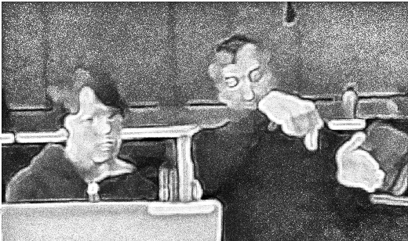
Dan: There are games where things drop down like Tetris.  Toby: … game. You could have a game where every 15 seconds 10 seconds you could add and enemy to such and such a random number between such and such . You could block it somewhere. | Dan makes a shape with hand and moves it up and down.  Toby holds up hands to indicate a range of parameters – as he says “between such and such”
Dan: So instead of.. instead of the world… the world being sideways. We could have the world being looked down on. | Dan reindicates the change of perspective with hand gestures.
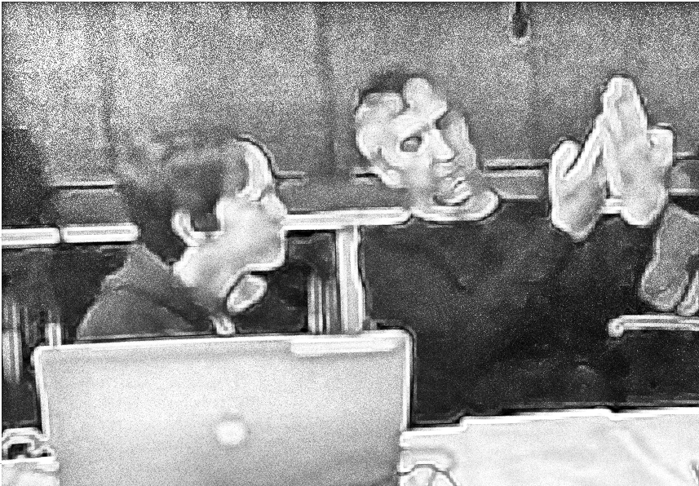
Toby: Hmm. How should I do this then?
Dan: That’s a good question. Shall we ask Mick to see if that would mess things up or not?
Later in the same session (see V7.12-16), Toby uses the code based tilemap tool to design a maze game instead of a platformer game drawing on existing knowledge of tools and home knowledge of the target game genre to rapidly make revisions without extensive planning. This use of GDPs to allow the spacial exploration of design in a visual and intuitive way suits being mapped onto paper, or onto graphical software which allows for a similarly rapid prototyping. By way of contrast, other pairs take advantage of paper prototyping. For example, Susanna(p) notices the child’s difficulty in using cursor and delete/backspace keys to edit a matrix allowing level design. The parent provides a book with grid paper to allow the child to replicate the matrix. The parent is then able to transcribe the design to the code example while engaging the child by checking she has interpreted the design correctly. Interview data with Mark and Ed uncovers complexities in the use of both digital and paper prototyping of related to GDPs explored in more detail in Appendix.tech.prototyping. WHY IMPORTANT?

GDPs aiding the process of division of labour (1400)
Addressing division of labour on an interpersonal plane, participants worked mostly as pairs or individuals, alternating between community playtesting and pair/individual design work. An overarching feature of the use of GDPs at this level, in line with existing research on design patterns (Erickson, 2000, p. @eriksson_using_2019), was a lingua franca. The use of GDP concepts to construct shared language and understanding was found in video data in varied forms related in particular to division of labour between participants.
In addition, the use of GDPs as an organisational strategy, structuring work processes through implementing modular sub-projects in the form of GDPs can aid division of labour. GDPs feature in processes division of labour in a variety of ways: working knowledge of different types of GDPs can help participants to divide work by working on different patterns or taking on project elements within patterns.
The examples below illustrate part of some of the varied strategies to divide labour adopted by participants at times involving complex tensions in activity. Data uncovered ways in which the participant divided the process of game making, in ways which uncovered traces of home collaboration practices. For example, In Vignette 2, Susanna(p) and Tehillah(c) relied on the parent to do the majority of code implementation but shared one computer. The parent took a lead on many activities but took care that they alternated between use of keyboard and mouse to give the child hands on experience when possible, particularly in level design activities and playtesting (see V2.7). In interview data (see V2.b), the parent notes “I resist the urge to fix things immediately when she struggles.” In another exchange (see), Tehillah (c) uses the name of a GDP within a request for her parent to take on a specific task within their making process, “Go on then. Key-Door person.” When the parent expresses confusion Tehillah gestures with her hands to indicate that her mother is the person she is referring to. The child appears to consider the level of complexity needed to add a new pattern into the code to be beyond her ability and thus directly delegate the task to her mother. At times Susanna(p) asked Tehillah(c) to seek help from facilitator (V2.1). On another occasion when the child appeared bored of waiting for parent to solve a code problem, she approached the facilitator to ask for help on behalf of the adult without prompting. At other times Tehillah(c) engages more peripheral activities such as watching older children playtest each others games, or observing community activity from under the table.
Madiha’s(p) family Nasrin(c) and Zidane(c) are all working on separate games on different computers. While Madiha sits next to Zidane who needs closer support, Nasrin often sits close by but next to a friend. In Vignette 5, as part of her process of building an emerging identity as a graphical asset designer (see V5.b), Madiha calls across the room to draw on Nasrin’s help to correct a design mistake. Nasrin affects reluctance in her support of her mother (see V5.a), but at other times shows that she enjoys her status of technical supporter (see V5.d). Nasrin appears reluctant to explain the technical processes she uses to help her mother:
“Madiha (to Nasrin): What are you doing? You have to tell me what you are doing so I can do it myself.” This may be driven by a desire to preserve this specialist status and utility to her mother. Madiha and Nasrin reversed the traditional helping relationship, and the child would reluctantly implement the parent’s requested technical elements of GDPs but would pointedly not explain the changes made, seemingly taking pride in knowing something that her mother didn’t.
Toby adopts different working arrangements dependent on which family members he attends with. While in P2 when supported by grandparents Toby had worked mostly alone (see V1), in P3, he works as a pair with his father (Dan) in closely guided practice (see V7.b). In several interchanges, the father starts as a facilitator, taking a lead from the direction of the child. As the child reaches the limits of their ability, he begins to be more directive, by asking leading questions and testing existing knowledge. Finally, in order to complete the programming or research tasks beyond the child’s knowledge, the father is more direct in instruction, directing the research and proposing a coding solution for their new game design pattern. Dan’s experience as a software engineer and volunteer at Coder Dojo (see glossary) is relevant as a fund of knowledge he draws on (see V7.a and later section).
While the context of the participants as families involved in home education makes any general claims difficult, these observations support findings in other research in this domain. For example, research shows that children have the potential to help parents as technology brokers (Correa et al., 2015). In joint technology work, parents can fulfil several reciprocal roles including collaborator, resource provider, learner, non-technical consultant, and emotional support (Barron et al., 2009).
Thus, in response to the creative support that parents and siblings provide, facilitators should design learning environments to facilitate these possibilities. The work of Roque provides guidance for helpers in the process to support parents to value and feel confident in these roles (Roque, Lin and Liuzzi, 2016) in a way which mirrors the use of helpers in this phase of my study (see Chapter 4).
The variety of repertoires of helping practice depends in part on the different funds of knowledge the parent has access to. The helping pattern of researching and accessing technical documentation is not available to all pairs, due to the level of skill and experience involved.
Toby and Dan’s pair process is more guided and focused than many other participants and includes accessing professional documentation and exploration of computational thinking concepts.
While Tehillah’s activity away from the screen while non-productive within the scope of technical progress, can be characterised as legitimate peripheral activity of observation of community activity (Lave, 1991 ; Rogoff, 2014). Indeed the possibility for children to not engage in community activities is seen by Rogoff (2003; 2016) as an important characteristics in participation based models of learning.
In Vignette 3 (V3.a), Mark(p) repeatedly steers Ed(c) to pick one GDP to allow them to carefully work through the associated documentation together, a process he later refers to in interview data (Interview ) as plodding . Early in that session Mark takes a significant amount of time puzzling over documentation on how to add animation to a character. This results in Ed being blocked from progressing and to address this tension child proposes dividing their labour and workig on two separate computer (see V3.9 “Why don’t you go there for a computer and you can do that?”). Ed appears to make a tactical decision allowing the father to specialise in GDPs that involve deciphering technical instructions, whilst he engages with a pattern that involves creating audio and graphical assets in a less technical, more exploratory process.
MOVED - INTEGRATE IN In Vignette 3 (see 3.c in particular), we see Ed(c) break out of the more restrictive approach of plodding that Mark(p) advocated for to engage in experimental, improvised design processes with no clear end goal. Mark (p) later joins in Ed(c)’s exploration of sound-making software. They start a process of tinkering and messing about with the capability of music-making tools in a way that spurs creativity. In this case, the joint improvised process sparks a new proposal to incorporate the two soundtracks they create in distinct levels.

Use of GDPs in the cultural plane / community level of activity
Continuing the three planes approach to analysis (Rogoff, 1995), the following section explores the use of GDPs at the community plane of activity. Rogoff’s (1995) initial analysis of activity on a cultural plane focused on existing communities emphasising the metaphor of apprenticeship. In later later work with Gutiérrez (Gutiérrez and Rogoff, 2003), there is a greater work on places greater emphasis on cultural activity as dynamic. This perspective examines existing and emerging norms and repertoires, adapted from participants’ engagement in other communities and contexts. Gutiérrez (2008) continued this line of reasoning to advance the concept of third spaces in education as a space where the repertoires of the repertoires of home meet and can mix with those of more formal schooling. This section explores the findings of existing and emerging cultural activity within this conceptual framework.

The role of GDPs to facilitate learners to design for others
The use of GDPs, particularly during playtesting, can support the process of imagining end-user experiences. This section examines how the concept of, and experience with, implementing GDPs encouraged participants to envision the experience of end users of their games. Chapter 2 explored the proposition from professional and participatory design processes that design should be informed by end-user experience (Redström, 2006), as well as the challenges involved in undertaking such an “operationalization of empathy” (Surma-aho and Hölttä-Otto, 2022, p. 1). From a CHAT interpretation, this process involves shifts in perspective by participants as they engage with objectives across different scopes of activity.
In the extract of Vignette 2, Tehillah (c) pursues a quirky design goal during her paired design work, which Susanna (p) resists. Imagining a shift in perspective to the intended audience at a community level of interaction, the parent aims to ensure a sense of challenge for the imagined player.
Dialogue | Activity
Susanna Are you putting one in your third level as well? | Susanna is referring to the putting in news “keys” into the level design which is possible after implementing the Key and Door pattern in code.
Tehillah: Yes and then I’m going to make more levels | Tehillah Smiles at Susanna and then looks away for a short while
Tehillah: You do this bit
Tehillah: And then delete those H’s. And in there. | The H’s refer to hazards in the level design matrix.
Susanna No! No! Tehillah: Then, let me do it. | (off screen) Tehillah takes over the keyboard.
Susanna It’s no fun having a game with any hazards to avoid. Tehillah: It is for me!
Tehillah:How do you go that way back?So sorry for deleting…They just… | Tehillah indicates that she wants to delete characters before teh cursor. Then on screen Tehillah deletes all hazards in Level 3 of the game
Back Back BackO O O.Back O | Tehillah laughs. On screen Tehillah adds three coins to Level 3 by inserting o characters in the level design matrix
Susanna: Goodness me what was the point of designing our car with fumes if we’re not going to use it?Tehillah: I don’t know. | Susanna’s tone of voice indicates frustration. After speaking Tehillah sighs deeply.
Susanna(p)’s alarm at the child’s deletion of all elements of hazard shows she has a sense of game balance to ensure a sense of challenge for the imagined player. “It’s no fun having a game without any hazards to avoid.” However, Tehillah (c) seems determined to remove all hazards. “It is for me!” she counters. My understanding is that she is may be aware of the implications for game balance but takes pleasure in this destruction of the key challenge of the game as an act of disruptive play. A later interaction with a peer shows that Tehillah (child) is indeed imagining the experience of the audience. “I like making it frustrating. That other people find it frustrating!” Tehillah (child) notes the persistence of a student helper who pushes past her frustration to complete the game. Her remark, “If people tried hard they would get to my level,” shows her awareness that not all players will persist in the same way to reach her final level, which has only rewards and no hazards. This being a “secret, special” experience, which plays against the norms of platform game design, is thus intended to provoke player surprise.
In contrast other participants created extremely challenging or impossible game levels that frustrated other players. DEVELOP THIS A BIT MORE WITH QUICK EXAMPLES.
This example serve to highlight two dimensions of the use of GDP concepts to facilitate the process of designing for others. The first is the influence of making in a cultural setting where regular playtesting by peers occurs on the making process. The second is through either direct advice by pair partners and peers in playtesting to imagining others’ user experience, or indirectly by gameplay feedback or suggesting alterations to GDP implementations. This research is in line with the interpretation within computer supported collaborative learning of the value of the of tangible, public digital products as both a motivating and focusing factor in computer-supported collaborative learning (CSCL) (Fields, Vasudevan and Kafai, 2015; Xambó et al., 2017). The results here are valuable as a contribution help address a deficit of results in the use of CSCL to support computer programming (Silva, Mendes and Gomes, 2020).

GDPs can facilitate the use of wider funds of knowledge and interest
Existing research outlines the motivations for social making incorporating cultural knowledge of gaming within non-formal making activities (Gee, 2003; Itō et al., 2010). Similarly, the ability to make personalised game assets and narratives and sustain engagement in digital making projects (Sefton-Green, 2013).
Existing constructivist research in CGD&P also highlight the motivating potential of incorporating home interests in games, coding and media projects (Papert, 1980; Resnick, 2012; Kafai and Vasudevan, 2015)]
Cocio-cultural research on the tactical use of FoK to overcome barriers to technical environments (Moje et al., 2001; Gutiérrez et al., 2019).
Research related to project based learning (PBL) benefits of working with participants’ home interests with project work include to motivate participants in initial stages (Swirski, Baram-Tsabari and Yarden, 2018; Penuel et al., 2022), sustain activity and overcome problems in order to share the personalised object created (Barron, 2006, 2010).
In Chapter 5 and Appendix.tech.gameframework I outlined the use of the MDA (mechanics, dynamics, and aesthetics) framework to theme the presentation of GDPs. In the following section I use the MDA themes to explore different examples of use of funds of knowledge and interest by participants.
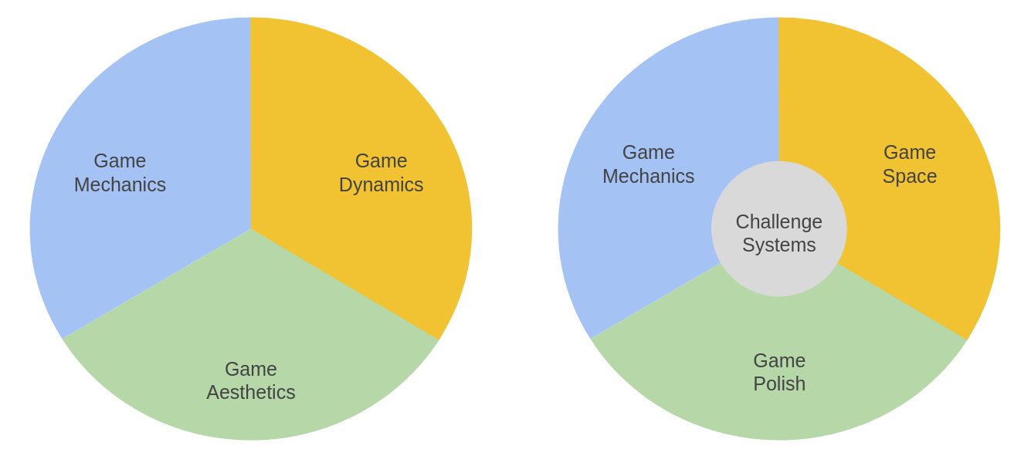
Illustration 6.x - MDA as an additional framework promoting multiple means of engagement - mapped to an grouping of GDPs
PERHAPS CHANGE THE GRAPHIC TO A TABLE HERE. DVELOP THIS A BIT OR LINK TO ANOTHER BIT EXPLORING THIS
Some participants focused their game making on the aesthetics of their projects. Madiha in the vignette extract above show identification (as an expert pixel) with the graphical-making process. Many examples of session data (see Vignette 5) confirm this preference for both Madiha(p) and her daughter Nasrin(c) and interview data shows that this art is also an interest that they pursue at home. Beyond their internal family interaction, the process of bringing that aspect of creativity into their games allows them to share this artistic flair and attention to detail with the emerging learning community. In another example, Mark and Ed designed a game around the character of a train driver that needed to collect coal. In interview data Mark describes the impact of the child feeling like they could bring their own identity and interest into the project. “I know just your eyes lit up when you realised you could expand your interests into gaming.” (see Appendix 4.x). Clive(p) and Pearl(p), the grandparents of Toby(c), included a narrative message at the start of their game surfacing the interest and expertise of the family as beekeepers (see Vignette 6) in a way that sparked interest and conversations with other participants.
Addressing game dynamics, Vignette 4 gives several examples of participant feedback on the dynamics of Madiha’s game in the level of the challenge experienced by players. Community norms of gameplay began to develop, some of which were influenced by home experience of game playing. The discussion of game challenge, specifically comments about how ‘hard’ participant games were, was a particularly common interaction during playtesting. Vignette 4 (V4.a) outlines the community norming of Madiha(p)’s game to conform to expected standards of a platform game. The vignette shows varied attempts to influence Madiha to change the game variables to make controlling her player avatar less frustrating. The indirect norming behaviours described in Vignette 4 mirror observations seen in the work of Rogoff and colleagues (Rogoff, 2003) on learning in community settings.
Turning to the area game mechanics, In see V1.b Bertie(c) comments on Toby(c)’s game, which has a dominant game experience of timed jumping: “It’s like parkour in Minecraft but timed. It’s like playing the game Wipeout. Have you ever played Wipeout?”. Parkour in Minecraft and Wipeout are both game experiences whose main gameplay mechanic is about judging jumps and landing accurately. Bertie makes links to his existing experience of games, making comparisons between Toby’s game, commercial games, and his own. In doing so, Bertie is able to show his knowledge and analysis of gameplay patterns. Additionally, the guidance of Dan(p) for Toby(c) explored above in Vignette 7, saw the parent explicitly drawing out the child’s home knowledge of games to enable an exploration of a different set of game mechanics. Thus, the tacit knowledge of GDPs of children and adults as game players serves them in knowledge-brokers roles in the process of feeding back and ideation (Wenger, 1998).
The previous examples have outlined varied was that participants used GDPs in incorporating elements of home funds of knowledge and interest into their games. I observed that families and individuals those less intrinsically interested in the gaming often engaged with the aesthetics elements of the graphical or audio design or the cast of characters the narrative of the game.
In summary, GDP concepts allow participants to share and explore funds of knowledge and interest (Esteban-Guitart and Moll, 2014; Fasso and Knight, 2020) related to gaming culture (Itō et al., 2010; Livingstone et al., 2018) in the emerging learning community. While existing work on computational design patterns by Repenning et al. (2015) addresses the motivational value of working with known games types, and the patterns as a way of scaffolding the process of programming, it does not address any aspect of choice when of drawing on FoK when creating games. In contrast, the different types of GDPs available to participants to choose from in the menu of GDP documentation and code snippets allowed for a choice in participant making paths, enabling alignment with home interests. As a contribution this area of research, I propose that the diversity and subdivision of a menu of GDPs aligned with the MDA framework can help participants to elect to follow varied learning pathways based on their home interests in a way which aligns with characteristics of the inclusive pedagogy (Sanger, 2020). Specifically, this is achieved by providing scaffolding and resources which allow exploration of concepts which providing multiple means of engagement with the learning process (Capp, 2017).

The propagation and evolution of GDPs concepts
The implementation of popular or novel GDPs by participant pairs or individuals often spread through peer activity. Both documented (those part of provided resources) and novel GDPs (those introduced by participants) were transmitted between participants, enriching the games of participants. At times, participants were influenced by playing the games of others, and at times, they would request the direct help of peers to implement GDPs in their own games.
In Vignette 1b, Toby’s work adding 21 levels to his game is noticed by Bertie who then asks Toby, “Can you show me how you add more levels onto yours?” The full exchange shows an example of the propagation of GDPs emerging from the process of community playtesting through a direct request. It is possible that Bertie’s request to Toby is prompted by Bertie noticing Toby helping Nasrin and Harper add levels to their games. Toby’s emerging role as a specialist that the community can draw on for practical help, and similar examples (see also that of Nasrin in Vignette 5), were welcomed by me as a way to reduce dependence on myself as a facilitator, or to provide an alternative to the instruction-based support documents.
Turning to evolution of patterns, the concept of a safe zone in the game of Pearl and Clive arrived as a direct result of adding many moving enemies in a way that it became essential for players to quickly identify and use ‘safe zones’ where enemies did not reach. This novel concept, became used as lingua franca in the playtesting of that game and that of others with moving enemies. Once concepts like safe zone or bonus level enters the linguistic and coding repertoire of this community of game makers, either from documentation, home gaming knowledge or genuine innovation, it became available for propagation for take up by other participants.
The data shows other examples of organic emergence of novel GDPs and related design concepts beyond those offered in the menu of supporting documentation. Tehillah’s concept of a kind of bonus level that eschews challenge and offers only rewards (see Vignette 2) emerged through playful experimentation. While this idea exists in popular games, it was experimental and novel for the child.
GDPs as components of emerging repertoires in an evolving idioculture
The preferences shown by some for peer learning and convention breaking became a part of the emerging culture of the game making sessions. The term idioculture (Cole and Packer, 2016), a local, non-geographical, non-demographic community where culture emerges via valued behaviours (Lecusay, 2015), can be applied to the role of GDPs as component parts in the emergence of a community culture.
To help foster an inclusive environment I led by warm up games at the start of sessions in early sessions of phases one two ad there. From phase two onwards I encourages playtesting time in the second half or each session. This playtesting time was open in scope allowed for natural play to emerge. While hard to quantify, phase two and three in particular can be characterised as having a playful and social atmosphere.
Other characteristics and norms of the emerging idioculture stemming which stem from the GDP use have already been described above. Elements of peer learning, incorporation of home interests and behaviours, concepts of appropriate challenge. These examples are emerging process where cultural concepts are mutually constituted by different actors involved in the game making activity system. They emerge not solely due to their embedded mediational potential within GDPs use, but as products of an expanded shared object of activity.

Discussion
This discussion section discusses the complexity of the expanded object of activity and the diverse mediational uses of GDPs using a activity theory as a framework. It summarises the different uses of GDPs in a table and notes the limitations of 3GAT to represent such diversity of mediational strategies.
To address the challenge of communicating the diverse motivations and forms of activity involved, it returns to concepts of proximal flow and computational fluency present in CGD&P research.

Addressing the use of GDPs in relation to theoretical understandings of processes of mediation and expanded objects of activity -
Chapter 5, via a design narrative of the pedagogical design used, exposed tensions where existing mediational strategies or tools were insufficient, and thus innovative forms of mediation were needed. This chapter has developed analysis of activity by focusing on the germ cell concept of GDPs used in a variety of ways, a summary of which has been represented in table form at the start of this chapter. A fuller table now summarises this chapter’s interpretation of the diverse roles of GDPs in the game-making activity using CHAT concepts. GDPs are used in diverse ways by participants, peers and facilitators, as principle or supporting parts of mediational strategies including as as a lingua franca, as a motivational element, or as a way of structuring the learning experience and supporting resources. The right column lists example behaviours and notes vignettes or appendices where the behaviour can be found in situ with more detailed analysis.

GDP usage in game making | Description (using CHAT concepts) | Examples in data – click links to move to evidence in vignette
Personal appropriation:
GDPs used in appropriation of personal knowledge. | Facilitators can use existing and planned GDPs to surface computational, design and systems concepts embedded in games.  Beyond curicular knowledge, participants demonstrate concrete and varied design knowledge.  Careful template design can aid experimentation with game dynamics via rapid prototyping techniques.  The implementation of GDPs can stimulate participants to adopt or to share technical processes. | Personal appropration of learning map concepts: Error: Reference source not found, Appendix.learningmap  Fluidity of design operations: Error: Reference source not found, Error: Reference source not found,  Use of code patching and code snippets in V1  Debugging in Vignettes 2, 1,
Guided Participation / Interpersonal focus

GDPs as a framework for supporting resources and navigation | The restricted set of GDPs can serve as a framework for code examples and step-by-step tutorials. Presentation of documentation of GDP implementation as a menu or collection can facilitate flexibility of learner pathway and diversity of end design and without restricting access to resources beyond programme based support | Use provided of step-by-step docucmentation  V.2 , Error: Reference source not found  Use of code snippet examples: V1  Utility of a graphical menu and map of GDPs: App.theming
GDPs used to scaffold ideation and prioritisation processes | GDP concepts can guide ideation processes in diverse ways including: use of GDP terms as shortcuts in ideation and prioritisation, the use of visual code structures | Use of GDPs concepts by participants during ideation: V2,3 ,Error: Reference source not found  GDPs altered via visual prototyping: Appendix.prototyping, Error: Reference source not found  Discussion of GDP dynamics facilitated by template game structure:
GDPs used to aid the process of division of labour | Participants can split work and resolve working blockages by allocating different GDPs or parts thereof.  The use of GDP concepts as a lingua franca and the sometimes modular structure of GDPs help the division of labour as participants to divide work by working on different patterns or taking on project elements within patterns, sometimes building specialisms in the process. | Dividing work between pairs by pattern based on difficulty or aptitude: Error: Reference source not found, Error: Reference source not found  Alternating between coding tasks and other non-coding tasks in Vignette 2.  Parents shifting from facilitating role to a more directive role: Vignette 7
Cultural activity focus
GDPs can encourage learners to design for others | Referring to the impact of implementing or changing GDPs can help scaffold the process of imagining the end user experiences. | GDPs used to stimulate awareness of designing for others: Error: Reference source not found  Present in 8 out of 12 coded sessions.
GDPs facilitate tPERHAPS DO A SUMMARY TABLE AT START OF THE CHAPTER AND A FULL TABLE HERE? he use of wider funds of knowledge (FoK) | Three dimensions of GDPs (mechanics, dynamics and aesthetics) can be used by participants to share and explore FoK and other interest within the emerging learning community. | Via incorporation of home interests and FoK in game narratives: Error: Reference source not found  and assets: V6.b  Coding and documentation practices: Error: Reference source not found  Bertie’s sharing of knowledge of game mechanics in Vignette 1b
GDPs are propagated into the community through playtesting | New GDPs emerge often from the merging of home knowledge, technical processes and existing patterns.  The implementation of popular or novel GDPs by participant pairs or individuals is often spread through peer activity.  GDPs as components of emerging repertoires in an evolving idioculture | A popular GDP implementation becomes a subject of community activity: V1b
Attempts to represent the variety of uses of GDPs within the technique of triangular visual representations would be problematic. In particular, the complexity in terms of the role of GDPs here which act sometimes as mediational strategies and at other times as motivational components of the object at hand would be difficult to communicate. Similarly, representation of the interplay of mediational strategies of tool use with the community level of activity and activity wider systems would also be challenging and unwieldy. As Engeström and Saninno (Engeström and Sannino, 2021) note in discussing challenges of representing new generations of AT, you can’t keep adding triangles.
Both the wider object of activity represented at the community game making process and the narrower object of each game instance, can be interpreted as a boundary object for expanded, interacting processes of activity. Narrower still, returning to Kynigos’s interpretation of the half-baked game as a boundary object facilitating communication (Kynigos, 2007), we GDP concept themselves can also been seen a boundary objects at a greater level of granularity. The work of Stahl and others (Stahl, Koschmann and Suthers, 2006) within the fields of technology use and collaborative learning is relevant here to highlight the importance of language development and the intersubjective interpretation of visual prototypes and gestures as tools in building mutual understanding in the kind of joint problem space we see in this study. While much research on teaching coding addresses the benefits of collaborative approaches (see Chapter 2), fewer studies outline strategies to facilitate such joint attention (Brennan, 2009). Thus, it potentially fruitful to align relevant uses of GDPs outlined above to existing research on the development of shared language to support joint work and guided participation (Stahl, Koschmann and Suthers, 2006).

Expanded object in terms of motivation - fluency towards agency
Given the complexity of the object being worked on in this research, and multi-faceted nature of the emerging activity, (Cormier, 2008; de Freitas, 2012; Biffi, Bissola and Imperatori, 2017), it is not surprising that a diversity of conceptualisations of what experience or attribute is being developed in participant in CGD&P or similar digital making.
However, a related strand grouped around different forms of technical fluency (Papert and Resnick, 1995) was explored in Chapter 2 with common features of domain proficiency, self-expression and identity formation and an experience of flow. One of the motivational factors guiding the evolution of the learning design of this study was to keep participants engaged and thus remaining or in a state of flow (Perttula et al., 2017). The guiding principle being technical proficiency with the relevant technology to share interests and identity within a community of peers. It is of value to now identifying manifestations of such fluency and identify the techniques used to design for this behaviour via in the mediational uses of GDPs outlined in this chapter. In other words, what can be observed about the interaction of participants use of GDPs and the experience of participant fluency?
Observations of participant design behaviour did not align with common design thinking concepts or design cycle frameworks advocated in CGD&P (Resnick, 2007; Wi̇Narno et al., 2020; Dam, 2024). The stages were instead fragmented and sometimes happened in parallel. In many interactions, I observed improvisational approaches which incorporated ideation, planning, implementation, and testing in the space of a minute or so. Younger participants in particular developed impressively fluid practice demonstrating extremely rapids shifts between code editing, game testing, authoring assets in online tools and migrating files often while talking with peers. Older participants also showed rapid, responsive creativity. Above Toby’s increased navigational proficiency was interpreted as transformation of actions into more fluent operations (Leontiev, 2009).
Clive (p) quickly incorporated a boost to player health after a level after being given feedback during playtesting. In exploring sound making software Ed and Mark start a process of tinkering and messing about with the capability of the tools which spurs creativity. The joint improvisation created two different soundtracks. This sparks a new proposal to incorporate different soundtracks for different levels. Pairs often adopted a similar spirit of improvisation. For example parent Dan makes a suggestion - “Use paper to design?” - to which Toby replies “I’m just going with it.”
Extending Basawapatna and colleagues [-(Basawapatna et al., 2013)] approach to support proximal flow (see Chapter 2) via just in time documentation aligned with participants goal to support participant engagement, adding greater specificity and choice over which game patterns participants implement. This adaptation help greater alignment with research on the interdependence of flow experience and possibilities for social identity development (Mao et al., 2016).

Conclusion
On a theoretical plane, this chapter has outlined the evolving use of GDPs as a meditational strategy to develop coding repertoires that are often shared. CHAT frames diverse use of shared resources and concepts, in this case GDPs, as meditational strategies. On a cultural plane, using GDPs can aid the propagation of technical and social processes game making practices within an emerging community of learners. GDPs served both researchers and participants by providing a common language to clarify first learner expression and researcher’s analysis of gameplay experience. The observations of this chapter show the diversity and flexibility of uses of GDP as an mediational tool. The next chapter builds on this to propose the potential of GDPs as a relatable navigational framework, occupying a the space between too concrete to be repeated and too theoretical to be grasped by novice game makers.
The findings identified a complex object with a diversity of motivation which pose challenges in communicating in simple terms in terms of what characteristics we are designing learning environments to develop. The candidates of proximal flow and computational fluency were explored in relation to existing research and gaps were identified in there coverage of the importance of learner agency and identify formation. In the next chapter characteristics and processes associated with fluency in this chapter are analysed using the lens of agency, in particular that of relational agency.

Barron, B. (2006) ‘Interest and Self-Sustained Learning as Catalysts of Development: A Learning Ecology Perspective’, Human Development, 49(4), pp. 193–224. Available at: https://doi.org/10.1159/000094368.
Barron, B. et al. (2009) ‘Parents as Learning Partners in the Development of Technological Fluency’, International Journal of Learning and Media, 1(2), pp. 55–77. Available at: https://doi.org/10.1162/ijlm.2009.0021.
Barron, B. (2010) ‘Conceptualizing and Tracing Learning Pathways over Time and Setting’, Teachers College Record: The Voice of Scholarship in Education, 112(13), pp. 113–127. Available at: https://doi.org/10.1177/016146811011201308.
Basawapatna, A.R. et al. (2013) ‘The zones of proximal flow: guiding students through a space of computational thinking skills and challenges’, in Proceedings of the ninth annual international ACM conference on International computing education research. ICER ’13: International Computing Education Research Conference, San Diego San California USA: ACM, pp. 67–74. Available at: https://doi.org/10.1145/2493394.2493404.
Basawapatna, A.R., Koh, K.H. and Repenning, A. (2010) ‘Using scalable game design to teach computer science from middle school to graduate school’, in Proceedings of the fifteenth annual conference on Innovation and technology in computer science education - ITiCSE ’10. the fifteenth annual conference, Bilkent, Ankara, Turkey: ACM Press, p. 224. Available at: https://doi.org/10.1145/1822090.1822154.
Bevan, B. et al. (2015) ‘Learning Through STEM-Rich Tinkering: Findings From a Jointly Negotiated Research Project Taken Up in Practice’, Science Education, 99(1), pp. 98–120. Available at: https://doi.org/10.1002/sce.21151.
Biffi, A., Bissola, R. and Imperatori, B. (2017) ‘Chasing innovation: a pilot case study of a rhizomatic design thinking education program’, Education + Training, 59(9), pp. 957–977. Available at: https://doi.org/10.1108/ET-01-2016-0007.
Brennan, K. (2009) ‘Scratch-Ed: an online community for scratch educators’, in Proceedings of the 9th international conference on Computer supported collaborative learning - CSCL’09. the 9th international conference, Rhodes, Greece: Association for Computational Linguistics, pp. 76–78. Available at: https://doi.org/10.3115/1599503.1599529.
Capp, M.J. (2017) ‘The effectiveness of universal design for learning: a meta-analysis of literature between 2013 and 2016’, International Journal of Inclusive Education, 21(8), pp. 791–807. Available at: https://doi.org/10.1080/13603116.2017.1325074.
Cole, M. and Packer, M. (2016) ‘Design-Based Intervention Research as the Science of the Doubly Artificial’, Journal of the Learning Sciences, 25(4), pp. 503–530. Available at: https://doi.org/10.1080/10508406.2016.1187148.
Cormier, D. (2008) ‘Rhizomatic education: Community as curriculum’, Innovate: Journal of online education, 4(5).
Correa, T. et al. (2015) ‘Brokering new technologies: The role of children in their parents’ usage of the internet’, New Media & Society, 17(4), pp. 483–500. Available at: https://doi.org/10.1177/1461444813506975.
Dam, R.F. (2024) The 5 Stages in the Design Thinking Process, The Interaction Design Foundation. Available at: https://www.interaction-design.org/literature/article/5-stages-in-the-design-thinking-process (Accessed: 17 July 2024).
Dietz, G. et al. (2021) ‘Design Guidelines for Early Childhood Computer Science Education Tools’, in C. Meinel and L. Leifer (eds) Design Thinking Research : Interrogating the Doing. Cham: Springer International Publishing (Understanding Innovation), pp. 291–306. Available at: https://doi.org/10.1007/978-3-030-62037-0_13.
Engeström, Y. and Sannino, A. (2021) ‘From mediated actions to heterogenous coalitions: four generations of activity-theoretical studies of work and learning’, Mind, Culture, and Activity, 28(1), pp. 4–23. Available at: https://doi.org/10.1080/10749039.2020.1806328.
Erickson, T. (2000) ‘Lingua Francas for design: sacred places and pattern languages’, in Proceedings of the 3rd conference on Designing interactive systems: processes, practices, methods, and techniques. New York, NY, USA: Association for Computing Machinery (DIS ’00), pp. 357–368. Available at: https://doi.org/10.1145/347642.347794.
Eriksson, E. et al. (2019) ‘Using Gameplay Design Patterns with Children in the Redesign of a Collaborative Co-located Game’, in Proceedings of the 18th ACM International Conference on Interaction Design and Children. IDC ’19: Interaction Design and Children, Boise ID USA: ACM, pp. 15–25. Available at: https://doi.org/10.1145/3311927.3323155.
Ernest, P. (1988) ‘What’s the Use of LOGO?’, Mathematics in School, 17(1), pp. 16–20. Available at: https://www.jstor.org/stable/30214422 (Accessed: 14 February 2025).
Esteban-Guitart, M. and Moll, L.C. (2014) ‘Funds of Identity: A new concept based on the Funds of Knowledge approach’, Culture & Psychology, 20(1), pp. 31–48. Available at: https://doi.org/10.1177/1354067X13515934.
Fasso, W. and Knight, B.A. (2020) ‘Identity development in school makerspaces: intentional design’, International Journal of Technology and Design Education, 30(2), pp. 275–294. Available at: https://doi.org/10.1007/s10798-019-09501-z.
Fields, D., Vasudevan, V. and Kafai, Y. (2015) ‘The programmers’ collective: fostering participatory culture by making music videos in a high school Scratch coding workshop’, Interactive Learning Environments, 23, pp. 1–21. Available at: https://doi.org/10.1080/10494820.2015.1065892.
de Freitas, E. (2012) ‘The Classroom as Rhizome: New Strategies for Diagramming Knotted Interactions’, Qualitative Inquiry, 18(7), pp. 557–570. Available at: https://doi.org/10.1177/1077800412450155.
Gee, J.P. (2003) ‘What video games have to teach us about learning and literacy’, Computers in Entertainment, 1(1), p. 20. Available at: https://doi.org/10.1145/950566.950595.
Gutiérrez, K.D. (2008) ‘Developing a Sociocritical Literacy in the Third Space’, Reading Research Quarterly, 43(2), pp. 148–164. Available at: https://doi.org/10.1598/RRQ.43.2.3.
Gutiérrez, K.D. et al. (2019) ‘Learning as Movement in Social Design-Based Experiments: Play as a Leading Activity’, Human Development, 62(1–2), pp. 66–82. Available at: https://doi.org/10.1159/000496239.
Gutiérrez, K.D. and Rogoff, B. (2003) ‘Cultural Ways of Learning: Individual Traits or Repertoires of Practice’, Educational Researcher, 32(5), pp. 19–25. Available at: https://doi.org/10.3102/0013189X032005019.
Hoyles, C. and Noss, R. (1992) ‘A pedagogy for mathematical microworlds’, Educational Studies in Mathematics, 23(1), pp. 31–57. Available at: https://doi.org/10.1007/BF00302313.
Itō, M. et al. (eds) (2010) Hanging out, messing around, and geeking out: kids living and learning with new media. Cambridge, Mass.: MIT Press (The John D. and Catherine T. MacArthur Foundation series on digital media and learning).
Kafai, Y.B. and Vasudevan, V. (2015) ‘Constructionist Gaming Beyond the Screen: Middle School Students’ Crafting and Computing of Touchpads, Board Games, and Controllers’, in Proceedings of the Workshop in Primary and Secondary Computing Education. New York, NY, USA: Association for Computing Machinery (WiPSCE ’15), pp. 49–54. Available at: https://doi.org/10.1145/2818314.2818334.
Kynigos, C. (2007) ‘Half-Baked Logo Microworlds as Boundary Objects in Integrated Design’, Informatics in Education - An International Journal, 6(2), pp. 335–359. Available at: https://www.ceeol.com/search/article-detail?id=60016 (Accessed: 15 September 2018).
Laurillard, D. (2020) ‘The significance of Constructionism as a distinctive pedagogy’, CONSTRUCTIONISM 2020, 29.
Lave, J. (1991) ‘Situating learning in communities of practice’, Perspectives on socially shared cognition, 2, pp. 63–82.
Lecusay, R. (2015) Telementoring Physics: University-Community After-school Collaborations and the Mediation of the Formal/ Informal Divide. Available at: https://doi.org/10.13140/RG.2.1.4131.5049.
Leontiev, A.N. (2009) ‘Activity and Consciousness’, Revista Dialectus [Preprint], (4). Available at: https://doi.org/10.30611/2014n4id5173.
Livingstone, S. et al. (2018) ‘In the digital home, how do parents support their children and who supports them?’
Mao, Y. et al. (2016) ‘Optimal Experience and Optimal Identity: A Multinational Study of the Associations Between Flow and Social Identity’, Frontiers in Psychology, 7. Available at: https://doi.org/10.3389/fpsyg.2016.00067.
Moje, E.B. et al. (2001) ‘“Maestro, what is ‘quality’?”: Language, literacy, and discourse in project-based science’, Journal of Research in Science Teaching: The Official Journal of the National Association for Research in Science Teaching, 38(4), pp. 469–498.
Papert, S. (1980) Mindstorms: children, computers, and powerful ideas. New York: Basic Books.
Papert, S. and Resnick, M. (1995) ‘Technological Fluency And The Representation Of Knowledge. Proposal to the National Science Foundation’. MIT Media Laboratory. Cambridge, MA. Available at: https://grantome.com/grant/NSF/DRL-9553474 (Accessed: 4 March 2023).
Penuel, W.R. et al. (2022) ‘Connecting student interests and questions with science learning goals through project-based storylines’, Disciplinary and Interdisciplinary Science Education Research, 4(1), p. 1. Available at: https://doi.org/10.1186/s43031-021-00040-z.
Perttula, A. et al. (2017) ‘Flow experience in game based learning – a systematic literature review’, International Journal of Serious Games, 4(1). Available at: https://doi.org/10.17083/ijsg.v4i1.151.
Petrich, M., Wilkinson, K. and Bevan, B. (2013) ‘It looks like fun, but are they learning?’, in Design, Make, Play. New York: Routledge, p. 21.
Redström, J. (2006) ‘Towards user design? On the shift from object to user as the subject of design’, Design Studies, 27(2), pp. 123–139. Available at: https://doi.org/10.1016/j.destud.2005.06.001.
Repenning, A. et al. (2015) ‘Scalable Game Design: A Strategy to Bring Systemic Computer Science Education to Schools Through Game Design and Simulation Creation’, Trans. Comput. Educ., 15(2), p. 11:1-11:31. Available at: https://doi.org/10.1145/2700517.
Resnick, M. (2007) ‘All I really need to know (about creative thinking) I learned (by studying how children learn) in kindergarten’, in Proceedings of the 6th ACM SIGCHI conference on Creativity & cognition. ACM, pp. 1–6. Available at: http://dl.acm.org/citation.cfm?id=1254961 (Accessed: 14 March 2017).
Resnick, M. (2012) ‘Mother’s Day, Warrior Cats, and Digital Fluency: Stories from the Scratch Online Community’, in Proceedings of the Constructionism 2012 conference. Athens, Greece. Available at: http://web.media.mit.edu/~mres/papers/mothers-day-warrior-cats.pdf (Accessed: 9 May 2015).
Resnick, M. and Rusk, N. (2020) ‘Coding at a crossroads’, Communications of the ACM, 63(11), pp. 120–127. Available at: https://doi.org/10.1145/3375546.
Rogoff, B. (1995) ‘Observing sociocultural activity on three planes: Participatory appropriation, guided participation, and apprenticeship’, in Sociocultural studies of mind. New York, NY, US: Cambridge University Press (Learning in doing: Social, cognitive, and computational aspects), pp. 139–164.
Rogoff, B. (2003) The cultural nature of human development. Oxford [UK] ;a New York: Oxford University Press.
Rogoff, B. (2014) ‘Learning by Observing and Pitching In to Family and Community Endeavors: An Orientation’, Human Development, 57(2–3), pp. 69–81. Available at: https://doi.org/10.1159/000356757.
Rogoff, B. et al. (2016) ‘The Organization of Informal Learning’, Review of Research in Education, 40(1), pp. 356–401. Available at: https://doi.org/10.3102/0091732X16680994.
Roque, R., Lin, K. and Liuzzi, R. (2016) ‘“I’m Not Just a Mom”: Parents Developing Multiple Roles in Creative Computing’, in Conference: International Conference of the Learning Sciences. Available at: https://repository.isls.org//handle/1/177 (Accessed: 30 October 2018).
Sanger, C.S. (2020) ‘Inclusive Pedagogy and Universal Design Approaches for Diverse Learning Environments’, in C.S. Sanger and N.W. Gleason (eds) Diversity and Inclusion in Global Higher Education. Singapore: Springer Singapore, pp. 31–71. Available at: https://doi.org/10.1007/978-981-15-1628-3_2.
Sefton-Green, J. (2013) Mapping digital makers: a review exploring everyday creativity, learning lives and the digital. Available at: http://www.nominettrust.org.uk/ (Accessed: 18 December 2018).
Silva, L., Mendes, A.J. and Gomes, A. (2020) ‘Computer-supported Collaborative Learning in Programming Education: A Systematic Literature Review’, in 2020 IEEE Global Engineering Education Conference (EDUCON). 2020 IEEE Global Engineering Education Conference (EDUCON), pp. 1086–1095. Available at: https://doi.org/10.1109/EDUCON45650.2020.9125237.
Stahl, G., Koschmann, T. and Suthers, D. (2006) ‘Computer-supported collaborative learning: An historical perspective’, in Cambridge handbook of the learning sciences. Cambridge, UK: Cambridge University Press, pp. 409–426.
Surma-aho, A. and Hölttä-Otto, K. (2022) ‘Conceptualization and operationalization of empathy in design research’, Design Studies, 78, p. 101075. Available at: https://doi.org/10.1016/j.destud.2021.101075.
Sutton-smith, B. (2001) The Ambiguity of Play. New Ed edition. Cambridge, Mass.: Harvard University Press.
Swirski, H., Baram-Tsabari, A. and Yarden, A. (2018) ‘Does interest have an expiration date? An analysis of students’ questions as resources for context-based learning’, International Journal of Science Education, 40(10), pp. 1136–1153. Available at: https://doi.org/10.1080/09500693.2018.1470348.
Wenger, E. (1998) Communities of Practice: Learning, Meaning, and Identity. Cambridge University Press.
Wi̇Narno, N. et al. (2020) ‘The steps of the Engineering Design Process (EDP) in science education: A systematic literature review’, Journal for the Education of Gifted Young Scientists, 8(4), pp. 1345–1360. Available at: https://doi.org/10.17478/jegys.766201.
Xambó, A. et al. (2017) ‘Experience and Ownership with a Tangible Computational Music Installation for Informal Learning’, in Proceedings of the Eleventh International Conference on Tangible, Embedded, and Embodied Interaction. TEI ’17: Eleventh International Conference on Tangible, Embedded, and Embodied Interaction, Yokohama Japan: ACM, pp. 351–360. Available at: https://doi.org/10.1145/3024969.3024988.

https://3m.flossmanuals.net/#game-mechanic-add-moving-enemies

