Dialogue | Activity / Notes / Gestures
Dan: Have you thought about pushing it a bit further and have a different style of game?
Toby: What do you mean?

Dan: Well the previous style of game was a platform game wasn’t it? You went along and there was gravity pushing down. There are other types of games aren’t there? | Dan makes shape with hands to indicate a platform.  Dan then points downwards to indicate gravity pushing down on that platform. And then the jumps of an imagined player between
Toby: Pause. I don’t know what to do thought.  Dan: Well quite but what other games are there?  Toby: I don’t know er.  Dan: Well I tell you what .. muffled.  Toby: Erm | Toby navigates to webpage menu of GDPs.
Dan: So. You played them before didn’t you  Toby: What do you mean?  Dan: The flying game that’s a different kind of game  Toby: Oh like kind of like moving along kind of thing | Toby moves hand left to right.
Dan: Yeah and those where. There are games where you are in a world and you have to move around the world like pac-man. | Dan points down and moves finger around like an imaginary character moving at right angles.  Toby nods
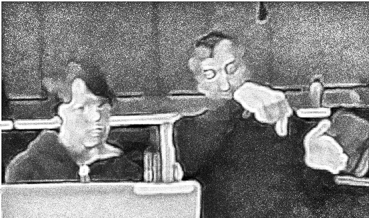
Dan: There are games where things drop down like Tetris.  Toby: … game. You could have a game where every 15 seconds 10 seconds you could add and enemy to such and such a random number between such and such . You could block it somewhere. | Dan makes a shape with hand and moves it up and down.  Toby holds up hands to indicate a range of parameters – as he says “between such and such”
Dan: So instead of.. instead of the world… the world being sideways. We could have the world being looked down on. | Dan reindicates the change of perspective with hand gestures.
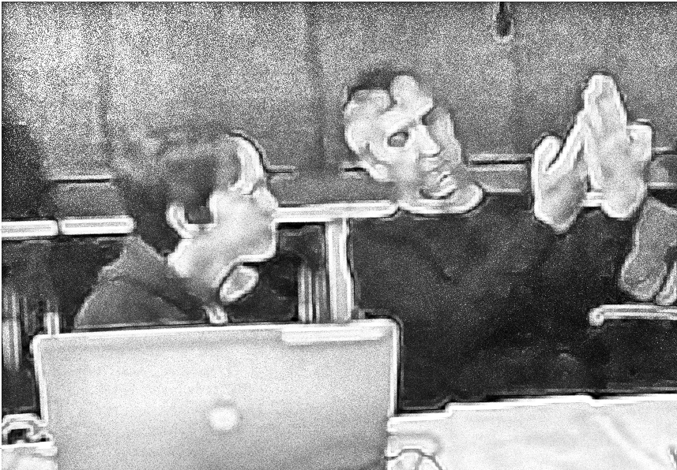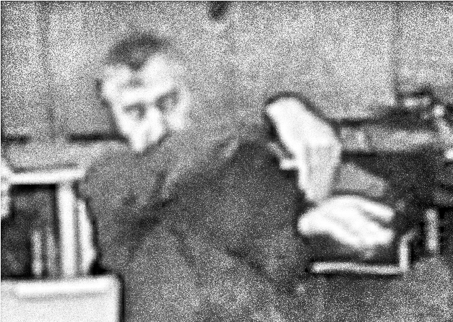
Toby: Hmm. How should I do this then?
Dan: That’s a good question. Shall we ask Mick to see if that would mess things up or not?

