6. Seeding and Nurturing Game Making Communities to Facilitate Learner Agency
- Research Questions - June 2023
- Introduction
  - Notes on structure of the chapter
- Re-examining barriers associated with cultural factors
  - Barriers and tensions associated with authenticity of audience - MOVE PERHAPS TO PLAYTESTING
    - Learners may not find coding a project a motivating project if it is only a private activity with no authentic audience
    - Restricted vs extended community - e.g. why not scratch with online community? - MOVE TO DISCUSSION ON PLAYTESTING?
  - Note this has been moved from Design chapter so needs a place to sit.
  - Using Physical Maps of Missions as Game Design Patterns
  - Barriers of identity hardcore coding & dysfunctional group work - REALLY COMPRESS UNLESS DATA BECOMES PRESENT - USE AS BASIS FOR DISCUSSION?
    - Navigating the conflict
- Exploring the impact of a drama processes
  - Vignette 4.1.a - Introducing a drama process
  - Description of Vignette 4.1.a
  - Vignette 4.1.b - Session reflections and secret missions
  - Description of Vignette 4.1.b
  - Reflecting in role
  - Observations on written interactions with the alien in the drama
    - Exploring documentation and accessing technical help within the drama frame
    - Playful dialogue with the aliens unrelated to game making
  - Use of side missions to encourage varied creative practices
  - Concluding remarks on process drama
- Emerging practices
  - Playtesting
  - Emerging use of narratives and graphics which drawing on home funds of knowledge
    - Summary: Home Funds and RQs
  - Flexible design practices
    - Supporting Digital/Game Jamming
    - The potential of emergent “non-productive” activities
- Discussion
  - COMMENTS ON FORMAT OF Discussions / Conclusion
  - Nurturing agency by creating space for emergent practices
  - Discussion on dimensions of authenticity in in relation to Agency
    - Positive affective space within a drama process
    - Extending the metaphor - anchoring in sheltered harbours
    - Implications in conceptualisations of forms of agency
- Conclusion

Research Questions - Feb 2023
- What pedagogical tools and processes are available to support novices to overcome barriers to participation in game coding processes?
- How can learners build agency in an evolving community of game makers?
- How can game design patterns support the development of coding practices with novices?

Introduction
This chapter explores the development of the emerging game making through the lens of the cultural and community activity.
The chapters have until now discussed tools and processes emerged in response to inferred learner need, in contract, the processes explored in this following section emerged more directly from input from the participants involved.

Notes on structure of the chapter
The chapter addresses research questions one and two. Thus, a guiding direction of this chapter is on how participants use the created and emerging cultural tools of this game making program, particularly in reference to the building of agency?
Planned activities introduced by myself and those by participants. However the distinction is not so neat, as explored in the last chapter. In later stages, game design patterns were collated into an organised collection with accompanying resources and a navigational menu. However, many of these patterns however, we introduced initially by participants who recognised them and wanted to add them to their own games.
The distinction between planned and emergent activities is of note and bears exploration.
NOTE - HOW AND WHY - Why because this allows a more detailed analyis of different aspects of agency.
How does this fit into other findings chapters?
Chap 4 - overall design context / evolution - Then in greater detail on personal observations on the evolutions and impact of the templated game approach and scaffolding of the code design. (not GDPs)
Chap 5 - zoom out in scale to main focus of the activity as communicated between participants and their impact and appropriation by participants. It
Chap 6 - zoom out in scale to cultural tools and their impact and appropriation by participants. It
The first section examines the impact of a process drama with an aim to establish and nurture community practice. It highlights the value of introducing almost-real processes, near authentic tools and the possibility of learners developing learning identities within a drama frame.
The drama process is an example of an introduced cultural tool. The process acts as wrapper to several supporting techniques. the side missions to and to sanction different approaches, the imagined audience encourages reflection and semi-authentic approaches.
It is the most advanced tools of a range that was put into place to create a space suitable for creativity, collaboration and self expression.
Other section explores the community behaviour of the group of game makers and some of the specifics of their design processes.
The processes include: emerging use of narratives and graphics which drawing on home funds of knowledge; playtesting as a social process; play testing and embodied participation in the games of others; community concepts and norming behaviour emerging during playtesting; the development of flexible divisions of labour;
In the discussion section, the chapter builds on material explored in this chapter in relation to exiting research to explore the development of agency in this learning design.
Particular attention is given to processes which support learners to develop agency in the game making process and the role of different levels of authenticity within these processes.

Re-examining barriers associated with cultural factors
In chapter 4 social and cultural barriers were treated in summary alongside other more technical obstacles.
In gdp chapter 5 - more detail on the social interaction in a good level of detail using data analysis from video capture.
This section explores the obstacles in practice tensions in more depth to give context to looking at impact of subsequent interventions.

Barriers and tensions associated with authenticity of audience - MOVE PERHAPS TO PLAYTESTING

Learners may not find coding a project a motivating project if it is only a private activity with no authentic audience
Making for peers has value but can be amplified and scoped using a fictional or controlled external audience often via scenarios.
Play Testing - each lesson can help with short term motivation of having a game product ready for others to play. Showcase events help longer-term motivation towards and aid prioritisation as learners near the end of their project.
The process of starting with a broken but playable template game allowed learners to be able to share their game with others from the start of the coding process.
As a designer I identified this tactic as a way to address learner disengagement if game coding is taught from scratch via a step by step instructions from first principles, especially in younger ages.
Similarly, in my journal notes, I reflect on the difficulty of interrupting the flow of making activities once they are underway. I thus began avoiding stopping making to share points to the whole class and avoid demonstrating key concepts on the screen.

Restricted vs extended community - e.g. why not scratch with online community? - MOVE TO DISCUSSION ON PLAYTESTING?
Beyond technical considerations regarding scratch and use of physics etc, Learning technology in community settings can engender feelings of agency and motivation from part of wide network and the diverse pathways. (Blunden, 2009).
Time consideration of the process of being involved in an online community may remove time spent doing real life playtesting.
Also - the diversity of creations available on a online commmunity could remove the more communal experience of the designed limitations.

Note this has been moved from Design chapter so needs a place to sit.

Using Physical Maps of Missions as Game Design Patterns
I used flip chart paper and print outs to draw a coastal landscape with GDPs represented as different islands. I asked learners to create and personalise a movable marker representing themselves. When learners selected their next mission, they moved their counter to the relevant island. Thus learners had to be intentional about their next goal and were implicitly encouraged to stick to it.
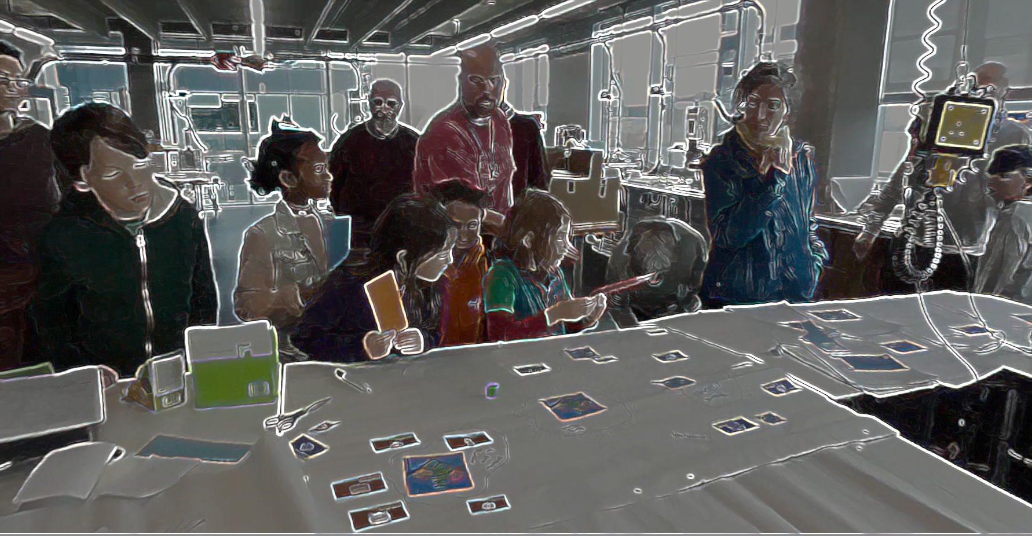 learning islands Missions as Islands
My motivations for this intervention were that it encourage a sense of community and peer learning, to help learners navigate their design experience and that the process would encourage reflect on the coding concepts or other learning dimensions that they had been working with. The use of space on the map on which GDP were arranged aimed to communicate which patterns were more complicated to implement. Starting patterns limited the maximum complexity of missions.
The following excerpts of dialogue are from a fuller transcription in appendix 4.x
Mick(f): I’m putting the ones that are hardest further away from our home island. So, because keys and doors is quite tricky, I’m going to put that one over there in the corner, if that’s one that you’re working on. ( Mick cuts a out an image from [^4] representing a GDP of key and doors.) Olivia(c): So I’ve gone really far away on the map.
The process of mapping the difficulty is something that the child picks up on here. Moments after we see a parent using the map and the resources to help her child fix a goal for the session.
Rozanne(p): Oh that’s something you were wanting to do (Roxanne points at a cut out that Mick has just stuck down.) Richie(c): I like the idea of making the enemies move. Roxanne(p): Ok, there’s a worksheet here about that. So you don’t want to any any heath meter? Richie(c): No. Roxanne(p): At least not right now. You want to to do this, on a sheet, right here, here you go. (Roxanne waves sheet and smiles at Mick.)
The new resources seem welcomed by the parent. This is probably as in previous sessions there had been conflict between them about goals. The process of aiding reflection and meta-cognition through the use of visual materials in the form of a map aligns with inclusive pedagogical design principles of UDL in that it provides means of action and expression. In chapter six, I explore the use of a process drama to achieve similar aims.
While it is beyond the remit of this thesis to examine the impact of these processes in more curricular focused environments, the following section offers a synthesis of the ideas in explored in this chapter and alignment with existing research.

Barriers of identity hardcore coding & dysfunctional group work - REALLY COMPRESS UNLESS DATA BECOMES PRESENT - USE AS BASIS FOR DISCUSSION?
NOTE DUPLICATION WITH DESIGN CHAPTER.
In chapter 4 I surfaced the conflict experiences by participants in phase one of the process where an alienation from the culture of coding prevented participation. While this was articulated clearly by just one family, this aligns with the thread of the LR exploring barriers to participation in the the culture of coding. In this section I explore the emerging tensions / barriers in more depth (and responses) to provide context for the following chapters sections. NOTE - REALLY HERE? IS THERE A BETTER PLACE? CH.4?
NOTE - MENTION SOURCE OF FAMILY FROM THE DIGITAL BRAVES ACTIVITY? While speculative, it may be of significance that this family had also attended an open workshop for families before this programme which used drama processes to begin to explore issues of digital tracking and give hands on coding experiences. It is possible that it was this combination of tech and non-tech activities which gave them the confidence to attend a program based around coding. When the family withdrew, in my journal notes I reflected that the they shared of alienation from the group process occurred in a session where, due to a sense of urgency to complete games, I had omitted drama-based warm up activities. Instead as participant entered I began to support to help some participants debug some pressing code errors.
Gulfs between desires and reality
While members of this family were able to engage in planing via sketching on paper and in creating pixel art, they were reliant on others to implement code changes. This was in part due to improvised group roles.
The freedom of choice and imagination allowed by designing on paper and via pixel art created compounding tensions. One crisis point involved a frustration of a child who was not able to implement a feature they wanted to add to the game next:
A 3d bee design of one participant which happened when there was no framework.
While personal expression can facilitates engagement and motivation it can lead to conflict if desired changes are not realistic.
In order to accelerate the process of making a game to fit into contextual expectations of an acceptable project timeframe, I pre-chose the genre of game to be made as a two dimensional (2D) platformer game.
The incident lead me to greater reflection on ongoing measures needed to prevent participant drop out for due to cultural tensions and negative affect to the working community. These include:
- An awareness of the danger that those more confident in coding create more involved code problems that need more facilitator time, potentially making others feel less valued.
- A concern for the fragility of learners positive affect towards the group game making process and thus the need for initial playful starting and closing activities to be continued beyond initial sessions.
- The value of a stronger buy-in by participants, ideally a greater commitment to the collective making process balanced with the need for low pressure (avoiding a negative sense of obligation).

Navigating the conflict
Via exit
One way of navigating this was via exit and certain families did drop out at different phases.
Encouraging peer learning with flexible working practices
CHECK FOR DUPLICATION WITH FOLLOWING SECTIONS
This tensions was resolved partly by freeing up some patterns of collaboration and interaction and removing others.
The process of parents getting in the way of children’s not minding jumping in and invading social space struck me. Together with the frustrations of complexities of larger group work the restrictions created a tension between the suggested community norm of how division of labour was organised.
Thus in the next iteration, rather than the larger groups, smaller groups, allowing some children to work by themselves and others with parents. Avoiding large group fragmentation and encouraging freedom of participation vs benefiting from parental involvement.
These tensions are mirrored in similar research and were highlighted in the practitioner interviews that I conducted.
A game encouraging maker / player types
My journal notes see an evolution of attempts to try to build into the program, activities which help build the participants sense of their own identities of game makers or more generally digital designers.
In and early tentative attempt to define in broad strokes the types of game maker behaviour and underlying goals. In doing this I have taken inspiration from Bartle’s game player types (Hamari and Tuunanen, 2014). I translated player types to maker types based on notes in my observation journal and extracts from screen capture data. The following list of Game Maker types:
- Social makers: form relationships with other game makers and players by finding out more about their work and telling stories in their game -
- Planners: like to study to get a full knowledge of the tools and what is possible before they build up their game step-by-step
- Magpie makers: like trying out lots of different things and happy to borrow code, images and sound from anywhere for quick results
- Glitchers: mess around with the code trying to see if they can break it interesting ways and cause a bit of havoc for other users
An additional rationale for this process was to help reduce potential internal bias about the kind of process that a computer programmer should adopt, echoing the call for pluralism in approaches explored in the literature review (Papert and Turkle, 1990). I wanted to try to communicate a message to participants that when you are learning something hard it is of value follow your own working preferences and try to discover a creative style that suits you.
This line of thinking developed from a warm-up activity trialled in P3 were participants took the Bartle test (what kind of game player are you).
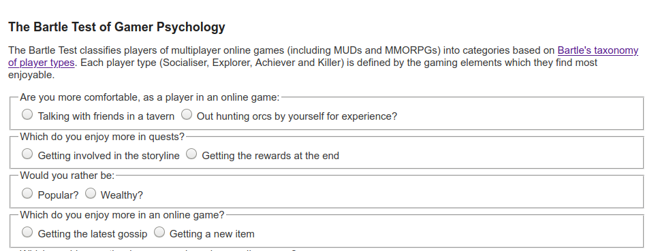}
The process was adapted so players moved to a different quadrant of the room based on their response to the question. The process allowed young people to see how their response differed from that of their parents. The process was very engaging and quite revealing. Parents responded that the process gave them new insight into the digital identities of their children.
After the results were revealed, I then proposed as facilitator that my observations were that there different game maker types. I read out the different types and asked them to place themselves in a two-dimensional grid based on their self evaluation of what kind of game maker they were. Other family members were then invited to comment to see if they agreed with this interpretation.
The process of exploring identity in this way surfaced the cheekiness of some young people and the pleasure they took in demonstrating their playful mischievousness. I began to make journal notes on this subject and talk to other games study practitioners. I began to ask the question can the surfacing maker types (as per player types) encourage awareness and celebrate the emerging practices that the community was producing.
As an example some layer created impossible or overly easy game levels. They appeared aware of implications for game balance but is taking pleasure in this seeming destruction of the key challenge of the game as an act of disruptive play. They seem to take pleasure from ignoring concepts of what should be done to maintain game balance and from the sense of shock from their current audience her parent. Going against this convention is a type of playful destruction in this context. The process mirrors play theory concept of playing against the game or dark play (Sutton-smith, 2001).
Narrative summary of conflict - TRANSITION TO DRAMA SCENARIO
The conflict comprised of compounding factors and resulted in a lack of desire to complete coding activities before fully engaging with them.
In the initial stages some families struggled to reconcile the obstacles presented but their active participation in warm up games shows ….
While many families talked of the challenge of coding, one family in particular were s In reflection on the session that ended their participation
INSERT SOME ANALYSIS HERE BASED ON AGENCY AND AFFORDENCES OFFERED

Exploring the impact of a drama processes
The introduction of a drama process was introduced in response to a the barriers to participation caused by not identifying with the culture of coding or gaming. This section describes the addition ot the intervention and explores its value as a pedagogical tool to seed game coding practices and to develop learner agency.

Vignette 4.1.a - Introducing a drama process
The participants have entered the room and chosen a laptop to work on. Some of the children play web-based games or reviewing the games that they have made previously. The session progresses with a warm-up game which includes many false starts, changes of rules, development of tactics, appeals to be serious, full throated laughter and many restarts and which ends in good hearted failure. The transcript below picks up at this point.
Mick: Ok. So I’ve got a surprise. I don’t know if you know but as part of our Home Ed club we did a page of different games. So it’s on glitch.com and it’s called Glitch Game Club and it’s on there, there’s one for Home Ed Winter 2019 and here are all the games that we made. We made a lot of games. 15 games. This has not gone unnoticed because I got a message through this account. This is kind of a story now. We are entering a story. You have to use your imagination. We got a message and it was an audio message. If you guys take your fingers off your keyboards and have a listen to this audio message which is quite unusual as I don’t think it was from anyone on … this … Earth.
Greetings Earthlings, we have an important message for the Glitch Game Makers.
We are the Weean. You would call us an alien lifeforce. We like to think of ourselves as friendly space cousins.
We can see your Internet from space. We are contacting you because we know you are making games on the Internet.
We are on our way to the Planet Earth, and we have an important mission for you. We are an Intergalactic Rescue team. We know you have problems on your planet. We can help.
But we need to find out one thing first. Are you worth it? After we are gone will you also be able to help yourselves? Or are you already doomed to make the same mistakes again?
You must pass this challenge. Make some games showing problems you have on earth. In the games also include ideas for how to solve them.

We have some guidelines:

• Make a game about a big or small problem to solve. If you can let us play it each week as you go along.
• Give us an update each week by recording a group update.
• Show you can work on your own but also work as part of a team.
• We will also send you text messages with some mini-missions sometimes. Be sure to tell us how you do.

Please now get started and come up with a new game about solving a problem on Earth.
Mick: I couldn’t understand all of it but I tried to write it down as best as I can. So from what I’ve work out they’ve looked at our games and they’ve come up with a challenge for us. They are coming to Earth so they need to find out if we are worth saving. And the way that they are going to decide is by playing the games that we come up with. And they are going to set us little challenges. So. yeah, that’s the story. (with heavy irony) I’m pretty sure it’s true. (Mick and others laugh).
Mick: So all they’re asking us to do is to come up with a game. We’ve got four sessions. They want a new game because they’ve already played our old games. It’s got to be something about the problems of the world. I’ve got a lot of problems. It could be big problem or a small problem. It could be about your problems. But also ideas on how to solve them.
And yeah. That we can work by ourselves but also work as part of a team. So we’ve got to give them a report by the end of each session as well. That’s our mission.

Description of Vignette 4.1.a
The process of introducing a scenario for participant to respond to is common in project based learning in this vignette. Here it is extended using a dramatic element in line with Heathcote on Mantle of the Expert and other process drama techniques (explored in Lit Review). In this section, I describe the vignette using concepts from MoE. Further analysis follows in a later section.
The following tenets of MoE from Aiken’s summary (2013) apply. Aitken’s and Heathcote’s terms follow in italics. Within a fictional context a responsible team is contracted into a commission by a client. The facilitator frames curriculum elements as productive tasks and plans for tensions to arise involving: authentic contexts, messiness of learning, maintaining learner interest and resilience to overcome the grappling and struggling involved. The following sections explore some of these key concepts via the example in vignette.
Contracting into drama
As a facilitator, I indicate that we are entering a dramatic process and attempt to draw everyone along with me using the following sentence “This is kind of a story now. We are entering a story. You have to use your imagination”. This serves to start the process of contracting in a drama. As a way to introduce the imagined audience, I reference that the games are online and have been noticed by aliens. The use of heavy irony in my voice when concluding the scenario, “I’m pretty sure it’s true” and the resulting laughter form an informal collusion that we are playing along with this fiction. The collusion is noted by both parents and children in recorded exchanges. For example, after engaging with a code example provided by myself in the role of the aliens, one pair make the following comment.
Parent: Look, this is what Mick’s showed, what Mick’s has done.
Child: The Weean have done!
Parent: The Weean, sorry yes.
Facilitator activities in role
My role is a link between the participant and the fictional commissioners of the games. The transcript above (a fuller version is in appendix 4.x) captures a rare example of myself extended facilitator input as instruction. As a practitioner teaching technology, I try to limit teacher talk and being overly directive to prevent learner disengagement. COMPLETE.
Balancing leaner choice with over-ambition is a tension explored in the previous chapter. The drama narrative helped resolve some of this personal tension by allowing me to outline boundaries and be directive using the dramatic commission as a foil to help avoid the encounter feeling personally combative or controlling [heathcote_drama_1985].
Learner activities in role
Beyond the wider fictional frame of the making activity, learners were also sometimes asked to undertake some activities in role, in particular reflection in role. This and other example are explored via the second vignette.

Vignette 4.1.b - Session reflections and secret missions
This second extract comes from the following session in phase four. In three of the four session the last 10 minutes of each session involved giving a progress update to the aliens.
Mick: Ok are you guys ready to share back if you could come to this side of the room we are going to get Mark and Edward to share back first. Everyone can share back using this computer that the Weean are watching if that’s alright. organiser
Mark: All we’ve done today is just get a background in and then we were just working on the one that the Weean had sent us about dropping the coins in. Now that the Weean have sent us the code we need for basically dropping stuff.
Mark: The idea is planting trees. about dropping seeds. So we want to drop those and have some enemies that are tweening randomly around and also taking them away. The idea is to have a timer to drop a certain amount in a certain time frame or you can’t go through to the next level. And the next level would be you go around and water all the trees. And the third one is you have to look after them all making sure they are not getting chopped down again by that tweening enemy. So we’ve got the concept and everything now and we’ve got the code So we should be able to make a bit of a jump forward now this week. It doesn’t look like we’ve got any where but we have. (Mark laughs and others follow). So we’ve got the the background in and we know what we need to do about scrolling as well because we want to scroll across.
Mick: That’s great. Is there anything that you think you definitely want to be able to do for next time that you might want help with?
Mark: Oh yeah. We’ll we’ve got a bit of space where we can work on it before we next come in so we’d like to ask the Weean some more questions. Is that the best way to do it?
Mick: Yeah for sure and I can see that you guys have been talking to the Weean, Here this project here in your home page called Talking to the Weean allows you to talk to the Weean. So you can go in there, click on Edit Project and if you click on this bit here that says WEEAN and then Markdown you can actually just ask questions in here.
(Mick reads out the following extract the organiser screen containting a text chat with the fictional alien audience)
Ed: Weean what’s it like up there?
Weean: It’s cold and very big but quite tranquil.
Ed: What is your name?
Weean: We are are the Weean we have no name, we are all the same.
Ed: That must be hard at xmas. (Mark and others laugh and smile.)
Weean: It is. It sure is.
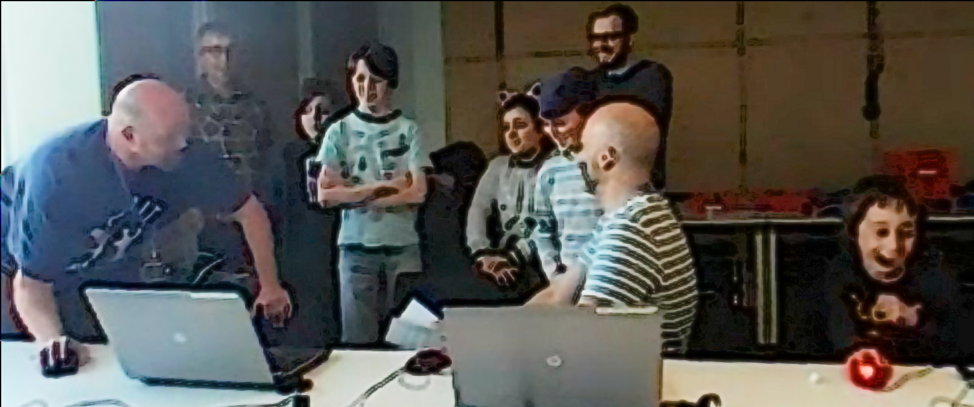
Mark: That’s tickled me that.
Mick: So there you go. You can have a conversation there with the Weean in there using mark up code you can copy what’s there. Nadine can you talk through what you have added to your game? Is yours called “No Toby Allowed” now. (Laughs from all)
Nadine: I’ve not really done much today as I was busy doing stuff with Toby’s
Dan: We noticed.
Nadine: We’ll I’ve changed the platform a bit
Molly : You had a secret mission though didn’t you
Nadine: Oh my secret mission was to change someone’s game, their character or something and see if they noticed. And I think they did notice.
Dan: We did. We did notice.
Molly : You couldn’t not notice.
Mick: It feels like you took the spirit of the mischievous thing and just turned up the volume. (All laugh.)
Molly: Sprite!
Mark: We also had a secret mission.
Mick: What was that?
Mark: Ours was to change the sound on somebodies game.
Nadine: Oh was it?
Mark: Did you notice?
Molly: Did you notice?
Nadine: No (laughing) (Incomprehensible many people talking or laughing at same time)
Mark: Play it now!
Richie: You definitely noticed. (Points to Mark and Ed) You definitely noticed my bit.
(Nadine goes to the keyboard and starts to play her game)
Nadine: I can’t hear anything different (Everyone laughs)
Mark: I thought you were going to go- Aaahgh! But you didn’t say anything.
Mick: So that’s interesting. some people notice some people didn’t.

Description of Vignette 4.1.b
In this extract participants are invited to take turns showing their game, recapping their progress and outlining next steps to the alien observers. I play the role as a liaison facilitating the process for the fictional, remote audience. I also draw attention to the secret missions that had been distributed to participants (along with social missions - both explore later in this chapter).

Reflecting in role
It doesn’t look like we’ve got anywhere but we have!
While drama scenarios can aid reflection both in or out of drama, O’Neill and Lambert outline the value of in-drama reflection, noting it is “likely to be more powerful than end-of-session discussion, since it allows individual and group insight to be articulated as part of the context” (1982:144). In line with this intervention, they propose one way of achieving in-role reflection is to introduce an additional character that acts as an external audience. In this intervention however, main activities happen only weakly in role, whereas the end reflection highlights the fictional frame of the making more strongly.
In my journal notes for phases prior to using the drama process, I documented that the occasional end of session debriefs as go-rounds had limited success in terms of amount and quality of participation compared to these sessions. The video and audio recordings document rich feedback from individuals and pair teams, near complete participation and productive elements of interaction as the feedback progresses.
In previous iterations, my omission of end-reflection in sessions stemmed fomr a lack of time in sessions and reluctance to shift learners away from making activities to reflective activities. I found the need to maintain the drama narrative served as a high motivation factor to complete reflection activities.
To begin the reflection session I ask participants to gather around a particular computer which the aliens are monitoring which helped moving participants closer to each other and stop their coding activity. It is of value to review the grouping of participants in the still image in the vignette above in Fig 5.x. The simple clustering of partfanicipants so they were side by side and talking to a disembodied audience via a computer seemed to make the feedback process less daunting for students. One of the younger participants Richie is participating on the margins but clearly following proceedings as his facial reactions to ongoing contents of feedback. He later participates more actively when reflecting on his process than in previous sessions. Even participants that were initially reluctant to share back and had never shared back publicly before in sessions, chipped in after other family member had started the process for them.
Using the terms of student agency explored in the literature review, here we can see the use of the drama narrative used as a second stimulus both by facilitator to help convene learners and to help them participate in reflection, and project sharing (Sannino, 2015).

Observations on written interactions with the alien in the drama

Exploring documentation and accessing technical help within the drama frame
In the first phase of the project, I had promoted the use of a mailing list to ask technical and code questions of the wider group. This surfaced a conflict where parents were reluctant to bother other participants with such issues.
To address this, as part of the drama process, I encouraged participants to communicate with the aliens to ask help. To do this in a way that encouraged other participants to join in, I created a project in the shared coding project area with a webpage that could be edited and viewed by participants. When in the vignette 4.1.b Mark asks “We’d like to ask the Weean some more questions (to overcome coding blockages), is that the best way to do it?”, he is referring to this project webpage. To seed this process, I had entered a question sent by Mark and Ed via email into the page, and written a response on behalf of the aliens.
Dan and Toby also received help from the aliens to implement a pattern of creating random movement in their pac-man clone game. For this pair, the process of reading a code suggestion from the aliens gives the parent opportunity to deconstruct the code in detail to explore coding concepts. In later discussion, Dan uses the fiction of the alien to playfully chastise me for using code syntax which was harder for novices to read.
"Mick, do you think the aliens would mind if we get rid of the switch statement and replace it with some if-thens? They're just showing off these aliens aren't they?"
Here the text dialogue with the aliens is used as a mediating artefact first by the facilitator to share help in-role, and then by a parent to suggest a modification to the code syntax used and indicating a more general tactic of using readable code structures in novices.
Thus, in summary, the process of writing down a text request in-role potentially addresses the (previously-explored in Chapter 4) barriers asking for help by de-personalising the process. It also encourages the adoption of professional practice of asking a written question to overcome a coding problem and thus builds experience of using technical terms. While this aspect of the drama process was introduced by the facilitator, in alignment with the understanding of Sannino’s concepts of transformative agency through double stimulation (TADS) participants transform the function of the alien conversation to their own purposes. This theme is developed in the next section.

Playful dialogue with the aliens unrelated to game making
The process of asking the aliens for technical help within a code project sparked a playful process of informal chatting with the aliens. During in our end of session reflection above, I noted the following ad-hoc encounter that a child initiated on the interactive page while his father was taking a break from coding.
Ed: hi WEEAN what is it like up there :)
Weean: It is cold and very big but quite tranquil too. all the same.
Ed: What is your name?
Weean: We are are the Weean we have no name, we are all the same.
Ed: That must be hard at xmas
Weean: It is. It sure is.
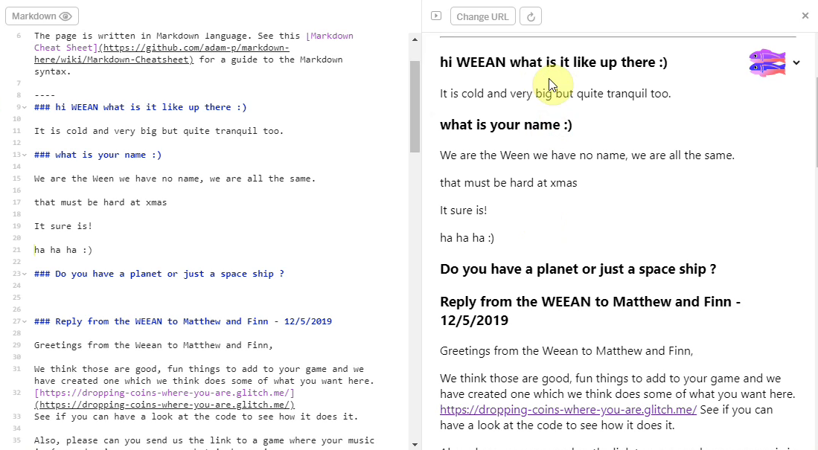
alien feedback
Inspired by the positive reaction of participants to this playful engagement with the fictional audience, I asked a student helper to participate remotely to play the part of the alien. The student then gave feedback via live text interaction to participants in the final session. The process started with supportive and celebratory messages posted from the alien. The impact was significant with the young people with 5 out of 7 engaging by writing messages and all mentioning the interactions verbally during the session.
The live chat began to fulfill a function of building insider rapport, creating a fun atmosphere, celebrating the completion of games in the absence of a public showcase, and signposting the achievements of other participants. For some pairs, while the child interacted in the live chat, parents performed final tweaks to code projects and challenges. Two parents in particular worked hard debugging more complex elements of the game with facilitators and peers. Other parents engaged with the chat and encouraged their children to get feedback from the aliens about their game in particular.
The start of process began when Ed in a moment of free time expanded the use of space initially imagined to address technical needs by initiation a playful interaction which, while in the motivation to support different learner identities, was a novel, volitional action in this context. It is helpful to expore this interaction using AT and TADS terminology. Ed is in conflict, not able or wanting to engage in his existing creative activities while his father has a social break. Using the secondary stimulus of a text chat with fictional aliens, he writes a playful personal question to the aliens as an expression of volitional action to play, casts out an experimental kedging anchor. By co-incidence, I was on a different computer, saw this question, and was able to respond in real time. Thus, by getting a response, Ed’s kedging anchor caught onto an anchor point and Ed was able to resolve this conflict of inactivity and in doing so both amuse himself and other other with humorous self-expression, and open-up a novel, child-centred activity for the whole group which could also address potential issues of alienation from the culture of serious coding expressed by other participants.

Use of side missions to encourage varied creative practices
In addition to the the main mission of given in role to make a game to entertain and inform visiting aliens, and extra social and secret mission were delivered with the frame of a drama process, with an explicit aim to encourage community-focused patterns of behaviour which had emerged in previous iterations of game making. These include social aspect of playtesting and playful interactions, explored in later section in this chapter, which I had identified these behaviours as potentially helpful in maintaining the positive affect and identification with the on-going group process of game making.
A table of both social and public missions follows. These mission were printed out on cards and one of each type was given to the participants in the first half of the first two sessions.
Your Alien Mission (social) | Your Secret Alien Mission:
Find out the names of 3 games that are being made. | Change the variables at the start of someone else’s game to make it play in a funny way.
Make a list of characters in two other games being made. | Change of the images in someone else’s project to a totally different image and see if they notice.
Find out the favourite computer games of 4 people. | Change the level design of the first level of someone else’s project to make it impossible but try to change as little as possible to do that.
Find out who plays the most computer games per week in your group. | Change of the images in someone else’s project to a very similar but slightly different version and see if they notice.
Find out what other people are planning. Give some friendly feedback to one other person / group. Why don’t you try… | Add a rude sound to someone else’s project.
Ask 2 different groups if they have thought about what sounds they are going to put in their game. | Swap over some sounds in someone else’s project and see if they notice.
Find out from three groups if they are going to try any totally new ideas. | Delete all of the code of someone else as they are editing it and see how they react. Then help them get it back using the Rewind function.

In the transcript above of vignette 4.1.b we see that in the end-of-session reporting back participants engage in a lively discussion about the secret missions they had been given. Encouraged by her mother Molly, Nadine shares that she has been highly engaged in a disruptive secret mission. Dan and Toby express playful frustration. Mark and Ed contribute by sharing their more subtle disruption and Richie is keen to have his rude noise mission noticed and commented on. Some public missions had a noticeable impact in this session particularly in stimulating a discussion among parents around which arcade games they played as youths.
These sanctioned non-design activities, designed to reduce participant stress, to encourage the exploration of the games of others are taken up enthusiastically by much of the community. In analysis of one key sessions involving missions from which the transcript was taken. Out of 10 participants, 8 visibly engaged with the secret missions during the session.
The process was not without friction. After initially engaging with the process of secret games, Toby and Dave, who were later working on a tricky coding process, expressed frustration at interference. Thus, while promising, limits to this process should be evaluated to avoid overly disruptive behaviour which create barriers to progress. For example, time limits could be in place.
The positive reaction of young people to the drama process was also picked up in interview data.
Mark: Tell us about the Weean?
Ed: er.
Mark: What did you like about the Weean?
Ed: Just very silly and I don't know. They answered your questions.
Mark: Was it, because there was a sense of play, a bit of fun and a bit of anarchy.
Ed: Yeah.
Mark: What else can you tell us about the Weean?
Ed: er.
Mark: There was the little sabotage things you had to do as well.
Ed: Yeah
Mark: So you liked those games where you had to kind of hack somebody else?
Ed: Yeah
...
Mark: The Weean thing was, I think, a massive hit for everybody because it just brought sense of play and fun. And it took attention away from it being overtly technical. Brought a personal element in and obviously that anarchy. Kids love the absurd.
There is more evidence of the impact of the drama process in the vignette above. In the end of session reflection, Richie occupies a peripheral position and continues to interact with his laptop. However, he reacts positively when Ed’s questions to the Weean are read out. He later adds to the discussion when it turns to the sabotage based missions set in the drama process. It is probably that the ability to represent his irreverent approach helped his participation in the more formal, collaborative reflection and feedback activity in a way that had not happened in previous sessions.
Side missions or side quests are also used in open world games are used in part to appeal to different kinds of players and are often models on Bartle’s taxonomy of game player types (Bartle, n.d.). In this phase, parents Molly and Mark both used the prompts of the social missions to take a break from their creative work using the software toolset to talk to other parents and children. This supported and encouraged behaviours that I had observed in the previous stage where they had been energised by breaks for coding and interactions with others. This activity helps addresses one of the key barriers to taking part in a coding community that of alienation from the culture of hardcore coding.
Mark: Right we’ve got a background in. Do you. Do you want to reply to the Weean.
Ed: Yes. (Ed starts to type very slowly)
Mark: (after some time) While you do that I’m going to go do my mission.
Ed: What's your mission?
Mark: To find out about other people's favourite games.
Ed: Alright.
While the some of the secret missions encouraged forms of disruptive play, griefing of playing against the game (Bakioglu, 2008; Bartle, n.d.). While this increases engagement for some learners, the process also suffered the danger that participants transgress levels of cheekiness and play which explores boundaries, to more disruptive ones. In this context this involved frustration and wasted time for other users. The vignette above shows a chance for the parent to express his frustration at the process in a playful way.
The use of missions introduced by facilitator are taken up voluntarily by participants and work to address conflicts caused by identity clashes by recognising and encouraging diverse making approaches and styles of community participation. A BIT MORE ON AGENCY?

Concluding remarks on process drama
This section has explored the use of the possibilities of a drama process to support both the leaner expression of agency and as a pedagogical process for facilitators to militate probable conflicts and obstacles for learners in the creative process. The mission-based interventions began as naturally occurring expression of learner agency which became incorporated into the drama process. The next section examines the affordances and impact of the coding environment and starting game template, which in a similar way, evolved in response to participant use of earlier iterations of the toolset. Conversely, examples of more unguided practices and use of tools which served to increase the scope of agency are explored in the final section of this chapter.

Emerging cultural practices
NOTE THIS NEEDS A QUICK INTRODUCTION TO MAKE A TRANSITION - LINK THIS PART AND RECONNECT IT WITH CHAPTER 4.
AT theory emphasises that the process of activity does not start in a vacuum. This helps justify the formative intervention process which is active in intervention and in the initial shaping of activity. In an educational context, this can involve introduction of tasks as starting activities to shape. This is justified conceptually from a view of not restricting participant agency in that some form of activity should be suggested in order for them to make a rational choice as to weather to participate. It follows that this activity should encourage the communication that participant choice is significant in the design.
Beyond the starting point, the focus shifts to the way participants appropriate and use these practices. Many outlined here were very minimal in embryonic form but extended significantly by participants.
However the focus should not solely rest on the emerging practices but on the measures that facilitators can encourage them. The following sections address these dimensions using a lens of inclusive pedagogy and authorial agency.

Playtesting

As explored in the literature review and previous chapter, playtesting is a rich and varied learning opportunities which encourages community-building behaviour.

Playtesting as a cultural process
Participants, particularly older ones, used playtesting as a way of showing support for fellow game makers. Example behaviours included: praising graphical content; making links with home interests of participants through questioning; and building rapport.
Molly in particular used playtesting to show her appreciation of the graphical work of others especially in the creation of cute animal characters. In response to one game which featured an image of a dog, other participants asked: Do you like dogs? Do you have a dog at home?.

Playtesting and embodied participation in the games of others
Some children added additional playful elements to playtesting. Because these interactions were mobile between works is it hard to extract audio and transcribe their speech. However, it is possible to communicate the characteristics of this play via a description of a typical encounter and the gestures of participants.
WATCH MORE CLOSELY AND TRANSCRIBE GESTURES
Play is initiated by calling across the room as an invitation to play, or as a provocation. When playtesting is underway it is normally undertaken with two or three participants standing around the computer rather than being seated. The core of those involved take turns to play the game, exclaiming frustration or triumph at completing levels or failing. Failure may be extremely performative with a rapid pulling way from the screen and keyboard. This may be followed with a battle to wrestle control of the keyboard to play the game next. This may involving playful pushing, and wrestling of hands and arms and vocalisations. While this play is happening it may attract other participants who remain on outskirts of the activity looking on able to watch what is happening on the screen and respond non-verbally with smiles or laughs.
These changes to the form and function of playtesting by young participants is another example of expression of agency by participants that widens the scope of possibility of actions.

Community concepts and norming behaviour emerging during playtesting
NOTE THERE IS SOMETHING HERE ABOUT ME STEPPING BACK AND LETTING THE COMMUNITY EVOLVE.
Ed gives a more technical explanation from involving the naming of the variable jump speed.
Other children come and play the game but only for less than a minute before leaving. Towards the end of the playtesting process, as one child leaves, Molly comments “It’s so frustrating.” This suggests an evolving understanding that her game is frustrating to players rather than pleasantly challenging.
The indirect norming behaviours … described in previous chapter … mirror observations seen in the work of Rogoff and colleagues(Rogoff, 2003) on learning in community settings. There is an apparent tension in play here between encouraging individual agency of expression within the game and an evolving community tendency to norm peoples games to be more playable, specifically that player movement should conforming to wider expectations.
To better understand this process it is relevant to locate the source of these wider expectations and to evaluate their utility here. This is attempted in the discussion section of the chapter.
What we can draw from the data at this stage is that playtesing provides many leverage points to facilitating learner agency and discuss the limits of designs. IN addition, playtesting is a process that allows participants to demonstrate informed criticality as a player and guide the creations of peers via gameplay feedback.

Emerging use of narratives and graphics which drawing on home funds of knowledge
The literature review outlined the potential of home interests as funds of knowledge, especially informal learning. This learning design provided participants with different ways to input and explore their home interests in the narrative and graphical elements of their created games. For example the choice of game characters allowed the expression of identity. Other designed elements for example audio and graphical effects or written messages added to the overall aesthetic or polish of the game.
Video evidence indicated that conflicts involved between learner expectations and their technical abilities are helped by the use of the starting template. The constraints of provided game elements and implied narrative structure of the template accelerated the initial creative process.
One pair Clive and Pearl, the grandparents of Toby, included a narrative message at the start of their game. This process surfaced the expertise of the family as beekeepers, sparking interesting conversations with other participants.
var starttext = "This is a game which pits a honey bee against a swarm of Asian hornets, which are alien invaders attacking bee hives in the UK and which beekeepers are trying to stop spreading here. Try to guide the bee to collect all the flowers without being caught by the hornets.
Use the arrow keys to move the bee. Press return to START.";
In another example, Mark and Ed designed a game around the character of a train driver that needed to collect coal. In subsequent post course interview Mark describes the impact of the child feeling like they could bring their own identity and interest into the project. “I know just your eyes lit up when you realised you could expand your interests into gaming.” See Appendix 4.x (Mark and Ed working with home interests)
Other participants expressed pride over their graphical creations. In this excerpt parent Molly has spent time creating a pixel art representation of an alien. The full exchange (see appendix 4.x) sees Molly cultivating a sense of ownership over the graphical element that she has created. There is also the development of a growing sense of competency in this area of asset design. She notes she is an “expert pixel”.
Molly: We’re finished. Right what’s next? Now I’m an expert pixel? Now I have to figure out how to get it in there, don’t I? Without losing it. I’ll be very upset.
Sonia: Have you saved it?
Molly: No I’ve not saved it.
Sonia: Save there. (points to relevant button on screen)
The growing mastery of this area also seems to help drive motivation to complete the next challenge. The sense of ownership spurs the technical process of saving projects. Her pride in her work and concern surrounding losing it provokes a fellow parent to show her how to save her work.

Summary: Home Funds and RQs
This research supports findings of other research which highlight value of incorporating home interests in games, coding and media projects (Papert, 1980; Resnick, 2012). It also aligns with PBL literature which advocates the personalisation of projects and the value of exploring concepts using home funds of knowledge (Moje et al., 2001)
This research indicates that in particular, allowing participants to incorporate home interests can be highly motivating in early stages of the design process. It can also sustain the coding activity later in the process encouraging participants to overcome problems in order to share the personalised object created.
In addition, the tacit knowledge of children as game players gives them access to varied affordances in the process of feeding back.
There is also evidence here that frictions involved in dealing with participant expectations of the genre and professionalism of the game they will create, are helped by the use of a templated game. Both in terms of the technical platform and the implied narrative and creative frame which scaffolds the initial creative process. This supports existing research on the value of constraints in facilitating rapid creative improvisation in the areas of music and drama. The domains of programming, game jams and hackathons also use constraints in a similar way (Gabler et al., 2005). HOW TO EXTEND?

Flexible design practices
As explored in the literature review design stages as a conceptual design tool is common in CS education, e.g. Resnick’s creative learning spiral (Resnick, 2007:2). While I did not ask learners to follow prescribed design stages, in data analysis I created a coding theme based on a design cycle framework: Ask / Imagine, Plan, Create, Test, Improve, Share. When coding I observed that naturalistic practice rarely matched the progression of the design cycle. The stages were instead fragmented and sometimes happened in parallel. In many interactions I observed improvisational approaches which incorporated ideation, planning, implementation and testing in space of a minute or so. If I had encouraged participants to follow prescribed design stages this may have restrict this flexibility in practice. This concern is echoed in research which critiques a similar, staged approach to creative writing in primary education using a writing cycle approach. (Kuby, 2016)
In a closer review of key literature claims of of the value for participants of following design cycles are implied but not supported. Instead stages is are proposed as a tool to “discusses strategies for designing new technologies” (Resnick, 2007:2). the following writing discusses the value of flexible approach to design processes observated in my research.

Supporting Digital/Game Jamming
While the concept of Game Jams are established, the free form flexibility of the Jam process is often left to the skills and evolving practices of the participants.
This section explores the process of jamming in the context of game making. While the processes identified are often improvised, there is a group element of the process where makers pick up techniques from other makers in the group. I propose the value of facilitators noticing and nurturing potentially productive practices.
I propose that this process can have value in other areas of digital making.
Flexible design practices are often present in recorded data. Younger participants in particular developed impressively fluid practice demonstrating extremely rapids shifts between code editing, game testing, authoring assets in online tools and migrating files often while talking with peers. Older participants also showed rapid, responsive creativity. Clive quickly incorporated a boost to player health after a level after being given feedback during playtesting. In exploring sound making software Ed and Mark start a process of tinkering and messing about with the capability of the tools which spurs creativity. The joint jamming created two different soundtracks. This sparks a new proposal to incorporate different soundtracks for different levels. Pairs often adopted a similar spirit of improvisaion. For example parent Dan makes a suggestion - “Use paper to design?” - to which Toby replies “I’m just going with it.”
These observations of the value of flexible design processes, invite discssion on how best to conceptualise and support these flexible approaches. Game Jams are accelerated events encouraging creative collaboration and innovation. While the event’s premise is to promote collaboration, these events are inconsistent in their support and scaffolding of collaborative approaches (Goddard et al., 2014).
Other relevant perspectives include rhizomatic design approaches (de Freitas, 2012). Research exists on the promise of rhizomatic approaches design thinking in creative educational programmes (Biffi et al., 2017). However researcher identify significant competencies required including to “identify and synthesize the body of technical and even complex knowledge into a feasible structure” (Biffi et al., 2017:972), which are not well-aligned with the age group of this context.
Instead, I propose that the tools, process and the community in this study mutually encourage an improvisational approach often referred to as jamming.
There are disparate resources available for game jams but due to the adult centric audience and mix of abilities they are less guided in nature than many supported design processes aimed at school age audiences.
NOTE - Explore jamming in relation to lit review concepts and data of the chapter.
Claim: The data in this chapter shows the value and further potential of mixing the more mature techniques of MoE and other process drama techniques with the ethos of game jams.
Recent research posits that Game Jams can be profitably used in formal education contexts (Aurava et al., 2021), although there is scant guidance on how to address potentially problematic issues (list these). A complementary approach would be to significantly adapt the overall Game Jam format and to add greater scaffolding to the process as in the learning design of this research.

The potential of emergent “non-productive” activities
NOTE - Within the concept of jamming, activity which is casual seemingly non-productive can still transmit useful information to guide collaborative practices.
Much time in sessions was spent on activities that did not fit nearly into an accepted design stage, for example: opening software tools; navigating to correct locations; and finding past assets. These processes often involved significant effort and collaboration between participants. For example the migrating assets between authoring tools, converting to correct formats, evaluating new tools, and finding previously created assets. These are practices that I am personally familiar with. I call them digital laundry or digital housekeeping. Things that at times can be low attention span. Faff time is even less productive switching on the computer and waiting for the internet to connect, waiting for a family member to finish their rushed lunch or navigating to the right location in creative software.

Skills to perform these activities were at often distributed between different family members. For some adult re-enforcing their identities as project managers, and for young participants forming identities as digital specialists. I noted in analysis of data that along with frustration there are also moments of creativity, and there are bonding moments which appear to be helped by this activity which is at times quite unfocused but also shared. In retrospect, many of the social missions explored above encouraged activity outside of established design stages. For example the lively discussion about game playing in response to the mission to find out the favourite games of 3 other people.
The process of swapping graphical assets used a shared Piskel gallery and games area which served to keep individuals informed in directly of progress being made, and to spark curiosity in the creations of others.
In addition, I observed that navigating these essential but non-creative tasks in a collaborative and playful way can reduce learner anxiety and help maintain a positive affect to the overall creative digital process. This observation is supported by an example in the next chapter available in appendix 5.x - an extract of which is included below.
Participant Dialogue | Participant Gestures & Activities
 | Nadine has just rapidly demonstrated how to bring a created graphical element into the game
Molly: How did you do that so quickly? I’ve got to like, carefully… | Molly makes hand gestures to show a sense of hesitant keyboard use)
 | A parent peer next to Molly laughs. Nadine, the child of Molly bounces up in place and smiles broadly.
In summary, it is of value to create spaces to leverage the potential of these in-between moments for participants. This a concept is developed later in this discussion.

Discussion

COMMENTS ON FORMAT OF Discussions / Conclusion
This doesn’t seem to hang together well. What about a more quantative approach to justify some of the findings above and below as a big part of the end of this chapter.
NOTE - What about coding based on “processes to develop agency” - as per thematic analysis doc - and chapter 4? This could work as a summary of the chapter and something to put in a table and give some

Nurturing agency by creating space for emergent practices
THIS SECTION IS STILL UNDER DEVELOPMENT
This section continues to explore tensions surrounding support learner agency, useful conceptions of agency, and starts to explore recommendations for researchers and educators working in this area. As previously explored, varied conceptions of agency exist including: instrumental, authorial and transformative agency (Matusov et al., 2016). (See methodology chapter). As a learning designer, design decisions to create a sheltered harbour, increase the instrumental agency of learners allowing them to experience a feeling of control over their creative process.
Adopting analysis which aligns authorial agency and transformative agency, there is a potential tension between instrumental agency and transformative agency. A design which minimises possible conflicts also reduces the potential for participants to solve them both individually and collective responses.
Thus, I propose that key areas of the learning design should be more open in structured to encourage the emergence of participant responses and novel practices. The concepts of affective space and magic circle previously explored in the context of drama process as a way to encourage participants to improvise from a starting structure are of value to provide guidance to practitioners in the domain of informal digital design.

Discussion on dimensions of authenticity in in relation to Agency
Returning to the work of drama processes, Heathcote (Heathcote and Bolton, 1994) warns against asking participants to genuinely make items in the processes explored. To do so, she argues, would expose their inexpertness in the cold light of day.
“if they are makers of things (for example, shoes, ballgowns, or aircraft) they must never (within the fiction, that is) be asked to create the actual objects. If they had to do this their in expertness would become immediately apparent.”(Heathcote and Bolton, 1994:18)
Authentic tools in settings where students may find their novice skills lacking can negatively impact on experiences of self-efficacy and thus agency. While this is clearly the case in factory-based drama process, the value of digital tools allows students to to work with more authentic practices.
CALL BACK TO AUTHENTICITY OF LAST CHAPTER - LINK TO AGENCY
In chapter four the use of coding tools and the impact on instrumental agency was explored.
Authenticity in project approaches can profitably be applied to tools, processes and project goals (Hung et al., 2006). Authenticity in goal here is clear. Participants make a real digital game. The authentic goal of making a game allowed participants to draw on tacit knowledge and navigate within implicit bounds reducing the need for intrusive instruction which might negatively effect feelings of agency.
As explored in this chapter and in chapter four, the authenticity of the tools and processes involved are more complex.
Playtesting processes are authentic and often informed by existing real experience as game players. These observations are in-line with existing research outlining the value of playtesting in game-making [FIND] and to address cultural barriers to coding cultures (Disalvo et al., 2009).
There are examples of the authenticity of the audience being used by participants
- Suzanna uses the imagined audience to norm behaviour.
- Olivia (Th) imagines the impact of her game on real students as a motivational factor and one which drives design decisions. The use of code playgrounds and js? structured along design principles which align with affordance theory.
THEREFORE - WHAT IS THE KEY POINT HERE?
While authenticity in coding context is potentially off-putting or prohibitive if too complex, it is motivating if linked with real life competencies and culturally relevant activities and outputs. In this context there is an explicit link between participant feelings of self-efficacy and their growing experiences of agency.
Educators should be aware of this tension and help resolve it by developing their competency and using simplified professional tools. The benefits to leaners are increased experience of agency, through x, y and z. And the development of an activity systems which has the following benefits / characteristics.
While this is broadly in line with PBL theories, and constructionism the use of CHAT perpective on agency brings some useful tools to the researcher and practitioner. CROSSREFF - list the benefits here.

Positive affective space within a drama process
The work in this research around designing and coding in role and creating a playful context and language mirrors work done in learning languages to reduce learner anxiety by leveraging the potential for drama processes to create positive “affective spaces” (Stinson and Freebody, 2006; Piazzoli, 2011). The drama process can be viewed as magic circle (Stenros, 2012; Whitton, 2018). A magic circle is a concept which transmits the idea that game players enter a loosely bounded play space where they accept arbitrary play rules and enter a social contact to adopt a playful attitude.
The experience of myself and participants being more comfortable performing some of the activities in role is facilitated by contracted together into a playful agreement where risk of perceived failure is reduced. In my journal notes, I observed, that when listing boundaries to activities within role, it felt similar to outlining the rules of a game rather that constricting their behaviour. Thus, I felt more relaxed restricting choice in role via the proxy of a playful encounter compared to my previously I concerns surrounding participants feeling overly controlled.
In addition, I believe part of my hesitancy in shifting activity from participant-led game making to reflection, or accessing documentation, stemmed from worrying that the learners would also find this shift in objective, from the organically developing design and play testing activity system to an externally imposed system of reflecting on progress, would be jarring, potentially disorientating and reduce learner engagement and positive affect towards the overall process. In other words, provoking a feeling that the fun’s over, it’s back to school. I propose that the drama fiction eases friction between competing activity system objectives.

Extending the metaphor - anchoring in sheltered harbours
This chapter has discussed affordences of a bespoke and mutually designed learning exeriences and their impact on learner agency. At times, Sannino’s metaphor of a kedging anchor thrown by participants to pull themselves out of a conflict or blockage in their process has been used. The metaphor is useful to explain the active process of participants seekig to resolve conflicts and problems in their creative processes. However, much research employing this metaphor is often used in less-structured workplace settings. As such, the designed nature of the environment is less relevant. This section proposes an expansion of the metaphor to encompass concerns of a more structured learning design.
In the original metaphor the casting of the anchor is random, experimental. It is unsure if the anchor will catch on anything under the surface. However, in this design, participants aim for affordances as visible anchor points. In the design above such anchor points include: regular play-testing; the use of documentation; and highlighed variables and level structure in the quick start stage.
To aid learners agency, designers notice existing paths of participants and add explicit anchor points and make them visible to learners. The process is on-going and mutual. Additionally, this work happens in an facilitated environment. Design decisions server to clarify common problems areas, thus making the water clearer to better see anchor points. The job of the designer is in part to identify the causes of turbulence and thus create support in a sheltered space of a harbour.
Many design decisions were made to create a supported, simplified coding environment. Relevant examples from the previous chapter include: using an online code playground; skirting use of specialist terminology; hiding away un-needed complexity in the code template.
While it is important to acknowledge the danger that such support may make learners run into trouble if coding other projects outside of this supported space, the use of authentic code language makes this less of an issues than with specialised coding environments aimed at novices (Hagge, 2018). Thus to make one addition to the metaphor this design is like a sea-harbour, tools like Scratch are like a swimming pool.

Implications in conceptualisations of forms of agency
Previous chapters explored varied understandings of agency. To here is a potential tension between instrumental agency and transformative agency. In designing out conflicts the facilitator may reduce the capacity for participants to profitably address them, both as individuals pair or collectively as a group. There is a balance here for the facilitator to take an appropriate position on. The following conclusion explores these tensions in more depth.

Conclusion
A different but relevant challenge is the difficulty of structuring resources in a way which can support the diversity of the directions in which participant want to progress their design. Drawing from authentic resources can be chaotic and create problematic errors.
Participants may also lack the concepts and technical language needed to find external support materials easily. Some of these challenges are potentially addressed through the combination of possibilities of the starting and a selection of curated code examples. The next chapter explores the use of a collection of game design patterns to help address these issues.

