Time | Dialogue | Activity
13:17 |  | Toby (T) returns to his computer. Open on the screen is a web browser with several tabs opened. The active tab shows the code view of Te’s project in the code playground glitch.com. Toby has extended the starting template of the game from its initial three levels to over twenty.
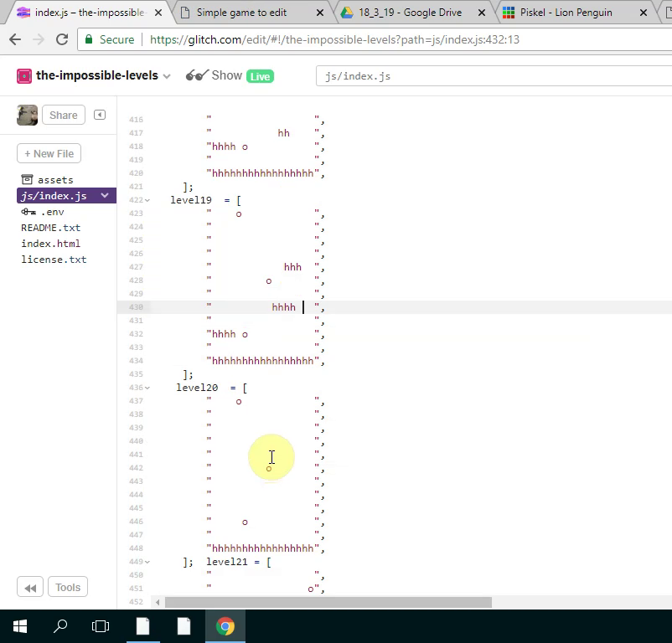
13:18 | Mick makes an announcement to all participants:  I don’t really have much to say now apart from we’ve got this one final making session next and then, if you can make it, the Monday after we can play our games and we can share them with students. We can make the students frustrated when they can’t beat our games. It’s usually quite fun. So, if we can do that - same time next week let me know.  So, we’ll keep trying to help you and yes good luck everyone! | As Mick is speaking Toby clicks on another browser tab to see a live preview of his game in a web page. He plays through the many different levels of his game showing fluidity and skill.
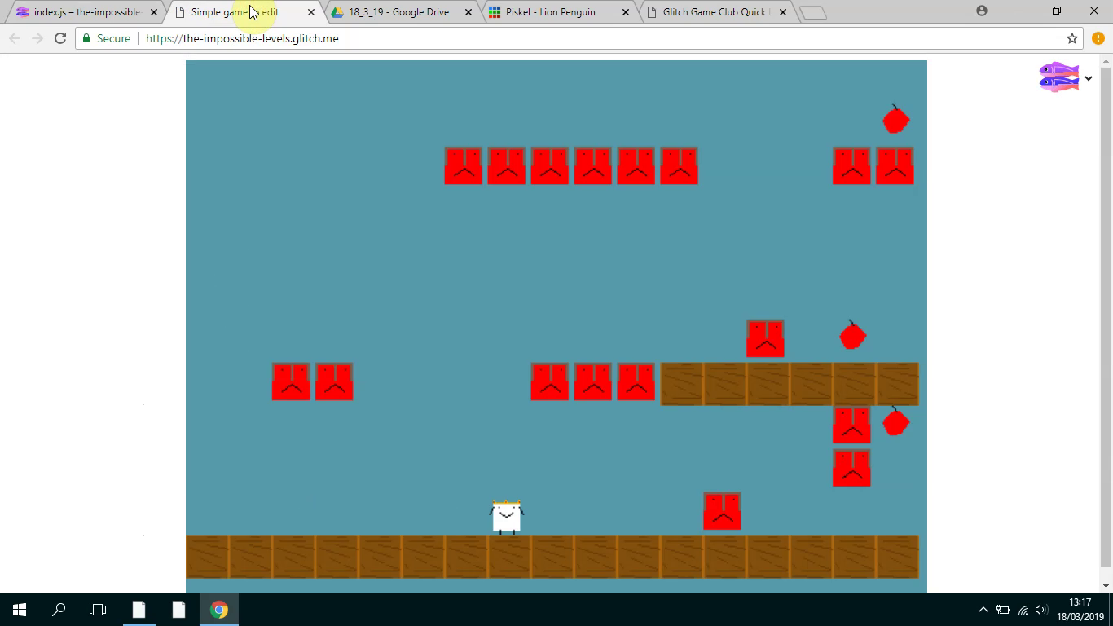
13:18 | Veronica: What was that website called?  Toby: Glitch.  Veronica: With the key on?  Toby: The what?  Veronica: We’re trying to work out how to make the game work. How to get that key and make it unlock that door. | Toby is still playtesting his game and tries to chip in to help Veronica who is seated next to him.  Mick also hears Veronica’s request and attends to demonstrate how to access two different forms of help in the form of code examples and step by step tutorials.
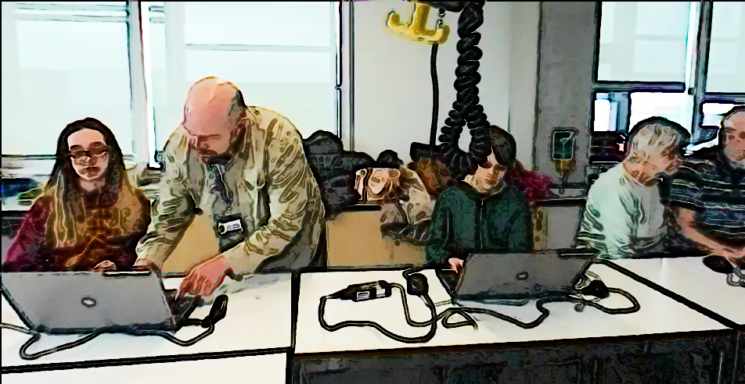
13:19 | Mick: So we’ve got two ones. Here’s the tutorial and there’s the examples of code so you can compare what you are doing and see where the new code should be placed. | Mick shows different sources of documentation on the screen. The tutorials mentioned at https://en.flossmanuals.net/phaser-game-making-in-glitch/_full/  And a menu linking to code snippet examples at  https://ggc-examples.glitch.me  Meanwhile Toby is playtesting his game.
13:20 |  | Toby finishes playtesting and navigates to the page containing a menu of game design patterns at https://ggc-examples.glitch.me  He clicks on the image of Game Mechanics - Moving Enemies
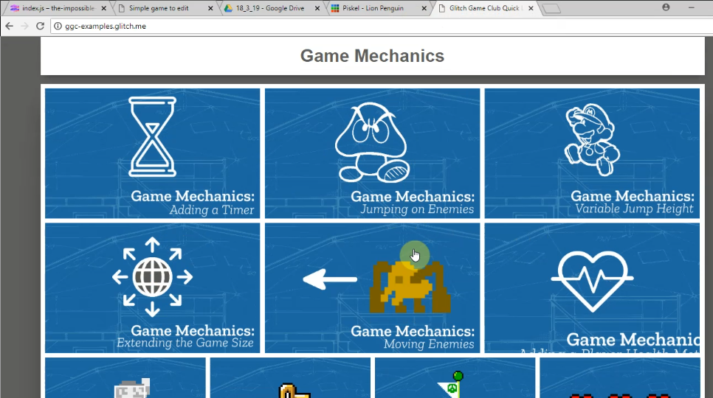
13:20 |  | This opens up a code project using the same code base as Toby’s existing project.  He takes time to examine the start of code carefully.
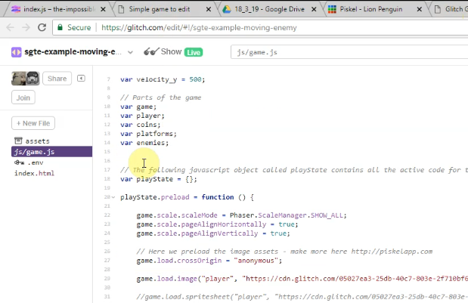
13:21 |  | Toby then clicks on the tab of his own game code and examines how it is different. He deletes a redundant line in his code.  He returns to the example code and scrolls down and examines the code needed to patch into his game. He hovers over it. He selects half of it and then hesitates. He then rapidly clicks on the Show Live button.
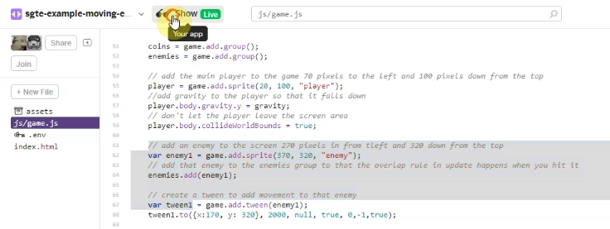
13:21 |  | This opens up a live preview of the example code in a new browser. Toby plays this example game and avoids the moving red block as he navigates around the screen away from and back into the danger zone of the patrolling enemy (red square).
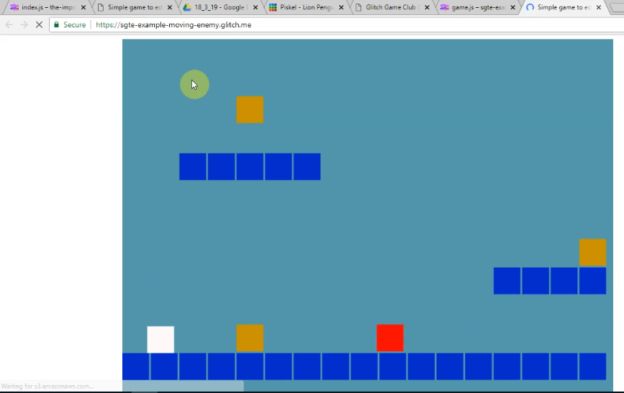
13:22 |  | When Toby dies in the game he navigates away from this screen and returns to copy the full code needed from the example. He then navigates to the same section of his own code project template. He seems to check this, as indicated by mouse movements checking what was above and below the space he has created. He then pastes the code into this space and then navigates to the live preview of his game to check the result.  The game now shows a new enemy moving back and forth. Toby check his game by playtesting it and struggles to get past this new enemy, failing multiple times.
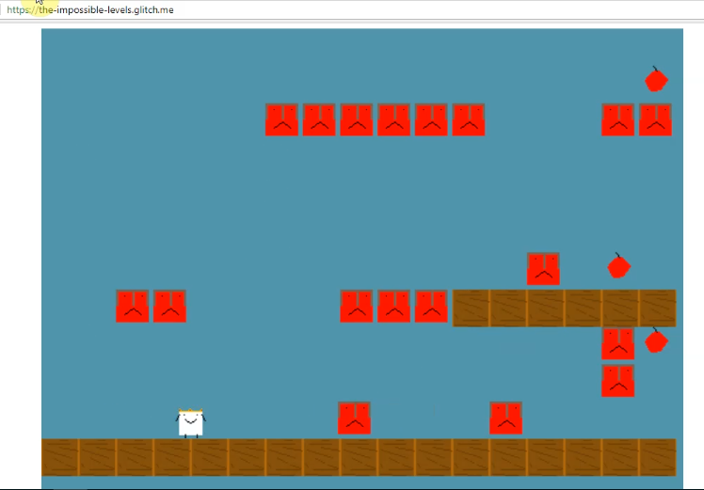
13:22-3 | Helper1: How is your game going? Have you got anything else you want to add to it?  Toby: I’m just adding this moving enemy. It’s so much harder. (laughs)  Helper1: You’ve got a lot of enemies going on here. What is it? Is it a sheep?  Toby: I’ve no idea my cousin designed it?  Helper: Has it got a crown on?  Toby: I think it does. My cousin designed it? I’m not that sure. (both laugh) | Toby is approached by a student helper.  As they begin to talk. Toby’s grandmother Pearl turns her attention away from her and Clive’s screen and looks over and looks at what is happening on the Toby’s screen and at the helper.
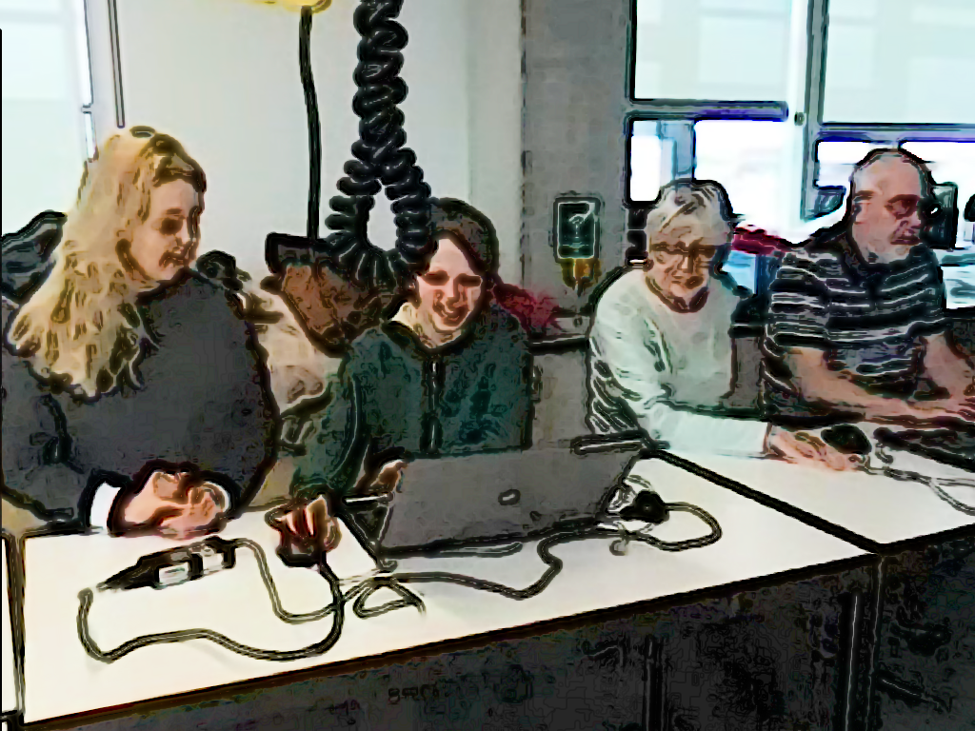
13:23 | Helper1: Is there anything else you want to add in this session?  Toby: Well I’m just trying to get this to work. I’m going to try to get it in the right position.  Pearl: (talking over Toby) Oh I see you’ve got one of those things to move.  Toby: I’m just going to check what it’s like on the second level if I can get to it.  Helper1: What level is this? Level One? Is yours the one where level one is harder than level three?  Toby: Yep! (both laugh)  Helper1: I like that. | Toby continues play testing as Helper1 and Pearl lean in and watch him play and comment .

