4. Exploration of the Formative Learning Design Process
- Research Questions - June 2023
- Chapter Introduction
- Short vignette illustrating shifts in scope of activity
  - Vignette 4.1 - An example of game making activity
    - Table of Vignette
  - Description of levels of activity illustrated using the vignette
    - Environmental factors and objectives
    - Larger objective - Making games for an audience
    - Mid-level objective - Constructing a game feature by feature
    - Smaller objectives and actions - Implementing discrete code and design structures
- Summary of design evolution
  - P1: Exploratory stage: Oct 2017 - Dec 2018
  - P2: Accelerated game making programme (5 weeks): Jan - Feb 2019
  - P3: Adding a process drama to the game making programme: April - May 2019
  - P4: Adapting to MakeCode Arcade and more formal settings: Jan 2020 - September 2020
- Conflicts and design tensions experienced by participants and facilitator/s
- 1. Conflicts stemming from tensions between privileging participant choices or underlying computing and systems concepts
  - Learning Dimensions Map
  - The potential of learning and navigational maps
- 2. Conflicts due to identity clashes and dysfunctional group work
- 3. Tensions due to lack of access and familiarity to game programming tools
  - Design adaptations to facilitate novice use of a code playground
    - Addressing code syntax errors
    - Distributed vs. self-contained approaches to asset creation
    - Shared community and remix ability
  - Design choices of the starter game template
    - Variable editing for player movement
    - Level design and prototyping
    - Background colour and a pixel art
    - Creating a simplified and clear project structure
    - Observations on design behaviours encouraged through use of game template
- 4. Participant conflict associated with project navigation and use of documentation
  - Code snippet examples
  - Stand-alone tutorials
  - Organising tutorials into a linear structure, specifically in the form of a book
  - Structuring and using a collection of game design patterns
- Chapter Discussion
  - On the emergent and mutual nature of the design and research process
  - Discussion on authenticity and agency concerning tools and resources
  - Summary of barriers and tensions explored in this chapter
  - Link to next chapter

Research Questions - June 2023
- What pedagogical tools and processes are available to support novices to overcome barriers to game coding and design?
- How can learners build agency in an evolving community of game makers?
- How can game design patterns support the development of coding practices with novices?

Chapter Introduction
Due to the novel nature of the learning design the detailed outline of the specifics of the participants experience of the design are important to situate findings in the following two chapters. To achieve this aim, this chapter gives an overview of the evolution of the key pedagogical features of the tools of learning design used in my research process. It draws chiefly and on my interpretation of participants reactions recorded in journal notes, these interpretations are also reflected in the evolution in the learning resources which are documented here. To explore emerging tensions in design in a way which communicates relevant context, I outline four conflicts in interrelated activity systems using the terminology of third generation activity theory (3GAT). This chapter discussion begins with an exploration of the tools used through the lens of authenticity. It continues by covering the mutual nature of the evolution of the design, and ends with a synthesis to initial barriers to engaging in game making practices and initial interventions to address them.

Short vignette illustrating shifts in scope of activity

Vignette 4.1 - An example of game making activity
The following vignette, consisting of extracts of participant activity over twenty minutes of a session, is presented as an summary of different scopes of activity. The participant a child Toby who in this session has been working independently on his game design.

Table of Vignette
https://docs.google.com/document/d/1vYeVxYaRMTWPDOHwC4DEGYAkGPRIDX7wLiz0l8b7LWc/edit

Description of levels of activity illustrated using the vignette
The following sections outline different scopes of activity to ground the reader in the overall activity and introduce later tensions between system elements. It will use concepts from activity theory to describe elements of the activity system. Activity theory allows researchers to identify intersecting or nested systems of activity with varied goals.

Environmental factors and objectives
As explored in the literature review, there are several wider objectives of the type creative design activity involved in this research. Aligning with my experiences, I have selected several important streams and represented them in an illustration 4.x below. These include: research goals on the part of the researcher/ participant; desire to create a useful learning experience on the part of student helpers; learning computing skills and concepts as a home education project; and participating with other home educators in a creative environment and thus building team and communication skills; and fun on the part of the children participants.
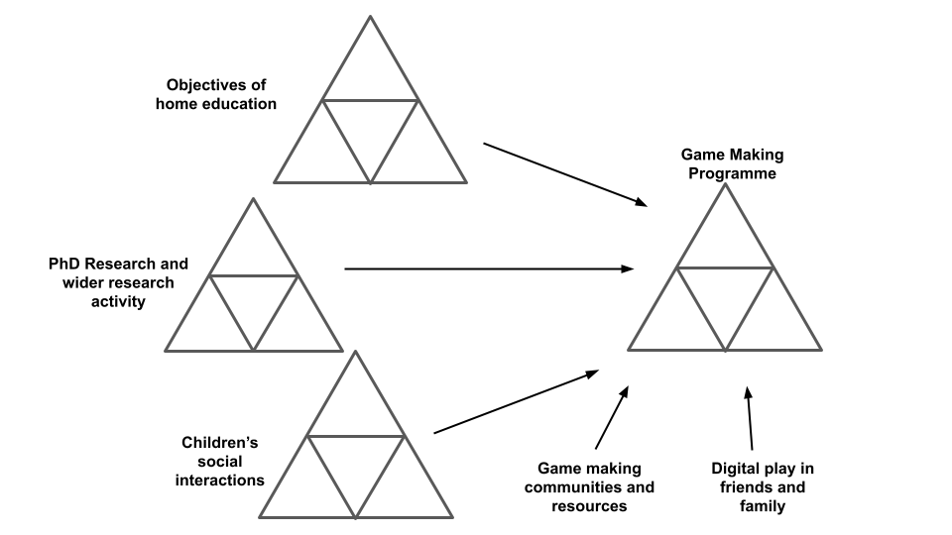
Illustration 4.x - Broad Environmental Activity Systems

Larger objective - Making games for an audience
The shared objective of one activity system is to make entertaining and educational games for an audience to play.
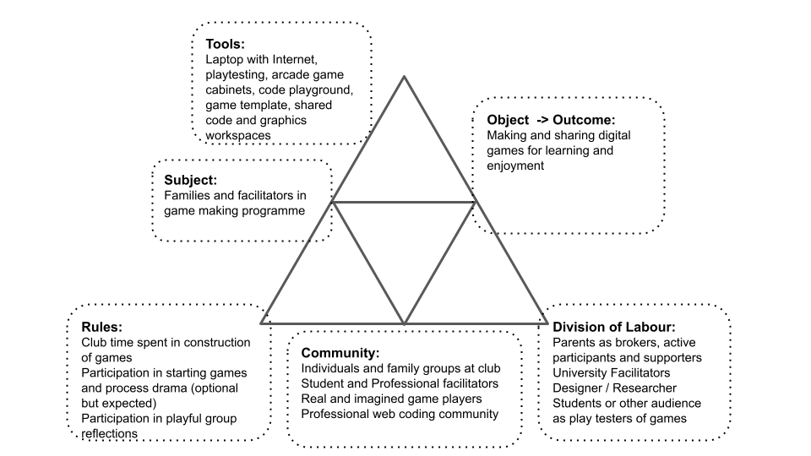
Illustration 4.x - Larger objectives at game making level
There are diverse end audiences for the games. The final target audience are students and staff in the Manchester Met Brooks building where their games are shared in arcade cabinets at the end of the course. An additional audience are friends and family who can be send the games to play online. The more immediate audience for the evolving games are peer game makers during the making sessions.
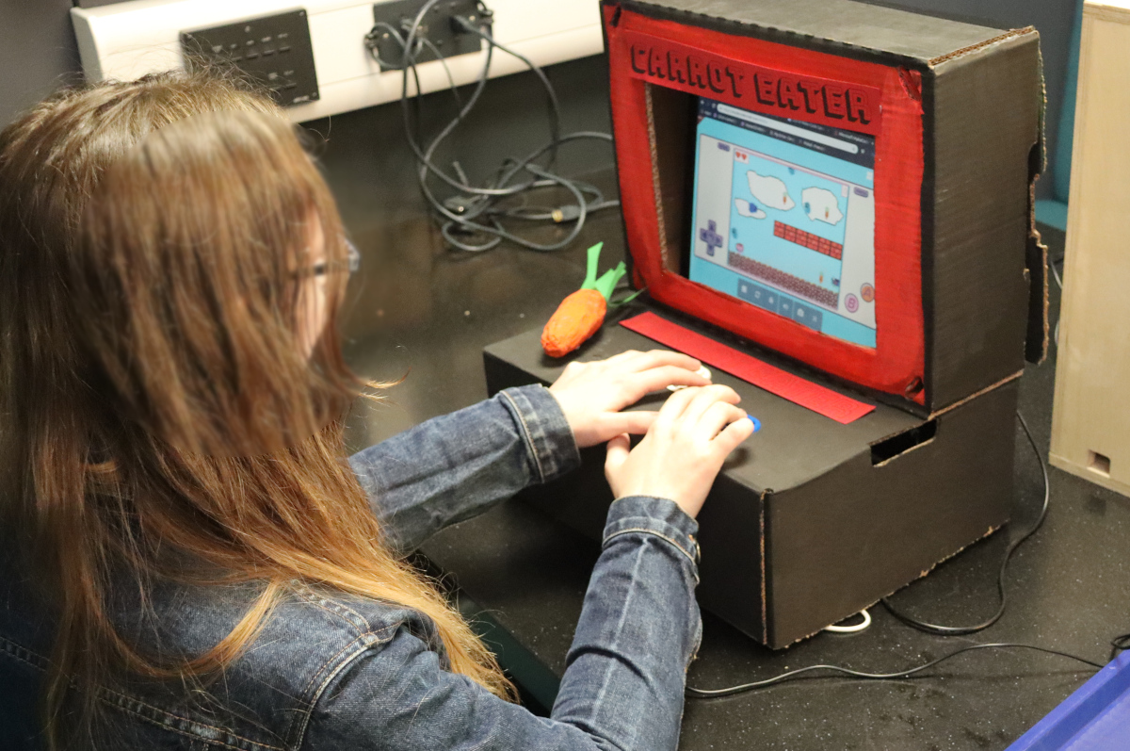
Carrot eater game with an self made arcade box made from cardboard
While the broad aim of making a game to share is tacitly agreed through participation, there are also diverse motivations stemming from environmental factors in the interrelated actors in this activity which bleed into the tensions which emerge at this level. In the vignette and surrounding data, Toby pays close attention to the challenge and variety of the game playing experience for his projected audience of players. A different example of the tension between competing motivations at this larger level of activity is explored in example 1 of this chapter and related analysis is continued in chapter six.
In the vignette above, I draw the participants attention to the showcasing of their games to an external audience. Toby begins the session playing his own game. During the course of this session he invites many other group members to play his game. He initiates and responds to conversations around the difficultly of the game he has designed.

Mid-level objective - Constructing a game feature by feature
At this scope of activity, participants work on the game code and and audio and graphical assets to achieve the broad objective is to alter and add new features to the game using tools available in the learning environment.
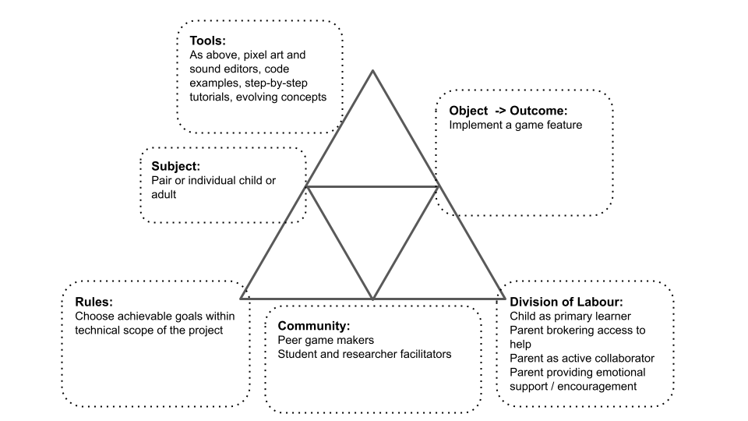
Mid-level activity system of game making
Overall activity at this level was driven by learners setting goals and requesting help to implement game features. By this stage of the process, Toby is able to browse a collection of game design patterns and use diverse of tools, resources and processes. Participants developed preferred approaches and tool choices especially in accessing help when adding a new feature to their game. In the vignette above I outline the two main sources of help at the level of adding a new feature to the game: “Here’s the tutorial and there’s the examples of code”. A later section of this chapter details the different supporting documentation as an example of an artefact that guides participation in game making practices. Chapter five then explore activity occurring at this scope in more detail with a greater focus on emerging concepts as tools.
In the course of the vignette above, Toby chose to access only a code example of the desired game behaviour. He did not, as others in the group were doing in this session, use the tutorial which provided more descriptive, step-by-step guidance. In contrast, others participants relied only on direct verbal help from myself or other participants (like Toby) to help them progress.

Smaller objectives and actions - Implementing discrete code and design structures
While the previous section focused on a mid-level scope of implementing game features, more complicated patterns involved several stages and varied tools to implement. Using the terminology of Leontiev (2009), in the example above Toby undertakes certain chains of processes in a fluid way that shows that actions had become operations. For example, his quick navigation between different areas of the game code, the game preview window and sources of documentation. In contrast, some tasks are new to Toby and are performed more hesitantly. In the example above Toby is careful is hesitant, checking and rechecking the process of copying and pasting new code into his game from a specially prepared code example which matches the game template he is working on.
Identifying shifts in participant activity in terms of scope aids analysis of the complex and interwoven cultural, social and personal actions (Rogoff, 1995). Above Toby shifts between to the wide activity of making a game and sharing it with peers to the narrower action on implementing a concrete code structure. This aspect is developed in chapter five in more detail. In addition to these shifts in scope, analysis of community processes also involves transformation over time. The next section offers a description of the evolution of tool use in different phases of the study with an aim to situate later analysis of emerging tensions in the use of tools, resources and processes in the subsequent section.

Summary of design evolution
The following overview of tool use by stage concisely explore the rationale for their selection or production. Fuller descriptions of the tools used at each stage and links to the online resources created are available as appendix 4.x

P1: Exploratory stage: Oct 2017 - Dec 2018
Phase one was an extended, exploratory series of game making sessions over several months. This stage was aimed not at collecting user data rather than building my competency as a facilitator. The process began with no pre-existing supporting materials. In response to need, I adapted a starting code template of a platform game and created various code examples to add functionality requested by participants. This template was base on the game genre of platformer (see glossary), a move which helped to limit expectations of the technical limits of their game. At the end of this stage participants showcased their games to students in the foyer of the MMU Brooks building. Feedback from participants this stage included; a general consensus that the process was too long and that more guidance in the process of familiarising themselves the coding tools initially before undertaking ideation would be useful. Extracts of feedback notes are included as appendix 4.x
The end of this phase in mid to late 2018 involved responding to this feedback and working together with PGCE computing students and delivery three one-off workshops at conferences and a Manchester library fun day. The requirements of this compressed time frame aligned with feedback to prompt me to design an accelerated process to bump start the game-production process. The new intervention involved a starting template and printable resources that highlighted particular key lines of code and variables that had a high impact on the game experiences. The results in terms of engagement and impact on changing the game were very promising.

P2: Accelerated game making programme (5 weeks): Jan - Feb 2019
By the beginning of P2 most of the resources and activities were in place and relatively stable. There were some incremental evolutions in the template that stemmed from participant feedback and my reflections. Key additions at this stage to support the use of a template were a collection of tutorials and code examples illustrating key game features that had been requested by participants. The collection of game patterns were presented in a web page together with the starting template and a link to an online book collecting the process into step-by-step chapter based tutorials. The resources are explored in more depth in sections three and four below. A more complete description of the resources used in P2 and P3 are included in appendix 4.x.

P3: Adding a process drama to the game making programme: April - May 2019
P3 used the same toolset as P2 however in addition, drew on my previous work with the MMU Faculty of Education drama department (Patterson et al., 2019) to create a simple drama process to give an external motivation and narrative to the creation of games using for a fictional audience of visiting aliens. The participant activity of these stages and tensions between system elements are discussed in detail in the remainder of this chapter and in following chapters.

P4: Adapting to MakeCode Arcade and more formal settings: Jan 2020 - September 2020
I also adapted and advanced resources with an aim that they could be used within secondary classrooms to support computing curriculum. To do this I added a learning dimensions map, a process which is explored in a later section of this chapter. In 2019 MakeCode Arcade was launched to make games using for novice coders via the use of a block coding approach. In 2020 I ran two iterations of game making course using MakeCode Arcade. The resources and facilitation approach was based that of P2 (Chesterman, 2023).

Conflicts and design tensions experienced by participants and facilitator/s
This section examines design contradictions between system elements and tensions experience by participants which developed into conflicts which significant in stopping participant progress. The processes here aligns design-based / formative research in that the surfacing of tensions and charting the detail of the evolution of resources and other responses used helps illuminate broader, systemic issues concerns in the overall activity (Barab et al., 2002). The first two tensions address issues of identity, ambition, and attempts to align with curricular concepts. The remaining sections detail responses to key contradictions in the tool set of the early design which stimulate the development of authoring tools and supporting documentation.

1. Conflicts stemming from tensions between privileging participant choices or underlying computing and systems concepts
While the focus on this research is informal environment, I wanted to create resources and processes which are of potential value to practitioners in the UK classroom. Chapter two explored ways in which digital game making is commonly aligned with curricular areas (Kafai et al., 2016). It also surfaced tensions that emerge between the exploration of curricular concepts participants desire to follow activities following learner expression and choice (Hoyles and Noss, 1992).
This section addresses my interventions to resolve this tension. From my own perspective as a research designer/facilitator, there are two dimensions of contradiction which are explored in the following section: one my perception of the contradiction between curriculum and learner choice; the second a conflict which manifested via my hesitancy to introduce tools and activities designed to address this tension.

Learning Dimensions Map
Research on concept maps (Cañas et al., 2003) as methods for teachers and researchers to identify key learning suited to particular computing projects has gained traction in the field of computing education (Keppens and Hay, 2008; Weinerth et al., 2014; Quick Read: Using concept maps to capture, communicate, construct, and assess knowledge, 2020). The value of facilitators presenting concepts and asking students to create maps of concepts for formative assessment. In addition, there is value in mapping which are likely to occur in project work especially when such concepts are embedded in activity in a way which resists superficial analysis. Research on hands-on tinkering in science museums by Bevan and Petrich (2013) together with educators examined video footage of families interacting with exhibits to make a structured list of the learning they observed. The resulting map of learning dimensions included underlying science concepts but also contained more general skills and helping behaviours involved in exploratory learning processes.
One of the outcomes of my research was to extract some of the concepts and practices that learners engaged with when making games from hours of recorded material. While some concepts are common to existing computational thinking frameworks others, including systems thinking concepts, are more unique to game making. Table 4.x. shows my resulting map of learning dimensions. WHY THESE CONCEPTS?
Coding Concepts | Systems Patterns | Design Practices
Sequences | Systems Elements | Goal Setting
Variables | Systems Dynamics | Being Incremental and Iterative
Logic | Reinforcing Feedback Loops | Developing Vocabulary
Loops | Balancing Feedback Loops | Web Navigation
Arrays |  | Problem Solving
Creating Functions |  | Version Control
Change Listener |  | Debugging
Input Event |  | Reusing and Remixing
To illustrate these concepts in more depth, I created concise descriptions of the concepts , and cross referenced with examples of the concepts in practice in the application common game features. This process aimed to be an aid to my existing attempts to highlight relevant concepts in-situ.
In journal notes I note my attempts to find learning relating to abstract concepts happening in-situ. A common example of use of loops or arrays or functions. I would highlight their use by participants and link to their activity. This mirrors the concept of the value of abstract in context for wider application is underlined in the work Davydov of rising to the concrete (Cole and Engeström, 2007).

The potential of learning and navigational maps
This process of mapping this framework is potentially of use for teachers and other researchers to help their observation of students in game making activities to align with design, coding and computational concepts. Offering student choice in project work can create stressful demands on a teacher trying to support a diverse design paths (Blumenfeld et al., 1991; Cole, 2006). To address this issue practically, rather than students working on varied game types and features, I restricted the genre of game and offered a significant but limited menu of features, a process explored in the next section. The mapping of specific design features to the related concepts, as outlined above, has potential to aid teachers and students to track and correlate the underlying curricular concepts being explored in these divergent learning pathways.
The process of adapting this learning design to the needs of more formal settings can be aligned to existing research on this area. For example the concept of semantic waves is relevant here as a way of visioning the alternation between concrete design experience and communicating the underlying abstract concepts (Maton, 2013; Curzon et al., 2020).
However, despite this alignment and potential utility in a school setting, I was reluctant to introduce these resources in this informal context, reflecting the lack of external motivation for participants to align with curricular demands driven by exam requirements. Introducing additional mediational tools with the aim of the communicating and reinforcing abstract computing or systems concepts risked effectively establishing a new competing activity system. This perspective validates my reluctance to introduce additional distracting stimulus, instead prioritising time spent in on-going hands on experimentation, peer learning and playful activities.
However, while this approach aligns with situated understandings of knowledge which problematise the separation of the content to be learned from the embodied social activity itself (Leont’ev, 1974; Rogoff, 1995), this alignment did not halt my concern over remaining locked into concrete experience and not noticing repeated abstract concepts which could be of future generalised utility (Maton, 2013). My ongoing discomfort surrounding the validity of the learning experience without direct alignment to abstract content, stem from wider concerns around avoiding danger of tacit learning by reinforcing learning and spur metacognition (Gherardi et al., 1998). Even if generalisable concepts can be explored in the context of an learner-driven activity, they may not be encountered of noticed without guidance from others. Hoyles and Noss term this tension a ‘play paradox’ (Hoyles and Noss, 1992:46). This theme is explored in more detail in chapter six concentrating on social processes rather than external documentation.

2. Conflicts due to identity clashes and dysfunctional group work
This conflict involved accumulating tensions which resulted in families feeling anxiety and alienation from the group coding environment and associated peer working dynamics. I illustrate this conflict using the experience of one family who withdrew from P1 three weeks before the end of the programme. They shared in feedback (see appendix 4.x) the moment that decided their withdrawal. At one point they looked around and just saw people doing hardcore coding and no longer felt at home in the environment. In early sessions the family members had planned design on paper and created digital pixel art. In the end stages of the game production process, due to the dynamic of the larger group, they were reliant on others to implement code changes for their imagined game, unable to contribute fully at this point and found themselves isolated.
To briefly summarise this dynamic using the language of 3GAT we can locate tensions between competing objectives. The shift from paper design stage with its greater freedom of choice and imagination to the technical limits and challenges appears to have created too great a rupture between this families objective to be creative and the technical environment they found themselves in available to them.
This experience aligns with research in this area explored in the literature review which explore pedagogies to address barriers concerning identity and technology-driven practices (Kafai and Burke, 2015). A contributing factor to this families alienation were tensions engendered by the large group size and the seriousness of end stages of coding.
I have shared the crisis of this family in particular, as the process drove me to focus on and further develop inclusive cultural practices which are explored in chapter six. While this conflict is cultural in nature, it is compounded by frustrations stemming from unfamiliarity with tools and processes. In participant feedback, the parent of this family described in the previous section indicated that it took too long before in the planning stage and called for more hands on play and use of the tools of production before being called on to make creative decisions. The parent likened this to an arts studio approach. The next section explores this related conflict in more detail.

3. Tensions due to lack of access and familiarity to game programming tools
Conflicts arose due to a contradictions between the desire of participants to use the tools to create games and their lack of experience of them. While AT has a broad definition of the concept of tool, including the use of language and concepts, this section focuses on software tools used to create games in this program and technical process needed within those applications. The process of helping participants build familiarity and competency in tool use was further complicated by my own motivations for working with as authentic as practical game authoring tools. Thus crux of the conflict is that coding games to create a webpage using a text environment is a complex process. While some of the group had some experience, many did not. In early stages, this gulf tension between the need to use the tools and text coding processes often resulted in frustration and paralysis in the activity of game coding. While, tensions stemming from gaps in knowledge and practice are commonly addressed in formal learning environments through forms of instruction, the informal nature of this learning setting allowed for more flexible approaches.
The resulted in a design challenge involved designing a bespoke game authoring environment by adapting existing tools and embedding where possible affordances within that toolset to facilitate participants to address gaps in their knowledge without needing explicit instruction. The following sections explore the evolution of the tool selection and the tool use of participants in response to this conflict in the game making activity system.

The motivation was to align to authentic web technology due to my previous experience. The reason for working with code this authentic bears exploration. Characteristics of broader dimensions of authenticity of tools and processes in learning environments are explored in the literature review. A brief summary being: similarity to workplace settings; facilitating activity which serves a need of participants; an ability to showcased resulting work to an audience (Shaffer and Resnick, 1999; Warr and West, 2020). While my choice of open source digital tools allowed for a high level of aligning with professional practices, it was also potentially complex in terms of use of tools. In part my motivation for choice of code language (Javascript, Phaser) was driven by desire to align with common workplace practices and to be potentially extensible for future student-led web projects.
By P2, learners first experience of the experience of the tools was in the process of playing an incomplete game in a webpage and controlling the character using the computers arrow/ cursor keys which for many was a familiar process. Due to an intentional fault, players needed to click a remix button, and alter the underlying code to progress in the game. The following section outlines responsive design process surrounding two main elements: first, the code playground toolset; and second the starting game template.
These sections contain a highly granular level of detail which is both helps situate the findings of the next chapter and is important, along with resources highlighted in this chapter footnotes, to allow the design by other practitioners and researchers in this area. I am guided in this respect by the lineage of research of constructionism, and in particular the sharing of practice between researchers and teachers regarding the use of LOGO. A seminal example of this practice is Papert and Solomon’s publication Twenty things to do with a computer which is replete with code examples and diagrams of their output on the screen (1971). Many such examples exist from Papert in published memos and grass-roots collaborations with teachers .

Design adaptations to facilitate novice use of a code playground
Code playgrounds, as described in chapter two, are an online environment used to test, share or invite help from online users. My choice to use a text code environment risked maximising barriers to participation by not profiting from design decisions in specialist coding software to help novice coders (previously explored in LR). These elements include steps to reducing syntax errors, shielding complexity, facilitating community commenting, sharing, remixing and other forms of collaboration. Learning computer coding presents challenges in part due to unfamiliarity with and potential complexity of code authoring tools and environments (Guzdial, 2004). To shed light on this conflict and to situate later findings, this section surfaces observations from my journal notes and video data on how participants responded the tools introduced and my design adaptations.

Addressing code syntax errors
Many software projects aimed at for novices use visual coding (block coding) approaches to reduce complexities of code use (Resnick et al., 2009; Bau et al., 2017). This process reduced possibilities for syntax errors (see glossary) and often provides a limited set of blocks to reduce complexity. While this approach not explored here for reasons previously outlined, there are some features of the glitch code playground which help. For example, the environment can detect the file type as javascript from the file extension and then uses a static analysis tool (linter) scan the code for signs of inconsistencies of code and syntax errors and highlight them (Tómasdóttir et al., 2017).
In glitch such code syntax errors are highlighted via a red dot provided a quick visual indication of where the error occurred. In addition if the user hovered over the dot would give an error message. In analysis of pair interactions, I frequently [how much from video data] observed the non-coding peer notice and point out the red dot, thus preventing further errors.
While block coding offers significant advantages (GL)in preventing syntax errors, in a comparison to text coding approaches, Bau and colleagues summarise the inherent disadvantages (Bau et al., 2017). These include: block coding can take of a lot of the users screen; making small changes to code can be tricker in blocks than text; block coding can complicate remote collaboration and version control; searching for code structures is simpler using text code. While these disadvantages are more applicable to more advanced users, they remain relevant to my general goal of working with an environment aligned to professional practices.

Distributed vs. self-contained approaches to asset creation
A key element of game creation is the creation and management of graphical and audio assets. Many coding tools for novices provide a library of prebuilt assets and tools within the environment to alter or creation graphical and audio multimedia assets. While there are practical limits to the audio and graphical authoring capabilities of tools like Scratch (Payne and Ruthmann, 2019), such self-contained approached reduce possibility for compounding errors and complexity caused by the compatibility of file formats and migration and management of external asset files.
In P1 I observed participant showing a high motivation to incorporate assets created in a diverse set of graphical and audio tools, often struggling to overcome the technical challenges in the process. Responding to the enthusiasm of participants in asset creation, I had introduced the following tools to participants including:
- Piskel - a graphical editor used to create pixel art sprite characters;
- Audacity - a desktop based application to record and edit audio using audio effects and filters like delay and echo;
- freesound.org - an open repository of audio files which could be downloaded, used directly or altered using Audacity;
- Sonic Pi - an education music application allowing the creation of music using text coding;
- Bfxr & jsfxr - web based tools to create sound effects aimed at game production;
- Scratch - while scratch was not use for game production, I encouraged participants to use its intuative graphical editor to create backgrounds for the game;
Not all participants would use all of these tools; rather suggested their use responsively based on their immediate need. However, similar patterns of use emerged. Participants would identify the need for an asset in their game. They would then use the separate software to create that asset, and the be supported to save assets to their computer’s hard drive in a compatible format. They would then need to upload assets to the code playground environment, discover the text link of the asset, and then insert that link into the main javascript game file at the relevant line of code.
There has been extensive research supporting the motivational value of the ability for young people to bring their interests into multi-media creations via choice of assets and narratives (Peppler and Kafai, 2007; Resnick, 2014; Kajamaa et al., 2018). In line with these findings, I observed a palpable a sense of achievement when participants succeeded in seeing and hearing their creations in their game after making the final changes in code. For some, the sense of a achievement appeared magnified by difficulty caused by the unfamiliar environment and processes. The process was successful in many in motivating the acquisition and use of diverse and authentic digital literacy skills.
Despite these benefits, I was concerned that in P1 the diversity of asset related approaches had caused a complexity and distraction from the leading activity of game making. To address this, in P2 I reduced the number of tools suggested when creating assets. The implications of working in this more porous learning space are explored in the later discussion section. ARE THEY OR DOES IT NEED TO BE HERE? AUTHENTICITY - RESTRICTED PLAYGROUND

Remixing and showcasing projects
Another common feature of novice coding tools is the use of a gallery of creations, in a way which aligns with the potential for community-based learning strongly advocated by Gee and Ito (Gee, 2003; Itō et al., 2010). The ability to easily remix community projects, supports the process of becoming familiar with, and using other projects or approaches as a base, thus supporting the use and modify stage of the UMC pedagogy (see glossary). Remixing also informs professional practice (Kotsopoulos et al., 2017) in the form of distributed revision control tools such. A practice known as code forking.
As explored in the LT, Code playgrounds address issues of complexity of web coding environment and practices of forking by providing access to a self-contained server structure from within a browser. However for novice users the web location still also offers friction in terms of digital literacy issues of logging in, remembering passwords, linking to email accounts for password reminders. To circumvent these issues in P2 and P3 all participants and facilitators used a shared account for code playground the graphics editor.
In this program, while participants where not encouraged to browse the creations of a wider web-based community, they were encouraged to view and interact with fellow participants projects.
Practically, in novice coding communities, this is encouraged by the use of community galleries and buttons encouraging. In Scratch this is seen in buttons named see inside and remix when viewing projects. Similarly both the Thimble (used in P1) and Glitch (used in P2 and P3) prominently featured remix buttons and view source buttons in the community interface. The shared community element on the other hand was quite different for glitch due to its very mixed user base and range of different web based projects. In this learning design I took a decision to not promote with existing online communities but to focus instead on internal sharing of projects between the group.
The process of adding a remix button, removes the needs for participants to copy underlying code by hand and set up the parameters of a new project. This process is especially relevant in reducing barriers to initial participation given the use here of authentic professional text-based coding language and potential alienation from unfamiliar syntax and file structures.
This theme of shielding from complexity is contained in all design choices detailed above and in turn aligns with a constructionist design principle to ‘choose black boxes carefully’ (Resnick and Silverman, 2005:119). A black box here refers to the process of hiding away aspects or functionality of the code or processes. The decisions made in the design each tool shape the skills and concepts the end user is guided towards. While the principle here is applied to software tool use, it also applies to the use of a starter game template, as explored in the next section.

Design choices of the starter game template
The initial use of a working structural template was an intuitive response based on my own experience of teaching technology. The choice to pre-select a particular genre was initially a pragmatic response to tensions experienced in P1. When offering feedback to address her family’s feeling of isolation from the coding process, the parent of the family described in part two of this section had more hands on play and use of the tools of production before being called on to make creative decision, likening this to an arts studio approach. I realised that to allow for this playful experimentation, a purely structural template was insufficient and that a working game template was preferred. To create the template I drew on the structure of three online tutorials to support create a two-dimensional platformer game .
The following section explores designs decisions relevant to the evolution of this starting template by drawing on UMC approaches, constructionist design heuristics, and the domain of human-computer interaction (HCI) research. In particular, the concept of affordances understood from a socio-cultural perspective as ‘technology affordances as possibilities for human actions mediated by cultural means’ (Kaptelinin and Nardi, 2012:927).
A note on structural design patterns
A web code project using the chosen game framework phaser consists of several interlinked files of Javascript, HTML and CSS and image files. Creating the project from first principles is relatively complex both semantically and practically. In the domain of web technology, starter templates consist of pre-built collections of HTML, JavaScript, CSS and other configuration files which allow users to avoid initial configuration and thus accelerate adding features to projects. For example the Next.js web framework comes with a large range of starter templates based on common requirements of web sites (Nelson, 2023). Phaser starting templates available from the website share this pattern of files .
Game states and functions to create the game loop (see glossary) are included natively in the phaser framework (Faas, 2017). Game states allow designers to deconstruct games and game code into collections of sub-units (states) (Kostolny and Bohacik, 2017). For example a simple arcade games may only had an insert coin state, a play state and a game over state. A game coding framework like phaser shields its users from code complexity by providing a game state manager and associated functions out-of-the-box, meaning that lots of underlying code is already written and hidden from view.
To increase simplicity for my participants the starting template I created had only one game state called Playstate. It followed the following structure : a beginning section out side of a function declaring variables; a preload function which loads assets into the game; a create function which sets up the initial game; an update function which listens to and responds to user input. The following illustration from the step-based instructions illustrates the structure for participants, including the possibility to create new game states e.g. a game over state.
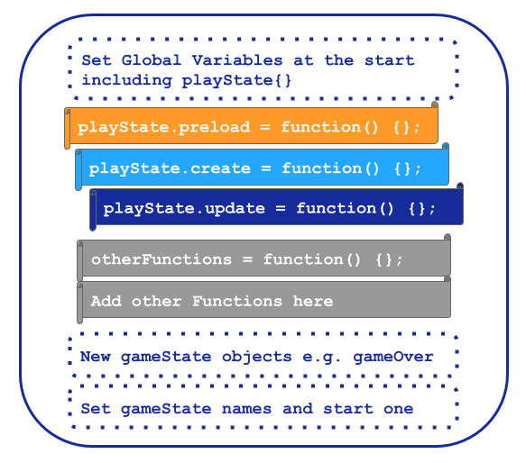
4.x - Game states and function structure explained in the Glitch Game Makers manual created for for P2 and P3
While access to HTML and CSS files of the base project was available in the left menu as show in by default participants would see only the JavaScript file names game.js (See Figure 4.x below)

Variable editing for player movement
To accelerate and support the experimentation of users, I identified changes to the code that were easily recognisable game experience features and where small changes could provoke a high impact on the game experiences. These include changing gravity, altering the player jump height and walking speed.
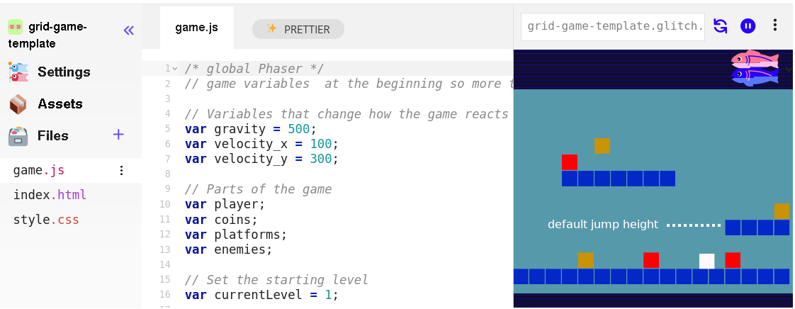 4.x glitch coding environment with code structure of left menu, a central code window with code, comments and game preview on the right.
The starting template began with the game in a broken state. The player’s maximum jump trajectory was not sufficient to progress via a jump to the first platform. This state invited participants to make changes to fix it. To progress, participants needed to change alter at least one of the key variables were highlighted at the very start of the game code (see Figure above). In their research Kynigos and colleagues (2018) explore this concept as a half-baked games where incompleteness or bugs in behaviour are a provocation to participants to correct or to further modify them.
This process also aligns with the motivations and techniques of the UMC framework explored in the literature review , in particular the guideline to “create choices that show visible and immediate changes” (Lytle, Catete, et al., 2019:6). In this design, the first participant choice and the need to transition from the use to modify stages is forced at an early stage by the half-baked design. While this design decision compromises the user choice initially, it allows a carefully scaffolding of early coding experiences and promotes a shared experience for all participants in a way which facilitates and encourages peer learning. After this shared first change, participants next choices varied greatly. While some participants engaged with extensive experimentation to find a player movement feel that seemed just right, others, mostly adults or younger participants, were much less concerned with this aspect of game play, despite sometime frustrating resulting player movement. Data explored in the next chapter supports foundational claims of contructionist computing and UMC advocates that greater user choice over the design process contributes to participant motivational and a feeling ownership of their projects (Lytle, Cateté, et al., 2019:@peppler_computer_2009)

Level design and prototyping
The use of a graphical grid structure to edit level design helped balance concerns of accessibility with the use of authentic code language. Platform games often conform to certain patterns in terms of the elements involved in a level and their affordances. Common elements include the player that you control to movement of, platforms to be jumped on, enemies to be avoided and rewards to be collected. In the templated used in P1 the process of adding game elements was involved relatively complex process which involved changing parameters of functions to alter to adjust their location. An example of the code needed to add two platforms is included one of my tutorial chapters . In the preload function the following code would be added.
game.load.image("grass:4x1", "images/grass_4x1.png");
Then in the create function the following code would be added.
var platform1 = platforms.create(150, 220, 'grass:4x1');
platform1.body.immovable = true;

var platform2 = platforms.create(250, 150, 'grass:4x1');
platform2.body.immovable = true;
This approach had several disadvantages including: complexity of adding function parameters for screen coordinates and difficultly of troubleshooting location; the need to add code to various places in the code; each platform needs to be added separately; and the difficultly of creating and swapping out different size graphical files when altering the length of a platform. A similar process was also needed for each reward and hazard. While in early stages I took measures to mitigate some of these complexities, the process remained too complex for the immediacy of game modification that I envisaged as desireable. For the template use in P2, I revised the starting template to created game elements was based on a visual design in a grid format(see figure 4.x below). Changes to the text based grid in the code area on the left would be immediately seen in the right hand project preview area.
 Figure 4.x - Grid based editing of level design with a simple key for hazards, coins, and platforms.
Technically, this approach involves the construction of a data array for each level of 17 blocks which can be one of the following: x (platform); h (hazard); o (coin); or left blank. The end result is that while participants alter a text-based array, the grid structure has a strong visual correlation with the resulting game layout. This design choice allowed alignment with design principles for tools for novice coders stemming from research highlighting the importance of visual approach to facilitate the programming multi-media projects for novices. (Guzdial, 2004; Resnick et al., 2009).
This design had a positive impact on engagement in level design in initial stages with many participants spending significant time and effort undertaking many iterations of changes to the level design. As explored in the vignette above, Toby designed many levels making the game very challenging but still technically possible. Participants varied in their approach to level design, some drew on their experiences to mirrors platform game conventions, while others enjoyed working against these conventions, a theme which is explored in more detail in chapter five.

Background colour and a pixel art
Participants were keen to replace the default coloured block sprites of game elements with their own art of characters and backgrounds. From P2 onwards the one suggeted tool to do this was the online Piskel tool . A pixel art approach to graphics allowed a balance between the potential for positive engagement with game making and the potential drain of time to this one activity, thus helping resolve one of the tensions emerging in P1. Piskel had proved to be intuative for many younger participants with three main areas: a set of editing tools; a canvas for creation; and a set of tools to export, save and import work (see Figure 4.x).
 Figure 4.x - Interface of Piskelapp tool
One of the complications encountered in P1 was the differing sizes of sprites created using different graphical tools. I helped resolve this for particpants by matching the size of the block in the grid level design structure described above to the default size of sprites created in Piskel (32 x 32 pixels).
Participants spent a widely different length of time creating these graphics for a variety of reasons. Some took a long time to master the process of using the editing tool while others created images rapidly but would keep redesigning and recreating their game elements. The process of the affordence of game art creation opportunities seeding narrative and artistic creativity is explored in more detail in chapter five.

Observations on the game template and core tools
The previous sections have outlined changes to the core tool use including the use of a starter game template which I enacted to address the struggles participants had in becoming accustomed to game making. Despite the relative simplicity of the highlighted affordances outlined above, complex and divergent patterns of design behaviour began to emerge. Small code changes resulted in potentially large changes in game behaviour, appearance and difficulty aligns with a long standing concept of HCI research that feedback is motivating for system users (Malone, 1982; Bernhaupt et al., 2015). In addition, the use of revised in starter template in P2 allowed participants to maintained their games in a mainly working, shareable state allowing regular feedback from peers.
The use of a starting template was inline with core motivations of UMC technique, namely, to build familiarity with the code structure, and confidence in use of tools in an accelerated way. As explored above, the shift in template design from P1 to P2 involved a much more careful and structured experience for participants in use and modify stages. However, participants still needed help to access and use the relevant affordances in code. In early trials with a limited number of families, I would point out the relevant part of the code and ask open questions like, I wonder what would happen if you changed that gravity variable? However, for larger groups this was not optimal, risking leaving some unsupported. My response was to turn to supporting documentation. In addition, participants soon began to ask how to make additions to the game which needed additional code structures, a development signifying a pivot to the create phase on the UMC model. During the create stage additional support is needed from supporting documentation. This section has described tensions stemming from code and asset authoring tools starting game code template. The next section explores similar tensions related to the role of supporting resources and documentation.

4. Participant conflict associated with project navigation and use of documentation
This section details a conflict where participants, frequently wanted to add new features or changes to their game but were not clear how to implement them. In P1 this caused delays and participant frustration, as although I could work with people directly to help them I had limited time with each participant or pair. The inability for participants progress due to lack of game and coding practices was compounded in early stages by little or no supporting documentation or supporting resources. This section outlines the evolutions and design choices informing the different forms of supporting documentation used to address this conflict.
The process of creating documentation which created enough support for users to be able complete coding tasks but also facilitated participants to choose their on path presented significant challenges.

Quick Start Cards
To address the limit of one-to-one facilitator support to seed the starting processes outlined in the section above, I used printable resources which highlighted the key lines of code and how they can be altered to impact on game behaviour(see figure 4.x below). These quick start cards provoked a strongly scaffolded initial interaction with the code in a way strongly aligned with the use and modify stages of the UMC framework (Franklin et al., 2020).
 4.x - Example of a Quick start card
The quick start cares were created at the end of P1 by trainee computing teachers in my faculty who volunteered to support a holiday outreach event for young people. I developed them by theming them into starting level, next level and boss level. Participants were encouraged to pick a card based on their interest and difficulty level.

Code snippet examples
The use of code snippets, while a promising authentic practice, presented initial challenges. To support a hands-on approach and responding the design choices of participants, I began by creating discreet code examples illustrating the requested elements. The use of code examples or snippets in code playgrounds is a common professional problem solving practice (Yang et al., 2017). These code examples allow users to see the behaviour in context with the code and output side by side. While code examples existed on the Phaser website and support forums, in line with other support sites like stack exchange, their utility has limitations including lack of relevant, consistency, being removed from the domain context, and not being structured in a self explanatory way (Treude and Robillard, 2017). Thus, while I initially encouraged participants to search within these examples, and authentic documentation and help forums , the resulting confusion and difficulties experienced by participants, prompted me to create other more bespoke documentation.
Creating a bespoke set of code snippets helped address the challenges described above. In P1 I responded by creating one off documents with the relevant code which were both printed, emailed and shared via google drive. In line with the practice of accessing help via code snippets, the code examples could be to be copied and pasted into the game. This process lacked coherent process for participants to navigation to the resource they need. The process also lacked a consistency in signposting how the code listed fit within the existing structure. To help students see the code in the correct structure, I began to create code snippets within code playgrounds and distinct project. These projects shared the structure of starter game template and added only the code needed for the additional requested functionality. My rationale was that each pattern added builds familiarity with the code structure, a theory supported by observations of Toby’s proficiency in the vignette above.

Structuring instructional tutorial chapters
For each code example I created descriptive step-by-step documentation which in P2 were developed into chapters of an online book . Each code snippet linked to a descriptive chapter. These chapters attempted to balance an informal, hands-on approach over pre-teaching concepts, with the request from some from parents in the feedback to P1 (see appendix 4.x) to provide background concepts and explanations of coding constructs. To address this tension, in addition to self-contained chapter focused on instrumental code changes needed to implement game features, I created opening chapters of the online manual which were more traditional in format and explained underlying concepts that the starting template had initially abstracted away from the participants.

Theming the a collection of game design patterns to aid navigation
Introducing documentation created additional tensions in the learning activity, specifically, I observed users failing or struggling to find the right resources online. This prompted me to design and introduce a themed hub for both snippets and tutorial chapters. My aim was to mitigate potential learner alienation from unfamiliar technical documentation through accessible design and to relating documentation to participants existing gameplay experience rather than underlying coding constructs. While time consuming, the process of aligning documentation, code snippets with more general concepts of game analysis, served to simplify the navigation of documentation. The guiding principle is that key affordances of the supporting secondary stimuli are designed to closely align with the objectives of leading activity at the predominant scope of activity.

Pattern Collection
INTRO SENTENCE
The process of theming the patterns has the potential to develop the community knowledge of game making concepts (Holopainen et al., 2007). In grouping the game design patterns into categories for the documentation hub page, I drew on academic and professional interpretations of game elements (Tekinbaş and Zimmerman, 2003; Salen et al., 2006; Schell, 2008). Schnell’s detailed analysis of tens of game elements presented as design lenses was too complex for this audience. Instead, I adapted a simplified introductory framework developed for use in youth-oriented Game Jams to help novice game makers hack/analysis and then adapt key elements of non-digital games (Cornish et al., 2018).
- SPACE: Where the game takes place.
- GOAL: What is the objective of the game? What are you trying to do?
- COMPONENTS: What are all the objects or actors in the game?
- MECHANICS: What actions take place in the game. What are the verbs involved?
- RULES: What can or can’t you do in the game? What defines boundaries? Does play happen in real time or do you take turns?
The framework youth game jams and in the Q2L school to help participants develop their implicit knowledge of game design concepts in to explicit share vocabulary before engaging in digital making via collaborative analysis of common games (Cornish et al., 2018; Institute of Play, n.d.). Similarly, in early stages of my design participants completed a similar activity after playing retro arcade games [included in appendix].
I related this simple categorisation the emerging list of requests for game features made by my participants.
Game Mechanics | Game Polish | Game Space | Challenge Systems
Jumping on Enemies | polish. | New levels | New levels
This categorisation, while simplified, is consistent with professional and technical frameworks popular in game making communities including: the MDA framework (Olsson et al., 2014) (which focuses on analysis of games based on the user experience), Elemental Tetrad (Schell, 2008), and DDE (Walk et al., 2017). The theme of using technical frameworks in an accessible way to facilitate the creations of novice participants is continued in the chapters five and six.

Chapter Discussion

On the emergent and mutual nature of the design and research process
The value of participant input to intervention-based research in the domain of technology use is well explored via participatory research (Iivari and Kuutti, 2017; Iversen et al., 2018), design-based approaches (Barab and Squire, 2004; Papavlasopoulou et al., 2019) and formative interventions (Cole, 2006; Blunden, 2023). In line with these research perspectives, the development of the tools and processes used by participants in this study emerged in response to my analysis of participant experience and their direct feedback. This process is particularly evident in the evolution of the learning design and resources. The trialling of the coding environment and starting templated occurred in various informal settings, over the course of two years and with input and concrete additions from parent volunteers, graduate trainee-teacher students, undergraduate students helpers University colleagues and with more indirect ongoing feedback from participating young people and their guardians.
While a full description of how this happened is beyond the remit of this chapter, this external input served several functions including: access to novel technical approaches proposed by parents and university volunteers; the surfacing of systemic conflicts hidden from my initial perception stemming from my pre-conceptions; observation of participant conflicts spurred the introduction of new tools to support development; and parental proficiency in adapting the learning environment to supporting their children leading to community-wide innovations in practice. My role as a facilitator included recognising and supporting the emergence of a repertoire of varied emergent practices in the responses of participants, and then to support these practices with suitable tools and resources. In this way, I support participants to build agency in their transformation of learning process.
While some of these dynamics are already well explored in work surrounding the 5th Dimension project (Cole, 2006) (explored in the literature review), the presence of parents adds significant opportunities. I propose that this informal and exploratory setting with the participation of engaged parents, young people and their access to family learning dynamics and wider expertise provides potentially fertile ground in the generation of resources and domain practices. I explore the potential of this theme in more detail in the conclusion of this thesis.

Discussion on authenticity and agency concerning tools and resources
This chapter has exposed the tensions that developed in the activity systems and subsequent evolution the tools used include code authoring environment, supporting resources of printed and digital format. This section begins to analyse these tensions in more depth, it also explores the value and implications of my choice to privilege authenticity of tool choice in this design in relation to concepts of participant agency. Introducing additional tools in the form of documentation to the initial coding environment and template provided in early stages introduced tensions between the opportunities for independent development and the additional complexity of the process. The concept of dual stimulation can help illuminate these tensions. Some interpretations of double stimulation see the problem task as the first stimulus, and means based tools as a second stimuli. Lund (2008) stresses the importance of multiple stimuli in the process open to learners outside of lab settings. Similarly, Sannino (Sannino et al., 2016) highlights the volitional aspect of the process of double stimulation in authentic settings to thus shed light on participants expression of agency.
The previous section can be viewed from perspective of designing coding tools to increase agency in practical terms by providing affordances to achieve common design aims and thought removing barriers or aspects of negative liberty (Matusov et al., 2016:433). In addition, I propose that the process of using more authentic toolsets has the potential for engendering transformative agency (Engeström, 2006; Haapasaari et al., 2016; Sannino et al., 2016).
The distributed nature of the toolset used helped build authentic digital literacy skills. Analysis of the video data of participants using the more fragmented tool set used, which involve one online tool for coding and others for asset authoring, reveals a large number of broader digital literacy skills. For example, the processes of replacing a block image with a bespoke pixel sprite which comprised: file downloading; file migration using the browser and file manager; browser tab navigation; graphics tool use in Piskel; copying and paste text code; and selecting more than one lines of text code with mouse or keyboard shortcuts. Undertaking the full process involved learning a complex chain of these individual actions. Some participants became remarkably adapt at this, thus transforming this chain of actions into a fluid operation. Learners who had mastered the skills were asked by others for help.
The process of creating a starting template aligns with the motivations and techniques of Microworlds and broader constructionist design principles explored in the Literature review (Resnick et al., 2005). Examples include reducing syntax errors through block coding, (Resnick and Silverman, 2005) and creating a Microwold like Mathland where because the turtle speaks only LOGO, children are drawn to speak LOGO to progress. In my design, I mirrored the goal of simplifying the creative process by implementing the following steps: creating the template, pulling up relevant variables to the fore, creating a grid to allow easy level design, and simplifying the syntax and the structure of the game code.
The motivations for creating starter templates are similar for both educators and professional template creators. The goal being to want to shield new users from the complexity of the underlying configuration of interrelated web-technologies and instead highlight design affordances that facilitate creative agency. This strong alignment with authentic, professional practice may help learners transition to other forms of web coding projects, due to the similarity of as this element of practice.
The emerging design decisions of use of tools and documentation create a kind of border between the participants experience and the open ecology of learning to code in the wild. One built as a shield area within a more genuine ecology of authentic tool use and practices. In outlining constructionist design principles Resnick refers to this process as using black boxes.
As outlined above, to avoid the barriers experienced when searching authentic, developer-focused documentation and the support forums, I created bespoke code examples in an online collection. Thus creating a pragmatic replica of authentic process of finding and incorporating code snippets. The careful alignment between tools code documentation and the starting template was designed to address barriers to the development skills used in authentic code based game making and professional coding. The impact of this is explored chapter five.
An illustrative design tension emerged surrounding which kind of documentation to prioritise. After initially steering participants directly to code snippets, I subsequently directed them instead to step by step tutorials which also included a link to the code snippets. I shifted between prioritising instruction-based practices and more piecemeal, bricolage inspired (see LR) developer practices. Whilst the process of instruction is problematic in terms of learner agency this vies with the practicality to establish a common understanding and shared framework for production.
Turning to broader, non-instrumental conceptions of agency, conversations between participants showing an inspirational or engaging impact on previously unknown technology. For examples, exchanges among participants that communicated a sense of awe of how much effort and coding must be involved in a professional game based on the relative complexity of the code of their simple game.
Pearl: It just shows you what goes into these games.
Student Helper 3: Think about how much effort goes into.
Pearl: You just take things for granted don’t you?
In summary, this chapter has explored the complexity of the interacting tools and documentation in relation to their authenticity and impact on participant experiences. While the use of authentic tools and processes, while challenging for novices, can be facilitated by careful alignment of key design principles. However, some barriers involving social and cultural factors suited interventions of other pedagogies. In later chapters I explore the interaction between authenticity and agency in more depth using the emerging pedagogies as an analytical lens.

Summary of barriers and tensions explored in this chapter
The following summary table lists barriers and tensions drawn from the literature review that were significant when reviewing my journal observations, feedback from participants and video data.
The purpose of this summary is to help recap and ground the reader before exploring the experiences of participants in more detail in chapters five and six. It focuses on use of tools but also signposts some social and cultural elements.
Barrier / Tension | Description | Related Intervention
Unfamiliarity with language and syntax | Example: Javascript use of punctuation especially in arrays and in the structuring of functions. | Use of UMC pedagogy and quick start examples to build familiarity
Unfamiliarity with coding concepts | Example: the use of if statements and global variables | Supporting resources to reinforce previous experimentation with the code base and facilitator explanation when concepts are met in-situ
Barriers to comprehending the overall game code template | The use of preload, create and update functions | Outlining the structure in supporting resources and game to reinforce and test tacit knowledge in a playful way
Lack of direct knowledge of game making approaches | Play states, game design patterns, impact of aesthetics | Games and activities to access and surface tacit knowledge, use of a structured GDP collection to reinforce concepts
Alienation from culture of computer coding | As outlined in literature review. | Use of games, play testing and other social approaches. Explored in chapter six
Professional coding tools increase authenticity at the prices of complexity | While suitable open source tools exist, they need careful curation by faciliators to reduce cognitive load | Design of template to surface key affordances.
NOTE - also return to this table https://docs.google.com/document/d/1DRgpgIUfq5XIktYy-lX4WlviUDnffNc0v8SOeLGgHho/edit or this one https://docs.google.com/document/d/18HrRPPx0-fj3PXVJTAf2dzYNTBSYGikpV_U0hu46r2c/edit
NOTE - PERHAPS INCLUDE ELEMENT OF AUTHENTICITY HERE AND SIGNPOST TO FUTURE WORK?

Link to next chapter
This chapter has dealt with the evolution of design in initial phases and responses to learner experience to resolve tensions. A key focus of this chapter has been barriers to computer coding and use of particular software. I have explored alignment with the results of extensive research from the constructionist school. While much the focus of much constructionist research is on the design of toolsets to facilitate to personal knowledge building and expression via open project work, more recent work from researchers in this school has started to embrace the value of situated, community driven production as a lens (Kafai et al., 2020). One of my central proposals regarding the methodology of this thesis is that while under-explored in this area, there is great potential in collaborative design based approaches to uncover situated and emergent practices in a way that can help seed community activity by other facilitators.
The following chapters have a focus on this gap. The next chapter explores a potentially fruitful aspect to help guidance for educational practitioners. The use of a design pattern approach. In this study the patterns take the form of working with common game elements game design patterns. In the language of the theoretical framework, I explore the process of working with GPDs as a germ cell of the overall game making activity. Chapter six explores the delivery and start to explore the impact of the process drama used and emerging community processes on cultural dimensions of the game making activity.
Gilbert is the worsted name.

https://mickfuzz.github.io/makecode-platformer-101/
https://mickfuzz.github.io/makecode-platformer-101/learningDimensions
https://mickfuzz.github.io/makecode-platformer-101/addHazard
https://en.flossmanuals.net/phaser-game-making-in-glitch/_full/#create-a-game-space
https://network23.org/3m-gamemaking/an-overview-of-game-coding-tools/
https://phaser.io/sandbox/templates
https://en.flossmanuals.net/phaser-game-making-in-glitch/_full/#create-a-game-space
https://www.piskelapp.com
https://phaser.io/examples/v2
https://en.flossmanuals.net/phaser-game-making-in-glitch/_full/

