Findings Ch 2 - Culturally Inclusive Methods to Kick Start Game Making Communities (with agency in mind)
- Research Questions - May 2023
- Introduction
- Scenarios - drama processes
  - Vignette one - starting a drama process
  - Description of vignette part one
  - Vignette part two
  - Impact of the drama on encouraging flexible design practices via missions
  - Observations on exploring documentation and accessing technical help within the drama frame
  - Observations on playful chat with the alien sessions
  - Initial discussion of the process drama ( ending with focus on authenticity of tools)
- The impact of starting tools, documentation and other processes
  - Impact of main learning design tools
    - Observations on the use of code playgrounds and other authoring tools
    - Impact of the half-baked starting template
  - Observations of rapid prototyping
  - Narratives and graphics drawing on home funds of knowledge
  - Documentation via code examples and step-by-step tutorials
  - Guided Code Patching Process
- Emerging processes and use of tools
  - Play-testing
  - Alternating coding
  - Shifting between Facilitator and more active partner
  - Code roles and experimentation
  - Accessing online, professional/community documentation
  - Emerging tactics in accessing help from peers and facilitators
- Discussion
  - Discussion - on learner identity, anxiety and implications in relation to other research.
  - Discussion on flexible design practices - (FLEXIBLE NOT JUST EMERGENT)
  - The limits of design cycle stages
  - Encouraging a culture of emergent improvisation/agency in the design process.
    - Conceptualising emergent agency in this study
  - Chapter conclusion
  - Link section to next chapter
- Appendices of this chapter_
  - Appendix 4.x - On creating narratives and game Assets
    - Appendix 4.x - Extract of interview with Mark and Ed.
    - Appendix 4.x - Extract of interaction between Molly and Sonia

Research Questions - May 2023
- What pedagogical factors are significant to support novices learning coding, particularly in game making contexts?
- How can learners build agency in an evolving community of game makers?
- How can game design patterns support the development of coding practices with novices?

Introduction
This chapter is concerned with examining the impact on participants of the learning design explored in the last chapter.
The first section examines the impact of a process drama with an aim to establish and nurture community practice. It highlighted the value of introducing almost-real processes, near authentic tools and the possibility of learners developing learning identities within a drama frame.
Inspired by Heathcote, the importance and challenges of authenticity in tool use are examined, using activity theory concepts, in the context of seeding and nurturing learning community processes. The learner agency and the ability for learners to develop their identities as designers are of key interest. In addition to the use of tools in the starting learning designs I explore emergent community behaviour and design processes.
In the final section, the chapter builds on material explored in the literature review to discuss pedagogical factors are significant to support novices learning coding in game making contexts. Particular attention is given to processes which support learners to develop agency in the game making process.

Scenarios - drama processes
media/mickfuzz/dataswap/phdvid/stills/filtered_360/2019-05-15-alien_feedback_3.png

Vignette one - starting a drama process
This sections starts with a vignette of the start of an game making programme. It takes place during the third iteration of the game making programme. The participants have entered the room and chosen a laptop to work on. Some of the children are playing web-based games or reviewing the games that they have made previously.
The session starts with a game which proceeds with a lot of developments including many false starts, changes of rules, development of tactics, appeals to be serious, full throated laughter and many restarts and which ends in good hearted failure.
After the following excerpt which introduces a dramatic scenario involving a fictional audience I orientate learners in suggested use of support documentation. A full transcript is available in the appendix which outlines that process.
Mick: Ok. So I’ve got a surprise. I don’t know if you know but as part of our Home Ed club we did a page of different games. So it’s on glitch.com and it’s called Glitch Game Club and it’s on there, there’s one for Home Ed Winter 2019 and here are all the games that we made. We made a lot of games. 15 games. This has not gone unnoticed because I got a message through this account. This is kind of a story now. We are entering a story. You have to use your imagination. We got a message and it was an audio message. If you guys take your fingers off your keyboards and have a listen to this audio message which is quite unusual as I don’t think it was from anyone on … this … Earth.
Greetings Earthlings, we have an important message for the Glitch Game Makers.
We are the Weean. You would call us an alien lifeforce. We like to think of ourselves as friendly space cousins.
We can see your Internet from space. We are contacting you because we know you are making games on the Internet.
We are on our way to the Planet Earth, and we have an important mission for you. We are an Intergalactic Rescue team. We know you have problems on your planet. We can help.
But we need to find out one thing first. Are you worth it? After we are gone will you also be able to help yourselves? Or are you already doomed to make the same mistakes again?
You must pass this challenge. Make some games showing problems you have on earth. In the games also include ideas for how to solve them.

We have some guidelines:

• Make a game about a big or small problem to solve. If you can let us play it each week as you go along.
• Give us an update each week by recording a group update.
• Show you can work on your own but also work as part of a team.
• We will also send you text messages with some mini-missions sometimes. Be sure to tell us how you do.

Please now get started and come up with a new game about solving a problem on Earth.
The recording ends and begins to play again. Mick: And it just kept looping. I couldn’t understand all of it but I tried to write it down as best as I can. So from what I’ve work out they’ve looked at our games and they’ve come up with a challenge for us. They are coming to Earth so they need to find out if we are worth saving. And the way that they are going to decide is by playing the games that we come up with. And they are going to set us little challenges. So. yeah, that’s the story. (with heavy irony) I’m pretty sure it’s true. (Mick and others laugh).
So all they’re asking us to do is to come up with a game. We’ve got four sessions. They want a new game because they’ve already played our old games. It’s got to be something about the problems of the world. I’ve got a lot of problems. It could be big problem or a small problem. It could be about your problems. But also ideas on how to solve them.
And yeah. That we can work by ourselves but also work as part of a team. So we’ve got to give them a report by the end of it as well. That’s our mission.

Description of vignette part one
In the following section I describe the vignette using concepts from the domain of process drama.
Contracting into drama
As a facilitator I indicate that we are entering a dramatic process and attempt to draw everyone along with me using the following sentence “This is kind of a story now. We are entering a story. You have to use your imagination.” This serves to start the process of contracting in a drama.
As a way to bring attention to an imagined audience. I reference that the games are online and have been noticed by aliens. The use of heavy irony in my voice when concluding the scenario, “I’m pretty sure it’s true” and the resulting laughter are an informal collusion that we are playing along with this fiction. This is picked up on by both parents and children in exchanges.
FIND AND REPLACE WITH CORRECT VERSION Mark: Let’s That Mick shared - Ed: That the Weean shared you mean.
Teacher in role This transcript is a rare example of extended facilitator input as instruction. SUPPORT THIS WITH STATISTICS FROM CODED DATA.
The facilitation of these sessions intersects with my own development as a educator, part of which is an increased waryness of too much teacher talk. However, clearly some is necessary. Also of significance is a sense of wishing be be non-directive. However, previous iterations had shown the importance if some direction to avoid false hopes and dead ends (3d bee).
The drama narrative helped resolve some of this tension by allowing me to outline boundaries withing a role [heathcote_drama_1985]. In this situation, my role does not involved playing a part. Instead the role is a link between the fictional commissioners of the games to be made as a tweaked tribute to the Heathcote’s workplace MoE processes (ibid). I found this liberating. When listing boundaries to activities it felt similar to outlining the rules of a game: thus, less about controlling individuals and more about contracting into a gameful or playful experience. I felt more relaxed restricting choice in role via the proxy of a playful encounter. Heathcote’s observations on this process posit that learners especially those resistant to authoritarian teaching techniques, appreciate the effort of the facilitator in aligning “needs interests” to “object interests” <Do Zotero Refresh: [-@heathcote_dorothy_1984, p. 185]>, arguing that it can create a generosity of spirit on the part of learners.
NOTE - Other benefits include; telling people to get on with their work in role.

Vignette part two
This extract comes from the second session in phase four. In these sessions the last 10 minutes of each session involved learners sharing back via one computer that, within the frame of the drama scenario, was a link to the alien observers.
Mick: Ok are you guys ready to share back if you could come to this side of the room we are going to get Mark and Edward to share back first. Everyone can share back using this computer that the Weean are watching if that’s alright.
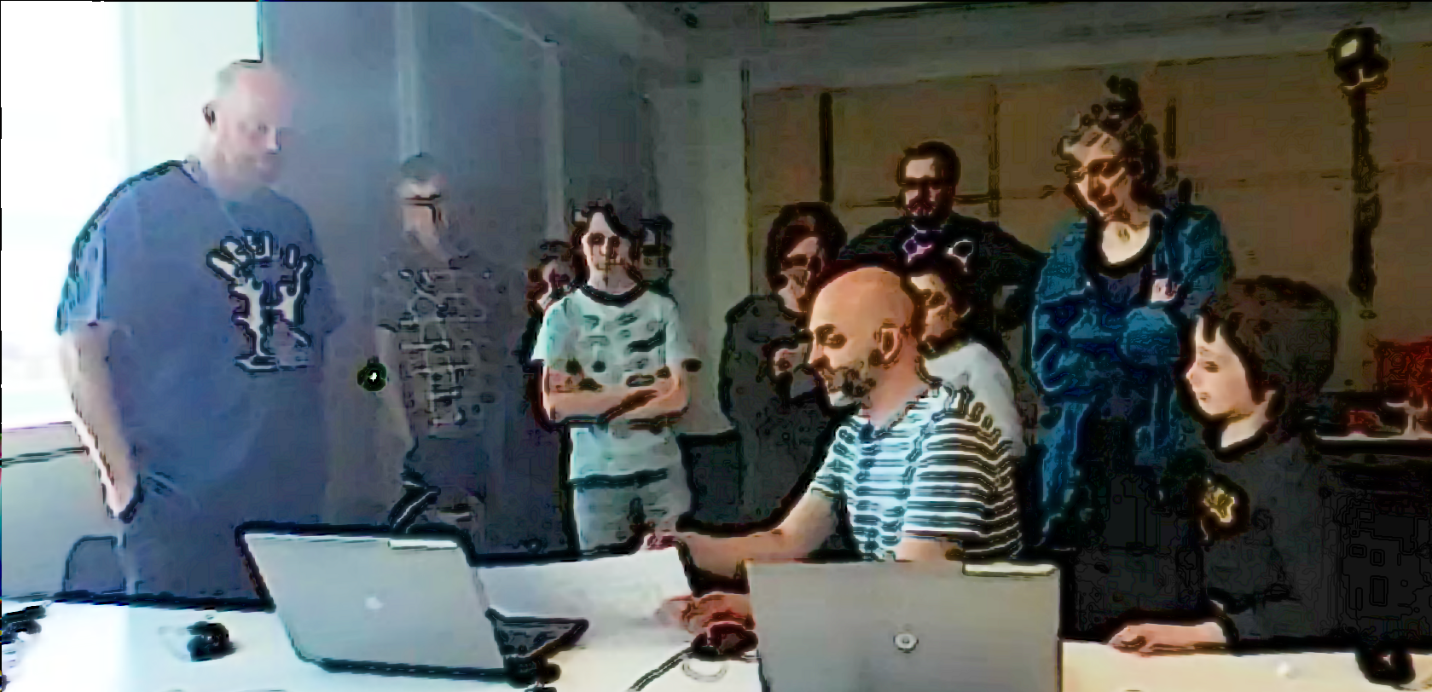
Mark: All we’ve done today is just get a background in and then we were just working on the one that the Weean had sent us about dropping the coins in. Now that the weean have sent us the code we need for basically dropping stuff.
The idea is planting trees. about dropping seeds. So we want to drop those and have some enemies that are tweening randomly around and also taking them away. The idea is to have a timer to drop a certain amount in a certain timeframe or you can’t go through to the next level. And the next level would be you go around and water all the trees. And the third one is you have to look after them all making sure they are not getting chopped down again by that tweening enemy. So we’ve got the concept and everything now and we’ve got the code So we should be able to make a bit of a jump forward now this week. It doesn’t’ look like we’ve got any where but we have.
(Mark laughs and others follow). So we’ve got the the background in and we know what we need to do about scrolling as well because we want to scroll across.
Mick: That’s great. Is there anything that you think you definitely want to be able to do for next time that you might want help with?
Mark: Oh yeah. We’ll we’ve got a bit of space where we can work on it before we next come in so we’d like to ask the Weean some more questions. Is that the best way to do it?
Mick: Yeah for sure and I can see that you guys have been talking to the Weean, Here this project here in your home page called Talking to the Weean allows you to talk to the Weean. So you can go in there, click on Edit Project and if you click on this bit here that says WEEAN and then Markdown you can actually just ask questions in here.
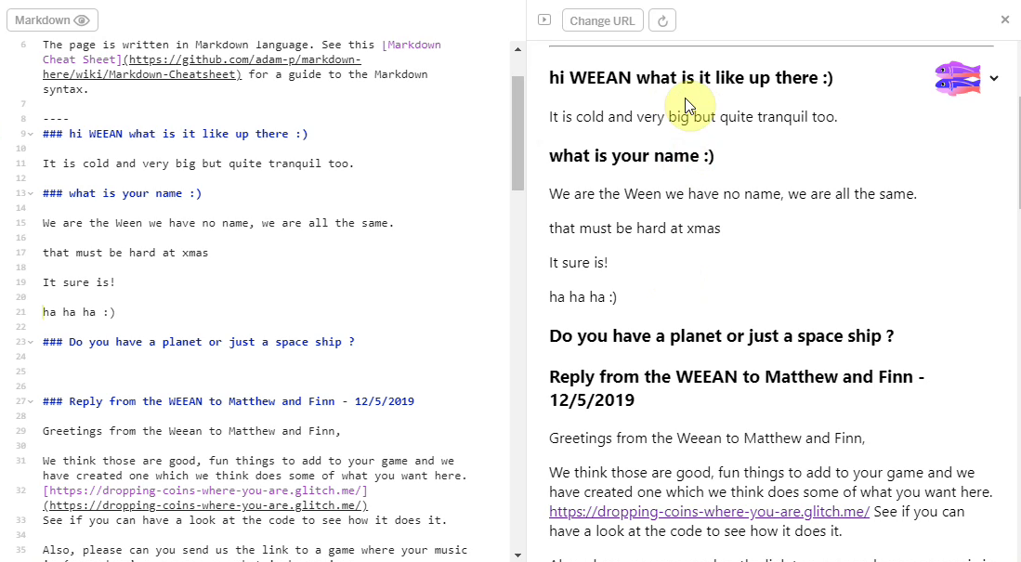
Mick: (reading out from the screen) Weean what’s it like up there? Asks Edward. It’s cold and very big but quite tranquil. What is your name? We are are the Weean we have no name, we are all the same. That must be hard at xmas (Mark and others laugh and smile.) It is. It sure is.
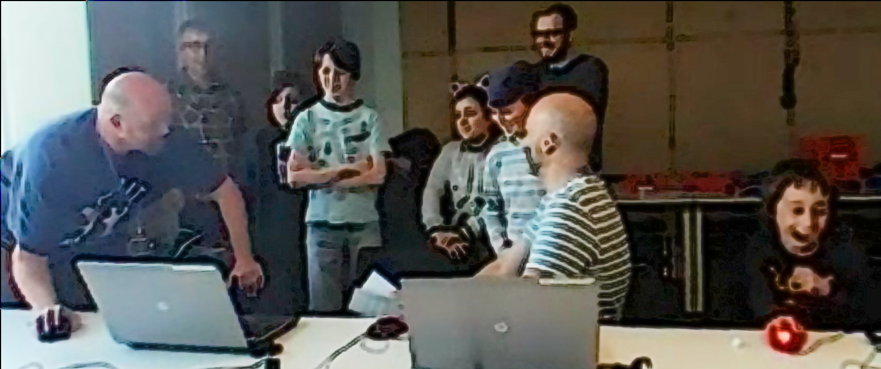
Mark: That’s tickled me that.
Mick: So there you go. You can have a conversation there with the Weean in there using mark up code you can copy what’s there. Nadine can you talk through what you ha- What pedagogical factors are significant to support novices learning coding, particularly in game making contexts? - How can learners build agency in an evolving community of game makers?ve added to your game? Is yours called “No Toby Allowed” now. (Laughs from all)
Nadine: I’ve not really done much today as I was busy doing stuff with Toby’s
Dan: We noticed.
Nadine: We’ll I’ve changed the platform a bit
Molly : You had a secret mission though didn’t you
Nadine: Oh my secret mission was to change someone’s game, their character or something and see if they noticed. And I think they did notice.
Dan: We did. We did notice.
Molly : You couldn’t not notice.
Mick: It feels like you took the spirit of the mischievous thing and just turned up the volume. (All laugh.)
Molly: Sprite!
Mark: We also had a secret mission.
Mick: What was that?
Mark: Ours was to change the sound on somebodies game.
Nadine: Oh was it?
Mark: Did you notice?
Molly: Did you notice?
Nadine: No (laughing) (Incomprehensible many people talking or laughing at same time)
Mark: Play it now!
Richie: You definitely noticed. (Points to Mark and Ed) You definitely noticed my bit.
(Nadine goes to the keyboard and starts to play her game)
Nadine: I can’t hear anything different (Everyone laughs)
Mark: I thought you were going to go- Aaahgh! But you didn’t say anything.
Mick: So that’s interesting. some people notice some people didn’t.

Impact of the drama process on reflection
At the end of each session for the
From my perspective, this technique added an additional advantage of distancing myself from the process of giving direct instructions as I was able to use the foil of the Weean. In my journal notes previously, I noticed that I was often reluctant to shift learners away from making activities to more structured reflective activities.
With reference to AT terminology, the game-making objective of one activity system to the larger system of reflecting on progress or on the skills being picked up was jarring. I also worried that the learners would also find it jarring. Time pressure to finish games also compounded this effect.
Drama scenarios can facilitate reflection on subject matter both in or out of drama. In their guidebook for practitioners O’Neill and Lambert outline the value of reflection that happens within drama structures, noting that it is “likely to be more powerful than end-of-session discussion, since it allows individual and group insight to be articulated as part of the context” <Do Zotero Refresh: [-@oneill_drama_1982, p. 144]>. They propose one way of achieving in-role reflection is to introduce an additional character that acts as an external audience. As a facilitator, I picked this technique from work with the MMU drama department <Do Zotero Refresh: [@caldwell_drama_2019]>, the vignette above shows

Impact of the drama on encouraging flexible design practices via missions
Both the main mission of given in role to make a game to entertain and inform visiting aliens, and extra social and secret mission were delivered with the frame of a drama process. In the transcript above we see that in the reflection participants engage in a lively discussion about the secret missions they had been given.
PULL OUT EXAMPLES FROM TRANSCRIPT
The ones that mentioned in the reflection of this session were the secret missions. However, public missions had a noticeable impact in this session particularly in stimulating a discussion among parents around which arcade games they played as youths.
A table of both social and public missions follows. perhaps move to previous chapter or appendixcomment.
Your Alien Mission (social) | Your Secret Alien Mission:
Find out the names of 3 games that are being made. | Change the variables at the start of someone else’s game to make it play in a funny way.
Make a list of characters in two other games being made. | Change of the images in someone else’s project to a totally different image and see if they notice.
Find out the favourite computer games of 4 people. | Change the level design of the first level of someone else’s project to make it impossible but try to change as little as possible to do that.
Find out who plays the most computer games per week in your group. | Change of the images in someone else’s project to a very similar but slightly different version and see if they notice.
Find out what other people are planning. Give some friendly feedback to one other person / group. Why don’t you try… | Add a rude sound to someone else’s project.
Ask 2 different groups if they have thought about what sounds they are going to put in their game. | Swap over some sounds in someone else’s project and see if they notice.
Find out from three groups if they are going to try any totally new ideas. | Delete all of the code of someone else as they are editing it and see how they react. Then help them get it back using the Rewind function.
Motivations of the social challenges / missions
As explore in the previous chatper my motivations for introducing missions for participants via the
- result of analysis of interactions during game making,
- to encourage some practices ignored by solely focusing on implementing code - game maker types (mention in previous design chapter)
NOTE - WHERE TO BRING IN BARTLE TYPES HERE?
Data from video analysis
In analysis of one key sessions involving missions from which the transcript was taken. Out of x participants, y visibly engaged with the secret missions during the session.
NOTE INSERT - Examples of interactions?
- link to drama process theory
- link to side missions of adventure games - zelda - perhaps find motivation there too.
The process was not without friction, some participants, notably Toby and Dave who were engaging with coding in a more heads down way, expressed frustration at interference.

Observations on exploring documentation and accessing technical help within the drama frame
In the full transcript of vignette gives an overview of the different kinds of documentation and attempting to shift patterns of working from printed sheets to working online. This was partly to be able to capture how participants interacted with documentation more easily as I would be able to review it on their screen in captured data.
- My own reactions in journal - overcoming reluctance in teaching
- via email chats / with aliens explored in vignette 2.
Not all participants engaged with written tutorials. This observation is supported by research which encourages varied approaches beyond instruction-based approaches. <Do Zotero Refresh: [@dietz_design_2021; @resnick_coding_2020]>. [SEE LIT REVIEW ON NON-TUTORIAL PEDAGOGIES]. Written instructions provide barriers of literacy and change of habit explored in previous studies <Do Zotero Refresh: [@blunden2014seeking]> which explore linking to written instructions within the drama frame provides greater incentive to engage in this way.
- (As noted above?) Mark and Ed make reference to the process of getting help via email.
- Dan and Toby also receive help and reference that too. Dan makes an observation that the way of completing the task using case rather than if then statements was not optimal in this learning environment and so asks to change it.
The process of writing down a request in a chat potentially addresses the barriers to asking a group email group for help noted in the previous chapter by distancing the process - you are asking in role. The process also mirrors professional practices in that asking a written question to overcome a coding snags.

Observations on playful chat with the alien sessions
As part of accessing help via the drama process, a line of communication was opened up with the aliens in the form of a simple web page that could be edited and viewed by participants. A playful process of a fictional chat with aliens began spontaneously as a parent was undertaking a social mission.
Inspired by the popularity of students engaging with the fictional audience, I asked a student to participate remotely to play the part of the alien. Impact at the final session was significant with the young people with X out of Y engaging by writing off-the-cuff messages to the fictional audience, and supportive and celebratory messages coming from the alien.
This addition to the main activity served a wider purpose of building an insider rapport, creating a fun atmosphere, celebrating the completion of games in the absence of a public showcase, and signposting other achievements.
However, in the final session where a large amount of time was devoted to interacting with the alien and thus was a danger of distracting from the primary aims. EXPLORE VIA AT LANGUAGE?

Initial discussion of the process drama ( ending with focus on authenticity of tools)
Drama Process Observations
This section discusses the use of drama process to help create coding communities of novices.
Discussion on Autheticity
The following discussion aims to frame existing conceptions of authenticity of tool use in seeding new learning communities. The following sections of the chapter then aim to contribute new knowledge in the area of authentic tool and processes use in the domain of learning coding.
The tensions associated with the use of time by participants of the drama processes in this iteration mirror existing concerns in research.
Here the prioritisation is the construction of a supportive culture given the research which problematises the alien culture of coding. The process of bringing people into the culture is worth allocating time to address inequalities.
These tactics (which?) and resulting tensions and have been explored in other domains particularly literacy and mathematics.
Exploring classroom culture, Engeström <Do Zotero Refresh: [-@engestrom1998reorganizing]> notes the challenges of nurturing the motivation of students. His exploration of tensions which surround the objectives of children of “schoolgoing”, cover aspects of x,y and z.
While the use of a fictional audience in the drama is clearly inauthentic, it is however justified in the goal of injecting learner motivation.
The drama process also mirrors some of the aspects of the 5th Dimension project <Do Zotero Refresh: [@blunden2014seeking]> <Do Zotero Refresh: [@blanton_effects_1997]>. Particularly the use of a playful, fictional absent character called the Golem or Wizard that both young people and adults collude to keep real.
Rainer, Bolton and other practitioner-researchers agree on the potential and value of exploring other subject matter and undertaking authentic project work within a drama frame <Do Zotero Refresh: [-@rainer_drama_2012]>. One key consideration is the authenticity of the tools and processes involved. While Heathcote often explored issues in the context of making of the workplace through replicating working models of practice, she warns against asking participants to genuinely make items in the process explored. To do so, she argues, would expose their inexpertness in the cold light of day. This is uncovered in an interview extract from Bolton and Heathcote.
“if they are makers of things (for example, shoes, ballgowns, or aircraft) they must never (within the fiction, that is) be asked to create the actual objects. If they had to do this their in expertness would become immediately apparent.”<Do Zotero Refresh: [@heathcote_drama_1994, p. 18]>
In this study, a high degree of authenticity made possible, in a material sense, by the digital nature of the learning resources in that beyond a general purpose computer, no prohibitive equipment is needed. However, in terms of complexity of tools use, careful shepherding is involved to screen participants from overly complex processes and tools. The next section examines impact of relatively authentic toolset and also explores some of the limitations to authenticity, justifies these choices, and explores impact of these choices.
MOVE THIS? The use of code playgrounds merits discussion in the way the tool itself is positioned. It is a tool based around a professional community. However in its styling it is playful and editorial picks and write up celebrate a playful spirit of creativity and sharing. There are strong mirrors there to the Scratch community and general maker ethos. The cross over between play and work may merit further investigation and integration into this model.

The impact of starting tools, documentation and other processes
This section argues that the use of authentic tools and processes, while challenging, can be facilitated by careful alignment of key design principles (NOTE PREVIOUSLY EXPLORED BY RESNICK ), and other pedagogical practices.
In the following section, evidence supporting the value of releasing control to allow emergent practices is presented.
The data in this chapter, and the majority of this thesis are drawn from stages 3 and 4. As such, the observations on starting point and subsequent emergent resources are based on that period.

Impact of main learning design tools
The choice of the starting toolset and mission shapes the balance and profile of initial community activity.

Observations on the use of code playgrounds and other authoring tools
As explored in the previous chapter the tools used by participants - Javascript as coding language, Phaser as a game making framework and Glitch as a code environment, are highly authentic and used by both professional coders and enthusiasts alike.
NOTE - compare this to Scratch community - in scratch its easy to find games to remix. This has less of a ready made community of learners but feels more real (potentially (no data))
Learning technology in community settings can engender feelings of agency and motivation from part of wide network and the diverse pathways. [(blunden_interdisciplinary_2009?).
OBSERVATIONS TO ANSWER RQS
I draw the following observations from interpretation of video data of the use of the code environment.
Having a shared log in and thus a shared page for projects - making the social projects more possible.
The use of code playgrounds significantly reduces the load and difficulty for students. While, there is no comparative data on this study, I can support this statement through the following observations and support from other research - setting up a local coding environment is tricky - running a server and connecting in that way is beyond the techincal capabilities of most.

Impact of the half-baked starting template
The last chapter outlined the use and design characteristics of the starting point of an incomplete 2D platformer with low-spec graphics, with graphical scaffolding for text-based code, and deliberately broken. While the following chapter explores the use of game design patterns in detail, this section addresses the impact of the template on participant coding practices, based on video observations of learners directly interaction with the template triangulated with journal notes from phases 2 and 3 and participant feedback from phase one.
Observations of the process of learners using template.
- level design and prototyping: use of
- fluid variable editing effective movement
- The swapping of assets and more complex work with code syntax
- development of simple stories to bump personal expression and narrative
All longer or shorter chains of actions , becoming operations
Also justify having so emergent results here , delay while accessing help to start 360 recordings h As the end process is visible in fluid behaviour
These observations can be explore in relation to other research
- This research supports claims that half-baked games invite development []
- This research also supports other research on the attraction (and motivation) of retro, (introduction) on culture and livingstone, sefon-green.
Exploring Tension - some left behind Some participant do not pick up all processes, some left behind and need support but that is available and creates a reason to ask for help.

Observations of rapid prototyping
As per Te and Da - example in previous chapter where the preview window replaced paper prototyping, rapids shifts between code and game are optimal and build a particular fluidity of practice
- Well suited to build a repeated design practice.
- Especially with starting documents,
- Small changes had big effects.
- Variable changes needed immediate testing.
While the design suits repeated design practice as illustrated by the example above, not all pairs or individuals interacted with GDP in such a neat way.
A later discussion section in this chapter illustrates a more complex interaction with design stages.
NOTE - TO INTEGRATE - SEPARATE SECTIONS OR BOIL DOWN
Fluid variable editing effective movement
Movement was a key to playtesting feedback.
Some evidence of building profiency with significant work to change these three key variables.
However some stay with the starting variables and don’t changes as much as they should.
Level design and prototyping
Lots of evidence of rapid changes and building of fluency of structured
We saw the beginning of that process in Toby’s practice in vignette in the last chapter.
A code snapshot showing the link of the graphical representation of the array.
There was also the process of messing the lines of code in the array. Which impacted syntax understanding.
The swapping of assets and more complex work with code syntax
Give overview.
This is also a good example of the digital literacy skills here are authentic including
- File downloading and migration from one Web app to another via desktop
- Tab navigation
- Tool bar use in piskel , simplified photoshop , list different , crop, fill , export
- Copy and paste
- Selecting more than one line with mouse
Incomplete graphical blocks to help seed narrative and art creativity
The use of blank blocks encourages design as does the theme of environmental as steers participants into games involving animals. This is relatively easy to design and bring its own sense of game mechanics potentially. LINK

Narratives and graphics drawing on home funds of knowledge
At all phases of the learning design participants were able to input their own preferences in the narrative elements and themes of games. The design processes involved choice of game characters and objects that allowed the expression of identity or a designed element - for example graphics, audio or a written message to appear at various stages of the game.
The literature review explored existing research on how interests the use of home funds of knowledge facilitate the adoption of design and coding practices.
One pair Ch and Pa the grandparents of Te, included a narrative at the start of their game.
var starttext = "This is a game which pits a honey bee against a swarm of Asian hornets, which are alien invaders attacking bee hives in the UK and which beekeepers are trying to stop spreading here. Try to guide the bee to collect all the flowers without being caught by the hornets.
Use the arrow keys to move the bee. Press return to START.";
This did bring their own role as beekeepers into the making space and started interesting conversations with other participants.
Participants Mark and Ed designed one game around the characters of a train driver that needed to collect coal. In subsequent post course interview the parent described the impact of the child feeling like they could bring their own identity and interest into the project. “I know just your eyes lit up when you realised you could expand your interests into gaming.”
See fuller extract in Appendix 4.x
Other participants were able to bring personal expression to the process via the creation of audio but in particular visual game assets.
NOTE - THERE IS A HIGH LINK WITH IDENTITY HERE - ESPECIALL IN MOLLY’S CASE STUDY - CAN THIS COME AS PART OF A DISCUSSION AFTER THE DRAMA SCENARIO SECTION? -
In one exchange we can see the growing sense of ownership and sharing helps develop skills of digital literacy concerning saving ongoing work.
In this exerpt parent Molly has spent time creating a pixel art representation of an alien
Molly:– We’re finished. Right what’s next? Now I’m an expert pixel? Now I have to figure out how to get it in there, don’t I? Without losing it. I’ll be very upset.
Sonia:– Have you saved it?
Molly:– No I’ve not saved it.
Sonia:– Save there. (points to relevant button on screen)
The full exchange sees Molly cultivating a sense of ownership over the graphical element that she has created. There is also the development of a growing sense of competency in this area of asset design. She notes she is an “expert pixel”. The growing mastering in this area also seems to help drive motivation to complete the next challenge. This ownership also appears to drives another technical process that of saving work. Or rather the identification with the work pushes her fellow parent to preserve her work to prevent a repeat of losing work previously which she had just shared. See fuller extract in Appendix 4.x
The aspect of pattern completion driving technical process adoption is explored in the next chapter.
While, the personal expression via narrative and asset design can be engage and sustain the motivation of participants, these processes brought tensions identified in the design chapter namely: (edit down into list? )
Exploring Tension - time spent on task - ALSO EXPLORED IN LAST CHAPTER Take the example above, through use of pixel art editor, and template with small, retro themed graphics, as a designer, reduce the propensity to spend along time on asset creation as retro pixel art is quicker to make.
Expectations- ALSO EXPLORED IN LAST CHAPTER
- incorporating familiar or personally meaningful elements can involve challenges including that of unrealistic expectations based on previous game playing experiences

Documentation via code examples and step-by-step tutorials
At this phase there were two main sources of documentation; code examples, and tutorials. The implementation of the same game features but more closely integrated with the new starting code template used. These individual tutorials were directive in nature. The step by step tutorials were available online and also as printed A4 hand outs which were provided on request of the older participants.
NOTE - LIMITS OF THIS DISCUSSION - NOT INCLUDING THE USE OF GDP

Guided Code Patching Process
QUESTION - KEEP FOCUS ON PATCHING - OR IS IT CODING ROLES?
THERE IS DUPLICATION WITH OTHER CHAPTERS HERE - ANY WITH GDP? MOVE SOME OF IT - FOCUS HERE ON THE IMPACT NOT DESIGN - OBSERVABLE RESULTS
The limits that the code environment imposed and the development of a new technique of patching as a process, and the use of code frameworks.
Patching rather than coding from scratch is authentic process which could get extended in other directions.
In response to on-going frustrations of time blockages, where were commonly reflected back by participants, even after step-by-step tutorials were introduced, I added an additional layer of a more systematic structure to the existing resources. Visual aids guided where to cut and paste code patches within their code structure with a greater level of specificity see figure as an example. This addressed a common lack of detailed understanding of the underlying code structure used in the code and the importance to place code extracts in the correct function to maintain the integrity of the syntax.
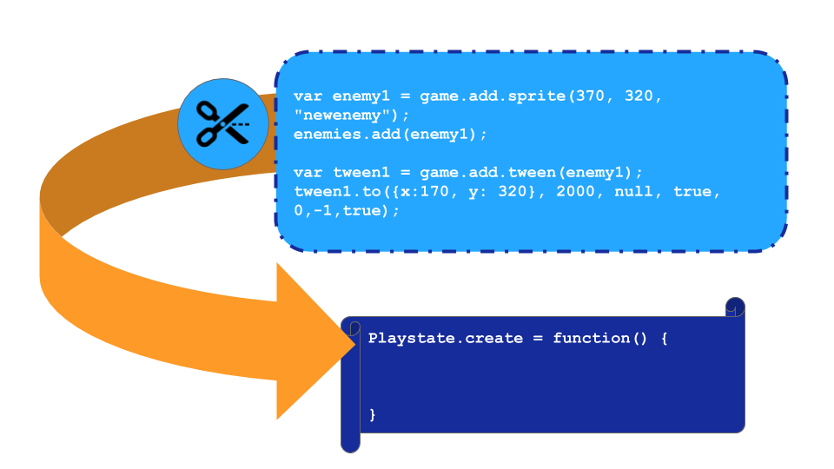
In making decisions like the one to include extra visual scaffolding in step by step documentations. I am balancing here many different factors of concern in the complex learning environment. These include; authenticity of programming environment and language, use of the existing structure of the phaser library, the learning process of participants getting stuck and having to resolve tensions, my time limits providing individual support as a facilitator of a group, and the patience of participants when they encounter incomplete documentation.
During this process of careful documentation I became concerned that over facilitation in this instructional way would remove the possibility for errors and thus reduce the opportunities for learning from resolving failure. However, while each stage of the process of adding game pattern was documented in as complete a fashion as possible, in practice mistakes were still made and additional customisations were made. Thus while the process did reduce dependency on my input as a facilitator there were still opportunities for me to support and resolve coding errors in person. When doing this I or other volunteers were able at times to give wider perspectives on the details of specific coding concepts and wider computational patterns. For example in terms of process, rather than writing code from first principles, this ‘code patching’ technique and subsequent debugging more closely represents the kinds of skills used by computer professionals on an everyday basis

Emerging processes and use of tools
The process of facilitating for emerging learner identities and practices, via the processes and tools explored above, opens up flexibility in the way learners approach the design processes.
My role as a facilitator rather than a instructor was key to this process as has been explored in related research (CoP, MoE ) - Heathcote’s take
Where the activities, processes in the previous section were imagined, often in response to community need, by myself, the following emerged from community use.

Play-testing

Playtesting was a part of the initial design from the beginning but barely consciously, and certainly under explored in my journal notes. However it became a vital part of the learning process.
By the time video data recording started there were already complex patterns and behaviours at work.
There were a variety of ways in which playtesting happens and how younger and older participants looked to give and take from the experience. Playtesting appeared to be suited to allow a diversity of community-building behaviour.
Older participants often used this as a way of being supportive to both parents and young people. This happened in the following ways: - praising graphical content - making links with home interests of participants and building rapport - ( e.g. do you like dogs? )
Emerging cultural norms of playtesting
Reviewing data around playtesting the games of others in sessions, and discussion around the final play of the external audience at final showcase. and challenge - a culture of “hardness”, curiousity about number of levels, as a vehicle for peer support,
In the last chapter, Find examples
When explored from wider perspective, the hard is good lens, is very limiting. The following paragraph explores different perspectives on hardness / challenge.
- arcade games were designed to be hard to extract money from players
- nes games reputation for being brutal as they often had no way to save states
- this developed later for snes games , finding challenge and other forms of ways of maintaining interest for different genres of games_
Other observations - The process of teaching challenge via balance cards can happen early on - some participants are resistange - see Molly’s interactions - does this matter?
Play testing - and embodied participation in the games of others
study the body language of those play testing games. what is there ? - included
- wrestling for control
- movement around the room between screens
- calling across room
- clustering, remaining on outskirts.

Alternating coding
Sh and Th The parent cedes the keyboard and mouse and sometimes swaps chairs to allow child to play test the game created.
This follows a pattern of X

Shifting between Facilitator and more active partner
At one point the testing process here is quite frustrating as gravity value is very low making any movement very slow with little control. While the child has previously rejected increasing the value, the parent’s initial acceptance of this decision is later questioned. The parent who has to do the majority of the testing is more insistent to remove a frustrating part of the testing process.
Discussion drawing on more radical attempts to describe the best way to bring young learners into a design practice. Perhaps in the field of participatory design.

Code roles and experimentation
While the parents are the ones doing the majority of the heavily lifting importing new code, children are observering and emulating this behaviour.
In one interaction child Ne visits the page to add a mechanic, starts to scan it, highlights some code, but then seems to change her mind - perhaps recognising limits - or fearing the process of breaking her game - and returns to more familiar territory of changing game assets and level design. FIND MORE EXAMPLES OF ROLES HERE - T AND D FOR EXAMPLE - CF OTHER CHAPTER

Accessing online, professional/community documentation
The provided documetation provided a safe space. However, some participants embraced more authentic sources of documenation and code examples. They risked the additional confusion in a trade off to overcome the limitations of the existing help.
Toby and Dan - Accessing documentation Phaser
The process of modelling the specific practices of accessing developer documents and help forums is a form of apprenticeship and a direct sharing of a professional cultural practice.
Te takes a lead on looking for help on added a new GDP following enemies. He starts with menu, then book, then Da suggests googling and thus taking a step outside of the walled garden.
Discussion. There are pros and cons stepping outside that garden. Confusion, conflicts, complexity. etc. Vs. generating new patterns and personalisation of game content. NOTE - THIS LINKS WITH DISCUSSION ON CHOICE OF DESIGN MORE GENERALLY.

Emerging tactics in accessing help from peers and facilitators
A common teacher tactic is ask three then me. The family group of Mi, Zi and Ne showed a lot of flexibility and tactical choices when trying to overcome blocks.
Zi more directly and loudly asking for help for faciliator often followed by comment from his mother to leave him alone.
in 2019-03-18 - 18.20 Mi’s meets many small blocks and asks for help from a variety of people. - Student helper to get online, - Peer parent about use of piskel, and then her son - Ne daughter - Mick overall facilitator
Other pairs and individuals had other tactics. Parent Mark made a comment showing that he was aware of the particular value of the in-class sessions to overcome some kinds of blockages.

Discussion
Deepening from observation, evidence to synthesis in relation to other research.

Discussion - on learner identity, anxiety and implications in relation to other research.
NOTE - INCLUDE HOME ED CONTEXT TO AN EXTENT TO PRECEED LATER CAVEATS IN CONCLUSION
While home education support practices of families are expressed in this setting, a computing context requires specific support techniques that may be unfamiliar to parents <Do Zotero Refresh: [@roque_engaging_nodate; @roque_becoming_2018]>.
This chapter has explored barriers to participation in coding project can be mitigated by allowing participants to bring in some of their existing collaborative practices and home interests.
In summary:
- the choice of retro games as a medium provokes sharing for older participants while their enduring popularity maintains common ground with younger participants;
- encouraing game playing and discussion of games helps surface positive affect and
Discussion on reducing learner anxiety surrounding text coding
The previous chapter addressed elements of the learning design that aimed to create an welcoming learning environment especially in response to the withdrawl of one family due to hardcore coding and feedback that
I introduced the following:
- adapted my sessions to ensure a consistency of non-digital and playful activities.
- reflection in role
- encouraging flexible making patte
- flexible pathways to making resources and navigating their learning.
This chimes with existing research:
- the importance of managing learner anxiety in second language acquisition <Do Zotero Refresh: [@krashen_principles_1982; @young_language_1992]>
- deeper into Heathcote
- something about authenticity of audience, and resulting time constriction creating the right kind of pressure / motivation. Game Jams/ Hackathons
And can be synthesised in this way :
- oh lordy - better write something here!

Discussion on flexible design practices - (FLEXIBLE NOT JUST EMERGENT)
Previously a broad range of observed design practices of participants which involve game design patterns were observed. The overall direction of the section is that it is beneficial to creative a community where there is a diversity of approaches being undertaken but with some underlying shared themes and practices.

To address this, this section looks as some of the emerging patterns which complexify the emerging norms of design thinking education. if that’s useful that is - if not just describe complexities

The limits of design cycle stages
When coding data a design cycle framework was one of the code structures. REFER BACK TO ENGINEERING SOURCE. Ask / Imagine, Plan, Create, Test, Improve, Share.
While design cycles was not an explicitly part of the game making instruction, certain interventions supported this approach. In particular the use of maps as a planning and reflection tool and the use of playtesting as a social and personal form of evaluation of emerging designs.
When coding I quick became aware of the limits and challenges to coding to this.
For example a lot of time in this informal game-making sessions were spent on activities outside of this cycle. For example, opening up the right tools, navigating to correct locations and finding past assets involved a fair deal of effort and collaboration.
I have been pragmatic and map elements like this these loosely. Where appropriate I make notes on that activity in free form areas of other documents like spreadsheets.
This limits claims I can make from the coded data. However it raises interesting points which merit discussion.
Value Faff Time. So much of the creative process is faffing. More precisely many creative moments happen in times not neatly represented in the cycle. For example the navigation to the right location in creative software, finding assets, migrating assets between authoring tools, converting to correct formats, evaluating new tools.
This is something that I do not have a precise name for. I call it digital laundry or digital housekeeping. Things that at times can be low attention span or which can be extremely frustrating like needing to tidy up so you can find your car keys. There is frustration here, but there are also moments of creativity, and there are bonding moments which are undirected activity but shared.
For example the process of finding assets in the shared Piskel gallery served to keep indivuals informed in directly of progress being made, and to spark curiousity in the creations of others.
In addition, some of the missions encouraged this kinds of faff time. As examples, Mark toured the other participants and sparked a lively discussion about game playing in response to the mision of “Find out the favourite games of 3 other people”. another?
Improving is Creating and Planning when remixing
For example when altering jump and move variable for the first time. They are deliberately set low. Thus while technically this is improving the code. As the participant is meeting those variable for the first time we can recategorise in the create category.
CASE - One parent did extensive design and then altered the variables at the end. Molly:-
Implication for design
When mapping the activity to a design cycle. There may not be neat matches and at some stage if the process is very fragmented the researcher or teacher can legitimately ask how valuable the design cycle is as a planning or analytical tool. Other less formulaic theoretical perspectives on creative processes exist including rhizomatic approaches <Do Zotero Refresh: [@de_freitas_classroom_2012]>. And some attempts have been made to incorporate design thinking with a rhizomatic approach <Do Zotero Refresh: [@biffi_chasing_2017-1]>.

Encouraging a culture of emergent improvisation/agency in the design process.
- Responses to choice of tools & Communities Choice of Coding Tools / Environment / Communities
In many interactions we see improvisational approaches.
Example from Te and Da - 2019-05-08 -
Da- use paper to design
Te - I'm just going with it
The tools, process and the community encourage a jam / improvisational approach. Remixing, chipping away, a shattering of design cycles. More of an informal approach
The concept of Jam is explored in rapid, improvisational events called Game Jams.
Some of the following sections discuss design factors and participant responses which fit this category of informal creative practices. player types
Digital Jamming
This has an example in the use of sound making software Fi & Ma - The process of tinkering and messing spurs creativity that doesn’t map to a design cycle.
They are in an evaluation of tools which could be said to be in planning stage, However this quickly become creation as they decide the spontaneously created music is preferable to the one created using a different tool at home.
The joint jamming then has created two different soundtracks. This sparks a new thought to create different soundtracks for different levels. This would fit within the Imagine stage. Plan then Create then Imagine then Revise all in the space of a minute.
Implication one - When mapping the activity to a design cycle. There may not be neat matches and at some stage if the process is very fragmented the researcher or teacher can legitimately ask how valuable the design cycle is as a planning or analytical tool. Other less formulaic theoretical perspectives on creative processes exist including rhizomatic approaches <Do Zotero Refresh: [@de_freitas_classroom_2012]>. And some attempts have been made to incorporate design thinking with a rhizomatic approach <Do Zotero Refresh: [@biffi_chasing_2017-1]>.
Implication two -when designing a program and thinking of how to present the process to participants, over structuring around a design cycle approach may be not be productive or accurate. Question? How does this relate to tinkering methodology? What other framework would be suitable here?
Discussion on choice of tools - e.g. why not scratch?
NOTE - Why not Scratch? Less of a community? So how to replace this? What of time considerations? SOME OF THE ABOVE IN DESIGN CHAPTER BUT REFLECTIONS HERE.
Beyond technical considerations regarding scratch and use of physics etc,
Time consideration of the process of being involved in an online community may remove time spent doing real life playtesting.
Also - the diversity of creations available on a online commmunity could remove the more communal experience of the designed limitations.
Fluidity of design practice (driven by playtesting?)
Another example shows an evolving fluidity in response. Ch incorporates a boost to player health after a level after being given feedback during playtesting.
Other participants also demonstrate fluidity of response although to a less sophisticated degree. The process of altering design especially suits a fluid response as makers build their design skills by rapidly altering
This is participatory appropriation in that it is a new GDP that stems from original thinking on the part of the participant.

Conceptualising emergent agency in this study
Designing for tool and process use invites discussion of active possibilities of the design - aka - embodied agency of the design - as per non human methodologies.
On affordances and anchors
Affordances have been misused, assigned magical properties, including agency of themselves. However, affordances are originally conceived of as part of activity, not separated from it <Do Zotero Refresh: [@ba_erentsen_activity_2002]>. Sannino augments the concept of transformative agency by double stimulation (TADS) with a metaphor of a sea vessel warping using kedging anchors.
We may think of the second stimulus as an anchor. Anchors are commonly understood as stabilising devices to prevent a vessel from moving. However, not all anchors have this function. Beside the heavy-weight anchors, there are also kedge anchors serving the purpose of ‘warping,’ that is, pulling the anchor once it has settled on the ground, for moving the vessel away from a problem area. [@sannino_transformative_2022, p. 4]
In this metaphor emphasises the active volition of participants to overcome tensions and blockages in learning. In our context learners would throw an anchor of intention out into the learning environment to then pull on to Not all throws will be successful. The anchor may slip or it may catch on something in the learning environment that allows the leaner to pull
Affordances in the learning design can be viewed in this frame as a catching point for these anchors <Do Zotero Refresh: [@hopwood_agency_2022]>. An effective learning environment provides a sea bed with many rocks (affordances) for warping anchors (volitional acts of participant agency to transform learning).
In a later chapter, I propose that The implications of these combination of concepts the practice of designing and facilitating effective and engaging creative and technical learning environments. I will extract observations from this research that extend beyond the process of coding into other domains.

Chapter conclusion
List concluding points here
- one
- two
- three

Link section to next chapter
We can note tension of restricting user choice in order to create more “visible anchor points” to increase potential for increasing the agency of learners. Like swimming in a protected pool rather than in the sea. This tension is explored more in following chapter.
This chapter has addressed x, the next chapter takes a deeper look at the mechanics of implementing code elements.

Appendices of this chapter_

Appendix 4.x - On creating narratives and game Assets

Appendix 4.x - Extract of interview with Mark and Ed.
Mick: (17-46) Can you tell me anytime that you felt like you bring your own identities or interests into what you were doing.
Ma - Oh, definitely. Yeah.
Mick: Let's ask Fi that as well.
Mark: Yeah.
Mick: Can you do feel like in making the games, you're able to bring your own interests or things that you related to into it?
Ed: Yeah. The Fireman.
Mark: Yeah, well, tell us about that game. Tell about your interests and stuff?
Ed: A little fireman, he's going around collecting coal for this train. They lost it. But then there's sheeps on the line.
....
Mark: What is your aspiration for your life?
Ed: I wanna be a fireman (on a steam train).
...
Ed: I really like trains, since like I was very, very young.

Mick: Do you think I mean, was that was that like something that helps you a little bit keep your interests go in for the game?
Mark: I think it excited you to have to build a fireman sprite? Is that right?
Ed: Yeah.
Mark: and to have it train themed, didn't that like, keep your interest in the designing part of it up? Is that true?
Ed: Yeah.
Mark: Because the whole theme of it. Just I know just your eyes lit up when you realised you could expand your interests into gaming.

Appendix 4.x - Extract of interaction between Molly and Sonia
Sonia: That's Good!
Molly: Oh do you like it?
Sonia: Yeah
Molly: Thank you. I'm very proud of it. Concentrated extremely hard. The thing is, you can get quite consumed doing things like this can't you?
Sonia: Yeah
Molly: That's the problem at home I get a bit kind of lost. I can't get the knack of some things. It takes me so long to get it. I'm like so excited.
- Both laugh.
Sonia: So are you going to do bits at home? When the kids are..
Molly: I tried and I lost it all. And you know when you just completely... And even Ne didn't know so I just ... what a shame.. hours .... (Laughs)

Molly: Lost time. Never mind. We live and we learn.

Molly: We’re finished. Right what’s next? Now I’m an expert pixel? Now I have to figure out how to get it in there don’t I? Without losing it I’ll be very upset.
Sonia:– Have you saved it?
Molly:– No I’ve not saved it.
Sonia:– Save there. (points to relevant button on screen)

