3. Theoretical Framework
- Theoretical Framework
  - Research Questions - July 2024
  - Introduction
  - The social turn
  - The foundational concepts of activity theory
  - Strands of emerging variations of Activity Theory
    - 3GAT and Expansive learning
    - Applying 3GAT via formative interventions
      - Rising to the Concrete
      - Double stimulation
  - Other strands of research based on activity theory
    - Interventionist and utopian approaches involving broader sociocultural concepts
      - The focus on mutual cultural appropriation in work between institutional partners.
      - Third spaces, idiocultures and designed systems
      - Funds of Knowledge within ideocultures
      - Community of learners
  - Putting AT to work via interventionist research in educational contexts (via CHAT interventions, formative interventions and DBR)
    - Alignments and divergences between varied forms of interventionist research based on AT
    - observations to integrate in this section
    - formative intervention research as an inclusive term for CHAT- informed education intervention
    - Formative Interventions compared to Design Based Research
    - Outline of the guiding principles and approaches of DBR and formative interventions
      - Principle : Researcher take and active interventionist approach
      - Principle: Mutuality
      - Principle : Utility of research - overcoming the tension between the rich context and generalisation of results
    - Critiques, development and synthesis within Activity theory approaches - NEEDED HERE? IF NOT WHERE?
      - Summary of critiques and challenges in the intersection of DBR and AT
      - Existing gaps in concepts & critiques
      - Alternatives
      - Synthesis
    - An operationalised example of Activity Theory concepts in context
  - Concepts of agency within CHAT
    - Agency and AT - big picture in relation to ANT (Latour) and agency of humans and artefacts
    - Addressing and disambiguating definitions of agency in education
      - Instrumental and relational agency
      - Dynamically Emergent Agency
      - Authorial and transformative agency
      - TAS
      - TADS - On double stimulation and agency
  - Conclusion / Synthesis.
    - Summary of Justification of choice - and how the RQs align with different concepts
      - Signposting where concepts are used in the thesis (in relation to RQs)
      - The role of AT in the analysis of HCI - MOVE?
  - Parked to replace or remove or rework

Theoretical Framework

Research Questions - July 2024
- What contradictions arose in participation in this research’s game coding processes and what pedagogical tools and processes are available to address these contradictions?
- How can game design patterns support the development of computational fluency in novices?
- How can learners build agency in an evolving community of game makers?

Introduction
The focus of this study is on the construction of shared meaning and practices as part of an emerging community of game makers. As my study seeks to address cultural factors which act as barriers to participation in digital making, it requires a method of research which allows the detailed description and evaluation of complex, emergent learning environments. The ability to study context, transformation and the development of participant agency are vital to the concerns of this study. To serve these ends I adopt cultural historical activity theory (CHAT) as a guiding theory, operationalised using formative interventions as a variant of design based research (DBR).
This chapter describes the guiding theoretical framework and key concepts which are relevant to the development of the thesis. As activity theory emerged from a movement know as a social turn in psychology (Sugiman et al., 2008), thus, a brief this chapter begins with a brief description of this movement. The foundational concepts of activity theory (AT) are then explored before turning AT’s evolution in the form of CHAT and third generation activity theory (3GAT) and more recent forms of cultural exploration. Then, in order to explore the enactment of CHAT in a research setting, DBR, and varied forms of formative interventions are analysed. The final section of the chapter looks specifically at understanding surrounding the development of agency within the theoretical framework of activity theory.

The social turn
This section addresses a turn away from a psychological approach towards a more social understanding learning and human behaviour(Sugiman et al., 2008). While this turn has impact in several disciplines, it is in learning that is the focus of this study. This social turn in psychology, involved a turn away from assumptions that studying human mental activity should be carried out in isolated, context free methods (Stetsenko, 2005). The reasoning behind this shift is present not only to address validity of results(Brown, 1992) but also the value of the research for designers and participants (Barab et al., 2019). This perspective allows a transcendence of conceptions of transmission models of learning to embrance the value of group-based, participatory processes.
The work of Brown (Brown, 1992) as prominent researcher within psychology advocating the importance of context within experimental design helped legitimise this focus, and facilitate a broad uptake in diverse fields. The growing work in these varied fields sometimes grouped by the term learning sciences, can be viewed in terms of a move way from randomised control trials and their attempt of severance of context away from a behaviourist view of learning as an internal psychology process, towards a diverse set of disciplines and tools drawn from emerging field of cognitive and cultural psychology (Hoadley and Van Haneghan, 2011). While this fragmentation can be seen as positive in terms of pluralism and interdisciplinary sharing of knowledge between fields as diverse as education, anthropology and computer science, is also a source of criticism in lacking an overall coherence in underlying understandings of the learning and human activity on a deeper conceptual level (Hoadley and Van Haneghan, 2011).

The work of Michael Cole in Laboratory of Comparative Human Cognition (LCHC) (Cole and Means, 1981). In his narrative account of his own turn towards a social understanding of learning and activity in the book Cultural Psychology, Cole (Cole, 1996) critiques the emerging trend of behaviourist and cognitive psychology towards interpretations that reduce the minds as an information processing unit rather than one component in complex cultural activity. While there have been varied schools influenced by the turn towards studying learning in context, I have chosen to use Cole’s articulation of activity theory as a base for the the theoretical framework of this study due to the overall coherence of the approach and its ability to deal effectively with bother wider cultural impacts on the focus on activity, and detail of narrower actions.
I take a broad approach to applying activity theory, drawing on 3GAT, with its attendance to systemic analysis and particular techniques and understandings of agency, the work of Cole and the importance of institutional mutuality, and the work of Rogoff in particular the attention paid to linguistic and cultural-historical repertoires (Rogoff, 2003)
While activity theory provides the base for this work, I also incorporate some elements of theoretical approaches from wider sections of the learning sciences, in particular design based research (DBR), to address issues of utility of research (Hoadley, 2002) and perceived utility of research (Barab et al., 2019). This chapter explores and justifies this choice and in a later section begins to describe how these concepts are operationalised in the setting of this study. To do this I begin by outlining the history and foundational concepts of activity theory.

The foundational concepts of activity theory
Before outlining the concepts driving activity theory, a short history here places them in context. For Marx human endeavour and change is based on activity and the subject of that activity is understood as the person or people driving it (Marx and Engels, 1975; Blunden, 2009). Vygotsky drew on Marxist conceptions of the importance of human activity as social mediated process, applied the core concepts to broader understandings of the learning process (Blunden, 2010). While Vygotsky’s student Leontiev formulated the work of Vygotsky into a prototypal activity theory (explored shortly), AT had stagnated in the repressive context of the USSR (Blunden, 2010) and had limited take up in western academia before Cole’s translations of Vygotsky’s work (Vygotsky, 1978). This work to bring some of the foundational concepts into an educational psychology setting, at the time of the broader social turn in the discipline.
The work in this emerging field of cultural psychology by scholars such as Wertsch (Wertsch, 1985) and Cole (Cole, 1996) explores the vital role of cultural mediation in human development in general and more specifically community and context in the studies of learning, situating learning pedagogies as form of meditational strategy. Before progressing to study the work of Cole and others in context, it is of value to examine Core concepts in activity theory (AT). Nardi and Kaptelinin outline activity theory as a series of foundational concept which form the base for wider theories (Wertsch, 1981; Kaptelinin and Nardi, 2009), namely: object-orientedness, tool mediation, hierarchical structure of activity, ongoing development of activity development, and psychological internalisation and externalisation.

A starting point in the exploration of key concepts of AT is Vygotsky formulation of the conception of activity the relation between subject, object and tools. Activity theory is seen as object-oriented in that understanding of human organisation and learning are based on activity driven by the goals or objectives of the individual or collective subject (Engeström, 1987). Kaptelinin and colleagues (Kaptelinin, Kari Kuutti, et al., 1995) note that while the materialist focus of the Marxist roots of activity theory has led some descriptions to focus on the object as the physical object being worked on and being transformed by the activity, conceptual objects are also included in Leontiev concept of activity theory (Leont’ev, 1974). Thus the term object is best understood within the context of wider motivation or objective. To clearly represent subject and object in a way which represents Vygotsky’s overcoming of the problems associated subject-object, mind-body, Cartesian dualism (Still and Costall, 1991), this relationship was developed by Vygotsky’s student Leontiev into a triadic relationship to including tools which mediate activity.. (Engeström, 1987) See fig 3.x below.
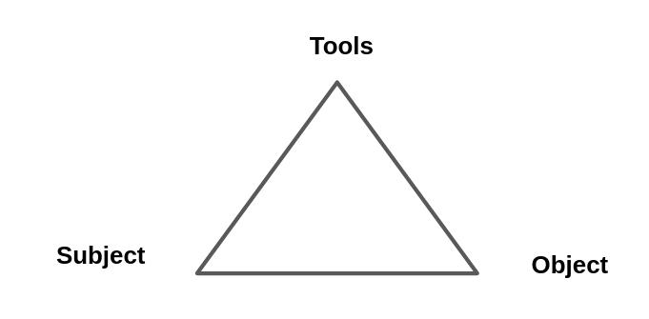 Fig. 3.x essential conception of Activity
Turning to mediation via tools, Vygotsky’s concept of tools here is broad including language, physical tools and representational concepts (Vygotsky, 1978). Mediation is of particular relevance to this study as the learning environment involved varied, dynamic forms of tool use. Physical, digital and conceptual tools evolve as a product of the experience of others in society and are thus a product of adaptation, containing within then evidence evolutionary processes of culture. This study situates pedagogies as forms of meditational strategy which can be drawn on by both facilitators and learners (Donato and MacCormick, 1994; Gutierrez et al., 2009).
For Vygotsky, the process of mediation via conceptual tools is examined through mutual processes of internalisation and externalisation of activity (Kaptelinin, Karl Kuutti, et al., 1995). Learners are actively processing and make sense of the world by both appropriating cultural learning from cultural practices and then by contributing back into shared cultural understandings of the world. This two way process is well described in learning context by Rogoff via a personal process she calls participatory appropriation (Rogoff, 1995). Here Rogoff situates Vygotsky’s concept of appropriation beyond an internalisation of external concepts experienced in society, as an ongoing and reciprocal contribution to practices and concepts in-situ. This distinction is important as a refutation of transmission based models of learning. Rogoff also cites this personal dimension as one key plane of three important in the study of community activity.
"Inherent to the participatory appropriation view is the mutual constitution of personal, interpersonal, and cultural processes." [@rogoff_observing_1995, p.154].
These planes are explored in a later section of this chapter.
To describe activity systems with greater granularity, Leontiev (2009), used terms and concepts of actions and operations happening which constitute a vertical hierarchy of activity structure. Activity works on a level of an overall motive and actions are a smaller component sub-goals to needed to achieve the wider goal of the activity. As we descend this hierarchy, underneath actions are series of unconscious operations carried out fluently in the process of undertaking actions. See figure below from (Daniels, 2001:87).
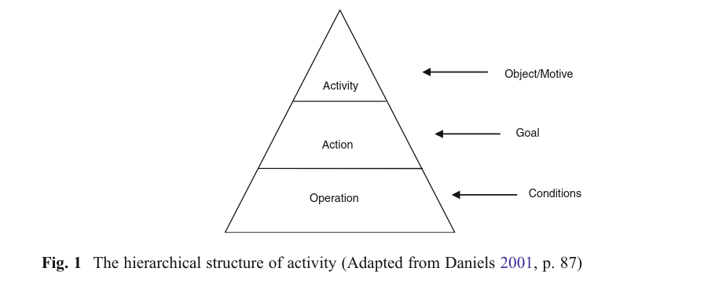
Figure 3. x - hierarchical structure of activity (adpated from (Daniels, 2001:87))
The concept of fluency is key to this study, as such it is important to be able to locate and describe these chains of operations and actions. Kutti (Kuutti, 1995) describes a shift from actions to operations in the following way.
Initially each operation is a conscious action, consisting of both the orientation and execution phases, but when the corresponding model is good enough and the action has been practiced long enough, the orientation phase will fade and the action will be collapsed into an operation, which is much more fluent." [@kuutti_activity_1995]
In addition, activity systems are also sometimes conceived as being nested within wider activity systems, for example the development and teaching of a series of lessons may take place within the wider activity of a school or university (Barab, Barnett, Yamagata-Lynch, et al., 2002; Lewin et al., 2018a). Thus the choice of which activity system to analyse in depth, is described as the process of finding an appropriate unit of analysis (Blunden, 2014). For example, in Barab et al’s research on a changes to a university course, a granular exploration of the tensions and processes at work in a complex educational environment is used to identify emerging barriers and responses to comprehension and communication. This level of detail which facilitated its replicability and utility to other practitioners, is used as a justification for using a smaller activity system than that typically represented in Engeström’s approach (Engeström, 1987, 1993; Barab, Barnett, Yamagata-Lynch, et al., 2002). Similarly, in this thesis, while game making at a community project studied as a system, interpersonal activity is also examined using an activity system of a smaller scope. This is explored in more detail in Chapter 4.
In terms of development, activity theory views activity as constantly evolving within its context. The theory is grounded in Marxist dialectical materialism, which suggests that activity is a dynamic system best understood through its transformations (Ilyenkov, 1960). A major driver of transformation in activity is the emergence and resolution of contradictions and conflicts, which arise from the build-up of tensions within the activity itself (Ilyenkov, 1960; Blunden, 2023a). Engeström’s work on what he called the third generation of activity theory includes the theory of expansive learning, which traces the changes and growth of the object being worked on. This often occurs due to tensions extending beyond a single activity system to involve others, acknowledging the influence of actors moving between systems (Engeström, 2001). Along with Cole’s work, this is crucial for expanding beyond a narrow view of activity and engaging with cross-cultural understandings of learning (Cole, 1988). These concepts are further explored in the section on expansive learning below.

Strands of emerging variations of Activity Theory
As part of the growing uptake of AT beyond the USSR, researchers forged new concepts in these varied strands of activity theory. Terms evolve over time and and used differently in varied settings. The following disambiguation is offered to address this in this context of this study. Activity theory AT is used to refer to underlying principles as described above. Cultural historial approach and cultural historical activity theory (CHAT) broad application of those principles which at times concepts associated sociocultural approaches: these include concept including communities of learners (Rogoff, 1994), communities of practice (Lave and Wenger, 1991), and social design experiments (Kris D Gutiérrez et al., 2020). The term third generation activity theory (3GAT) is used to refer to Engeström’s more specific interpretation of AT when a distinction is needed.
The next section explores concepts within two broad strands of activity. The first is that of third generation activity theory (3GAT), centred around the work of Engeström and colleagues in Finland. The second is a more loosely grouped strand of researchers based on a tradition of both the soviet tradition at AT described above and American pragmatism in the tradition of Dewey. This body of work aligned with CHAT principles from the work of Michael Cole and colleagues, carried out to a great extent within the context of funding programme and publications of learning sciences, includes concepts of funds of knowledge, ideocultures and legitimate peripheral participation which are relevant to this study.

3GAT and Expansive learning
Addressing the first strand, 3GAT represents an important development of conceptual tools to apply activity to authentic learning settings. Engeström concept of the activity system model extends Leontiev’s work via a triangular representation of key cultural aspects of the activity in question. The model features a further tier cultural factors including, norms and rules, division of labour and community (Engeström, 1987).
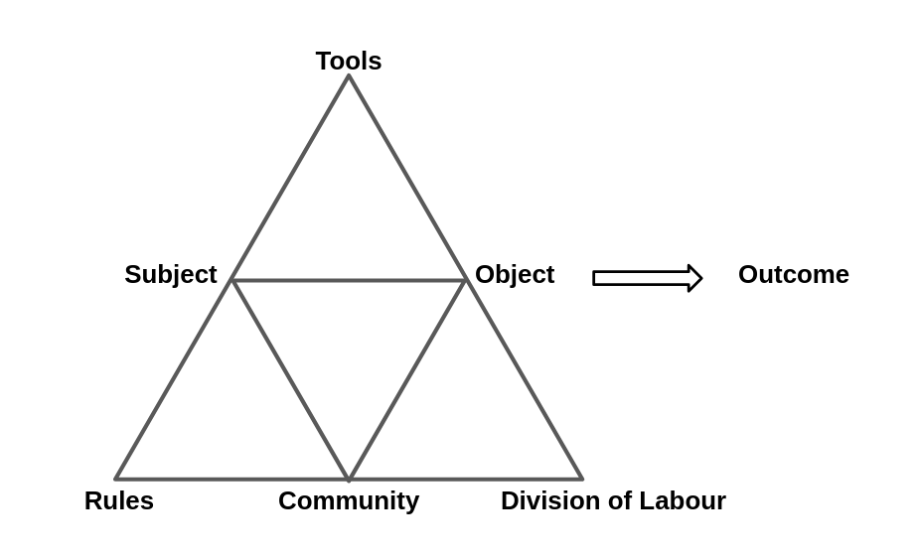 Figure 3. x - Engeström’s representation of community concepts an activity system
Engeström visually represents Leontiev’s focus on issues of the wider community (those involved in activity beyond the subjects themselves), division of labour (either through division of tasks between community member or a more vertical power structure) and the emergence of rules or norms (guiding and emerging community behaviours) (Sannino and Engeström, 2018).
To address 3GAT expands its focus to encompass the role of interacting activity systems, the movement of subjects between systems and the possibility for joint work on a shared object. The recognition of wider activity systems and the transfer of motivations and practices of actors into new systems is represented in Engeström’s view of AT (Spinuzzi, 2020). This shared, or expanded object being worked on by more than one activity system is represented in Fig 3.x below.
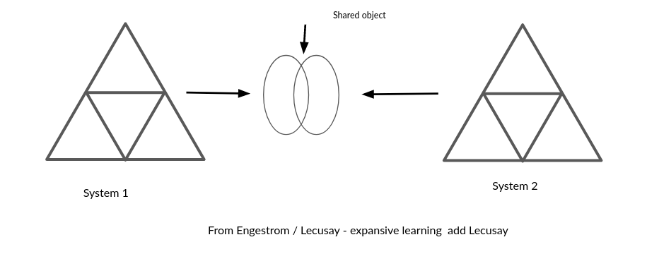
Figure 3. x - Engeström’s concept of expansive learning via a shared object, from (Sannino et al., 2016) (Engeström et al., 2014)
To explain this relationship more clearly an example in context is helpful. In research on a joint activity involving school, Cakir and colleagues represent the joint activity as an objective share between school, family and researchers.
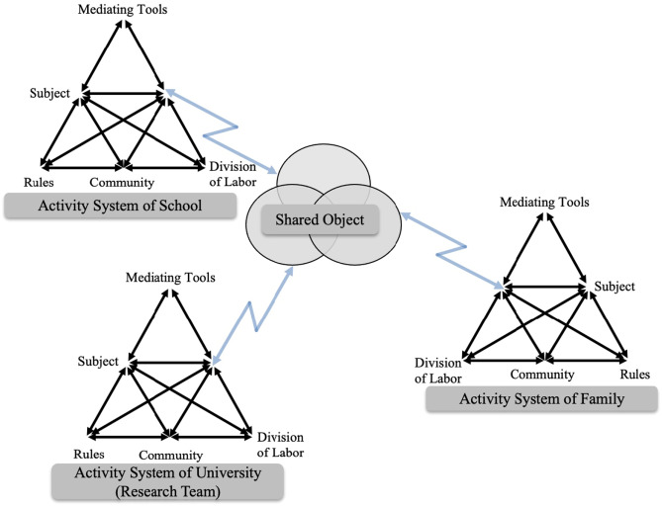 Figure 3. x - An object shared between different activity systems
This conception incorporates the importance of the roles of researchers and other stakeholders within this interventionist and participatory processes. The need to analyse activity through its transformation through contradictions of tensions of systems elements, drawn from Marxist conceptions of dialectics forms the base of the concepts of expansive learning. In 3GAT the this view of transformation via joint work between activity systems on a new expanded object is called expansive learning (Engeström, 2011).
Drawing on concepts of tensions and contradictions existing in foundational concepts of dialectal materialism, the 3GAT allows for a granular exploration of tensions and contradictions are a vital source of change and evolution of new and ongoing activity systems (Engeström, 2001). 3GAT achieves this via careful of description, analysis, and representation of system elements, interaction between systems and resulting contradictions. Tensions between participant motives and different parts of activity system are sometimes revolved quickly through change, or remain more persistent and can be referred to as conflicts (Sannino and Engeström, 2018). These unresolved contradictions develop into impasses or conflicts which may serve as motivational factors driving agentic responses from participants in dysfunctional systems. A later section explores Sannino’s view of such conflicts positively as the source of transformative agency in greater depth.
Kamanga notes the value of locating system congruencies or strengths within activity systems (Kamanga and Alexander, 2021). For a comprehensive analysis of systemic contradictions see the work of Engeström and Cakir (2011; 2022). While I agree with the potential value of precise use of the terms tensions and contractions (Karanasios et al., 2017), in this study rather than larger systems of workplace analysis happening over years, analysis of tensions takes place in the context of shorter interventions as seen in diverse research (Barab, Barnett and Squire, 2002; Barab, Barnett, Yamagata-Lynch, et al., 2002; Lewin et al., 2018b). As such longer terms conflicts are less likely to occur, and the concrete description of contradictions are helpful in themselves as a source of disambiguation. Therefore, following Kuuti (1995), this study adopts contradictions as a term encompassing concepts of tensions, barriers and conflicts. Engeström states such sub-terms can be “understood as manifestations of contradictions” (Engeström and Sannino, 2011:340). I use more specific terms are used when needed to disambiguate meaning.

Applying 3GAT via formative interventions
The term formative intervention (FI) has its roots in Cole and Engeström’s exploration of two models of CHAT based interventionist research (Cole and Engeström, 2007). While both interventions, namely Change Laboratory (from Helsinki school) and 5th Dimension (Cole’s intervention carried out in partnership with wider sociocultural researchers), were designed to align with principles of AT, and termed formative interventions in early publications, it is Engeström who has used the term most consistently and who has defended against it being used more flexibly (Engeström et al., 2014). In this section I explore the Helsinki school’s narrower interpretation of formative interventions as an application of 3GAT theory. In the following section I turn to wider applications of interventionist approaches.
A model of formative intervention that has been addressed by much research is Engeström’s implementation of expansive learning in workplace environments, a set of processes applied in a workplace setting called Change Laboratory (CL) (Engeström, 2007).
The CL interventions takes the form of a series of workshops with stakeholders important in the workplace setting with the researchers act as facilitators of the process. The structural model of 3GAT is used as a tool to identify, analyse and provoke reflection on current workplace practices and dynamics and to facilitate discussion on possible actions to enact change. The CL processes suits a formal, relatively stable workplace where there are existing concepts of community, division of labour and existing norms are readily identifies.
Another form of FI relevant to this study is that of the Learning Lab which is represented above in Fig.3.x (Bal, 2011; Cakir et al., 2022). While Learning Lab takes place in a context of a school environment, interventions retain the form of stakeholder workshops. For more on formative interventions have taken other forms that have been used or endorsed by Engeström’s team in Helsinki team see (Engeström et al., 2022).
Cole and Engeström’s exploration of two models of formative interventions (Cole and Engeström, 2007) concludes that while the methodology aligns with key principles of AT, there are practical changes in aligning with perceived rigour of social science given the changing environmental factors and lack of standardised tests. It also notes issues of financing such lengthy and repeated interventions in the experimental process and the challenge the status quo, and thus those that might fund such research, by developing the agency of workers and learners.
Cole notes the need to align research interventions with the ongoing aims of educational or community parters to maximise their ongoing sustainability beyond research period (Cole, 2006; Cole and Engeström, 2007). To illustrate this point he describes a model of formative intervention in the form of an after school programme called the 5th Dimension. In a following section, this case study is used as a starting point for a comparison of different approaches to interventions based on CHAT. Penuel (2014) proposes the formative intervention research as a useful term to encapsulate a variation of process closely aligned with CHAT including those drawing on elements of DBR. In reply, Engeström resists this proposition, insisting that formative interventions should contain a clear articulation of double stimulation and the process of rising to the concrete within the framework of Engeström and Sannino’s understanding of these concepts (Engeström and Sannino, 2011; Engeström et al., 2014; Sannino et al., 2016). The following section addresses these concerns.
The concept of rising the the concrete via a germ cell of activity (or unit of analysis) can be traced through the work of Vygotsky and Leontiev to Hegelian and Marxist concepts of holistic understandings of phenomena (Blunden, 2023a). Varied forms of activity are conceived as concreted instances and iterations of underlying germ cell concepts, which exist as an abstracted form. For example, Marx’s analysis of a complex capitalist system was based on a more simple germ cell of commodity exchange in pre-industrial economies. The works of Blunden and Davydov (Davydov, 2008; Blunden, 2010, 2014, 2023a) provide as comprehensive justification the utility of the process of finding a germ cell/ unit of analysis in relation to collaborative and learning projects. Blunden describes the germ cell of activity and the unit of activity as two similar concepts with slightly different foci.
... the germ-cell and the unit of analysis are one and the same thing, but in one case the developmental aspect is emphasised and in the other case the analytical aspect is emphasised. [@blunden_unit_2020]
In this thesis, my role as both researcher and practitioner, make both aspects are relevant. Examining the analytical aspect, the process of seeking and defining a key activity scopes as units for analysis helps define boundaries of what to analyse in depth. A challenge of the application of this approach, is the duration and relative stability needed taken to identify these germ cell. In their critique of Penuel Engestrom and Sannino (Engeström et al., 2014) give no suggestion on adapting their models to more rapidly changing situations where actors from different activity systems.
Double stimulation refers to a process in the use of tools to overcome contradictions that emerge in joint activity. Engeström’s early work on formative interventions frames the first stimulus as the problem itself and a potential series of secondary stimuli be presented as part of intervention (Cole and Engeström, 2007:492). Engeström and Sannino describe that the process is active and goes beyond simple mediation via existing tools, as the stimuli, either presented as suggested tools or discovered in the environment, are actively imbued with meaning by the participants through transformation (Engeström et al., 2014).
"Most likely the initially given potential second stimuli are rejected or reshaped by the participants, and the participants typically pick up or invent devices of their own, often as if behind the back of the interventionist." [@engestrom_methodological_2014, p.121]
For example, the Change Laboratory model, the first stimulus would be mirror data from ethnographic video recordings which locate a problem to address. The second stimulus (more accurately a series of stimuli) are the use of techniques to provoke, shape, record and reflect on the emerging discussion (Engeström, 2007). Sannino’s (Sannino, 2015) work on the volitional aspect of the process of double stimulation see auxiliary stimulation as triggers for will and agency in participants. (Hopwood and Sannino, 2023) is explored in more detail later in this chapter.

Other strands of research based on activity theory

Interventionist and utopian approaches involving broader sociocultural concepts
A strand of activity theory perhaps best typified by the pioneering work of Michael Cole and colleagues focuses on the joint development and analysis of culture via a joint activity (Cole and Engeström, 2007). Here describing the approach to culture as hybrid of American anthropological approaches and those of USSR researchers.
Cole’s approach is often profitably explored using the 5D case study. The practicalities are is explore in more detail later, for now it is useful to describe the motivations of the research programme. The focus of the programme was on sustainability and mutuality and a utopian ideal of creating a new activity system shielded from some of the more debilitating contexts of mainstream school and wider societal forces (Blunden, 2023b).

The focus on mutual cultural appropriation in work between institutional partners.
Here cultural appropriation is seen as a positive and mutual process between instit

Third spaces, idiocultures and designed systems
Cole notes that the creation of idiocultures by researchers (Cole, 2017), the created allowing researchers to be present from the beginning of the process.
This can be compared to methods addressing existing existing activities like the change laboratory. LATER?
However, (Downing Wilson, 2011) notes that even novel idiocultures are not created from nothing but encompass cultural traits of other systems in which participant engage with.

Funds of Knowledge within ideocultures
Many studies in the school of research Cole describes above align with concepts of how home discourses or and FoK can be drawn on as a resource by participants to facilitate learning in new environments (Moje et al., 2004) .
The process of merging the knowledge and discourses of first space (home life) with the process of of the second space (school or institution) into a new third space has been explored in many studies (Moje et al., 2004; Gutiérrez, 2008, 2008; Bryant et al., 2009).
Cole’s recent work address the use of FoK to form ideocultures in educational interventions (Rajala et al., 2023)
The work problematises the possible superficial use of FoK and FoI in a ways which may perpetuate status quo negatively (Rajala et al., 2023)

Community of learners
On cultural-historical repertoires
The work of Rogoff and Gutiérrez on linguistic and cultural-historical repertoires (Rogoff, 2003), is important both as a way of being clear about the cultural sources of difference in groups to avoid cultural-historical practices of participation being misrepresented as innate practices, particualar problematic in dimensions of race.
This work also is useful in the way it draws on Rogoff’s work of Rogoff on Communities of Learners and in particular analysis of complex group activities using three planes of observation. Rogoff’s (1995) describes three planes of personal, social and community activity which she advocates as foci for analysis. While the author’s original research was on indigenous cultural practices on a village level, the model has been applied in both formal and informal educational settings. For example, in a primary school setting, Morcom (Morcom, 2014) applies Rogoff’s (1995) three planes of activity to help understand the development of classroom activity. In this interpretation, teachers design learning environments and interventions to support learners to enter into a pattern of activity, in this case focusing on those beneficial to student’s positive affect.
The model problematises the dichotomy of learner led, teacher led approaches (Mascolo, 2009) in a way which suits the space between formal and informal learning that this community based model of game making occupies.
Guided participation as a middle ground between instruction and discovery.
This focus on the cultural repertoires of group continues of the work of Gutiérrez on social design experiments (Gutiérrez and Jurow, 2016; Kris D. Gutiérrez et al., 2020), in a way which will be explored in Chapter 7.

Putting AT to work via interventionist research in educational contexts (via CHAT interventions, formative interventions and DBR)

Alignments and divergences between varied forms of interventionist research based on AT
The section above outlined advancement in concepts of activity theory carried out by differing schools of researchers. Whereas there is broad agreement in the theoretical understandings therein, there is more disparity in the way they are applied in a research settings. This section explores these dimensions using the lens of the influence of DBR on the operationalisation of AT and vice versa.

observations to integrate in this section
This section continues to explore how the theoretical framework of AT can be operationalised.
In the intro to (Cole et al., 2018:5) Cole and colleagues outline three variations in focus in application. Formative interventions, as per Change Laboratory focusing on
mutual appropriation (Downing-Wilson et al., 2011)
It also grounds this exploration in the specific domain of education.
It compares the approaches of formative interventions and design based research.
It also begins to apply concepts to the context of this study.
Mutual appropriation highlighted the importance that researchers adapt to contextual factors including the practicalities of the setting.
Rajala and Cole echo limits (Rajala et al., 2023) and argues for the use of FoK in design experiments in the form of funds of identity (FoI). The identity objects here be likened to the creation of artefacts in the game making process, and the evocative objects of Turkle and work of Papert.

formative intervention research as an inclusive term for CHAT- informed education intervention
This section explains the CHAT method of formative interventions aiming to later link it to broader research intervention in education including DBR
Penuel (2014), in an attempt to summarise differences between DBR and CHAT interventions talks of the focus of DBR by learning scientists on developing theory and advancing practice around innovative learning tasks, while CHAT interventions are more focused on transformations in activty and the increasing agency of those involved. This section covers the CHAT interventions by exploring the concept of formative intervention in particular. A following section contrasts this description with previous generations of DBR and articulates current synergies.

Formative Interventions compared to Design Based Research
Penuel (2014) charts a shared foundations and of AT and wider research intervention in education including DBR and proposes greater dialogue between CHAT and DBR researchers on alignment of processes. This stance was taken in response to Engeström’s critique of design experiments and DBR more widely (Engeström, 2011). It is of value to explore this debate to highlight similarities and differences. WITH WHAT AIM?
The process of comparing FI and DBR is complicated by DBR’s wide application and its diverse interpretations beyond some generally agreed principles (Penuel, 2014; McKenney and Reeves, 2021).
The core elements include: research as an intervention, iteration, involvement of participants in the evolution of designs, and a flexibility of research outcome based on how events unfold (Easterday et al., 2014).
Hay describes DBR thus “learning occurs within a context of use, learning is frequently collaborative, learning as authentic, learning as inquiry-based not transmission-based” (Hay and Barab, 2001:3).
Sandoval notes diverse methods at use (2014), but notes the alignment of approaches within DBR namely, “the joint pursuit of practical improvement and theoretical refinement; cycles of design, enactment, analysis, and revision; and attempts to link processes of enactment to outcomes of interest”.
However, while the broad approaches are in alignment with wider socio cultural approaches, Engeström characterisatise key problems with DBR when applied to education in the following way: vague in description of systemic elements in analysis, overly focused on a linear approach to refining the researcher’s learning design in a way that limits the input and agency of participants (Engeström, 2011). O’Neill (2016) echoes some of these concerns and develops them to encourage fellow DBR researchers to applied CHAT methodology to addressed limitations in existing DBR practice in the learning sciences community. He highlights that DBR researchers in this field do not always take time to familiarise themselves with existing learning practices of the contexts in which they study in a way which aligns with CHAT approaches. (DOES THIS NEED ELABORATING IN CONTEXT AT THE START OF THIS SECTION OF CHAPTER?).
O’Neill (2016) also outlines The causes of this state of affairs. In particular, he outlines the myth of the heroic researcher/ designer who drives change and updates the proposed learning design in the face of adversity stems from a need to report successes within the time span of research funding awards.
Penuel (2014) describes design based researchers as an appropriately eclectic in methodical as a way of flexibly responding to context, but notes that there are calls for more formalisation and engagement with a current lack in of terms of elucidation of design process, and factors influencing design process (Ormel et al., 2012; McKenney and Reeves, 2013).
The critique reflects different strands of DBR some of which hold closer to the lab based approaches that DBR was initially conceived of to transcend (Brown, 1992)
Bakker (Bakker, 2018) also explores varied strands under the unifiying term “design research”. He challenges Engeström’s critique of the closed goals of DBR as outlined in his critique of the work of Collins and colleagues (Collins et al., 2004) as a caricature which misrepresented their work stating they did “not want to fix variables or educational goals upfront” (Bakker, 2018:17). Bakker echoes the call of a Penuel, Cole, and O’Neill for more dialogue and greater acknowledgement of the shared traditions of CHAT and design research (Cole et al., 2018).
This view does seem to have been taken up by Engeström and Sannino and colleagues in recent work (2022) as they take a more amicable position “Formative interventions can contribute to the new generation of DBR by providing a robust theory and methodology for systemic transformation, collective agency, and expansive learning”
Engeström and Sannino consistently argue for the concepts of double stimulation and rising to the concrete to be applied to research interventions in this domain. These concepts are explored shortly. However, before doing so, the following section explores increasing alignments between how CHAT is applied and the use of design research more generally.

Outline of the guiding principles and approaches of DBR and formative interventions
Cobb and colleagues summarise the characteristics of design based approaches as “extended (iterative), interventionist (innovative and design-based), and theory-oriented enterprises whose “theories” do real work in practical educational contexts” (Cobb et al., 2003:13).
In addition, mutuality is key to later conceptions of design
One of the key motivations of DBR approach is to produce educational research that has a high utility for practitioners through developing theory that is rooted in contextual practice and which can produce new pedagogies and resources (Cobb et al., 2003).
IS THIS NOT WHAT JUST HAPPENED ABOVE? COMBINE? The following section explores key similarities and distinctions in the application of principles shared by both design based research and formative interventions using CHAT. To help explore these principles, this section describes some of the fault-lines in the theoretical debates surrounding the methods of DBR and formative interventions.

Principle : Researcher take and active interventionist approach
In both DBR and formative interventions, the researchers take an active role, a stance which has been critique from the perspective of traditional psychological experimental researchers CLARIFY.
Learning environments are understood as designed systems with accumulated culture of tools and artefacts (Cole and Packer, 2016; Barab et al., 2019). Cobb and colleagues note a common goal of DBR in education is to study a new form of learning and that in order to do that naturalistic, existing learning environments may need to be disrupted (Cobb et al., 2003).
While the process of intervention in a real learning context is present in broad interpretations of DBR [FIND SOURCES], when compared to CHAT there is debate surrounding the extent to which original designs should originate from researchers. Formative interventions running close to Engeström’s model rarely work with entirely new design, favouring existing systems within relativelyDifferent approaches are needed depending on if the activity and context of that activity is already established an on-going or if it is a new venture created by researchers / participants. stable groups of stakeholders (Spinuzzi, 2020).
However, within DBR there is an understanding for the need for new interventions as the context may involve working in a new partnership or with new technology. Thus learning designers may need to start from a relatively blank canvas, as is the case in my study on game making, where there are little in the way of established community or working processes. Different approaches are needed depending on if the activity and context of that activity is already established an on-going or if it is a new venture created by researchers / participants.
Engeström critiques the starting process of an introduced design stemming from the researcher rather than a community process (Engeström, 2011). DBR however is more comfortable with new designs that are introduced fully by the researcher but with feedback from participants for ongoing iterations. To address issues of mutuality, early stages are often suggested to be rough prototypes which, so that if they are changed radically by participants, less time and resources are expended (Easterday et al., 2014). Issues of intervention lead to questions of mutuality in other ways.

Principle: Mutuality
Engeström critique of DBR for lack of mutuality within its linear approach (Engeström, 2011) negates a wide uptake of concepts of mutuality in DBR. For example, the principle of DBR advanced by many researchers is that that research participants also influence the ongoing design of the research (Cobb et al., 2003; Barab et al., 2004; Downing-Wilson et al., 2011).
Indeed the DBR and its link with participatory design provides a wealth of methods which invite participants to input into the design process. FIND HOW HOW.
ADD MUTUALITY FORM 5D PERSPECTIVE BEGINNING ON AN INSTITUTIONAL NEGOTIAON BASIS.

Principle : Utility of research - overcoming the tension between the rich context and generalisation of results
Hoadley and Campos (Hoadley and Campos, 2022) analyse DBR is also through the possible utility and outcomes of the research which the authors synthesise as including: design processes, domain theories, design principles or patterns, onological innovations, new hypothesis, and transformative learning of the researcher.
Barab and Squire (Barab and Squire, 2004) describe the messiness of design-based research and that this creates a challenge to the researcher of how to present results in a coherent way which is of use to other practitioners. There is a tension between sticking closely to the context of the research and the concrete specifics or stepping back to generalise and being lost in abstraction.

Critiques, development and synthesis within Activity theory approaches - NEEDED HERE? IF NOT WHERE?

Summary of critiques and challenges in the intersection of DBR and AT
In addition to previously mentioned critiques, Engeström’s view of DBR (Engeström, 2009) is that it lacks rigorous examination of the dynamic nature of context with CHAT conceptions of Activity.
O’Neill also frames this a challenge to DBR researchers from the area of learning sciences but advances more contextual factors which explain the pressures on researchers using DBR (O’Neill, 2016). The time frame for funding windows, the push of funders to see change and impact explored in research.
However conversely, a mirrored critique of 3GAT is that it is overly complex and prescriptive for either a narrower focus on efficacy of a learning design, or a more broadly cultural approach. Take for example, the focus on particular concerns of double stimulation, work with germ cell and expansive learning.
The depth of analysis of context may provide challenges to some DBR processes.
“In CHAT/DBR, innovations for learning are ideally historicized, meaning that the designs leverage recognized practices in partner communities. At the risk of stating the obvious, historicizing design in this way demands a degree of knowledge of and legitimacy within the partner community that design-based researchers in the learning sciences/DBR tradition do not always take time to develop.” (O’Neill, 2016:499)
In addition, it is of note that the formal approach of formative interventions is often used in stable institutional systems of work environments in European contexts where there are more stable understandings of stakeholders involved compared to less formal learning environments (Spinuzzi, 2020). The author notes the impact of this context on they types of mutuality possible based on unstable stakeholders as a critique of 3GAT and formative interventions.
More recently Engeström and colleagues (2022) have advocated the advantages of incorporating more rigour of formative interventions to add to DBR, rather that critiquing it wholesale.
Also the bias of reviewers of journals is noted by Bakker (Bakker, 2018). As well as problems fitting in the description of design process. SEE OTHER CONCERNS ABOUT DESIGN NARRATIVE.
These concerns of design representation, present also from Engeström on representing design evollution of formative interventions can be addresssed via the form of a design narrative (Hoadley, 2002)
The concept of design narrative emerged within DBR as a way to communicate the important detail of context (Hoadley, 2002; Bell, 2004; Brase, 2024).
I propose, given the general direction of this chapter and alignment of DBR and CHAT interventions, to augment the existing language of design narratives (Brase, 2024) with descriptive and analytical tools provided by activity theory.

Existing gaps in concepts & critiques
One critiques of AT is that the concepts are complex and the process unwieldy when putting into practice.
A critique of 3GAT is its implementation via formative interventions, in the form of Change Laboratory is that the interventions are not easily replicable. They are also context dependent, see critique on participtory design and limits in US context.

Alternatives
Alternatives include DBR & COP and Social Design Experiments
- are they less theoretically heavy?
- How do they differ?
- what is the value of exploring these theories here?

Synthesis
Some elements of synthesis are emerging which address some of the existing gaps and incorporate some of the processes of alternatives.
More recent conception of DBR and AT process such as formative interventions are working to align the approaches and mitigate against Engeström’s initial critiques in a way which is explored in next section.

An operationalised example of Activity Theory concepts in context
To situate the learner at this stage, concepts explored within the context of this study.
The following example gives broader picture by arranging the focus of the represenation as Cole does in describing the 5D programme (Cole and Engeström, 2007:497)
 Fig 3.x - environmental positioning with game making activity mediating the interactions between stakeholders.
This echoes research depicting wider constellations of activity systems working together on shared project (see diagram in) (Cakir et al., 2022).
The broad intention here would be to examine the parts that make up each of the system with the learning experience being a partnership intervention between the activity systems of different stakeholders.
The following diagram includes a break down of factors typified by Engeström’s model.
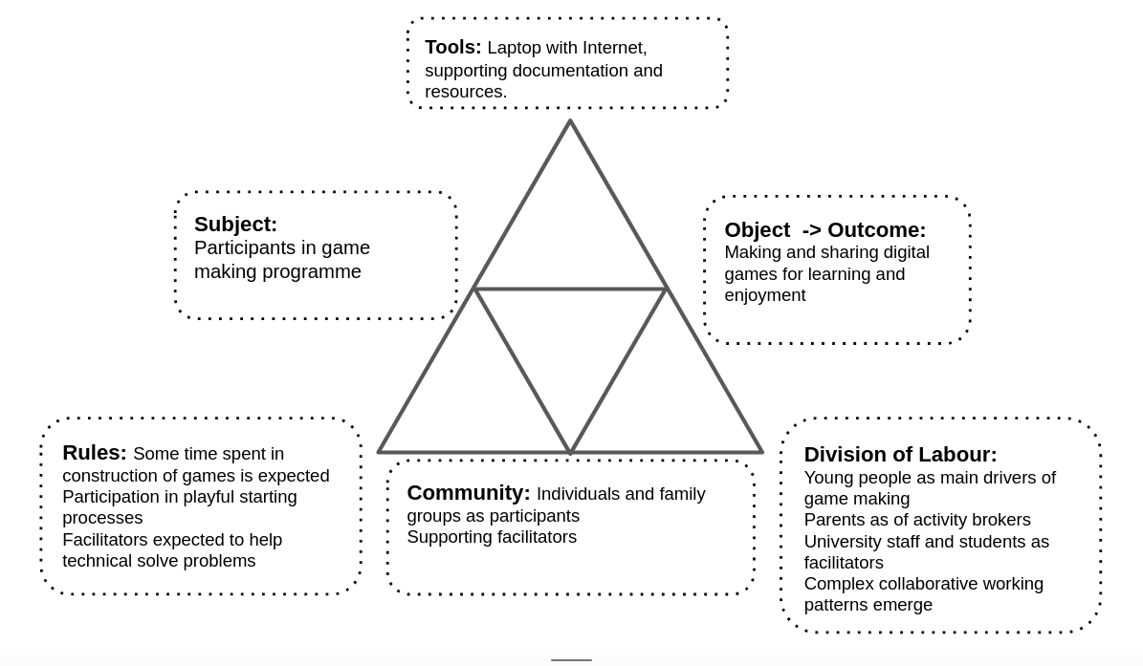 Fig 3.x - a wide scope of activity
The objective of activity is to make a game to share, that process is mediated by tool use. The tools themselves have been created by a wider community including the facilitator (drawing on the product of a wider on-line community)
On development What this static representation does not cover is the development and transformation. The next sections address this with relevant concepts.
Germ cell and analysis RQ2 of this thesis addresses the potential role of game design patterns (GDPs) as a guiding process in varied forms.
While this concept of germ cell / unit of analysis is typically used in a larger scope of activity, the principles apply this smaller scope. While game making can as an overarching activity system, a narrower activity whose objective is implementing GDPs became a significant unit of activity for this study. The justification for this is explored in more depth in Ch.4
Later in Ch. 6 I employ a narrow focus on the implementation of gameplay design patterns (GDPs) allowing for the identification and analysis of patterns of participant behaviour and introduced and emerging community practices to do with GDPs.

Concepts of agency within CHAT

Agency and AT - big picture in relation to ANT (Latour) and agency of humans and artefacts
Who and what has agency is a thorny philosophical question.
In addition socio cultural concepts of agency also distinguish between agency as a personal property and one that exists within a context.
Stetsenko places agency in a socio-cultural theory between conceptions of humans as chiefly individualistic or instead as helpless bodies in wider cultural phenomenon
(Matusov et al., 2016; Stetsenko, 2020), thus acknowledging both the importance of context and human volition.
For the purposes of this thesis agency is considered as a a cultural phenomenon which humans experience in relation to their peers and learning environment.
The following sections draw on research in line with this understanding to further clarify dimensions of agency.

Addressing and disambiguating definitions of agency in education
To effectively answer RQ2 the concept of agency needs disambiguating in relation to informal education. Agency and autonomy have disputed, often inter-related definitions or are often ill defined in studies (Huang and Benson, 2013; Matusov et al., 2016).
INTEGRATE THIS WORK SOMEHOW? Hopwood’s (2022) exploration of agency also focuses primarily on transformational agency and relational agency.
To help chart varied philosophical and professional concepts of the development of agency within education I am informed by the work of Matusov and colleagues (Matusov et al., 2016). Their sythesis presents several genres of agency including: instrumental agency with a focus on developing capacities; effortful agency which enhances motivation and commitment; dynamically emergent agency which includes concepts of affordances and actor network theory; and authorial agency which involves agentic changes to the learning environment. Matusov and colleagues critique effortful agency in education as focusing only on achieving goals predefined by educational establishments. Thus this summary focuses deepening an analysis on instrumental and authorial agency in relation to the theoretical framework of activity theory.

Instrumental and relational agency
Instrumental agency reflects a concept of agency as the ability to get things done, thus, a view of agency as a set of capacities (Edwards and Mackenzie, 2005). Matusov and colleagues highlights an often technological view of educational environments where educators seek to increase instrumental agency by building the individual capacity of learners to achieve relevant tasks (Matusov et al., 2016). Edwards’ concept of relational agency is framed as an extension to this concept to include a more social view of instrumental agency where leaners are able to offer and request support (Edwards and Mackenzie, 2005). While this view of relational, instrumental agency in an school setting is laudable, Edwards and D’Arcy note it is often restricted by curricular and institutional norms. Explored within a CHAT framework this type of agency would be understood as increasing fluidity of practice (operationalisation) using objects and people as tools within mediated activity.

Dynamically Emergent Agency
Matusov and colleagues’ interpretation of this dimension of agency is complex and diverse allow agency to be recognised in distributed form such as ‘emerging collective agency, agency of bureaucracy, non-human agency of animals, agency of distributed machine-human network, agency of Internet, and so on’ (Matusov et al., 2016:432). The authours recognise the value of this framing of agency to explore and to remove removing constraints and designing support in the form of affordances in the learning environment.
Affordances are a key aspect of HCI, and as this study involves the use of computer systems to learn computer coding, the concept is relevant.
Work by Bærentsen and Trettvik (B\a erentsen and Trettvik, 2002) linking the use of affordances in HCI to a foundation in activity theory highlights, following Gibson (Gibson, 1979), that affordances exist as opportunities provided by the environment and objects within it, either natural or culturally created, to organisms within that environment. The authors also note that the distinction between the intended (designed) use of affordances and their possible use, an important distinction in the field of HCI, is one best explored via activity theory’s study of the interaction of humans and artefacts as joint activity, thus preventing the view that that affordances have magical powers outside of a cultural context.
The work of Nardi and Kaptelinin is also helpful here to examine the concept of designed affordance in learning environments through a lens of activity theory (Kaptelinin and Nardi, 2012a). The authours also regrounding Gibson’s concept of affordances as possibilities in line with activity theory concepts of mediated action (Kaptelinin and Nardi, 2012b). They situate the creation of affordances in designed systems as a form of delegated agency (Kaptelinin and Nardi, 2012a).
Artefacts or tools used in mediated activity may be given a form of delegated agency through designed affordances, e.g a phone may prompt its user to charge its battery via notifications. However, unlike Latour’s (Latour, 2013) concept of compare to actor network theory object would not delegate to a human (Kaptelinin and Nardi, 2012a:42), although there may be unintended consequences once the artefacts are placed in context creating what Engeström calls runaway objects (Spinuzzi, 2011).
While there is a The wealth of HCI literature in line with activity which discusses and applies concepts of affordances, the focus is often on the individual rather than on collective action (Kaptelinin and Nardi, 2012b).
Link to next section
IN A SIMILAR WAY TO Affordances? For the purposes of this study, I agree with the view that the nature of agency as situated in context. Thus we do not say learners have or lack agency, as it is not a learner property independent of context (Nieminen et al., 2022).
The following section is more concerned with group actions and situations where agency is not experienced as delegated but rather created.

Authorial and transformative agency
Matusov proposes authorial agency (Matusov et al., 2016) as the concept of agency, as the most active and best aligned with an ideal form of education. REDEFINE
Matusov bases much of the definition of authorial agency on existing work from social cultural school drawing on of increasing participation in educational communities of practice [], and transformational concepts of agency from Stetsenko in the form of TAS [ ] and Sannino in the form of TADS []
This section focuses on transformative agency. JUSTIFY

TAS
TAS from Stetsenko addresses grand ideas of agency directly. However the authour also grounds these grand ideas in concrete explorations, including play (Stetsenko and Ho, 2015)
Similarly while TADS addresses lofty ideas of “quote” they can be played out in smaller situations.
In exploring their differences Hopwood x and y.
Transformative agency (Engeström, 2006; Haapasaari et al., 2016; Sannino et al., 2016).

TADS - On double stimulation and agency
The active use of secondary stimulus can facilitate agency (Sannino, 2015). While many studies have examined the process in professional settings there is a paucity of study in the area of “student-centered contexts of learning” (Isaac et al., 2021:93).
Blockages caused by contradictions are also analysed the fields of design and HCI with an aim of revising designs to remove them (Karanasios et al., 2021).
Sannino augments the concept of transformative agency by double stimulation (TADS) with a metaphor of a sea vessel warping using kedging anchors.
We may think of the second stimulus as an anchor. Anchors are commonly understood as stabilising devices to prevent a vessel from moving. However, not all anchors have this function. Beside the heavy-weight anchors, there are also kedge anchors serving the purpose of ‘warping,’ that is, pulling the anchor once it has settled on the ground, for moving the vessel away from a problem area. [@sannino_transformative_2022, p. 4]
In this metaphor emphasises the active volition of participants to overcome tensions and blockages in learning. In our context learners would throw an anchor of intention out into the learning environment to then pull on to Not all throws will be successful. The anchor may slip or it may catch on something in the learning environment that allows the leaner to pull
Sannino’s metaphor of a kedging anchor thrown by participants to pull themselves out of a conflict or blockage is particularly useful to explain processes where participants seek to resolve conflicts and problems in an existing setting. Indeed, much research employing TADS process and kedging metaphor is located in workplace settings. As such, the designed nature of the environment is less relevant and less explored than research on the co-creation of a new learning environment. By contrast the work on idioculture by Cole and colleagues explores this more actively via design narratives and similar techniques.

Conclusion / Synthesis.
Synthesis of different concepts as they are applied to the context of this study.
- DBR vs AT?
- Role of 3 planes?
- Scope of concepts of agency

Summary of Justification of choice - and how the RQs align with different concepts
For the focus of this study on developing game coding abilities particular aspects of importance are of understanding of the importance of context, and the ongoing development of cultural artefacts. NOTE - Thus in the next chapter particular attention is paid to the development of the artefacts and processes developed as part of the learning design.
HOWEVER - MOVE TO DISCUSSION. IS A STRICT ADHERANCE TO Helsinki SCHOOL
This insistence on a strict interpretation of formative interventions may limit its uptake. The instance may prevent someone who could benefit from other AT concepts in a DBR approach to improve and codesign a learning environment.
However, given this interpretation, this study does aim for a full application of this concept in analysis, an ambition of which the limits are explored in the conclusion.

Signposting where concepts are used in the thesis (in relation to RQs)
The concept of germ cell is explore later in more detail in Chapter 5.

The role of AT in the analysis of HCI - MOVE?
NOTE BE SURE TO USE THE RIGHT TERMS HERE.
It is of note that the work of Kaptelinin and Nardi on conceptualising activity theory happens in the context of Human Computer Interaction (HCI). The link of concepts of mediation and affordances are of note (Kaptelinin and Nardi, 2009:71).

Parked to replace or remove or rework

Situating this study using third space and FoK terminology and processes
In the context of this study we can conceptualise the learning context as a third space mixing home learning and culture and the context of university research and outreach work.
It draws on cultural processes of cultures of family learning, coding cultures and informal science clubs. Of particular relevance is retro Gaming framed as a fund of identity. A process that emerged from early consultation with home educating families.
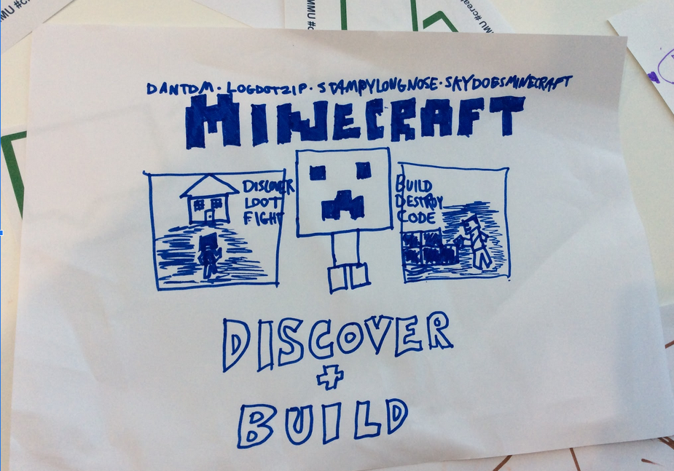
Retro gaming cultures emcompass broad media and practices beyond the games themselves. The image above shows now only a sketch of the Minecraft game, but also the names of YouTubers making videos about games.
This study positions this interest and identification as a fund of knowledge which designers should be aware of and utilise to help address some of the affective barriers to taking part in coding processes.
This study contributes to work which explores the potential does that give to developing game coding practices as per RQ3.

Change labs

