Findings Seeding Game Making Communities to Facilitate Learner Agency
- Research Questions - May 2023
- Introduction
- Exploring the impact of a drama processes
  - Vignette 4.1.a - Introducing a drama process
  - Description of Vignette 4.1.a
  - Vignette 4.1.b - Session reflections and secret missions
  - Description of Vignette 4.1.b
  - Reflecting in role
  - Observations on exploring documentation and accessing technical help within the drama frame
  - Observations on playful chat with the alien sessions
  - Use of side missions to encourage varied creative practices
  - Discussion of the process drama
- The impact of the core tools of code playgrounds and templated game
  - Observations on the use of code playgrounds and development tools
  - Impact of the half-baked starting template
    - Observations on design behaviours encouraged through use of game template
- Emerging processes and use of tools
  - Playtesting
    - Summary Playtesing and RQs
  - Emerging use of narratives and graphics which drawing on home funds of knowledge
    - Summary: Home Funds and R**
  - Emerging divisions of labour
    - Alternating coding
    - Shifting roles in partner work
    - Helpers supporting supportive community behaviours
  - The potential of “non-productive” activity (faff-time and digital laundry)
    - Summary: Division of Labour and RQs
- Conceptualising emergent agency in this study
  - On double stimulation and agency
  - On affordances and anchors
- Discussion on designing for emergent practices and agency
  - purpose of this section
  - Participants developing agency in their use of documentation
  - “Authentish” - goals in drama and project-based processes and related scenarios
  - Supporting flexible design practices
    - Supporting Digital Jamming
  - Evolving writing on how the above answer RQS
  - Link to next chapter - Agency within Microworld design

Research Questions - May 2023
- What pedagogical tools and processes are available to support novices to overcome barriers to game coding and design?
- How can learners build agency in an evolving community of game makers?
- How can game design patterns support the development of coding practices with novices?

Introduction
This chapter is concerned with examining the impact on participants of the learning design explored in the last chapter.
- The first section examines the impact of a process drama with an aim to establish and nurture community practice. It highlights the value of introducing almost-real processes, near authentic tools and the possibility of learners developing learning identities within a drama frame.
- the use of core tools in the initial learning design
- community behaviour and design processes
In the discussion section, the chapter builds on material explored in the literature to explore:
- conceptions agency in this learning design, Particular attention is given to processes which support learners to develop agency in the game making process.
- design concepts to support novices learning coding in game making contexts.

Exploring the impact of a drama processes

Vignette 4.1.a - Introducing a drama process
This sections starts with a vignette of the start of the forth phase an game making programme (as outlined in previous chapter). The participants have entered the room and chosen a laptop to work on. Some of the children play web-based games or reviewing the games that they have made previously. The session progresses with a warm-up game which includes many false starts, changes of rules, development of tactics, appeals to be serious, full throated laughter and many restarts and which ends in good hearted failure. The transcript below picks up at this point.
Mick: Ok. So I’ve got a surprise. I don’t know if you know but as part of our Home Ed club we did a page of different games. So it’s on glitch.com and it’s called Glitch Game Club and it’s on there, there’s one for Home Ed Winter 2019 and here are all the games that we made. We made a lot of games. 15 games. This has not gone unnoticed because I got a message through this account. This is kind of a story now. We are entering a story. You have to use your imagination. We got a message and it was an audio message. If you guys take your fingers off your keyboards and have a listen to this audio message which is quite unusual as I don’t think it was from anyone on … this … Earth.
Greetings Earthlings, we have an important message for the Glitch Game Makers.
We are the Weean. You would call us an alien lifeforce. We like to think of ourselves as friendly space cousins.
We can see your Internet from space. We are contacting you because we know you are making games on the Internet.
We are on our way to the Planet Earth, and we have an important mission for you. We are an Intergalactic Rescue team. We know you have problems on your planet. We can help.
But we need to find out one thing first. Are you worth it? After we are gone will you also be able to help yourselves? Or are you already doomed to make the same mistakes again?
You must pass this challenge. Make some games showing problems you have on earth. In the games also include ideas for how to solve them.

We have some guidelines:

• Make a game about a big or small problem to solve. If you can let us play it each week as you go along.
• Give us an update each week by recording a group update.
• Show you can work on your own but also work as part of a team.
• We will also send you text messages with some mini-missions sometimes. Be sure to tell us how you do.

Please now get started and come up with a new game about solving a problem on Earth.
Mick: I couldn’t understand all of it but I tried to write it down as best as I can. So from what I’ve work out they’ve looked at our games and they’ve come up with a challenge for us. They are coming to Earth so they need to find out if we are worth saving. And the way that they are going to decide is by playing the games that we come up with. And they are going to set us little challenges. So. yeah, that’s the story. (with heavy irony) I’m pretty sure it’s true. (Mick and others laugh).
Mick: So all they’re asking us to do is to come up with a game. We’ve got four sessions. They want a new game because they’ve already played our old games. It’s got to be something about the problems of the world. I’ve got a lot of problems. It could be big problem or a small problem. It could be about your problems. But also ideas on how to solve them.
And yeah. That we can work by ourselves but also work as part of a team. So we’ve got to give them a report by the end of each session as well. That’s our mission.

Description of Vignette 4.1.a
The process of introducing a scenario for participant to respond to is common in project based learning in this vignette. Here it is extended using a dramatic element in line with Heathcote on Mantle of the Expert and other process drama techniques (explored in Lit Review). In this section, I describe the vignette using concepts from MoE. Further analysis follows in a later section.
The following tenets of MoE from Aiken’s summary (2013) apply. Aitken’s and Heathcote’s terms follow in italics. Within a fictional context a responsible team is contracted into a commission by a client. The facilitator frames curriculum elements as productive tasks and plans for tensions to arise involving: authentic contexts, messiness of learning, maintaining learner interest and resilience to overcome the grappling and struggling involved. The following sections explore some of these key concepts via the example in vignette.
Contracting into drama
As a facilitator, I indicate that we are entering a dramatic process and attempt to draw everyone along with me using the following sentence “This is kind of a story now. We are entering a story. You have to use your imagination”. This serves to start the process of contracting in a drama. As a way to introduce the imagined audience, I reference that the games are online and have been noticed by aliens. The use of heavy irony in my voice when concluding the scenario, “I’m pretty sure it’s true” and the resulting laughter form an informal collusion that we are playing along with this fiction. The collusion is noted by both parents and children in recorded exchanges. For example, after engaging with a code example provided by myself in the role of the aliens, one pair make the following comment.
Parent: Look, this is what Mick’s showed, what Mick’s has done.
Child: The Weean have done!
Parent: The Weean, sorry yes.
Facilitator activities in role
My role is a link between the participant and the fictional commissioners of the games. The transcript above (a fuller version is in appendix 4.x) captures a rare example of myself extended facilitator input as instruction. As a practitioner teaching technology, I try to limit teacher talk and being overly directive to prevent learner disengagement. Balancing leaner choice with over-ambition is a tension explored in the previous chapter. The drama narrative helped resolve some of this personal tension by allowing me to outline boundaries and be directive using the dramatic commission as a foil to help avoid the encounter feeling personally combative or controlling [heathcote_drama_1985].
Learner activities in role
Beyond the wider fictional frame of the making activity, learners were also sometimes asked to undertake some activities in role, in particular reflection in role. This and other example are explored via the second vignette.

Vignette 4.1.b - Session reflections and secret missions
This second extract comes from the following session in phase four. In three of the four session the last 10 minutes of each session involved giving a progress update to the aliens.
Mick: Ok are you guys ready to share back if you could come to this side of the room we are going to get Mark and Edward to share back first. Everyone can share back using this computer that the Weean are watching if that’s alright. organiser 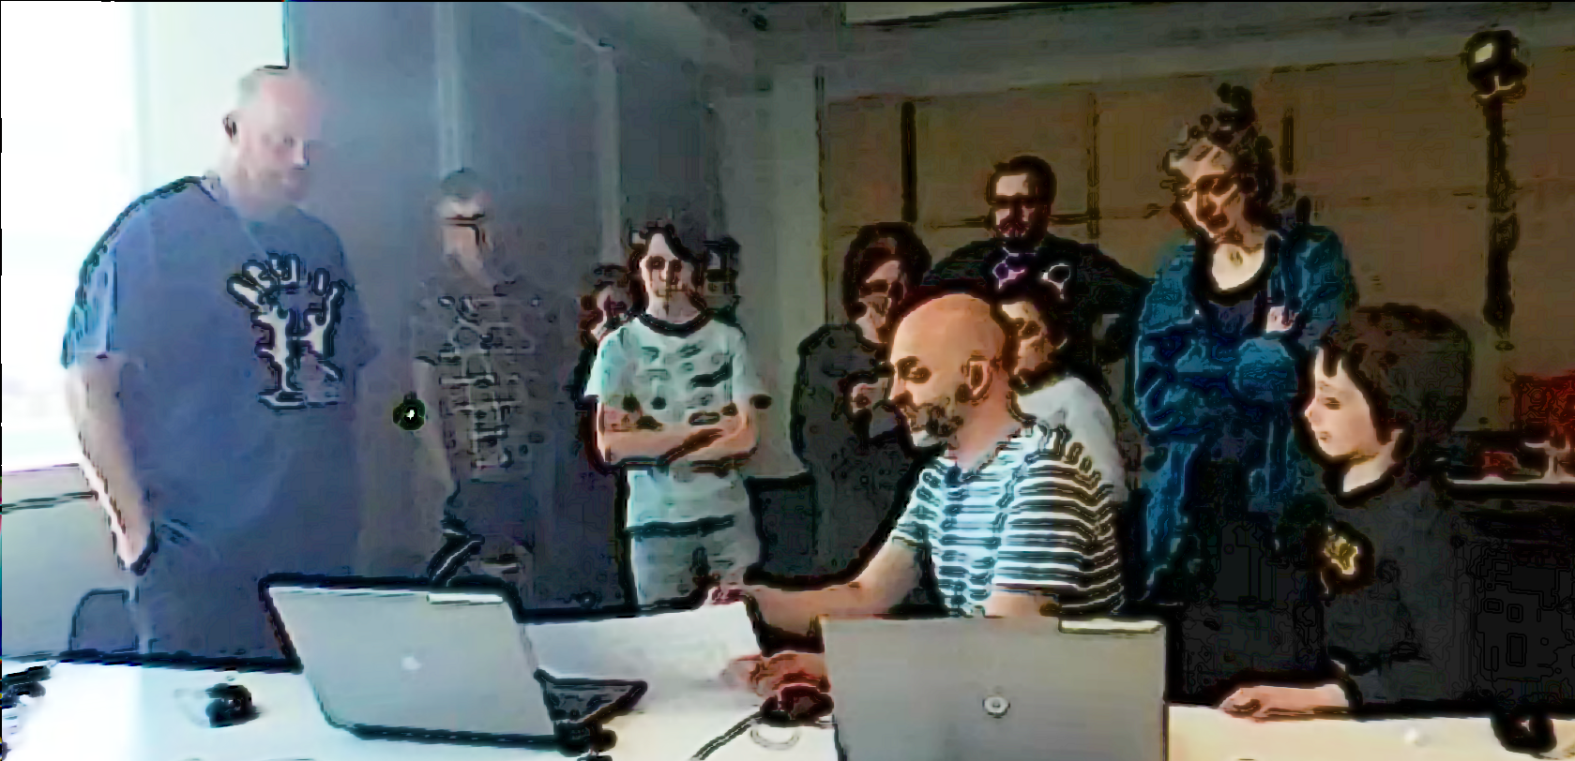
Mark: All we’ve done today is just get a background in and then we were just working on the one that the Weean had sent us about dropping the coins in. Now that the Weean have sent us the code we need for basically dropping stuff.
Mark: The idea is planting trees. about dropping seeds. So we want to drop those and have some enemies that are tweening randomly around and also taking them away. The idea is to have a timer to drop a certain amount in a certain time frame or you can’t go through to the next level. And the next level would be you go around and water all the trees. And the third one is you have to look after them all making sure they are not getting chopped down again by that tweening enemy. So we’ve got the concept and everything now and we’ve got the code So we should be able to make a bit of a jump forward now this week. It doesn’t look like we’ve got any where but we have. (Mark laughs and others follow). So we’ve got the the background in and we know what we need to do about scrolling as well because we want to scroll across.
Mick: That’s great. Is there anything that you think you definitely want to be able to do for next time that you might want help with?
Mark: Oh yeah. We’ll we’ve got a bit of space where we can work on it before we next come in so we’d like to ask the Weean some more questions. Is that the best way to do it?
Mick: Yeah for sure and I can see that you guys have been talking to the Weean, Here this project here in your home page called Talking to the Weean allows you to talk to the Weean. So you can go in there, click on Edit Project and if you click on this bit here that says WEEAN and then Markdown you can actually just ask questions in here.
(Mick reads out the following extract the organiser screen containting a text chat with the fictional alien audience)
Ed: Weean what’s it like up there?
Weean: It’s cold and very big but quite tranquil.
Ed: What is your name?
Weean: We are are the Weean we have no name, we are all the same.
Ed: That must be hard at xmas. (Mark and others laugh and smile.)
Weean: It is. It sure is.
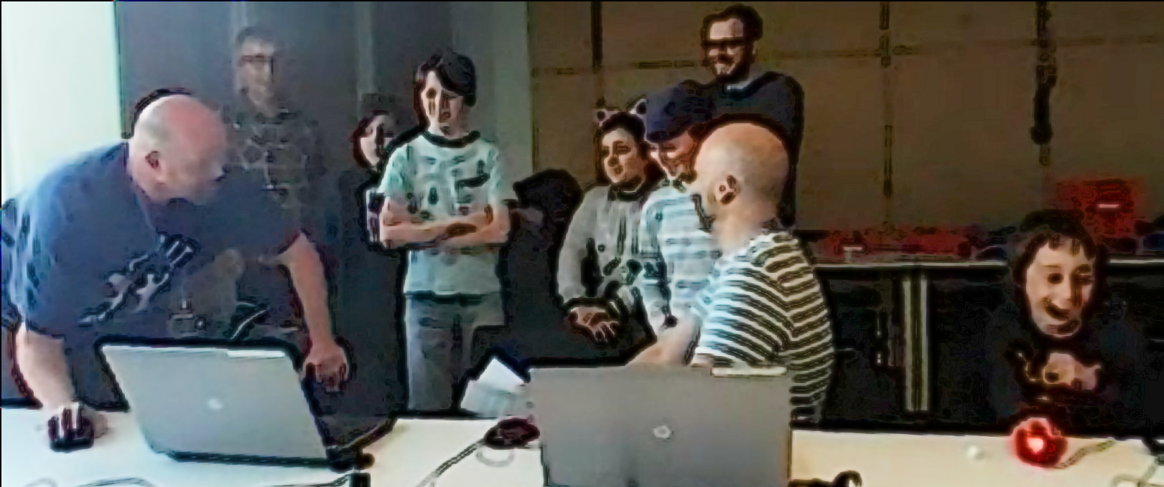
Mark: That’s tickled me that.
Mick: So there you go. You can have a conversation there with the Weean in there using mark up code you can copy what’s there. Nadine can you talk through what you ha- What pedagogical factors are significant to support novices learning coding, particularly in game making contexts? - How can learners build agency in an evolving community of game makers?ve added to your game? Is yours called “No Toby Allowed” now. (Laughs from all)
Nadine: I’ve not really done much today as I was busy doing stuff with Toby’s
Dan: We noticed.
Nadine: We’ll I’ve changed the platform a bit
Molly : You had a secret mission though didn’t you
Nadine: Oh my secret mission was to change someone’s game, their character or something and see if they noticed. And I think they did notice.
Dan: We did. We did notice.
Molly : You couldn’t not notice.
Mick: It feels like you took the spirit of the mischievous thing and just turned up the volume. (All laugh.)
Molly: Sprite!
Mark: We also had a secret mission.
Mick: What was that?
Mark: Ours was to change the sound on somebodies game.
Nadine: Oh was it?
Mark: Did you notice?
Molly: Did you notice?
Nadine: No (laughing) (Incomprehensible many people talking or laughing at same time)
Mark: Play it now!
Richie: You definitely noticed. (Points to Mark and Ed) You definitely noticed my bit.
(Nadine goes to the keyboard and starts to play her game)
Nadine: I can’t hear anything different (Everyone laughs)
Mark: I thought you were going to go- Aaahgh! But you didn’t say anything.
Mick: So that’s interesting. some people notice some people didn’t.

Description of Vignette 4.1.b
In this extract participants are invited to take turns showing their game, recapping their progress and outlining next steps to the alien observers. I play the role as a liaison facilitating the process for the fictional, remote audience. I also draw attention to the secret missions that had been distributed to participants (along with social missions - both explore later in this chapter).

Reflecting in role
The impact of this end reflection in role can be compared to previous reflection in sessions. In my journal notes for previously phases, I noted my reluctance to shift learners away from making activities to reflective activities. I attempted sporadic “go-arounds” at the session conclusions but with limited success in terms of amount and quality of participation compared to these session which provided richer feedback from a wider variety of participants.
The use of the screen as a link to the aliens helps justify moving participants and stopping all activity. It is of value to review the grouping of participants in the still image in the vignette above in Fig 5.x. The simple clustering of participants so they were side by side and talking to a disembodied audience via a computer seemed to make the feedback process less daunting for students. One of the younger participants Richie is participating on the margins but clearly following proceedings as his facial reactions to ongoing contents of feedback. He later participates more actively when reflecting on his process than in previous sessions. Even participants that were initially reluctant to share back and had never shared back publicly before in sessions, chipped in after other family member had started the process for them.
While drama scenarios can aid reflection both in or out of drama, O’Neill and Lambert outline the value of in-drama reflection, noting it is “likely to be more powerful than end-of-session discussion, since it allows individual and group insight to be articulated as part of the context” (1982:144). They propose one way of achieving in-role reflection is to introduce an additional character that acts as an external audience.
DEVELOP AND DEEPEN ANALYSIS IN RELATION TO EXISTING RESEARCH

Observations on exploring documentation and accessing technical help within the drama frame
To develop the idea that participants could communicate directly with the aliens to ask help, I created a project in the shared glitch area that could be edited and viewed by participants. When in the vignette 4.1.b Mark asks “We’d like to ask the Weean some more questions (to overcome coding blockages), is that the best way to do it?”, he is referring to that page. To seed this process, I had entered a question sent by Mark and Ed into the page, and written a response on behalf of the aliens.
Dan and Toby also received help from the aliens to implement a pattern of creating random movement in their pac-man clone game. For this pair, the process of reading code answers gives the parent opportunity to deconstruct the code in detail to explore coding concepts. In later discussion, Dan uses the fiction of the alien to playfully chastise me for using code syntax which was harder for novices to read.
"Mick, do you think the aliens would mind if we get rid of the switch statement and replace it with some if-thens? They're just showing off these aliens aren't they?"
The process of writing down a request in a playful chat potentially addresses the barriers to asking fellow group members in an email group for help (noted in the previous chapter) by distancing the process. It also encourages adoption of professional practice of asking a written question to overcome a coding snag and thus builds experience of using technical terms.
While not all participants engaged with written tutorials. The next chapter explores the process in more detail from the perspective of a participant wanting to implement a particular game design pattern.
This observation is supported by research which encourages varied approaches in addition to instruction-based approaches (Resnick and Rusk, 2020; Dietz et al., 2021). Other studies address barriers to literacy in technical project work explore written instructions within the drama frame thus providing a greater incentive for participants to engage with the material (Blunden, 2014). [SEE LIT REVIEW FOR MORE EXPLORATION].
Evidence for this means of communication is promising however because these processes were brought into the design at a relatively late stage, there is not enough data to make larger claims beyond surfacing this potential.

Observations on playful chat with the alien sessions
The process of asking the aliens for technical help within a code project sparked a playful process of informal chatting with the aliens. I noted the ad-hoc encounter in our end of session reflection.
Ed: What is your name?
Ween: We are are the Weean we have no name, we are all the same.
Ed: That must be hard at xmas
Ween: It is. It sure is.
Inspired by the popularity of participants engaging with the fictional audience, I asked a student helper to participate remotely to play the part of the alien and give feedback via live text interaction to participants in the final session. The process started with supportive and celebratory messages coming from the alien. The impact was significant with the young people with 5 out of 7 engaging by writing messages and all mentioning the interactions verbally.
In addition to the stated feedback activity the live chat served wider purposes of building an insider rapport, creating a fun atmosphere, celebrating the completion of games in the absence of a public showcase, and signposting other achievements.
For some pairs, while the child interacted in the live chat, parents performed final tweaks to code projects and challenges. Two parents in particular worked hard debugging more complex elements of the game with facilitators and peers. Other parents engaged with the chat and encouraged their children to get feedback from the aliens about their game in particular.
Summary: The process supports: - addressing tension of feeling alienated from coding cultures, by bringing playful dialogue elements into the code authoring environment - this conversational process emerged from a chance interaction - thus nurting learner agency

Use of side missions to encourage varied creative practices
The live chat process started unintentionally as one child was left to their own devices as a parent was undertaking a social mission (see below and previous chapter). Both the main mission of given in role to make a game to entertain and inform visiting aliens, and extra social and secret mission were delivered with the frame of a drama process. As explored in the previous chapter, my motivations for introducing these missions for participants in role stemmed from a desire to encourage or to encourage emerging patterns of behaviour which appeared to help affect and identification with the community process of making.
A table of both social and public missions follows.
Your Alien Mission (social) | Your Secret Alien Mission:
Find out the names of 3 games that are being made. | Change the variables at the start of someone else’s game to make it play in a funny way.
Make a list of characters in two other games being made. | Change of the images in someone else’s project to a totally different image and see if they notice.
Find out the favourite computer games of 4 people. | Change the level design of the first level of someone else’s project to make it impossible but try to change as little as possible to do that.
Find out who plays the most computer games per week in your group. | Change of the images in someone else’s project to a very similar but slightly different version and see if they notice.
Find out what other people are planning. Give some friendly feedback to one other person / group. Why don’t you try… | Add a rude sound to someone else’s project.
Ask 2 different groups if they have thought about what sounds they are going to put in their game. | Swap over some sounds in someone else’s project and see if they notice.
Find out from three groups if they are going to try any totally new ideas. | Delete all of the code of someone else as they are editing it and see how they react. Then help them get it back using the Rewind function.

In the transcript above of vignette 4.1.b we see that in the reflection participants engage in a lively discussion about the secret missions they had been given. Encouraged by he mother Molly, Nadine shares that she has been highly engaged in the disruptive secret mission (explored later). While Dan and Toby express playful frustration, Mark and Ed contribute by sharing their more subtle disruption and Richie is keen to have his rude noise mission noticed and commented on. Some public missions had a noticeable impact in this session particularly in stimulating a discussion among parents around which arcade games they played as youths.
Thus these sanctioned non-design activities, designed to reduce participant stress, to encourage the exploration of the games of others are taken up enthusiastically by much of the community. In analysis of one key sessions involving missions from which the transcript was taken. Out of 10 participants, 8 visibly engaged with the secret missions during the session.
The process was not without friction. After initially engaging with the process of secret games, Toby and Dave, who were later working on a tricky coding process, expressed frustration at interference. Thus, while promising, limits to this process should be evaluated to avoid overly disruptive behaviour which create barriers to progress. For example, time limits could be in place.
During the vignette above, Richie occupies a peripheral position and is interaction with his laptop still. However, he reacts positively when Ed’s irreverent questions to the Weean are read out.
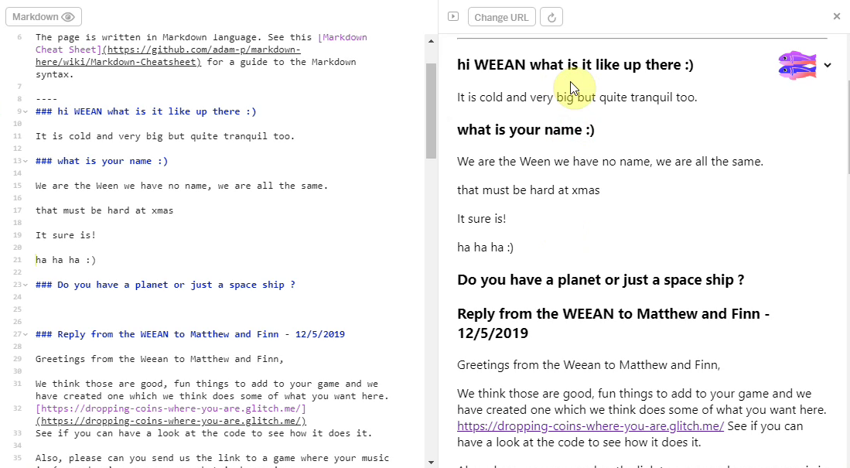
The positive reaction of young people to the drama process was also picked up on by one pair in interview data.
Mark: You liked those games where you had to kind of hack somebody else?
Ed: Yeah
Mark: It was it because there was a sense of play ... and a bit of anarchy.
Ed: Yeah.
Mark: The weird thing was, I think it was a massive hit for everybody because it just brought sense of play and fun. And it took attention away from it being overly technical process.
Summary: The process supports: - addressing tension of identity clashes by recognising and encouraging diverse making approaches and styles of community partipation

Discussion of the process drama
This section discusses the use of drama process to help create coding communities of novices.
It is of value to briefly discussion the value of the missions in relation to drama process theory and play theory. I first encountered these kinds of secret missions in a session which explored game design theory via creating a game collaboratively.
The secret missions encourage various forms of disruptive play, griefing of playing against the game (Bakioglu, 2008; Bartle, n.d.). While this increases engagement for some learners the process also suffered the same bleed from acceptable cheekiness and play which explores boundaries, to mildly disruptive ones which in this context involved frustration and wasted time for other users. Side missions or side quests are also used in open world games are used in part to appeal to different kinds of players (Bartle, n.d.).
The drama process can be viewed as magic circle (Stenros, 2012). A magic circle is a concept which transmits the idea that game players enter a loosely bounded play space where they accept arbitrary play rules and enter a social contact to adopt a playful attitude. I previously made observations on myself and participants being more comfortable performing some of the activities in role. This feeling may stem from being positioned together with participants within a playful agreement. Other processes beyond social and secret missions were completed in role namely; the wider mission of making a game; the end reflection sessions; and guiding participants in the use of supporting documentation.
In my journal notes, I observed, that when listing boundaries to activities within role, it felt similar to outlining the rules of a game rather that constricting their behaviour. Thus less about controlling individuals and more about contracting into a game-ful or playful experience. I felt more relaxed restricting choice in role via the proxy of a playful encounter.
I believe part of my hesitancy in shifting activity from participant-led game making to reflection, or accessing documentation, stemmed from worrying that the learners would also find this shift in objective, from the organically developing design and play testing activity system to an externally imposed system of reflecting on progress, would be jarring, potentially disorientating and reduce learner engagement and positive affect towards the overall process. In other words, provoking a feeling that the fun’s over, it’s back to school.
I propose that the drama fiction eases friction between competing activity system objectives. For example, Heathcote refers to curricula content as an example of object interests, e.g. exploring detail in history, geography and writing accurately or with expression. Heathcote posits that learners especially those resistant to authoritarian teaching techniques, appreciate the effort of the facilitator in aligning “needs interests” to “object interests” (1984:185), arguing that it can create a generosity of spirit on the part of learners.

The impact of the core tools of code playgrounds and templated game
NOTE - THIS IS VERY DESCRIPTIVE - SHOULD SOME OF THIS BE MOVED TO THE DESIGN CHAPTER?
As explored in the literature review, the concept of a Microworld which embodies target concepts has extensive supporting and descriptive research.
This section outlines the characteristics of a game microworld which served as a base for learner’s creations during the phase studies here.

Observations on the use of code playgrounds and development tools
As explored in the previous chapter, my motivation for choice of code development tools (Javascript, Phaser and Glitch) were driven by desire to be authentic and extensible. In this section I draw on my journal notes and past experience and observations from interpretation of video data to share observations on the use of the coding environment.
The use of glitch as a code playground significantly reduced technical barriers for students. It removing the process of setting up a server for web development, and the delay of transferring files to the server. While the code project consisted of several files of javascript, HTML and CSS, learners were shielded from the complexity of how they were interlinked and there were practically no extended blockages to undertaking work using this environment. There were some issues of access for some participants who did not remember or recall log in details or their project name. These issues were mitigated through the use of a log in details shared between participants.
When users struggled to log in or to find the games or assets that they had created earlier there sought and received help from family members or other peers. Direct help from facilitators was rarely required. In the glitch environment code errors were highlighted in with red dot in the interface which gave a quick visual indication of where the error occurred, when the user hovered over gave an error message as a pop up. the which while limited
Online code playgrounds like glitch or CodePen arrange the user interface to promote and celebrate community contributions in such a way as to promote a feeling of community and experimentation via remixing and contributing to the projects of others. However, despite this, the choice of glitch compared to a tool aimed at young coders potentially reduced access to suitable games or other suitable projects which a community like Scratch would allow. However, the shared log in details created a shared page for projects of all participants which made the social sharing of projects more possible.
NOTE - MORE DATA/FOCUS IS NEEDED FOR THIS SECTION

Impact of the half-baked starting template
The last chapter outlined the use and design characteristics of the starting game template, namely: an incomplete 2D platformer; pixel graphics; with graphical scaffolding for text-based code; and deliberately incomplete thus inviting improvement. This section addresses the impact of these characteristics on participant coding practices, based on video observations of learners.
In phase one, I noted that any addition to the game in terms of adding new any quantity of code created a many possible problems. To counter this I adapted the starting game template to allow changes in code were relatively easy to perform but which resulted in potentially large changes in game behaviour and appearance.
I initially highlighted these possible changes to the embedded game design patterns that could be made to existing code in person via informal instruction during pilot workshops. To facilitate working with larger groups, I later extended the process by creating supporting cards that highlighted and demonstrated the relevant code changes. While the code changes involved were minor in nature, they allowed a diversity in output to such an extent that participants were often kept occupied for an extended period of time. I kept the process informal and responsive by allowing participants to choose which one they wanted to work on next. The following sections outline different areas and patterns of activity.
Variable editing effective movement
Player movement was a key to playtesting feedback as such three key variables were highlighted at the very start of the game code and given descriptive names to facilitate their editing. When testing the game, the player’s jump height was not great enough to allow progression up from the floor to one of the platform thus thwarting the collection of items.
Game progression require altering at least one of the descriptively names variables associated with jump height and then activating a preview window to observer the changes by playing the game in a new browser tab.
// Variables that change how the player moves
var gravity = 500;
var velocity_x = 100;
var velocity_y = 300;
While some participants engaged with extensive experimentation to find a player movement feel that seemed just right, others were much less concerted with this aspect of game play, lowering gravity drastically to allow a greater jump size but a more frustrating floaty jump.
Level design and prototyping
The starting game template included a minimal amount of platforms, hazards to avoid and golden blocks to collect. The following image is of a printable quick start cards to aid participants to begin the process of changing level design. 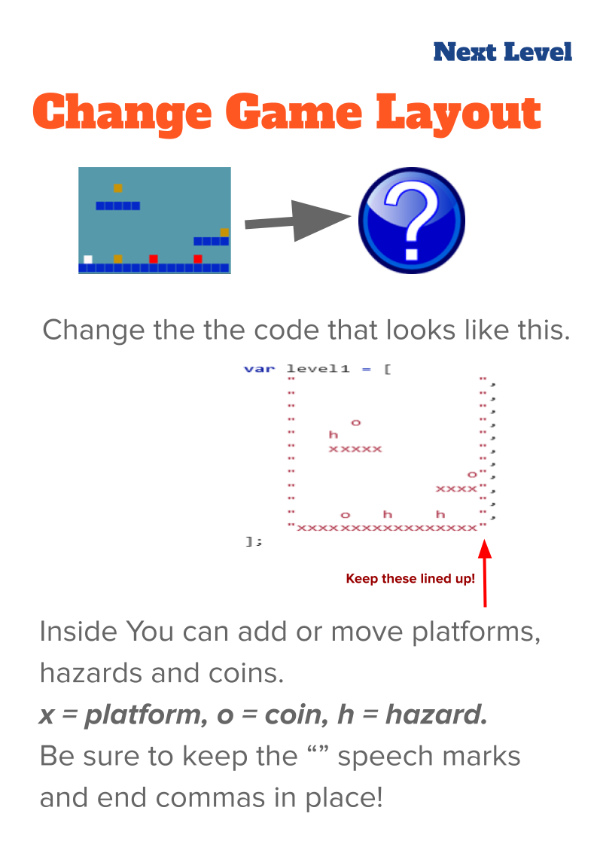
The possibility of disturbing the syntax of the of code in the array. When participant did this it provided a good opportunity for facilitators or parents to outline the importance of correct syntax of and to explain the code structure. The vignette in the last chapter saw Toby’s adding new levels to his game and undertaking many iterations of changes to the level design. He and several other participants spent extensive time performing level design activity with a goal of making the game extremely challenging but still technically possible. Others played with the convention of the game by removing all hazards and filling the screen with rewards/coins (an example is outlined in the starting vignette of the next chapter).
Incomplete graphical blocks to help seed narrative and art creativity
The use of blank, coloured blocks of 32 x 32 pixels encouraged participants to change the graphical design and the relatively small size of the sprites encouraged rapid design. The theme of creating a game with moving characters often resulted in participants redesigning sprites to games involving animals. The following image shows a whale as a player character and plastic bottles.

The process of creating a pixel art characters and hazard involved using an online grid design tool called Piskel, creating an design of an appropriate size, saving, exporting as an image, downloading to the hard drive of the laptop in use and finally uploading and incorporating the image into the code project and linking using code syntax.

Observations on design behaviours encouraged through use of game template
There was a great divergence in the amount of time learners took to want to progress beyond these changes to additional new game design patterns rather than altering the ones embedded in the starting template. The following chapter outlines this transition in greater detail.
When compared to the process of learning to code in a text language from first principles, knowledge of very few coding concepts were essential. In contrast, a large number of broader digital literacy skills involved. These include: file downloading ; file migration using the browser and file manager; browser tab navigation; graphics tool use in Piskel (a simplified Photoshop including - crop, fill and export tools); copying and paste text code; and selecting more than one lines of text code with mouse or keyboard shortcuts.
The process of swapping assets in involved developing a complex chain of many of the individual actions listed above. There was a large divergence in the speed and proficiency with which these processes were performed by participants. Some became remarkably adept at these processes and in doing so transformed these changes into a fluid operation. Learners who had mastered the skill were asked by others for help. The rapid adoption and transfer of these processes between community members indicated the high motivational factor for participants of incorporating self-created graphical elements. These motivational factors are explored in the following section.

Emerging processes and use of tools
The chapter has until know discussed some of the uses of processes and tools which as a designer I brought to the learning design
While these tools and processes emerged in response to articulated and inferred learner need, the following process emerged more directly from input from the participants involved.
One major process added in response to the requests of learners was that of adding game design patterns. This is covered in the following chapter.

Playtesting

As explored in the literature review and previous chapter, playtesting is a rich and varied learning opportunities which encourages community-building behaviour. By the time video data recording started in phase three there were already complex patterns of playtesting underway. In this section, I review data to describe some of the emerging playtesting behaviours of participants.
Playtesting as a social process
Participants, particularly older ones, used playtesting as a way of showing support for fellow game makers. Example behaviours included: praising graphical content; making links with home interests of participants through questioning; and building rapport. For example, if a game featured an image of a dog other participants may ask: Do you like dogs? Do you have a dog at home?.
Playtesting and embodied participation in the games of others
By the time phase three and video capture of data was underway, the process of playtesting began to take on interesting characteristics for some younger participants who were working more independently.
Playtesting took on additional playful elements often staring in one part of the working environment and then migrating to other areas. Because of this mobility is it hard to transcribe interactions. However, description of the physical movement and gestures of the young people is relevant to explore the value of this behaviour which I will call playful playtesting. It is possible to communicate the characteristics of this play via a description of a typical encounter.
Play is initiated by calling across the room as an invitation to play, or as a provocation. When playtesting is underway it is normally undertaken with two or three participants standing around the computer rather than being seated. The core of those involved take turns to play the game, exclaiming frustration or triumph at completing levels or failing. Failure may be extremely performative with a rapid pulling way from the screen and keyboard. This may be followed with a battle to wrestle control of the keyboard to play the game next. This may involving playful pushing, and wrestling of hands and arms and vocalisations.
While this play is happening it may attract other participants who may remain on outskirts of the activity looking on able to watch what is happening on the screen and respond non-verbally with smiles or laughs.
Community concepts and norming behaviour emerging during playtesting
THERE IS DOUBLICATION WITH NEXT CHAPTER - REEVALUATE / REFACTOR - ESP CONCEPT OF SAFE ZONE
Participants concepts of game challenge evolved through informal feedback during playtesting and served to influence peers to modify their games to increase the enjoyment of peer players. The discussion of game challenge, specifically comment about how ‘hard’ participant games were the most common interaction during playtesting.
This concept of the feel of the game or the challenges maps to the Dynamics of MDA framework.

Parent Molly had been focused mostly on completing asset design this had created a very frustrating game experience in terms of the player’s movement. As a facilitator, I shared feedback about using quite indirect technical language when giving feedback (See appendix 4.x). Younger participants are more direct.
Bertie: That looks nice (referring to the graphical look of the game)

Molly invites Bertie: to play as she can't progress due to the difficult game controls.

Bertie: It jumps super high but so slow
Pause
Molly: He has to go slow because he's an astronaut, you see.
Bertie: It's hard.
(Bertie leaves.)
Molly: (to peer parent with proud tone.) It's hard. Wow.

(Ed comes to play the game)
Ed: How much jump speed to you have?
Ed: Your jump speed is massive.
Mi initially misconstrue the feedback that her game is hard as a positive thing. Other children come and play the game but only for less than a minute before leaving. While their feedback is non verbal the very short length of time that some of them spend is noticeable. After the last one leaves Mi comments “It’s so frustrating.” This suggests that through he process she understands her game is frustrating rather than pleasantly challenging.
A variety of comments suggest comply with an emerging community norm of what a sensible jump behaviour should be. Feedback from Mick attempts to bridge a technical and conversational approach, direct feedback from Ch and then a more specifically technical explanation from involving the naming of the variable jump speed. These norming behaviours some of the informal norming behaviours that are less directive seen in the work of Rogoff and colleagues as explored in literature review (Rogoff, 2003). DEVELOP THE LINK TO NORMING PRACTICES HERE OR IN DISCUSSION LATER

Summary Playtesing and RQs
Playtesing provides many leverage points facilitating learner agency:
- playtesting as a way to show informed criticality as a player and guide the creations of peers via gameplay feedback

Emerging use of narratives and graphics which drawing on home funds of knowledge
While the potential to add graphics was a core affordence of the half-baked templated game, the process of designing and sharing and the peer commentary on the process emergered as the sessions evolved.
The literature review explored existing research on how the use of home interests and funds of knowledge facilitate the adoption of design and coding practices. At all phases of the learning design participants were able to input their own preferences in the narrative elements and themes of games. For example the choice of game characters allowed the expression of identity. Other designed elements for example audio effects or written messages were also possible.
One pair Clive and Pearl, the grandparents of Toby, included a narrative message at the start of their game. This process surfaced the expertise of the family as beekeepers, sparking interesting conversations with other participants.
var starttext = "This is a game which pits a honey bee against a swarm of Asian hornets, which are alien invaders attacking bee hives in the UK and which beekeepers are trying to stop spreading here. Try to guide the bee to collect all the flowers without being caught by the hornets.
Use the arrow keys to move the bee. Press return to START.";
In another example, Mark and Ed designed a game around the character of a train driver that needed to collect coal. In subsequent post course interview Mark describes the impact of the child feeling like they could bring their own identity and interest into the project. “I know just your eyes lit up when you realised you could expand your interests into gaming.” See Appendix 4.x (Mark and Ed working with home interests)
Other participants expressed pride over their graphical creations. In this excerpt parent Molly has spent time creating a pixel art representation of an alien. The full exchange (see appendix 4.x) sees Molly cultivating a sense of ownership over the graphical element that she has created. There is also the development of a growing sense of competency in this area of asset design. She notes she is an “expert pixel”.
Molly: We’re finished. Right what’s next? Now I’m an expert pixel? Now I have to figure out how to get it in there, don’t I? Without losing it. I’ll be very upset.
Sonia: Have you saved it?
Molly: No I’ve not saved it.
Sonia: Save there. (points to relevant button on screen)
The growing mastery of this area also seems to help drive motivation to complete the next challenge. The sense of ownership spurs the technical process of saving projects. Her pride in her work and concern surrounding losing it provokes a fellow parent to show her how to save her work.

Summary: Home Funds and R**
This research supports fiding of other research which highlight value of games and media projects to incorporate home funds [Resnick , Scratch]. It also aligns with PBL literature which advocates the personalisation of projects [find a nice one].
The use of home funds of knowlege as a tactic by facilitators can be highly motivating in early stages of the design process and sustain the coding activity to overcome problems to share the personalised object created.
The tacit knowledge of children as proficient consumers of games gives them agency in the process of feeding back.
There is evidence here that frictions involved in dealing with expectations, are helped by the use of a templated game which has an implied narrative and creative frame which scaffolds the initial creative process. (like a core musical style from which to jam from, or provided constraints in a drama process which help guide improvisation.) This shifts the focus of the microworld concept away from emboddied STEM concepts, often maths or computing concepts, to provide a base for creative expression.

Emerging divisions of labour
NOTE THIS SECTION DESCRIBES EMERGING PATTERNS OF BEHAVIOUR - BUT IT IS NOT CLEAR IF IT ANWSERS THE RESEARCH QUESTIONS DIRECTLY. ALSO DUPLICATION WITH NEXT CHAPTER - SO REFACTOR
An additional fund which participant drew on in the design process was their home collaboration practices.

Alternating coding
The parent cedes the keyboard and mouse and sometimes swaps chairs to allow child to play test the game created. One parent-child pair alternate between use of keyboard and mouse. The parent is keen to give the child hands on experience when possible, noting “I resist the urge to fix things immediately when she struggles.”
The parent may take the driving seat to overcome code blockages early in a create stage but yield to allow the child to input their design choices when more complicated work is complete.

Shifting roles in partner work
At one point the testing process Suzanna shows frustration as gravity value is very low making any movement very slow with little control. While the child has previously rejected increasing the value, the parent’s initial acceptance of this decision is later questioned. The parent who has to do the majority of the testing is more insistent to remove a frustrating part of the testing process.
Toby and Dan’s pair process of using supporting documents here as they work shows similar shifts. The professional practices of accessing professional documentation involves cultural elements here of a family learning culture between these two playing out in these processes. Toby and Dan’s design process is more guided and focused than many other participants. As this interchange exploring professional documentation resources continues, the father starts as a facilitator taking a lead from the direction of the child. However, as the dialogue progresses he begins to be more directive, initially by asking leading questions and testing existing knowledge. Finally, in order to complete the research task after reaching the beyond of the child’s knowledge, the father issues a series of more direct instruction, directing the research and proposing a coding solution for their new game design pattern.
This approach appears to be influenced by Dan’s experience as a software engineer and volunteer at Coder Dojo (Glossary). Interview extracts (included as appendices) show a direction to support the novices direction as a facilitator where possible.
I try never to touch the keyboard of who's there. If they are stuck on something I always tell them what to do. Even if it's then taken me five minutes to explain what a semicolon is. And point. It's that key. Because it was just, I could do it so effortlessly. I think I'm sure I put people off very quickly by "Dave did something really quickly. I don't know what it was.".
This extract from interview data indicates a priority to support the learner to develop independently but to still be very present in the support process.

Helpers supporting supportive community behaviours
While not a key part of this study, it is of value to briefly examine the role of student helpers in this phase. One of their remits was to support the work of participants and to guide reflection by asking simple questions like “What have you been working on?”, What are you working on now. What do you want to add to your game. Beyond this, students also gave feedback between playtestings sessions, connected different participants, supported parental behaviours, into the design process via debriefing sessions. In journal notes I made observations and gathered feedback, while not fo extensively studied there is potential here. Especialy in the potential to replicate family supportive behaviours with non-expert facilitators in a volunteering settings, specifically with bespoke guidance to support game making. DEVELOP IN RELATION TO DISUCSSION BELOW.

The potential of “non-productive” activity (faff-time and digital laundry)
Much time in sessions was spent on activities outside of the established design stages. For example, opening up the right tools, navigating to correct locations and finding past assets involved a fair deal of effort and collaboration. For example the migrating assets between authoring tools, converting to correct formats, evaluating new tools, and finding previously created assets. These are practices that I am personally familiar with. I call them digital laundry or digital housekeeping. Things that at times can be low attention span. Faff time is even less productive switching on the computer and waiting for the internet to connect, waiting for a family member to finish their rushed lunch or navigating to the right location in creative software.

Skills to perform these activities were at often distributed between different family members. For some adult re-enforcing their identities as project managers, and for young participants forming identities as digital specialists. I noted in analysis of data that along with frustration there are also moments of creativity, and there are bonding moments which appear to be helped by this activity which is at times quite unfocused but also shared.
In retrospect, many of the social and secret missions encouraged activity outside of established design stages. For example the lively discussion about game playing in response to the mission to find out the favourite games of 3 other people. The process of swapping graphical assets used a shared Piskel gallery and games area which served to keep individuals informed in directly of progress being made, and to spark curiosity in the creations of others.
I observed that navigating these essential but non-creative tasks in a collaborative and playful way helps maintain a positive affect to the overall creative digital process. This observation is supported by an example in the next chapter available in appendix 5.x - and extract of which is included below.
Molly: How did you do that so quickly? I’ve got to like, carefully… (makes hand gestures to show a sense of hesitant keyboard use) Parent peer laughs Nadine bounces up in place and smiles broadly.
Thus it is of potential value to learn to value the potential of these liminal moments between design spaces for participants and facilitators alike.

Summary: Division of Labour and RQs
It is hard to make general claims in this area because of the context of the participants as families involved in home education.
However, many of the observations. similar practices exist in other research in this domain. For example, children have the potential to help parents as technology brokers (Correa et al., 2015). And parents can fulfil several valid roles including, advocate, emotional support, etc (Barron et al., 2009)
Thus, it is not contraversial to suggest that parents and siblings can provide a large form of support in the creative process and that facilitators can design learning environments to facilitatte these possibilities. And that research on the roles that they provide can be of use to facilitators to advance their work. The work of Roque on FCL provided guidance for helpers in the process to support parents to value and feel confident these roles (Roque et al., 2016) in a way which mirrors the use of helpers this phase of my study.

Conceptualising emergent agency in this study
DOES THIS NEED MOVING?. PERHAPS TO METHODOLOGY THIS WOULD THEN MAKE SENSE WHEN LOOKING AT TENSIONS / BLOCKAGES IN THE DESIGN CHAPTER.
Cultural mediation via artefacts [cole], as a base. Look for tensions in ATs - and how learners overcome barriers or blockages.

On double stimulation and agency
Conflicts and tensions between participant motives and different parts of activity system are sometimes revolved quickly through change, or remain more persistent and can be referred to as blockages.
Double stimulation refers to the use of tools and processes to overcome such conflicts awareness of these tools and active use of them engenders agency (Sannino, 2015). While many studies have examined the process in professional settings there is a paucity of study in the area of “student-centered contexts of learning” (Isaac et al., 2021:93).
Blockages caused by contradictions are also analysed the fields of design and HCI with an aim of revising designs to remove them (Karanasios et al., 2021).

On affordances and anchors
Affordances have been misused, assigned magical properties, including agency of themselves. However, affordances are originally conceived of as part of activity, not separated from it (B\a erentsen and Trettvik, 2002). Sannino augments the concept of transformative agency by double stimulation (TADS) with a metaphor of a sea vessel warping using kedging anchors.
We may think of the second stimulus as an anchor. Anchors are commonly understood as stabilising devices to prevent a vessel from moving. However, not all anchors have this function. Beside the heavy-weight anchors, there are also kedge anchors serving the purpose of ‘warping,’ that is, pulling the anchor once it has settled on the ground, for moving the vessel away from a problem area. [@sannino_transformative_2022, p. 4]
In this metaphor emphasises the active volition of participants to overcome tensions and blockages in learning. In our context learners would throw an anchor of intention out into the learning environment to then pull on to Not all throws will be successful. The anchor may slip or it may catch on something in the learning environment that allows the leaner to pull
Affordances in the learning design can be viewed in this frame as a catching point for these anchors (Hopwood, 2022). An effective learning environment provides a sea bed with many rocks (affordances) for warping anchors (volitional acts of participant agency to transform learning).
In a later chapter, I propose that The implications of these combination of concepts the practice of designing and facilitating effective and engaging creative and technical learning environments. I will extract observations from this research that extend beyond the process of coding into other domains.

Discussion on designing for emergent practices and agency

purpose of this section
This section is structured as designing for to : - Explore observations in line with conceptions of agency and other studies - Identify material that could help researchers / practitioners replicate practice & understandings - Beginning of recommendations
NOTE THIS SHOULD BE IN LIT REVIEW
Face to face coding communities, especially with families have a large range of behaviours and potential. As explored previously the literature on design for face-to-face communities which encourages community members to develop their own practices is sparse.
I share a synthesis of my findings in the sections below in
NOTE - MY THOUGHTS IN THIS AREA STILL NEED TO BE INFORMED BY WIDER READING ON EXISTING RESEARCH.
NOTE - PUT THE BELOW IN TO FOLLOWING CATEGORIES. In making design decisions, I am balancing here many different factors of concern in the complex learning environment. These include; authenticity of programming environment and language, use of the existing structure of the phaser library, the learning process of participants getting stuck and having to resolve tensions, my time limits providing individual support as a facilitator of a group, and the patience of participants when they encounter incomplete documentation.
A relevant challenge is the difficulty of structuring resources in a way which can support the diversity of the directions in which participant want to progress their design. Drawing from authentic resources can be chaotic and create too many problematic errors.
Participants may also lack the concepts of computing and necessary language needed to find external support materials easily. Some of these challenges are potentially addressed through the combination of possibilities of the starting and a selection of curated code examples. The next chapter explores the use of a collection of game design patterns to help address these issues.
NOTE - This could move to a discussion chapter OR the start of a conclusion - as there is overlap with the next chapter.

Participants developing agency in their use of documentation
Perhaps a suitable space here?

“Authentish” - goals in drama and project-based processes and related scenarios
The concept of an near-authentic project goal is a key tool for educators to support game making via project based learning.
Making for peers has value but can be amplified and scoped using a fictional or controlled external audience.
In relation to existing literature this is well explored but the use of drama processes to add to this experience is potentially very fruitful to: increase learner motivation; seed community practice; and ADDITIONAL (soemthing about learner identities)
Similar to many PBL projects, the use of a fictional audience in the drama is clearly inauthentic,
The tensions associated with the use of time and efforts spent by participants engaging with the drama processes.
Here, in response to potential alienation from the culture of coding, I have prioritised the introduction of tools and processes which participants can draw on
The process of bringing people into the culture merit allocating time to address inequalities.
Rainer, Bolton and other practitioner-researchers agree on the potential and value of exploring other subject matter and undertaking authentic project work within a drama frame (2012).
One key consideration is the authenticity of the tools involved. While Heathcote often explored issues in the context of making of the workplace through replicating working models of practice, she warns against asking participants to genuinely make items in the process explored. To do so, she argues, would expose their inexpertness in the cold light of day. This is uncovered in an interview extract from Bolton and Heathcote.
“if they are makers of things (for example, shoes, ballgowns, or aircraft) they must never (within the fiction, that is) be asked to create the actual objects. If they had to do this their in expertness would become immediately apparent.”(Heathcote and Bolton, 1994:18)
In the activities of study, a high degree of authenticity made possible, in a material sense, by the digital nature of the learning resources. Beyond a general purpose computer, no prohibitive equipment is needed.
However, in terms of complexity of tools use, careful shepherding is involved to screen participants from overly complex processes and tools.
The use of code playgrounds mirrors that of professionals. The process of creating a microworld with embedded concepts brought to the fore for students to bump against,
While early use of microworlds as a “acceptable” authentic-ish a concept endorsed in literature on authentic approaches [].
The work here of creating and coding in role and creating a playful context and language mirrors work done in learning languages to reduce learner anxiety by leveraging the potential for drama processes to create positive “affective spaces”. (Stinson and Freebody, 2006; Piazzoli, 2011). PERHAPS MOVE THIS UP OR TO LIT REVIEW - ALSO THE TERM AFFECTIVE SPACE IS NOT WIDELY USED - FIND PARALLEL IN MOE
This invites further work to explore on the value of drama processes to act as a bridge to cover the gap between novice skills and the value of engaging in practices in a realistic a way as possible.
Heathcote highlighted the value and dangers of authentic tools and processes in settings where students may find their novice skills frustrating.
Research on project based learning supports the motivational factors of authentic tools. The motivational factor of lifting the lid was reflected in a conversation among participants communicating a sense of awe of how much code must be involved in a professional game based on the relative complexity of the code of their simple game.
The use of authentic tools and processes, while challenging for novices, can be facilitated by careful alignment of key design principles.

Supporting flexible design practices
When designing program to prioritise learner engagement on to respond to their interests I found over structuring activity via design stages may be not be productive. The emerging process in this design related more closely to tinkering methodologies (previous explored). However, while tinkering and improvisational approaches have been advocated in the domains of hands-on STEM exhibits in museums as part of the Maker movement, they have been less adopted in the domain of learning computer coding.
When coding data a design cycle framework was one of the code structures. Ask / Imagine, Plan, Create, Test, Improve, Share. However, when coding I quick became aware that naturalistic practice rarely matched the progression of the design cycle. The stages were instead fragmented and sometimes happened in parallel.
I did not give explicit facilitator input or guidance on the stages which may also have avoided norming participants towards such patterns.
Another cause for a less stuctured was the use of a templated game which contained and which invited testing and sharing with after only quick changes.
I propose designing for more chaotic practices can increase agency as it reduces a feeling of prescription that may reduce a feeling of agency.
While there is limited data as this was not a subject for participant interviews, and there is no comparative data here, this is an area that merits further investigation. There are parallels in existing research.
While computer design stages taught using perspective stages approaches [Waterfall etc], there has been a more recent move towards agile, iterative approaches which allow for more flexible and responsive working processes.
Other more chaotic perspectives on creative processes exist including rhizomatic approaches (de Freitas, 2012). And some attempts have been made to incorporate design thinking with a rhizomatic approach (Biffi et al., 2017).
In other areas of creative processes the concept of jamming is potentially useful as a grounding.

Supporting Digital Jamming
In many interactions I observed improvisational approaches which incorporated the Imagine, Plan then Create then Revise stages in the space of a minute. I propose that the tools, process and the community in this study mutually encourage an improvisational approach often referred to as jamming. Jamming, a term common in music and theatre, describes responsive, improvised, rapid and fluid responses to collaborators ideas and audience reactions (Sawyer, 2003; Pinheiro, 2011). Such behaviour is often present in recorded data. Younger participants also developed impressively fluid practice demonstrating extremely rapids shifts between code editing, game testing, authoring assets in online tools and migrating files often while talking with peers. Older participants also showed fluid practice. Clive quickly incorporated a boost to player health after a level after being given feedback during playtesting. In exploring sound making software Ed and Mark start a process of tinkering and messing about which spurs creativity. The joint jamming then has created two different soundtracks. This sparks a new thought to create different soundtracks for different levels. Other pairs often adopt a similar spirit. For example parent Dan makes a suggestion - “Use paper to design?” - to which Toby replies “I’m just going with it.”
While, the process of jamming is put into practice in this domain partially via accelerated events encouraging collaboration and innovation called Game Jams, these events are inconsistent and opaque in the way they may support improvisational approaches (Goddard et al., 2014).
A suitable context for create jamming here aligns with conceptions of affective space previously explored in drama process conditions .

Evolving writing on how the above answer RQS
See here for table https://docs.google.com/document/d/1iULJILpLhfaG4q2jPLuyNSnSrk9xXRA6A6GZC5UesOc/edit#

Link to next chapter - Agency within Microworld design
A of the key elements of engagement and affordances providing agency was the embodied choices offered in the game template.
While, initially conceived as a starting activity, many learners stuck with those possibilities for a long period of time.
The embodied elements allowed access to agency via expression of home interests, play with dynamics, game layout, ANCHOR METAPHIR
The partially working environment and immediate feedback this allowed also gave rapid access access to varied forms of face to face community activity including varied forms of playtesting and social interaction and ways to access help from peers and facilitators.
The next stage was to imagine game elements to add to the design in the form of GDPs.
The next chapter explores the use of GDPs by participants in detail using varied data.
Aitken, V. (2013) ‘Dorothy Heathcote’s Mantle of the expert approach to teaching and learning: A brief introduction.’ Connecting curriculum linking learning pp. 34–56.
B\a erentsen, K. B. and Trettvik, J. (2002) ‘An Activity Theory Approach to Affordance.’ In Proceedings of the Second Nordic Conference on Human-computer Interaction. New York, NY, USA: ACM (NordiCHI ’02), pp. 51–60.
Bakioglu, B. S. (2008) ‘Spectacular Interventions of Second Life: Goon Culture, Griefing, and Disruption in Virtual Spaces.’ Journal For Virtual Worlds Research, 1(3).
Barron, B., Martin, C. K., Takeuchi, L. and Fithian, R. (2009) ‘Parents as Learning Partners in the Development of Technological Fluency.’ International Journal of Learning and Media, 1(2) pp. 55–77.
Bartle, R. (n.d.) ‘HEARTS, CLUBS, DIAMONDS, SPADES: PLAYERS WHO SUIT MUDS’ p. 27.
Biffi, A., Bissola, R. and Imperatori, B. (2017) ‘Chasing innovation: a pilot case study of a rhizomatic design thinking education program.’ Education + Training, 59(9) pp. 957–977.
Blunden, A. (2014) ‘Seeking to combat educational inequality: The 5th dimension.’ In Collaborative projects. Brill, pp. 125–157.
Correa, T., Straubhaar, J. D., Chen, W. and Spence, J. (2015) ‘Brokering new technologies: The role of children in their parents’ usage of the internet.’ New Media & Society, 17(4) pp. 483–500.
Dietz, G., Han, J., Gweon, H. and Landay, J. A. (2021) ‘Design Guidelines for Early Childhood Computer Science Education Tools.’ In Meinel, C. and Leifer, L. (eds) Design Thinking Research : Interrogating the Doing. Cham: Springer International Publishing (Understanding Innovation), pp. 291–306.
de Freitas, E. (2012) ‘The Classroom as Rhizome: New Strategies for Diagramming Knotted Interactions.’ Qualitative Inquiry, 18(7) pp. 557–570.
Goddard, W., Byrne, R. and Mueller, F. ‘Floyd’ (2014) ‘Playful Game Jams: Guidelines for Designed Outcomes.’ In. ACM Press, pp. 1–10.
Heathcote, D. and Bolton, G. (1994) Drama for Learning: Dorothy Heathcote’s Mantle of the Expert Approach to Education. Dimensions of Drama Series. ERIC.
Heathcote, D., Johnson, L. and O’Neill, C. (1984) Dorothy Heathcote: collected writings on education and drama. London: Hutchinson.
Hopwood, N. (2022) ‘Agency in cultural-historical activity theory: strengthening commitment to social transformation.’ Mind, Culture, and Activity. Routledge, 29(2) pp. 108–122.
Isaac, G., Barma, S. and Romero, M. (2021) ‘Cultural historical activity theory, double stimulation, and conflicts of motives in education science: Where have we been? (2012-2021).’ Revue internationale du CRIRES : innover dans la tradition de Vygotsky / CRI_SAS international Journal: Vygotsky’s Heritage: Innovation in Education. Centre de recherche et d’intervention sur la réussite scolaire, 5(2) pp. 86–94.
Karanasios, S., Nardi, B., Spinuzzi, C. and Malaurent, J. (2021) ‘Moving Forward with Activity Theory in a Digital World.’ Mind Culture and Activity, 28, April.
O’Neill, C. and Lambert, A. (1982) Drama Structures: A Practical Handbook for Teachers. Nelson Thornes.
Piazzoli, E. (2011) ‘Process drama: the use of affective space to reduce language anxiety in the additional language learning classroom.’ Research in Drama Education: The Journal of Applied Theatre and Performance. Routledge, 16(4) pp. 557–573.
Pinheiro, R. (2011) ‘The creative process in the context of jazz jam sessions.’ Journal of Music and Dance, 1(1) pp. 1–5.
Rainer, J. and Lewis, M. (2012) Drama at the Heart of the Secondary School: Projects to Promote Authentic Learning. Routledge.
Resnick, M. and Rusk, N. (2020) ‘Coding at a crossroads.’ Communications of the ACM, 63(11) pp. 120–127.
Rogoff, B. (2003) The cultural nature of human development. Oxford [UK] ;a New York: Oxford University Press.
Roque, R., Lin, K. and Liuzzi, R. (2016) ‘“I’m Not Just a Mom”: Parents Developing Multiple Roles in Creative Computing.’ In Conference: International Conference of the Learning Sciences.
Sannino, A. (2015) ‘The principle of double stimulation: A path to volitional action.’ Learning, Culture and Social Interaction, 6, September, pp. 1–15.
Sawyer, R. K. (2003) Group creativity: Music, theater, collaboration. Mahwah, NJ, US: Lawrence Erlbaum Associates Publishers (Group creativity: Music, theater, collaboration), pp. ix, 214.
Stenros, J. (2012) ‘In defence of a magic circle: The social and mental boundaries of play.’ In Proceedings of.
Stinson, M. and Freebody, K. (2006) ‘The Dol Project: The Contributions of Process Drama to Improved Results in English Oral Communication.’ Youth Theatre Journal. Routledge, 20(1) pp. 27–41.

https://playthinklearn.net/blog/ten-steps-to-game-design/
https://docs.google.com/presentation/d/1fZYko5dL-r3RHF6NZsLyZspBE77K8XIfLgnZ2HFj58Q/

