3. Theoretical Framework
- Theoretical Framework
  - Research Questions - July 2024
  - Introduction
  - Socio-cultural approach
    - Communities of Practice and Learners
      - Community of practices
      - Community of learners
    - Link to next section - DOESN’T SEEM RIGHT.
  - The foundational concepts of activity theory
    - History in brief
    - Core AT concepts
    - Object / objective in activity and varied interpretations
    - The hierarchical structure of activity
      - Activity, Actions and Operations
      - Selecting activity systems as units of analysis
    - On Mediation and internalisation and externalisation of concepts
      - Mutual process via internalisation and externalisation
      - Tools as a propagation of cultures
      - Double stimulation and Affordances
    - Development and design
  - Later iterations of activity theory, 3GAT / Cole / etc
    - 3GAT
    - The value of surfacing areas of contradictions
      - Disambiguating terminology - Conflicts, tensions, contradictions, dilemmas
      - Double stimulation and its interaction with contradiction in joint activity through method of double stimulation
    - Expansive learning
    - Third spaces, idiocultures and designed systems
      - Funds of Knowledge within ideocultures
    - Critiques and alternatives to Activity theory.
  - Putting AT to work via interventionist research via formative interventions and DBR
    - An operationalised example of Activity Theory concepts in context
    - On formative interventions
    - What is DBR and why and how do I use it in this study?
    - Outline of the guiding principles of DBR and formative interventions
      - Ongoing alignments between DBR and the CHAT community / ethos
      - Principle : Researcher take and active interventionist approach
      - Principle: Mutuality - LINKED TO THE ABOVE POINT TOO
      - Principle: The importance of context
      - Principle : Utility of research - overcoming the tension between the rich context and generalisation of results
  - Concepts of agency within CHAT
    - Addressing and disambiguating definitions of agency in education
      - Instrumental and relational agency
      - Authorial and transformative agency
    - Conceptual tools associated with agency
      - Specifically, TAS, TADS
      - Affordances
      - TADS - On double stimulation and agency
  - Conclusion / Synthesis.
    - Summary of Justification of choice - and how the RQs align with different concepts
      - Signposting where concepts are used in the thesis (in relation to RQs)
      - The role of AT in the analysis of HCI - MOVE?
  - Parked to replace or remove or rework

Theoretical Framework

Research Questions - July 2024
- What contradictions arose in participation in this research’s game coding processes and what pedagogical tools and processes are available to address these contradictions?
- How can game design patterns support the development of computational fluency in novices?
- How can learners build agency in an evolving community of game makers?

Introduction
This chapter describes the guiding theoretical framework and key concepts which are relevant to the discussion of the thesis. Specifically, activity theory, the concepts of formative interventions as a form of design based research (DBR).
A brief justification of the use of the framework can be given due to the importance of context, transformation and the development of participant agency to this study.
- Social turn / socio cultural approach
- AT is explored via x, y z,
- In order to operationalise AT concepts DBR is compared to formative interventsions
- Finally concetions of agency within AT are explored
The second part of the chapter looks specifically at theoretical framework for understanding the development of agency.

Socio-cultural approach
The focus of this study is on the construction of shared meaning and practices as part of an emerging community of game makers. To do this I adopt a sociocultural approach and specifically cultural historical activity theory CHAT in the form of design-based research.
Socio-cultural research and perspectives can be broadly described as…<Do Zotero Refresh: [@barnett_ecosystem_2019]>
An assumption underlying the approach is ” abstraction of ‘content’ from its ecological functioning (e.g., use within a particular situation) is likely to undermine its perceived value for any situation (Bransford, Brown, & Cocking, 2000; Nathan, 2012) or the learners’ belief that they are likely to do something meaningful with that which they are learning.”<Do Zotero Refresh: [@barnett_ecosystem_2019]> REWRITE.
The social turn in psychology, was a turn away from assumptions in congitivism that studying human mental activity in isolated, context free methods <Do Zotero Refresh: [@stetsenko_activity_2005]>.
This primacy of context described above underlies much of the social turn of educational and psychological research. As my study seeks to address cultural factors which act as barriers to participation in digital making, it requires a method of research which allows the detailed description and evaluation of complex, emergent learning environments.

Communities of Practice and Learners
RQx addresses the of a game-making community. This process is co-constituted by planners, facilitators, parents and children.
Rogoff’s concept of communities of learners and Lave and Wegner’s community of practice are helpful illustrations of the social turn

Community of practices
- Applied often in work settings to address questions of how learning happens.
- nature of activity between outsider status into insider status
- Idea of legitimate peripheral participation and transfer of
Communities of practice - legitimate peripheral participation boundaries and barriers to participation

Community of learners
the messyness from outside. the process of guided participation the element of non/passive
(Continue to) refute or problematise dichotomy of learner led, teacher led approaches <Do Zotero Refresh: [@mascolo_beyond_2009]>.
Participation on community activities as a valid approach.
Cultural and social factors are vital to development process even if hidden in as school setting. Guided participation as a middle ground between instruction and discovery.
Teachers benefit from the concept of scaffolding, and designing learning environments and interventions to support learners to enter into a pattern of activity.
3 planes - perhaps just guided participation? or 3 aspects and 3 planes next chapter Following the approach of Morcom <Do Zotero Refresh: [@morcom_scaffolding_2014]> Rogoff’s <Do Zotero Refresh: [-@rogoff_observing_1995]> three planes of sociocultural activity used to help understand activity in a Community of Learners. This is drawn on as a method in a way explained in Chapter 4.

Link to next section - DOESN’T SEEM RIGHT.
There are a range of valid methodological approaches suited to this study. These include participatory design Muller, 2007), ethnography and guided participation, communities of practice , Activity Theory . (laveSituatedLearningLegitimate1991?)
I have chosen to use activity theory as a base for the the theoretical framework of this study as it is a sociocultural approach which goes beyond a conception of transmission model of learning and embraces learning in context.

The foundational concepts of activity theory
Before outlining these concepts a short history places them in context.

History in brief
Vygotsky drew on Marxist conceptions of activity to describe the importance of mediation via objects and concepts by the learning subject to active an objective or object <Do Zotero Refresh: [@luriia1976cognitive]>. Human endeavour and change is based on activity and the subject of that activity is understood as the person or people driving it.
Vygotsky formulated the conception of the relation between subject, object and tools into a triadic relationship.
Vygotsky also held context as vital to development, For even individual activities take place in the context of a culture. (objectives can be )
For example the use of tools as objects, concepts which facilitate and constituent cultural participation.
The role of cultural mediation in development, and role of objects to study human culture (cole_beyond_1996-1?; cole_culture_1995?).
Of particular relevance to this study is the situating of pedagogies as a meditational strategy.
Vygotsky’s student Leontiev developed to extend the triadic conception of activity to include key cultural aspects of the activity in question, specifically those of a characterisation later represented as an extended trianle shown in Fig 5.x <Do Zotero Refresh: [@engestrom_learning_1987]>
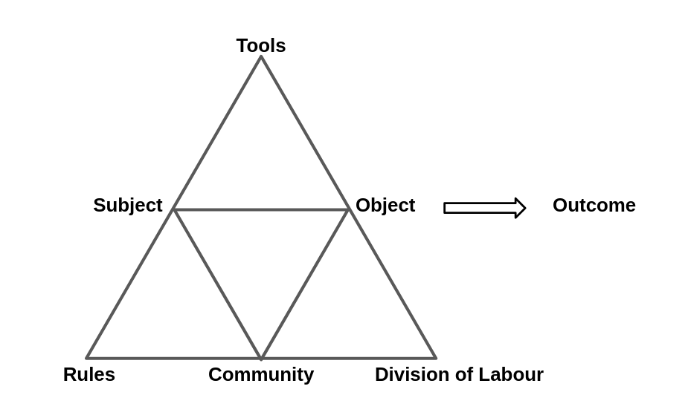
Fig. 5.x Leontiev’s conception of Activity <Do Zotero Refresh: [@engestrom_learning_1987]>
Historically AT had limited take up in western academia before Cole’s translations of Vygotsky and work to bring some of the foundational concepts into an educational psychology setting, aligning them with a broader social turn in psychology, explored as cultural psychology <Do Zotero Refresh: [@cole_cultural_1996]>. The work in this field by scholars such as Wertsch and Cole places community and context as vital in studies of learning. The vital role of cultural mediation in development (cole_beyond_1996-1?) situating learning pedagogies as form of meditational strategy.
SIGN POST IF AND HOW THESE ARE EXPLORED LATER.

Core AT concepts
Nardi and Kaptelinin outline the activity theory (AT) as a series of foundational concept which form the base for wider theories <Do Zotero Refresh: [@kaptelinin_acting_2009; @wertsch_concept_1981]>, namely: object-orientedness, tool mediation, hierarchical structure of activity, ongoing development of activity development, and psychological internalisation and externalisation.
While this study is on community activity, some of the concepts and tools of AT inherit meaning from a tradition of exploring personal psychology and thus a clarification of the terms used in a community setting is helpful. To help make this process more concrete, at times I will give examples related to the context of this study.

Object / objective in activity and varied interpretations
While the materialist language of Marxism has led some descriptions to focus on the object as the physical object that is being worked on and transformed by the activity, conceptual objects are also included in this concepts. Thus an object can comprise a physical object but is best understood within the context of wider motivation, for in many complex environments when more than one physical or conceptual object is at play.
Paying attention to the objective of AT systems is important as it helping to differentiate the scope of activity systems. Example?
It also helps identify conflicts between the stated objective of the system and the actual objective of participants.
This concepts is also helped by understanding activity as a hierarchy.

The hierarchical structure of activity

Activity, Actions and Operations
To describe these wider activity systems with greater granularity, Leontiev <Do Zotero Refresh: [-@leontiev_activity_2009]>, used terms and concepts of actions and operations happening which consitue the broader units of actity. Kutti <Do Zotero Refresh: [@kuutti_activity_1995]>. describes actions in the following way.
“…actions consist of chains of operations, which are well-defined habitual routines used as answers to conditions faced during the performing of the action. Initially each operation is a conscious action, consisting of both the orientation and execution phases, but when the corresponding model is good enough and the action has been practiced long enough, the orientation phase will fade and the action will be collapsed into an operation, which is much more fluent.”
The concept of fluency is key to this study, as such it is important to be able to locate and describe these chains of operations and actions in detail. While game making as a community learning project is clearly as an important activity system in this study, to answer alll the research questions of this thesis, it is important to also examine interpersonal activity in more detail. In order to do this an activity system of even smaller scope is examined in greater detail in Chapter 6 on the use of game design patterns by participants.

Selecting activity systems as units of analysis
The process of finding a germ cell/ unit of analysis is seen as a productive technique of explorative activity theory research (with what aim?). The work of Blunden (blundenInterdisciplinaryConceptActivity2009?; blundenGermCellUnit2014?) provides as comprehensive justification the utility of the process. He describes the germ cell of activity and the unit of activity as two similar concepts with slightly different foci.
... the germ-cell and the unit of analysis are one and the same thing, but in one case the developmental aspect is emphasised and in the other case the analytical aspect is emphasised. [@blunden_unit_2020]
In this thesis, as a designer / researcher and practitioner both aspects are relevant. Examining the analytical aspect, the process of seeking and defining a key activity scope/unit for analysis helps define useful boundaries of what to analyse in depth. RQ2 of this thesis addresses the potential role of game design patterns (GDPs) as a guiding process in varied forms. To do this Ch. 6 has a narrow focus on the implementation of gameplay design patterns (GDPs) allowing for the identification and analysis of patterns of participant behaviour and introduced and emerging community practices to do with GDPs. While this concept of germ cell / unit of analysis is typically used in a larger scope of activity, the principles apply this smaller scope. While game making can as an overarching activity system, a narrower activity whose objective is implementing GDPs became a significant unit of activity for this study.
Turning to the developmental aspect, a granular exploration of the tensions and processes at work in a complex educational environment can via identifying emerging barriers and responses to comprehension, communication and practical barriers to implementing design challenges facilitates replicability of research and supports its potential value to other practitioners <Do Zotero Refresh: [@barab_using_2002]>.
Concl? In Chapters 5 and 6 GDPs are explored as a developmental, germ cell concept in practical terms.
While units of analysis are often chosen on an broad scope to allow for sociological concepts to emerge, Blunden makes a pragmatic proposal to use projects as they key unit of analysis [-(blunden_interdisciplinary_2010?); -(blunden?)#### Development and design] . His rationale is INCLUDE SUMMARY OF RATIONALE HERE
IS THE RATIONALE ALIGNED WITH THE IMPORTANCE OF OBJECTIVE?

On Mediation and internalisation and externalisation of concepts
The concept of tools here is broad including language, physical tools and representational concepts. The overall view of learning is seen as highly mediated by these cultural tools.

Mutual process via internalisation and externalisation
The process of mediation through the use of conceptual tools is seen as mutual through the process of in .
Learners are actively processing and make sense of the world by both appropriating cultural learning and by contributing back into shared cultural understandings of the world.

Tools as a propagation of cultures
Tools are a product of adaptation and hold within them an evolution of culture.

Double stimulation and Affordances
There is a link between double stimulation and affordances <Do Zotero Refresh: [@romero_analysing_2022]>

Development and design
Activity theory is based on the concept that activity in context should be understood as in a state of ongoing transformation. The foundation of the theory builds on understandings of Marxist dialectical materialism, in which activity is a dynamic system best analysed through its transformations <Do Zotero Refresh: [@ilyenkov1960dialectics]>.
Engeström’s work on what he termed a third generation includes theory of expansive learning which charts changes and expansion of the object being worked on, often due to tensions beyond a single activity system to encompass others thus but through acknowledging the impact of movement of actors between systems <Do Zotero Refresh: [@engestrom_expansive_2001]>. This along with the work of Cole, is vital to move beyond a limited view of activity to engage with cross cultural understandings of learning <Do Zotero Refresh: [@cole_cross-cultural_1988]>

Later iterations of activity theory, 3GAT / Cole / etc
As part of a the broader social turn of psychology explored, these authors and their colleagues also forged new concepts which I draw on in this study and which are explored in the next section (on 3gat and Cole’s cultural work) including:
- tensions between system elements
- double stimulation
- ideocultures and
- mutual appropriation.
- expansive learnig
The next section explores these concepts and their utility to this study.
NOTE - THE CONCEPTS LISTED ABOVE ARE NOT THE SAME AS THE DBR PRINCIPLES BUT SEE MORE IMPORTANT - DOES THIS NEED RESTRUCTURING?

3GAT
An important development of conceptual tools to apply activity to authentic learning settings takes the form of a formulation knows as third generation activity theory (3GAT).
As mentioned in the section above, the recognised the importance of interacting activity systems, the movement of subjects between systems and the possibility for joint work on a shared object. These concepts are represented via an extension of Engeström’s triangular representation of key cultural aspects of the activity in question, now also include a second triable representing other cultural factors including, norms and rules, division of labour and community <Do Zotero Refresh: [@engestrom_learning_1987; @engestrom_expansive_2001]>
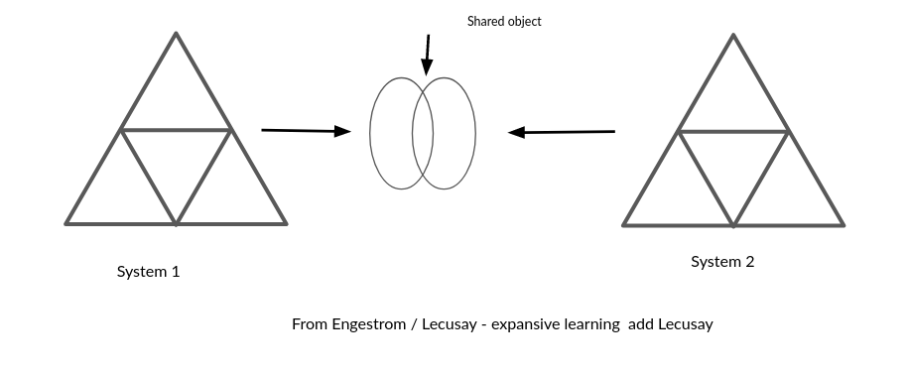 Figure 3. x - Engeström’s concept of expansive learning via a shared object
The recognition of wider activity systems and the bleed of motivations of actors into new systems is represented in Engeström’s view of AT as a foundation for interventionist and participatory processes on <Do Zotero Refresh: [@spinuzzi_trying_2020-1]>

The value of surfacing areas of contradictions
In activity theory tensions and contradictions are a vital source of change and evolution of new and ongoing activity systems.
While the concept of tensions and contradictions exists in foundational concepts of dialectal materialism, the work of Engeström addressed this in more granular details and also vitally created more detailed understandings, more specific methods of description and analysis, and representations of these contradictions.
Engeström <Do Zotero Refresh: [@engestrom_expansive_2001]> explains the role of contradictions as build up of tensions between different elements of the activity system. His detailed analysis of work based activity identifies the role of contradictions in systems is the source of “change and development” <Do Zotero Refresh: [@engestrom_expansive_2001]>
Conflicts and tensions between participant motives and different parts of activity system are sometimes revolved quickly through change, or remain more persistent and can be referred to as blockages.
While much of the literature focuses on larger systems of workplace analysis happening over years, the role of analysis of tensions in shorter interventions is also present in diverse research. <Do Zotero Refresh: [@barab_developing_2002; @barab_using_2002]>
Unresolved contradictions develop into impasses or conflicts. These can serve as more urgent motivational factor driving an agentic response from participants in disfunctional systems. In particular work by Sannino on agency from a chat perspective frames the potential of such conflicts positively as a source of activist transformation. A later section explores agency in more detail.

Disambiguating terminology - Conflicts, tensions, contradictions, dilemmas
Even within schools of CHAT, terms are not set. To avoid the dangers of the vague use of the terms tensions and contractions <Do Zotero Refresh: [@karanasios_exploring_2017]>, this section outlines my interpretation based on the scope of this study.
While guided by the concept of analysing manifestations of systemic contradictions, <Do Zotero Refresh: [@cakir_contradictions_2022; @engestrom_discursive_2011]> this study does not use that detailed framework.
NOTE - there is also the concept of congruencies - or strengths within activity systems. Where appropriate these systems strengths and positive alignments are helpful to note <Do Zotero Refresh: [@kamanga_contradictions_2021]>.
On a smaller scale, design tensions exist. These do not block progress completely but may disrupt some activities. Combinations of tensions can compound to create longer lasting and more serious conflicts if not resolved [Engeström early]. The concept of levels of contradictions are helpful <Do Zotero Refresh: [@sannino_cultural-historical_2018]> the forth being a conflict.
In Sannino’s later work on transformational agency TADS conflicts are examined - greater scope than tensions - thus larger shifts are implied.
Instrumental agency is relevant here to help examine and the work of learning designers to remove barriers, Transformational and authorial agency serves to explore the potential for learners to address and overcome tensions and conflicts in their own way.
The definition used in this study
Instead of a more technical definition <Do Zotero Refresh: [@engestrom_discursive_2011]>, following Kuuti <Do Zotero Refresh: [-@kuutti_activity_1995]>, this study adopts contradictions as a broader definition encompassing concepts of tensions, barriers, breakdowns, conflicts.
In the following chapters I focus on tensions which help explore the research questions and which help inform the findings of later chapters. In particular I draw out more visible conflicts which threaten more serious disruption of activities.

Double stimulation and its interaction with contradiction in joint activity through method of double stimulation
Link to next section Check overlap with methodology chaper.
Double stimulation refers to the use of tools and processes to overcome such conflicts. Engeström’s early work on formative interventions sets out the importance the concept of double stimulation <Do Zotero Refresh: [@valsiner_cultural-historical_2007]>.
While Sannino’s <Do Zotero Refresh: [@sannino_principle_2015]> work on the volitional aspect of the process of double stimulation cautions ‘double stimulation cannot be subsumed to the general idea of mediation by symbolic tools’ <Do Zotero Refresh: [-@sannino_principle_2015, p.2]>, it shares the a perspective that there is value in exploring the process to explore participants development of agency in professional and educational settings <Do Zotero Refresh: [@sannino_formative_2016]>.
One example in an educational settings is the use of a Change Laboratory methodology <Do Zotero Refresh: [@engestrom_putting_2007]> to intervene in kindergarten educational process and organising structure <Do Zotero Refresh: [@rajala_utopian_2023]>.
In research on the use of wiki technology by students Lund and Ramussen <Do Zotero Refresh: [-@lund_right_2008-1]> caution against mismatches between the first and second stimulus; interpreting project tasks or objectives as the first stimuli, and the tools used to the as secondary stimuli. They also outline the importance of awareness of the likelihood of multiple stimuli in modern technical working environments.

Expansive learning
The concept of the expanding learning can be applied via formative interventions.
The broad AT principle of the need to analyse activity through its transformation can be seen in several
<Do Zotero Refresh: [@sannino_formative_2016; @engestrom_methodological_2014]>
Figure 3. x - Engeström’s concept of expansive learning via a shared object
Expansive learning leads to the formation of a new, expanded object and pattern of activity oriented to the object. This process, known as ascending from the abstract to the concrete, involves the formation of a theoretical concept of the new activity, based on grasping and modeling the initial simple relationship, the “germ cell,” that gives rise to the new activity and generates its diverse concrete manifestations Davydov 1990. <Do Zotero Refresh: [@engestrom_design_2011]>
REWRITE THE ABOVE? FOCUS ON EXPANDED OBJECT and the the role of the unit of activity in rising to the concrete and thus expanding learning <Do Zotero Refresh: [@sannino_formative_2016; @engestrom_methodological_2014]>

Third spaces, idiocultures and designed systems
REWORK THIS TO SIT IN THIS SECTION
This study aligns with concepts of how home discourses or and FoK can be drawn on as a resource by participants to facilitate learning in new environments <Do Zotero Refresh: [@moje_working_2004]> .
The process of merging the knowledge and discourses of first space (home life) with the process of of the second space (school or institution) into a new third space has been explored in many studies <Do Zotero Refresh: [@moje_working_2004; @gutierrez_developing_2008; @gutierrez_developing_2008; @bryant_academic_2009]>.
Cole notes that the creation of idiocultures by researchers <Do Zotero Refresh: [@cole_idiocultural_2017]>, the created allowing researchers to be present from the beginning of the process.
This can be compared to methods addressing existing existing activities like the change laboratory.
However, <Do Zotero Refresh: [@downing_wilson_sociogenesis_2011]> notes that even novel idiocultures are not created from nothing but encompass cultural traits of other systems in which participant engage with.

Funds of Knowledge within ideocultures
Cole’s recent work address the use of FoK to form ideocultures in educational interventions <Do Zotero Refresh: [@rajala_utopian_2023]>
The work problematises the possible superficial use of FoK and FoI in a ways which may perpetuate status quo negatively <Do Zotero Refresh: [@rajala_utopian_2023]>

Critiques and alternatives to Activity theory.
It’s complex and unwieldy when putting into practice.
While examples like formative interventions, in the form of Change Laboratory and 5th D are available, they are highly context dependent and not easily replicable.
There are also other critiques. - Such as
Alternative which are less theoretically heavy include DBR & COP
More recent conception of DBR and AT process such as formative interventions are working to align the approaches and mitigate against Engeström’s initial critiques in a way which is explored in next section.

Putting AT to work via interventionist research via formative interventions and DBR
This section covers a summary of how the theoretical framework of AT can be operationalised. It compares the approaches of formative interventions and design based research.

An operationalised example of Activity Theory concepts in context
These concepts are used in later analysis in findings chapters. However, to situate the learner at this stage I include a diagram .
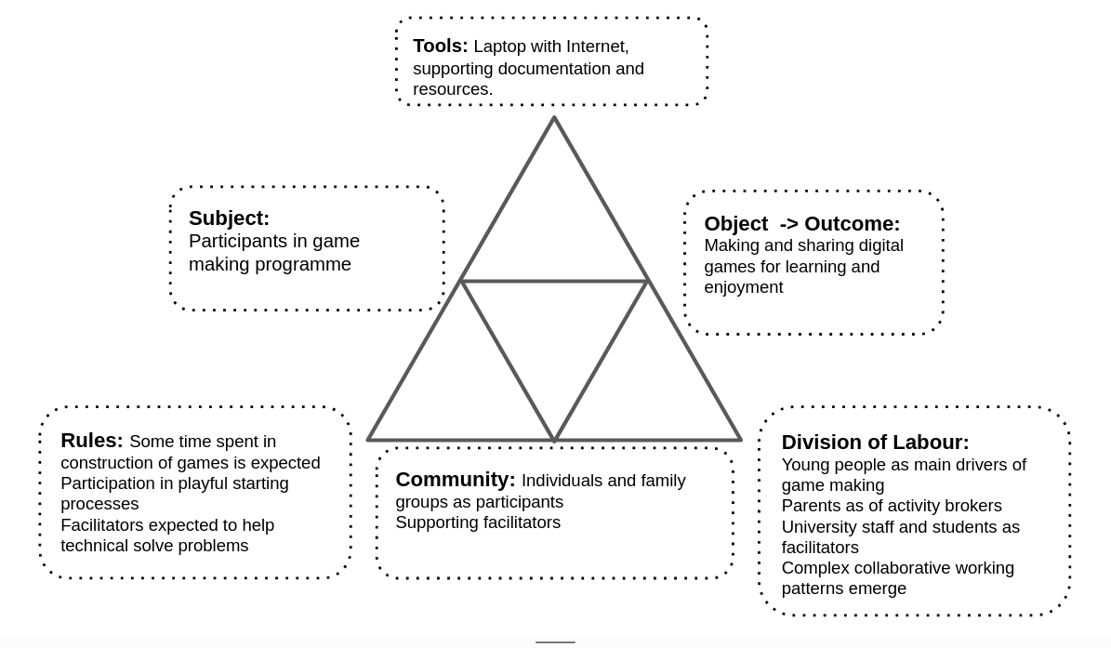 Fig 3.x - a wide scope of activity
The concepts above are now used in context.
The objective of activity is to make a game to share, that process is mediated by tool use. The tools themselves have been created by a wider community including the facilitator (drawing on the product of a wider on-line community)
On develoment What this static representation does not cover is the development and transformation. The next sections address this

On formative interventions
This section explains the CHAT method of formative interventions and proposes this study as an example of a formative intervention.
Penuel <Do Zotero Refresh: [-@penuel_emerging_2014]> proposes the formative interventions as a useful term to encapsulate a CHAT process closely aligned with DBR.
A key text here is Cole and Engeström’s exploration of two models of formative interventions, namely Change Laboratory and 5th Dimension, designed to align with principles of AT <Do Zotero Refresh: [@valsiner_cultural-historical_2007]>
A model of formative intervention that has been addressed by much research is Engeström’s implementation of expansive learning in workplace environments, a set of processes applied in a workplace setting called Change Laboratory (CL) <Do Zotero Refresh: [@engestrom_putting_2007]>. The CL processes suits a formal workplace where there are existing concepts of Community and Division of Labour and Norms that have resulted in contradictions to be explored and resolved.
EXPAND THIS WITH EXAMPLES? kindergarten one below?

What is DBR and why and how do I use it in this study?
Design based research (DBR) is a varied discipline which can take a multitude of forms <Do Zotero Refresh: [@mckenney_educational_2021]>. The core elements include: research as an intervention, iteration, involvement of participants in the evolution of designs, and a flexibility of research outcome based on how events unfold <Do Zotero Refresh: [@easterday_design-based_2014]>.
Hay describes DBR thus “learning occurs within a context of use, learning is frequently collaborative, learning as authentic, learning as inquiry-based not transmission-based” <Do Zotero Refresh: [@hay_constructivism_2001]> p. 3. Thus the broad claims are in alignment with wider socio cultural approaches.
Penuel <Do Zotero Refresh: [-@penuel_emerging_2014]> describes design based researchers as an eclectic in approach but that there are calls for more formalisation.
The critique reflects different strands of DBR some of which holder closer to the lab based approaches that DBR was initially conceived of to transcend <Do Zotero Refresh: [@brown_design_1992]>
Sandoval notes critique from some of the diverse methods at use <Do Zotero Refresh: [-@sandoval_conjecture_2014]>, but notes the alignment of approaches namely, “the joint pursuit of practical improvement and theoretical refinement; cycles of design, enactment, analysis, and revision; and attempts to link processes of enactment to outcomes of interest”
Indeed, there is a strength in the flexibility if approach, for the purposes of this study. Allowing me to draw on useful techniques used in relevant context, and to align the process with underlying guiding theory of AT.
One of the key motivations of this approach is to produce educational research that has a high utility for practitioners through developing theory that is rooted in contextual practice and which can produce new pedagogies and resources <Do Zotero Refresh: [@cobb_design_2003]>.

Outline of the guiding principles of DBR and formative interventions
This section addresses concepts common to DBR, and interventions of CHAT. The aim is to identify a working definition and terminology suitable for this study.
The broad alignment of DBR and the CHAT in terms of ethos and processes has been explored, including in special editions of journals<Do Zotero Refresh: [-@penuel_emerging_2014]>
One of the key differences is that while DBR is more flexible in underlying theoretical framework, formative interventions are more perscriptively based on AT.
The following sections explore key similarities and disctinctions in the application of principles shared by both design based research and formative interventions using CHAT.
Namely:
- iterative and responsive design process
- the research process creates new forms of activity and associated resources
- the mutuality of the process: aligned with research ethic of participation rather than extraction
- generating both theoretical understanding and practical educational interventions suitable for sharing with other communities, be this via tools, process or a guiding pedagogy
To help explore these principles, this section describes some of the fault-lines in the theoretical debates surrounding the methods of DBR and formative interventions.

Ongoing alignments between DBR and the CHAT community / ethos
Adaptations including mutual appropriation from Cole’s work <Do Zotero Refresh: [@downing-wilson_design_2011]> and formative interventions from Engeström’s work
Mutual appropriation highlighted the importance that researchers adapt to contextual factors including the practicalities of the setting.
Later work on DBR applied from a CHAT perspective has addressed limitations in this methodology <Do Zotero Refresh: [@oneill_understanding_2016]>.
Cakir and colleagues <Do Zotero Refresh: [-@cakir_contradictions_2022]> draw on DBR but also include the wider constellations of activity systems working together on shared project.
Rajala and Cole echo limits <Do Zotero Refresh: [@rajala_utopian_2023]> and argues for the use of FoK in design experiments in the form of funds of identity (FoI). The identity objects here be likened to the creation of artefacts in the game making process, and the evocative objects of Turkle and work of Papert.

Principle : Researcher take and active interventionist approach
In both DBR and formative interventions, the researchers take an active role, a stance which has been critique from the perspective of traditional psychological experimental researchers.
Designed systems: Learning environments are understood as designed systems with accumulated culture of tools and artefacts <Do Zotero Refresh: [@barnett_ecosystem_2019; @cole_design-based_2016]>.
However, in a situation where working in a new context or with new technology, learning designers often starting from a blank canvas. For example, in the context of this study on game making the activity is novel there are few if any established community or working processes.
Formative interventions rarely work with new educational design, favouring existing systems within
DBR however is more comfortable with new designs that are introduced fully by the researcher but with feedback from participants for ongoing iterations.
Different approaches are needed depending on if the activity and context of that activity is already established an on-going or if it is a new venture created by researchers / participants.

Principle: Mutuality - LINKED TO THE ABOVE POINT TOO
One principle of DBR advanced by many researchers is that that research participants also influence the ongoing design of the research <Do Zotero Refresh: [@barab_critical_2004; @cobb_design_2003; @downing-wilson_design_2011]>. However in application this not a key part of all definitions <Do Zotero Refresh: [@easterday_design-based_2014]>. Thus Cole critiques (CHECK) <Do Zotero Refresh: [@cole_design-based_2016]>. In addition, lack of adaptability and mutuality in terms of taking on board the suggested adaptations of learners.
Engeström has been critical of DBR for lack of mutuality within its linear approach and lack of rigour more generally <Do Zotero Refresh: [@engestrom_design_2011]>.
This bears examination on two levels.
Firstly, it is of note that the formal approach of formative interventions is often used in stable institutional systems of work environments in European contexts where there are more stable understandings of stakeholders involved compared to less formal learning environments <Do Zotero Refresh: [@spinuzzi_trying_2020-1]>. The author notes the impact of this context on they types of mutuality possible based on unstable stakeholders as a critique of 3GAT and formative interventions.
Secondly, it is out of date, see Penuel <Do Zotero Refresh: [-@penuel_emerging_2014]> for an more updated take on alignment of formative interventions and DBR. More recently Engeström and colleagues <Do Zotero Refresh: [-@cakir_contradictions_2022]> have advocated the advantages of incorporating more rigour of formative interventions to add to DBR, rather that critiquing it wholesale.

Principle: The importance of context
One of Engeström’s critiques of DBR <Do Zotero Refresh: [@engestrom_learning_2009]> is that it lacks rigorous examination of the dynamic nature of context with CHAT conceptions of Activity.
For example, the context of experiments, particularly viewing the classroom as a controlled environment <Do Zotero Refresh: [@cole_design-based_2016]>.

Principle : Utility of research - overcoming the tension between the rich context and generalisation of results
Barab and Squire <Do Zotero Refresh: [@barab_design-based_2004]> describe the messiness of design-based research and that this creates a challenge to the researcher of how to present results in a coherent way which is of use to other practitioners. There is a tension between sticking closely to the context of the research and the concrete specifics or stepping back to generalise and being lost in abstraction.

Concepts of agency within CHAT

Addressing and disambiguating definitions of agency in education
To effectively answer RQ2 the concept of agency needs disambiguating.
Agency and autonomy have disputed, often inter-related definitions or are often ill defined in studies <Do Zotero Refresh: [@huang_autonomy_2013; @matusov_mapping_2016]>.
See also feminist reconceptualisations of autonomy as agency<Do Zotero Refresh: [@abrams_autonomy_1998]>.
Concepts of agency are explored in more depth in chapter three, however a brief definition of agency in relation to informal education and this study is useful to ground the findings of the literature review.
Concepts of facilitating the development of agency in education have diverse threads <Do Zotero Refresh: [@matusov_mapping_2016]>. These include: instrumental agency with a focus on developing capacities; effortful agency which enhances motivation and commitment; and authorial agency which involves agentic changes to the learning environment.
Matusov and colleagues critique effortful agency in education as focusing only on achieving goals predefined by educational establishments. Thus this summary focuses deepening an analysis on instrumental and authorial agency in relation to other research on the subject.
Matusov and colleagues (USEFUL BUT COMPLEX) outline many forms of agency to educational concepts. <Do Zotero Refresh: [@matusov_mapping_2016]>
The concept of instrumental agency to aid learner control is also useful as a way to reduce friction in learning designs. This more limited conception of agency as a way of getting things done is an attractive concept in designing for learners by designing out obstacles.

Instrumental and relational agency
Instrumental agency reflects a concept of agency as the ability to get things done. Conceptually these practical dimension involve removing aspects of negative liberty caused by technical barriers <Do Zotero Refresh: [@matusov_mapping_2016, p. 433]>.
In this sometimes technological view of educational environments teachers or facilitators can to increase agency by removing individual barriers to use. However, a more social view of instrumental agency also includes relational aspects where leaners are able to offer and request support <Do Zotero Refresh: [@edwards_steps_2005]>.

Authorial and transformative agency
Other takes of socio cultural school of research focus less on the individual and more on broader conceptions of activity. Stetsenko places agency in a socio-cultural theory between conceptions of humans as chiefly individualistic or instead as helpless bodies in wider cultural phenomenon
<Do Zotero Refresh: [@stetsenko_critical_2020; @matusov_mapping_2016]>.
Matusov proposes authorial agency <Do Zotero Refresh: [@matusov_mapping_2016]> as the concept of agency most aligned with x
DEFINE
As well as the work on Lave and Wegner on community based conceptions of agency, Matusov bases much of the definition of authorial agency on existing work on transformational agency.
Hopwood’s <Do Zotero Refresh: [-@hopwood_agency_2022]> exploration of agency also focuses primarily on transformational agency and relational agency.

Conceptual tools associated with agency

Specifically, TAS, TADS
TAS from Stetsenko addresses grand ideas of agency directly. However the authour also grounds these grand ideas in concrete explorations, including play <Do Zotero Refresh: [@stetsenko_serious_2015]>
Similarly while TADS addresses lofty ideas of “quote” they can be played out in smaller situations.
In exploring their differences Hopwood x and y.
Transformative agency <Do Zotero Refresh: [@engestrom2006development; @haapasaari_emergence_2016; @sannino_formative_2016]>.
For the purposes of this study, I agree with the view that the nature of agency as situated in context. Thus we do not say learners have or lack agency, as it is not a learner property independent of context <Do Zotero Refresh: [@nieminen_what_2022]>.

Affordances
Affordances can be explored within the AT concept of mediation.
There is a link between double stimulation and affordances <Do Zotero Refresh: [@romero_analysing_2022]>
A good summary of affordances related to HCI is here <Do Zotero Refresh: [@galliers_affordance_2017]>
Other researchers have found the the scope and focus of affordances important to clarify <Do Zotero Refresh: [@wolff-piggott_activity_2016-1]>.
They focus particularly in terms of who the affordance is for.
Affordances have been misused, assigned magical properties, including agency of themselves [SUPPORT].
This study follows socio-cultural take that while objects have a forma of agency, affordances are not magic and become interesting to educators as part of activity stemming from human-initiated activity.
Nardi and colleagues give an overview regrounding Gibson’s concept of affordances as action possibilities in line with activity theory concepts of mediated action <Do Zotero Refresh: [@kaptelinin_affordances_2012]>. Their focus is primarily on individual action.
While there is a The wealth of HCI literature in line with activity which discusses and applies concetps of affordances, the focus is often on the individual rather than on collective action <Do Zotero Refresh: [@kaptelinin_affordances_2012]>.
However, affordances are originally conceived of as part of activity, not separated from it <Do Zotero Refresh: [@ba_erentsen_activity_2002]>.
NOTE - more on affordances here from Nardi
Link with TADS? TADS and the associated metaphor of warping anchors is normally applied in settings of group action.

TADS - On double stimulation and agency
The active use of secondary stimulus can facilitate agency <Do Zotero Refresh: [@sannino_principle_2015]>. While many studies have examined the process in professional settings there is a paucity of study in the area of “student-centered contexts of learning” <Do Zotero Refresh: [@isaac_cultural_2021, p. 93]>.
Blockages caused by contradictions are also analysed the fields of design and HCI with an aim of revising designs to remove them <Do Zotero Refresh: [@karanasios_moving_2021]>.

Conclusion / Synthesis.
Synthesis of different concepts as they are applied to the context of this study.
- DBR vs AT?
- Role of 3 planes?

Summary of Justification of choice - and how the RQs align with different concepts
For the focus of this study on developing game coding abilities particular aspects of importance are of understanding of the importance of context, and the ongoing development of cultural artefacts. NOTE - Thus in the next chapter particular attention is paid to the development of the artefacts and processes developed as part of the learning design.

Signposting where concepts are used in the thesis (in relation to RQs)
The concept of germ cell is explore later in more detail in Chapter 5.

The role of AT in the analysis of HCI - MOVE?
NOTE BE SURE TO USE THE RIGHT TERMS HERE.
It is of note that the work of Kaptelinin and Nardi on conceptualising activity theory happens in the context of Human Computer Interaction (HCI). The link of concepts of mediation and affordances are of note <Do Zotero Refresh: [@kaptelinin_acting_2009, p.71]>.

Parked to replace or remove or rework

Situating this study using third space and FoK terminology and processes
In the context of this study we can conceptualise the learning context as a third space mixing home learning and culture and the context of university research and outreach work.
It draws on cultural processes of cultures of family learning, coding cultures and informal science clubs. Of particular relevance is retro Gaming framed as a fund of identity. A process that emerged from early consultation with home educating families.
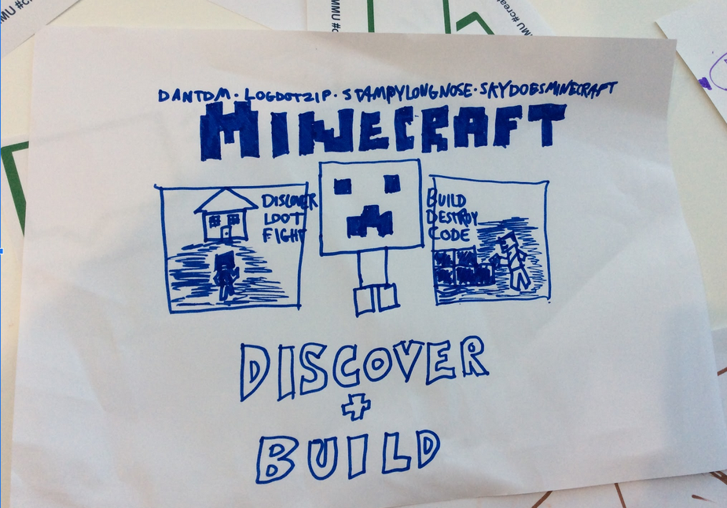
Retro gaming cultures emcompass broad media and practices beyond the games themselves. The image above shows now only a sketch of the Minecraft game, but also the names of YouTubers making videos about games.
This study positions this interest and identification as a fund of knowledge which designers should be aware of and utilise to help address some of the affective barriers to taking part in coding processes.
This study contributes to work which explores the potential does that give to developing game coding practices as per RQ3.

Change labs

