7. Seeding and Nurturing Community Game Making Practices to Facilitate Learner Agency
- Research Questions April 2025
- Introduction
- Part one - Exploring concepts of abstract and concrete knowledge frameworks in relation to Game Design Patterns
  - Conceptions of abstraction in the research field
  - Comparing to pedagogies explicitly teaching abstraction, computational thinking and LOA
    - Exploring data using concepts of Levels of Abstraction (LOA) & PRIMM
    - Description
    - Processes of blackboxing
    - Rationale for black boxing
    - Alternative/s in approaches are possible
    - Reflections on design in relation to other research - PERHAPS VIA PRIMM AND UMC? AND HOW DO DESIGN PATTERNS FIT INTO THIS PICTURE - SGD & DENNER (AS FORM OF ANALYSIS)
    - Summary of structural components of applied pedagogy - REEPP & A gateway view of learning dimensions. MOVE DISCUSSION UP
  - Reexaming the use of GDPs from intermediate-level knowledge (to a gateway framework)
  - Link to next section - limits of this personal dimension approach
- Part Two - Agency, and re-mediation of repertoires in third spaces
  - Instrumental and transformational agency
    - A dilemma involving engendering for transformational agency
  - Relational agency
  - Shifting forms of agency
- Reframing findings using socio-cultural understandings of agency and repertoire blending
  - Revisiting understandings of relational agency and repertoires
  - A - Repertoire importation into the the game making community
  - B - The process of blending of repertoires in a third space
    - Playtesting as a suitable medium for emerging activities creating third spaces via blending of repertoires
    - Specialism and expressions of identity in variations in approaches to game making and playtesting
  - C - Supporting emerging identity formation and specialisation through interventions to support relational repertoire blending
    - Helping styles and helpers
    - The introduction of side missions & maker types to make visible emerging repertoires as cultural affordances of my pedagogy to increase and legitimise diversity / hybridity
- Implications for design and summative design frameworks
  - Designing for relational agency by repertoire blending (RARB)
    - What is RARB
    - Narrative descriptive of a proposed procedure for facilitation relational agency by repertoire blending (RARB)
    - Specialism - INTEGRATE ABOVE
    - Summary of discussion on designing for agency - INTEGRATE ABOVE / BELOW
    - Summative table illustrating stages of facilitating RARB in this study
  - Metaphors as a way to communication dimensions of agency design concerns
    - Harbours as both protective and authentic
    - Spaces to play - playgrounds and jam sessions
- Part Three : Synthesis & contributions to the field = EDITING DOWN OR MOVING TO CHAP 8
  - CCRREEPP & GDPs as a gateway pedagogical framework
  - GDPs used as a gateway pedagogical framework aligned with RARB process
    - Summary of the potential utility of GDPs for wider stakeholders
- Conclusion

Seeding and Nurturing Community Game Making Practices to Facilitate Learner Agency

Research Questions April 2025
Principle question: How can pedagogies to support CGD&P be enriched using socio-cultural approaches (CHAT more specifically)?
- What contradictions arose in this research’s evolving design process and how were they addressed in the resulting CGD&P pedagogy?
- How can the use of a collection of game design patterns support CGD&P, in particular in relation to abstract and concrete dimensions of existing pedagogies?
- How can varied dimensions of agency be identified and nurtured in an evolving community of game makers? (and thus what subsequent implications does this have on understandings of pedagogy design)

Introduction
PURPOSE & GAPS - ADD IN EACH SECTION.
This chapter deepens the analysis and discussion on RQ2 regarding the potential uses of gameplay design patterns (GDP) and concludes with an analysis and discussion on RQ3, addressing reflections on participant agency. Chapter 6 presented findings on the different uses of gameplay design patterns (GDP) using three foci of analysis: personal, social, and cultural activity. To begin, this chapter discusses these findings in relation to existing relevant research. Part one specifically addresses the complexities of the abstract and concrete dimensions of computing education using a concept from design research that explores the value of gameplay design patterns as an intermediate-level, pedagogical framework.
Part two shifts focus away from individual conceptions of knowledge and skill to examine the broader empowerment-related motivations driving this study. The goal here is to address gaps in the existing landscape of CGD&P research via an application of socio-cultural conceptions of agency. To begin this process, I undertake an interpretation of shifting forms of agency grounded in the data explored in the last chapter.
To achieve this, I begin with an exploration of the study’s findings in relation to instrumental and transformative agency and the concept of mediation in CHAT. As a way to address cultural development in more depth, particularly the development of learner identities within the research activities, I develop an interpretation of relational agency drawing on Rogoff and Gutiérrez’s (Gutiérrez and Rogoff, 2003) concept of learner repertoires. To present a holistic picture of the complex cultural activity recorded in the research data, this discussion briefly addresses the wider aspects of the learning design. However, it concludes with a proposed contribution suggesting that a collection of GDPs can help participants and facilitators as both as component features of emerging game making repertoires and as a orienting framework to increase the inclusive characteristics of the learning environment.
The final part of this chapter returns to gaps in the research landscape and outlines an applied computing pedagogy structured around the use of GDPs.
An exploration of metaphors that synthesise significant features of the learning design which influence dimensions of agency.
As framework is developed via a utopian and utilitarian approach to design-based research and formative interventions. As such, it communicates insights for equity and diversity via practical concerns to inform future recommendations for practice.

Part one - Exploring concepts of abstract and concrete knowledge frameworks in relation to Game Design Patterns
The tension between abstract and concrete dimension of the process of learning to program runs as a theme through the literature of the domain of computer game design and programming (CGD&P) (see Chapter 2). Yet, the field is still lacking in depth in terms of specific pedagogies which explore the complexities of conceptions of abstraction. Complexities which include areas of… computational thinking; the role of levels of abstraction for teachers and learners; and the value of epistemological pluralism as a way to value concrete approaches. To address this this chapter explores these characteristics in relation to the data surfaced in Chapters 5 and 6 of this thesis. The section concludes with a proposal of GDPs as pedagogical constructs located between abstract and concrete poles of the learning experience and an exploration of their utility for educational designers, researchers and for participants. Finally, a technical pedagogical structure is advanced and given an term of remix enabled elective pattern patching (REEPP)

Conceptions of abstraction in the research field
Before exploring dimensions of abstraction and concreteness in the use of GDPs within context of computing education by revisiting relevant pedagogies outlined in Chapter 2, it is of value to revisit relevant framings which justify the utility of such exploration. Firstly, following Hook (2012), Eriksson et al. (2019), in their use of a curated collection of GDPs to structure game design, framed design patterns as a form of intermediate-level concept, between the detail of concrete implementation and more general theories. The value of the intermediate nature of the knowledge generated is to serve the replicability and generalisation of research work. Similarly, in activity theory, specifically in formative interventions, the research process and the evolving design involve a process of rising to the concrete. This analytical process involves identifying from concrete data an abstraction of interest and utility and leveraging the power of this concept to generate distinct concrete instantiations of it. Thus this research advances the use of GDPs as both a form on intermediate learning design principle (explored in Chapter 5) and as an analytical germ cell which is manifested in varied motivational and mediational forms (Chapter 6).
Revisiting concepts of abstraction in foundational computing education research
Chapter 2 explores definitions of computational thinking varying in degrees of abstraction or application. Two notably interpretations include Wing’s (2006) focus on abstraction encompassing as overarching computing principles and high level structural design approaches, and Resnick and Brennan’s (2012) more applied approach including computational practices and perspectives. This applied approach draws on the legacy of Papert and Turkle’s (1990) research on diversity in coding approaches to counter potentially alienating abstract approaches. Framed as bricolage, concrete coding approaches included an iterative approach, proximity to the code and strong links between function and form, and maintaining closer contact with a concrete sense of the outcomes even at the expense of programming efficiency or neatness of code.

Comparing to pedagogies explicitly teaching abstraction, computational thinking and LOA

Exploring data using concepts of Levels of Abstraction (LOA) & PRIMM
The use of the concept of levels of abstraction (LOA) and semantic profiles within the PRIMM pedagogy was explained as pedagogies in Chapter 2, the common value being in alternating between abstract and concrete levels of project structure and semantic concepts. The pedagogies are advanced to help teachers design learning experiences which allow for participant shifts in perspectives and thus deepen knowledge by packing and unpacking abstracted concepts via concrete experiences. There are two relevant dimension of abstraction at play. The first has the abstraction and generalisation concepts present Wing’s definition of computational thinking at one pole and concrete code implementation at the other. The second dimension present in the LOA framework is a hierarchy of elements: namely goal-design-code-results. The goal here being the most abstract element (see Table 7.x for more details).
Addressing interpretations of LOA (Waite et al., 2018a) in video data we can map the levels of abstraction to shifts between conceptions of goals, implementation in code structures, and observations of results in my findings. While the teaching of the theories levels of abstraction is not explicit, movement is clearly happening, as demonstrated by the table below.
Level | Focus | Example
Conceptual Level | Thinking about the GDPs to be added to the game | Goal formation, prioritisation
Design Level | GDP supporting documentation scaffolds this process | What it should do is to a large extent preset via documentation.
Code Level | Writing the actual code, is supported via code patching | is supported via code patching, and a structure which encourages modification. Debugging of code also happens at this level.
Execution Level | Understanding the outputs | A strong correlation between goal and outcome, as playing the game product is very immediate.
Table. 2.x Breakdown or Table of levels of abstraction. (Waite et al., 2018a)
Semantic Profiles
The navigation between abstract and concrete poles in semantic profiles is different from that of LOA in that if we follow the guidance to place concepts of higher semantic density (for this read abstraction), in the the upper scale, this would suggest Wing’s interpretation of abstract CT concepts. However, given that in observations from video data, exploration of abstract CT concepts are rarely present, the resulting of semantic profiles show relatively shallow semantic waves. For the purposes of this analysis, it is appropriate to place the LOA in the lower half of the profile (See Figure 7.x below)
As such, GDPs would be situated between abstract CT processes and concrete implementation. Thus, returning to the framing the design element of the use of GDPs as intermediate-level concept (Eriksson et al., 2019), the interpretation of the data of this study using semantic profiles above supports this interpretation and opens up a new positioning within a pedagogical framework.

Description
This shallow semantic wave above is typical in describing the data of other participants in analysed session recordings. This profile aligns with the description of Papert and Turkle’s (Papert and Turkle, 1990) maker styles a bricoleur. The data of Chapter 5 details the development of a learning pedagogy which aligns primarily to the more concrete applied approach as a way of ameliorating barriers of conceptual complexity. Observations show most participants operating as bricoleurs, feeling their way through their game-making via smaller-scale iterations rather than extensive periods of planning followed by implementation.
The following diagram is an approximate representation of this relatively shallow scope of movement using typical behaviour seen in Vignette 2.
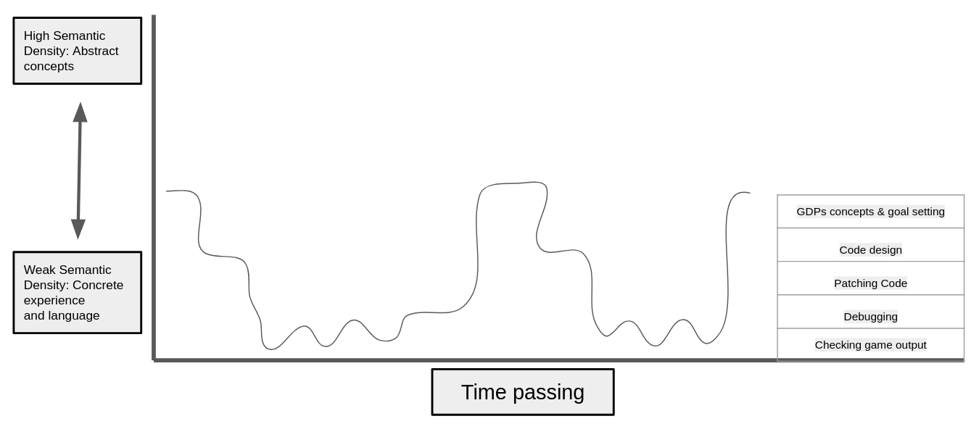
Illustration 7.x - Semantic profile in Vignette 2
With this focus, we can analyse my learning design where movement between layers of abstraction and concrete is happening. shifts do occur between participants goal formation and the concrete implementation using design practices and specific code structures. However, rather than a neat semantic sine wave as depicted in Fig 2.x in Chapter 2, for my participants,
MORE DETAIL ALIGNED TO FIGURE Each time the participants imagine and choose a design pattern, implement it code patching, test it and then debug it shifts occur.
Examples pervade the data of Vignettes, and descriptions of fluency in Chapter 6 in part stem from the fluid shifts in these levels. The level of detail in Vignette 2 for example is a good indication of rapid shifts.
Participant perspectives shift between the wider goal of making an engaging game for a real or imagined audience and a narrower goal of implementing a game design pattern and the technical actions and operations needed to complete it. GDPs help (or are relevant) in this process as they provide a tangible level of feedback in the most concrete level, and games provide high motivation to adjust code to get the result feeling just right (as seen in Chapter 6).
The packaging up together of code design and sample implementation in the gameplay design patterns provided facilitated rapid iterations of project changes and navigation between the poles of LOA via careful structuring of resources and documentation.
For other participants, see Vignette (Ed and Mark) shift are often more chaotically structured reflecting a jumping around in the process. In addition the observations in the discussion section of Chapter 6, which reject design stages, in favour of more chaotic improvisational approach.
Explicit exploration of CT code concepts and processes are present in data, but only when adults with relevant knowledge facilitator, either myself or parents, do point them out and during the process of code implementation. More implicit use of coding constructs is more common. In summary, observations on of the typical semantic profile shows little or no activity show little activity on the level of code design.
This pattern is due the black-boxing of more complex and abstract element of the starting template and to structuring support around GDP implementation as explored in Chapter 5.
This is explored via rationale and the process. REMOVE THIS LATER MAKE BETTER LINK.

Processes of blackboxing
The typical semantic profile which shows little code design activity is due to design decisions to facilitate rapid feedback and code implementation through by abstracting (or black-boxing) more complex and abstract element of the starting template.
This is present in the close coupling present between the design and coding levels (present in LOA) in the scaffolding of GDP patterns via pre-designed code solutions with code snippets provided.
The judicial process of abstraction, referred to in design domain as black-boxing is present in several aspects of this technical approach (see Appendix.tech for fuller details). Examples include: use of code playground and existing template to simplify the use of the interacting web technologies; structural and syntactical template design decisions,
The processes of abstraction or simplification for the user were outlined in Chapter 5 and can be summarised as.
- Code decomposition via the pre-existing functions in the code template
- Abstraction via the structuring of the template with key variables moved to the start of the code
- Abstraction again in template via the graphical design tool in the form of a grid matrix in an array data structure.
- Decomposition and generalisation (pattern recognition) were present in the structuring of the collection of GDPs
These were initially intuitive decisions taken in response to participant need to facilitate concrete exploration. Subsequent analysis showed an alignment with constructionist design heuristics (Resnick and Silverman, 2005) . IS THIS EXPLORED PREVIOUSLY IN CHAPTER 5?
Thus as a facilitator I undertook some code template design and implementation that would have been a potentially valuable learning experience requiring more generalisable computational thinking skills. However, these decisions were justified.

Rationale for black boxing
Given the barriers present in abstract approaches explored in Chapter 2, the restriction in semantic density in terms of abstraction is chosen here in order to prioritise accessibility and flow experience. A bricolage approach in at that level would avoid abstract design structures which detract from a close relationship between the code and the desired results.
The process of scaffolding this abstraction allowed greater focus on more relational and affective elements of the learning design, processes which are described in more depth later.
Given the previously explored advocacy for alternating between abstract and concrete dimensions in semantic waves(Curzon et al., 2020), and LOA research (Waite et al., 2018a), is it of value to ask how the approach of concrete bricolage is odds with research on the value of semantic profiles.
The strongly coupled link (present in this design) between description, and implementation, articulated as a problem-solution structure that is present in conventional conceptions of design patterns.
This coupling bears examination in relation to the positioning of GDPs as a leading activity, as illustrated by my decision to treat the implementation of each GDP as an activity system in itself. While the previous chapter explored the use of GDPs in various facets, this section turns to their utility for learners in this abstract/concrete domain.
The close coupling between design and code structure levels in my design may not align with LOA principles given that “1:1 mapping between the design/algorithm and the code may lead to confusion between the levels” (Waite et al., 2018b:21). However, this is a teacher focused view and the benefits of participants being aware of what level they are working at are not fully explored in the research. LINK TO NEXT SECTION.
Given that lack of explicit teaching, and the possibility that participants may confuse the the level they are working, it follows that Waite would cite this as problematic limitation in approach.
However, while explicit awareness of LOA, and the model of PRIMM imply explicit teaching of abstract concepts, the rationale and evidence to support the process is not clear. The difficultly in explicitly teaching abstraction rather than implicit approaches of appropriation (Kramer, 2003), while contested by (Statter and Armoni, 2016), and based on work of Hazzan (2008), underlying concerns are not fully addressed. Waite’s research does not include examples of activity explicitly teaching abstraction (Sentance et al., 2019a, 2019b). Therefore details of what counts as explicit teaching of abstraction is not clear.
Turning instead to the value for designers and facilitators, my reflections on research data support a proposition that there is utility for facilitators to be aware of the level of abstraction present in different elements of project learning design. This value encompasses both the concepts that learners are working with and those which are potentially accessible via explicit teaching.
While this research doesn’t negate or preclude the value of explicit teaching of more abstract dimension of computational thinking, it suggests that GDPs are a more suitable accessible leading pedagogical framework than computational thinking.

Alternative/s in approaches are possible
Thus, while the scope of movement here is relatively shallow, given a different focus or motivation, say that of a need to explore concepts due to curricular or exam pressures, an alternative pathway involving the exploration of abstract elements of computational thinking would have been possible. A possible alternative profile is represented in the illustration below.
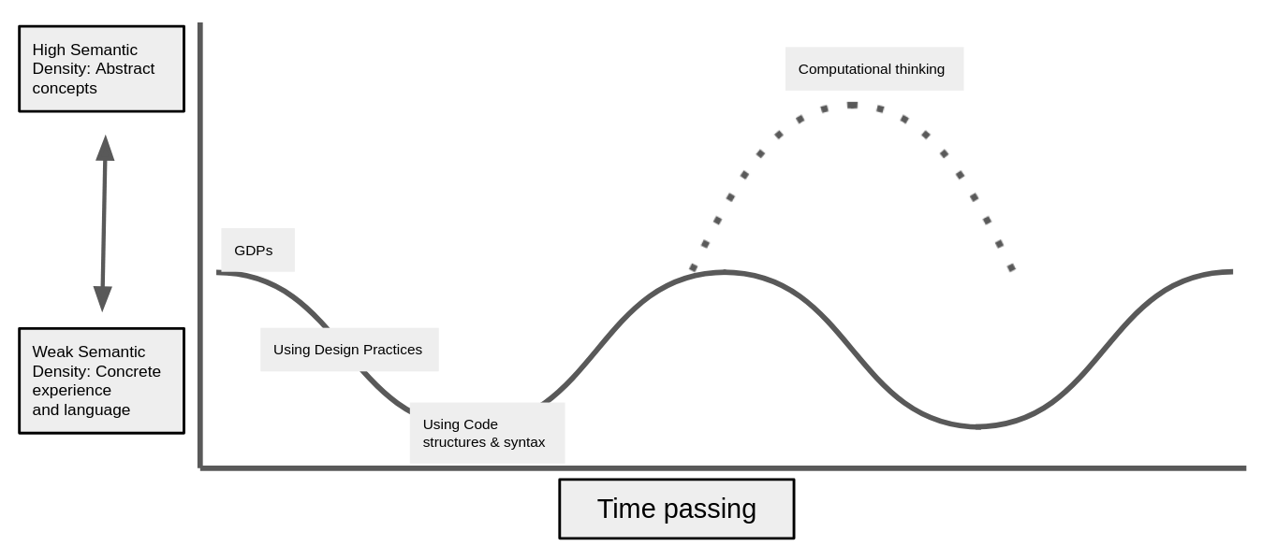
Illustration 7.x - Possible alternative semantic profile
In different contexts, the process of supporting students to follow the dotted path into areas of more abstract concepts could have been scaffolded further through guided reflective processes. As explored in Chapter 5, I explored modifications to the documentation to include candidate of the map of learning map dimensions in the initial descriptions of GDPS ( see Appendix.learningDimensions.)
A process to encourage this would be a gamification of the process of reflection, perhaps by attributing badges or points to the a successful reflection of different elements of learning dimension. The extrinsic nature of the process of gamification matches here the extrinsic contextual factors of examination-driven education. While this is a potentially fruitful area for future work, given the core context of non-formal learning of this study it was de-prioritised in this thesis.

Reflections on design in relation to other research - PERHAPS VIA PRIMM AND UMC? AND HOW DO DESIGN PATTERNS FIT INTO THIS PICTURE - SGD & DENNER (AS FORM OF ANALYSIS)
While, the table of uses of GDPs in Chapter 6 focuses primarily on value for learners there are aspects which are relevant to facilitators or teachers in either non-formal or formal settings.
Turning to the utility for designers and and facilitators, it follows that the concerns above are also relevant for this group of stakeholders in terms of supporting learners. GDPs can also be useful for wider pedagogical and analytical motivations. One such motivation is the ability for a solid understanding of GDPs to open up exploration of other concepts.
Such a possibility returns to a tension in research on project-based approaches to digital making, in finding appropriate level of scaffolding (Quintana et al., 2004; Waite and Sentance, 2021). The use of conceptual and practical frameworks to scaffold domain specific working practices can help ameliorate the dialectical tension between engagement via tinkering and requirements to promote “principled understanding” (Barron et al., 1998:63).
Turning more specifically to the utility of the identification of structural use of GDPs as a germ cell concept, this break through facilitated the development of different progressively graded objectives (recognition, use and modification), as a concrete instance of UMC principles, which helps address the tension between freedom of choice of learner pathway, and expression of interest within a manageable technical structure (with relevant supporting documentation).
The structure synthesises element of scalable game design (SGD) and Use Modify Create (UMC) pedagogies.
Similar to SGD a progressively stepped approach is taken here. These varied forms of documentation, and their varied adoption and propagation represent different approaches to scaffolding the process of becoming familiar with and then modifying to the code in often increasingly ambitious ways.
While SGD was limited in participant pathway choice, my design is not. Following the rationale of choice limitation as a strategy to reduce facilitator stress (Lytle et al., 2019), this design using a limited menu of GDPs as a structural and navigational framework.

Summary of structural components of applied pedagogy - REEPP & A gateway view of learning dimensions. MOVE DISCUSSION UP
This technical structure synthesises use of a code playground, game library, a half-baked game template, UMC pedagogy, and the use of a collection of game design patterns. While similar approaches exist this pedagogical structure is innovative in the way systemic tensions have been resolved and congruencies introduced. I propose that key elements of this pedagogy constitute a replicable approach which is a valuable contribution to coding education. To communicate the essence of this structural, technical model I propose an acronym remix enabled, elective, progressive, pattern patching (REEPPP).
REEPPP Letter | REEPPP Term | Description
RE | Remix Enabled | Project formation is accelerated, limited and scaffolded through the use of a structural starting template in a recognisable project genre.
E | Elective | Participants have choices over their learning pathways in dimensions of content and design patterns to be added.
P | Progressive | The processes involves progressive steps. In this case pattern recognition through exploration/play, quick start activities involving minimal changes with high impact on the project outcomes, using progressively more challenging documented patterns, finally implementing patterns without support
P | Pattern | The process has at its core the use of recognisable design patterns which are presented together with suggested design solutions and concrete code snippets.
P | Patching | The authentic technical process of code patching accelerates production and creates errors suitable for debugging at a novice level.
The above summary has been written to be applicable to projects beyond the use of games.

Reexaming the use of GDPs from intermediate-level knowledge (to a gateway framework)
MOVE LATER? AND DEVELOP WITH REFERENCE TO SOCIAL AIMS TOO? NO - KEEP HERE AND FOCUS ON PERSONAL AIMS FIRST.
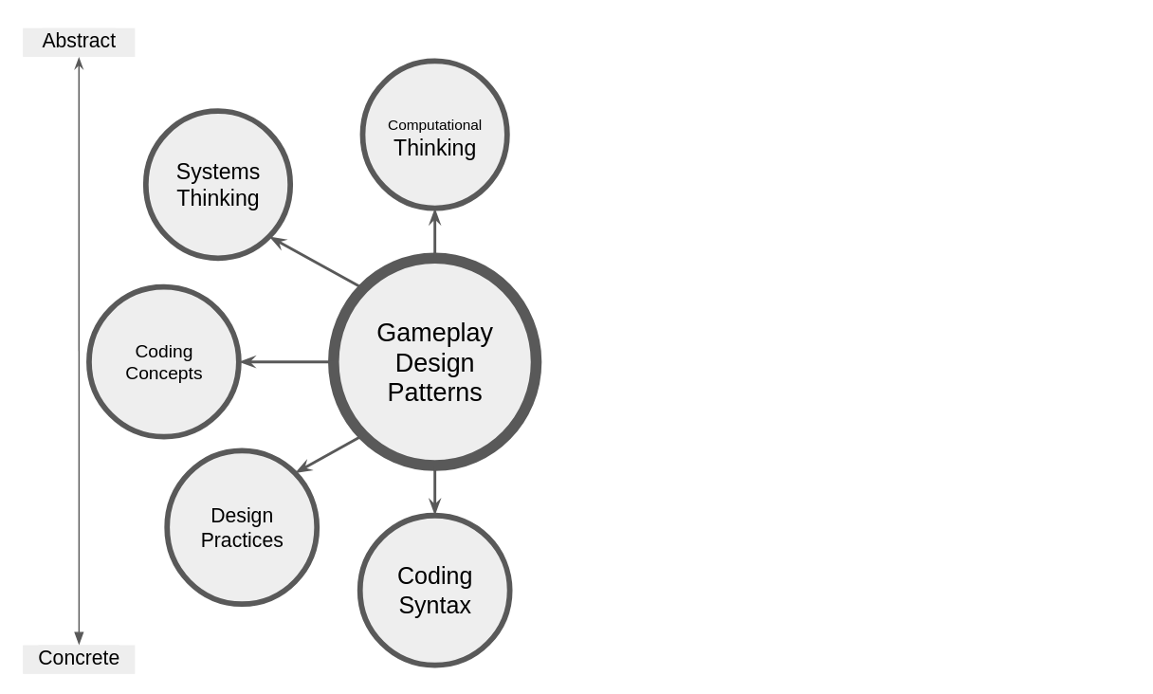
Illustration 7.x - GDPs as a pedagogical framework
MOVE SOME OF THIS UP TO THE REEEPP SECTION - KEEP FOCUSED ON ABSTRACT / CONCRETE.
Within this line of inquiry concerning navigation of different levels of abstraction within this process, the characteristics of such a pedagogical framework would usefully include the following elements.
The process guides learners to use GDPs as their primary leading activity or object of activity. - Use just in time personal instruction to provoke reflection or to link abstract concepts with code in play - Can be supported via gamification
THE MAIN POINT IS ABOVE
MOVE THIS ASPECT? PERHAPS KEEP SOME ? - Secondly, a working code framework or template is provided with affordances strongly coupled with object output, providing immediate feedback.
Thirdly, just-in-time supporting resources are provided, closely aligned to the sub-goals of GDPs. Finally, this gateway framework may also facilitate reflection on its use, and reinforcement of this process can be structured using supporting tools, such as a learning map (see appendix.learningmap for an example in P4).

Link to next section - limits of this personal dimension approach
My research data shows the value of the REEPPP approach, structured around the use of GDPs, to access and facilitate dimensions of game making associated with both concrete and abstract knowledge and practices.
Broad descripton - SUMMARY OF UTILITY - DOES THIS LIVE HERE? For participants, the GDPs facilitates goal formation. Once engaged with this goal, participants can use the affordances of the design to traverse different LOA without explicit instruction in the process of playtesting.
This analysis of the use of GDPs through the lens of research on the abstract and concrete dimensions in computing education, there is an alignment with the personal dimension of knowledge highlighted in the previous chapter. This line of research also opens up other dimensions
The scaffolding provided by the template and the close coupling of the purpose, description and implementation of each GDP accelerates and supports the making process which in turn allows for greater possibilities of social and cultural making via playtesting outlined in the following section.
Thus the structural elements of this design facilitate the kind of relational pedagogies originally advocated by Papert and but which have too often been missing from research in this field.
The following section develops an analysis of the findings from the last chapter, outlining the potential of GDP concepts, especially within playtesting, to support these participant shifts in perspective. The following section addresses the social and cultural aspects of this study, using the development of varied forms of participant agency as an analytical lens.

Part Two - Agency, and re-mediation of repertoires in third spaces
Revisiting - Motivation and gaps in research:
The motivation of this study transcends concepts of efficacy of how to support the technical aspects of coding process.
At this point we can readdress one of the gaps addressed by the problem statement of the thesis: The lack of studies using socio-cultural perspectives to facilitate an agency based approach.
As noted in Chapter 2 (Kafai and Vasudevan, 2015). Despite Papert’s (Lodi and Martini, 2021) foundational focus on the community application of created projects continues in legacy of constructionism. For example, the articulation of Resnick on computational fluency, addresses the limitations of research focusing too narrowly on technical approaches and toolsets rather than their expressive potential (and thus within a community) and focused on toolsets rather than pedagogies (Resnick, 2020; Resnick and Rusk, 2020).
In a UK computing education context, while the work of Waite and Sentence begins to address sociocultural aspects of teaching programming (Sentance et al., 2019b; Hwang et al., 2023), but as explored in Chatper 2 this work is limited in scope and invites further exploration.
Why agency in particular revisit / gaps
Given that a guiding motivation of this study to explore the process of designing and facilitating for participant empowerment in learning to program, it is valuable to explore terms.
Chapter 2 examined varied concepts and characteristics of fluency in constructionist research, and concepts of flow. Chapter 6 explored these concepts in relation to the data of this study and found agency to be better aligned to a socio-cultural approach.
Setting out pathway - & thread for reader
Firstly, an exploration of evolving expressions of agency emerging from the research data, specifically instrumental, transformational and relational agency, is undertaken.
The second section is an exploration of the key characteristics of participants agency using concepts from the work of Rogoff, Cole and Gutiérrez to re-examine the evolution of participant agency as a utopian process of blending or even patching of repertoires of different types and sources.
CHANGE THIS It concludes by proposing that understandings of CGD&P pedagogies can be enriched in two dimensions, firstly in design and secondly in a deeper theoretical understanding of concepts of agency development.

Instrumental and transformational agency
The exploration of tensions in Chapter 5 summary, design decisions of tool use can to increase agency in practical terms by providing affordances or by removing barriers to use. Conceptually these practical dimension can be framed as instrumental agency or removing aspects of negative liberty caused by technical barriers (Matusov et al., 2016:433). Chapter 6 outlined examples of mediation and instrumental agency in the use of GDPs aligned often with a personal appropriation (are shown in varied forms in Table 6.1). The process of abstraction of complexity explored above would also fall into this category. Examples of designed attempts to facilitate instrumental agency would be steps taken the resolution of tensions surrounding authenticity of coding web development language, coding environment and documentation.
A distinction can be made with and a transformative agency (Isaac et al., 2022), in that expression of instrumental agency are unlikely to provoke environment changes in the activity system at hand. Thus instrumental agency in education can be viewed as an uncomplicated view of mediation as a means to achieve pre-set goals. Thus designing for instrumental agency is often framed within an instruction or school setting.
In line with collective conceptions of agency explore in in Chapter to, transformational agency may stem from transcending individual motivation but also involves a transformation to systemic constraints. As outlined in chapter 3, Sannino explains TADS using a metaphor of a using a kedging anchors (Hopwood, 2022). In this metaphor the act of casting out the anchor is a visible act of volition which aims overcome conflicts blocking activity progress.
While affordances for mediation in conceptions of instrumental agency may be visible within the learning community, this metaphor encompasses a sense of the exploratory nature of the transformation, and that the leverage or catching point for change may not be immediately visible to activity participants in the activity system. The process may serve to surface previously unknown forms of mediation and use of tools not only for those undertaking this volitional activity but also others in the learning community.
Understandably, examples of this process in the research process were prevalent in early stages where participants had access to little in terms of supporting resources. Illustrative attempts of TADS are present in (Appendix.design.p1). For example, email correspondence from myself to participants asking for help in organising project work resulting in the emergence of list of proto-typical GDPs. Additionally the process of leading with exploration of a half-baked template was an experimental response from feedback from participants requesting more hand-on work with the tools before beginning planning. Thus emergence, via interaction between participants and myself, of and the use of a half baked template and GDPs as a suggested leading activity and pedagogical framework is a manifestation of transformational agency.

A dilemma involving engendering for transformational agency
In the introduction I outlined that a driving motivation of this research was to better understand chaotic learning environments, of which P1 is an example. To engender transformative agency, a suitable starting point should be sketchy, half-baked or incomplete pedagogy and tools set.
Then as a designer and facilitator, I would help participants to lead design decisions to reduce practical tensions, increase the instrumental agency of learners allowing them to experience a feeling of control over their creative process. However, in adapting designs, and thus increasing affordances and instrumental agency here is a danger of designing away the possibility for transformational agency.
To retain this potential for transformation it may be advantageous to keep some key areas of the learning design should be more open in structure to encourage the emergence of participant responses and novel practices.
In later stages, evidence of this exists, beyond P1, there were still spaces for TA once the core pedagogy is in place. For example, in Vig. Tody and Dan the break out of the template to create a different genre.
In early stages I propose one of the roles of the facilitator to make available a variety of affordances in terms of types of activities and materials available for facilitate the process of double stimulation.
Not everyone loves such open sketchy learning environments. Some find it confusing and potentially overwhelming, posing a danger that levels of stress for participants may reduce the inclusivity/ Thus, the role of play and other processes to create an inclusive, low-stress environment are beneficial to participant feeling able to experiment with new forms of mediational strategies and thus enact transformational agency.
This realisation led me to increased scaffolding and to begin to recognise and value other manifestations and characteristic of emerging agency.

Relational agency
The process of developing new repertoires is not a solo process. The complex relations between participants outlined in the vignettes and data of the last chapter, in particular that in guided participation and cultural activity, demonstrate interdependence characteristic of relational agency.
Edwards (Edwards, 2009) explores relational agency within a CHAT framework as transcending individuals capacity to encompass collective problems solving via specialisation and diversity of approaches within activity systems. As a collective participants can overcome systemic contradictions via expansive learning, rearranging working relationships and thus opening new forms of relational agency. This concept is illustrated by the importance of feedback in community making and tinkering activities leading to increased “relational expertise” in partipants (DiGiacomo and Gutiérrez, 2016 , p.144),

Shifting forms of agency
This interpretation highlights possible shifts in forms of agency and an emerging dilemma in the evolving learning design. Initial blocks are solved by transformative agency, patterns and tools become established in the community, and agency shifts to and more instrumental.
Name | Transformative Agency | Instrumental Agency | Relational Agency
Characteristics: | When participants are blocked from progressing or what to move their work in an new direction | Instrumental agency is present in the straight-forward mediational use of existing written instructions and in-template affordances. | Relational agency is present in the interactions between participants asking for help, sharing developing expertise, and via incorporation of home interests in new repertoires of practice
When shown: | In P1 before written instructions were available. Also in P3 when diverting from the existing template paradigm (V?). | Present from P2 onwards. | Relational agency is present in P2 where forms of it emerge organically during playtesting and in P3 where it is also structured by introduced activities
Examples: | In P1 participants suggest the use of lists of features as a key organising tool, a process culminating in a collection of GDPs. In P3 Toby and Dan make a maze game instead of a platformer game (V?). | Examples: in use of quick start activities, and in V2 Toby use of written instructions | In the following vignettes
Table. 2.x Characterisation of types of agency in the design
NOT SURE ABOUT THIS TABLE - I’VE KEPT IT IN AS A POSSIBILITY IF SUPERVISORS THINK IT COULD BE USEFUL

Reframing findings using socio-cultural understandings of agency and repertoire blending

Revisiting understandings of relational agency and repertoires
This section moves beyond instrumental and transformative agency to a wider more ecological interpretation of agency helpful in deeper analysis of the cultural plane of activity. In chapter 6 we examined the complexity of the expanded object in this research, noting the diversity in terms of motivations and mediational strategies using 3GAT terminology (Engeström, 1996). The following section builds on the foundation of 3GAT in terms of conceptions of interacting activity systems (Engeström, 1996) using concepts of repertoires of practice and third spaces.
Previous observations highlighted an emerging idioculture [LOCATE THESE ON WALL]. Gutiérrez develops this idea with a space-based concept for such emerging cultural activities in the form of third space theory. Third spaces for Gutiérrez are collective zones of proximal development, which can be both an specific environment and/ or a process within existing contexts supporting a hybrid approach where formal and informal repertoires are blended in collaborative work on an expanded object with an aim to ADD IN?.
To augment this setting related concept, Rogoff and Gutiérrez (Gutiérrez and Rogoff, 2003; Kris D. Gutiérrez et al., 2019) use repertoires as a lens to contribute to discussion of expansive learning in CHAT as a positive enacted demonstration of diversity and equity.
The following section reframes my research data using concepts of repertoires and third space via attention to issues of participant identity and movement of practices between learning settings. The overall goal is to communicate a diversity of participant repertoires (Gutiérrez et al., 1999), via mediational tactics and resources in learning contexts in order to answer the research questions RQ.P AND RQ3: most specifically clearly in identifying and nurturing dimensions of agency formation in this research to contribute to the field of CGD&P.

A - Repertoire importation into the the game making community
Following Gutiérrez’s (2008; 2019) concept of learning as movement between spaces, key observation from the data of the previous chapter can be reframed as repertoires that existed on other activity systems and that are imported into a new activity happening in an emerging third space. While this commentary draws on some examples highlighted in video recordings used in Chapter 6, it draws mostly on interview data which allows a greater precision in locating the repertoires as pre-existing in other settings rather than being rapidly developed in the new setting. Two key themes of repertoires emerged, those of repertoires involving funds of knowledge and repertoires involving divisions of labour.
Addressing first repertoires involving divisions of labour, Barron’s helping roles (Barron et al., 2009) in technology use (teacher, project collaborator, learning broker, nontechnical consultant and learner) are present from initial stages. These these roles are illustrated in observed practice or in interview data. EXAMPLES
In video data and interview data with Susanna and Tehillah, the parent details how she is able to support her child based on her home knowledge of working styles and the use of paper to help the child sketch (see Vignette 2). The paper prototyping as a home practice imported to this space is also cited by Mark and Ed in interview data (see Interview.2.a )
In addition, other divisions of labour which highlight the emerging roles of young people are present the data. For example, in Interview.1.c Madiha(p) describes Nasrin(c)’s strong preference for independent working which her mother Madiha respects and accommodates. This game making program set an expectation parents to get involved with the game coding as well as young people. Maggie shares her thoughts on the changing nature of Home Education communities, that parents are now more passive and think of their roles as arranging tutoring for their childrens, whereas she is more aligned with a DIY approach, and keen to get involved. Anastasia (P1.debrief) also shared reflections on the issues of family and home education dynamics, suggesting that parents may get in the way of young people’s ability to move into other’s spaces to learn things, and that parental helping roles may therefore be a hindrance.
ANY MORE/ PERHAPS NORMS
Turning to funds of knowledge and interest, present in the areas of game playing interests, art, environmental and other global concerns and professional knowledge. For example, some adults imported knowledge from professional communities or previous studies, for example Maggie had studied Pascal previously and Dan brought practices from work and from volunteering at Coder Dojo.
Movement of repertoires was also well illustrated in the mobilisation of game related knowledge. In Interview.2.a Nasrin shares some of the links between Minecraft practices and graphical asset authoring in the Piskel software. Madiha shared that via joint game making she was now more aware of an involved in Nasrin’s gaming activity.
Early in the P1 and P2 process participants were able to incorporate some of their concerns about wider ecological and global issues in the planning of their game narrative. In interview data Madiha (Interview.2.b) describes her own choice to address social media, Nasrin’s choice to make a game on sea pollution and Xavier’s topic of AI robots taking over the world. On a smaller scale some participant chose their hobbies or fan interests as game subjects: Ed choosing trains and Maggie, Pearl and Grandad choosing beekeeping. Interview data surfaced the identification with art as a hobby practice by Ed, Nasrin and Madiha. This was echoed in video data where both Madiha and Nasrin appeared to favour working with graphical elements and bringing characters to the game. Madiha created a collage which she brought in to use as the game’s background.
For some participants the process of blending their interests with those of the game making program began immediately and intuitively as illustrated by Mark(p)’s comments on Ed(c)’s use of the Piskel graphical art editor (Interview.2).
From P2 onward the use of a half-baked game as a starting point also allowed FoK to be mobilised in several ways. The knowledge of what was normal in such a platform game, the use of gravity as a known concept in variables. And motivation to change such a game and personalise it via the graphical matrix.
Similarly, the findings of Chapter 6 show some initial uses of FoK and DoL that met this description of initial blending with GDP concepts. For example.

B - The process of blending of repertoires in a third space
Other processes took longer to emerge, requiring more active effort to incorporate.
Drawing on the concept of zones of proximal development, Stone and Gutiérrez (Stone and Gutiérrez, 2007:51) underline the importance of explicit creation of “zones of competency” where learner’s identities can develop. In this learning design, several facilitator suggested processes and technical repertoires served this purpose. These included process explored in Chapters 6, Namely goal formation using a menu of GDPs, code patching, following documentation and debugging.
One intervention already described in Chapter 6 was the structuring of GDP collection around the MDA game framework as a way to allow choice of different approaches drawing on aesthetics, dynamics and mechanics of the game.
The varied use of documentation has already been explored in Chapter 6.

Playtesting as a suitable medium for emerging activities creating third spaces via blending of repertoires
The process of playtesting, beyond a technical evaluation phase of design thinking and user testing in HCI (Fullerton, 2018), took on a role a stimulus and incubator for facilitating the emergence of new blended repertoires.
DROP? OR REREAD. MOVE TO ANOTHER SPOT. The role of play as leading activity is explored by Gutierrez (Kris D. Gutiérrez et al., 2019) to facilitate movement between sites of learning (Addressing issues of motivation and positive affect, ).
NOTE - ADD ANYTHING MORE IN THIS BIT SECTION B? Section B - is more personal and guided participant with parents. Not fully tbf
But C is more cultural, emerging visible identities, specialism and making styles and interventions to support that process.
Noticing Emerging identity formation and specialisation apart to facilitate relational aspects of the blending process
Turning to supporting varied identities in playtesting, In P2 playtesting noticed naturally emerging behaviours that increasingly idiosyncratic.
Playtesting played a role in the surfacing and opportunities for this specialism to propagate. I observed both initial styles and evolutions of the form and function of playtesting by participants.
The emergence of new forms of identity within the idioculture is particularly significant to this research given the barriers participation in programming communities explored in Chapter 2.
It is of note to make a distinction between the leverage of existing competencies and interests as repertoires (explored above ) and the emergence of new ones.
The process of new identity formation via repertoire blending is explored here via the concept of specialism.
The process of feedback, recognising and valuing the merging areas of specialisation and expertise helps the development of diverse practices (DiGiacomo and Gutiérrez, 2016). The specialisation contributes to possibilities of relational agency for the learning environment as a whole. It exists as a form of identity within an individuals repertoire and for others to draw on as an affordance of the learning system.
These repertoires become public, and are in part socially motivated, via the process of playtesting.

Specialism and expressions of identity in variations in approaches to game making and playtesting
Playtesting surfaced design practices and amplified emerging specialisms.
Within more narrowly defined game making activities centred around altering code and assets of their products, learners who had mastered certain specialist skills were asked by others for help. Their developing roles as domain experts provided additional affordances in the learning community and building an identify as specialist within it.
MOVE TO SECTION A? Some decided to focus extensively on the creation and implementation of graphical assets and level design being motivated by narrative placement in the game via GDPs
Some approached game making objectives in a methodical manner (see Vignette V3.c), picking up technical processes from documentation and interaction with facilitator. Some participants refrained from extensive testing of other games, waiting for others to test their games and carefully observing their responses. Others were very social in their playtesting approach.
Others socially motivated used playtesting interactions to build affective relationships via kind and supportive feedback and personal identification with created characters. Madiha for example often said how cute the characters created were. The last chapter showed that some participants used playtesting as a way to gain idea of what to add to their game next and to ask for direct help in that process.
Others embracing a playfully disruptive stance. Playtesting times in particular surfaced design practices which some participants involved breaking conventions game design norms of the genre, as a way to cause frustration or confusion, illustrated by Tehillah’s behaviour in (V2).
Some children added additional playful elements to playtesting (see Appendix.playtestingtypes). Some in particular brought a physicality to the process, clustering in a particular zone of the class, referencing the game play elements, acting them out, attempting to change the games of others and playful tussling as part of resistance to those changes.
Link from noticing to then supporting The diversity in playtesting behaviours drove my reflection on the relationship between developing effective repertoires and an affective relationship to the activity relies on the participants being able to identify with the ongoing activity (thus informing a processes of inclusion)
As, the area of explicit cultural creation of spaces is under explored in existing research in CGD&P, it is of value to explore the process of explicit learning design for identity development within via repertoire blending.

C - Supporting emerging identity formation and specialisation through interventions to support relational repertoire blending
The above prompted me to ask if suitable affordances be added to the design to encourage their further growth in line with Gutiérrez’s valuing of the diverse properties of hybridity in practices as a way to increase the inclusive potential in non-formal, educational third spaces (Gutiérrez et al., 1999).

Helping styles and helpers
Rogoff and Gutierrez’s initial motivation in their exploration of repertoires was to challenge simplistic, overgeneralising approaches regarding learning styles especially if applied to non-dominant communities (Gutiérrez and Rogoff, 2003). The researchers highlight the value of identifying potential funds of knowledge framed as “linguistic and cultural-historical repertoires” that learners bring to learning environments (Gutiérrez and Rogoff, 2003:22).
Inspired by the work of Barron and Roque (Roque, 2016; Roque et al., 2016) to begin to surface and nurture making and helping styles. The use of these roles by facilitators reinforce a existing competence in a new space.
I extended this beyond parent roles and identity to include all participants, via design as well as feedback, with a similar aim to engender a feeling of domain competency.
Roque (Roque, 2016; Roque et al., 2016) employed Barron’s helping roles (Barron et al., 2009) in guidance for supporting facilitators to highlight and celebrate the helping processes parents used to support children in a making environment.
Student helpers as vectors and reflectors
One of their remits of student helpers in P2 and P3 was to support the work of participants and to guide reflection during making and playtesting by asking simple questions like “What have you been working on?”, What are you working on now. What do you want to add to your game. MOVE? Beyond this, students also gave feedback between playtestings sessions, connected different participants, and input into the design process via debriefing sessions.
Especially in the potential to replicate family supportive behaviours with non-expert facilitators in a volunteering settings, specifically with bespoke guidance to support game making.

The introduction of side missions & maker types to make visible emerging repertoires as cultural affordances of my pedagogy to increase and legitimise diversity / hybridity
The awareness of and conversations about maker styles and related side-missions created in this research are potential powerful tool to support this process in novice game making communities.
Side missions
Side missions explored in Chapter.5 and Appendix. x?
The process contextualises and legitimises the previously peripheral activities with the groups conceptions of the idioculture of the wider activity. This recognition of the hybridity of possible modes of participation increases conceptions of enacted diversity of the community.
This strand of thought also invites an theoretical examination of the value of identify formation via the blending of repertoires of play and design approaches.
The invitation to play, can be seen as a familiar affordance leading to more unfamiliar territory. A helping process in blending through opening a door to a new collaborative zone of proximal development.
Maker types
As explored in Chapter 5, to aid group reflection on, I grouped and shared a loose typology of participant approaches to playtesting and game making approaches in to social makers, planners, magpie makers and glitchers (see Appendix .makertypes for fuller detail). This typology extends the styles of planners and bricoleurs (Papert and Turkle, 1990) and broadens the focus to include playtesting as well as coding behaviours.

Implications for design and summative design frameworks

Designing for relational agency by repertoire blending (RARB)

What is RARB
Relational agency by repertoire blending (RARB) is a term that I advance to describe a process happening in this study. I advance it as there is no real equivalent to TADS (transformative agency by double stimulation) as a concept in the work of Rogoff and Gutiérrez upon which the second half of this chapter is based. RARB is a process which in this study can be best described via three stages.

Narrative descriptive of a proposed procedure for facilitation relational agency by repertoire blending (RARB)
In stage one the motivation is to create an inclusive learning environment where participants are able to import existing repertoires from other spaces in the form of competencies and interest. For some participants this may involve the use of designed affordances in pre-planned (by the learning designer) ways via instrumental agency, or they may cast around to find novel uses of affordances present in a process of TADS. As participants load their existing repertoires in the use of new tools a process of blending is already in process.
Stage two involves both a natural slow stewing of these repertoires in the melting pot of new third space (e.g. the game making sessions) into new repertoires. In this research the repertoires blending process leading was facilitated by the favourable conditions provided by regular playtesting and other playful elements of the programme. These emerging making behaviours and specialisms involving interests and helping behaviours resulting from manifestations of instrumental and transformative agency may start to propagate via playtesting and other social and cultural interactions in the space.
In stage three facilitators can recognise the use of novel and begin to help other participants to use that same processes by incorporating them into the learning design or in some way highlighting the possibilities they offer. The role of the facilitator here involves adding yeasts or other accelerants to allow the body of the emerging idioculture grow faster by making relational, socio-cultural affordances more visible to all participants. The culture should be kept warm by checking that such processes are not overwhelming, that they are optional, and maintaining a playful environment at this stage to allow this form relational agency to flourish.

Specialism - INTEGRATE ABOVE
It is of value to examine specialisation as a form of agency and new identity formation.
It can be seen through the lens of double stimulation. The choice to specialise, marks a form of transformative agency. Participants craft for themselves a specialist status which becomes shared and celebrated by the group.
Thus transformation is happening here but not in a revolutionary way. It is more of a blend of practices. In my data this happens in vignette data we can see elements of personal interest of young people, of home education collaborative work patterns, and of practices introduced by the facilitator from professional and educational contexts.

Summary of discussion on designing for agency - INTEGRATE ABOVE / BELOW
INTEGRATE IN THE RARB TABLE
Agency in this in game making community is seen as multi-dimensional and as a process located in community participation rather than an individualised property.
A straight forward manifestation of agency stems from the importance of the collection of GDPS as a guiding activity. The resulting choice over learner pathway helps transcend limitations typical in instruction based approaches.
Beyond that element of choice, development of relational agency is a part of the social and cultural aspects of repertoires development, which can be aided by the use of techniques including: - explicit structuring of playtesting with side missions - implicit pedagogy of supporting maker types - and parental helping roles.

Summative table illustrating stages of facilitating RARB in this study
In Chapter 5 a summary table outlined tensions and congruencies. In Chapter 6 a summary table of the varied uses of GDPs
The purpose of this table is geared more towards synthesis of approach in relation to creating relational agency through repertoire blending. As such characteristics and descriptions are more decontextualised.
Characteristics of design | Design example and description
Stage One - Facilitating participants to import existing repertoires of practice
Allow quick demonstrations of game knowledge | Quick start activities scaffold learners to alter game players allow learners to show competency
Encourage early use of art and music abilities via scaffolded tool use | Learners interested in art can use an intuitive pixel art and music editors to quickly integrate their home interests in digital creations.
Stage Two - Engendering blending of repertoires
Protection from complexity via technical limitations | Participants benefit from more relaxed making environment as key design complexities are baked into template design
Try to create a level playing field between generations | The use of an unfamiliar text coding process for both YP and adults created a more horizontal power relationship
example 1 | example 2
Stage Three - Recognising and encouraging emerging specialism and identity behaviours
example 1 | example 2
Table 7.x - Summative table illustrating stages of facilitating RARB in this study

Metaphors as a way to communication dimensions of agency design concerns
The previous sections have explored a complex and multi-faceted view of participant agency in this learning design. Before undertaking a fuller summary in the final section of this chapter, this section reinterprets some of these aspects using a metaphorical approach. The use of metaphor here has two functions. The first is to help deepen my analysis via a move to the abstract, searching for communicable generalisations. Secondly, given the multi-faceted nature of the pedagogy, and bearing in mind previous reflections on the value of an utopian approach to communicating the future possibilities of findings (Gutiérrez et al., 2020; Rajala et al., 2023), I draw on metaphors as a framing tool to present an initially simplified viewpoint for further discussion. The discussion will draw from the core principles in Table 7.x to aid the accessibility of this research for an audience of practitioners as well as researchers.

Harbours as both protective and authentic
The intrigue of opening up previously mysterious areas and seeing or experimenting with what makes them tick, often referred to as looking under the hood, applies here in the early stages of the learning experience. The process of clicking remix to fix a broken, half-baked game involves entering unfamiliar and potentially exciting waters. However, the motivational impact of an authentic process and set of tools must be balanced by possible accompanying complexity (Nachtigall et al., 2024).
Harbours are protective spaces suitable for docking ships. They may be natural or designed. If designed, protection is offered by artificially created harbour walls extending out into the sea, creating a sheltered space, preventing large waves from entering but also allowing movement out into the open sea. Harbours provide the possibility for refuelling or maintaining sea vessels and infrastructure to connect to rail or road links for transport inland. The term harbour is used metaphorically to indicate a space of safety, nurturing, and a gathering space f
While this design uses an authentic, professional text-coding language with its inherent challenges, many other design decisions in this study were made to create a supported, simplified coding environment. Relevant examples from the previous chapter include: using an online code playground; shielding learners from the underlying configuration of interrelated web technologies; removing or obscuring structural code complexity in the code template.
The practice of starting from a template mirrors professional practice. The goal being to shield new users from the complexity of the underlying configuration of interrelated web technologies and instead highlight design affordances that facilitate creative agency. This strong alignment with authentic, professional practice may help learners transition from a supported harbour to venture out into the open seas of less supported research and practice.
An example of this being Toby and Dan in Vignette X. who, in their choice to change the game genre from platformer to maze game, leave the safety of a set of design patterns and paired support documentation. Instead, Toby must develop his code patching skills in choppier waters by accessing more authentic documentation and charting their own patterns in the open sea of internet-based resources. This is made possible by having an experienced navigator with him, in the form of a parent with relevant skills. I propose that the curated replication of authentic processes of finding and incorporating code snippets into the starting template supported the development of skills used in the authentic waters of professional coding communities.
In terms of agency and choice over learner pathway, we can see that the safe nature of the harbour encourages free exploration within its area. There are limits to the rhizomatic nature of this exploration. The boundaries of the harbour walls represent the restrictive decisions in terms of the genre of end product, and simplifications in code structures used. The following section explores the restrictions (e.g. in genre) from a perspective of the creative potential of such limitations (Rosso, 2014).

Spaces to play - playgrounds and jam sessions
A similar metaphorical dimension of protection is present in metaphors of play spaces, a link which is immediately present in this design in the use of code playgrounds (web-based environments which reduce the complexity of web development and provide immediate feedback and community). Additionally, the process of checking the performance of games is called play-testing, with connotations of a playful, and therefore social space. Similarly, the term sandbox is used extensively in web development to indicate a safety in terms of non-critical space to trial new code and make mistakes. As with harbours, a space of play space evokes protection within designed limitations (Rosso, 2014), but beyond that they provide affordances to encourage learners to evolve their own play processes as a form of transformational and relational agency. The concept of musical play within jam sessions is a productive way to explore this tension between freedom and structure.
In the previous chapter, I explored the flexible nature of emerging design behaviours and proposed them as a form of improvisation or jamming. Jamming, a term common in music and theatre, describes responsive, improvised, rapid and fluid responses to collaborators’ ideas and audience reactions (Sawyer, 2003; Pinheiro, 2011). The area of improvisation is underexplored in the game jam context compared to that of music and theatre (Jaffurs, 2004; Meriläinen et al., 2020). The following section makes a closer parallel in the context of the data of this study.
On a macro-level, at a jam event, infrastructure in terms of drums, microphones and amps are provided often by established regulars of the process. A jam on a micro-level is an introduced, familiar framework, restricted in that it is based on a familiar, popular song (often referred to as standards), within agreed genres (most often blues and jazz). The short structure of a song and the key in which it is performed form a base guiding improvisation. Within a jam process, bringing your own style to build on that structure is welcomed. The process is augmented by the group element of the musical jam, where music makers pick up techniques from others in the process. Visual and verbal encouragement is often present in successful jam nights to encourage newcomers. If a jam session is regular, local popular standard songs emerge. This provides opportunities to hear them played regularly, allows potential participants to hear them versioned before entering, a useful form of peripheral participation.
Several parallels to the design and processes in my research exist. The half-baked game template can be seen as a shared song framework that participants build on in idiosyncratic ways. The value of a process that incorporates an authentic audience made up partly of peer makers is important for the development of repertoires of practice in both contexts. The value of the possibility to blend established repertoires with those brought by new players is a shared contextual motivation.
ADD MORE HERE IF RELEVANT.
The following table serves as a visual summary of some of the relevant space/place based characteristics relevant to the importance of this research.

Part Three : Synthesis & contributions to the field = EDITING DOWN OR MOVING TO CHAP 8

CCRREEPP & GDPs as a gateway pedagogical framework
This chapter contend that the underlying structure of the learning design in addition to support the social and cultural processes described above, is a valid contribution to the field as a technical pedagogical structure.
There is a value of attempting to integrate the holistic approach outlined in this research by unifying the strands of part one and part two of this chapter. To do this the structural element of the REEPP framework would need to be augmented with the socio-cultural elements explored in part two. To do this, I propose the lengthy but logical acronym: collaborative, culturally responsive, remix enabled, elective, progressive pattern patching (CCRREEPPP).

GDPs used as a gateway pedagogical framework aligned with RARB process
ADDING IN DETAIL FOR RARB - INTEGRATE - EXPLAIN RELATIONSHIP
The work of Quintana et al contains useful guidelines for checking the suitability of a framework to support science education (Quintana et al., 2004). In particular guideline x, and y can be identified in the use of GDPS in this research.
I propose that providing a menu of GDPs can, as with accessing more abstract concepts, act as a framework to facilitate to process of development of social and cultural repertoires of practice.
I suggest a change in terminology. Instead of interpreting design patterns here as intermediate constructs, I propose the term gateway pedagogical framework to communicate potential utility in opening up exploration of different dimensions of learning.
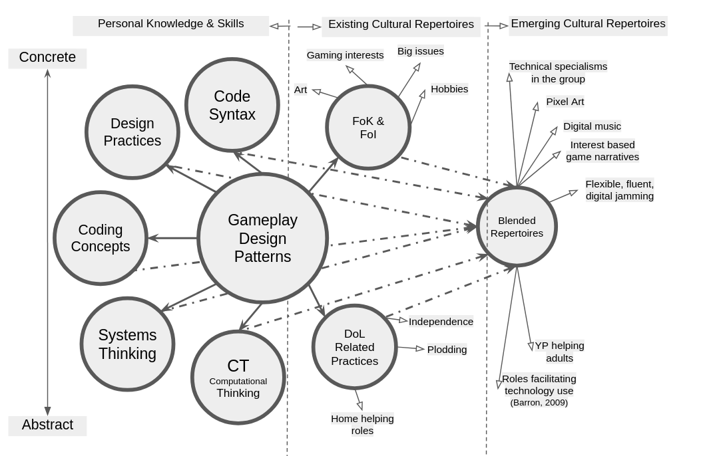
Illustration 7.x - GDPs as a gateway pedagogical framework
The shift from intermediate to gateway also addresses the issue of how to present the dimensions of abstract and concrete. Abstract concepts are often positioned as higher in a spacial representation. This is present in semantic profiling diagrams above, in y example, and even the phrase top-down planning from Papert and Turkle in their challenging of this privileging of abstract approaches communicates an implied superiority of approach. By way of contrast, the Mark’s phrase rising to the concrete reverses this polarity. Similarly, as a small attempt to challenge this convention I reverse the polarity placing concrete dimension at the top of the illustration.

Summary of the potential utility of GDPs for wider stakeholders
The evidence and examples surfaced in Chapter 6 and the previous section support a view that the GDPs can form the basis of productive research and pedagogical frameworks.
While the work of Eriksson et al. explored the utility of GDP concepts in several dimensions the focus was on utility for the research community. Instead this research outlines potential uses of GDPs participants and facilitators/ learning designers.
The value for facilitators is best explored by returning to the narrative of RARB in this research above.
Addressing utility for participants, in computing education, design pattern-based approaches have benefits in making complex problems more modular and concrete (Muller et al., 2004; Waite and Sentance, 2021).
GDPs are particularly helpful in participant goal formation, as explored in Chapter 6 in the sections on ideation and prioritisation. GDPs also help with the division of labour between collaborators, which is relevant here as when tackling more abstract processes, concepts, and terminology, these roles are often taken on by a more competent partner.

Conclusion
NOTE - As this chapter is ongoing this conclusion is in draft form. Feedback on what to include in this chapter conclusion is welcome.
- the place of this chapter in the narrative of the thesis
- the limitations or questions arising that may be addressed in the following chapter.
limitations/ further work
This work invites exploration of related issues of - inclusion as a lens
The final chapters aims to address this with recommendations for facilitators and researchers. The scope of the applicability is addressed as the findings of this thesis can inform the wider debate of how to best support project based learning in wider domains. Specifically the use of concrete design frameworks and step-based iterative project in scaffolding PBL.

