3. Theoretical Framework
- Theoretical Framework
  - Research Questions - April 2024
  - Introduction
  - Theoretical framework
    - Socio cultural approaches and the primacy of context
      - Conceptualising AT via foundational theory - IN INTRO OR LIT REVIEW?
  - The methodology of this study
    - Design-based research
    - Formative Intervention
      - Formative intervention as stimulus for expansive learning
    - Outline of the guiding principles of DBR and formative interventions
      - Principle: Mutuality
      - Principle: The importance of context
      - Principle: Finding suitable dimensions and units of analysis by focusing on objects of activity
      - Principle : Utility of research - overcoming the tension between the rich context and generalisation of results
      - Principle : Researcher take and active interventionist approach
      - Principle: Analysis of activity system through conflicts and contradictions between elements
    - Summary of Justification of choice
      - Ongoing alignments between DBR and the CHAT community / ethos
  - Methods used in this study
    - 3 planes approach - noting tensions and behaviours
    - Surfacing areas of contradiction in joint activity through method of double stimulation
    - Third spaces, idiocultures and designed systems as a research method
    - On affordances
  - Parked to replace or remove or rework
    - Why not use constructivism / constructionism

Theoretical Framework

Research Questions - April 2024
~1. What pedagogical tools and processes are available to support novices to overcome barriers to participation in game coding processes?~
- What _{barriers} contradictions arose in participation in this research’s game coding processes and what pedagogical tools and processes are available to address these contradictions?
- How can game design patterns support the development of coding practices with novices?
- How can learners build agency in an evolving community of game makers?

Introduction
This chapter describes:
- guiding theoretical framework
- the methods that make up the methodology
The methdology of this chapter is closely aligned with the activity theory concept of expansive learning within formative interventions. It also uses methods widely adopted in design based research (DBR)

Theoretical framework

Socio cultural approaches and the primacy of context
The focus of this study is on the construction of shared meaning and practices as part of an emerging community of game makers. To do this I adopt a sociocultural approach and specifically cultural historical activity theory CHAT in the form of design-based research.
Socio-cultural research and perspectives can be broadly described as…<Do Zotero Refresh: [@barnett_ecosystem_2019]>
An assumption underlying the approach is ” abstraction of ‘content’ from its ecological functioning (e.g., use within a particular situation) is likely to undermine its perceived value for any situation (Bransford, Brown, & Cocking, 2000; Nathan, 2012) or the learners’ belief that they are likely to do something meaningful with that which they are learning.”<Do Zotero Refresh: [@barnett_ecosystem_2019]> REWRITE
This primacy of context described above underlies much of the social turn of educational and psychological research. As my study seeks to address cultural factors which act as barriers to participation in digital making, it requires a method of research which allows the detailed description and evaluation of complex, emergent learning environments.
I have chosen to use activity theory as a base for the the theoretical framework of this study and to supplement it with the technique of design-based research.

Conceptualising AT via foundational theory - IN INTRO OR LIT REVIEW?
Foundation sociocultural approach which goes beyond a conception of transmission model of learning and embraces learning in context.
- Vygotsky (and friends) - foundational ideas - activity as unit of analysis - mediation via objects and ideas <Do Zotero Refresh: [@luriia1976cognitive]>
- Wertsch and Cole - community and context as vital in studies, role of cultural mediation in development, role of objects to study human culture (cole_beyond_1996-1?; cole_culture_1995?).
The vital role of cultural mediation in development (cole_beyond_1996-1?) which recalls a situating of pedagogies as a meditational strategy.
This clearly aligns with community-based digital making and the use of objects as mediated objects and creative processes which facilitate and constituent participation.

The methodology of this study

Design-based research
Design based research (DBR) is a varied discipline which can take a multitude of forms <Do Zotero Refresh: [@mckenney_educational_2021]>. The core elements include: research as an intervention, iteration, involvement of participants in the evolution of designs, and a flexibility of research outcome based on how events unfold <Do Zotero Refresh: [@easterday_design-based_2014]>.
Penuel <Do Zotero Refresh: [-@penuel_emerging_2014]> describes design based researchers as an eclectic in approach but that there are calls for more formalisation.
One of the key motivations of this approach is to produce educational research that has a high utility for practitioners through developing theory that is rooted in contextual practice and which can produce new pedagogies and resources <Do Zotero Refresh: [@cobb_design_2003]>.
The definition of DBR is evolving. Sandoval notes critique from some of the diverse methods at use <Do Zotero Refresh: [-@sandoval_conjecture_2014]>, but notes the alignment of approaches namely, “the joint pursuit of practical improvement and theoretical refinement; cycles of design, enactment, analysis, and revision; and attempts to link processes of enactment to outcomes of interest”
There are different strands of DBR some of which holder closer to the lab based approaches that DBR was initially conceived of to transcend <Do Zotero Refresh: [@brown_design_1992]>

Formative Intervention
This section explains the CHAT method of formative interventions and proposes this study as an example of a formative intervention.
Penuel <Do Zotero Refresh: [-@penuel_emerging_2014]> proposes the formative interventions as a useful term to encapsulate a CHAT process closely aligned with DBR.
It is widely used within CHAT circles, specific enough to capture the ethos of this research bur broad enough not to require complex clarifications on how it differs from more pescritive methods.
A key text here is Cole and Engestrom’s early exploration of two models (CL and 5D) of formative interventions designed to align with principle of AT <Do Zotero Refresh: [@valsiner_cultural-historical_2007]>
A model of formative intervention that has been addressed by much research is Engeström’s implementation of expansive learning in workplace environments, a set of processes applied in a workplace setting called Change Laboratory (CL) <Do Zotero Refresh: [@engestrom_putting_2007]>. The CL processes suits a formal workplace where there are existing concepts of Community and Division of Labour and Norms that have resulted in contradictions to be explored and resolved.
EXPAND THIS WITH EXAMPLES? kindergarten one below?

Formative intervention as stimulus for expansive learning
The role of the expanding learning can be applied to formative interventions. <Do Zotero Refresh: [@sannino_formative_2016; @engestrom_methodological_2014]>
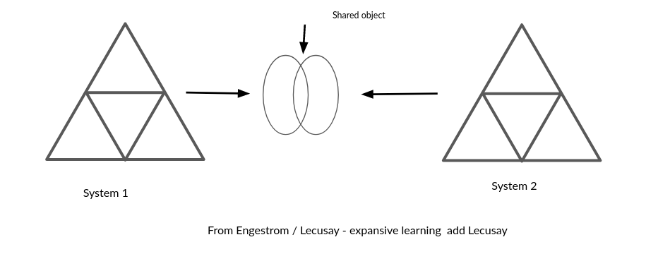
Figure 3. x - Engestrom’s concept of expansive learning via a shared object
Expansive learning leads to the formation of a new, expanded object and pattern of activity oriented to the object. This process, known as ascending from the abstract to the concrete, involves the formation of a theoretical concept of the new activity, based on grasping and modeling the initial simple relationship, the “germ cell,” that gives rise to the new activity and generates its diverse concrete manifestations (Davydov, 1990). From [@engestrom_design_2011]
REWRITE THE ABOVE? FOCUS ON EXPANDED OBJECT and the the role of the unit of activity in rising to the concrete and thus expanding learning
<Do Zotero Refresh: [@sannino_formative_2016; @engestrom_methodological_2014]>

The concept of germ cell is explore later in more detail in Chapter 5.

Outline of the guiding principles of DBR and formative interventions
This section addresses concepts common to DBR, and interventions of CHAT. The aim is to identify a working definition and terminology suitable for this study.
The broad alignment of DBR and the CHAT in terms of ethos and processes has been explored, including in special editions of journals(2014)
The process of researching a suitable methodology for this study surfaced of they key debates and issues of design based research and similar formative interventions in CHAT school. Namely:
- iterative and responsive design process
- the research process creates new forms of activity and associated resources
- the mutuality of the process: aligned with research ethic of participation rather than extraction
- generating both theoretical understanding and practical educational interventions suitable for sharing with other communities, be this via tools, process or a guiding pedagogy
To help explore these principles, this section describes some of the fault-lines in the theoretical debates surrounding the methods of DBR and formative interventions.

Principle: Mutuality
One principle of DBR advanced by many researchers is that that research participants also influence the ongoing design of the research (Cobb et al., 2003; Barab et al., 2004; Downing-Wilson et al., 2011). However in application this not a key part of all definitions (Easterday et al., 2014). Thus Cole critiques (CHECK) (Cole and Packer, 2016). In addition, lack of adaptability and mutuality in terms of taking on board the suggested adaptations of learners.

Principle: The importance of context
One of Engestrom’s critiques of DBR (Engeström, 2009) is that it lacks rigorous examination of the dynamic nature of context with CHAT conceptions of Activity.
For example, the context of experiments, particularly viewing the classroom as a controlled environment (Cole and Packer, 2016).

Principle: Finding suitable dimensions and units of analysis by focusing on objects of activity
Scopes of analysis, three planes approaches and other learning community methods
This concept of shifting focus from individual activity to that of an expanded and shared object has parallels with more observational research on collective activity [@ rogoff_observing_1995].
In the case of this study, activity can be seen as different planes; wider educational context and the culture of the whole program; guided activity; specific actions and operations carried out on a personal level.
To answer this study’s RQs, all three aspects and their interactions need to be investigated.
Blunden makes a pragmatic proposal to use the project as they key unit of activity (2010, 2014)
While game making as a community process is clearly as an important activity system to study, chapters four and five explores the value of interpersonal activity around the goal of implementing discrete game design patterns.
Activity, Actions and Operations
Following the terms and concepts used by Leontiev (2009),
Move summary of Activity, actions, operation (as per Barab here), link to GDP as a project / unity of activity.
The concept of activity as a primary unit for analysis to research community activity was outlined.

Principle : Utility of research - overcoming the tension between the rich context and generalisation of results
Barab and Squire (Barab and Squire, 2004) describe the messiness of design-based research and that this creates a challenge to the researcher of how to present results in a coherent way which is of use to other practitioners. There is a tension between sticking closely to the context of the research and the concrete specifics or stepping back to generalise and being lost in abstraction.

Principle : Researcher take and active interventionist approach
In both DBR and formative interventions, the researchers take an active role, a stance which has been critique from the perspective of traditional psychological experimental researchers.
Different approaches are needed depending on if the activity and context of that activity is already established an on-going or if it is a new venture created by researchers / participants.
Designed systems: Learning environments are designed systems; be they existing systems like that of the classroom, or newly designed systems (Cole and Packer, 2016; Barab et al., 2019).

Principle: Analysis of activity system through conflicts and contradictions between elements
In activity theory tensions and contradictions are a vital source of change and evolution of new and ongoing activity systems.
Engestrom (Engeström, 2001) explains the role of contradictions as build up of tensions between different elements of the activity system. His detailed analysis of work based activity identifies the role of contradictions in systems is the source of “change and development” []
While much of the literature focuses on larger systems of workplace analysis happening over years, the role of analysis of tensions in shorter interventions is also present in diverse research. (Barab, Barnett and Squire, 2002; Barab, Barnett, Yamagata-Lynch, et al., 2002)
Unresolved contradictions develop into impasses or conflicts. These can serve as more urgent motivational factor driving an agentic response from participants in disfunctional systems. In particular work by Sannino on agency from a chat perspective frames the potential of such conflicts positively as a source of activist transformation. The following section explores agency in more detail.

Disambiguating terminology - Conflicts, tensions, contradictions, dilemmas
In HCI and DBR and other design based research, similar concepts are are explored using a variety of different terms.
Even within schools of CHAT, terms are not set. To avoid the dangers of the vague use of the terms tensions and contractions (Karanasios et al., 2017), this section outlines my interpretation based on the scope of this study.
While guided by the concept of analysing manifestations of systemic contradictions, (Engeström and Sannino, 2011; Cakir et al., 2022) this study does not use that detailed framework.
NOTE - there is also the concept of congruencies - or strengths within activity systems. Where appropriate these systems strengths and positive alignments are helpful to note (Kamanga and Alexander, 2021).
On a smaller scale, design tensions exist. These do not block progress completely but may disrupt some activities. Combinations of tensions can compound to create longer lasting and more serious conflicts if not resolved [Engestrom early]. The concept of levels of contradictions are helpful (Sannino and Engeström, 2018) the forth being a conflict.
In Sannino’s later work on transformational agency TADS conflicts are examined - greater scope than tensions - thus larger shifts are implied.
Instrumental agency is relevant here to help examine and the work of learning designers to remove barriers, Transformational and authorial agency serves to explore the potential for learners to address and overcome tensions and conflicts in their own way.
The definition used in this study
Instead of a more technical definition (Engeström and Sannino, 2011), following Kuuti (1995), this study adopts contradictions as a broader definition encompassing concepts of tensions, barriers, breakdowns, conflicts.
In the following chapters I focus on tensions which help explore the research questions and which help inform the findings of later chapters. In particular I draw out more visible conflicts which threaten more serious disruption of activities.

Summary of Justification of choice

Ongoing alignments between DBR and the CHAT community / ethos
Adaptations including mutual appropriation from Cole’s work (Downing-Wilson et al., 2011) and formative interventions from Engeström’s work
Mutual appropriation highlighted the importance that researchers adapt to contextual factors including the practicalities of the setting.
Later work on DBR applied from a CHAT perspective has addressed limitations in this methodology (O’Neill, 2016).
Cakir and colleagues (2022) draw on DBR but also include the wider constellations of activity systems working together on shared project.
Rajala and Cole echo limits (Rajala et al., 2023) and argues for the use of FoK in design experiments in the form of funds of identity (FoI). The identity objects here be likened to the creation of artefacts in the game making process, and the evocative objects of Turkle and work of Papert.

Barab and Squire (Barab and Squire, 2004)
For the focus of this study on developing game coding abilities particular aspects of importance are of understanding of the importance of context, and the ongoing development of cultural artefacts. NOTE - Thus in the next chapter particular attention is paid to the development of the artefacts and processes developed as part of the learning design.

Methods used in this study
This section examines the use of methods aligned with activity theory and DBR to help conceptualise and analyise the learning environment and processes.
The methods outlined in this section combine to create a methodology aligned with formative intervention and DBR principles.
MAKE MORE SPECIFIC TO THIS INTERVENTION AND RESERACH QUESTIONS. FIND MORE DIRECT PARALLELS? 5D FOR EXAMPLE
As the game making activity for participants is novel there are few if any established community or working processes.
However, the expansive process and the use of transformational agency through double stimulation as a guiding technique offers significant opportunities. LINK THE CONCEPTS / PROCESS HERE.
For example, in and educational settings INSERT QUICK CASE STUDY
When interrogating the literature on formative there is often the assumption of an activity already in progress which learners, often in work place settings, question as the first stage of the process. How this maps onto a new activity in informal setting with novice learners is requires some clarification.
The next section explore techniques and methodological concepts which facilitate research on social and cultural dimensions of activities.
Methods / Conceptual tools associated with agency
Some of the following deal specifically with agency. NOTE - Are these methods, are they useful theories that need to be framed in a different way?
- agency as choice already explored in in 5D
Cultural mediation via artefacts [cole], as a base.
Look for tensions in ATs - and how learners overcome barriers or blockages, is an instrumental type of agency

3 planes approach - noting tensions and behaviours
The principle noted above of analysis of tensions and areas of conflict guides more specific methods.
For example in study x, y is used to surface tensions.
RQx addresses the formation of a game-making community. This process is co-constituted by planners, facilitators, parents and children.
Following the approach of Morcom (Morcom, 2014) I drew on Rogoff’s (1995) three planes of sociocultural activity used to help understand activity in a Community of Learners.

Surfacing areas of contradiction in joint activity through method of double stimulation
Conflicts and tensions between participant motives and different parts of activity system are sometimes revolved quickly through change, or remain more persistent and can be referred to as blockages.
The principle noted above of analysis of tensions and areas of conflict guides more specific methods.
Double stimulation refers to the use of tools and processes to overcome such conflicts. Engestrom’s early work on formative interventions sets out the importance the concept of double stimulation (Cole and Engeström, 2007).
One example in an educational settings is the use of a Change Laboratory methodology (Engeström, 2007) to intervene in kindergarten educational process and organising structure (Rajala et al., 2023).

TADS - On double stimulation and agency
The active use of secondary stimulus can facilitate agency (Sannino, 2015). While many studies have examined the process in professional settings there is a paucity of study in the area of “student-centered contexts of learning” (Isaac et al., 2021:93).
Blockages caused by contradictions are also analysed the fields of design and HCI with an aim of revising designs to remove them (Karanasios et al., 2021).

Third spaces, idiocultures and designed systems as a research method
This study aligns with concepts of how home discourses or and FoK can be drawn on as a resource by participants to facilitate learning in new environments (Moje et al., 2004) .
The process of merging the knowledge and discourses of first space (home life) with the process of of the second space (school or institution) into a new third space has been explored in many studies (Moje et al., 2004; Gutiérrez, 2008, 2008; Bryant et al., 2009).
Cole notes that the creation of idiocultures by researchers (Cole, 2017), the created allowing researchers to be present from the beginning of the process.
This can be compared to methods addressing existing existing activities like the change laboratory.
However, (Downing Wilson, 2011) notes that even novel idiocultures are not created from nothing but encompass cultural traits of other systems in which participant engage with.

Funds of Knowledge within ideocultures
Cole’s recent work address the use of FoK to form ideocultures in educational interventions (Rajala et al., 2023)
The work problematises the possible superficial use of FoK and FoI in a ways which may perpetuate status quo negatively (Rajala et al., 2023)

Situating this study using third space and FoK terminology and processes
In the context of this study we can conceptualise the learning context as a third space mixing home learning and culture and the context of university research and outreach work.
It draws on cultural processes of cultures of family learning, coding cultures and informal science clubs. Of particular relevance is retro Gaming framed as a fund of identity. A process that emerged from early consultation with home educating families.
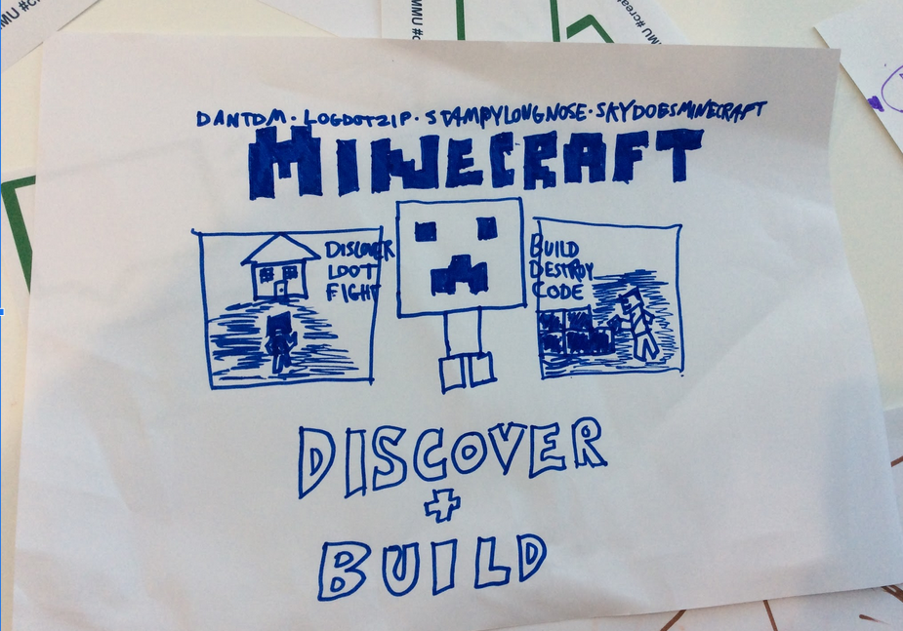
Retro gaming cultures emcompass broad media and practices beyond the games themselves. The image above shows now only a sketch of the Minecraft game, but also the names of YouTubers making videos about games.
This study positions this interest and identification as a fund of knowledge which designers should be aware of and utilise to help address some of the affective barriers to taking part in coding processes.
This study contributes to work which explores the potential does that give to developing game coding practices as per RQ3.

On affordances
Affordance theory and associated research in the context of designing for created learner experiences provides concept useful for this study.
There is a link between double stimulation and affordances (Romero and Barma, 2022)
A good summary of affordances related to HCI is here (Volkoff and Strong, 2017)
Other researchers have found the the scope and focus of affordances important to clarify (Wolff-Piggott, 2016).
They focus particularly in terms of who the affordance is for.
Affordances have been misused, assigned magical properties, including agency of themselves [SUPPORT].
This study follows socio-cultural take that while objects have a forma of agency, affordances are not magic and become interesting to educators as part of activity stemming from human-initiated activity.
Nardi and colleagues give an overview regrounding Gibson’s concept of affordances as action possibilities in line with activity theory concepts of mediated action (Kaptelinin and Nardi, 2012). Their focus is primarily on individual action.
While there is a The wealth of HCI literature in line with activity which discusses and applies concetps of affordances, the focus is often on the individual rather than on collective action (Kaptelinin and Nardi, 2012).
However, affordances are originally conceived of as part of activity, not separated from it (B\a erentsen and Trettvik, 2002).
NOTE - more on affordances here from Nardi
Link with TADS? TADS and the associated metaphor of warping anchors is normally applied in settings of group action.

Parked to replace or remove or rework

Why not use constructivism / constructionism
COMPRESS THIS - ALMOST DROP TOTALLY - NOTE THE GENERAL ALIGNMENT OF CONSTRUCTIONISM WITH DBR METHODS
Hay describes DBR thus “learning occurs within a context of use, learning is frequently collaborative, learning as authentic, learning as inquiry-based not transmission-based” (Hay and Barab, 2001) p. 3. Thus the broad claims are in alignment with wider socio cultural approaches.
Cobb (1994) identifies two broad schools of constructivism, one focusing more on individual cognitive processes which follows the work of Piaget and the other drawing on the academic lineage of Vygotsky which locates knowledge formation as a cultural activity.
NOTE - THERE IS IMPORTANT WORK HERE ON AUTENTICITY- and the potential tensions with agency - ie if authenticity is working a the elbows of professionals, students have less ownership over the process. (Hay and Barab, 2001:34)
Constructionism as applied learning and design theory
Much of the foundational literature on game making names constructionism as a guiding theory (Harel and Papert, 1991; Kafai and Burke, 2015; Kafai and Resnick, 1996).
Constructionism as a movement has done important work in creating design guidelines but much weaker as either an underlying theoretical or analytical framework.
Some PhD studies, many from MIT, use it as a guiding theory [Roque]
It can be viewed as a design technique based on constructivist roots (kynigos_constructionism?)
Constructionism is also described as a theory of learning by Noss (Noss and Clayson, 2015) rather than a methodology.

