Abstract and Concrete Approaches to Computing

Introduction
In the UK, computing and computational devices are all around us. Young people interact with them in many ways including, general communication, games, social media and creative apps. Computing as a subject can draw on this diverse engagement. Since the launch of a new computing curriculum, many computing teachers have used Computing at Schools and social media platforms to share their creative approaches to covering subject knowledge and building fluency in programming. This chapter highlights the value of hands-on teaching approaches as an inclusive pedagogy. It does this by describing on-going tensions in the world of educational between abstract and concrete approaches, looking at definitions and the role of Computational Thinking in an accessible way, and examining inclusive approaches to computing education. This chapter starts by exploring the terms inclusion and engagement as they are used frequently in this and other chapters.

Inclusion and Inclusive Pedagogies
The term inclusion is used in many ways in the area of education but is seen generally as ‘increasing the participation of students in, and reducing their exclusion from, the cultures, curricula and communities of local schools’ <Do Zotero Refresh: [@booth2002index]>. More recent educational research in this area has widened from having a chief focus on SEN and disability issues to including barriers of culture and other exclusionary elements of school discourse <Do Zotero Refresh: [@black-hawkins_achievement_2008]>. The issue of alienation from the culture of computing in schools can be an issue especially for girls and some ethnic minorities <Do Zotero Refresh: [@the_royal_society_after_2017]>. As such bringing the out of school interests and experiences of pupils into the classroom is vital. To be inclusive schools and teachers must identify barriers to progression and work to help student overcome them.
One emerging principle of inclusive pedagogy is to move away from a view that most students learn well and that others need particular support through adapted approaches. If you include wider understandings of neurodiversity and cultural and language diversity to identify students who need support, then planning alternative activities or learning pathways for these learners could quickly become so time-consuming and complex that it would be unsustainable. Instead, we should design learning experiences so that all learners can choose their own learning tasks (and thus levels of challenge), are supported to reflect via self-assessment and can bring their own experience and cultural understandings into their work. These principles - among others - are presented in a framework called Universal Design for Learning (UDL).

Universal Design for Learning
Universal Design for Learning (UDL) is a set of principles which are align with our earlier exploration of inclusive practices. UDL encourages teachers to create diverse ways to engage pupils, to represent the ideas being communicated and for students to express their own ideas. According to the USA Center on Universal Design for Learning, “UDL provides a blueprint for creating instructional goals, methods, materials, and assessments that work for everyone—not a single, one-size-fits-all solution, but rather flexible approaches that can be customized and adjusted for individual needs.”
UDL provides guidelines for three key areas of representation, expression and engagement. Rather than designing separate activities and support for learners with different educational needs in the classroom - often labelled accommodations for disability - UDL facilitates learners to choose a learning pathway that suits their individual abilities and learning strategies.
These strategies are sometimes presented in a way that highlights the technical elements of accessibility and assistive learning technologies, for example text in different sizes, the presentation of materials in accessible ways online and in the classroom. However, beyond representation, approaches for engagement and expression lend themselves to more radical learning techniques.
UDL places great value on the personal relevance and value of learning experiences. In exploring the tension between abstract concepts and concrete activities, UDL prioritises engagement, encouraging the teacher to start by setting concrete class goals that are relevant to the learners. Students can then be supported in the discovery and recording of the underlying concepts after undertaking activities. One aspect of inclusion is to engage the interests of learners. In the next section we briefly examine some of the techniques educators are using to make computing engaging to a diverse set of learners.
###On Making Computing Engaging
In general terms student engagement refers to the level of interest, involvement and participation of learners. We certainly notice when it is absent as bored learners are hard to motivate. Embracing the challenge of making computing projects engaging and is something that many individuals and organisations have engaged with. University and industry partner programs have created a wide range of computing materials and computing environments designed to aid novice programmers. Teachers themselves have been a tremendous source in the sharing of knowledge, materials and approaches to make the subject matter engaging in diverse ways.
A quick search the web for creative computing or tech for kids yields countless activities, tools and materials designed to engage the home and hobby interests of young people. Physical examples include fashion and textiles based computing, robotics, colourful lighting displays and programming lego constructions. Working with home interests and using visual, tangible and touchable materials is a way of increasing the participation and inclusion of learners. They look and feel like fun and exciting objects to engage with.
Web-based or software activities include game making, meme creation, hobby website creation or making storytelling adventures. Incorporating materials from narrative forms like books, films, games and social media content into computing projects increases the ability for learners to bring their own interests into the mix. However, while the range of materials and possible creative projects is exciting and full for promise for computing teachers, it is not always clear how to best approach these opportunities from an educational point of view. This chapter will explore teaching and learning approaches to increase learner engagement with computing, firstly by defining and exploring concrete approaches, and then by sharing useful classroom tactics.

Computational Thinking, the Abstract and Concrete

Concrete and Abstract learning approaches
When reading about different approaches to teaching computing you are likely to meet the terms concrete and abstract. In an everyday sense concrete objects are ones you can get hold of and abstract objects exist only as concepts. A pound coin is concrete but the idea of profit is abstract. There is another everyday usage which hints that abstract knowledge is harder to get to grips with than more concrete understandings. We might ask for a concrete example if we don’t understand a more abstract definition. It is the use of something in context that makes something concrete. In traditional conceptions of education abstract knowledge is often of greater value. If you can understand a concept as it applies in different situations then this ability to transfer it and have a more global understanding is held as a higher form of knowledge. This concept exists in Piaget’s influential model of ages and stages. Specifically in the progression to more abstract thinking in the transition from the concrete to formal stages.
There are drawbacks of adopting teaching in either solely abstract or concrete ways. For example, learners may not make a connection between abstract material and real-life situations. They can then only recall rather than apply the knowledge. A term for this is inert knowledge. In computing, you may be able to give a definition of what a function is in a coding language but not be able to write one. There are also downsides to learning only in a concrete way. If you learned coding by teaching yourself or just picking it up from other people then you may be able to complete tasks but not be able to explain what you have done to others, or may really struggle to recognise similar patterns in other computing contexts. This kind of knowledge is sometimes called implicit, tacit or embodied skills and knowledge. Unlike explicit knowledge, it is tricky for to explain or communicate this knowledge in a written or even spoken format. The learner or teacher just “know how to do it”.
Ideas around abstract and concrete knowledge have been key in shaping how we teach coding today in schools. A key critical voice challenging the idea that abstract approaches were superior was Seymour Papert. Papert’s work on creative computing at MIT created a legacy that includes the development of the Scratch programming tool and the use of physical computing in education. Papert and Turkle <Do Zotero Refresh: [-@papert_epistemological_1990]> thought it was vital that we value and recognise concrete approaches to computing and coding. While they do not discard the technical value of abstract approaches, they draw on feminist theory to make a convincing case that approaches like abstract planning and formal language can be off putting to certain learners and especially girls. They argue that the process of finding solutions to coding issues for novice coders should be a matter of personal preference. As well as abstract and concrete - they use a top down and bottom up analogy. In a bottom up approach problems are tackled piece by piece, experimentally. Desmond Tutu once said that “there is only one way to eat an elephant: a bite at a time.” Bottom-up (concrete) coders take this approach.
To clarify this Papert and Turkle give the example of a young coder Lisa, who is aware of a more formal way to approach the kinds of programming tasks she is undertaking, but maintains that way doesn’t work for her. As she continues her journey as a coder this frequent message that she is doing things the wrong way demotivates her enthusiasm around coding. Abstract coding concepts are tools for thinking. But they are only useful to the learner if they match with her experiences. Forcing the learner to adopt an abstract approach in this example is counter productive as it undermines her experience and progress. The authors outline that the danger of leading with the abstract is to devalue this bottom up approach to coding. This way of coding has also been called a craft approach. It is an way of doing things that has been shown to have a lot of value in many professions.
Many theories of learning explore the value of both concrete and abstract phases. The theory of experiential learning from Kolb is often expressed as a cycle of concrete experience, reflection, abstract conceptualisation, experimentation and then repeats. When applied to coding and computing, a student’s knowledge of a coding concept may deepen a little bit each time you apply it in practice.

Activity - Recognising the Concrete and Abstract in your Teaching
To help your learners to embed the knowledge of your lessons, it is helpful to identify what parts of your sessions address more abstract conceptions of computing knowledge and those that are more concrete. To do this ask you can yourself the following questions about your sessions.
- What are the core skills and concepts I want to communicate in my session? How many of them are more abstract and how many are more concrete? Do I have a good balance?
- How do learners first meet core concepts? How are they re-enforced? Is it through an abstract definition, supported by a more concrete explained example, or via hands on work that they are engaged in?

Definitions of Computational Thinking
The promotion of Computational Thinking has been a key factor in the development of the UK’s computing curriculum. Computational Thinking started to gain wider attention when Jeanette Wing an academic and computer scientist began to promote it as a concept and approach that could be useful beyond the field of computing as a way to express and solve problems in the same kind of way as a computer would.
We can use the distinction between concrete and abstract to examine the differences between two popular interpretations of Computational Thinking (CT). The first is an influential take from Jeanette Wing. “The most important and high-level thought process in computational thinking is the abstraction process. Abstraction is used in defining patterns, generalizing from instances, and parameterization” <Do Zotero Refresh: [@wing_computational_nodate]>. Many learning resources designed to support the computing curriculum present this principle as four key pillars: decomposition, pattern recognition, abstraction algorithmic thinking<Do Zotero Refresh: [@bbc_bitesize_introduction_nodate]>. The essence here is to deal with concepts and principles as abstract and separate from the context. This approach suits assessing knowledge via formal written exams and tests.
Another widely used definition of CT by Brennan and Resnick <Do Zotero Refresh: [-@brennan_new_2012]> was developed in response to a thought experiment “How do we describe what Tim, Shannon, and Renita are learning as they participate as designers of interactive media with Scratch?”. The researchers took a grounded / situated approach to mapping the potential learning dimensions of student undertaking collaborative, creative computing projects. The resulting map they created includes computational concepts, computational practices and computational perspectives. This framework based on observation of learners in action is more concrete and more accessible to teachers and learners as they can more easily recognise their own practice.
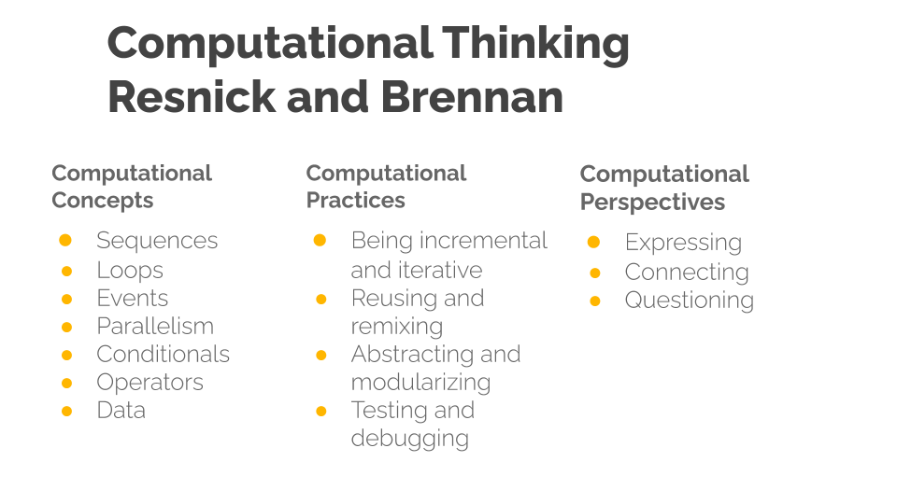
Computational Thinking model by Resnick and Brennan - Diagram created by Mick Chesterman
This wider and process driven definition of CT has been used and adapted by many organisations seeking to support the new computing curriculum. As such it may be familiar from websites, posters and other supporting material created by groups like Barefoot computing. A review of teaching Computational Thinking <Do Zotero Refresh: [@lye_review_2014]> used this second definition as the basis for their review, which point to the widespread use of Brennan and Resnick’s more applied approach. The wider definition of CT here assumes an environment where learners are engaged in the collaborative coding of a computing project. The review adopted this applied framework over other more abstract CT frameworks where showing CT could be applied outside of a coding context, as in a computing teaching environment the wider factors are useful to teachers. It allows them to observe and plan for computational practices and more general problem solving.
RELATE THIS DEFINITION OF CT TO INCLUSION

Tactics for Teaching Computing Concepts
Classroom practice is strongly influenced by curriculum content and more specifically the format of exam questions. The removal of course work from exams due to the widespread sharing of worked examples on-line created a real challenge for those setting exams. Exam boards had to rethink how to test the practical programming experience and ability of students in a written exam setting. At GCSE level most exam questions test the more applied definitions of Computational Thinking, particularly the process of writing, analysing and revising algorithms in the form of written code examples. Students are required to demonstrate and explain fundamental code building blocks and approaches from first principles. However exam questions on coding are by nature fragmented and decontextualised compared to project coding experience. The questions in the format of small coding challenges must be fragmented to be able test a particular part of the curriculum. Thus, there is limited potential for students to show design or authentic debugging skills.
Spending a lot of time solving decontextualised exam questions has potentially negative impacts on student engagement and such disengagement is a serious barrier to inclusion <Do Zotero Refresh: [@kanevsky_produce_2003]>. A focus on written exam approaches can reduce time to explore more authentic projects where students follow their own interests and develop design and troubleshooting practices. In an ideal situation practical work can deepen and broaden more abstract knowledge. However given the reality of schools’ focus on exam results, teacher must balance the development of students’ hands-on coding practices with the ability to recognise and respond to more abstract written questions.
The NCCE has produced a series of resources based on research on computing practices to help teachers. As a way of summarising the diverse opportunities and requirements of the subject, they have provided a set of 12 principles for teaching computing (http://tiny.cc/12-principles-computing) aimed at mainstream teachers. What these approaches have in common is an attempt to address the tricky issue of understanding complex and abstract concepts. In this section we look at some of principles and other tactics for classroom teaching that aim to enable teachers to explore more abstract computing concepts and integrate them with concrete examples and practices.

Pair Programming
Pair programming is one aspect of social learning but there are others associated with being part of a wider community of learners. A benefit of pair programming is that it can develop student’s experience of the different roles involved in coding. A summary of these roles and tips on how teachers can help learners to adopt them in present in this Quick Read from NCCE - http://tiny.cc/pairprogramming
The approach can be particularly useful as it divides up the tasks so that one student does the hands-on concrete coding while the other is free to think about more the abstract design of the overall programme.
Modelling and breaking down a process that is often difficult to understand is helpful not only to aid a deeper understanding of the process but also to build the identity of a learner as being strong in a particular element of coding. This process building an identity of coding with the help of peers is key to a socio-cultural understanding of how learners pick up coding in a classroom (or other settings). The importance of a coding community is explored in another chapter in this collection on design and project approaches.

PRIMM
PRIMM stands for Predict, Run, Investigate, Modify and Make. This learning model has been gained popularity in resources aimed at UK computing teachers. PRIMM helps learners adopt coding practices and computational concepts through providing them with a concrete code example that they run after predicting what it does. They then dig deeper and make changes to the existing code. PRIMM’s starting point is students reading and predicting code results. It aligns with the NCCE principle of Lead with Concepts . Identifying the target computing concepts in code examples allows teachers to highlight key computational thinking process or algorithmic details. Thus PRIMM is well suited to the classroom as starting with prediction of a code allows a whole class learners to unpack and repack the same set of concepts in a restricted time scale. It is a process well aligned with some of the more formal problems solving, paper-based questions of the GCSE exams. For a more detailed summary of the PRIMM approach see this quick read pedagogy article. http://tiny.cc/primmqr
PRIMM is a modification of the Use Modify Create framework which was developed to represent the learning process of learners engaging with extensive computing projects like game design, designing simulations and robotics projects. I write in more detail about the Use Modify Create framework in another chapter in this collection.

Unplugged activities
Unplugged activities are carried out away from the computer and aim to illustrate computing concepts. They are explored in more detail in another chapter in this collection. Unplugged activities often use very familiar non-school examples and draw on learners’ understanding of their own concrete experiences. As an example teachers may use the cooking recipes as a way to illustrate the importance of correct sequencing in a code context. However, the danger is that being introduced to computing concepts outside of an authentic context where they can be put into practice leads to inert knowledge.
Unplugged activities are also often embodied activities. Embodied ways of learning involve moving beyond a computational view of cognition to recognise the importance of physical experience and emotions in the learning process. “Disability studies scholars have been vital architects of frameworks for understanding the integrative relationship between body, mind, and self.”(???)

Semantic Waves and Leading with Concepts
Two concepts in the NCCE’s principles are Lead with Concepts and Unplug, Unpack and Repack. These principles are commonly explored using the theory of semantic waves <Do Zotero Refresh: [@macnaught_jointly_2013]>. http://tiny.cc/semantic-waves
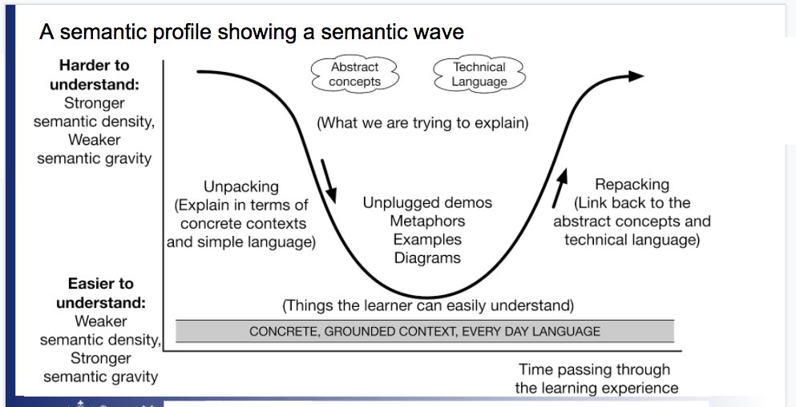 semantic waves This image needs to be reconstructed as it is taken from the web.
The Semantic Wave approach is usually presented as leading with concepts, unpacking them, then giving concrete examples or applying the concepts in a practical example, and then returning to the re-examine the concept from a more abstract perspective once again - hopefully with a richer understanding informed by the concrete experience. The terms semantic density and gravity can be substituted for abstract and concrete. In some ways the concept can be seen as simplification of Kolb’s experiential learning cycle. Instead of cycling through four dimensions - learners oscillate between the two.
PERHAPS DIAL DOWN OR MOVE THE FOLLOWING TWO PARAGRAPHS - TO SECTION BELOW.
Exploring semantic wave profiles is being promoted by NCCE an aid to teachers wanting to plan their lessons in a way that communicates the key abstract curriculum knowledge that students will need for exams, and to allow them to put the concepts into practice to build real coding skills and to make valuable connections to personal experience. Diagrams or examples showing semantic wave profiles usually start with the process beginning with the abstract or with high semantic density which suggests this is optimal. However the underlying research does not dictate where on the wave teachers should start.
Leading with concepts has the advantage of being specific about the target subject matter being taught, as this is process familiar to classroom practice and preparing for testing. However, there are advantages of starting with concrete experience and meeting abstract concepts in context. For example starting with activities can increase student engagement and can allow more hands on time for different approaches to coding and creating.
Thus if we return to the semantic wave profiles, in a UDL approach teachers would start with activities that allow the use of more concrete (high semantic gravity) language and then explore more abstract (high semantic density) concepts and patterns as they emerge in these authentic situations. While examples of semantic wave often start with the abstract, an approach familiar with traditional lesson plans, according to the research it is the continued movement between concrete and abstract poles that is important. Thus why not trial start with hands-on activities to help the engagement of students and to align with UDL principles? Can you to try this out in your own lessons? Is there an upcoming situation where you could try different approaches and evaluate how students respond?
This section has looked at tactics to address the realities that teachers face preparing students for Computing exams. The next section focuses on inclusive approaches which involves providing students with multiple ways of engaging with the computing subject materials and practice of coding. While it is in line with research on inclusive practices it may be challenging to implement in many classrooms. WHY? << MORE SIGNPOSTING

Inclusive, Concrete and Student-led Approaches
Inclusive / student-led approaches.
Could move expansive framing here. The tactics above are useful - but they assume a set status quo or lessons following a certain format. We should advocate for something better. We have a duty given increased needs for inclusion.
Inclusive / student-led approaches can take many forms, but they are are different from the tactics above in the following ways.
This has the following benefits for inclusion. Laser in - more details on inclusion. Sign post to other chapters - but state essence of value on the concrete.
Perhaps contrast - Semantic Wave profiles - and the lead with concepts advice with the idea of “concreteness fading”.
Particularly explore the Bruner example in Fyfe’s 2015 review - 3 stage (1) an enactive form, which is a physical, concrete model of the concept; (2) an iconic form, which is a graphic or pictorial model; and finally (3) a symbolic form, which is an abstract model of the concept
###Activity - Applying UDL in the Classroom
Many of the principles of the UDL framework will be ones that experienced teachers have already adopted based on their intuition and experience.
- What choices do students have to apply the target knowledge or skills? Can activities and learning be related to student’s interests?
- Are learners able to connect to real-life application of the concepts and skills you are introducing? How motivating do they find that link?
- How are you helping learners to make connections between the concepts and skills they are learning through hands-on activities and the more abstract representations that may occur in test or exam situations?

CRA - Concrete, Representational and Abstract - and Concreteness Fading
CRA follows three stages.
Researchers Cook and colleagues (???) explored an alignment of UDL with another framework CRA. The researchers break down the
The term Concreteness Fading is also widely used in Mathematics research and practice.

Expansive Framing
Researchers Lee and Vincent <Do Zotero Refresh: [-@lee_expansively-framed_2019]> were concerned that CT practices are not easily transferable to other areas. They applied an approach of expansive framing to develop students Computational Thinking. Expansive Framing is about students meeting similar abstract concepts in different contexts (or frames). This makes the abstract more concrete by experiencing lots of examples in different situations. Thus to increase the effectiveness of Unplugged activities the researchers also introduced an additional context. For their study they used loom based weaving. Students analysed weave patterns, created a graphical representation of the pattern on grid paper, and then used this to codify the pattern and represent it on a computer screen using Scratch.
Lee and Vincent’s research provides a practical approach to help overcome some of the difficulties of transferring knowledge between contexts. See http://tiny.cc/expansive-framing

Observing and Assessing Hands-On Practices
There is an ongoing tension for teachers between giving learners the freedom to pursue their own concrete coding goals, and the need to bring their attention back to the learning goals and target knowledge of the curriculum. In the current educational climate teachers have to be able to show how classroom work applies to the curriculum and exam goals. This tension can be helped using a technique promoted by NCCE (at teachcomputing.org) - that of using observational techniques in the classroom to assess user progress. Techniques to help teacher observation and assessment of what student are completing are vital if we are be able to keep a track of some of the ways they solve problems as they apply knowledge in the concrete stage of their learning. The NCCE have created this quick read on observation - http://tiny.cc/observingstudents . A summary is below.
Structured observations: Before lessons, teachers create a framework of the behaviour or use of concepts you want to observe and observe them as you interact with students, via recordings or their created work.
Unstructured observations: Teachers record or reflect on some of the more unexpected turns that happen during the lesson, often after the event from memory or recordings.
Verbal protocols: Teachers assess the learning and understandings of students by asking them to talk aloud the way they are solving problems and undertaking tasks.
One way to align a computing learning with UDL principles involves teachers set learners meaningful projects, giving students access to suitable tools, inspiration and to sustain their motivation. Assessment would then follow the activities that students undertook using a mixture of the observation techniques listed above. Such observation is time consuming, as such teachers may need support to undertake detailed observation while you teach.
The Use of Concept Map and Learning Frameworks
In order to use structured observation a predetermined framework of the kind of behaviours, practices and concepts that suit the project work being undertaken is needed. One way that teachers can develop such frameworks is via the technique of Concept Maps. The NCCE have created a guide for teachers to create concept maps which focuses on more technical knowledge (http://tiny.cc/concept-map). You may wish to include other the coding practices in line with a more participatory definition of Computational Thinking that we have explored in this chapter. It is also a good idea to provide students with this framework to help them navigate their learning journey. The ability for students to monitor and assess their own work and progress is in line with both inclusive education and project-based approaches. I explore project approaches in another chapter of this book. The final part of this chapter looks at an activity to include inclusive approaches into your classroom using Universal Design for Learning (UDL).

Conclusion
The purpose of this chapter has been to celebrate the educational value of hands-on, concrete activity. In many ways as computing educators we are lucky to have such rich and engaging resources at our disposal which invite tinkering and learning through trial and error experimentation. However this can bring a tension as teachers feel the pressure to bring students attention back to underlying abstract concepts that are assessed through test material. The NCCE has played a pivotal role in supporting teachers to recognise and navigate abstract and hands-on teaching techniques; that work has been discussed in this chapter.
This key tension between the concrete and the abstract has been around since the dawn of computing education. Papert, the inventor of Logo invited us to use creative computing revalue the concrete. More recently, Resnick and Rusk <Do Zotero Refresh: [-@resnick_coding_2020]> from the Scratch research community caution against some of the dangers of adopting exclusively formal approaches to coding including: too much memorisation of computational terms rather than application, devaluing hands-on coding compared to abstract concepts, not enough time devoted to complete projects and, finally, learners not given enough choice in their coding projects. The researchers share the concern is that the potential for computing to build creative and design thinking competencies is being undermined. http://tiny.cc/codingcrossroads.
This chapter then explored the alignment of between inclusive education principles and concrete, student-led ways of approaching computing education. We have also explored the value of UDL principles for teachers looking to inclusive practice and the possibility to assess content knowledge through observing students during hands-on work. In another chapter I explore the same principles via design and project based approaches. These methods can also help teachers balance the requirements of the curriculum and the value of letting students spend more getting their hands dirty in the concrete of coding.
<Bibliography: Do Zotero Refresh>

