5. The Use of Gameplay Design Patterns “It’s like a project in itself, really”
- The Use of Gameplay Design Patterns “It’s like a project in itself, really”
  - Research Questions - March 2024
  - Chapter outline
  - On GDP as a germ-cell and unit of analysis recap of design patterns
    - Recap on design patterns and game design patterns
    - On the utility of identifying a germ cell/ unit of analysis
  - Study of Vignette A
    - Descriptive Commentary on Vignette A
  - Observations and analysis of use of Game Design Patterns (GDPs) by participants
  - The role of GDPs in the personal appropriation of computational, design and systems concepts
  - GDPs used in the process of guided participation
    - GDPs offer the potential to assist project navigation, acting as a framework for code examples and step-by-step tutorials
    - GDPs used to scaffold ideation processes
      - Knowledge of game design patterns used to stimulate and communicate new ideas
      - The use of GDPs to encourage intuitive and visual prototyping
      - GDPs as used by participants in their prioritisation in the ideation process
    - GDPs aiding the process of division of labour
      - Working knowledge of different types of GDPs can help participants to divide project elements by pattern
      - Structuring work processes through implementing modular sub-projects in the form of GDPs can aid division of labour
      - Other notable observations concerning division of labour in the video data
    - The role of GDP used in emerging technical processes
      - Use of GDPs to facilitate use of tools
      - Diverse use of technical processes driven by GDPs
      - Use of GDPs in the development of shared language
      - Code Patching as a guided process
      - GDPs used to nurture tactical responses to coding errors
      - Concluding remarks on debugging and revision
  - Cultural Dimension
    - The role of GDPs to facilitate learners to design for others
      - Referring to GDPs (especially during playtesting) can help scaffold the process of imagining the end user experiences.
      - GDPs, the scale/nature of project goals & designing for others
      - Other examples and interpretation on designing for others / shifts of perspective
    - Role of playtesting and feedback and GDPs
      - GDP concepts and language used in informal feedback for peers to influence modification of games
      - The propagation of use of GDPs through playtesting
    - GDPs facilitate the use of wider funds of knowledge
      - Family funds of knowledge
      - Funds of knowledge from professional and enthusiast communities
  - Discussion on the use of game design patterns in the 3M learning design
    - Design patterns as a mid-level pedagogical framework
    - Discussion on GDPs, emerging processes and learner agency
      - GDPs used in mediational strategies and impact on participant agency
      - Tensions between facilitating agency and norming practices
  - Chapter Conclusion
    - Summary of the pedagogical opportunities of Game Design Patterns
    - Transition to next chapter

The Use of Gameplay Design Patterns “It’s like a project in itself, really”

Research Questions - March 2024
- What pedagogical tools and processes are available to support novices to overcome barriers to participation in game coding processes?
- How can game design patterns support the development of coding practices with novices?
- How can learners build agency in an evolving community of game makers?

Chapter outline
In the last chapter I outlined use of tools focusing on emerging tensions in activity on a micro-level. Guided by Rogoff’s concept of guided participation, this chapter analyses this emergent activity at a scope between concrete tool use and the wider cultural context of the game making community. I focus on the implementation of individual game design patterns (GDPs) and in doing so addresses how data gathered informs thinking on the research question - how can game design patterns support the development of coding practices by novices?
This chapter begins with re-examining of game play design patterns as a unit of analysis for this research. Following this a vignette of parent child interaction in game making process helps contextualise findings. The chapter then undertakes a systematic analysis of varied uses of game design patterns by participants drawing on detailed observations of practice in recorded video data. A discussion section explores implications and observations from these findings in relation to existing research and concepts. As part of this discussion, I draw on the examples of use of game design patterns in practice to explore the analysis of GDPs as a mid-level construct, of use both to educational designers and researchers.

On GDP as a germ-cell and unit of analysis recap of design patterns
This chapter centres on an interpretation of the implementation of game design patterns (GDPs) as a unit of analysis or germ-cell of activity.

Recap on design patterns and game design patterns
In chapter two the use of design patterns in an education context were summarised. Design patterns provide a relatable contextual basis for learning complex code structures. More specifically, game design patterns they have been used in educational settings. In the work of Repenning and colleagues (Basawapatna et al., 2010; Repenning et al., 2015) GDPs are framed as science simulation concepts that aid transfer of concepts to similar setting. Eriksson and colleagues (2019) draw on catalogue of GDPs can provide a useful basis for co-design work to help deepen the knowledge of participants and provide a shared language to help collaborative design.

On the utility of identifying a germ cell/ unit of analysis
This chapter develops analysis of the role of GDPs as a guiding process in varied forms in a way that aligns with activity theory concept of unit of analysis/ germ cell.
These are two similar concepts with slightly different foci.
... the germ-cell and the unit of analysis are one and the same thing, but in one case the developmental aspect is emphasised and in the other case the analytical aspect is emphasised. [@blunden_unit_2020]
In this thesis, as a designer / researcher and practitioner both aspects are relevant.
Examining the analytical aspect, the process of seeking and defining a key activity scope/unit for analysis helps define useful boundaries of what to analyse in depth. This chapter has a narrow focus on the implementation of gameplay design patterns (GDPs) allowing for the identification and analysis of patterns of participant behaviour and introduced and emerging community practices to do with GDPs. As explored in chapter three, while this concept of germ cell / unit of analysis is typically used in a larger scope of activity, the principles apply this smaller scope. Following the outlines of chapter two, while game making can as an overarching activity system, a narrower activity whose objective is implementing GDPs became a significant unit of activity for this study.
Turning to the developmental aspect, a granular exploration of the tensions and processes at work in a complex educational environment can via identifying emerging barriers and responses to comprehension, communication and practical barriers to implementing design challenges facilitates replicability of research and supports its potential value to other practitioners (Barab et al., 2002). The last chapter explored the mutual evolution of the learning design, shaped by direct input, explicit requests and the implicit needs of the community and resulting feedback. The leading activity of iteratively of altering a game at the level of gameplay design pattern which emerged from this experimental process. This chapter develops analysis of the role of GDPs as a guiding process for supporting resources and support processes in varied forms. These include a set of code examples, instruction tutorials, quick start activities which proposed micro level code modification. While these approaches are distinct in their pedagogical use, they stemmed from the same germ-cell activity of altering the game through the use of game design patterns via varied means. These include: use as part of meditational strategies by participants and facilitators and as shared objects between participants, facilitators and peers (as explored in chapter three and four).
.

Study of Vignette A
In this section, to give an overview of the specifics of the learning design, and participant interactions I use vignette to give a snapshot of the interactions of one family. This comprises a table of participant dialogue, screenshots and description of their interactions including gestures followed by a summary interpretation of interactions.
Context: For the previous ten minutes the parent and child dyad have struggled a tutorial chapter in the text book included as appendix 5.x. on adding the pattern of keys and doors ( players must collect a key and then navigate to a door to progress to the next level). The parent Suzanna has been making multiple changes to the code while the child Olivia has been expressing boredom. Suzanna suggests that Olivia asks the facilitator Mick for help to resolve the coding problem and after help has been given to solve the bug Suzanna cedes the keyboard to Olivia to test the working game.

Suzanna: I’ll reload it. Here you go | Suzanna presses refresh key to reload the preview game view to reflect the changes that have just been made.
Olivia: Laughs | Olivia moves laptop to point towards her and takes over using the keyboard
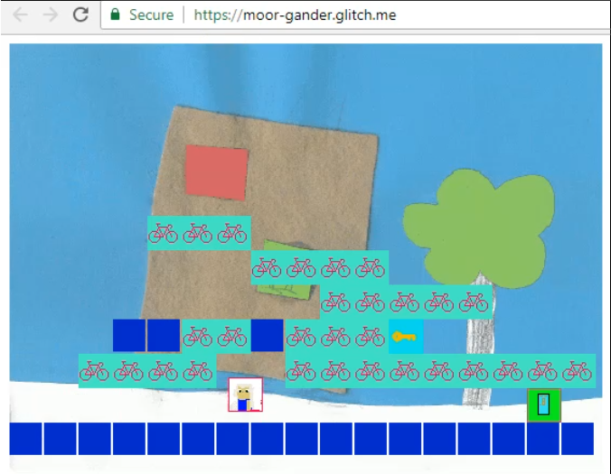
On the Screen: Olivia is uses the keyboard’s arrow keys to control the game player. She checks the desired behaviour of the player progressing to level 2 after collecting a key and then traveling to a door - is working. It does and Olivia progresses to level 2 of their game where there is not a door or key.

Olivia: (Makes excited cat noise)
Olivia: We need a door in this one.
I want to make more levels now.
So you can put lots of doors and lots of keys

Olivia: (in a rhythmic voice)  Key Door Key Door Key Door  Olivia: (in a sing song voice)  Key Door Level. Key Door Level, Key Door Level | Suzanna moves computer to take over the use of the keyboard. She changes browser tab and navigates to the section of the code which deals with the design of levels and placement of different game components.
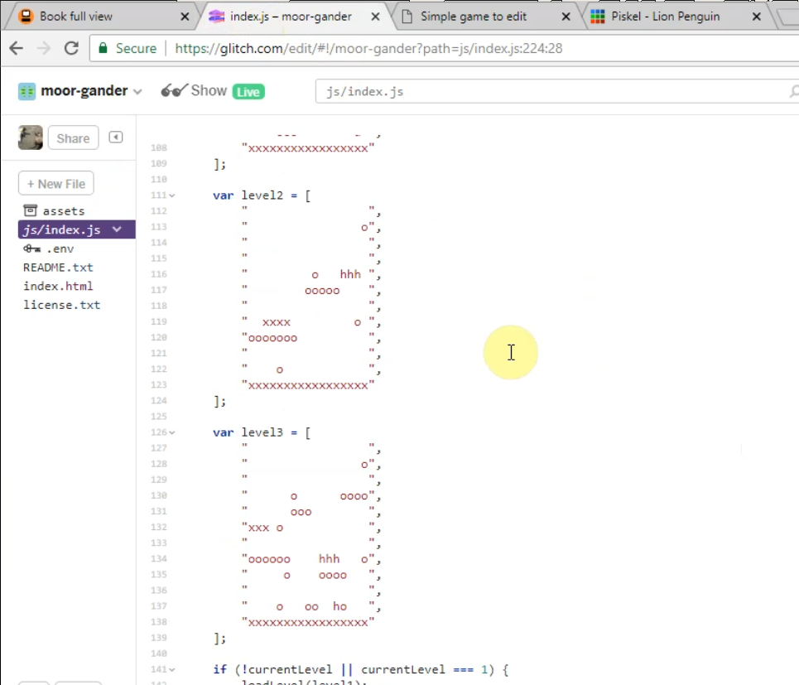
Suzanna: Well. Where are you going to put your door in level two? Do you want to change the layout at all? | Suzanna gestures to screen
Olivia: What’s door? | Suzanna doesn’t move laptop but gets closer to take over keyboard
Suzanna: d | Suzanna interprets Olivia’s question
Olivia: Ok
Olivia: d . Door right there.
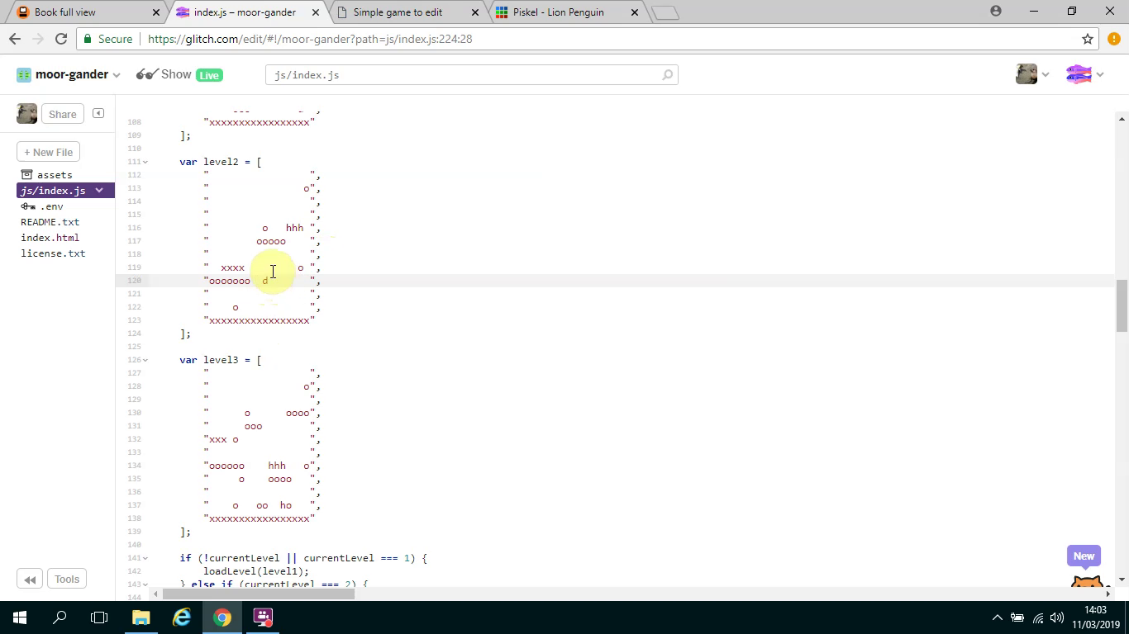

On the Screen: Olivia Inserts a “d” high above the floor.
Suzanna: And where’s the key going?
Suzanna: Must be quite hard through get to that door
Suzanna: Key is K
Olivia: (Calmly) Ok just let me do something | Olivia starts to delete multiple characters on a line
Suzanna: (Alarmed) What are you doing?
Olivia: Back. You’ll see!
Olivia: Ah yes.
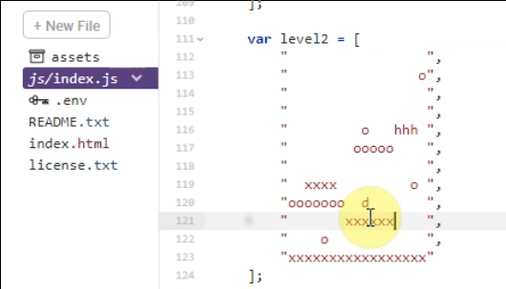
On the Screen: Olivia starts to add x’s to replace the spaces she has deleted
Suzanna: What are you.. Ah you’re making a platform. I see.
Olivia: See!

Descriptive Commentary on Vignette A
The key and door pattern is one of the harder ones to implement as it involves adding two new functions, which while simple enough, represent new code structures and thus this adds a new level of conceptual and practical complexity. The implementation of a new game design pattern (GDP) involve adding new code to the game. The amount of code and/ changes needed varied depending on its complexity. Larger changes typically need more careful manipulation of code and subsequent debugging. For this pair, these more involved coding activities were beyond the ability of the child. The parent Suzanna has taken on the role of solving harder code problems and in doing so has built important proficiency in coding practice. These include which include; finding and comprehending supporting documentation, fluidly navigating between undertaking more advanced coding to implement new GDPs, playtesting and preparing the coding environment for more basic coding of her child.
The parent takes action to involve her child in the design process when technical possible and to incorporate her child’s interests. The parent overcomes her own hesitancy regarding asking for facilitator help by sending out her child to ask. She signals clearly to her child when the process returns certain design stages indicating that she is aware of the greater possibility for effective child input at these moments. After a blockage caused by debugging coding is removed, the parent immediately re-engages the child prompting the child to play-test the game. The child is one of the younger participants when blockages occur she explores the room or to dwell on the periphery of other participants interactions.
The child Olivia also wants to add additional levels to their game. In recent sessions several young participants had added new levels to their games, including Toby who added over twenty. This activity had sparked much discourse between participants. It is likely that this Olivia’s interest stems in part from observations of other participants games and this discourse. The child shows ongoing affective connection to the game making patterns. For example, one target game design pattern Keys and Doors is repeated in a sing song voice by the child along with chivvying to the mother to get started on it.
There is also awareness of and playfulness surrounding the conventions of a platformer game as a dynamic system in way which drives their work on the design and coding mechanics of the game. An understanding of the game as a dynamic system is seen clearly in the parent’s alarm when, shortly after this interaction, the child deletes all elements of hazard in one level. The parent cautions “it’s no fun if their are no hazards”. I interprete the response of the child - “It is for me!” - to show her awareness of the conventions of game design and a desire to work against them. Later the child articulate her motivation to surprise players with this level design.

Observations and analysis of use of Game Design Patterns (GDPs) by participants
The following sections focus on the way design patterns are used by parents, children and facilitators in this emerging game making community. To present findings from video data, I draw on the Rogoff’s three planes of analysis (Rogoff, 1995) as explored in chapter 3. Acknowledging that these observation do not fall nearly into each of the three planes, I cover observation on the use of GDPs relating to, in turn, personal knowledge, interpersonal activity and finally cultural activities. The observation of these sections are also guided by concepts of the development of shared objects and meditational tools and strategies and their role in emerging community norms and practices.

The role of GDPs in the personal appropriation of computational, design and systems concepts
Facilitators can use a prepared collection of GDPs to facilitate participants to surface chosen computational, design and systems concepts embedded in games. In the previous chapter, the use of a map of learning dimension in the studies design was examined in relation to contextual tensions relating to the motivations surrounding of curriculum concepts.
While there is a lot of potential, building testable progress in CT and other personal dimensions are not explored significantly in this study, but are explored extensively in other research as explored in the literature review.
This can help justify activities in formal contexts as per Bevan and Petrich’s work on tinkering. However, in this learning context the motivations of the learners both children and adults differ from formal schooling setting and its requirements of teaching to a curriculum and potential exam content. Thus as there was no external imposition, and no organic desire to explore more abstract concepts.
I also noted my own caution about overloading learners with shifting and competing goals. My concern hinged on the potential disorientation of the learner that imposed shifts of focus may provoke. As learners shift between different stages of creation the object of their activity shifts from the larger goal of making an engaging game to a narrower goal of implementing a game design pattern to narrower still of completing one of several actions to complete the implementation of a GDP.
Participants appropriate such concepts and feed them back into the community.
This dimension is not fully explored in the thesis which has a greater focus on community and social aspects of use of GDPs.
However, following Rogoff’s interpretation the personal appropriation of concepts is demonstrated in community activity through evolving peer practices. As one-to-one instruction from facilitators was limited which encouraged the community to teach each other.
The process of reusing and modify code to create a computer game can surface both abstract and concrete computing concepts present in the concrete application of code that have emerged organically at different stages of the creative process. The repeated, solo, incremental changes of the details of implementation of game design patterns indicate a personal appropriation of concepts like game feel and challenge and broad concepts of CT based on Resnick and Brennan’s framework.
The following section outlines some examples:
EXAMPLE/S:
BRIEF EXAMPLES FROM DATA FOLLOW
Following Papert and subsequent research on Microworlds, learning designers shape what they want learners to encounter and explore [research on Microworlds]. While, this thesis focuses on community aspects in line with my own interests, I have written a chapter which explores There are significant possibilities to alter this design to suit more exploration of systems concepts and computational thinking. NOTE - INCLUDE REFERENCE TO CHAPTER

GDPs used in the process of guided participation
This section explores data on the use of GDP from the perspective of interpersonal interaction the process of being guided into planned activity or peer work which is exploratory but helps developing of interpersonal processes which serve the completion of the activity. From observations of video data, I observe how GDPs are used in diverse meditational strategies by different participants.

GDPs offer the potential to assist project navigation, acting as a framework for code examples and step-by-step tutorials
The use of a catalogue of design patterns addresses a tension of participants choice and the need for documentation to support the technical implementation of code structures. However, not all participants used provided instructions and develop diverse ways to implement patterns.
The tension between of participant choice and use and providing appropriate scaffolding materials to support implementation of code was explored in the previous chapter. The decision to base supporting resources around a menu of game design patterns was an end product of a mutual evolution.
The vignette in this chapter shows the parent following the child’s desire to implement a GDP using a step by step tutorial. The vignette of the chapter four showed Toby copying a code example which he chose from a graphical menu of patterns. The previous chapter also outlined the use of starting activities which selected key changes to code or simplified design processes designed to maximise personalisation and changes to the starting game template. These varied forms of scaffolding represent different approaches to supporting the process of making alterations to the code inline with a use-modify-create (UMC) approach.
In addition to use of printed or online resources, this chapter will explore how varied forms of help between peer participants also became important process of the game making community from early stages. Later sections explore varied strategies used to implement GDPs including, informal propagation of GDPs as a result of playtesting, the development of specialists division of labour and
However, despite this variety, this chapter will explore how the evolving collection of GDPs acted as a base for the variety of approaches that emerged from it. To do this, the following sections explore different uses of game design patterns.
Key characteristics of structuring support around quick start activities and a subsequent menu of GDPs which align with existing research include:
- supporting the value of informal approaches to learning technology [ITO etc] whilst avoiding the lack of support in P1 where participants called out for more support with technical and organisational processes.
- providing shorter, just-in-time tutorials to reduce barriers associated with more extensive instruction-based approaches including barriers of literacy (Resnick and Rusk, 2020; Dietz et al., 2021).

GDPs used to scaffold ideation processes
GDPs are used in a variety of ways to guide the ideation process via restriction of choice in pattern collection, starting template includes core dynamics, visual code structures of GDPs suit rapid prototyping.
The design chapter explored the tension between reduced choice of genre of game. In my journal notes and observations of the games created, I note that the provision of a graphical menu of GDPs significantly decreased in time spend in ideation phase by providing scaffolding and a restriction of choice. Analysis of participant use of the menu as detailed in the documentation section above Toby supports this analysis. Other techniques that leveraged the characteristics of game design patterns to support the ideation process emerged in community design activities.

Knowledge of game design patterns used to stimulate and communicate new ideas
In the following example home-base knowledge is utilised to help shape new design ideas and problem solving practices. Dave and Toby are working closely as a pair. The following interaction shows a rich interchange where the parent is trying to draw on the game playing experiences to promote innovation in the design of the existing template.
Dave: Have you thought about pushing it a bit further and have a different style of game?
Toby: What do you mean?
Dave: Well the previous style of game was a platform (makes shape with hands) game wasn’t it? You went along and there was gravity pushing down (points down). There are other types of games aren’t there?
Toby: Pause. I don’t know what to do thought.
Dave: Well quite but what other games are there? again
Dave invites thinking outside of the constraints of the suggested design early in this first session. In this example the family bring their knowledge of game play patterns and genre conventions and more broadly experience and a perspective of coding as a creative challenge to the activity.

The use of GDPs to encourage intuitive and visual prototyping
Some GDPs allow the spacial exploration of design in a visual way that suits being mapped onto paper, or onto graphical software which allows for a similarly intuitive and rapid prototyping.
The use of paper prototypes was one technique used by several parents to support their children to form and develop their design ideas. In our starting vignette the matrix helped the child design with little coding or literacy ability.
Later in their interactions the parent notices the child’s difficulty in using cursor and delete/backspace keys to edit a matrix allowing level design. The parent provides a book with grid paper to allow the child to replicate the matrix. The parent is then able to transcribe the design to the code example while engaging the child by checking she has interpreted the design correctly.
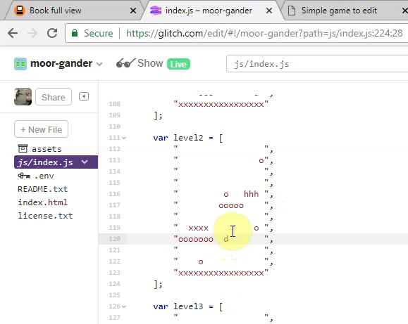 Graphical representation of code
The way the code is structured has been chosen to allow a graphical analogue between the lines of code in the form of a comma separated array and the appearance of the resulting game output on the screen. The parent uses the graphical representation of design in the code template as a jumping off point to make a connection to home practice of sketching things out in paper. The process of turn the sketched into reality on the screen and sharing with others appears to be transformative in terms of the engagement level of the child.
One pair’s ideation helped by the use of a GDPs is the following example which shows Toby and Dave are creating a new tilemap for a maze game. Toby is able to map existing knowledge of tools and home knowledge of the kid of game he is imagining to rapidly make revisions.
Toby: Oo. Shall we try to make it (unintelligible). Cos in pac man you can go off the edge.
Dave: and you wrap round the other way?
Dave: Yeah, yeah. We can do that. Save that for version 1.1
Toby continues making changes to the code design.
Dave: What’s the theme? What are you drawing?
Toby: What? I’m trying to make like a pac-man type thing.
Dave: Alright. What if you sketched it on paper first? Or have you got it in your head?
Toby: I’m just kinda going for it it. (laughs)
Dave: Ok go for it, see what you get up to.
Toby: I’ll leave a hole there.
As aligned with the learning design principle of rapid feedback, changes in the code which Toby is altering to impact on the new design pattern of a top down game, are immediately apparent in the preview window. As such, Toby does not feel the need to prototype on paper.
NOTE - ADD IN A SUMMARY OF THE POST INTERVIEW DATA from Mark and Ed TO UNDERLINE THIS POINT.
Other examples of GPDs helping the ideation process
NOTE - TO DEVELOP AFTER MORE ANALYSIS OF VIDEO DATA.
The use of GDPs to scaffold the ideation process was a common pattern used by X of the Y sessions analysed.

GDPs as used by participants in their prioritisation in the ideation process
GDPs are mentioned by name and via verbal and physical descriptions as a lingua franca and as shortcuts by participants when prioritising work
The following exchange between participants Ed and Mark shows GDPs being used to try to organise future activity.
At this stage of their process, some of these patterns have been discussed and sketched out some started but only partially completed. For example, the child has designed different frames of animation but this has not been exported to the right format or implemented in code form. This interchange shows a tension between a more chaotic style of working jumping from one goal to another and a parental motivation to prioritise one work to be done. This tension is outlined when a parent Mark gives an update on progress. “So, we’ve made quite a lot of progress this week. I think the issue we’re having is that Fi’s super excited so we’re kind of jumping from one thing to another and that’s kinda overwhelming me a bit.” An earlier interaction illustrates this dynamic clearly.
Mark: I’ve brought the music, and also we could just concentrate on one thing and just change that. You know, keep working through.
Ed: Yeah. I think I want to get an enemy in - oh no - my person animated.
Mark: So you want to get your person animated that’s the main thing.
Mark: Shall we concentrate on that and changing the platforms into something different?
The child’s initial listing of features is a brainstorming technique. Such techniques are used to aid a creative process. This example shows the use of the approximate names of a number of game design patterns by the child adult. These are get the person animated, get an enemy in, changing the platforms into something different, make a theme tune. However while this use of terms shows the promise of the use use of GDPs as conceptual short cuts to aid planning and prioritisation, the process is still not unproblematic. The parent seems to lack a process to map these out and then to work together to prioritise them. Instead he appears to be keen to quickly pick one. His suggested process is to then work through the documentation on that pattern. Ed appears reluctant to both work on adapt a the working process suggested by his father. Hence, the next section continues to explore this interaction in an exploration of the division of labour between participants.

GDPs aiding the process of division of labour
Participants worked mostly as pairs or individuals, alternating between community playtesting and pair/individual design work. Participants split work between them and resolve problems. GDPs feature in processes of division of labour in a variety of ways.

Working knowledge of different types of GDPs can help participants to divide project elements by pattern
The implementation of some GDP involved the use of different tools and activities. As learners build the familiarity with the component actions needed to implement design patterns, some start to specialise as they divide labour between pairs or peers.
In the last section, Mark and Ed used GDPs to attempt to prioritise work. However, following this Mark is engaged puzzling over documentation on how to add animation to a character for some time. This results in Ed being blocked from progressing. In the next exchange, they progress to more successfully divide their labour informally.
Mark: Quite complicated. But we can do it. But it would mean a lot of mucking around
Ed: Ah Er
Mark: Which is difficult to do while we’re here. But it’s doable.
Mark: It’s like a project in itself really.
Ed: Project in itself?
Mark: Yeah! (laughing). I just want to know like. We can get him in. So if I ask about the sizing.
Ed: Hmmn
Mark: I think you can edit the size here.
Ed: Why don’t you go here for a computer and you can do that?
Mark: Why. What. While you’re doing what?
Ed: Um making a sound track or something. I could do something like that.
Mark: Ok. Yeah. I’ll see if there’s any more computers in the cupboard.
The father describes previous behaviour which showed issues involving prioritisation as ‘skipping around like that’ or ‘jumping all over the place’ as ‘overwhelming’. The child does not respond to this suggestion to focus on one GDP, suggests a different option. He suggests splitting and using one laptop each. He names one of the other pattern. The child continues to work on parallel patterns or component actions of pattern using tools and processes which he is more familiar with. This child also begins researching other toolsets, in this session, research to identify an online tool to create an short audio soundtrack. This serves the child as it allows them to avoid waiting for their father and moving different parts of the overall project forward.
The familiarity with GDPs facilitates the young person to direct an informal division on labour. (HOW EXACTLY?) The child appears to make a tactical decision allowing the father to specialise in GDPs that involve deciphering technical instructions, whilst he engages with a pattern that involves creating assets in non-code / GUI environments.

Structuring work processes through implementing modular sub-projects in the form of GDPs can aid division of labour
Structuring code implementation on relatively small code stages of GDP implementation steers the production process towards relatively frequent iterations of design cycle. Specifically the design stages here typically involve; ideation, planning, implementation, testing and modification and sharing via playtesting.
Sh and Olivia relied on the parent to do the majority of code implementation and shared one computer. The opening vignette shows the child use the name of a GDP as a way to communicate about the shared work of making a game.
Olivia: Go on then. Key - Door - Person.
Suzanna: Person?
Olivia: Key Door Person.
Olivia gestures with her hands to indicate that her mother is the person she is referring to.
The utterance by the child “Key Door Person” work on the game design pattern called Keys and Doors to the adult. The child appears to consider the level of complexity needed to add a new pattern into the code to be beyond her ability and thus directly delegate the task to her mother. Feedback from the parent indicated that this division of labour was partly due to reading ability.
"Olivia got on better during the coding once the student who was hovering initially left us alone. Because every time Olivia hesitated, she jumped in to do it for her. Whereas I know her better so can judge how to facilitate more minimally, and I resist the urge to fix things immediately when she struggles. Plus she can't read yet, so she was recognising the relevant bits of code by matching the individual letters, which takes longer."
The parent outlines her strategies used to address lack of reading ability as a barrier to participation. The design choice of a grid of letters representing different elements of the platform game appears appropriate in the case of a novice learning to code and read at the same time. After the child has delegated a coding task to her mother she undertakes other activities. At times her activities directly contribute to the main goal of game making. At times the parent asked the child to seek help from facilitator. On another occasion when the child appeared bored of waiting for parent to solve a code problem, she approached the facilitator to ask for help on behalf of the adult without prompting. At other times she engages more peripheral activities such as watching older children playtest each others games, or observing community activity from under the table.
Analysis of video data uncovered flexible way in which the participant divided the process of game making. While these processes were emergent in that they were not in by the facilitator, they show traces of home collaboration practices. For example, Suzanna and Olivia alternated between use of keyboard and mouse to give the child hands on experience when possible. In interview data the parent note “I resist the urge to fix things immediately when she struggles.” The parent driving seat to overcome code blockages then allowed the child to input their design choices when more complicated work is complete.

Other notable observations concerning division of labour in the video data
While these following observations are more generally inked to the overall design process rather than the specific note they are of value to RQ2 on developing agency.
While Olivia’s activity away from the screen and the main objective of coding and creating assets for their game could in a conventional educational model be seen an non-productive, in a community model of learning this can be interpreted differently. For example as legitimate peripheral activity (Lave, 1991), or as an observation stage of LOPI model (Rogoff, 2014). The possibility for children to not engage in community activities is seen by Rogoff (2003; 2016) as an important characteristics in participation based models of learning.
These examples illustrate the varied strategies to divisions of labour that parents and children adopt. While seem beneficial for many participants however complex tensions in activity emerge. For example Molly and Nadine reversed traditional helping relationship, and the child would reluctantly implement the parent’s requested technical elements of GDPS but would pointedly not explain the changes made, seemingly taking pride in knowing something that her mother didn’t.
Molly: I’m trying to delete them but they turn light grey.
Nadine : So you want to get rid of them?
Molly: What are you doing? You have to tell me what you are doing so I can do it myself.
Molly: laughs
Nadine : laughs.
Molly: I’ll just have to keep shouting at you if you don’t tell me.
Molly - How did you do that so quickly? I’ve got to like, carefully... (makes hand gestures to show a sense of hesitant keyboard use)
Parent peer laughs
Nadine bounces up in place and smiles broadly.
<!-- NOTE - this is a secondary examples - where GDPs as a concept are not vital. -->
Here the child has a powerful position and seems to enjoy this. In contrast the parent explains her frustration but does this light heartedly.
In terms of division of labour, the interaction here is complex. Both the parent and child here takes great pride in the graphical work of game making. The parent shows this after being complemented by a fellow parent on graphical design saying “Thank you I’m very proud”.
This allows them a level of participation which is helpful without being stuck on more tricky technical or code related problems.
The child also specialises in this aspect spending much time on this aspect. This interaction show her demonstrating to her mother on request proficiency in tool use, another example shows this in asset migration.
This example shows a practical division of labour based on the building of emerging skills and technical processes. The learning design which prioritises choice of different GDPs facilitates this. The process here illuminate the process of building an identity as an individual or a family is. The next section develops this theme.
Toby and Dan’s pair process of accessing professional documentation also illustrated an aspect of their family learning culture. The pair’s process is more guided and focused than many other participants. In several interchanges the father starts as a facilitator taking a lead from the direction of the child. As the child reaches the limits of their ability he begins to be more directive, by asking leading questions and testing existing knowledge. Finally, in order to complete the programming or research tasks beyond of the child’s knowledge, the father is more direct in instruction, directing the research and proposing a coding solution for their new game design pattern.
This approach appears to be influenced by Dan’s experience as a software engineer and volunteer at Coder Dojo (Glossary). Interview extracts (included as appendices) show a direction to support the novices direction as a facilitator where possible.
I try never to touch the keyboard of who's there. If they are stuck on something I always tell them what to do. Even if it's then taken me five minutes to explain what a semicolon is. And point. It's that key. Because it was just, I could do it so effortlessly. I think I'm sure I put people off very quickly by "Dave did something really quickly. I don't know what it was.".
This extract from interview data indicates a priority to support the learner to develop independently but to still be very present in the support process.
Leveraging the possibilities of emerging divisions of labour: While the context of the participants as families involved in home education makes any general claims difficult, these observations support exist in other research in this domain. For example, research shows that children have the potential to help parents as technology brokers (Correa et al., 2015). In joint technology work parents can fulfil several,reciprocal roles including, collaborator, resource provider, learner, non-technical consultant and emotional support (Barron et al., 2009).
Thus, in response to the creative support that parents and siblings provide, facilitators should design learning environments to facilitate these possibilities. The work of Roque provides guidance for helpers in the process to support parents to value and feel confident these roles (Roque et al., 2016) in a way which mirrors the use of helpers this phase of my study.

The role of GDP used in emerging technical processes
The emergence, use and propagation of new technical processes motivated by a drive to implement or complete a GDP often happen informally between peers.
The processes are not static but are modified by the community as they are adopted and passed on. Some processes are introduced in a basic form through scaffolded activities like those provoked by the quick start cards. For some groups, they were introduced explicitly as a parent explains, facilitates or guides a process or at times technical processes are passed on informally in more casual help interactions as illustrated in the previous example.

Use of GDPs to facilitate use of tools
In this interaction above which was used to illustrate Molly and Nadine’s division of labour, the parent is focused on completing the action of creating a graphical asset of a hazard as part of the activity of adding the GDP of including a hazard into the game. Nadine appears reluctant to help at first and when she does she is mostly non-verbal and makes changes quickly in a way that her mother cannot initially follow or replicate. The process of explaining this to her parent would be more time consuming. There may also be a power dynamic happening as well with the child enjoying showing proficiency without sharing the process perhaps as a performative demonstration agency or growing status within this community.
THERE IS CROSS OVER HERE WITH CHAPTER 4 - ACTION TO OPERATION - WHAT DOES THIS ADD? HOW TO COMPRESS IT?
We can see that the process of changing pen colours on the graphical tool is one which the child has been able to translate into a effortless process whereas the parent is still consciously building her competency. Nadine has operationalised the process and it becomes part of the toolset of practices that she can draw on [CITE]. Molly also benefits, the expertise of her child to undertake that process is added to her distributed toolset. However, she is also keen to develop her own competency as indicated by her asking child to explain the process.

Diverse use of technical processes driven by GDPs
MOVED SO EDIT DOWN
References to such emerging practices driven by GDPs were present in many exchanges during directed playtesting and pair interactions.
Other examples of processes being adopted by participants through the implementation of GDPs including the fluidity of navigation between playing and coding window shown by all younger participants and many adults and the development of keyboard and mouse coordination to facilitate navigation within the code environment and external support resources to facilitate the code patching process.
In describing this research it is important to avoid overreach when describing the possible utility of GDPs by making a distinction between primary and secondary involvement of GDPS in technical processes.
Some examples contain processes that are linked to the language and the concepts and player experience of GDPs, for example the use of GDP language of hazards and rewards (see extract).
Other examples are more secondary where the emerging processes and adoption of language concern more to do with more general digital design, which are needed due to the process of implementing game features - which are in this case structured via GDPs.
Thus while the concepts of GDPs are some times useful to explain a technical concepts directly, especially where direct / immediate feedback involving concrete example of experience are relevant, at times the process in more indirect.
After giving feedback on the jump speed Molly’s game Ed sharing a process to redundant space at the edges of design sprite characters.
The following example for the most part covers a the technical process of removing redundant space from around art in graphical editors. However the process becomes much clearer to Molly when linked directly to here experience of a game design pattern of altering the sprites hit box.
Ed: for people with background like yours You can use the cramping tool.
Ed leads Molly to his workstation and involves his father in the process.
...
Mark: In Piskel. You can crop it to the sprite - cause it take that area too. (gestures – draws a large square with hands – then gestures to the edges). You approach an enemy if you’re close to it, it’ll trigger it.
Molly: ‘cause, sometimes you think how am I just sitting on this ledge here?
Mark: And you’re floating?
Molly: Yeah. Yeah that’s what’s happening. So..
Mark: So you can put your sprite back in again and you can crop it down.

Use of GDPs in the development of shared language
Language which has been introduced facilitator interventions is then modified and used organically through community interaction.
The following example shows a patchy but evolving use of some of the terminology that has been introduced partly by facilitator interventions and partly emerging organically through community interaction. As the community adopt the practices the become community norms.
As background information on this pair, the mother’s focus has been on creating graphics and has expressed pride in this her growing expertise in this area.
The mother wants to export an image from the graphical editing tool and to import this into the game.
Molly: Right so I don't want this rocket here. I want the rocket to be the yellow thingie.
Nadine – Gold coins.
Molly - Right so, What are you doing? Do you know what you are doing?
I want the aliens to be the hazard, the rockets to be the gold coins and the spaceman to be the character.
Molly: Poop Ping? (alarmed) What are you doing? What's poop ping.
Where's my spaceman?
Nadine : Wait! What do you want the aliens as?
Molly: The hazards.
Molly: Yaaay!
Molly: And now the rocket thing as the like you know the good thing - the reward.
Nadine : Who wants a rocket for their reward?
Molly: Because if a spaceman gets to a rocket he can get home. But if he doesn't then the aliens get him.
Nadine : It's a very violent game.
Molly: What?
Nadine : It's a very violent game.
The mother develops her proficiency of expressing GDP related concepts and language as this interaction develops. This may be to show her increased level of understanding and participation on overall process after being challenged by daughter about her use of technical language. “Do you even know what export means?”. Nadine also appears to enjoy using the language and norms of game culture to tease her mother. “Who wants a rocket for their reward?” Here the daughter recognises the GDP of reward after used by her mother but questions the aesthetic choice and its appeal to game players.

Code Patching as a guided process
While the process of copying and pasting fixes into on-going projects is not technically equivalent to modern software patching processes, it contains many appropriate conotations. A patch is a quick fix to repair or to add new features to already existing code, supplied to avoid a complete rewrite or more extensive process, and designed to easy for the end user to apply via a guided process. I also like the real world connotations of craft and physical repair of materials in a relatable way.
During this process of careful documentation I became concerned that over facilitation in this instructional way would remove the possibility for errors and thus reduce the opportunities for learning from resolving failure. However, while each stage of the process of adding game pattern was documented in as complete a fashion as possible, in practice mistakes were still made and additional customisations were made. Thus while the process did reduce dependency on my input as a facilitator there were still opportunities for me to support and resolve coding errors in person.
Code patching is a processes which is suggested by the UMC process, not explicitly perhaps, but it is a logical adaptations. This is an under explored area in research and the use of code patching raises some interesting questions.
- Question - do more useful / less de-motivating errors result from remixing and game patching?
- Question - what impact does the process of being driven by GDPs have on how users deal with errors?
- For example does the closely paired code structure and game output help with motivation?
- How do you develop a more granular sense of the kinds of blocks, errors and how to overcome them.

GDPs used to nurture tactical responses to coding errors
NOTE - rewrite the below highlighting the possibility of highlighting different possible errors and responses helped by the high level of context present in GDP framing
In analysis of journal notes and recorded screens I began to identify different kinds of problems that blocked participants from progressing. I refer to different kinds of blockages which result from tensions and contradictions between different elements in activity systems.
Some blockages were non-technical including hunger or grumpyness between participants, others were due to lack of access to the right tools or understanding of processes, others were particular types of coding error. I propose that more granular understanding of different kinds of design blocks can help facilitators and ultimately learners in building agency in their response to them.
In critique of online tutorials researchers note few provide common errors(Kim and Ko, 2017). This lack of problem solving techniques communicated in online tutorials may addressed through use of GDPs.
Professionals build up this sense through experience. While some practices are taught many others become ad-hoc rules of thumb that are difficult to communicate in abstract ways.
More research would be welcome on how to help learners pick up these understandings. Further analysis of the different kinds of errors that are likely to arrive and testing different strategies for dealing with them that take into account the zone or proximal development of the participants may provide not only useful input for the participants, but also opportunities to check understandings of processes and game patterns and computational patterns in use.
For example, on into the detail and types or errors. These include:
- Syntax and Program Errors are errors in your code which stop the game from functioning at all, often resulting in a blank screen.
- No Behaviour Bugs are errors which in your code which don’t stop the game from functioning but your intended effect is not present when it should be.
- Glitches don’t stop your game from running but as you play you see that there is an unintended effect. The game does something different from what we want it to do.
NOTE - Perhaps explore glitch examples.
Not fully understanding every line of code can create a fun, unpredictable environment. We can infer from these examples that wrong behaviour may be easier to investigate and to correct than no-behaviour errors. Aspects of the design encourage this kinds of error. Certainly the process of code patching does.
In a similar way that the initial provisions of a broken games are valuable to engage initial participation, the becoming of a broken GDP state, has similar potential. EXPLAIN?
This area show potential but is under explored. However, just surfacing the issue feels valid in terms of useful stream of facilitator practice to explore.

Concluding remarks on debugging and revision
Many participants spent significant periods of time improving, testing and fixing coding errors in their games. Analysis of the coding of video data showed that revision and debugging was often a solo effort. In a way that mirrors the spread of other creative technical processes, certain revision and debugging practices that were transmitted through interaction with the facilitator that were adopted and used by the community. Some practices were straight-forward, for example the swift navigation between the source code window and a preview window of the live game. Others were more specialist like the use of the developer console of the internet browser to debug JavaScript errors or the process of hovering over red dots in the code playground to explore error messages.
The experience of debugging appears to be a particular practice evoking certain feelings. Feelings of frustration alternate with elation at solving a tricky bug. As I built proficiency as a facilitator I began to identify different kinds of errors. The use of code patching often provoked glitch bugs which where actually behaviour did not match intended behaviour. In analysis of interactions with participants when trying to solve coding blockages, I note different strategies in responding to such errors. For some participants I quickly solve them with short explanation to allow them to continue. For other participants who I judge to be receptive I may celebrate the glitch and explore with them the opportunities they provided to understand the related code in a way that allowed the exploration of more abstract concepts using a concrete example afforded by the mechanics of the game design pattern. The following section provides an example of this kind of interaction and examines the surfacing of computational thinking concepts in particular.

Cultural Dimension

The role of GDPs to facilitate learners to design for others

Referring to GDPs (especially during playtesting) can help scaffold the process of imagining the end user experiences.
As explored previously, playtesing as a regular practice can shift learners to a perspective of designing for others. This section examines how some GDPs provoked participants to imagine the experience of end users of their game. Game design patterns focused on gameplay rather than code structure focus on recognisable behaviour. Thus in the same way that visually organised code can aid ideation, designing code framework to help participants alter on a noticeable change in game play can foreground key GDPs.
In the starting vignette of the chapter Olivia and Suzanna come into conflict over the imagined experience of future players. The parent is keen to keep a sense of game balance to ensure a sense of challenge for the imagined player. Suzanna shares “Must be quite hard to get through that door._” when Suzanna places the exit door high above a platform. She then continues - “It’s no fun having a game without any hazards to avoid.”_ The child seems determined to remove all hazards. “It is for me!” the child counters. She may be aware of the implications for game balance but takes pleasure in this destruction of the key challenge of the game as an act of disruptive play (as explored in the previous chapter). This interaction shows the use of terms from GDPs to both explain and negotiate a conflict over the imagined user experience.
Th comments that she wants players to be frustrated when playing the game and that this is a contrast to final level which has only rewards and no hazards. This being a “secret, special” experience which plays against the norms of platform game design, thus provoking player surprise and fun. She notes the persistence of the student helper who pushes past her frustration to complete the game. Suzanna remark “If people tried hard they would get to my level” shows her awareness of that not all players will persist in the same way.
THIS SEEMS RELATIVELY WEAK AND PERHAPS A GOOD STRAND TO DROP A common proposal of research on professional and participatory design processes is that that ideation is more productive when informed by a realistic sense of the end user experience. (explored in Lit Review) The examples show different forms of designing for others. One is to imagine a user experience and make a playable game in the abstract which matches the mother’s approach. Th’s playful imagining of the experience of a more immediate audience of fellow game makers and supporting students appears to provide a tangible motivation with rapid rewards.

GDPs, the scale/nature of project goals & designing for others
GDPs aid the overall process of design for others by providing discreet and clear goals which are nested in the wider goal of making an engaging game. - is this feedback cultural or guided participation - discuss?
This process involves shifts in perspectives from participants as they engaging with objectives on different scopes of activity. For example, participants may get caught up in a particular design goal on a micro-level, engagement may drive an implementation of a quirky characteristic. When this game is self-tested or playtested, that characteristic may not withstand the shift in perspective to the wider goal of making an engaging game if it interferes with the engagement of the test suers.

Other examples and interpretation on designing for others / shifts of perspective
In interpreting data there were other examples of pair partners and peers either commenting on or suggesting to others that they should imagining others user experience to suggest game design alterations.

Role of playtesting and feedback and GDPs

GDP concepts and language used in informal feedback for peers to influence modification of games
The concepts of game challenge and game feel evolved through informal feedback during playtesting and served to influence peers to modify their games to increase the enjoyment of peer players.
The discussion of game challenge, specifically comment about how ‘hard’ participant games were as the most common interaction during playtesting.
The concept of difficulty for most of the participant’s games was dependent on the interaction between the feel of the game controls and elements of game challenge associated with placement of hazards and moving enemies. In this design the jump mechanic is determined by the use of variables controlling gravity, jump velocity and movement velocity.
Parent Molly had been focused mostly on completing asset design. The only changes she had made to the deliberately frustrating initial player movement (discussed in design chapter) was to change player jump velocity. Player jump (y) velocity was set very high but left right (x) velocity was slow. This created a very frustrating game feel.
She had been made aware by her daughter Ne about the relevant game variables. In response, Molly asked for advice but Ne gave none walking away. Molly noted “She’s left me to my own devices.”
Bertie: That looks nice (referring to the graphical look of the game)

Molly invites Bertie to play as she can't progress due to the difficult game controls.

Bertie: It jumps super high but so slow
Pause
Molly: He has to go slow be cause he's an astronaut, you see.
Bertie: It's hard.
Bertie leaves.
Molly: (to peer parent with serious tone.) It's hard. Wow.

Ed comes to play the game.
Ed: How much jump speed to you have?
Ed: Your jump speed is massive.
Other children come and play the game but only for less than a minute before leaving. While their feedback is non verbal the very short length of time that some of them spend is noticeable. After the last one leaves Molly comments “It’s so frustrating.” In interactions we can see a similar message coming from peers in the playtesting process. They praise the look of the game but offer feedback on the experience of the game mechanic of jumping. While the players do not tell Molly directly to change the game, these comments appear to direct direction of the design to comply with an emerging community norm of jump feel stemming from the personal experiences of the participants and from tangible feeling of lack of control over the player’s character in the game.

The propagation of use of GDPs through playtesting
The implementation of particular GDPs by participant pairs or individuals often spread through peer activity.
NOTE CAN THIS FOCUS ON NON TEMPLATED GDPs?
For example, the work of the child to add 21 levels to their own game served as a way to publicise this possibility. The process was also spread by that child’s willingness to help others to add that feature to their game. This shifted dependence on myself as a facilitator, or on the instruction-based support documents. This excerpt shows this more experience child coder Toby, agreeing to show another child Bertie how to add new levels.
Bertie: Why’s that enemy in every level
Toby: He’s not.
Bertie: Can you show me how you add more levels on to yours?
Toby: Yeah sure.
Pause
Toby: I’m just going to have one go of beating this (refering to his own game which he is playtesing). It’s 21 levels in it. So .. Yeeeeah.
Pause
Bertie: It’s like parkours in Minecraft but times. It’s like playing the game Wipeout. Have you ever played Wipeout?
Toby: Er not really.
Bertie: Or seen it?
Bertie: That’s like my second level.
Toby: Ah so hard (Tobyfails at a high level on his game and starts to move off)
Toby: (To someone else calling for attention) No I’m helping Bertie.
_(Toby then follows Bertie to his workstation to help him implement more levels.)_
When Toby moves to Bertie’s game he playtests it and then looks at the code. He notes that Bertie has added a variable for a fourth level but then goes on to demonstrate to to add an array representing the next level, and a conditional statement to select level 4 when level 3 is completed. At Toby uses the keyboard completes this work, Bertie reads aloud the code which is being typed in by Toby.
Exchanges like this allow the propagation of GDPs. The process of playing a game of another and sharing your appreciation of it invites participants to add new patterns to their own game. In this example, the process is very direct with the one asking another to help them directly. It is very likely that Bertie has noticed Toby helping others add levels to their games and thus this may help him to feel empowered to do the same. The propagation here is emerges from and is completed entirely through peer activity. A different and more common pattern of propagation was that participants notice and comment on a game element or pattern during during playtesting, and then to use supporting resources or facilitator help to implement it. A less frequent pattern involved participants’ diligent and deliberate use of supporting resources to identify and implement features without peer influence. Typical examples of propagating patterns include placing hazards in tricky places like a lava pit, the use of moving enemies and changes to jump dynamics.
New GDPs emerged from existing patterns through peer activity during playtesting
In addition to the propagation of main game design patterns, sub patterns and related design concepts emerged organically from the community. The concept of safe zone in the game of Pearl and Clive arrived as a direct result of after adding a moving enemies GDP, the extensive use of that pattern dominates the game challenge to such an extent that it is essential for players to quickly identify and use ‘safe zones’. DEVELOP

GDPs facilitate the use of wider funds of knowledge
GDPs allow participants to share and explore their home and professional funds of knowledge and practices in the emerging learning community.

Family funds of knowledge
In the last chapter outlined ways in which participants could to create their own graphical and audio assets.
This process facilitated participants to bring their own interests into the game making process. As outlined in literature [Gee / Ito & Scratch community] , graphical assets along with via the use of the creation of game narratives), are motivating and sustain engagement. While not contributing anything new in this area to the research, these finding support existing research, and this aspect remains a vital part of inclusive game making.
In some of the examples above we saw Molly and Nadine showing identification with graphical making process and the process of bringing it the game.
Beyond there internal family interaction, they share this artistic flair or attention to detail which is likely to be a part of their home funds of knowledge into the emerging learning community.
NOTE ALSO NARRATIVE OF PEARL (next chapter?)
In the above example, Bertie comments on Toby’s game which has a dominant game experience of timed jumping, noting “Bertie:”It’s like parkour in Minecraft but timed. It’s like playing the game Wipeout. Have you ever played Wipeout?“. Parkour in Minecraft and Wipe out are both game experiences whose main gameplay mechanic is about judging jumps to landing accurately. Bertie makes links to his existing experience of games making comparisons between Toby’s game, commercial games and his own. In doing so Bertie is able to show his knowledge and analysis of gameplay patterns to this community. While his motivation is not clear, one interpretation is that Bertie could be making this contribution not only to openly share experience but also as a offering in return for his request for help which he has just made.
GET SOME OTHER EXAMPLES HERE IF POSSIBLE - LINK TO STATS - AND NEXT CHAPTER.
A wider exploration of use of FOK in the programme related to art and narrative is explored in chapter six.

Funds of knowledge from professional and enthusiast communities
This aspect is addressed in the next chapter in part. (or should be)
Dave helps Toby access professional documentation, and debugging processes?
My experience as a facilitator. From Mozilla, from being an enthusiast for messing around for learning and fun.

Discussion on the use of game design patterns in the 3M learning design
The majority of this chapter has focused on interpretation of observations of participant interactions and the resulting cultural processes. Game design patterns provide learners with a suitable vehicle to engage with coding practices partly due to their position between abstract computational concepts and concrete implementations of code structures. The following section explores potential implications for facilitators and researchers on use of GDP collection as an intermediate pedagogical construct. The remainder of this chapter discusses the use of game design patterns facilitate the emergence of learner agency.

Design patterns as a mid-level pedagogical framework
In chapter two I described the characteristic and limits of computational thinking as a pedagogical framework, specifically concepts include: varied interpretations; the role of levels of abstraction for teachers and learners; and the value of epistemological pluralism as a way to value concrete approaches.

DROP THIS PARAGRAPH? OR COMPRESS AND TACK ON TO LAST ONE? This conception of levels abstraction can be applied in this learning design to the different scopes game making activity systems. Through this lens the most abstract activity system is the larger one who’s objective, to make an engaging game that tells an environmental story, aligns with the problem level of LOA. The level between abstract and concrete is that of choosing, implementing and testing game design patterns, which aligns with design. The most concrete in this interpretation is then the implementation of different lines of code or creation and migration of digital assets.

RECAP OTHER WORK ON GDP AND THEIR USES - REINTERPRETE IT VIA AT CONCEPTS - MEDIATION
In professional coding environment and training programmes design patterns are seen as a middle ground between abstract CT concepts and more concrete techniques. In chapter two I outlined the work of Eriksson and colleagues using gameplay design patterns with young people (2019) which drew inspiration from the value of design patterns as a form of “intermediate-level concept” as advocated by fellow researchers as a way of sharing results of research (Barendregt et al., 2018). In addition, when choosing design patterns, choosing a suitable the level of abstraction is recommended.
In order to be useful, patterns must present an abstraction of good practice at a meaningful level of granularity. Formulations that are too abstract will be impractical in real design use; those that are too specific will be difficult to re-use in new scenarios.[@dearden_pattern_2006, p. 20]
Similarly, here the implementation of GDPs as a key unit of activity and analysis for this study, the justification being that it was at this level that richest use and development of tools and processes by the emerging community took place.
The observations of this chapter show the advantages of GDP as an intermediate design concept, hovering in the space between too concrete to be repeated and too abstract to be grasped by novice game makers. GDPs create a tangible link between concrete player experience and the affordances of a guided creative process. Learners use of GDP as relatable and flexible constructs that facilitate communication, sustaining engagement, planning and division of labour. The creation of designed objects using GDPS aid the personal appropriation and the propagation of technical and social processes game making practices.
Previously abstract concepts or processes become concrete through familiarisation via direct use and indirect observations through community participation. In many of the outlined uses of GDPs in chapter we can see processes at play that help bridge shifts in design perspective (MDA here?).
Both the GDPs and the sub-actions of the wider activity design become short-cuts which stand in for previously tricky to complete set of actions. Rather than promising the transfer abstract concepts to other domains, we see learners build competency in participation in replicable processes. These processes which aid future iterations of the GDP implementation design cycle. The process of operationalisation of these sets of actions contributes to the creation of an informal, complex networked resource of operations which complement the more visible curated catalogue of GDPs.
Game design patterns or their fragments are used as a form of design short cuts. Examples from the above include, get an enemy in , animate player or get it in the game (when referring to transferring an graphical asset from authoring tool to the coding environment). The advantages of such shortcuts are, as discussed, to help with the prioritisation and ideation processes, to facilitate peer propagation of ideas, and potentially to inform debugging and improvements to increase game playability.
NOTE - SUPPORT NEEDED FOR SOME OF THE BELOW - AND MORE DISCUSSION NEEDED ON CHALLENGE IN GENERAL
There are challenges of the use of these short cuts and at a more general the design choice to lead with a menu of intermediate-level constructs in the form of a menu of GDPs. There may be confusion over use of terms to new comers and these GPD related terms may hide more complex patterns within the name. For example, the shortcuts in Mark and Ed’s interaction hides a large amount of problems solving which seems “overwhelming”. GDPs can limit the ideation process through an accelerated approach. Also as the menus themselves are not all used by students, and while GDPs do propagate from student to student, which risk further constraints on the process of asking questions about user experience and exploring ideas before committing to implementation.

Discussion on GDPs, emerging processes and learner agency
The process of creating a learning design where students were able to choose from a curated set of game design patterns is covered in the design chapter of this thesis. This chapter has begun a process of exploration of the nature and evolution of agency in the practices of the participants through the varied use of GDPs. In this final section I continue to explore emerging thoughts on learner agency, the use of game design patterns, especially within the context of a collection of patterns.
RECAP ON WHAT AGENCY IS HERE

GDPs used in mediational strategies and impact on participant agency
GDPs are frequently used as mediational strategies (Lecusay, 2015).
These process contributes to the development of agency on the part of participants.

The concept of a restricted activity is outlined in varied educational concepts including Bruner’s reducing degrees of freedom (Wood et al., 1976). In the 3M design the process of offering a choice of games patterns emerged to counter a previous open design process of which many learners found too challenging. The patterns emerged chiefly in response to requests from learners and partly from facilitator decision making which broadly matched the criteria of the other study. However, in Eriksson’s study the authors selected from an extensive, pre-existing pattern collections (Bjork and Holopainen, 2005).
As explored in the literature review a key challenge to project based learning is finding appropriate conceptual and practical frameworks to scaffold domain specific working practices (Barron et al., 1998). Different types of scaffolding are available to support PBL and the authors highlight trade-offs between engagement via tinkering and pushing “principled understanding” (Barron et al., 1998:63). Design patterns have been explored as a form of scaffolding (Ertmer and Glazewski, 2019) for project based learning experiences. Research on design online experiences shows value in interrelated scenarios, features and underlying patterns and principles (Kali, 2006; Mor and Warburton, 2014).
In computing eduction pattern based instruction has benefits of making complex problems more modular and concrete (Muller et al., 2004; Waite and Sentance, 2021).

Tensions between facilitating agency and norming practices
Participants are able to use the affordances of the existing learning design and add their own evolving practice to them as a way of expressing and building agency.
However, as a seeming counterpoint to this growing agency is the norming effects of concepts that gain community currency in playtesting. The repeated attempts by participants to make the jumping mechanic of Molly less frustrating can be seen as a potential drag on the agency or autonomy of Molly as a designer. However this may be a false dichotomy. Such norming practices can be seen from a different perspective. The following chapter begins with a deeper exploration of learner agency in relation to existing research in this domain.
SOME MORE DETAILED SYNTHESIS OF GDP AND AGENCY.

Chapter Conclusion

Summary of the pedagogical opportunities of Game Design Patterns
While their results on the advantages and challenges of patterns use focus principally on the perspective of designers (as a way to frame analysis of the activity and shifting interpretations of pattern interpretations), the participant is also shared. I explore some of the opportunities and challenges they surface addressing learner perspective.
The use of GDPs by participants has been outlined in this chapter. A summary is included in Table 6.x
SUMMARY TABLE HERE - https://docs.google.com/document/d/12EmPhm8E_TE4rimvRdRf2wC5XRwT3EXO4cRZ99RNkTQ/edit
This table can be developed by adding a column use perspective of agency and affordances in processes)”
GDPs served both researchers and participants by providing a common language to clarify first learner expression and researcher’s analysis of gameplay experience. Gdps functioned as an inspirational structured design tool Eriksson’s study outlines the utility notes teacher observations that GDPs served to stimulate learner imagination and ideation stages. The use of a patterns and their collection as a form intermediate-level knowledge by both researchers and participants is under-explored in this study but builds on related work by two of the authors and is explored in the next part of this chapter.

Transition to next chapter
This chapter focused on GDPs which while mostly interpersonal, guided participation also touched on emerging cultural elements of the learning community. Despite these challenges, research of data overwhelmingly indicates the positive affect of participants in implementation of GDPs. This is shown particularly in a growing sense of mastery towards technical processes becoming second nature and the resulting ability to share them with family and other peer groups. This complements previous observations on the development and nature of agency in this learning design. The next chapter explores cultural aspects in greater detail continuing to explore emergent agency in this design by primarily focusing on a drama process as a lens for analysis.

