7. Seeding and Nurturing Community Game Making Practices to Facilitate Learner Agency
- Seeding and Nurturing Community Game Making Practices to Facilitate Learner Agency
  - Research Questions April 2025
  - Introduction
  - Part one - Exploring concepts of abstract and concrete knowledge frameworks in relation to Game Design Patterns
    - Conceptions of abstraction in the research field
    - Comparing to pedagogies explicitly teaching abstraction, computational thinking and LOA
      - Exploring data using concepts of Levels of Abstraction (LOA) & PRIMM
      - Summary of structural components of applied pedagogy - REEPP
    - Link to next section - limits of this personal dimension approach
  - Part Two - Agency, and re-mediation of repertoires in third spaces
    - Instrumental and transformational agency
      - Tensions related to transformational agency
    - Relational agency
  - Reframing findings using socio-cultural understandings of agency and repertoire blending
    - Revisiting understandings of relational agency and repertoires
    - A - Repertoire importation into the the game making community
    - B - The process of blending of repertoires in the third space of this research (playtesting in particular)
      - Playtesting as a suitable medium for emerging activities creating third spaces via blending of repertoires
        - Different styles of playtesting- conditions for playtesting & resulting ways of being - and Relational expertise in playtesting
        - The sharing of specialism and proficiency via material feedback and guided participation
    - C - Supporting emerging identity formation and specialisation through interventions to support relational repertoire blending
      - Helping styles and helpers
      - The introduction of side missions & maker types to make visible emerging repertoires as cultural affordances of my pedagogy to increase and legitimise diversity / hybridity
      - Reflections on explicit interventions
  - Part Three : Reframing for an audience? Communicating the findings to a broad audience
    - What is relational agency and why should it be facilitated
    - HOW - Narrative descriptive of a proposed procedure for facilitation relational agency by repertoire blending (RARB)
      - Summative table illustrating stages of facilitating RARB in this study
    - Metaphors as a way to communication dimensions of agency design concerns
      - Harbours as both protective and authentic
      - Spaces to play - playgrounds and jam sessions
    - Representing the use of REEPP, RARB and the use of GDPs within a pedagogical framework
      - Summary of the potential utility of GDPs for wider stakeholders - MOVE?
  - Conclusion

nity Game Making Practices to Facilitate Learner Agency

Research Questions April 2025
Principle question: How can research on and pedagogies to support CGD&P be enriched using socio-cultural approaches?
- What contradictions arose in this research’s evolving design process and how were they addressed in the resulting CGD&P pedagogy?
- How can the use of a collection of game design patterns support CGD&P, in particular in relation to abstract and concrete dimensions of existing pedagogies?
- How can varied dimensions of agency be identified and nurtured in an evolving community of game makers? (and thus what subsequent implications does this have on understandings of pedagogy design)

Introduction
PURPOSE & GAPS - ADD IN EACH SECTION.
This chapter deepens the analysis and discussion on RQ2 regarding the potential uses of gameplay design patterns (GDP) and concludes with an analysis and discussion on RQ3, addressing reflections on participant agency. Chapter 6 presented findings on the different uses of gameplay design patterns (GDP) using three foci of analysis: personal, social, and cultural activity. To begin, this chapter discusses these findings in relation to existing relevant research. Part one specifically addresses the complexities of the abstract and concrete dimensions of computing education using a concept from design research that explores the value of gameplay design patterns as an intermediate-level, pedagogical framework.
Part two shifts focus away from individual conceptions of knowledge and skill to examine the broader empowerment-related motivations driving this study. The goal here is to address gaps in the existing landscape of CGD&P research via an application of socio-cultural conceptions of agency. To begin this process, I undertake an interpretation of shifting forms of agency grounded in the data explored in the last chapter.
To achieve this, I begin with an exploration of the study’s findings in relation to instrumental and transformative agency and the concept of mediation in CHAT. As a way to address cultural development in more depth, particularly the development of learner identities within the research activities, I develop an interpretation of relational agency drawing on Rogoff and Gutiérrez’s (Gutiérrez and Rogoff, 2003) concept of learner repertoires. To present a holistic picture of the complex cultural activity recorded in the research data, this discussion briefly addresses the wider aspects of the learning design. However, it concludes with a proposed contribution suggesting that a collection of GDPs can help participants and facilitators as both as component features of emerging game making repertoires and as a orienting framework to increase the inclusive characteristics of the learning environment.
The final part of this chapter returns to gaps in the research landscape and outlines an applied computing pedagogy structured around the use of GDPs.
An exploration of metaphors that synthesise significant features of the learning design which influence dimensions of agency.
As framework is developed via a utopian and utilitarian approach to design-based research and formative interventions. As such, it communicates insights for equity and diversity via practical concerns to inform future recommendations for practice.

Part one - Exploring concepts of abstract and concrete knowledge frameworks in relation to Game Design Patterns
The tension between abstract and concrete dimension of the process of learning to program runs as a theme through the literature of the domain of computer game design and programming (CGD&P) (see Chapter 2). Yet, the field is still lacking in depth in terms of specific pedagogies which explore the complexities of conceptions of abstraction. Complexities which include areas of… computational thinking; the role of levels of abstraction for teachers and learners; and the value of epistemological pluralism as a way to value concrete approaches. To address this this chapter explores these characteristics in relation to the data surfaced in Chapters 5 and 6 of this thesis. The section concludes with a proposal of GDPs as pedagogical constructs located between abstract and concrete poles of the learning experience and an exploration of their utility for educational designers, researchers and for participants. Finally, a technical pedagogical structure is advanced and given an term of remix enabled elective pattern patching (REEPP)

Conceptions of abstraction in the research field
Before exploring dimensions of abstraction and concreteness in the use of GDPs within context of computing education by revisiting relevant pedagogies outlined in Chapter 2, it is of value to revisit relevant framings which justify the utility of such exploration. Firstly, following Hook (2012), Eriksson et al. (2019), in their use of a curated collection of GDPs to structure game design, framed design patterns as a form of intermediate-level concept, between the detail of concrete implementation and more general theories. The value of the intermediate nature of the knowledge generated is to serve the replicability and generalisation of research work. Similarly, in activity theory, specifically in formative interventions, the research process and the evolving design involve a process of rising to the concrete. This analytical process involves identifying from concrete data an abstraction of interest and utility and leveraging the power of this concept to generate distinct concrete instantiations of it. Thus this research advances the use of GDPs as both a form on intermediate learning design principle (explored in Chapter 5) and as an analytical germ cell which is manifested in varied motivational and mediational forms (Chapter 6).
Revisiting concepts of abstraction in foundational computing education research
Chapter 2 explores definitions of computational thinking varying in degrees of abstraction or application. Two notably interpretations include Wing’s (2006) focus on abstraction encompassing as overarching computing principles and high level structural design approaches, and Resnick and Brennan’s (2012) more applied approach including computational practices and perspectives. This applied approach draws on the legacy of Papert and Turkle’s (1990) research on diversity in coding approaches to counter potentially alienating abstract approaches. Framed as bricolage, concrete coding approaches included an iterative approach, proximity to the code and strong links between function and form, and maintaining closer contact with a concrete sense of the outcomes even at the expense of programming efficiency or neatness of code.

Comparing to pedagogies explicitly teaching abstraction, computational thinking and LOA

Exploring data using concepts of Levels of Abstraction (LOA) & PRIMM
The use of the concept of levels of abstraction (LOA) and semantic profiles within the PRIMM pedagogy was explained as pedagogies in Chapter 2, the common value being in alternating between abstract and concrete levels of project structure and semantic concepts. The pedagogies are advanced to help teachers design learning experiences which allow for participant shifts in perspectives and thus deepen knowledge by packing and unpacking abstracted concepts via concrete experiences. In this thesis, there are two principle dimensions of abstraction at play. The first has the abstraction and generalisation concepts present Wing’s definition of computational thinking at one pole and concrete code implementation at the other. The second dimension present in the LOA framework is a hierarchy of elements: namely goal-design-code-results. The goal here being the most abstract element (see Table 7.x for more details). Addressing interpretations of LOA (Waite et al., 2018a) in video data we can map the levels of abstraction to shifts between conceptions of goals, implementation in code structures, and observations of results in my findings. While the teaching of the theories levels of abstraction is not explicit, movement is clearly happening, as demonstrated by the table below.
Level | Focus | Example
Conceptual Level | Thinking about the GDPs to be added to the game | Goal formation, prioritisation
Design Level | GDP supporting documentation scaffolds this process | What it should do is to a large extent preset via documentation.
Code Level | Writing the actual code, is supported via code patching | is supported via code patching, and a structure which encourages modification. Debugging of code also happens at this level.
Execution Level | Understanding the outputs | A strong correlation between goal and outcome, as playing the game product is very immediate.
Table. 2.x Breakdown or Table of levels of abstraction. (Waite et al., 2018a)
Semantic Profiles
The navigation between abstract and concrete poles in semantic profiles is different from that of LOA in that if we follow the guidance to place concepts of higher semantic density (for this read abstraction), in the the upper scale, this would suggest Wing’s interpretation of abstract CT concepts. For the purposes of this analysis, it is appropriate to place the LOA in the lower half of the profile (See Figure 7.x below)
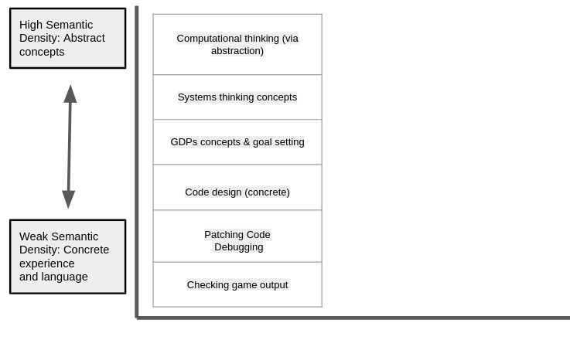
Figure 7.x - Semantic density of the key concepts of this research
As such, GDPs would be situated between abstract CT processes and concrete implementation. Thus, returning to the framing the design element of the use of GDPs as intermediate-level concept (Eriksson et al., 2019), the interpretation of the data of this study using semantic profiles above supports this intermediate positioning.
The following diagram is an approximate representation of the scope of movement using typical behaviour seen in Vignette 2. In this vignette, as exploration of abstract CT concepts and explicit use of systems concepts are rarely present, the resulting of semantic profiles show movement in the lower areas of the gradation of semantic density. This shallow semantic wave above is typical in describing the data of other participants in analysed session recordings.
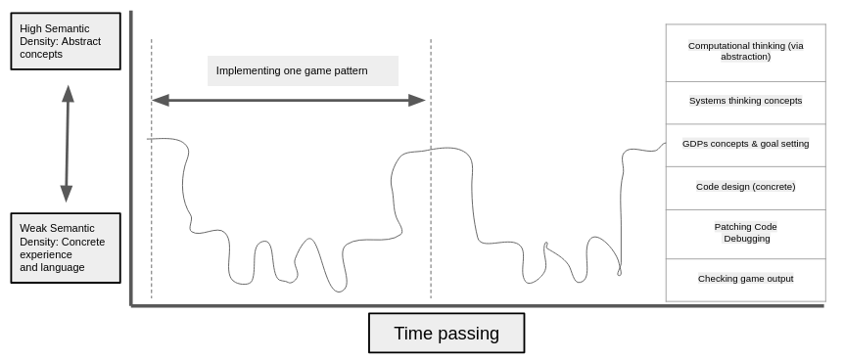
Figure 7.x - Semantic profile in Vignette 2
Each time the participants imagine and choose a design pattern, implement it code patching, test it and then debug it .
MORE DETAIL ALIGNED TO FIGURE - ANNOTATIONS ?
This profile mirrors the description of Papert and Turkle’s (Papert and Turkle, 1990) bricoleur maker styles. The data of Chapter 5 details the development of a learning pedagogy which aligns primarily to the more concrete applied approach as a way of ameliorating barriers of conceptual complexity. Observations show most participants operating as bricoleurs, feeling their way through their game-making via smaller-scale iterations rather than extensive periods of planning followed by implementation.
With this focus, we can analyse my learning design where movement between layers of abstraction and concrete is happening. Shifts do occur between participants goal formation and the concrete implementation using design practices and specific code structures. Examples pervade the data of Vignettes, and descriptions of fluency in Chapter 6 in part stem from the fluid shifts in these levels. The level of detail in Vignette 2 for example is a good indication of rapid shifts.
GDPs are relevant in this process as they provide a tangible level of feedback in the most concrete level, and games provide high motivation to adjust code to get the result feeling just right (as seen in Chapter 6). For example the alternation between checking game level and debugging level in Vignette 2 data results from Toby wanting to get the positioning of the moving enemy correct and making several changes to achieve the desired behaviour.
Description of impact of blackboxing on semantic profile of learners
This relatively typical semantic profile shows rapid iterations of project changes and navigation between the upper and lower poles but little activity at the code design activity. This pattern is due the black-boxing of more complex and abstract element of the starting template and the carefully structured menu of GDPs and closely coupled documentation supporting implementation as explored in Chapter 5. These black-boxing decisions were initially in response to barriers present to abstract approaches explored in Chapter 2 in order to prioritise accessibility and flow experience, inline with a bricolage approach and constructionist design heuristics (Resnick and Silverman, 2005) (see Appendix.tech for fuller details). The process of scaffolding this abstraction allowed greater focus on more relational and affective elements of the learning design, processes which are described in more depth later.
Thus as a facilitator I undertook some code template design and implementation that would have been a potentially valuable learning experience requiring more generalisable computational thinking skills. These can be summarised using Wing’s CT concepts namely:
- Code decomposition via the pre-existing functions in the code template
- Abstraction via the structuring of the template with key variables moved to the start of the code
- Abstraction again in template via the graphical design tool in the form of a grid matrix in an array data structure.
- Decomposition and generalisation (pattern recognition) were present in the structuring of the collection of GDPs
One framing of this approach is that over-scaffolding here deprives learners or the chance to learn and practice these valuable CT practices. WHERE IS MY JUSTIFICATION?
HOW TO PHRASE THIS CORRECTLY BELOW.
Given the limits of bricolage approach in exploration of more abstract concepts, is it of value to ask how if the learning design is at odds with previously explored advocacy for alternating between abstract and concrete dimensions in semantic waves(Curzon et al., 2020), and LOA research (Waite et al., 2018a). For example, The close coupling between design and code structure levels in my design may not align with LOA principles given the statement from Waite and colleagues (Waite et al., 2018b:21) that “1:1 mapping between the design/algorithm and the code may lead to confusion between the levels”. Given that lack of explicit teaching of either LOA or more abstract concepts in my bricolage-like approach, it is likely participants would not be aware of the level at they are working. In addition, while systems concepts are being explored concrete level they are not surfaced explicitly in this learning design. It follows that the authors would cite this as problematic limitation in approach or at the least missed opportunities to unpack and repack concepts.
However, while LOA and PRIMM imply an explicit teaching of abstract concepts or processes, the authors (2018b:21) acknowledge that rationale and evidence to support this is not clear for younger coders. In addition, related research does not include examples of activity explicitly teaching abstraction (Sentance et al., 2019a, 2019b). Certainly, the difficultly in explicitly teaching abstraction rather than implicit approaches of appropriation (Kramer, 2003), while contested by (Statter and Armoni, 2016), and based on work of Hazzan (2008), underlying concerns are not fully addressed. CLARIFY THIS WHOLE SECTION.
In conclusion, the authors also state that the overall utility of LOA as a useful tool for younger participants is an open question, and that more research is needed on claims that it can help “use of design as a self-regulation tool to develop independence”
Turning instead to the value for designers and facilitators, Waite and colleagues (Waite et al., 2018b:21) state “the LOA hierarchy may be a useful tool for improving and reviewing teaching and learning in programming”, my reflections own on research data support this proposition more clearly.
The processes outline above support a position that there is utility for facilitators to be aware of the level of abstraction present in the participants learning experience in order to design to increase accessibility for participants. Specifically, this research suggests that GDPs are a more suitable accessible leading pedagogical framework than computational thinking.
Reframing GDPs from intermediate-level concept or gateway concept
While this research has avoided of explicit teaching of concepts, it has conversely surfaced a mechanism, via the use of GDPs which allows this in an accessible way. I propose that the use of GDPs concepts as a primary object of activity allows them to open up exploration of both abstract and concrete concepts for examples those contained within the learning map (see appendix.learningmap for an example in P4), or more aligned to curricular concerns. This is represented conceptually in Figure 7.x below.
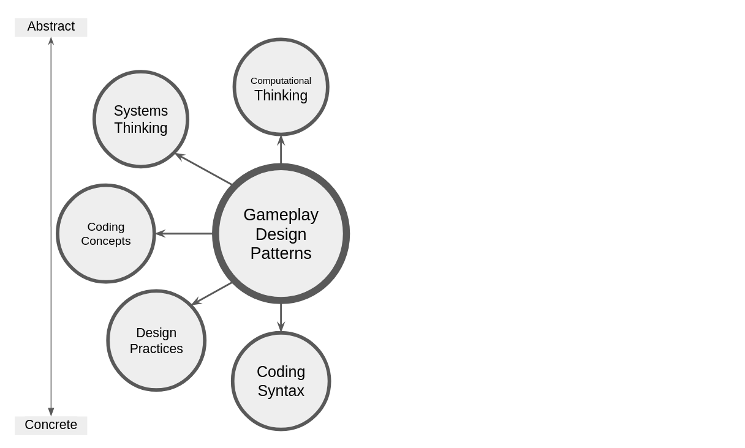
Figure 7.x - GDPs as a gateway concept
To help imagine how this could be operationalised in the context of this research. A possible alternative profile is represented in the illustration below. Given a different focus or motivation, say that of a need to explore concepts due to curricular or exam pressures, an alternative pathway involving the exploration of abstract elements of computational thinking would have been possible.
QUESTION HOW WOULD THE USE OF THIS CONCEPT WORK WITH PRIMM.
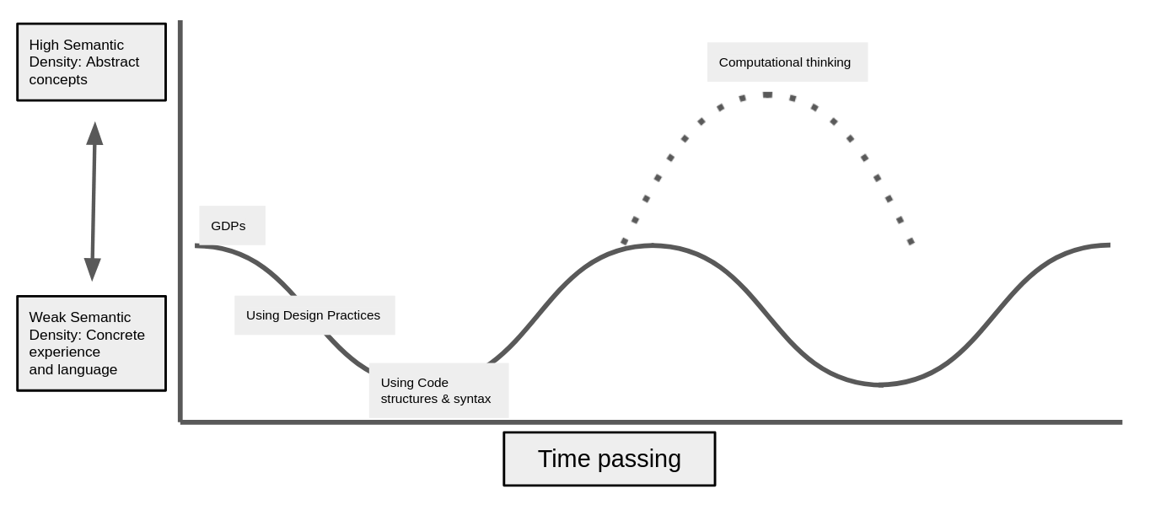
Figure 7.x - Possible alternative semantic profile
An example would be via facilitator intervention. Say Tehillah has made an error altering level design and has made changes to the array comprising graphical matrix. The error which compromising the the structure of the array could be used to draw attention to that coding construct, and the more theoretical construct of nested objects, a form of abstraction in CT terms. Interventions of these kind were not uncommon and could easily form an intentional part of a facilitation strategy when I judged it appropriate or welcome.
Thus, while in my research, the use of in time personal instruction or documentation is used to provoke reflection on abstract concepts while code is being worked on, the value of explicit teaching of more abstract dimension of computational thinking, is not challenged here.
In different contexts, the process of supporting students to follow the dotted path into areas of more abstract concepts could have been scaffolded further through more explicitly guided reflective processes. As explored in Chapter 5, I explored modifications to the documentation to include candidate of the map of learning map dimensions in the initial descriptions of GDPS ( see Appendix.learningDimensions.)
A process to encourage this would be a gamification of the process of reflection, perhaps by attributing badges or points to the a successful reflection of different elements of learning dimension. The extrinsic nature of the process of gamification matches here the extrinsic contextual factors of examination-driven education. While this is a potentially fruitful area for future work, given the core context of non-formal learning of this study it was de-prioritised in this thesis.

Summary of structural components of applied pedagogy - REEPP
The use of conceptual and practical frameworks to scaffold domain specific working practices can help ameliorate the dialectical tension between engagement via tinkering and requirements to promote “principled understanding” (Barron et al., 1998:63). Broadening the focus of this chapter beyond an exploration of abstract and concrete elements of the learning design, I now return to the gap in research on project-based approaches to digital making, in finding appropriate level of scaffolding (Quintana et al., 2004; Waite and Sentance, 2021).
The identification of structural use of GDPs as a germ cell concept, this break through facilitated the development of different progressively graded objectives (recognition, use and modification), as a concrete instance of UMC principles, which helps address the tension between freedom of choice of learner pathway, and expression of interest within a manageable technical structure (with relevant supporting documentation).
Similar to SGD a progressively stepped approach is taken here. These varied forms of documentation, and their varied adoption and propagation represent different approaches to scaffolding the process of becoming familiar with and then modifying to the code in often increasingly ambitious ways.
While SGD was limited in participant pathway choice, my design is not. Following the rationale of choice limitation as a strategy to reduce facilitator stress (Lytle et al., 2019), this design using a limited menu of GDPs as a structural and navigational framework.
This technical structure synthesises use of a code playground, game library, a half-baked game template, UMC pedagogy, and the use of a collection of game design patterns. While similar approaches exist this pedagogical structure is innovative in the way systemic tensions have been resolved and congruencies introduced. I propose that key elements of this pedagogy constitute a replicable approach which is a valuable contribution to coding education. To communicate the essence of this structural, technical model I propose an acronym remix enabled, elective, progressive, pattern patching (REEPPP).
REEPPP Letter | REEPPP Term | Description
RE | Remix Enabled | Project formation is accelerated, limited and scaffolded through the use of a structural starting template in a recognisable project genre with easily discoverable affordances strongly coupled with object output, providing immediate feedback.
E | Elective | Participants have choices over their learning pathways in dimensions of content and design patterns to be added.
P | Progressive | The processes involves progressive steps. In this case pattern recognition through exploration/play, quick start activities involving minimal changes with high impact on the project outcomes, using progressively more challenging documented patterns, finally implementing patterns without support
P | Pattern | The process has at its core the use of recognisable design patterns which are presented together with suggested design solutions and concrete code snippets.
P | Patching | The authentic technical process of code patching accelerates production and creates errors suitable for debugging at a novice level.
The above summary has been written to be applicable to projects beyond the use of games.

Link to next section - limits of this personal dimension approach
In the first part of this chapter, I have proposed that while explicit teaching of abstraction is not necessary or even optimal at this stage of learning coding, this research has surfaced a method which facilitates a principles second approach using GDPs as a gateway concept to dimensions of abstract practice based on reflection of completed activity.
My research data shows the value of the REEPPP approach, structured around the use of GDPs, to access and facilitate dimensions of game making associated with both concrete and abstract knowledge and practices.
Broad descripton - SUMMARY OF UTILITY - DOES THIS LIVE HERE? For participants, the GDPs facilitates goal formation. Once engaged with this goal, participants can use the affordances of the design to traverse different LOA without explicit instruction in the process of playtesting.
This analysis of the use of GDPs through the lens of research on the abstract and concrete dimensions in computing education, there is an alignment with the personal dimension of knowledge highlighted in the previous chapter. This line of research also opens up other dimensions
The scaffolding provided by the template and the close coupling of the purpose, description and implementation of each GDP accelerates and supports the making process which in turn allows for greater possibilities of social and cultural making via playtesting outlined in the following section.
Thus the structural elements of this design facilitate the kind of relational pedagogies originally advocated by Papert and but which have too often been missing from research in this field.
The following section develops an analysis of the findings from the last chapter, outlining the potential of GDP concepts, especially within playtesting, to support these participant shifts in perspective. The following section addresses the social and cultural aspects of this study, using the development of varied forms of participant agency as an analytical lens.

Part Two - Agency, and re-mediation of repertoires in third spaces
Revisiting - Motivation and gaps in research:
The motivation of this study transcends concepts of efficacy of how to support the technical aspects of coding process.
At this point we can readdress one of the gaps addressed by the problem statement of the thesis: The lack of studies using socio-cultural perspectives to facilitate an agency based approach.
As noted in Chapter 2 (Kafai and Vasudevan, 2015). Despite Papert’s (Lodi and Martini, 2021) foundational focus on the community application of created projects continues in legacy of constructionism. For example, the articulation of Resnick on computational fluency, addresses the limitations of research focusing too narrowly on technical approaches and toolsets rather than their expressive potential (and thus within a community) and focused on toolsets rather than pedagogies (Resnick, 2020; Resnick and Rusk, 2020).
In a UK computing education context, while the work of Waite and Sentence begins to address sociocultural aspects of teaching programming (Sentance et al., 2019b; Hwang et al., 2023), but as explored in Chatper 2 this work is limited in scope and invites further exploration.
Why agency in particular revisit / gaps
Given that a guiding motivation of this study to explore the process of designing and facilitating for participant empowerment in learning to program, it is valuable to explore terms.
Chapter 2 examined varied concepts and characteristics of fluency in constructionist research, and concepts of flow. Chapter 6 explored these concepts in relation to the data of this study and found agency to be better aligned to a socio-cultural approach.
Setting out pathway - & thread for reader
Firstly, an exploration of evolving expressions of agency emerging from the research data, specifically instrumental, transformational and relational agency, is undertaken.
The second section is an exploration of the key characteristics of participants agency using concepts from the work of Rogoff, Cole and Gutiérrez to re-examine the evolution of participant agency as a utopian process of blending or even patching of repertoires of different types and sources.
CHANGE THIS It concludes by proposing that understandings of CGD&P pedagogies can be enriched in two dimensions, firstly in design and secondly in a deeper theoretical understanding of concepts of agency development.

Instrumental and transformational agency
The exploration of tensions in Chapter 5 summary, design decisions of tool use can to increase agency in practical terms by providing affordances or by removing barriers to use. Conceptually these practical dimension can be framed as instrumental agency or removing aspects of negative liberty caused by technical barriers (Matusov et al., 2016:433).
Instrumental agency in education can be viewed as an uncomplicated view of mediation as a means to achieve pre-set goals. Thus designing for instrumental agency is often framed within an instruction or school setting.
EXAMPLES IN THIS SETTING NEEDED. REFERENCE CHAPTER 5.
A distinction can be made with and a transformative agency (Isaac et al., 2022), in that expression of instrumental agency are unlikely to provoke environment changes in the activity system at hand.
Transformational agency may stem from transcending individual motivation but also involves a transformation to systemic constraints (Hopwood, 2022). Participant acts of volition which aims overcome conflicts blocking activity progress may serve to surface previously unknown forms of mediation and use of tools.
Examples of this process in the research process were prevalent in P1 where participants had access to little in terms of supporting resources. Thus emergence, via interaction between participants and myself, of the P2 pedagogy is a result of transformational agency. For more details using TADS terminology see (Appendix.design.p1)

Tensions related to transformational agency
In early stages I propose one of the roles of the facilitator to make available a variety of affordances in terms of types of activities and materials available for facilitate the process of double stimulation. Then after noticing volitional attempts by participant to access affordance in novel ways via TADS, the facilitator should then incorporate learning design decisions to increase visibility and ease of use of such affordances with an aim to increase feelings of control over their creative process.
This raises a question, does adapting designs to increase affordances and instrumental agency reduces opportunities for transformational agency. And therefore, if it is advantageous to keep some key areas of the learning design should be kept incomplete to encourage the emergence of participant responses and novel practices thus retain the potential for transformational agency. In practice, there were still spaces for transformation once the core pedagogy is in place. For example, in Vig. Tody and Dan the break out of the template to create a different genre.
An additional challenge as a facilitator in this regard is how to balance the transformative potential of an incomplete learning environments with the potential for participant, confusing and stress. In this research this tension was ameliorated via the use of play and other processes to create an inclusive, low-stress environment. These were beneficial to participant feeling able to experiment with new forms of mediational strategies and thus enact transformational agency. Another relevant concern is how to best incorporate new affordances and processes that emerge from TADS processes back into the learning community. This questions is explored in the following section on relational agency.

Relational agency
The complex relations between participants outlined in the vignettes and data of the last chapter, in particular that in guided participation and cultural activity, demonstrate interdependence characteristic of relational agency. Edwards (Edwards, 2009) explores relational agency within a CHAT framework as transcending individuals capacity to encompass collective problems solving via specialisation and diversity of approaches within activity systems. As a collective participants can overcome systemic contradictions via expansive learning, rearranging working relationships and thus forging new forms of helping and learning strategies.

Reframing findings using socio-cultural understandings of agency and repertoire blending

Revisiting understandings of relational agency and repertoires
DOES THIS LIVE AT THE START OF PART TWO?
The discussion section of chapter 6 we examined the complexity of the expanded object in this research, noting both the diversity in terms of motivations and mediational strategies present and the limitations of 3GAT to clearly represent the important interactions between activity systems (Engeström, 1996). This section draws on diverse conceptions of agency to undertake an ecological analysis of the cultural plane of activity. To do this, it works with findings from Chapter 6 regarding GDP use and introduces new data from interviews with participants. It (re)frames these findings using concepts of repertoires and third space via attention to issues of participant identity and movement of practices between learning settings.
KEEP RECAP FOR NOW. Third spaces for Gutiérrez are collective zones of proximal development, which can be both an specific environment and/ or a process within existing contexts supporting a hybrid approach where diverse repertoires are re-mediated or blended in collaborative work on an expanded object (Gutiérrez, 2008). To augment this setting related concept, Rogoff and Gutiérrez (Gutiérrez and Rogoff, 2003; Kris D. Gutiérrez et al., 2019) use repertoires as a lens to contribute to discussion of expansive learning in CHAT as a positive enacted demonstration of diversity and equity. Rogoff and Gutierrez’s initial motivation in their exploration of repertoires was to challenge simplistic, overgeneralising approaches regarding learning styles especially if applied to non-dominant communities (Gutiérrez and Rogoff, 2003). The researchers highlight the value of identifying potential funds of knowledge framed as “linguistic and cultural-historical repertoires” that learners bring to learning environments (Gutiérrez and Rogoff, 2003:22).
THERE IS ALSO A LINK TO MUTUAL APPROPRIATION HERE.
MAKE CLEARER The overall goal is of this section is to
- explore the source of diverse participant repertoires (Gutiérrez et al., 1999)
- explore the development of mediational tactics in learning contexts
with a wider aim of understanding and facilitating the development of agency and other socio-cultural aspects of this research relevant to the field of CGD&P as addressed in research questions RQP AND RQ3.

A - Repertoire importation into the the game making community
Following Gutiérrez’s (2008; 2019) concept of learning as movement between spaces, we can locate participant repertoires in the data of this study that are imported into a new activity happening in an emerging third space from other activity systems. This section draws mostly on interview data which allows a greater precision in locating the repertoires as pre-existing in other settings rather than being rapidly developed in the new setting. Two key themes of repertoires emerged, those repertoires involving funds of knowledge and repertoires involving divisions of labour.
Addressing first repertoires involving divisions of labour, Barron’s helping roles (Barron et al., 2009) in technology use (teacher, project collaborator, learning broker, nontechnical consultant and learner) are present from initial stages. These these roles are illustrated in observed practice or in interview data. EXAMPLES
In video data and interview data with Susanna and Tehillah, the parent details how she is able to support her child based on her home knowledge of working styles and the use of paper to help the child sketch (see Vignette 2). The paper prototyping as a home practice imported to this space is also cited by Mark and Ed in interview data (see Interview.2.a )
In addition, other divisions of labour which highlight the emerging roles of young people are present the data. For example, Mark(p) describes he and Ed’s(c) styles of working through documentaiton carefully at home as plodding - “we are plodders”. In Interview.1.c Madiha(p) describes Nasrin(c)’s strong preference for independent working which her mother Madiha respects and accommodates. This game making program set an expectation parents to get involved with the game coding as well as young people. Maggie shares her thoughts on the changing nature of Home Education communities, that parents are now more passive and think of their roles as arranging tutoring for their childrens, whereas she is more aligned with a DIY approach, and keen to get involved. Anastasia(p) (P1.debrief) also shared reflections on the issues of family and home education dynamics, suggesting that parents may get in the way of young people’s ability to move into other’s spaces to learn things, and that parental helping roles may therefore be a hindrance.
ANY MORE/ PERHAPS NORMS
Turning to funds of knowledge and interest, present in the areas of game playing interests, art, environmental and other global concerns and professional knowledge. For example, some adults imported knowledge from professional communities or previous studies, for example Maggie had studied Pascal previously and Dan brought practices from work and from volunteering at Coder Dojo.
Movement of repertoires was also well illustrated in the mobilisation of game related knowledge. From P2 onward the use of a half-baked game as a starting point also allowed FoK to be mobilised in several ways. The knowledge of what was normal in such a platform game, the use of gravity as a known concept in variables. And motivation to change such a game and personalise it via the graphical matrix. In Interview.2.a Nasrin shares some of the links between Minecraft practices and graphical asset authoring in the Piskel software. AS AN ADDITIONAL BENEFIT?.. Madiha shared that via joint game making she was now more aware of an involved in Nasrin’s gaming activity.
Early in the P1 and P2 process participants were able to incorporate some of their concerns about wider ecological and global issues in the planning of their game narrative. In interview data Madiha (Interview.2.b) describes her own choice to address social media, Nasrin’s choice to make a game on sea pollution and Xavier’s topic of AI robots taking over the world. On a smaller scale some participant chose their hobbies or fan interests as game subjects: Ed choosing trains and Maggie, Pearl and Grandad choosing beekeeping. Interview data surfaced the identification with art as a hobby practice by Ed, Nasrin and Madiha. This was echoed in video data where both Madiha and Nasrin appeared to favour working with graphical elements and bringing characters to the game. Madiha created a collage which she brought in to use as the game’s background.
This section is not an attempt to exhaustively list initial imported uses of FoK and DoL, rather it details an important stage in a longer process. At times the practice of blending with either GDP concepts or technical tools is very rapid. For some participants the process of blending their interests with those of the game making program began immediately and intuitively as illustrated by Mark(p)’s comments on Ed(c)’s use of the Piskel graphical art editor (Interview.2). Other processes took longer to emerge, requiring more time or active effort to incorporate as described in the following section.

B - The process of blending of repertoires in the third space of this research (playtesting in particular)

Playtesting as a suitable medium for emerging activities creating third spaces via blending of repertoires
The process of playtesting, beyond a technical evaluation phase of design thinking and user testing in HCI (Fullerton, 2018), took on a role in surfacing and amplifying opportunities for new repertoires, specialism and associated identities to propagate via wider group playtesting of the games of others which was more social in nature. The work of DiGiacomo and Gutiérrez (2016:144) (see Chapter 3) explored social making in a similar context highlighted the importance of (a) feedback from making activities to nurture relational expertise in the form of emerging specialisms in activity and of (b) social feedback to increase relational agency between participants. Playtesing can thus be seen a both a process and a (third) space suited to both the re-mediation of mediational strategies in response to the diverse practices, and thus organic and introduced development of hybrid practices which blend existing repertoires of young people, parents and facilitators (Gutiérrez and Vossoughi, 2010). In addition, group playtesting unlocks the relational aspects of both expertise and wider agency, a process are explored in this section using the data of this thesis.

Different styles of playtesting- conditions for playtesting & resulting ways of being - and Relational expertise in playtesting
The development of different styles of being in playtesting represented new forms of re-mediated strategies incorporating home practices and new introduced repertoires.
Some participants refrained from extensive testing of other games, waiting for others to test their games and carefully observing their responses.
Some children added additional playful elements to playtesting (see Appendix.playtestingtypes). Some in particular brought a physicality to the process, clustering in a particular zone of the class, referencing the game play elements, acting them out, attempting to change the games of others and playful tussling as part of resistance to those changes.
Some participants were very social in their playtesting approach and used playtesting interactions to build affective relationships in a variety of ways. Some via kind and supportive feedback and personal identification with created characters. Madiha for example often said how cute the characters created were. Some participants used playtesting as a way to gain idea of what to add to their game next and to ask for direct help in that process (see x in Chapter 6).
Others embraced a playfully disruptive stance. Playtesting for some participants provided a chance to break conventions game design norms of the genre, as a way to cause frustration or confusion, illustrated by Tehillah’s behaviour in (V2).
There is potential for identity formation within the idioculture to address barriers participation in programming communities explored in Chapter 2. The role of playtesting aligns here creating a helpful system congruency.
The diversity in playtesting behaviours drove my reflection on the relationship between developing effective repertoires and an affective relationship to the activity relies on the participants being able to identify with the ongoing activity (thus informing a processes of inclusion)

The sharing of specialism and proficiency via material feedback and guided participation
Beyond playtesing styles to visible repertoires sharing other repertoires involving expertise
Beyond general playtesting styles, playtesting developed specialisms related to growing participant proficiency. Self-playtesting by individuals and pairs allowed immediate feedback from the material affordances of the learning design (as explored in Chapter 5).
As explored in Chapters 6, the structuring of GDP collection around the MDA game framework drawing on aesthetics, dynamics and mechanics of the game, reflected initial participant interests. Some participants developing their imported home interests into areas of game making specialism. Some focused extensively on the creation and implementation of graphical assets and level design being motivated by narrative placement in the game via GDPs. Some approached game making objectives in a methodical manner (see Vignette V3.c), picking up technical processes from documentation. Others relied on trial and error or interaction with facilitator.
Re-mediation into relational agency
Social playtesting made the resulting specialisations on learning visible, the specialisations contributes to possibilities of relational agency for individuals the learning environment as a whole. It exists as a form of identity within an individuals repertoire and for others to draw on as an affordance of the learning system. Thus following the logic of DiGiacomo and Gutiérrez (2016) the emerging relational expertise helped develop relational agency.
The process can create a positive feedback loop as technical repertoires which are developed through game making may be social motivated via to prepare for playtesting and then once shared publicly may propagate (see Chapter 6) providing relational affordances for others. An example of this is Toby’s adding of new levels to his game to make ie more challenging for others in playtesting, an innovation noted by others who then asked Toby to help them implement it (see Vignette 1).
MORE EXAMPLES NEEDED HERE?

C - Supporting emerging identity formation and specialisation through interventions to support relational repertoire blending
While the previous examples have focused on relational agency between participants, the role of the designer and facilitators are also relevant. My recognising and valuing the emerging areas of specialisation and expertise, both technical and social in nature, helped the development of diverse practices. Specifically the responsive design revisions outlined in the first part of this chapter help keep the games in progress in a working state and more time devoted to open playtesting helped reinforce and support the diverse practices of social feedback in playtesting. The emerging diversity and repertoire blending happening in playtesting practices in particular, in this non-formal, educational third spaces (Gutiérrez et al., 1999) prompted me to ask if suitable affordances be added to the design to accelerate or encourage the process. This is explore here in the form of support styes and mission

Helping styles and helpers
While it is important to acknowledge the importance of the role of students helpers in the formation of relational agency, given the wealth of existing research on this subject in similar settings (Stone and Gutiérrez, 2007; Kafai et al., 2008; Barron et al., 2009; Roque, 2016; Roque et al., 2016), only a brief summary of where experience aligns is included here. For a descriptive summary see - add appendix?
- identifying tensions and blocks
- Similar to a study by Stone and Gutiérrez (2007:51) student helpers highlighted emerging “zones of competency” of learner’s identities and relational expertise.
- Students acted as pollinators, highlighting the work of other makers, thus acting as a vector for relational agency.

The introduction of side missions & maker types to make visible emerging repertoires as cultural affordances of my pedagogy to increase and legitimise diversity / hybridity
Turning to address two more explicit interventions in P2 and P3 which aimed to accelerate the process of relational expertise and repertoire blending. This section is also limited in scope but for a different reason. While the are novel and promising elements here which synthesise the helping roles described above with elements of drama practice and mantle of the expert, a detailed exploration would take this thesis in a different direction.
From observation of the emerging specialism and identities explored above, I created working typology of participant approaches to playtesting and game making approaches. This grouping became a topic of reflection via a playful game exploring Bartle’s player types. Subsequently, to support these maker styles, I created a selection of side missions and presented these together with a wider mission within a drama frame (see Appendix .makertypes for fuller description and participant feedback on the process via interview data).
In interview data participants shared their positive feelings towards both the shared fictional frame of making a game for an audience of judgemental aliens, and the social and mischievousness of the social missions within that drama. The value of the drama narrative and side missions aligns with work on play theory as a technique giving participants permission to play (Walsh, 2019), legitimising the previously peripheral activities and bringing them into the shared conceptions of the idioculture. The recognition of the hybridity of possible modes of participation increases conceptions of enacted diversity of the community.

Reflections on explicit interventions
This strand of thought invites an theoretical examination of the particular value of identify formation via the blending of repertoires of play and design approaches. The role of play as leading activity is explored by Gutierrez (Kris D. Gutiérrez et al., 2019) to facilitate movement between sites of learning (Addressing issues of motivation and positive affect, ).
The invitation to play, can be seen as a familiar affordance leading to more unfamiliar territory. A helping process in blending through opening a door to a new collaborative zone of proximal development.

Part Three : Reframing for an audience? Communicating the findings to a broad audience
Implications for design and summative design frameworks
Different part of this thesis have addressed different research questions. This section aims to reframe findings further to communicate to a broad audience including facilitators and teachers.
Part one of this chapter addressed RQ1 () by synthesised the findings of Chapter 5 and Chapter 6 regarding a deep analysis of concrete and abstract
In Chapter 6 addressed RQ2 () via a summary table of the varied uses of GDPs P art
Returning to the gaps in existing reseach driving the question of this study we can see the importance not only of research exploring and analysing the development of socio cultural approaches to CGD&P but also on means to disseminate these practices into an atropified but still exant grassroot community, and via remaining funded communication channels.
The following section prioritises key messages arising from this research and with an aim to frame them in an accessible but theoretically consistent way.

What is relational agency and why should it be facilitated
To address the under explored areas of agency development in existing research in CGD&P, it is of value to re-examine and synthesise the characteristics of the learning design described using the agency as a lens.
Agency in this in game making community is seen as multi-dimensional and as a process located in community participation rather than an individualised property. In analysis the concept of relational agency represent an end point achieved through building on and incorporating processes of instrumental and transformative agency. Thus it is tactical to highligh relational agency as an end goal for participant to reach, for designer to design for and faciliators to faciliate. Additionally, this chapter has explored a process of developing relational agency in a way which .
Analysis of the finding were framed via a staged approach to re-mediating existing repertoires into new repertoires and an emerging game making idioculture. To help conceptualise this goal and process I propose the term relational agency by repertoire blending (RARB). This term based on the work of Gutiérrez and others (gutierrez2020utopian?; stone_problem_2007?) mirrors Sannino’s (Sannino, 2015) concept of TADS (transformative agency by double stimulation). It is advanced with a motive to provide an accessible framing and a metaphorical structuring to a complex process.

HOW - Narrative descriptive of a proposed procedure for facilitation relational agency by repertoire blending (RARB)
RARB is a process which in the context of this study can be best described via three stages. In stage one the motivation is to create an inclusive learning environment where participants are able to import existing repertoires from other spaces in the form of competencies and interest. For some participants this may involve the use of designed affordances in pre-planned (by the learning designer) ways via instrumental agency, or they may cast around to find novel uses of affordances present in a process of TADS. As participants load their existing repertoires in the use of new tools a process of blending is already in process.
Stage two involves a natural stewing of these repertoires in the melting pot of new third space (e.g. the game making sessions) into new repertoires. In this research the repertoires blending process leading was facilitated by the favourable conditions provided by regular playtesting and other playful elements of the programme. These emerging making behaviours and specialisms involving interests and helping behaviours resulting from manifestations of instrumental and transformative agency may start to propagate via playtesting and other social and cultural interactions in the space.
In stage three facilitators can recognise the use of novel and begin to help other participants to use that same processes by incorporating them into the learning design or in some way highlighting the possibilities they offer. The role of the facilitator here involves adding yeasts or other accelerants to allow the body of the emerging idioculture grow faster by making relational, socio-cultural affordances more visible to all participants. The culture should be kept warm by checking that such processes are not overwhelming, that they are optional, and maintaining a playful environment at this stage to allow this form relational agency to flourish.

Summative table illustrating stages of facilitating RARB in this study
The purpose of this table is geared more towards synthesis of approach in relation to creating relational agency through repertoire blending. As such characteristics and descriptions are more decontextualised.
Characteristics of design | Design example and description | Evidence & related research
Stage One - Facilitating participants to import existing repertoires of practice
Allow quick demonstrations of game knowledge | Quick start activities scaffold learners to alter game players allow learners to show competency | Example of quick start activities (Appendix )
Encourage early use of art and music abilities via scaffolded tool use | Learners interested in art can use an intuitive pixel art and music editors to quickly integrate their home interests in digital creations. | example 2
Facilitate flexible group sizes to allow importation of relational helping and working repertoires. | Use of a foundational game template helps novices get started without help and facilitates a larger number of groups | example 3
Use a project theme that is relevant to participants. | Use of a relevant theme in the project design brief. | example 4
Stage Two - Engendering blending of repertoires
Protection from complexity via technical limitations | Participants benefit from more relaxed making environment as key design complexities are baked into template design | example 5
Provide feedback mechanisms in the materials of making process | Uise of code playground and structuring template with key affordences with high impact on the game | Microworld research, rapid feedback via code playground
Try to create a level playing field between generations | The use of an unfamiliar text coding process for both YP and adults created a more horizontal power relationship | example 7
Provide regular social or community feedback on emerging designs as a way to recognise and engender participant specialisms | The use of playtesting allowed for regular feedback | see Gutiérrez, example 2
Stage Three - Recognising and encouraging emerging specialism and identity behaviours
Engedering a low stress and playful frame within overall activity with explicit fictional narrative | Use of a drama process, | example 2
Structuring reflection on relational expertise | Use of maker styles as a tool to faciliate emerging specialims, and to communicate a validity of a pluralism of approaches to design and programming | Papert & Turkle, Appendix.maker
Explicit interventions to support the development of new blended helping styles | Use descriptions of helping styles in digital environments to reinforce adaptation of existing home helping repertoires | example 2
Table 7.x - Summative table illustrating stages of facilitating RARB in this study

Metaphors as a way to communication dimensions of agency design concerns
The previous sections have explored a complex and multi-faceted view of participant agency in this learning design. Before undertaking a fuller summary in the final section of this chapter, this section reinterprets some of these aspects using a metaphorical approach. The use of metaphor here has two functions. The first is to help deepen my analysis via a move to the abstract, searching for communicable generalisations. Secondly, given the multi-faceted nature of the pedagogy, and bearing in mind previous reflections on the value of an utopian approach to communicating the future possibilities of findings (Gutiérrez et al., 2020; Rajala et al., 2023), I draw on metaphors as a framing tool to present an initially simplified viewpoint for further discussion. The discussion will draw from the core principles in Table 7.x to aid the accessibility of this research for an audience of practitioners as well as researchers.

Harbours as both protective and authentic
The intrigue of opening up previously mysterious areas and seeing or experimenting with what makes them tick, often referred to as looking under the hood, applies here in the early stages of the learning experience. The process of clicking remix to fix a broken, half-baked game involves entering unfamiliar and potentially exciting waters. However, the motivational impact of an authentic process and set of tools must be balanced by possible accompanying complexity (Nachtigall et al., 2024).
Harbours are protective spaces suitable for docking ships. They may be natural or designed. If designed, protection is offered by artificially created harbour walls extending out into the sea, creating a sheltered space, preventing large waves from entering but also allowing movement out into the open sea. Harbours provide the possibility for refuelling or maintaining sea vessels and infrastructure to connect to rail or road links for transport inland. The term harbour is used metaphorically to indicate a space of safety, nurturing, and a gathering space f
While this design uses an authentic, professional text-coding language with its inherent challenges, many other design decisions in this study were made to create a supported, simplified coding environment. Relevant examples from the previous chapter include: using an online code playground; shielding learners from the underlying configuration of interrelated web technologies; removing or obscuring structural code complexity in the code template.
The practice of starting from a template mirrors professional practice. The goal being to shield new users from the complexity of the underlying configuration of interrelated web technologies and instead highlight design affordances that facilitate creative agency. This strong alignment with authentic, professional practice may help learners transition from a supported harbour to venture out into the open seas of less supported research and practice.
An example of this being Toby and Dan in Vignette X. who, in their choice to change the game genre from platformer to maze game, leave the safety of a set of design patterns and paired support documentation. Instead, Toby must develop his code patching skills in choppier waters by accessing more authentic documentation and charting their own patterns in the open sea of internet-based resources. This is made possible by having an experienced navigator with him, in the form of a parent with relevant skills. I propose that the curated replication of authentic processes of finding and incorporating code snippets into the starting template supported the development of skills used in the authentic waters of professional coding communities.
In terms of agency and choice over learner pathway, we can see that the safe nature of the harbour encourages free exploration within its area. There are limits to the rhizomatic nature of this exploration. The boundaries of the harbour walls represent the restrictive decisions in terms of the genre of end product, and simplifications in code structures used. The following section explores the restrictions (e.g. in genre) from a perspective of the creative potential of such limitations (Rosso, 2014).

Spaces to play - playgrounds and jam sessions
A similar metaphorical dimension of protection is present in metaphors of play spaces, a link which is immediately present in this design in the use of code playgrounds (web-based environments which reduce the complexity of web development and provide immediate feedback and community). Additionally, the process of checking the performance of games is called play-testing, with connotations of a playful, and therefore social space. Similarly, the term sandbox is used extensively in web development to indicate a safety in terms of non-critical space to trial new code and make mistakes. As with harbours, a space of play space evokes protection within designed limitations (Rosso, 2014), but beyond that they provide affordances to encourage learners to evolve their own play processes as a form of transformational and relational agency. The concept of musical play within jam sessions is a productive way to explore this tension between freedom and structure.
In the previous chapter, I explored the flexible nature of emerging design behaviours and proposed them as a form of improvisation or jamming. Jamming, a term common in music and theatre, describes responsive, improvised, rapid and fluid responses to collaborators’ ideas and audience reactions (Sawyer, 2003; Pinheiro, 2011). The area of improvisation is underexplored in the game jam context compared to that of music and theatre (Jaffurs, 2004; Meriläinen et al., 2020). The following section makes a closer parallel in the context of the data of this study.
On a macro-level, at a jam event, infrastructure in terms of drums, microphones and amps are provided often by established regulars of the process. A jam on a micro-level is an introduced, familiar framework, restricted in that it is based on a familiar, popular song (often referred to as standards), within agreed genres (most often blues and jazz). The short structure of a song and the key in which it is performed form a base guiding improvisation. Within a jam process, bringing your own style to build on that structure is welcomed. The process is augmented by the group element of the musical jam, where music makers pick up techniques from others in the process. Visual and verbal encouragement is often present in successful jam nights to encourage newcomers. If a jam session is regular, local popular standard songs emerge. This provides opportunities to hear them played regularly, allows potential participants to hear them versioned before entering, a useful form of peripheral participation.
Several parallels to the design and processes in my research exist. The half-baked game template can be seen as a shared song framework that participants build on in idiosyncratic ways. The value of a process that incorporates an authentic audience made up partly of peer makers is important for the development of repertoires of practice in both contexts. The value of the possibility to blend established repertoires with those brought by new players is a shared contextual motivation.

Representing the use of REEPP, RARB and the use of GDPs within a pedagogical framework
The social and cultural processes described in part two of this chapter, is a valid contribution to the field as a technical pedagogical structure. In line with the summary of gaps in existing reseach, the process of communicating a holistic understanding of the learning design that evolved in the course of this research is challenging. The structural element of the proceedural REEPP framework could be augmented with the socio-cultural elements explored in part two. To do this, I could propose logical acronym: collaborative, culturally responsive, remix enabled, elective, progressive pattern patching (CCRREEPPP). While logical, I have concerns that it may be percieved as a bit daft.
The work of Quintana et al contains useful guidelines for checking the suitability of a framework to support science education (Quintana et al., 2004). In particular guideline x, and y can be identified in the use of GDPS in this research.
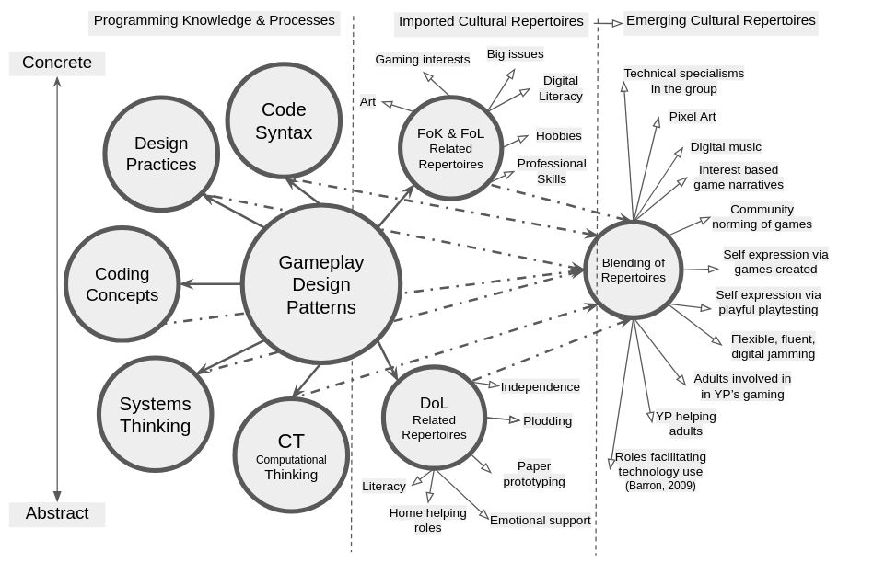
Illustration 7.x - GDPs as a gateway pedagogical framework
I propose that providing a menu of GDPs can, as with accessing more abstract concepts, act as a framework to facilitate to process of development of social and cultural repertoires of practice.
I suggest a change in terminology. Instead of interpreting design patterns here as intermediate constructs, I propose the term gateway pedagogical framework to communicate potential utility in opening up exploration of different dimensions of learning.
The shift from intermediate to gateway also addresses the issue of how to present the dimensions of abstract and concrete. Abstract concepts are often positioned as higher in a spacial representation. This is present in semantic profiling diagrams above, in y example, and even the phrase top-down planning from Papert and Turkle in their challenging of this privileging of abstract approaches communicates an implied superiority of approach. By way of contrast, the Mark’s phrase rising to the concrete reverses this polarity. Similarly, as a small attempt to challenge this convention I reverse the polarity placing concrete dimension at the top of the illustration.

Summary of the potential utility of GDPs for wider stakeholders - MOVE?
The evidence and examples surfaced in Chapter 6 and the previous section support a view that the GDPs can form the basis of productive research and pedagogical frameworks.
While the work of Eriksson et al. explored the utility of GDP concepts in several dimensions the focus was on utility for the research community. Instead this research outlines potential uses of GDPs participants and facilitators/ learning designers.
The value for facilitators is best explored by returning to the narrative of RARB in this research above.
Addressing utility for participants, in computing education, design pattern-based approaches have benefits in making complex problems more modular and concrete (Muller et al., 2004; Waite and Sentance, 2021).
GDPs are particularly helpful in participant goal formation, as explored in Chapter 6 in the sections on ideation and prioritisation. GDPs also help with the division of labour between collaborators, which is relevant here as when tackling more abstract processes, concepts, and terminology, these roles are often taken on by a more competent partner.

Conclusion
NOTE - As this chapter is ongoing this conclusion is in draft form. Feedback on what to include in this chapter conclusion is welcome.

Narrative recap on how the RQs have been answered in each section?
- the place of this chapter in the narrative of the thesis
- the limitations or questions arising that may be addressed in the following chapter.
limitations/ further work
This work invites exploration of related issues of - inclusion as a lens
The final chapters aims to address this with recommendations for facilitators and researchers. The scope of the applicability is addressed as the findings of this thesis can inform the wider debate of how to best support project based learning in wider domains. Specifically the use of concrete design frameworks and step-based iterative project in scaffolding PBL.

