7. Findings on RQ3
- Findings related to agency
  - Introduction
  - Part one - Exploring concepts of abstract and concrete knowledge frameworks in relation to game design patterns
    - Conceptions of abstraction in the research field
    - Exploring findings in relation to existing pedagogies
      - Computational thinking and bricolage
      - Exploring findings using concepts of semantic profiles, LOA, & PRIMM
      - Interpreting GDPs as both intermediate-level knowledge and as a gateway pedagogical concept
    - Summary of structural components of applied pedagogy - REEPP
  - Part Two - Agency, and re-mediation of repertoires in third spaces
    - Exploring the learning process of my finding using the lens of transformations in agency
    - Reframing findings using socio-cultural understandings of agency and repertoire blending
    - Repertoire importation into the the game making community
    - The process of blending of repertoires in the third space of this research (playtesting in particular)
    - Supporting emerging identity formation and specialisation through interventions to support relational repertoire blending
  - Part Three - Synthesising and reframing the findings of this research for a broad audience
    - How can varied dimensions of agency be identified and nurtured in an evolving community of game makers?
      - Narrative descriptive of a proposed procedure for facilitating relational agency by repertoire blending (RARB)
      - Summative table illustrating stages of facilitating RARB in this study
    - Communicate dimensions of agency and related design concerns via jamming as a metaphor
    - Conclusion
  - Footnotes

Findings related to agency

Introduction
This discussion chapter draws together the findings of previous chapters to deepen the analysis of the concepts explored and to synthesise observations into formulations that can be communicated in an accessible way. To begin, this chapter continues discusses the findings of Chapter 6 in relation to existing research on programming pedagogies. It specifically addresses the complexities of the abstract and concrete dimensions of computing education.
The second section addresses gaps in the existing landscape related to social and cultural dimensions of CGD&P research through examining participants’ development of agency via game making. To achieve this, I begin with an exploration of the study’s findings in relation to instrumental, transformative, and relational agency. I develop an interpretation of relational agency drawing on Rogoff and Gutiérrez’s <Do Zotero Refresh: [@gutierrez_cultural_2003]> concept of learner repertoires. To do this, the findings of this research are framed within a novel model describing three stages of a process agency development.
A final section summarises findings for a broad audience, addressing the characteristics of the design that support relational agency, a graphical representation of the development of agency, and an exploration of metaphors that synthesise significant features of the learning design. ADD A LITTLE MORE DETAIL.

Part one - Exploring concepts of abstract and concrete knowledge frameworks in relation to game design patterns
The tension between the abstract and concrete dimensions of the process of learning to program runs as a theme through existing research on computer game design and programming (CGD&P). Yet, the field would still benefit from research on novel pedagogies that explicitly address the complexities of abstraction in computing education (see Chapter 2). Areas of complexity relevant to this study include: issues of degrees of abstraction in understandings of computational thinking <Do Zotero Refresh: [@wing_computational_2006; @brennan_new_2012]>; the potential benefit of understanding the role of levels of abstraction for teachers and learners <Do Zotero Refresh: [@waite_abstraction_2018]>; and epistemological pluralism as a way to value concrete approaches<Do Zotero Refresh: [@papert_epistemological_1990]>. This chapter explores these characteristics in relation to the data surfaced in Chapters 5 and 6 of this thesis. This section develops the proposal of GDPs as a construct located between the abstract and concrete poles of the learning experience and examines the utility of this positioning for facilitators and participants. Finally, a technical pedagogical structure is advanced and given the term of remix-enabled elective pattern patching (REEPP).

Conceptions of abstraction in the research field
This section explores dimensions of abstraction and concreteness in the use of GDPs within the context of computing education by revisiting relevant pedagogies outlined in Chapter 2. In this study, GDPs are conceptualised as both intermediate-level learning design principles (explored in Chapter 5) and as units of analysis (see Chapter 3), as well as analytical germ cells manifested in varied motivational and mediational forms (Chapter 6). In my research process guided by CHAT formative interventions, involved analysis identifying from concrete data GDPS as an abstraction of interest and utility, leveraging the concept to generate distinct concrete instantiations of it within the evolving design: a process refered to within CHAT as rising to the concrete.

Exploring findings in relation to existing pedagogies

Computational thinking and bricolage
While computational thinking is not a pedagogy, it has formed the basis of a significant amount of research on diverse pedagogies to support its development. As such, a summary in relation to the findings of this research is relevant here. Chapter 2 explored definitions of computational thinking varying in degrees of abstraction or application. Two notable interpretations include Wing’s <Do Zotero Refresh: [-@wing_computational_2006]> focus on abstraction encompassing overarching computing principles and high-level structural design approaches, and Resnick and Brennan’s <Do Zotero Refresh: [-@brennan_new_2012]> more applied approach including computational practices and perspectives. The applied approach of Resnick and Brennan draws on the legacy of Papert and Turkle’s <Do Zotero Refresh: [-@papert_epistemological_1990]> research on diversity in coding approaches to counter potentially alienating abstract dominant approach. By way of contrast bricolage approaches maintain strong links between function and form. The findings of this research suggest that participants’ practices resembled bricolage, a theme explored further in the following sections.

Exploring findings using concepts of semantic profiles, LOA, & PRIMM
Concept of levels of abstraction (LOA) and semantic profiles within the PRIMM pedagogy were explored in the pedagogical discussion in Chapter 2 <Do Zotero Refresh: [@waite_abstraction_2016; @sentance_teachers_2019]>. A shared feature of both models is the recommendation that learners shift their focus between abstract and concrete levels of project structure and semantic concepts respectively. The pedagogies are advanced to help teachers design learning experiences that allow participant shifts in perspective and thus deepen knowledge by packing and unpacking abstracted concepts via concrete experiences, in line with legitimation code theory <Do Zotero Refresh: [@maton_making_2013]>.
In this thesis, there are two principal dimensions of abstraction at play. The first follows Wing’s definition of computational thinking (centred around decontextualised concepts of abstraction, generalisation, and decomposition) at one pole and concrete code implementation at the other. The second dimension of abstraction is represented in the LOA framework as a hierarchy of elements, namely: goal, design, code, and results. The goal, being the most abstract element, situates GDPs between these levels (see Table 7.x for more details). To represent GDPs on a graded scale of semantic density <Do Zotero Refresh: [@macnaught_jointly_2013]> , following Barendregt et al. <Do Zotero Refresh: [-@barendregt_intermediate-level_2017]>, they would be situated between abstract CT processes and concrete implementation. Thus, for the purposes of this analysis, it is appropriate to place the LOA in the lower half of the profile (see Figure 7.x below), and at levels above GDP place more abstract concepts of systems thinking and computational thinking.
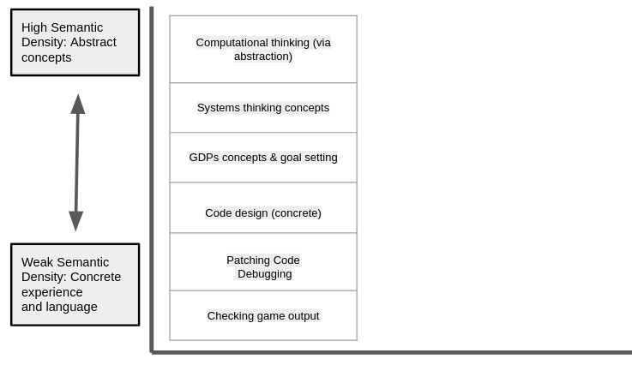
Figure 7.x - Semantic density of the key concepts of this research
Addressing interpretations of LOA <Do Zotero Refresh: [@waite_abstraction_2018]> in video data, we can map the levels of abstraction to shifts between conceptions of goals, code implementation structures, and observations of results in my findings.
Level | Focus | Example
Conceptual Level | Goal formation. | Choosing what features to add to the game in the form of GDPs.
Design Level | Design choices involving coding concepts and knowledge of structural organisation of the code project. | Documentation organised around GDPs scaffolds this process. What needs to be done is to a large extent prescribed.
Code Level | Adding, checking and debugging the lines of code. | This process is supported via a template structure which encourages simple modification, and code patching. Debugging of code also happens at this level.
Execution Level | Understanding the outputs. | There is immediate feedback here and a strong correlation between goal and outcome in the self-playing of the game product.
Table. 7.x - Description of levels of abstraction located in the findings
MISS MATCH IN LEVELS - CHECK ORIGINGAL SEE CL COMMENT. CLARIFY SENTANCE
This table therefore outlines some of the impact of the design decisions made on the level at which participants are spending time in their game making. To continue this process, the following diagram is an approximate representation of the scope of movement using the scale of semantic density outlined in Figure 7.x above, using participant (Toby) behaviour seen in Vignette 1 (also explored in Chapter 5). In this vignette, an exploration of abstract CT concepts and explicit use of systems concepts are rarely present, and the resulting semantic profiles show movement in the lower areas of the gradation of semantic density. This shallow semantic wave above is typical in describing the data of other participants in analysed session recordings.
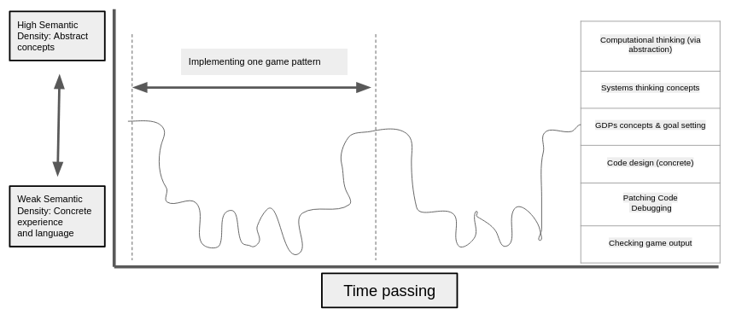
Figure 7.x - Semantic profile in Vignette 2
Movement between layers of abstraction and concrete occurs as Toby(c) shifts between goal formation and the concrete implementation using design practices and specific code structures. Toby starts by imagining and choosing a design pattern and navigates to the relevant documentation. He progresses to implement the pattern via patching in code from the code example. He tests it via previewing and playtesting the game. He then revises or debugs it iteratively. For example, when Toby needing to make several changes to get the positioning of the moving enemy correct his activity oscilates between checking game output level and the code debugging level results. Examples pervade the data of Vignettes of similar iterative shifts between these levels. The descriptions of increasing participant fluency via operationalisation in Chapter 6 are interrelated with this repeated movement between levels and perspectives. Games provide high motivation to adjust code to get the result feeling just right. GDPs provide a framework and shared language to help guide and articulate this process to other designers. The is a stong link between the concept of a GDPs and the tangible experience of it during feedback during the process of playing the resulting game (as explored in Chapter 5 and 6). This contributues to a clearer trajectory for participants in navigating levels of abstraction at play within the GGD&P process.
While the semantic profile shows rapid iterations, they are limited in scope with little activity at the code design level or use of more abstract computing concepts. This pattern is due in part to the format of supporting resources structured as design patterns . Additionally, as a learning designer, I had pre-completed aspects of project implementation that required more generalisable computational thinking skills which would have been a potentially valuable learning experience. For example, abstraction was present in the structuring of key variables within the starting template and via the graphical design tool in the form of a grid matrix in an array data structure. Decomposition and generalisation (pattern recognition) were present in the structuring of the collection of GDPs based on the MDA framework. For advocates of the potential of abstract interpretations of computational thinking, this process could be perceived as over-scaffolding, depriving learners of the chance to learn and practice valuable practices <Do Zotero Refresh: [@pea_logo_1987; @curzon_developing_2014]>.
These scaffolding decisions were initially made to address barriers associated with abstract approaches and conceptual complexity, thus prioritising accessibility and flow experience for participants as explored in chapters 5 and 6. As such, the resulting semantic profile of Figure 7.x above can be aligned with the description of Papert and Turkle’s <Do Zotero Refresh: [@papert_epistemological_1990]> bricoleur maker styles and constructionist design heuristics <Do Zotero Refresh: [@resnick_reflections_2005]> (see Appendix.tech for fuller details). Observations show most participants operating as bricoleurs, feeling their way through smaller-scale iterations rather than extensive planning followed by implementation. The process of scaffolding the design in this way, and thus abstracting away complexity (refered to as created black-boxes by constructionist researchers <Do Zotero Refresh: [@resnick_design_2005]>), allowed greater focus on the relational and affective elements of the learning design, processes which are described in more depth in part two of this chapter.
As a researcher and designer, mapping participant experience of learning design to LOA helps review its accessibility <Do Zotero Refresh: [@waite_abstraction_2018-1, p.21]>. However, there remains the question of the value of participants being explicitly aware of LOA. While systems concepts and computational thinking concepts are being explored at the concrete level, and were included in written instructions, they were not explicitly taught in sessions. These intentional limits in exploration of more abstract concepts, in line with a bricolage approach, appear to be at odds with advocacy for alternating between abstract and concrete dimensions in semantic waves <Do Zotero Refresh: [@curzon_using_2020]>. It follows that the authors would cite this as a problematic limitation in the approach, or at the least as missed opportunities to unpack and repack concepts <Do Zotero Refresh: [@maton_making_2013]>.
While the value of explicit teaching of more abstract dimensions of computational thinking is not challenged here, my findings expose underlying tensions. In my use of just-in-time personal instruction of abstract concepts while code is being worked on, I balanced factors such as how welcome this underpinning knowledge would be to students. Would it interrupt their flow? A tension involving competing demands on the facilitator is also relevant, as there was a high demand on my time and I prioritised getting people unstuck to keep them engaged. Given a different focus or motivation, for example a need to explore concepts due to curricular or exam pressures, the process of supporting students to explore more abstract concepts could have been scaffolded further through more explicitly guided reflective processes. The map of learning dimensions (see Chapter 6 & Appendix.learningDimensions) could assist practitioners and participants to chart and thus facilitate exploration of relevant coding and systems concepts. A semantic profile which pref-figures such a pathway is represented in Figure 7.x.
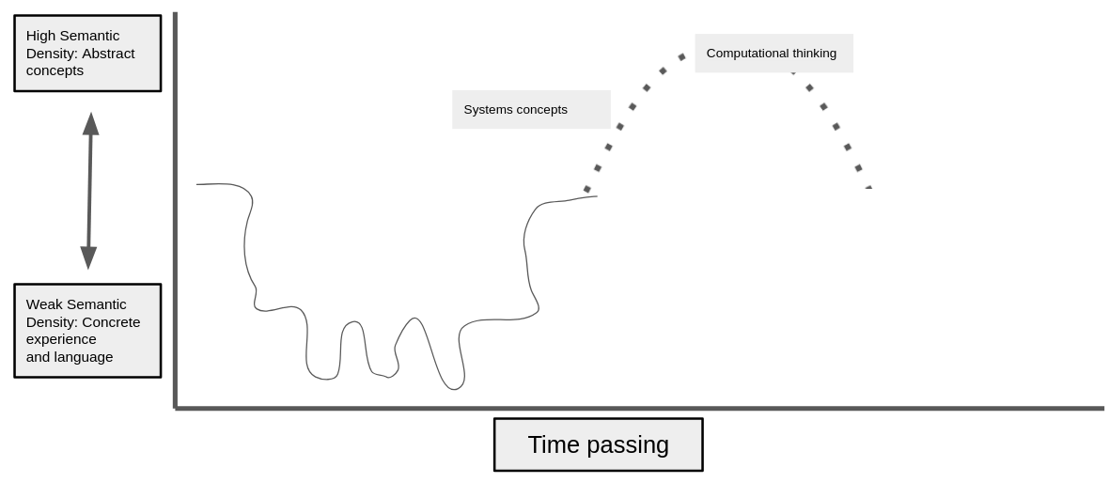
Figure 7.x - An alternative semantic profile
The trajectory represented in Figure 7.x can be clarified by describing an imagined facilitator intervention in the context of Vignette 1. After the participant has completed iterative code changes to add a moving enemy and is ready to progress to another goal, the facilitator could initiate joint reflection on the processes and concepts used in the implementation of the pattern. In this example, this would allow the participant and facilitator to explore relevant computing knowledge in context. In Vignette a suitable occasion to do this would be when Toby makes experimental changes to the code settings involving moving enemies which provokes unexpected results . Similarly, when Toby made changes to the graphical level design grid construct, a facilitator could drawing attention to the technical aspects of that coding construct .
In order to prompt and support the process of reflection, as well as initial goal formation, in P2 I asked participants to plot their progress by moving self-created avatars on a physical map (see Vignette.map). This encouragement of the process of reflection via playful methods could also be achieved in different ways, perhaps by attributing badges or points to a successful reflection of different elements of learning dimensions. While this aspect has not been prioritised in this thesis, it is an area of future interest which could be explored by adapting the design for use in a more formal setting. The extrinsic nature of the process of gamification would appear to align with contextual factors of examination-driven education.

Interpreting GDPs as both intermediate-level knowledge and as a gateway pedagogical concept
While this research has avoided focusing on the explicit teaching of concepts, it has, as described in the section above, surfaced a mechanism using of GDPs that allows more accessible access to both abstract and concrete elements present in the learning environment. Eriksson et al. <Do Zotero Refresh: [-@eriksson_using_2019, p.15]> frame design patterns as a form of “intermediate-level knowledge” between the detail of concrete implementation and more general theories <Do Zotero Refresh: [@hook_strong_2012]>. In addition to this interpretation, I propose that GDPs act as gateway concepts that communicate pedagogical utility to access different dimensions of learning. The use of GDP concepts as a primary object of activity allows them to open up exploration of both abstract and concrete concepts. This is represented conceptually in Figure 7.x below.
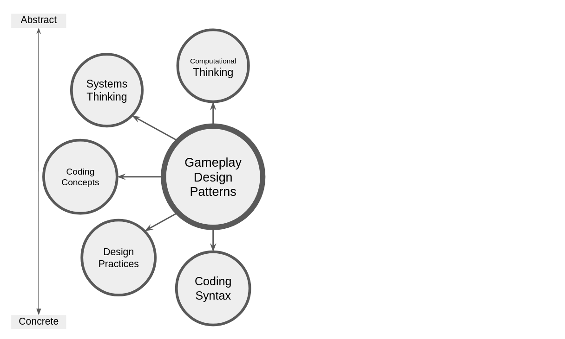
Figure 7.x - GDPs as a gateway construct opening up the exploration of wider related concepts
The framing of design patterns as an intermediate construct <Do Zotero Refresh: [@eriksson_using_2019; @barendregt_intermediate-level_2017; @hook_strong_2012]> was originally used as a tool for researchers to surface design concepts and practices. While this remains valid in this research, a similar process is clearly present for purposes beyond research utility. For example, participants in the last chapter outlined the varied uses of GDPs in terms of mediational strategies and as a motivational element, repeated in varied forms as different patterns are implemented. Additionally, for facilitators, GDPs serve functions within the pedagogical approach of this research, including: the ability to structure participant choice within practical limitations, and acting as a unifying construct to aid the packaging of documentation and the support provided to assist project navigation.

Summary of structural components of applied pedagogy - REEPP
The previous section has shown how, instead of explicit teaching of concepts, the structural support provided by the use of GDPs allows flexible navigation of the abstract and concrete elements of the learning experience, driven by participant choice. This section summarises an approach to facilitate the use of GDPs via a technical structuring of resources. I propose that key elements of this pedagogy constitute a replicable approach, which is a valuable contribution to coding education. To communicate the essence of this structural, technical model, I propose an acronym: remix-enabled, elective, progressive, pattern patching (REEPPP). The summary table outlining the features of the REEPPP approach has been written to be applicable to projects beyond the use within game making, potentially extending to wider digital media making.
REEPPP Term | Description
Remix Enabled | Project formation is accelerated, limited and scaffolded through the use of a structural starting template in a recognisable project genre with easily discoverable affordances strongly coupled with object output, providing immediate feedback.
Elective | Participants have choices over their learning pathways in dimensions of content and design patterns to be added.
Progressive | The processes involves progressive steps. In this case pattern recognition through exploration/play, quick start activities involving minimal changes with high impact on the project outcomes, using progressively more challenging documented patterns, finally implementing patterns without support
Pattern | The process has at its core the use of recognisable design patterns which are presented together with suggested design solutions and concrete code snippets.
Patching | The authentic technical process of code patching accelerates production and creates errors suitable for debugging at a novice level.
Table Figure 7.x - REEPPP as a technical structure which synthesises key elements of the learning design
This technical structure synthesises the use of a code playground, a game library, a half-baked game template, UMC pedagogy, and a collection of game design patterns . While similar approaches exist, this structural pedagogy is innovative in the way systemic tensions have been resolved and congruencies introduced .
The first part of this chapter has, through an analysis of the characteristics of the learning design related to abstract and concrete elements of computing knowledge, addressed a gap in research in finding an appropriate level of scaffolding <Do Zotero Refresh: [@waite_teaching_2021; @quintana_scaffolding_2004]> supporting CGD&P identified in the problem statement of this thesis. The use of conceptual and practical frameworks to scaffold domain-specific working practices can help ameliorate the dialectical tension between engagement via tinkering and requirements to promote “principled understanding” <Do Zotero Refresh: [@barron_doing_1998, p.63]>. This research has surfaced a method which facilitates a principles second approach using GDPs as a gateway concept to dimensions of abstract practice based on reflection on completed activity. In addition, findings of Chapter 5 are reframed to communicate the value of a structural approach I call the REEPPP approach, which hinges on the use of design patterns to access and facilitate varied dimensions of game making. While this chapter has so far focused on the personal dimension of knowledge, the scaffolding provided by the REEPPP approach accelerates and supports the making process, which in turn allows for greater possibilities of social and cultural making via playtesting, outlined in the following section.

Part Two - Agency, and re-mediation of repertoires in third spaces
A key motivation of this study is to better understand how to mobilise potentially fruitful socio-cultural perspectives via replicable pedagogical strategies to facilitate participant agency during CGD&P. This second part of the chapter is guided by Papert’s foundational focus on community-oriented project work <Do Zotero Refresh: [@lodi_computational_2021]> and his related articulation of computational fluency as a challenge to research focusing too narrowly on technical approaches rather than expressive dimensions <Do Zotero Refresh: [@resnick_seeds_2020; @resnick_coding_2020]>. This section is structured in the following way. Firstly, given that a guiding motivation of this study is to gain understanding of participant empowerment within CGD&P, an exploration of evolving expressions of agency shown in findings is undertaken using the concepts of instrumental, transformational, and relational agency <Do Zotero Refresh: [@hopwood_agency_2022; @matusov_mapping_2016]>. Following this is an ecological analysis of the cultural plane of activity emerging from the findings of this research. To do this, I draw on socio-cultural understandings of agency development as a utopian process <Do Zotero Refresh: [@gutierrez2020utopian; @rajala_utopian_2023]>, using concepts of third spaces, movement of participant repertoires, and the evolving hybridity of repertoires.

Exploring the learning process of my finding using the lens of transformations in agency
Chapter 2 examined the concepts of flow and varied characteristics of fluency in constructionist research. Chapter 6 explored these concepts in relation to the data of this study and proposed the related concept of agency as one more closely aligned to a socio-cultural approach. Many of the decisions outlined in Table 5.x summarising tensions involved in the learning design can be interpreted as increasing agency in practical terms by developing elements within the design which acts as mediational affordances or which help reduce barriers to undertaking programming. Conceptually, these practical dimensions can be framed as addressing instrumental agency, as they remove aspects of negative liberty caused by technical barriers <Do Zotero Refresh: [@matusov_mapping_2016, p. 433]>. Instrumental agency in education can be viewed as a relatively uncomplicated view of mediation as a means to achieve pre-set goals <Do Zotero Refresh: [@matusov_mapping_2016]>. A distinction can be made between instrumental agency and transformative agency <Do Zotero Refresh: [@isaac_cultural_2022]>, in that expressions of instrumental agency are unlikely to provoke environmental changes in the activity system at hand. Transformational agency, by way of contrast, may stem from transcending individual motivation but also involves a transformation of systemic constraints <Do Zotero Refresh: [@hopwood_agency_2022]>. Sannino <Do Zotero Refresh: [@sannino2015emergence; @sannino_transformative_2022]>, via the concept of transformative agency via double stimulation (TADS), highlights that participant acts of volition which aim to overcome conflicts blocking activity progress may serve to create or surface previously unutilised forms of mediation and tool use.
The emergence of the pedagogy used in the next phase of activity was informed by observation of acts of volition and the resulting changes. In early stages, as a facilitator, I made available a variety of activities and materials to facilitate the potential for double stimulation . After noticing that volitional attempts by participants were reaching for more structured supporting resources, I produced relevant resources and increased their visibility within the design . This process raises a question: does adapting designs to increase instrumental agency reduce opportunities for transformational agency in future iterations? If so it would be it advantageous to keep some key areas of the learning design incomplete to encourage the emergence of participant responses and novel practices, thus retaining the potential for transformational agency.
This line of thinking raises an additional challenge as a facilitator in this regard is how to balance the transformative potential of incomplete learning environments with the potential for participant frustration associated with learning programming. In this research, this tension was ameliorated via the use of play and other processes to create an inclusive, low-stress environment. These strategies were beneficial to participants feeling able to experiment with new forms of mediational strategies and thus enact transformational agency. Another relevant concern is how to support the incorporation and propagation of strategies that emerge from individual TADS processes into the game making community. This concern is explored through the concept of relational agency in the following section.
Turning to relational agency in the learning design, the complex relations between participants outlined in the vignettes and data of Chapter 6. These relations, particularly evident in the sections addressing guided participation and cultural activity, are characterised interdependence, one of the key characteristics of relational agency <Do Zotero Refresh: [@edwards_relational_2005]>. Edwards <Do Zotero Refresh: [-@edwards2009systemic]> explores relational agency within a CHAT framework, describing it as transcending individuals’ capacity to encompass collective problem-solving via specialisation and diversity of approaches within activity systems. As a collective, participants can overcome systemic contradictions via expansive learning, rearranging working relationships, and thus forging new, mutual forms of helping and learning strategies. In subsequent writing in this chapter, the concepts of instrumental and transformational agency are understood to be incorporated within this wider definition of relational agency.

Reframing findings using socio-cultural understandings of agency and repertoire blending
The discussion section of Chapter 6 examined the complexity of the expanded object in this research. It highlighted both the diversity in terms of motivations and mediational strategies present, and the limitations of 3GAT to clearly represent the important interactions between activity systems <Do Zotero Refresh: [@engestrom_development_1996]>. To address these limitations, this section draws on techniques used within social design based experiments (SDBE) to reframe these findings using the concepts of repertoires and third space, with attention to issues of participant identity and the movement of practices between learning settings <Do Zotero Refresh: [@gutierrez_social_2016-1]>. For Gutiérrez <Do Zotero Refresh: [-@gutierrez_developing_2008]>, third spaces are collective zones of proximal development, which can be both a specific environment and/or a process within existing contexts supporting a hybrid approach where diverse repertoires are re-mediated or blended in collaborative work on an expanded object. To augment this setting-related concept, Rogoff and Gutiérrez <Do Zotero Refresh: [-@gutierrez_cultural_2003; -@gutierrez_youth_2019-1]> use repertoires as a lens to contribute to the discussion of expansive learning in CHAT as a positive, enacted demonstration of diversity and equity. The overall goal of this section is to explore the appropriation of diverse, existing participant repertoires <Do Zotero Refresh: [@gutierrez_rethinking_1999]> into the third space of the game-making community and to explore the development of new mediational tactics and other repertoires.

Repertoire importation into the the game making community
Following Gutiérrez’s <Do Zotero Refresh: [-@gutierrez_developing_2008; -@gutierrez_learning_2019-1]> concept of learning as movement between spaces, we can locate participant repertoires that are imported from other activity systems into an emerging third space of the game-making activity. To do this, this section draws primarily on interview data, which allows a greater precision in locating the repertoires as pre-existing in other settings rather than being rapidly developed in the new setting. Two key themes of imported repertoires emerged from the data: those involving funds of knowledge and those involving divisions of labour.
Addressing first repertoires involving divisions of labour, helping roles identified by Barron and colleagues <Do Zotero Refresh: [@barron_parents_2009]> in technology use (teacher, project collaborator, learning broker, non-technical consultant, and learner) are present from the initial stages. These roles are illustrated in observed practice or in interview data (see summary in Appendix.helping roles). Some imported practices are parent-led. In video data and interview data with Susanna and Tehillah, the parent details how she is able to support her child based on her home knowledge of working styles and the use of paper to help the child sketch (see Vignette 2). The paper prototyping as a home practice imported to this space is also cited by Mark(p) and Ed(c) in interview data (see Interview.2.a). Mark(p) describes a style of working slowly and methodically as plodding . The recruitment process for the game-making program of this research set an expectation for parents to get involved with the game coding as well as young people. Maggie (Interview.3.a) shares her thoughts on the changing nature of Home Education communities, noting that parents are now more passive and think of their roles as arranging tutoring for their children, whereas the adults in her family and others they are aligned with and are also keen to be involved in their children’s learning activities where possible. CHECK INTERVIEW / CASE STUDY.
Other divisions of labour, which highlight imported repertoires and roles of young people, are present in the data. In Interview.1.c, Madiha(p) describes Nasrin(c)’s strong preference for independent working, which her mother Madiha respects and accommodates. Anastasia(p) (P1.debrief) also shared reflections on the issues of family and home education dynamics, suggesting that parents may get in the way of young people’s ability to move into other people’s spaces to learn things, and that parental helping roles may therefore be a hindrance.
Turning to funds of knowledge and interest, which are present in the areas of game playing interests, art, environmental and other global concerns and professional knowledge. For example, some adults imported knowledge from professional communities or previous studies, for example Maggie had studied Pascal previously and Dan brought practices from work and from volunteering at Coder Dojo (see Interview 3 & 4). Movement of repertoires was also well illustrated in the mobilisation of game related knowledge. From P2 onward the use of a half-baked game as a starting point also allowed FoK to be mobilised in several ways. The knowledge of what was normal in such a platform game, the use of gravity as a known concept in variables. And motivation to change such a game and personalise it via the graphical matrix. In Interview.1.a Nasrin shares some of the links between Minecraft practices and graphical asset authoring in the Piskel software. This surfacing of home interests into a shared process had an additional benefit for some parents. In Interview.1.b Madiha shared that via joint game making she had developed greater understanding of and had become more involved in Nasrin’s gaming activity.
Participants were able to incorporate some of their concerns about wider ecological and global issues in the planning of their game narrative. In interview data Madiha (Interview.1.c) describes her own choice to address social media, Nasrin’s choice to make a game on sea pollution and Xavier’s topic of AI robots taking over the world. On a smaller scale some participant chose their hobbies or fan interests as game subjects: Ed choosing trains (Interview.2.b) and Maggie, Pearl, Toby and Clive choosing beekeeping (Interview 3.a). Interview data surfaced the identification with art as a hobby practice by Ed, Nasrin and Madiha. This was echoed in video data where both Madiha and Nasrin appeared to favour working with graphical elements and bringing characters to the game. Madiha created a collage which she brought in to use as the game’s background.
The purpose of this section is not an attempt to exhaustively list initial imported uses of repertoires of interest and division of labour, rather it serves to highlight an important stage in a longer process of agency development. At times the practice of initial combining of these repertoires with either GDP concepts or technical tools was very rapid. For some participants the process of blending their interests with those of the game making program began immediately and intuitively as illustrated by Mark(p)’s comments on Ed(c)’s use of the Piskel graphical art editor (Interview.2.a). Other processes took longer to emerge, requiring more time or active effort to incorporate as described in the following section.

The process of blending of repertoires in the third space of this research (playtesting in particular)
The work of DiGiacomo and Gutiérrez <Do Zotero Refresh: [-@digiacomo_relational_2016-1, p.144]> (see Chapter 3) explored social making in a similar context and highlighted the importance of both material feedback from making activities to nurture relational expertise in the form of emerging specialisms in activity, and of social feedback to increase relational agency between participants. Key designed elements of the learning design afforded immediate feedback during self-playtesting by individuals and pairs. This process was structured to encourage diversity in learner pathways that helped developed specialisms related to growing participant proficiency. As explored in Chapter 6, the structuring of the GDP collection around the MDA game framework, drawing on aesthetics, dynamics, and mechanics of the game, reflected initial participant interests. Some participants developed their imported home interests into areas of game-making specialism. Some focused extensively on the creation and implementation of graphical assets and level design, being motivated by narrative placement in the game via GDPs.
The process of playtesting, beyond an evaluation phase <Do Zotero Refresh: [@fullerton_game_2018]>, became a community process. Group playtesting of the games of others surfaced existing practices and amplified opportunities for new repertoires, specialisms, and associated identities to propagate. Playtesting can thus be seen as both a process and a (third) space suited to both the re-mediation of mediational strategies in response to the diverse practices, and thus the organic and introduced development of hybrid practices which blend existing repertoires of young people, parents, and facilitators <Do Zotero Refresh: [@gutierrez_lifting_2010]>. In addition, group playtesting unlocks the relational aspects of both expertise and wider agency, a process that is explored in this section using the data of this thesis.
The development of different styles of being in playtesting represented new forms of re-mediated strategies incorporating home practices and newly introduced repertoires. Some adults who developed new technical processes by working through documentation in a methodical manner (see Vignette V3.c & Vignette 2) refrained from extensive testing of other games, waiting for others to test their games and carefully observing their responses. Some participants were very social in their playtesting approach and used playtesting as a way to gain an idea of what to add to their game next and to ask for direct help in that process (see Vignette 1.b). Others built relationships during playtesting in different ways. For example, some gave feedback via kind and supportive comments. Madiha voiced her personal identification with created characters and often said how cute the characters were (Vignette 5.b). Others embraced a disruptive stance in playtesting which, for some participants, provided a chance to break conventions and game design norms of the genre, as a way to cause frustration or confusion, illustrated by Tehillah’s behaviour in (Vignette 2.c). Some children added additional playful elements to playtesting (see Appendix.playtestingtypes). Some, in particular, brought a physicality to the process, clustering in a particular zone of the class, referencing the gameplay elements, acting them out, attempting to change the games of others, and playful tussling as part of resistance to those changes.
The re-mediation of hybridisation of existing and new repertoires shows the development of participant interests into game-making specialism. This identity formation alleviates barriers to participation in programming communities explored in the problem statement of this thesis. The role of specialism within playtesting creates helpful system congruencies helping the development of novel and effective repertoires through a positive affective relationship to the overall activity. The diversity in making and playtesting behaviours shows the development of a robust community with a variety of modes of participation echoing Rogoff’s characteristics of a community of learners <Do Zotero Refresh: [@rogoff_developing_1994]>, and the hybrid modes of participation made possible in third spaces <Do Zotero Refresh: [@gutierrez_rethinking_1999]>.
Importantly, social playtesting made the specialisations within individual and pair activity visible at a community level, thus contributing to possibilities of relational agency within the learning environment as a whole. New expertise exists as a form of identity within an individual’s repertoire and can be mobilised by peers as a relational affordance of the learning system. In short, following the logic and terminology of DiGiacomo and Gutiérrez <Do Zotero Refresh: [-@digiacomo_relational_2016-1]> the emerging relational expertise helped develop relational agency.

Supporting emerging identity formation and specialisation through interventions to support relational repertoire blending
While the previous examples have focused on relational agency between participants, the role of the designer and facilitators are also relevant. My recognising and valuing the emerging areas of specialisation and expertise, both technical and social in nature, helped the development of diverse practices. Specifically, the responsive design revisions outlined in the first part of this chapter help keep the games in progress in a working state and more time devoted to open playtesting helped reinforce and support the diverse practices of social feedback in playtesting. I reflected on the possibility that the success of some participants in drawing on imported repertoire could be encouraged or accelerated in others if suitable affordances were designed into to the learning environment . This is explored in this section via reflection the roles of supporting helpers and the facilitator interventions of side missions.
The role of supporting student helpers and their helping styles took on a important role in the process of repertoire blending. In phases 2 and 3, I asked students to circulate during making time as a way of replicating some of the features of playtesting with a smaller disruption to game programming time. While it is important to acknowledge the importance of the role of student helpers in the formation of relational agency, given the wealth of existing research on this subject in similar settings <Do Zotero Refresh: [@kafai_mentoring_2008; @roque_family_2016; @roque_im_2016; @barron_parents_2009; @stone_problem_2007-2]>, only a brief summary of activity is included here. I asked helpers to identify and bring to my attention coding blocks which were preventing participants from progressing, thus overcoming some parent’s unwillingness to make demands on facilitator time. Student helpers were asked to prompt descriptive reflection by asking participants what features they were working on and to notice and reflect on any distinctive behaviours emerging in participants’ product or practice (see Vignette 1). This parallels a similar study by Stone and Gutiérrez <Do Zotero Refresh: [-@stone_problem_2007-2, p.51]> where student helpers highlighted emerging “zones of competency” of learner’s identities and relational expertise. While not part of if their given remit, student helpers also communicated to participants innovations in practice made by peers, a reflexive response which helped contribute to relational expertise within the group and thus an increased overall possibility of relational agency.
Turning to address two interventions in P2 and P3 which aimed to accelerate the process of relational expertise and repertoire blending, the introduction of side missions and maker types made visible emerging repertoires as cultural affordances in a way which increased and legitimised diversity of learner pathway and over approach to participation . This section is limited in scope as while there are novel and promising elements here, a detailed exploration is beyond the scope of this thesis. From observation of the emerging specialism and identities explored above, I created a working typology of participant approaches to playtesting and game making approaches. This grouping became a topic of reflection via a playful game exploring Bartle’s player types. Subsequently, to support these maker styles, I created a selection of side missions and presented these together with a wider mission within a drama frame. In interview data participants shared their positive feelings towards both the shared fictional frame of making a game for an audience of judgemental aliens, and the social and mischievousness of the social missions within that drama .
The value of the drama narrative and side missions aligns with work on play theory as a technique giving participants permission to play <Do Zotero Refresh: [@walsh_giving_2019]>, legitimising the previously peripheral activities and bringing them into the shared conceptions of the idioculture. The recognition of the hybridity of possible modes of participation increases conceptions of enacted diversity of the community. This strand of thought invites a theoretical examination of the particular value of identity formation via the blending of repertoires of play and design approaches. The role of play as a leading activity is explored by Gutierrez <Do Zotero Refresh: [@gutierrez_learning_2019-1]> to facilitate movement between sites of learning. This invitation to play may be evocative of repertoires already familiar to participants: and thus as a helping process to welcome participant to take part in to a new collaborative zone of proximal development.

Part Three - Synthesising and reframing the findings of this research for a broad audience
Returning to the gaps in existing research driving the question of this study we can see the importance not only of research exploring and analysing the development of socio cultural approaches to CGD&P but also on means to disseminate these practices into an atrophied but still extant grass-roots community, and via remaining channels of dissemination of practice. The following section prioritises key messages arising from this research and with an aim to frame them to be accessible but theoretically consistent with socio-cultural approaches.

How can varied dimensions of agency be identified and nurtured in an evolving community of game makers?
Returning to address RQ3 directly, and the under-explored area of agency development in existing research in CGD&P, it is of value to re-examine and synthesise the characteristics of the learning design described using agency as a lens. Agency in this game making community is seen as multi-dimensional and as a process located in community participation rather than an individualised property. In this analysis the concept of relational agency represents an end point achieved through building on and incorporating processes of instrumental and transformative agency. It follows that it is advantageous to highlight relational agency as a guiding principle for varied stakeholders. For example, as an objective for participants to develop, for designers to design for, and facilitators to facilitate.
This chapter has explored a process of developing relational agency via analysis of the findings that were framed via a staged approach to re-mediating existing repertoires into new repertoires and an emerging game making idioculture. To help conceptualise this goal and process I propose the term relational agency through repertoire blending (RARB). This term, based on the work of Gutiérrez and others <Do Zotero Refresh: [@gutierrez2020utopian; @stone_problem_2007-2]>, mirrors Sannino’s <Do Zotero Refresh: [@sannino_principle_2015]> concept of TADS (transformative agency by double stimulation). It is advanced with a motive to provide an accessible framing and a metaphorical structuring to a complex process.

Narrative descriptive of a proposed procedure for facilitating relational agency by repertoire blending (RARB)
RARB is a process which, in the context of this study, can be best described via three stages. In stage one, the motivation is to create an inclusive learning environment where participants are able to import existing repertoires from other spaces in the form of competencies and interests. For some participants, this may involve the use of designed affordances in pre-planned (by the learning designer) ways via instrumental agency, or they may cast around to find novel uses of affordances present in a process of TADS. As participants load their existing repertoires through the use of new tools, a process of blending is already in the process.
Stage two involves a natural stewing of these repertoires in the melting pot of a new third space (e.g., the game making sessions) into new repertoires. In this research, the repertoire-blending process leading was facilitated by the favourable conditions provided by regular playtesting and other playful elements of the programme. These emerging making behaviours and specialisms involving interests and helping behaviours resulting from manifestations of instrumental and transformative agency may start to propagate via playtesting and other social and cultural interactions in the space.
In stage three, facilitators can recognise the use of novel processes and begin to help other participants to use those same processes by incorporating them into the learning design or in some way highlighting the possibilities they offer. The role of the facilitator here involves adding yeasts or other accelerants to allow the body of the emerging idioculture to grow faster by making relational, socio-cultural affordances more visible to all participants. The culture should be kept warm by checking that such processes are not overwhelming, that they are optional, and by maintaining a playful environment at this stage to allow this form of relational agency to flourish.

Summative table illustrating stages of facilitating RARB in this study
The purpose of this table is geared more towards the synthesis of the approach in relation to creating relational agency through repertoire blending. As such, characteristics and descriptions are more decontextualised.
Characteristics of design | Design example and description
Stage One - Facilitating participants to import existing repertoires of practice
Allow quick demonstrations of game knowledge | Quick start activities scaffold learners to alter game players allow learners to show competency
Encourage early use of art and music abilities via scaffolded tool use | Learners interested in art can use an intuitive pixel art and music editors to quickly integrate their home interests in digital creations.
Facilitate flexible group sizes to allow importation of relational helping and working repertoires. | Use of a foundational game template helps novices get started without help and facilitates a larger number of groups
Use a project theme that is relevant to participants. | Use of a relevant theme in the project design brief.
Stage Two - Engendering blending of repertoires
Protection from complexity via technical limitations | Participants benefit from more relaxed making environment as key design complexities are baked into template design
Provide feedback mechanisms in the materials of making process | Use of code playground and structuring template with key affordances with high impact on the game
Try to create a level playing field between generations | The use of an unfamiliar text coding process for both YP and adults created a more horizontal power relationship
Provide regular social or community feedback on emerging designs as a way to recognise and engender participant specialisms | The use of playtesting allowed for regular feedback
Stage Three - Recognising and encouraging emerging specialism and identity behaviours
Engendering a low stress and playful frame within overall activity with explicit fictional narrative | Use of a drama process
Structuring reflection on relational expertise | Use of maker styles as a tool to facilitate emerging specialisms, and to communicate a validity of a pluralism of approaches to design and programming
Explicit interventions to support the development of new blended helping styles | Use descriptions of helping styles in digital environments to reinforce adaptation of existing home helping repertoires
Table 7.x - Summative table illustrating stages of facilitating RARB in this study
Having explored the abstract and concrete dimensions of design and facilitation (Part One), and the development of agency through social and cultural processes (Part Two), this final section draws together these strands to consider their relationship to the overarching research question. The discussion moves from analytical interpretation to pedagogical synthesis, offering a conceptual framework that links technical structuring, repertoire blending, and inclusive facilitation. The aim here is not to rehearse each research question in turn, but to present an integrated perspective on how socio-cultural insights can be translated into practical design strategies for CGD&P learning environments.
At this stage, it is also useful to return to the problem statement of the study in Chapter 2. One of the gaps identified in existing research concerned the challenge of communicating a holistic understanding of the learning design that evolved through this project. The following summary addresses this by offering a synthesis of the overall pedagogy, presented in three parts. First, it describes how the REEPP, RARB and GDP elements interrelate within a broader pedagogical framework. Second, a graphical representation is introduced to support communication of this model to varied audiences. Finally, a metaphor drawn from musical jamming is explored as a way to communicate key principles of the design in a more accessible and evocative form. This metaphor serves both as an interpretive device and as a bridge to the concluding chapter’s recommendations for practice.
The structural element of the REEPP approach could be augmented with the socio-cultural elements explored in part two. To do this, I could propose a logical acronym: collaborative, culturally responsive, remix enabled, elective, progressive pattern patching (CCRREEPPP). While this term is logical and playful in approach, I have concerns that it may be perceived as cumbersome. Instead, I will focus here on describing the relationship between REEPP, RARB and the use of GDPs as gateway concepts. The structural scaffolding provided by the REEPP framework facilitates the initial stage of the RARB process where GDPs play a key role as a gateway to abstract / concrete concepts and practices which are available to be blended with imported participant repertoires resulting in new repertoires manifested as relational expertise and relational agency in a new community of learners. While this is difficult to represent in a figure, I have attempted to do so in Figure 7.x, focused on combining the role of GDPs as a gateway concept to facilitate wider remediation of diverse imported and emerging repertoires.
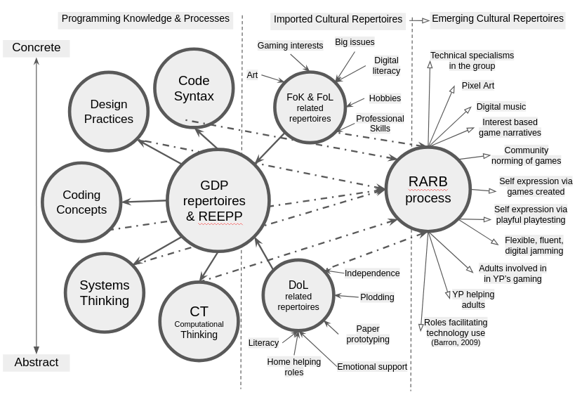
Figure 7.x - A graphical representation of the inter-related elements of the of RARB
There are some additions to the previous representation in Figure 7.x of GDPs as a gateway construct. The REEPP structural framework is added as a foundation of the pedagogy. The gateway role of GDPs to access more personal concepts and practices remains, but more social repertoires are represented within the initial stage of RARB (labelled importing of cultural repertoires). The process of relational agency by repertoire blending (RARB) is represented as a nexus of activity where re-mediation of other repertoires occurs and emerging, blended repertoires are represented as a product of that process. Finally, in this version, as a challenge to the convention of placing the abstract dimension at the top of the illustration, I reverse the polarity aligning with the CHAT concept of rising to the concrete. Recommendations on how this representation may be helpful for different stakeholders are present in a section in the concluding Chapter 8.

Communicating dimensions of agency and related design concerns via jamming as a metaphor
The previous sections have explored a multi-faceted view of participant agency and the process of repertoire development in this learning design. This section reinterprets some of these aspects, in particular the principles in Table 7.x above, using a metaphorical approach. The use of metaphor here has two functions. The first is to help deepen my analysis via a move to the abstract, searching for communicable generalisations. Secondly, to aid the accessibility of this research for an audience of practitioners as well as researchers. Given the complex nature of the pedagogy, a metaphorical approach allows a simplified but evocative perspective which communicates the future possibilities of findings <Do Zotero Refresh: [@rajala_utopian_2023; @gutierrez2020utopian]>.
Jamming, a term common in music and theatre, describes responsive, improvised, rapid, and fluid responses to collaborators’ ideas and audience reactions <Do Zotero Refresh: [@pinheiro2011creative; @sawyer_group_2003]>. The concept of musical improvisation within jam sessions is a productive way to explore a tension between freedom and structure within the domain of research. As with harbour metaphor of Chapter 5, a jamming process has structure and designed limitations <Do Zotero Refresh: [@rosso_creativity_2014]>, but beyond that they provide affordances to encourage learners to evolve their own play processes as a form of transformational and relational agency. In a jam session, foundational infrastructure is provided in the form of drums, microphones, and amps. And more established regulars act as facilitators of the process. A jam on a micro level can refer to a musical piece which follows conventions. It may be based on a familiar, popular genre, say a slow blues jam. Common jam genres are folk, blues, rock, funk, and jazz). Jam pieces are often based on variations on a song familiar to the community of musicians (often referred to as standards). The structure, tempo of the piece, and the key in which it is performed form a base guiding improvisation. Within a jam process, bringing your own style to build on that structure is welcomed. The process is augmented by the group interaction present in the musical jam, where music makers pick up techniques from others in the process. Visual and verbal encouragement is often present in successful jam nights to encourage newcomers. If a jam session is regular, local popular standard songs emerge. This provides opportunities to hear them played regularly, allows potential future participants to hear different versions, and even sing along in the audience, a useful form of peripheral participation.
Linking this metaphor to the process of game making, the process of improvisation based on a prototype of a familiar created genre is present in the half-baked platformer game template. This research has outlined the value of an authentic audience made up partly of peer makers to motivate the development of repertoires of practice in a game making context. Additionally, the value of the possibility to blend established repertoires with those brought by peer players is also a motivation in the context of the metaphor and this research.
Parallels between the guiding frameworks advanced in this chapter and the metaphorical description of the jamming process above and the harbour in Chapter 5 help conceptualise and communicate the diverse processes at play. The structural elements, particularly those of the harbour metaphor, are represented in the REEPPP approach. The element of transport links facilitating loading of material aligns with the importation of repertoires stage of the RARB process outlined above. While the overall broad description of the musical jam communicates the essence of the RARB process at work. There are other elements of the jam, including the role of the facilitator to hold an inclusive and welcoming space, which are less explored in this research. This and other broad limitations are now addressed in a concluding section.

Conclusion
This chapter has synthesised and reframed findings across three interrelated domains: the structuring of abstract and concrete knowledge in CGD&P, the development of agency through cultural and social processes, and the articulation of a holistic pedagogical framework grounded in socio-cultural theory. Together, these strands form a response to the overarching research aim of understanding how learning environments can be designed to support diverse, interest-driven participation in game making.
The first part of the chapter examined how gameplay design patterns (GDPs) supported shifts between levels of abstraction in computing activity. This was developed through the proposal of the REEPP approach, a structural framework which scaffolds progression while maintaining participant autonomy. The second part reframed earlier findings through the lens of agency, with particular focus on relational and transformative processes supported by repertoire blending and third space dynamics. Drawing on concepts from sociocultural theory, the analysis explored how participants developed new specialisms, identities and helping styles through joint activity, reflection, and playful social feedback. In the third and final part of the chapter, these insights were drawn together into a composite pedagogical model combining the REEPP structure, the RARB process, and the use of GDPs as gateway concepts. A visual representation and metaphorical framing were introduced to support future communication of this model to a range of audiences.
Taken together, these elements offer a theoretically grounded but practically oriented pedagogy that foregrounds participation, identity, and learner agency in CGD&P contexts. Chapter 8 will build on this by identifying the study’s key contributions to theory and practice, summarising its methodological innovations, and outlining directions for future research and application.

Footnotes

Chapter 2 contains a description of semantic density used within computing pedagogy <Do Zotero Refresh: [@curzon_using_2020]>.
design pattern resources contain a description of a GDP packaged together with a suggested code design and sample lines of code as a concrete implementation (see Chapter 5).
Regarding syntax, the use of x and y coordinates as separate parameters of the tween function, and the role of the tween function as an abstracted element provided by the underlying Phaser code library. See appendix ? for clarification.
See Chapter 5 for a description of the grid coding construct. The facilitator could describe the level design matrix variable as an object consisting of an array with an entry for each line of level design. Additionally, if appropriate, the facilitator could highlight the relevant function later in the code which parses each array and component element, applying conditional numerical operations to correctly place game elements in the corresponding area of the game screen.
These tools and processes are described in Chapters 2 and 5.
Chapter 5 describes these innovations in depth and contains a table synthesising the findings.
Example of TADS are therefore present within Chapter 5’s design narrative which outlines transformations in the design driven by contradictions in activity, including the use of restricted toolset, starting code template, structuring of documentation, etc.
See section C3 in Chapter 5 for a summary of how observations of participant behaviour shaped a subsequent reduction of the toolset used.
More details on this process of change informed by the TADS process are included in Chapter 5 and Appendix.design.p1.
This logic follows literature on the difficulties of learning to programme, and subsequent design innovation which address those issues outlined in Chapter 2 and the discussion section of Chapter 5.
Examples of such propagation related to the use of GDPs are present in Chapter 6.
Mark says “we are plodders” within interview data (see Interview.2.b - check) to describe their systematic progression through the step-by-step as documentation created as part of the online manual of P2 and P3 process which the family accesses at home. See http://3m.flossmanuals.net
See chapter 6 for descriptions of emerging specialisms including the focus on game dynamics of Toby in Vignette 1 and on graphical concerns by Mahida in Vignette 5.
Affordances were described in Chapter 4 as “refers to the”perceived and actual possibilities for action enabled by an environment or artefact”.
See Chapter 5 and Appendix D.3.x for further description and discussion.
Particularly in the way participant helping roles are integrated within elements of drama practice via techniques drawn from Heathcote’s <Do Zotero Refresh: [-@heathcote_drama_1994]> mantle of the expert approach.
See Appendix D.3.x for a discussion involving participant feedback on the process via interview data.

