Keeping it Real – Inclusive frameworks to support computing projects

Outline

Part one - Intro, context and terms
- Introduction & Context
  - Inclusion - define and how relevant to abstract / Concrete
- A note on making computing engaging
- Concrete and Abstract terms defined in relation to learning ### Part two - Computational Thinking, the Abstract and Concrete
- Concrete and Abstract learning approaches
- The Issue of Transfer
- CT explored - Wing and Resnick - wider - narrower - abstract / concrete
- Coding is not CT - but a good medium

Part Three - Tactics for teaching Computing in the Classroom
- gcse exam context
- tactics for teaching Coding
- expansive framing
- semantic wave - presented and applied as concepts first often - can be either but danger of flatlining - how to avoid that in tinkering projects?
- peer programming
- limitations of concepts first approach as a link to the next section

Part Four - Alternative, Authentic Approaches
- Intro to alternative models suiting bottom up / concrete approaches
- Design approaches -
  - creative spiral / iterative
  - studio thinking
  - using design patterns
- PBL as an inclusive models - - Value of PBL - personal summary - diversity of projects possible- cf the uncertainty of pedagogy, given freedom
- UDL universal design for learning.

Part Five - Conclusion

Introduction
Computing as a subject lends itself to being taught in a multitude of ways. That’s one of the things that makes it fascinating. Many sources of inspiration exist for computing teachers promoting diverse approaches to covering the computing curriculum, building skills in programming and developing wider computer science knowledge. This chapter highlights the value of some of the more hands-on teaching approaches and will put this into an academic context in an accessible way by drawing on influential and inspirational research and projects in the field of creative computing.
The promotion of Computational Thinking has been a key factor in the presentation of the UK’s current computing curriculum. Computational Thinking started to gain wider attention when the academic and computer scientist Jeanette Wing began to promote it as a concept and approach that could be useful beyond the field of computing. Wing’s perspective is that “everyone… can benefit from thinking like a computer scientist” (2008). Computational Thinking is the ability to express and solve problems in the same kind of way a computer would.
The start of this chapter outlines some of the theory and practice of applying an inclusive approach to computing projects, specifically the benefits of a project based approach. I then look at different interpretations of Computational Thinking from a critical perspective to contrast the concepts-first approach to other more concrete approaches like project-based learning. (not sure about the terms or even the whole approach of the last sentence)
Whereas the diversity of materials and end goals of computing projects are readily visible for teachers and family members enthusiastic to help, the best way to help learners learn, or effective pedagogies to support the coding and computing process are less visible and less exchanged.

Inclusion and Participation
Later in this chapter I will outline several approaches to support inclusive pedagogy but before doing that it is important to have a quick look at the term inclusion. Inclusion in education is used in many ways but is seen generally as ‘increasing the participation of students in, and reducing their exclusion from, the cultures, curricula and communities of local schools’ (Booth et al., 2002). More recent educational research in this area has widened from having a chief focus on SEN issues to including barriers of culture and other exclusionary elements of school discourse (Black-Hawkins et al., 2008).
The issue of alienation from the culture of computing in schools can be an issue especially for girls and some ethnic minorities. As such, a social and cultural approach to understanding and incorporating the learning experience of pupils in a wider ecosystem beyond school is vital.
An important guiding principle of inclusive pedagogy is to move away from a view that most students learn well and other need particular support particular, adapted approaches. Indeed if you include wider understandings of neurodiversity and cultural and language diversity then planning alternative activities or learning pathways for all learners with particular needs could quickly become so time-consuming and complex that it would be unsustainable.
Instead, inclusive pedagogy promotes the design of learning experiences so that all learners start to develop abstract concepts from concrete examples, can choose their own learning tasks (and thus levels of challenge), are supported to reflect via self-assessment and bring their own experience and cultural understandings into their work. (Good citation needed?)
These design choice among others are presented in a framework called Universal Design for Learning which embodies this inclusive approach. UDL, design-based approaches and the value of projects and are explored further in the latter part of this chapter. In the next section we look at one of the ways educators have tried to make computing engaging to a diverse set of learners.

A Note on Making Computing Engaging
Embracing the challenge of making computing projects broadly accessible and engaging and has something that many individuals and organisations both funded and enthusiast have engaged with. University and industry partner programs have created a diversity of computing materials and computing environments designed to aid novice programmers. Teachers themselves have been a tremendous source in the sharing of knowledge, materials and approaches to respond to the challenge.
A quick search the web for creative computing shows a tremendous diversity of activities and mediums designed to engage the home and hobby interests of young people. Physical examples include fashion and textiles based computing, robotics, colourful lighting displays and programming lego constructions. Beyond the value of working with home interests as a way of increasing participation and inclusion there is also outreach value is in the visual, tangible and touchable nature of the materials. They look and feel like fun and exciting objects to engage with.
Other web-based or software activities include game making, meme creation, hobby website creation or making storytelling adventures. Adapting other narrative forms like books, films, games and social media content increases the ability for learners to bring their own interests into the mix.
However while the range of materials and possible creative projects is exciting and full for promise for computing teachers, it is not always clear how to get best approach these opportunities from an educational point of view.

Computational Thinking, the Abstract and Concrete

Concrete and Abstract learning approaches
When reading about different approaches to teaching computing you are likely to meet the terms concrete and abstract. As these are such foundational terms, and because they are often used without introduction, lets define them quickly. In an everyday sense concrete objects are ones you can get hold of and abstract objects exist only as concepts. A pound coin is concrete but the idea of profit is abstract.
There is another everyday usage which hints that abstract knowledge are harder to get to grips with than more concrete understandings. We might ask for a concrete example if we don’t understand a more abstract definition. It is the use of something in context that makes something concrete. In everyday language to grok something is a concrete understanding. In traditional conceptions of education abstract knowledge is of greater value. If you can understand a concept as it applies in different situations then this ability to transfer it and have a more global understanding is held as a higher form of knowledge.
However there are also dangers of adopting teaching in a abstract way. For example, learners may not make a connection to a real situation and then can only recall rather than apply the knowledge. This is termed inert knowledge. For example in computing terms you may be able to give a definition of what a function is in a coding language but not be able to write one.
There are also dangers associated with learning things in a concrete way as well. If you learned you coding by teaching yourself or just picking it up for other people then you may be able to complete tasks but not be able to explain what you have done to other people, or may really struggle to recognise similar patterns in other computing contexts. This kind of knowledge is sometimes called embodied skills.
Interestingly, one critical voice challenging the idea that abstract approaches were a higher form of knowledge was Seymour Papert whose work on creative computing at MIT created a legacy that includes the work on the Scratch programming tool. Papert and Turkle (1990) talk about revaluing concrete approaches to computing and coding. While they do not discard the technical value of abstract approaches, they draw on feminist theory to make a convincing case that some of the hard approaches and formal language can be off putting to certain learners and especially girls.
In this light, the process of finding solutions to coding issues for novice coders should be a matter of personal preference. As well as abstract and concrete - they use a top down and bottom up analogy. In a bottom up approach problems are tackled piece by piece, experimentally. Desmond Tutu once said that “there is only one way to eat an elephant: a bite at a time.” Bottom up (concrete) coders take this approach.
To clarify this Papert and Turkle give the example of a young coder Lisa, who is aware of a more formal way to approach the kinds of programming tasks she is undertaking, but maintains that way doesn’t work for her. As she continues her journey as a coder this frequent message that she is doing things the wrong way demotivates her enthusiasm around coding. The more abstract concepts are thinking tools that are only useful to the learner if they match with her experiences. Forcing the learner towards them in this example is counter productive as it invalidates her experience and progress.
The authors outline that the danger of leading with the abstract is to devalue this bottom up approach to coding. This way of coding has also been called a craft approach, getting close to the materials. It is an way of doing things that has been shown to have a lot of value in many professions. It has been behind many scientific break-throughs (LATOUR CITATIONS?). For someone like myself, who taught themselves how to code in this concrete ways, it is really encouraging to know about this perspective.
The debate of the desirability of testing using more formal abstract measures of success has been going on for many years. The IQ test is a good example which has been criticised for being culturally biased in favour of more Western understandings of intelligence which favour formal logical and abstract elements and ignore other measures of emotional, cultural and practical intelligence.
However, while this valuing of concrete approaches is important, it is potentially unhelpful to express concrete and abstract as two paths that never meet. Abstract concepts are useful after all. The danger is when the abstract concepts chosen by educators or included in the curriculum are don’t seem relevant to learners, leading to their disengagement.
Many educational approaches value both abstract and concrete knowledge and experience as parts of an ongoing process which alternates between the two poles to help organise and make connections with wider bodies on knowledge. For example the theory of experiential learning which was make popular by Kolb and socio cultural approaches based on the ideas of Vygotsky. Kolb’s model is expressed as a cycle as kind of learning experience here is circular in nature. When this comes to coding and computing this rings true as your knowledge of a coding concept may deepen a little bit each time you apply it in practice. The socio-cultural school holds that rather than being a separate thinking machine, the mind is dependent on the social and cultural webs of meaning that surrounds it. We think socially.
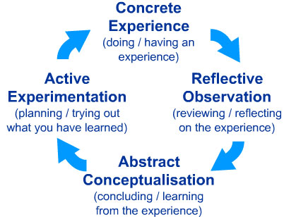 kolb

The Issue of Transfer
The implications of thinking socially are that our mind is motivated and activated by the context of the problems that we meet. While it would be great if we could transfer the knowledge we gain in one area to another or to be able to apply an abstract idea to a more specific problem, researchers from the socio-cultural perspective are very critical of this idea.
This problem of transfer creates a problem for Computing teachers. If they are aiming for good exam results of their students. If students are unlikely to be able to transfer the computing skills they have picked up from undertaking creative projects, then it is logical to teach to the test as this will be the cultural context that they need to perform in. Of course this may have long term detrimental effects, as then students will not be able to transfer the exam knowledge into practical experience after school.
The difference between exam-focused computing and real life coding and computing is …. (find citations / example )
As with many other subjects, teachers are being asked to both teach to the particular requirements of exams and to build more transferrable skills. In this case this process of being pulled in different directions seems particularly noticeable.

Definitions of Computational Thinking
We can use this distinction between concrete and abstract to examine the differences between two popular interpretations of Computational Thinking One is Jeanette Wing’s original take. “The most important and high-level thought process in computational thinking is the abstraction process. Abstraction is used in defining patterns, generalizing from instances, and parameterization” (Wing, n.d.). The essence is abstract away concepts and principles from the context. This approach suits a formal exam approach. Many learning resources designed to support the computing curriculum present this principle as for key pillars; decomposition, pattern recognition, abstraction algorithmic thinking(BBC Bitesize, n.d.).
Another widely used definition of CT by Brennan and Resnick (2012) was developed in response to the question "“How do we describe what Tim, Shannon, and Renita are learning as they participate as designers of interactive media with Scratch?”. They take a situated approach to mapping the potential learning dimensions of working with others creating computing projects. The resulting map they create includes computational concepts, computational practices and computational perspectives. This framework based on observation of learners in action is more concrete and more accessible to teachers and learners as they can more easily recognise their own practice.
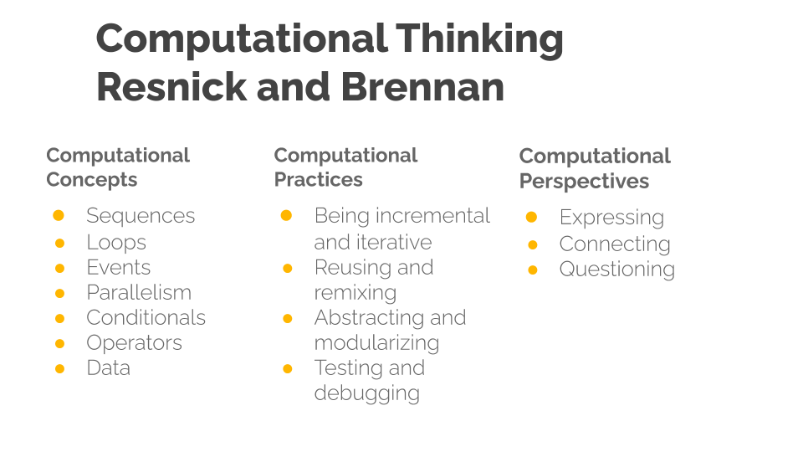 CT
Computational Thinking model by Resnick and Brennan - Diagram created by Mick Chesterman
This wider and process driven definition of CT has been used and adapted by many organisations seeking to support the new computing curriculum. As such it may be familiar from websites, posters and other supporting material created by groups like Barefoot computing. A review of teaching Computational Thinking (Lye and Koh, 2014) used this second definition as the basis for their review, which point to the widespread use of Brennan and Resnick’s more applied approach.
Much analysis has been done about the relative merits of different definitions of CT. From my perspective I feel that from an academic perspective Wing’s definition does a good job of describing what is most unique about Computational Thinking compared to other frameworks. The way it looks at the special ways abstraction is done in computer science is convincing. The concept of Computational Thinking as more abstract, transferable knowledge became significant aspect of the 2015 Computing curriculum. It suited the conservatives government’s back to educational basics agenda based, a perceived move away a progressive skills based approach to a knowledge-based curriculum.
This agenda has been championed by education ministers Nick Gibbs and Michael Gove. A good example can be found in a speech by Nick Gibb at a launch of a collection of essays The Question of Knowledge (http://tiny.cc/gibbsknowledge). I suspect most educators would find this oppositional setting of knowledge against skills unconvincing. If we return to Kobl’s experiential cycle, it is through application of knowledge in concrete contexts that skills develop and understandings of knowledge deepen. Ironically in the foreword of the publication in question, references the importance of Young’s concept of powerful knowledge which is knowledge put into practice in a concrete context, and putting the knowledge into practice will involve developing practical skills.
SINGPOSTING - Given this, educational practices and frameworks which support learners and teachers to help reflect on and develop skills are clearly helpful. Also, from the perspective inclusive teaching practice there are many benefits to more concrete approaches. The wider definition of CT here assumes the collaborative coding of a computing project. This chapter will explore some of the benefits in context and highlight other frameworks and approaches that can help teachers deliver in this way.

Coding is not Computational Thinking
We have explored that Computational Thinking is a contested term. While there is a general agreement that computational thinking is not just computer coding, most applied definitions include algorithmic thinking, and thus the more concrete aspects of coding structures.
Coding may not be the same as computational thinking but it is part of the computing curriculum and a useful skill in itself. It is the water in which learners swim when creating engaging computing projects where such wider computing concepts are developed.
However while there is a technical distinction, in practical terms as the process of computing is learned through coding projects, for the purposes of this chapter the terms coding and computing are used quite freely.
There is a tension between the skills required of Real Life coding and the time it takes to learn via real projects and the more abstract knowledge needed to answer more formal exam questions. In GCSE exams include a paper which tests application of coding concepts in a paper based format. Which aims to strike a balance. This would then justify devoting more time to applied coding projects especially if they can be done collaboratively to take advantage of the benefits of social learning.

Part Three - Tactics for teaching Computing in the Classroom
This section gives tips and examples pitched at a typical classrooom computing environment. The following section examines wider project based approaches which are more challenging to integrate but which provide particular benefits to the learner.

The context of GCSE exams papers
In a very real sense the contents of GCSE exams determine a lot of what happens in the computing classroom in the preceding years. In practical terms, as abstract concepts are a part of our computing curriculum as educators we need to share tactics to help our learners develop them.
The removal of course work from exams due to widespread sharing of worked examples on line created a real challenge for those setting exams. How to test the practical programming experience and ability of students in a written exam setting. At GCSE level most exam questions test the more applied definitions of Computational Thinking, particularly the process of writing, analysing and revising algorithms in the form of written code examples. Students are required to demonstrate and explain fundamental code building blocks and approaches from first principles. However the end results are a slightly frustrating mix of trying to be applied and authentic, and yet strangely artificial as the coding problems are fragmented and written on paper rather than in a real code environment.
The questions which address CT and programming in the format of small coding challenges have to be broken into small fragments to be able test a particular part of the curriculum. By necessity, the challenges include little in the way of context. There is little or no potential for students to apply design and debugging skills or follow their own interests. This passes another challenge on to teachers, how to prepare students for these more kinds of questions which require coding in a non coding environment. It is a hard challenge as there is a diversity of material to cover which in an exam setting takes both good degree of understanding and memorisation of detail.
In the following section we look at some of the practical tactics for teaching some of the more abstract CT concepts in a classroom setting.

12 Principles for Teaching Computing
To counter act the challenges addressed in the last section the NCCE has produced a series of resources based on research on computing practices to help teachers. As a way of summarising some of the diverse and sometimes seemingly contradictory opportunities and requirements, they have provided a set 12 principles for teaching computing aimed at mainstream teachers.
INCLUDE BETTER SUMMARY OF THESE PRINCIPLES IF NOT INCLUDED IN ANOTHER CHAPTER
What these theories have in common is an attempt to address the tricky issue of understanding complex and abstract concepts. The principles also help us to be aware of to balance the promise of transfer with the difficulties associated with the more abstract nature of the concepts.

Specific techniques

Unplugged activities
Unplugged are activities carried out away from the computer that aim to illustrate computing concepts.
Unplugged activities often use very familiar non-school examples and draw on learners’ understanding of their own concrete experiences. However the danger is that meeting the concepts outside of an authentic context where they are put into practice leads to inert knowledge.

Semantic Waves and Leading with Concepts
Two concepts in the teach computing principles are lead with concepts and Unplug, Unpack and Repack. These principles have been explored with the theory of semantic waves. http://tiny.cc/semantic-waves
semantic waves
The Semantic Wave approach is usually presented as leading with concepts, unpacking them, then giving concrete examples or applying the concepts in a practical example, and then returning to the re-examine the concept from a more abstract perspective once again - hopefully with a richer understanding informed by the concrete experience. The terms semantic density and gravity can be substituted for abstract and concrete. In some ways the concept can be seen as simplification of Kolb’s experiential learning cycle. Instead of cycling through four dimensions - learners oscillate between the two.
This concept of semantic waves can help us map a process of students working to integrate abstract concepts into practice or working knowledge. It can also act as an aid to teachers wanting to plan their lessons in a way that communicates the key abstract curriculum knowledge that students will need for exams, and to allow them to put the concepts into practice to build real coding skills and to make valuable connections to personal experience.
Diagrams or examples explaining semantic waves usually start with the process beginning with the abstract or with high semantic density. This suggest that this is the optimal. However the underlying research does not say that it is important where you start.
Leading with concepts has the advantage of being specific about the target subject matter being taught. As this is process familiar to classroom practice and preparing for testing. However, there are disadvantages as it is out of step with project based approaches as we will explore in a later section of this chapter.

Expansive Framing
Another similar approach to the semantic wave is that of expansive framing. The core idea of this approach is to meet similar abstract concepts in different contexts.
A particular example of this technique has been used to increase the effectiveness of unplugged approach by Lee and Vincent using an context of weaving as well as physical activities before exploring such ideas in a context of coding. The idea be

PRIMM
PRIMM stands for Predict, Run, Investigate, Modify and Make. This learning model has been gained popularity in resources aimed at UK teachers. PRIMM helps learners adopt coding practices and computational concepts by starting them with a concrete code example that they run after predicting what it does. They then dig deeper and make changes to the existing code. PRIMM is a modification of Use Modify Create framework which was developed to represent the learning process of learners engaging with extensive computing projects like game design, designing simulations and robotics projects. I write in more detail about the Use Modify Create framework in another chapter in this collection on game making.
The key modification PRIMM makes is in it’s starting point of students reading and predicting code results. It aligns with the NCCE principle of concepts first. This engagement with the motivation of the code allows teachers to focus on the target computing concept of the lesson. It allows them to highlight key computational thinking process or algorithmic details. Thus PRIMM is well suited to the classroom as the process of leading with prediction narrows the focus of the class, thus allowing a larger set of learners to unpack and repack the same set of concepts in a restricted time scale. It is a process well aligned with some of the more formal problems solving, paper-based questions of the GCSE exams.
For a more detailed summary of the PRIMM approach see this quick read pedagogy article. http://tiny.cc/primmqr

Pair Programming
Peer programming is one aspect of social learning but there are others associated with being part of a wider community of learners. One of the key values of pair programming is to start to develop different roles involved in coding. A summary of these roles and tips on how teachers can help learners to adopt them in present in this Quick Read from NCCE - http://tiny.cc/pairprogramming
The process of modelling and breaking down a process that is often difficult to understand is helpful not only to aid a deeper understanding of the process but also to build the identity of learners as being strong in a particular element of coding.
This process of using building an identity of coding with the help of peers is key to a socio-cultural understanding of how learners pick up coding in a classroom (or other settings) and is explored in the final section.
POSSIBLE CASE STUDY - Werner et al study (see quick read) - This research showed the value of pair programming to build confidence and provide a social coding environment that was welcoming to girls without excluding boys.

Summary of section
This section has draw on resources provided by NCCE on the website teach computing. They often have a focus on techniques that work well in a classroom settings and help prepare for exam like questions.
As discussed, there is an ongoing tension for teachers between giving learners the freedom to pursue their own concrete coding goals, and the need to bring their attention back to the learning goals and target knowledge of the curriculum. This tension could potentially be addressed by a technique promoted by NCCE - that of using observational techniques in the classroom to assess user progress. Quick read on observation - http://tiny.cc/observingstudents
Techniques to help teacher observation and assessment of what student are completing are vital if we are be able to keep a track of some of the ways they solve problems as they apply knowledge in the concrete stage of their learning.
In an ideal situation teachers are able to introduce concepts and then give student suitable tools, inspiration and to sustain their motivation as they solve real computing tasks. However this sets the bar high for many classrooms. Not all schools can provide this kind of motivation and support within a classroom environment. To address this there are educational projects which are designed to allow for this kind of project based approach to learning coding and computing. This is visible in maker fairs, online videos and communities and initiatives like the Coolest Project where MORE ON COOLEST PROJECT…..

Part Four - Alternative, Authentic Approaches
You could argue that the skills required to answer the GCSE questions outlined in the previous section are quite different from coding in a real life setting. For example in a real setting coders will often be working within existing projects, patching and remixing existing code, including external libraries and adapted to existing practices and patterns used by their colleagues and code communities.
As discussed teachers must resolve the trade off between leading concepts tested in exams and the engagement potential of student working on their own projects.
We have looked at some of the 12 principles and quick reads promoted by the NCCE both abstract and concrete approaches. These include of them are Make concrete and Get hands-on. While it is not contradictory to encourage both abstract and concrete approaches, given the tactic moving between the two perspectives via semantic waves , the resources provided, perhaps because they are targeted at school, supporting more formal learning approaches.
We have already looked at pair programming which can build confidence and support to girls in the learning coding process. The value of Pair programming can also be compared to that of peer programming. Peer programming looks at - among other things - how coders learn partly by pick up the nuts and bolts computing projects from a community they are a part of. This process comes in many flavours and goes by many names. Some researchers into professional coding communities call this a craft approach to coding. There are also parallels with artistic Studio-based learning.
These are pedagogies and frameworks that support the creative processes involved in undertaking computing projects in an educational setting are less explored in the UK teaching context. This is partly due to difficulties in implementing them in a school setting which we explore later in this section.

Design Approaches
Design approaches have been adopted widely in software production, creative industries and wider business contexts. These principles and practices have also influenced areas of education and research.
In the following section I explore certain design approaches including - iterative design, studio thinking and the use of design patterns.
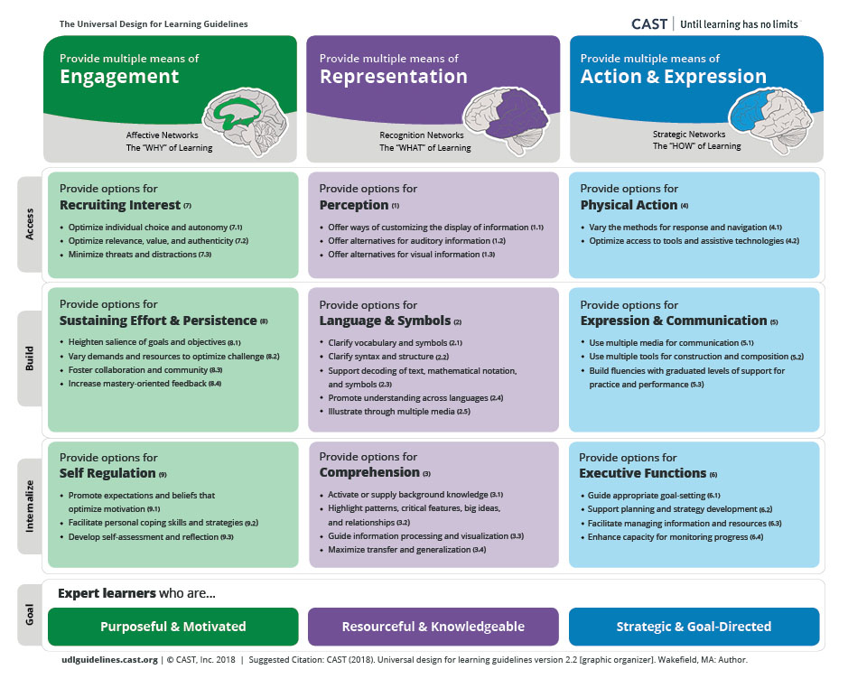 semantic waves

Iterative Design Approaches
Iterative design involves coming back to reflect on the outcomes of creative goals and revising them based on results. In simple terms the process involves; goal setting, creating quick prototypes, user testing and evaluation, revision and reflection. Like reflective cycles the process is iterative in that testing and revision of the prototype design can be repeated until the desired result is achieved.
Michel Resnick was instrumental in the Scratch development team and a pioneer of constructivist learning approaches. We have already seen his work in the development of his take on Computational Thinking. That interpretation is drawn from work creating and observing the use of Scratch and similar tools as a programs suitable for novices to use code to create design projects. One of the principles behind the design of Scratch are to make more concrete some of the more abstract principles of coding through design decisions about the program’s interface.
In more recent works Resnick has been promoting a five stage creative cycle http://tiny.cc/creativespiral with tips for both parents and teachers to create a fertile environment for creativity. It explicitly values the process over any particular content.
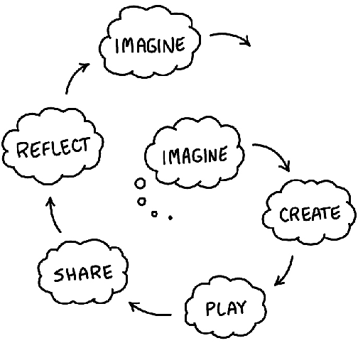 creative spiral
Diagram of five circular stages; Imagine - Create - Play - Share - Reflect - Imagine

Studio Thinking
Research of on the design approaches in artistic architecture studios has described them as Studio Thinking and described as 8 studio habits of mind. A framework was arrived at though ethnographic observation, and each of these habits was supported by teachers through stages of lecture/demonstration, hands on making, and critique/reflection.
Too large to describe in detail but it is useful to look at some of the key aspects. These include the importance of craft approaches, the process of learning to use the production tools, familiarising yourself with the materials and hands on reality of creating something.
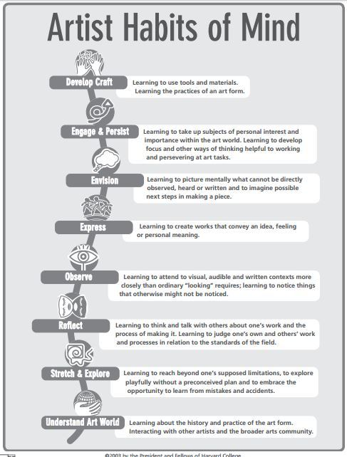 studio thinking
Other STEM focused researchers have drawn on the process that emerged from art education community of practice in a studio and have proposed it as a good learning process for STEM. Sawyer argues for a reduced formulation of studio practice in STEM outlining the following aspects.
- Complex, authentic, real-world projects
- Guided problem solving
- Curriculum design
- Externalization and reflection
He argues this approach is more suited to the learning sciences than the instruction based or apprentice oriented ones often in place. He cites these approaches as two sides of a spectrum. Studio practice is a third approach, open but guided. Sawyer also makes a link with PBL, an approach that is explored later in this chapter.

Design Patterns as an educational tool
When I retrained in computing at Master level one the most instructive and relatable pieces of coding tuition came in the form of studying design patterns to support an object oriented approach. Design patterns are solutions to problems or common scenarios in design areas. They have a origin architecture but are perhaps most commonly used in object oriented software design.
The advantage of DP as a way of teaching and learning coding is that they are often rooted in real life examples of problems that are often solved in a particular way. This can be described as a concrete implementation of object oriented principles.
For educators the use of Design Patterns to support learners develop coding proficiency provides certain advantages. As a bridge between abstract concept and concrete implementations As a way to join and navigate participation in a community of coders.
A similar principle to Design Patterns is presented for the classroom in the form of the concept of worked examples. A quick read is available here - http://tiny.cc/worked-examples

Case Study - Computational Patterns
There is one stand out study that uses design patterns extensively to support young people’s computing in schools. The project name is Scalable Game Design undertaken by the University of X. In this study over x students made games.
The project was developed in partnership with teachers and modified an original goal of teaching a more traditional view of transferable Computational Thinking to one of Computational Patterns. This move was in response to a key piece of feedback from teachers who were slightly mystified by the abstract definitions of CT but felt that they understood their expectation of the underlying usefulness. One expressed that they would like to be able to have the following expectation of students. “Now that you can make Space Invaders, can you also make a science simulation.” (Repenning et al., 2010, p. 4)
INSERT Details of the programme - SIZE ETC
In the case of SGD these patterns were and those present in games which could also be applied to science simulation. Examples include hill climbing, collision and transportation. Without going into details about the technical elements of the patterns they could be expressed in code but also as a concept that could be applied in other settings.
This brings up a question of what patterns to choose. This study pragmatically chose to work in a cross curricular way linking computing and science. The questionable promise of transfer drove the patterns chosen. However, in coding communities, other design patterns emerge. For example in website or the design of multimedia applications a particular set of problems with tried and tested solutions will exist. In a review of research to go with the report After the Reboot, Waite proposed that other studies which explore the utility and promise of patterns to learn coding are needed. CITATIION.
In my case study on a 3M game making framework, I argue that this element of transfer is not essential, that learning to code via applying and analysing game specific design patterns that have little application outside of game is still a useful process in developing authentic coding practices.

Projects and Project Based Learning
- Engagement
- Hands on use of tools
  - Maker fairs and movement
  - tools that are pitched to learners interests
- Studio approaches
PBL is of the 12 teach computing principles.
In the next section I’ll cover the potential of project-based learning (PBL) and how this can create inclusive educational approaches. I propose that PBL has strong parallels with UDL especially in promoting choice and authenticity in projects.
Project-based learning is a wide set of approaches and put simply can be seen as the value of learning via students undertaking practical projects rather than more traditional approaches designed to help the absorption and recall of more book based knowledge.
As PBL has been adopted by higher education and become the focus of academic study then frameworks have emerged as a way of helping practitioners to help students squeeze as much learning as they can from the process and to recognise the complexity of some of the learning happening. This is important as sometimes some of the learning is tacit/hidden learning which is hard to assess in traditional ways.
As a way of quickly communicating the kind of learning that PBL promotes we can represent them in a visual form followed by a table to break down what the categories mean.
PBL Terms
Challenging Problem Authenticity Real Life Relevance Student Voice and Choice Public Project Critique and Revision Reflection Sustained Inquiry
Computing education is an excellent vehicle for a project-based approach to learning. As we explored in the introduction, the nature of digital making and the many flavours that are available provides a wide-range of choices of outputs. Projects that create real outcomes that the learner has a choice over are a great way to motivational factor (Blumenfeld).

More about challenges and benefits of PBL
But a bit more about project based learning - and how to design it in a computing situation.

UDL revisited
In a previous section we looked at the foundations of inclusive pedagogies and UDL as an application of these principles. UDL is useful as a set of principles however there is less research available of application in specific settings. Universal design for learning is based around the principle that rather than designing separate activities and support for learners with different educational needs in the classroom, it is possible to embrace a set of guidelines that allow learners to choose a learning pathway through a designed learning experience that suits their abilities.
The process of in the form of designing a learning experience in a way that allows learners to choose the level that is most appropriate for them.
There are areas of overlap of the mechanics of UDL and PBL.
As previously explored the guideline to provide options for individual choice and autonomy can be challenging in a classroom environment. EXPLAIN WHY.
Another is authenticity and personal relevance and value. This could be one of the biggest challenges to a concepts first approach.

Summary of Design, Project, Authentic Approaches
We can start to see large similarities between different strands of design and project approaches. The craft approach and design patterns approach will be familiar to most professional and hobbyist coders.
It is rare in today’s coding environment to approach a coding project using a top down / abstract approach and then code everything from scratch. Instead for most coders the first stage will be to mess around with the tools, and then to research what code frameworks will help your job and what already written modules can be incorporated. Once you have worked out where the gaps are then you start coding to start plumbing the pieces together and to patch any of the gaps that appear.
This links back to PRIMM and the underlying approach of Use Modify Create, which is explored in more detail in a case study involving game making in another chapter in this collection.
What they have in common - that is distinct from more traditional classroom approaches - is a focus on devoting time to hands on making, structured support to aid inspire learners and facilitate observation of practice of others and a great choice in what goals learners set.

Creatively Overcoming Limitations In Context
All of the approaches above have research to support the benefits of the approach and in a context of inclusive pedagogies we can make a strong case for teachers to adopt them in computing education as a suitable candidate for project based, inclusive approaches.
But there are challenges of exam focus, time poverty, and lack of PBL delivery skills that are among factors hindering take up. This section looks at tips and strategies that have been used by other educators and researchers to overcome these barriers.

Time factors - sustaining the effort
Central to both iterative design approaches and PBL is the idea of coming back to failed experiments, learning from revising them, and reflecting on that process. This takes time. In research surrounding barriers to PBL in schools, teacher commonly cite time restrictions due to curriculum pressures.
I can only advocate to try to free up the time as it can be frustrating to teachers and learners alike to cover potentially interesting projects only fleetingly. I have witnessed this frustration first hand when personally meaningfully projects are side-lined to cover compulsory curriculum material that have less personal relevance to the learners.
Resnick advises double lessons and whole terms devoted to projects. This may not be possible in exam focused classes but may be possible in some situations especially in KS2.
For example, cross-curricular projects may free up more time by linking. As explored above Kafai was successful in gaining more time linking computing project with maths as a subject by asking students to create a game that taught maths concepts. Thus deepening their learning of a particular area of the maths curriculum. Science is a common way to explore cross over. As we saw the successful Scalable Game Design project used computational patterns and their overlap with science simulations as a base.
Many teachers will add in projects to the end of a series of work to reinforce concept in a practical context and that is certainly better than nothing, but it is likely to reduce effectiveness.

Meeting in the Middle - A learner choice approach to semantic density
I explore my own experiences teaching coding practice and concepts through coding games together in another chapter in this collection. My own approach is very much led by the interests and preferences of learners. I initially struggled to resolve the dilemma of learners sticking with certain areas of concrete practice without exploring some of the rich. They might
The student that favour a concept first approach are able to choose that path from the start building up coding knowledge and foundational concepts in a structured way. Other student may favour more concrete approaches and jump right in, the learning design then allows teachers to guide their reflection on completed activities that allows connection to the underlying concepts that are a required part of the curriculum.
PBL and UDL would promote not Concepts First, but Choice First. The choice of the student maybe to understand underlying theory before engaging in hands-on coding or perhaps the opposite, a concrete exploration, which allows students to meet the concepts in a practical setting first.
A tactic to bridge this potential disconnect is have two tracks of learning - one concepts first - and one choice first and to plan for learners that to ‘meet in the middle’ where their abstract teacher teacher-led learning connects with their project-based concrete explorations. The role of the teacher to help the learners make those connections.
In the classroom there is an additional challenge for teachers to observe and measure learner progress. How can this be done without it being overwhelming? In the last section we looked at different observations techniques outlined in the NCCE quick read. In PBL the more closely aligned technique is that of supporting learners to monitor and document their own progress. Teachers can support that process by helping learners to map their activities and
The process of planning a course of learning in this way may seem daunting. It is certainly a very different approach. It is worth restating that the advantages are not only in the engagement of students but also that the process is in line with the principles of Universal Design for Learning. By providing a variety of possible activities and choice, a tangible, sharable outcome
I explore this strategy that allows students to experience both the more abstract concepts entangled in the process of planning and coding a project in the context of game making in another chapter in this collection.

Conclusion - Supporting the Development of Learning Communities
In much of the research surrounding motivation, participation and peer learning we see that the learning of complex processes doesn’t happen in a vacuum. There is a clear value of creating a learning community of coders to support creative projects. We can draw on some of the rich research that is available from different streams of practice including project based learning, Universal Design for Learning and design-based approaches.
We have explored that while there are challenges to balancing the more open-ended goals and the degree of learner choice needed by these approaches, there are new resources from NCCE that draw on socio-cultural research on PBL, observation, pair programming AND ??. These resources and supporting articles from teachers and other practitioners in blogs and publications like Hello World have a focus on the reality of mainstream school environment.
WHAT’S MISSING IS MORE HELP ON DEVELOPING COMMUNITIES - WE CAN TURN TO X - TO HELP?
If you are like me and are a supporter of the more authentic coding practices in schools then we can only hope that some of the more flexible techniques for observing and assessing learner progress can be brought into exam practice to reduce the gap between exam and real life coding practices.

BBC Bitesize, n.d. Introduction to computational thinking - KS3 Computer Science Revision [WWW Document]. BBC Bitesize. URL https://www.bbc.co.uk/bitesize/guides/zp92mp3/revision/1 (accessed 3.26.21).
Black-Hawkins, K., Florian, L., Rouse, M., 2008. Achievement and inclusion in schools and classrooms: Participation and pedagogy, in: Artículo Presentado En La Conferencia de British Educational Research Association. Universidad Heriot Watt. Edinburgh.
Booth, T., Ainscow, M., Black-Hawkins, K., Vaughan, M., Shaw, L., 2002. Index for inclusion: developing learning and participation in schools. CSIE, Bristol.
Brennan, K., Resnick, M., 2012. New frameworks for studying and assessing the development of computational thinking 25.
Lye, S.Y., Koh, J.H.L., 2014. Review on teaching and learning of computational thinking through programming: What is next for K-12? Computers in Human Behavior 41, 51–61. https://doi.org/10.1016/j.chb.2014.09.012
Papert, S., Turkle, S., 1990. Epistemological Pluralism and the Revaluation of the Concrete. Signs 16.
Repenning, A., Webb, D., Ioannidou, A., 2010. Scalable game design and the development of a checklist for getting computational thinking into public schools, in: Proceedings of the 41st ACM Technical Symposium on Computer Science Education - SIGCSE ’10. Presented at the the 41st ACM technical symposium, ACM Press, Milwaukee, Wisconsin, USA, p. 265. https://doi.org/10.1145/1734263.1734357
Wing, J.M., 2008. Computational thinking and thinking about computing. Philosophical Transactions of the Royal Society A: Mathematical, Physical and Engineering Sciences 366, 3717–3725. https://doi.org/10.1098/rsta.2008.0118
Wing, J.M., n.d. Computational Thinking--What and Why? Carnegie Mellon School of Computer Science.

