Vignette of Toby’s activity - engaging with Documentation & scopes of Activity

Time | Dialogue | Activity
13:17 | : | Toby (T) returns to his computer. Open on the screen is a web browser with several tabs opened. The active tab shows the code view of Te’s project in the code playground glitch.com.
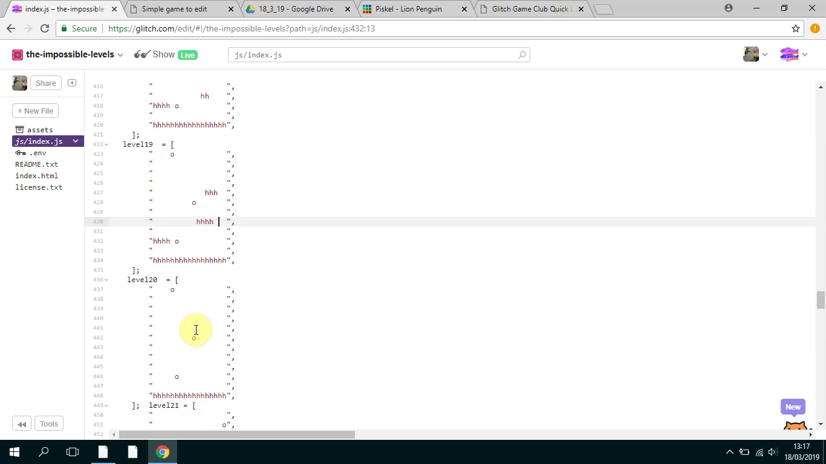
13:18 | Mick makes an announcement:  I don’t really have much to say now apart from we’ve got this one final making session next and then, if you can make it, the Monday after we can play our games and we can share them with students. We can make the students frustrated when they can’t beat our games. It’s usually quite fun. So if we can do that the same time next week let me know….  So we’ll keep trying to help you and yes good luck everyone | As Mick is speaking Toby clicks on another browser tab to see a live preview of his game in a web page. He plays through the many different levels of his game showing fluidity and skill.
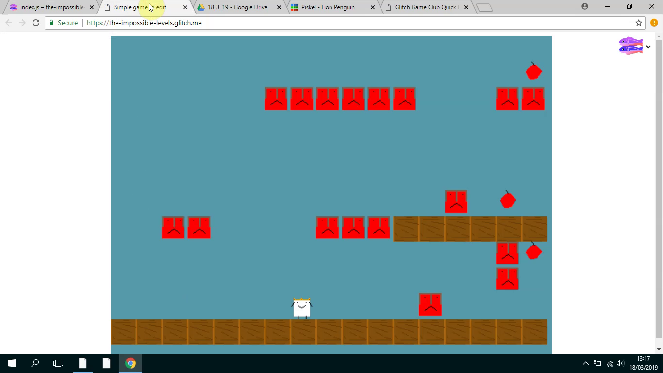
13:18 | Veronica: What was that website called?  Toby: Glitch.  Veronica: With the key on?  Toby: The what?  Veronica: We’re trying to work out how to make the game work. How to get that key and make it unlock that door. | Toby is still playtesting his game and tries to chip in to help Veronica who is seated next to him.  Mick also hear’s Veronica’s request and attends to demonstrate how to access two different forms of help in the form of code examples and step by step tutorials.
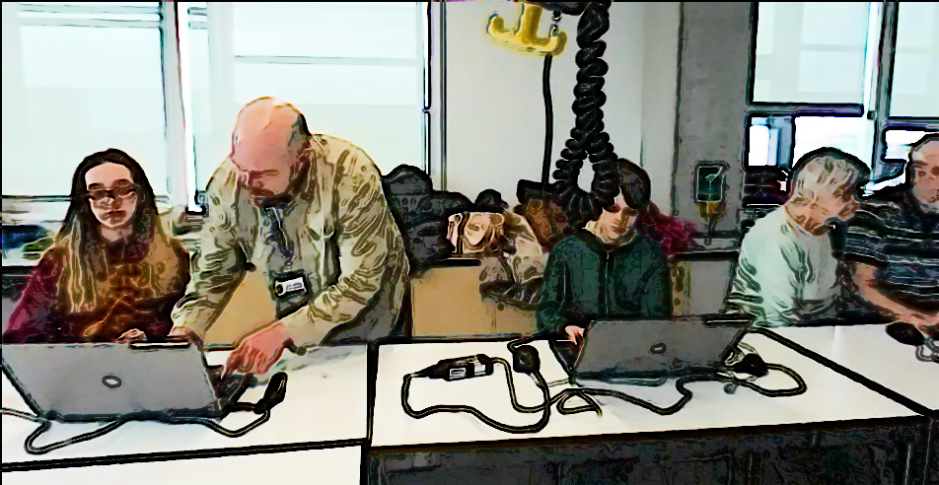
 | Mick: So we’ve got two ones. Here’s the tutorial and there’s the examples of code so you can compare what you are doing and see where the new code should be placed. | Mick explains different sources of code. The tutorials at https://en.flossmanuals.net/phaser-game-making-in-glitch/_full/  And the other more with graphical prompts linking to code exables available at  https://ggc-examples.glitch.me and the other

