4. Exploration of the Formative Learning Design Process
- Research Questions - June 2023
- Notes on structure
- Chapter Introduction
- Exploring issues and context from practitioner interviews and existing research
- Short vignette illustrating shifts in scope of activity
  - Context of Vignette
- Summary of design evolution
- Commentary on evolution of design by Phase
  - P1 and P2: Explorations and innovations
  - P3 and P4: The main game making programmes
  - P5: Adapting to MakeCode Arcade and more formal settings
  - Description of the nested levels of activity & tools used
    - Diverse Environmental Objectives
    - Wider Objective - Making games for an audience
    - Intermediate Objective - Implementing a game element
- Conflicts and design tensions experienced by participants and facilitator/s
  - Design tensions experienced as a researcher / designer
    - Tensions surrounding authenticity of tool use
- The impact of the core tools of code playgrounds and templated game
  - Code playground
  - Impact of the half-baked game template
    - Observations on design behaviours encouraged through use of game template
  - Discussion on Authenticity of Tools
- Participant conflicts / contractions
  - 1. Identity hardcore coding & disfunctional group work - P1
    - Navigating the conflict
  - 2. Participant conflict due to lack of relevant technical support
    - Tensions and related to navigation of various documentations sources
  - 3. Facilitator conflict addressing the Play Paradox
    - Using Physical Maps of Missions as Game Design Patterns - COMPRESS
    - Learning Dimensions Map
    - NOTES ON TENSIONS WHICH THIS LEARNING MAP HAS POTENTIAL TO ADDRESS
  - Limits to the learning dimensions map in an informal setting
- Conclusion
  - Summary of barriers exposed in this study
  - Discussion on the emergent (and mutual) nature of the design (and reseach?) process.
  - Link to next chapter

Research Questions - June 2023
- What pedagogical tools and processes are available to support novices to overcome barriers to game coding and design?
- How can learners build agency in an evolving community of game makers?
- How can game design patterns support the development of coding practices with novices?

Notes on structure
- drawing mostly on my journal notes and the evolution of the tools and design themselves.
- Interviews (and Lit review ): exposes motivations and barriers to undertaking activity this domain from interviews with peer practitioners and literature review
- gives an overview of the evolution of the learning design
- draws on immediate analysis of participants reactions and contributions from journal notes, and participant interviews and analysis of changes in the learning resources created to present an exploration of tensions
However in terms of tensions - there is one on cultural tensions - this may need moving to the next chapter - a more thematic approach.
In most of this chapter focus on the tools and authenticity in relation to other tools.
Also the practitioner interviews - could be a bit disjointed - as they do relate to cultural barriers and tactics. But could say those are explored in other chapters. DONE

Chapter Introduction
This chapter
- exposes motivations, tactics for and barriers to undertaking activity this domain from interviews with peer practitioners (supplementing the literature review)
- gives an overview of the evolution of the key pedagogical features of the learning design used in the research process
- draws on immediate analysis of participants reactions and contributions from journal notes, and participant interviews and analysis of changes in the learning resources created to present an exploration of tensions
- explores 2 key conflicts using the terminology of Saninno in TADS
- Presents a synthesis to initial barriers (and) tactics to overcome them
Due to the novel nature of the learning design the detailed outline of the specifics of the participants experience of the design are important to situate findings in the following two chapters.
Key questions / motivations in creating a new learning community
The game making community is not authentic or mature in the practices they are undertaking, the kind of community practices which we can undertake are focused partly on building connections to existing knowledge and practice.
One of my roles as designer here was to uncover and to help participants explore knowledge that they were unaware they possessed. Another was to help support the development of peer learning practices and in order to do that help foster a creative environment which suited that.
As explored in other chapters X, there is a gulf between instruction based tutorials and more open create your own game challenges in project work.
This chapter charts this tension and the evolutions of resources which ended up trying to occupy this middle ground between instruction and (overwhelmingly) free choice.

Exploring issues and context from practitioner interviews and existing research
While the literature on game making and other forms of digital making is extensive, much has a focus on curricula driven, personal knowledge. Research in the domain of informal learning and the resulting characteristics and emerging tensions is less prevalent. In addition the process of writing interview questions and the conversational process of semi-structured interviews helped expose new streams of thought, that which while present in existing researched helped bring them into clearer focus.
Summary of background of interviewees
Saskia Leggett is a researcher who was active in the in Creative Family Learning program under direction of Ricarosa Roque. She took a leading role in creating the programme’s support resources. Matt Curinga is an academic at Columbia and teaches in educational technology and computer science. He is also active in a non-profit organisation, Zero Day Camp, promoting learning coding and engineering through engaging projects. Dave Potts is a professional programmer and a parent and volunteer at Coder Dojo which is a volunteer run teaching technology monthly event. James Clegg is PGCE Computing student/teacher and volunteer student helper for the game making programme.
Summary of themes emerging
In my analysis, I have proritised data which in forms the first research question and specifically addressing barriers and tensions for both practitioners and participants which exist in this domain of activity. NOTE - REVIEW THIS BASED ON THEORETICAL LANGUAGE - PERHAPS OBSTACLES, CONTRADICTIONS, TENSIONS AND INTERVENTIONS.
Table of initial data
https://docs.google.com/document/d/1aEF0EsZRe-Ovok2VP7ouYH_v-SdepnNnXFhLtj6SseU/edit
Issue | Instances
Barrier: Isolation during problems solving increases frustration and inhibits learning | 3
Tension: the goal for students to be self-directed vs. the advantages of providing a shared collaborative foundation for production | 4
Tactic: Non-coding activities amd games to increase group connections as a good preparation for coding related challenges and frustrations. | 5
Barrier: students not considering them selves as STEM / coding types of people
Barrier: logistical issues of time and equipment in school settings
Additional short commentary
The themes that emerged above.
One key issue is the clash of cultures.
There's this idea of a clash of cultures where to learn like the dominant school culture, you have to release some of your self-identity or you need to learn to bridge these worlds. And I think at least in the writing, the literature, that there's this resistance of seeing yourself as someone who does STEM, as someone who does computer science. It's like we're not people that do that. And I think by doing it with their family, like there's no better way to kind of mitigate that effect and that hesitation, that barrier, because they're all becoming your whole family, like your, your closest identity is becoming people that write code or people that make robots.

Short vignette illustrating shifts in scope of activity

Context of Vignette
The following vignette, consisting of extracts of participant activity over 20 mins of a session, is presented as an summary of different scopes of activity. The participant is the child Toby who in this session has been working independently.
https://docs.google.com/document/d/1vYeVxYaRMTWPDOHwC4DEGYAkGPRIDX7wLiz0l8b7LWc/edit ### Commentary on Vignette
This sections outlines a short description of the vignette above focusing on the overall activity and its place within evolution of learning design. It will signpost to where tensions in the activity system are explored in this chapter.

Summary of design evolution
The following table is provided to give the reader an overview of the stages and tools used. Emerging tensions in activity systems are used to explore the rationale for the creation and selection of these tools.
Phase, Name and Date | Description | Starting Resources
P1: Oct 2017 - Mar 2018; Experimental Course | Participants started with a blank canvas and were asked to plan and make a game in two larger groups of 5-6 participants of mixed ages. A minimal incomplete starting game code template was introduced to support students after the course has started. | Phaser 2.6.2 javascript library; Thimble code playground; online graphics editor Piskel; audio creation tools
P2: May 2018 - Dec 2018; Resource Development Stage | One-off workshops at Mozilla and Feral Vector conferences and to PGCE computer students helped focus and the creation of a “half baked” game template and supporting online and printable resources. | Phaser; Glitch code playground; quick start cards; incomplete game template
P3: Jan - Feb 2019; Glitch Game Club | First iteration of game making course of 5-6 weeks. The template and resources created in the previous stage were used as a starting point but continued to evolve. | Phaser; Glitch, Piskel; updated game template; quick start cards; step-by-step tutorials; code examples
P4: May 2019; Glitch Game Club 2 | Second iteration of game making course with additional drama and reflective elements | As per P3; drama scenario; interactive chat page in glitch
P5: Jan 2020 - September 2020; Make Code Arcade | Two iterations of game making course of 5-6 weeks using MakeCode Arcade tool. | Make Code Arcade (MCA) tool; MCA Template starting game; MCA quick start cards; MCA game pattern menu; MCA game pattern tutorials; Learning Dimensions Map

Commentary on evolution of design by Phase

P1 and P2: Explorations and innovations
Phase one was an extended, exploratory series of game making sessions over several months. This stage was aimed not at collecting user data rather than building my own background knowledge and competency as a facilitator.
In terms of supporting resources, stage one was responsive; I had no pre-existing supporting materials and created a starting code framework of a platform game and code examples to add extra functionality to the game as the programme developed.
A final public showcase - At the end of this stage participants showed their games to students in the foyer of the MMU Brooks building and gave me feedback on their participation in the programme.
Feedback from participants this stage included; a general consensus that the process was too long and that more guidance in the process of familiarising themselves the coding tools initially before undertaking ideation would be useful.
Other emerging tensions and participant conflicts are explored in the next section of this chapter. Phase two comprised one-off workshops at summer conferences and to PGCE computing students.
The requirements of this compressed time frame aligned with feedback to prompt me to design an accelerated process to bump start the game-production process.
The new intervention involved a starting template and printable resources that highlighted particular key lines of code and variables that had a high impact on the game experiences.

P3 and P4: The main game making programmes
By P3 most of the resources and activities were in place and relatively stable. There were some incremental evolutions in the supporting resources that stemmed from participant feedback and detailed reading of relevant literature.
One key addition brought to start of P3 was a more coherent list of tutorials and code examples illustrating key game features that had been requested by participants. These were presented in a web page together with the starting template as a collection of game design patterns.
P4 used the same toolset as P3 however in addition, drew on my previous work with the MMU Faculty of Education drama department <Do Zotero Refresh: [@caldwell_drama_2019]> to create a simple drama process to give an external motivation and narrative to the creation of games using for a fictional audience of visiting aliens.
The participant activity of these stages and tensions between system elements are discussed in detail in the remainder of this chapter and in following chapters.

P5: Adapting to MakeCode Arcade and more formal settings
I ran two iterations of game making course of 4-5 weeks using MakeCode Arcade tool. MakeCode Arcade uses block language system. The template, resources and facilitation approach was based that of P3 and P4.
I also adapted and advanced resources with an aim that they could be used within secondary classrooms to support computing curriculum. To do this I added a learning dimensions map. This is explored in a later section of this chapter.

Description of the nested levels of activity & tools used
Activity Theory allows researchers to identify intersecting or nested systems of activity with varied goals. These descriptions mirror the work of AT researchers who conceptualise scope of activity as concentric circles from Broffennbrenner with “larger” scopes of cultural and societal goals and smaller, narrower, lower scopes of more personal activity [Engestrom][Cole].
Subsequent analysis of the identified activity systems allows both the researcher and practitioner to identifying existing and emerging tensions and to thus observe (spontaneous) or plan (designed) responses. A short description of the activity systems follows using the to the vignette above to anchour the process.

Diverse Environmental Objectives
There are several wider objectives of activity which may vary including; parents facilitating coding and design learning for children, the children’s motivations of being part of a fun club-like programme, and my own motivation of conducting research.
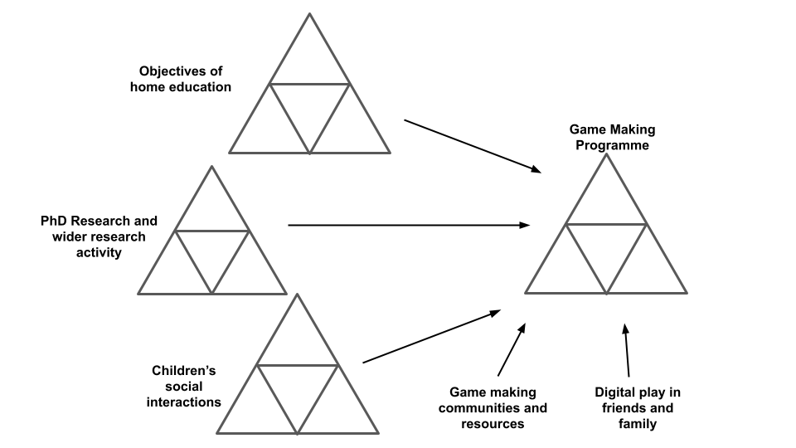
At Dia Environmental
More shared objectives exist within these wider aims and include: a larger-scoped objective of the group creating games which is fun to share and play, intermediate goals of identifying and implementing key game features to add to individual games; and narrow objectives involving creating or altering game assets and code constructs.
NOTE - The purpose of this following description is to situate the reader in full spectrum of activities before further analysis and to give an overview of the different activity system elements in situ before exploring tensions arising between them.

Wider Objective - Making games for an audience
In this larger scoped activity system the direct objective of the activity is to make games which are fun for the intended audience to play and which explores an environmental theme.
NOTE - WHY MENTION / REVEVANT? As previously indicated, other high level objectives exist including: research goals on the part of the researcher/ participant; desire to create a useful learning experience on the part of student helpers; learning computing skills and concepts as a home education project; and participating with other home educators in a creative environment and thus building team and communication skills.
Insert an AT diagram from here - https://docs.google.com/presentation/d/1vR6dzFG6qXIdpB_-s6PbCePiB87qTs6YAXCljxNcb5Y/edit#slide=id.g57b5e8e9ad_0_0
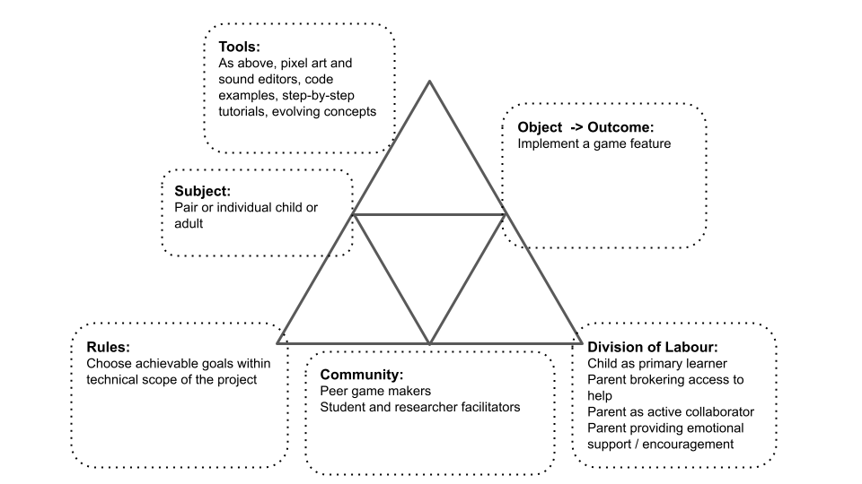
At Dia 1
In exploring the community of the activity system.
While the primary audience for the created games are peers via ongoing informal testing, the theoretical end users are students and staff in the Manchester Met Brooks building where their games will be shared in arcade cabinets.
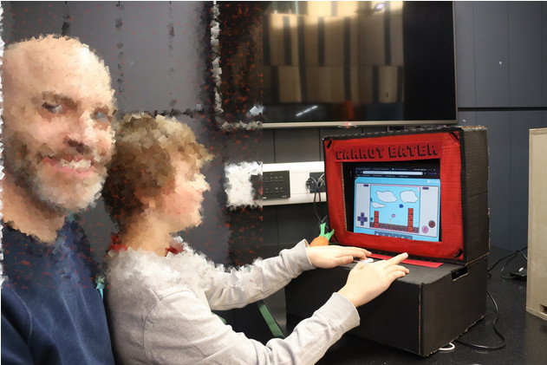
Carrot Eater
In the vignette of Toby’s activity this wider objective is present in the facilitator orientation at the start which references this audience - the Monday after we can play our games and we can share them with students. We can make the students frustrated when they can’t beat our games. At the end of the vignette text, one of the student helpers also imagines this audience playing the game of Toby.
Toby begins the game making session playing his own game which he has developed from a shared starting template. During the session he invites many other group members to play his game. He initiates and responds to may conversations around the difficultly of the game he has designed.
Analysis TO COME.

Intermediate Objective - Implementing a game element
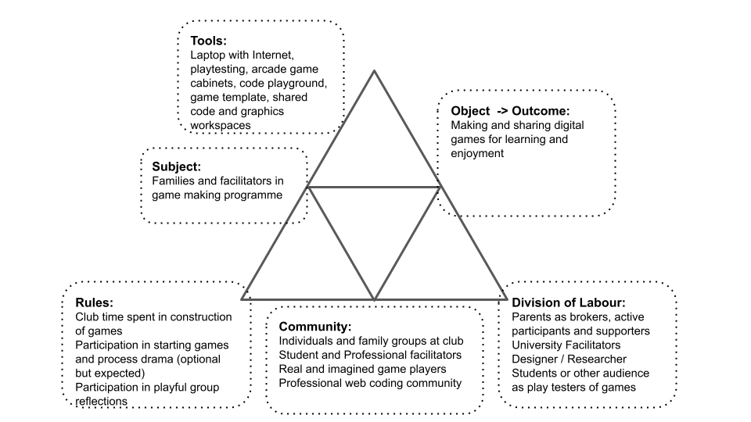
At Dia 2
The process of making a game was driven from early stages by learners requests to implement game features which followed freely with little prompting.
By this stage, the process of collecting a user generated list of features and trying to respond to all of them as a facilitator had been abandoned as unrealistic. Instead a collection or menu of elements for the chosen game type of a platformer was in place. From now now these elements are named game design patterns from professional and amateur game coding terminology.
In the example above Toby progresses from playtesting his own game to altering it by adding a new platform to the game. Toby retests immediately by clicking on the preview element of the game. On this page participant can pick missions from a choice of resources.
Toby then browses the web page of a menu of game design patterns and selects moving enemies. At this scope of activity the goal is to increase the challenge and variety of the game experience. It appears probable that his is also guided by the expectations embodies in the page itself. EXPLAIN affordances OF DESIGN HERE.
Other participants were less proficient using this online resources and used printed out versions of documentation.
Scope of activity: While other interpretations are possible which view the implementation of each pattern as a form of action with each activity system, I have chosen to privilege this as a sub-activity system. The justification for this mirrors choices by other researchers who see the utility in a more granular exploration of the processes at work in a complex process.
As explored in the previous chapter, Barab and colleagues, outline the value of a more granular approach to analysis of nested activity systems.
In the next section narrower actions still within this system are explored as discreet actions which combine to be come the activity of implementing a game pattern.
Narrower Actions - Implementing discrete code and design structures
While some game patterns were simple to add to to alter, other more complicated features involved several stages in implementation. For example, creating a new graphical element in a separate online pixel-art editor called Piskel, exporting and downloading it to the laptop, and uploading it to the glitch code playground and then making code changes in several parts of the code to initialise and implement new behaviour for this element.
Some of these operations are performed by Toby quickly and fluently by Toby indicating that he has performed them many times. One example is the quick navigation between the different tools. However some are new to Toby and are performed more hesitantly. For example, Toby is careful in his checking of the process of copying and pasting new code to his game code.
In this example he is competent in the process of comparing the own code to the code example to work out what code is new and relevant to the desired behaviour. He does not check the step by step tutorials which would provide more extensive, step-by-step help.
Others in the group did not experiment in this way and used more direct help or detailed written instructions.
Transition
In a simlar approach to Rogoff’s 3 lenses of cultural, social and personal activity analysis of activity using the scopes of activity systems explore above is useful to researchers to highlight possible tensions and contradictions between competing goals of interrelated activity systems. For example a common contradiction may be an immediate goal of children to mess around, play games and have fun while the goals of parent may be to maximise the acquisition of skills

Conflicts and design tensions experienced by participants and facilitator/s
As explored in the theoretical framework in activity theory tensions and contradictions are a vital source of change and evolution of new and ongoing activity systems.
To avoid the dangers of the vague use of the terms tensions and contractions <Do Zotero Refresh: [@karanasios_exploring_2017]>, this chapter will aim to be more descriptive.
NOTE - there is also the concept of congruencies - or strengths within activity systems. Where appropriate these systems strengths and positive alignments are helpful to note <Do Zotero Refresh: [@kamanga_contradictions_2021]>.
On a smaller scale, design tensions exist. These do not block progress completely but may disrupt some activities. Combinations of tensions can compound to create longer lasting and more serious conflicts if not resolved [Engestrom early]. The concept of levels of contradictions are helpful <Do Zotero Refresh: [@sannino_cultural-historical_2018]> the forth being a conflict.
In Sannino’s later work on transformational agency TADS conflicts are examined - greater scope than tensions - thus larger shifts are implied.
It also useful to recap here the interpretations of agency explored in the theoretical framework. (NOTE IS IT OR SHOULD I JUST PICK TADS AND USE THAT LANGUAGE?) Instrumental agency is relevant here to help examine and the work of learning designers to remove barriers, Transformational and authorial agency serves to explore the potential for learners to address and overcome tensions and conflicts in their own way.
In the process of reflection on sessions I both observed and project tensions between activity system elements and between different scopes of activity. In response, I introduced new tools or processes or removed existing or potential barriers. I observed participants responding to tensions both in expected and novel ways.
In the following sections of this chapter I focus on such which relate directly to the research questions and which help inform the findings of later chapters. In particular I draw out more visible conflicts which threaten more serious disruption of activities.

Design tensions experienced as a researcher / designer
This section is written from my own perspectives to inform discussion on design tensions. The process here is driven not only from user feedback but also on a more intuitive experience as an experienced facilitator in this field. I also draw on the tensions explored in the previous exploration of fellow participants. I focus on tensions involving authenticity as a precursor to exploring their relationship with participation experience of agency.
Rainer, Bolton and other practitioner-researchers agree on the potential and value of exploring other subject matter - e.g. literacy, maths, science and history - and undertaking authentic project work within a drama frame <Do Zotero Refresh: [-@rainer_drama_2012]>.
This authenticity has several relevant dimensions in this study including: audience; toolset; and supportive processes / documentation. This section explores the these dimensions of authenticity and the resulting relationships with agency of the learners.

Tensions surrounding authenticity of tool use
PBL is adapted to schools in many settings thus, authenticity is “on a scale” in PBL The concept of an authentic-as-possible project is a key tool for educators to support game making via project based learning [find support]. One advatange of working with digital tools is that if issues of complexity and cost can be addressed access to laptops and the internet allow learners to use very similar production tools to professionals.
Key message: authentic tools and processes can increase agency but facilitators should use them with careful curation - as there are negative effects too
Javascript as coding language, Phaser as a game making framework and Glitch as a code environment, are highly authentic and used by both professional coders and enthusiasts alike. A Mozilla white paper <Do Zotero Refresh: [@mozilla_foundation_webmaker_2014]> outlines the power of exploring web technology as an empowering activity. My own work in this area has been informed by work developing teaching materials for the Mozilla Foundation as part of the Teach the Web programme.

Javascript is an authentic language, core to modern web pages and applications. Phaser is a professional and enthusiast framework. Glitch is a code playground which while used for learning and which was chosen by Mozilla as a replacement tool for the education focused Thimble, is also used by professionals. In the early selection of tools the use of a framework based on javascript and web technology is driven by authenticity and thus an ability . My work on teach the web for Mozilla was motivated in part in the extensibility of this choice of language which can be compared to block based environments or game specific making tools like game-star mechanics.
Phaser is a javascript framework embedded in html page. Unlike many game making tools this tools set can be extended to other kinds of projects and is a professional and foundational toolset used to build the majority of websites and many phone applications.

Research on project based learning using technology supports the motivational and inspirational factors of authentic tools in the fields of STEM computing <Do Zotero Refresh: [@garneli_computing_2015-1; @humble_use_nodate]>, media making and STEM in general. [IF SO FIND THIS ]
In the activities of study, a high degree of authenticity made possible, in a material sense, by the digital nature of the learning resources. Beyond a general purpose computer, no prohibitive equipment is needed.
However, in terms of complexity of tools use, careful shepherding is involved to screen participants from overly complex processes and tools.
The use of code playgrounds mirrors that of professionals. The process of creating a microworld with embedded concepts brought to the fore for students to bump against,
While early use of microworlds as a “acceptable” authentic-ish a concept endorsed in literature on authentic approaches [].

The impact of the core tools of code playgrounds and templated game
The last chapter outlined the design characteristics of the coding tools in a face-to-face learning environment, namely: an incomplete 2D platformer; pixel graphics; with graphical scaffolding for text-based code; and deliberately incomplete thus inviting improvement. In this section, I draw on my journal notes and past experience and observations from interpretation of video data to share observations on the use of these tools.

Code playground
My motivation for choice of code language (Javascript, Phaser) was driven by desire to be authentic and extensible. The use of glitch.com as a code playground significantly reduced technical barriers for students related to this choice. In terms of first impressions, learners first experience of the experience was in the process of playing a game in a webpage and controlling the character using the computers arrow/ cursor keys which for many was a familiar process.
In terms of technical complexity, using a code playground removed the process of setting up a server for web development, and the delay and complexity of transferring files to the server. While the code project consisted of several files of javascript, HTML and CSS, learners were shielded from the complexity of how they were interlinked. In the video data analysed, there were practically no extended blockages to undertaking work related to the use of this environment. While this study does not attempt to quantify this factor, the experience compares very favourably to my experiences of using and teaching coding environments.
There were some issues of access for some participants who did not remember or recall log in details or their project name. These issues were mitigated through the use of a log in details shared between participants. When users struggled to log in or to find the games or assets that they had created earlier there sought and received help from family members or other peers. Direct help from facilitators was rarely required. In the glitch environment code errors were highlighted in with red dot in the interface which gave a quick visual indication of where the error occurred, when the user hovered over gave an error message as a pop up, which while limited and sometimes misleading, gave participants immediate feedback on syntax errors. In analysis of video data, I observed learners reacting to this feedback and either reversing errors such as deleting commas, semi-colons and quotations marks. When participants were coding as a pair, especially the parent was observing they would often notice and point out the red dot, thus preventing further errors. The next chapter explores different types of errors and participant responses to them.
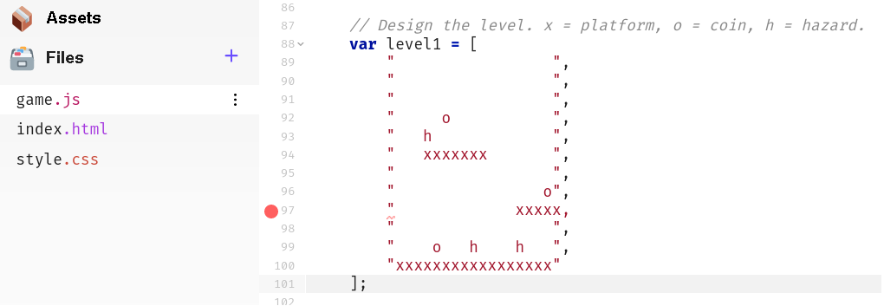

Impact of the half-baked game template
As explored in the last chapter, participants starting with an incomplete game template to scaffold the initial creative and coding process.
Brief help was available via in-line text code comments allowing for self-directed or previously proficient learners to progress with minimal support. In addition, supporting cards (see figure 4.x below) suggested possible adaptations and illustrated the relevant code changes needed.
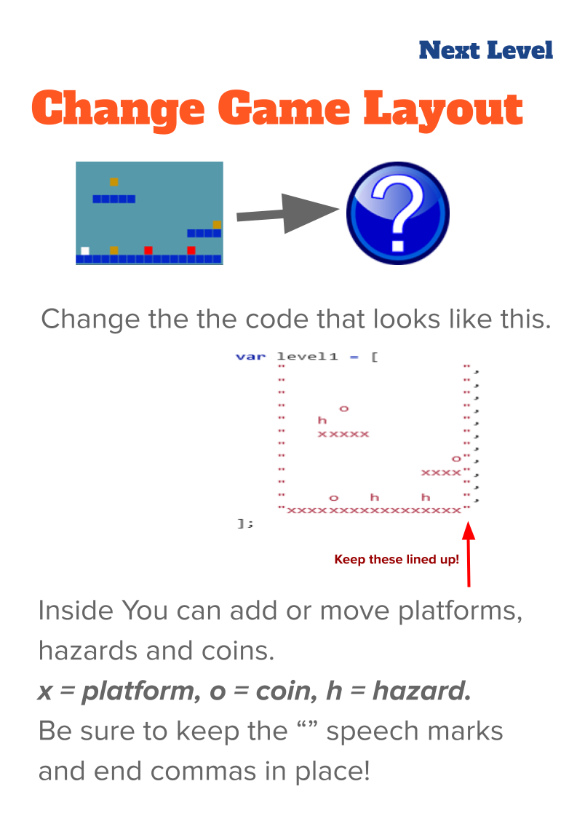 4.x - Example of a Quick start card
The templated game was structured to allow changes in code which were relatively easy to perform but which resulted in potentially large changes in game behaviour, appearance and difficulty. This created a large diversity in the games created and in the making activities of participants at this stage despite the small scale of the code changes involved. Thus while I created these resources and the corresponding code structures to facilitate a quick start, the diversity of experience kept some participants extended periods of time.
These observations build on the description of the game template in the last chapter.
Variable editing for movement: Participants needed to change the code to allow effective player movement. This thus forced all participants to alter at least one of the key variables were highlighted at the very start of the game code. Following this first change however behaviour varied greatly. While some participants engaged with extensive experimentation to find a player movement feel that seemed just right, others, mostly adults or younger participants, were much less concerned with this aspect of game play, despite sometime frustrating resulting player movement.
Level design and prototyping: The starting game template included a minimal amount of platforms, hazards to avoid and golden blocks to collect. Many participants spent significant time and effort on level design both in initial stage and in subsequent sessions, undertaking many iterations of changes to the level design. As explored in the vignette in the previous chapter, Toby and several others designed to make the game challenging but still technically possible. In contrast, two participants played with the convention of the game by removing all hazards and filling the screen with rewards/coins.
Use of pixel art to seed narrative and art creativity: One activity that all participants spent some time on was to replace the coloured block of the starting template with pixel art sprites created using the Piskel tool. Participant spent a widely different length of time creating these graphics. Some took a long time to master the process of using the editing tool. Some others struggled with the process of exporting the images to the code editor. Others were relatively rapid in creation but returned to alter their creations. As they had been guided to make a game on a broadly environmental theme. Participants often redesigned sprites to games involving animals. The following image shows a whale as a player character and plastic bottles.


Observations on design behaviours encouraged through use of game template
While the simple changes to the game dynamics and patterns embedded in the starting template were motivation and enagement, some participants soon began to ask how to make additions to the game. A common request was to add a moving enemy to the game. There was a great divergence in the amount of time learners took to want to progress beyond making embedded changes to adding new game design patterns. One parent Molly did not progress beyond this point despite engaging in phase three and phase four, focusing on graphical design and developing narratives. In the feedback session she commented that she was happy to reinforce her existing learning.
At this quick start stage, knowledge of very few coding concepts were essential. It useful to compare this to a typical process of learning to code in a text language from first principles where the learner is met with a great many new concepts in the process of being guided to construct even the most basic of programs. Thus, while some basic alterations are being made, this stage of learning design aligns mosst closely with the Use stage of the UMC model (see lit review/ glossary) <Do Zotero Refresh: [@lee_computational_2011]>.
Instead analysis of the video data of participants reveals a large number of broader digital literacy skills involved in certain processes. For example, the processes of replacing a block image with a bespoke pixel sprite which comprised: file downloading; file migration using the browser and file manager; browser tab navigation; graphics tool use in Piskel (a simplified Photoshop including - crop, fill and export tools); copying and paste text code; and selecting more than one lines of text code with mouse or keyboard shortcuts. Undertaking the full process involved learnign a complex chain of these individual actions.
Some participants became remarkably adapt at this, thus transforming this chain of actions into a fluid operation. Learners who had mastered the skills were asked by others for help. The rapid adoption and transfer of these processes between community members indicated a high motivational factor for participants of incorporating self-created graphical elements, a topick which is also addressed in the following section.

Discussion on Authenticity of Tools
NOTE - Section moved from conclusion.
An inspirational aspect of lifting the lid on previously unknown technology was reflected in a conversation among adult participants. They communicated a sense of awe of how much code must be involved in a professional game based on the relative complexity of the code of their simple game [FIND IN VIGNETTE OF THIS CHAPTER].
The design of the starting template shields learners from much of the complexity of the underlying web-technology and provided potential affordances via embodied elements that facilitated learner agency via expression of home interests, play with dynamics and game layout.
The partially working environment and immediate feedback this allowed also gave rapid access access to varied forms of face to face community activity including varied forms of playtesting and social interaction and ways to access help from peers and facilitators.
These observations support existing research on computing projects in the work of Papert <Do Zotero Refresh: [-@papert_mindstorms_1980]> on Mircoworlds and subsequent research on programming tools in the constructionist tradition <Do Zotero Refresh: [@kafai_constructionism_1996-1; @kafai_mindstorms_2014]>. In this study, in contrast to the specially created tools of Scratch and Logo, the protected Microworld is built as a shield area within a more genuine ecology of authentic tool use and practices.
While the use of authentic tools and processes, while challenging for novices, can be facilitated by careful alignment of key design principles and other pedagogies. For example, while the complexity of authentic text code languages and authentic developer focused documentation can be intimidating, a following chapter explores the potential for drama processes to address learner anxiety in this domain.

Participant conflicts / contractions
Beyond the design tensions above that were smaller in scope and addressed relatively quickly, this section examines more extensive contradictions between system elements which developed into conflicts which significant in stopping participant progress.
The first which involves clashes of identity and ambition is outlined briefly and explored in more depth in a later chapter.
The second frustrations due to technical processes.

1. Identity hardcore coding & disfunctional group work - P1
1. Participants stuck / demotivated : scope of ambition to high, clashes of identity not hard core coders, no on-going playtesting, collaboration groups too big (transition),
For some families and individual participants there were conflicts to do with a sense of anxiety and alienation from the group coding environment and associated peer working dynamics.
One family dropped out and in their exit interview they shared that at one point we looked around and just saw people doing hardcore coding and we no longer felt at home in the environment. In this emergent design, they had mostly completed asset design and narrative development and the only coding remained. I thus wanted to address the tension between completing the project and alienation from just coding.
The value of playfulness is illustrated with one exit interview with a parent where they shared their reasons for leaving the program. At one stage after a week where they had missed a session, their family looked around and saw other groups involved in ‘hardcore coding’ and no longer felt at home. They compared this previous sessions which had more fun and group oriented activity.
I was struck that his incident happened during a session where I had not played customary drama games to create an inclusive environment. The games had been omitted as I was responding to a sense of urgency coming from families to solve problems. The scarcity in facilitator time drove me to crack on supporting families to debug code errors.
Gulfs between desires and reality
While members of this family were able to engage in planing via sketching on paper and in creating pixel art, they were reliant on others to implement code changes. This was in part due to improvised group roles.
The freedom of choice and imagination allowed by desining on paper and via pixel art created compounding tensions. One crisis point involved a frustration of a child who was not able to implement a feature they wanted to add to the game next:
A 3d bee design of one participant which happened when there was no framework.
While personal expression can facilitates engagement and motivation it can lead to conflict if desired changes are not realistic.
In order to accelerate the process of making a game to fit into contextual expectations of an acceptable project timeframe, I pre-chose the genre of game to be made as a two dimensional (2D) platformer game.
The incident lead me to greater reflection on ongoing measures needed to prevent participant drop out for due to cultural tensions and negative affect to the working community. These include:
- An awareness of the danger that those more confident in coding create more involved code problems that need more facilitator time, potentially making others feel less valued.
- A concern for the fragility of learners positive affect towards the group game making process and thus the need for initial playful starting and closing activities to be continued beyond initial sessions.
- The value of a stronger buy-in by participants, ideally a greater commitment to the collective making process balanced with the need for low pressure (avoiding a negative sense of obligation).

Navigating the conflict
Via exit
One way of navigating this was via exit and certain families did drop out at different phases.
Encouraging peer learning with flexible working practices
CHECK FOR DUPLICATION WITH FOLLOWING CHAPTER
This tensions was resolved partly by freeing up some patterns of collaboration and interaction and removing others.
The process of parents getting in the way of children’s not minding jumping in and invading social space struck me. Together with the frustrations of complexities of larger group work the restrictions created a tension between the suggested community norm of how division of labour was organised.
Thus in the next iteration, rather than the larger groups, smaller groups, allowing some children to work by themselves and others with parents. Avoiding large group fragmentation and encouraging freedom of participation vs benefiting from parental involvement.
These tensions are mirrored in similar research and were highlighted in the practitioner interviews that I conducted.
The fruits of this freedom of participation are explored in chapter five.
A game encouraging maker / player types
My journal notes see an evolution of attempts to try to build into the program, activities which help build the participants sense of their own identities of game makers or more generally digital designers.
In and early tentative attempt to define in broad strokes the types of game maker behaviour and underlying goals. In doing this I have taken inspiration from Bartle’s game player types <Do Zotero Refresh: [@hamari_player_2014]>. I translated player types to maker types based on notes in my observation journal and extracts from screen capture data. The following list of Game Maker types:
- Social makers: form relationships with other game makers and players by finding out more about their work and telling stories in their game -
- Planners: like to study to get a full knowledge of the tools and what is possible before they build up their game step-by-step
- Magpie makers: like trying out lots of different things and happy to borrow code, images and sound from anywhere for quick results
- Glitchers: mess around with the code trying to see if they can break it interesting ways and cause a bit of havoc for other users
An additional rationale for this process was to help reduce potential internal bias about the kind of process that a computer programmer should adopt, echoing the call for pluralism in approaches explored in the literature review <Do Zotero Refresh: [@papert_epistemological_1990]>. I wanted to try to communicate a message to participants that when you are learning something hard it is of value follow your own working preferences and try to discover a creative style that suits you.
This line of thinking developed from a warm-up activity trialled in P3 were participants took the Bartle test (what kind of game player are you).
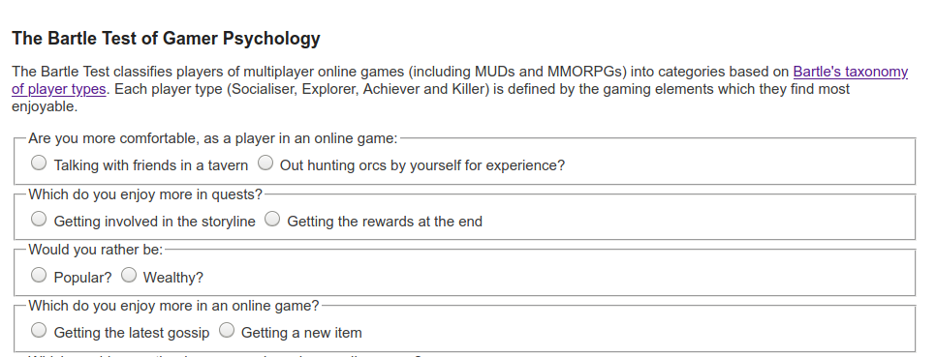}
The process was adapted so players moved to a different quadrant of the room based on their response to the question. The process allowed young people to see how their response differed from that of their parents. The process was very engaging and quite revealing. Parents responded that the process gave them new insight into the digital identities of their children.
After the results were revealed, I then proposed as facilitator that my observations were that there different game maker types. I read out the different types and asked them to place themselves in a two-dimensional grid based on their self evaluation of what kind of game maker they were. Other family members were then invited to comment to see if they agreed with this interpretation.
The process of exploring identity in this way surfaced the cheekiness of some young people and the pleasure they took in demonstrating their playful mischievousness. I began to make journal notes on this subject and talk to other games study practitioners. I began to ask the question can the surfacing maker types (as per player types) encourage awareness and celebrate the emerging practices that the community was producing.
As an example some layer created impossible or overly easy game levels. They appeared aware of implications for game balance but is taking pleasure in this seeming destruction of the key challenge of the game as an act of disruptive play. They seem to take pleasure from ignoring concepts of what should be done to maintain game balance and from the sense of shock from their current audience her parent. Going against this convention is a type of playful destruction in this context. The process mirrors play theory concept of playing against the game or dark play <Do Zotero Refresh: [@sutton-smith_ambiguity_2001]>.
Narrative summary of conflict
The conflict comprised of compounding factors and resulted in a lack of desire to complete coding activities before fully engaging with them.
In the initial stages some families struggled to reconcile the obstacles presented but their active participation in warm up games shows ….
INSERT SOME ANALYSIS HERE BASED ON AGENCY AND AFFORDENCES OFFERED
The next chapter explores responses to the aspect of identity in more detail.

2. Participant conflict due to lack of relevant technical support
2. Frustrating delays - Not enough support from facilitator/s: especially tech help - no dedicated documents, exiting docs not learner focused, coding process frustrating needing
The nature of this conflict stemmed from tensions surrounding and knowledge of coding and lack of access to relevant technical support.
The conflict was distinct from the previous one in that it related less to identity and alienation from the whole process and was manifested in periods of frustration and inactivity where participants wanted to progress but were unable to.
While tensions between lack of knowledge in how to undertake activities are common in learning environments, the informal nature of this learning setting made most classroom approaches unsuitable.
More social model of learning often propose social apprenticeship approaches.
In this setting there were limits to this approach due to the limits of my attention, and also limits in terms of my technical fluency in the details of the language and framework being used.
For example, to troubleshoot a code error might take between one minute and 10 minuted depending on the complexity of it. To work with participants to identify and then implement a new coding structure could take up to 30 minutes.
At times I was able to identify a discreet new code construct and to implement an example of this between sessions. At times I would attempt to do this in the group setting with varying results.
Based on group work with adults on creating media projects together I created an email group that all participants could post to to ask for help. However this option was hardly ever used taken up. I was given feedback from one parent that asking on for technical help via an email forum not something that they felt comfortable doing. The same family also gave useful feedback about social norms of not bothering people getting in the way of asking for help.
Thus other ways of addressing this conflict were called for.
The need to get started somewhere emerged - and the template was a response to that. Just an immediate, intuitive way to bring something to the table as a starting point to develop. The template was based on a prominent tutorial on the phaser website called Making your first game. https://web.archive.org/web/20180426051205/http://phaser.io/tutorials/making-your-first-phaser-2-game
As preparation for the sessions I had followed the tutorial. When the and adapted it. I removed out as much code as possible and thus simplifying the structure and readability. https://github.com/glitch-game-club/glitch-game-club/blob/master/games
Other interventions were called for directly by parents. Two relevant and relates requests happened at the end of P1.
One was a call for more hands on play and use of the tools of production before being called on to make creative decisions. The parent likened this to an studio approach. Another was a request for additional supporting resources which explained the coding structures used in accessible but detailed ways. A request which hinted at a more structured, instruction based approach.
However, interview data from participants placed great value on the flexibility of the approach which allowed participants to choose what they wanted to add to their game next.

Code Playground to overcoming lack of software feedback
One design principle explored in the literature review <Do Zotero Refresh: [@resnick_designing_2013]> in the use of creative coding tools was that of immediate feedback for participants. Code playgrounds provide such immediate feedback. For example, in the code editing interface of glitch.com shown in Fig 4.x, changes made to the code on the left section take immediate effect in the resultant game on the right side of the screen.

Changes made to the code on the left section take immediate effect in the right-hand preview window
Fig 4.x, Changes made to the code on the left section take immediate effect in the right-hand preview window
The a game template served to remove technical barriers to getting immediate feedback and offered other affordances explored in the next section.
Structuring a game template
In response, at the start of P3 I further adapted a game template used in a Phaser tutorial and other techniques I had encountered in similar resources. Thus, the learning design started to follow the Use-Modify-Create model to build familiarity with and to scaffold the adaptation and use of coding constructs <Do Zotero Refresh: [@lee_computational_2011]>.
DESCRIBE IN MORE DETAIL THE AFFORDANCES?
FIND MORE ON BLOCKS ETC EXAMPLE OF CODE STRUCTURE? - USE OF PHASER 2? - BLOCK SIZE TO MATCH PISKEL
In line with this research, I posited that using a starting template would to increase speed and consistency of feedback from learner input, reduce coding syntax knowledge needed to progress, and thus reduce learner anxiety for novices. This approach responds to the feedback from the participant that greater time allocated to hands-on use of tools before making design decisions would be welcome.
The impact of this starting template in the P3 and P4 sessions is explored in the following chapter in greater detail.
Linear and stand-alone tutorial and code snippet resources
I struggled to resolve how best to provide support coherently in a way which met the tension of providing background concepts and explanations of coding constructs to those that wanted it.
I began by creating discreet code examples and then tutorials of how to add new elements to the starting game template. Code examples the first resources created. As explored in the literature review, the use of code examples or snippets is a common professional problem solving practice. They allow users to see the behaviour in context with the code and output side by side. While code examples existed on the Phaser website, their use there is not consistent or structured for novices. As with many developer created documentation, focused on demonstrating the code constructs in isolation rather than in the context of any particular game.
So instead, I began each code snipped with a very stripped down version of the starting 2D platformer game template and added the code examples within this code framework. Ideally each pattern added builds familiarity with the code structure.
For each code example I created a text based step-by-step documentation. While the collection of tutorials took the form of chapters of an online book, readers were encouraged to tackle them in any order. In practice each chapter was printed out for participants and linked to from the list of code examples. Thus rather than choosing a defined order readers could choose which order they wanted to add game elements.
While writing self-contained tutorials added a challenge to the documentation authouring process, the documents, especially when printed became a vital resource for this community.
However, as these tutorials took as a starting point the code of the starting template and did not attempt to explain that, they did not however resolve the issue of participants wanting resources that explained these core constructs and underlying concepts.
Meeting yourself in the middle
Thus I created opening chapter of the online manual which were more traditional in format and contained foundational knowledge. I wondered how to best frame the relationship between these chapters and the self-contained ones described above. In practice, as user had started with a template game that is already up and running, to use this resources which would have involved backtracking.
I named this concept meeting yourself in the middle to represent the possibility of retracing the process of learning from first principles. The key concept here was that after making the game from a template, these foundational chapters resources are available at any time to explain all underlying concepts that the starting template had initially abstracted away from the participants. Thus the process would have value to reinforce computing concepts present in the design. Narratively these chapters form the equivalent of a prequel for readers interested in the full story.

Tensions and related to navigation of various documentations sources
The previous stage had created a variety of supporting documents and processes. However at the start of P3 I still had not managed to devise a system to communicate these options consistently and effectively to students. My initial attempts were a list of code examples in a shared google document and printed out self-contained chapters.
Thus, there were two main ways of approaching adding a new pattern. One to examine a code example which was built around the same code base. This would involve searching for new code constructs and notes in the code designed to orientate the learner, alerting them to the location and purpose of the relevant code. It is this approach that we see the child Toby adopt in the vignette presented in this chapter. The second approach was to use the longer form step by step help.
Using of a collection of game design patterns
while these resources were developed in response to one conflict they introduced new tensions. Specifically, users found the navigation of the resources, finding the right resources online was initially confusing. As such this barrier was in turn mitigated by printing step by step tutorials.
In addition, I decided to create a web page using the same technology and hosting systems that housed the template game and remixes of participants to at as a navigational menu for the collection of code examples that had been created. For easy of navigation I also included the starting template and a link to the online book of step-by-step resources.
Learning resources linked to game design patterns were presented in a grid format with images that focused on the player experience rather than underlying coding constructs.
My motivations driving this design work were to mitigate potential learner alienation from unfamiliar technical documentation through accessible and attractive design and to relating documentation to participants existing gameplay experience.
Tactical structuring of the pattern collection
In trying to organise and represent code examples to participants in a logical way I drew on existing frameworks of game elements. Initial design were just in response to grouping participant requests.
I noted that some of these were aesthetic in nature for example; the graphical representation of game characters; adding sounds; and adding background images. Others are described in professional literature as game mechanics including: jumping on enemies; finding a door or flag to progress to the next level; and collect all food before progressing to next level. Others concerned other fundamental aspects concerning game space like the size and shape of game world and adding new levels the game.
I experimented with different categories and themes to contains the emerging game elements. I also explored the concept of mapping the different challenges by difficulty on a map via structuring via concentric rings. In contemporary journal notes I also explored the concept of open-world approaches to structuring resources and helping learners navigate the learning experience based on choosing challenges based on their interests and appropriate difficulty levels.
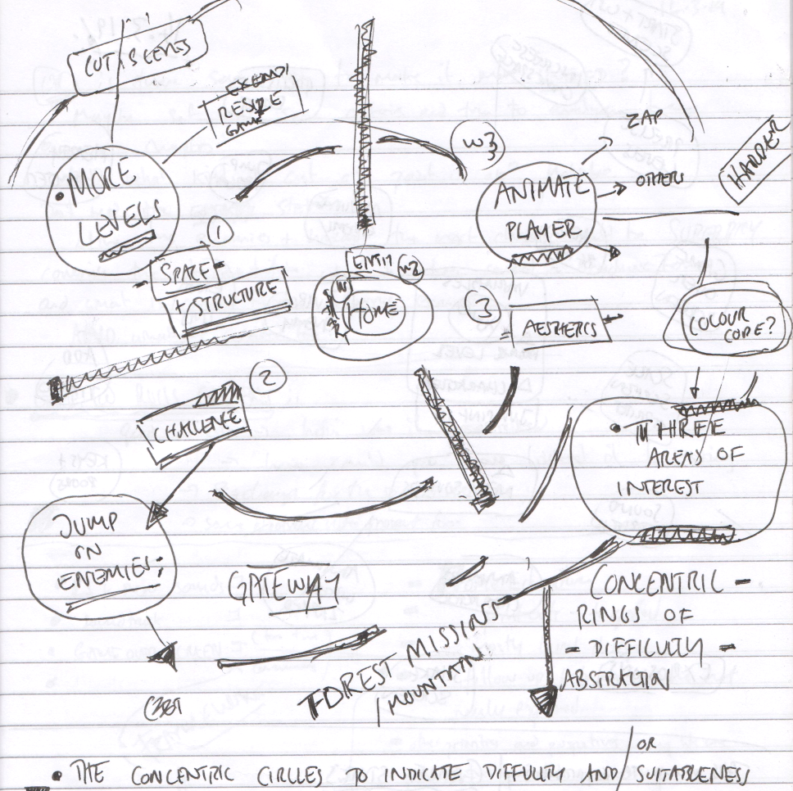
Scan of Journal Sketch of early attempt at dividing features by type and difficulty
Fig 4.x. Scan of Journal Sketch of early attempt at dividing features by type and difficulty - Dated 11.3.2019
The process of sketching, revising and re-sketching the elements led me to connect this process of categorisation with the work of game theorists. I had previously used collaborative analytical techniques which drawing on academic and professional interpretations of game elements <Do Zotero Refresh: [@salen_game_2006; @schell_art_2008; @tekinbas_rules_2003]>. These had been developed for use in youth-oriented Game Jams to help novice game makers hack/analysis and then adapt key elements of non-digital games, and thus build participants use of language of game design concepts before engaging in digital making <Do Zotero Refresh: [@cornish_game_2018; @institute_of_play_gamestar_nodate]>.
In my adaptation I had asked participants to do play a number of retro arcade and console games and then to complete created a printable A3 hand out which was given to participant after playing The key elements I are:
- SPACE: Where the game takes place.
- GOAL: What is the objective of the game? What are you trying to do?
- COMPONENTS: What are all the objects or actors in the game?
- MECHANICS: What actions take place in the game. What are the verbs involved?
- RULES: What can or can’t you do in the game? What defines boundaries? Does play happen in real time or do you take turns?
This work also aligns with the MDA framework. I was drawn also to this framework due to the similar focus to the user experience which has potential to make the process of analysis games more accessible <Do Zotero Refresh: [@olsson2014conceptual]>.. I then took the existing list of game elements that have been identified by students and categorised them based on a blend of these two frameworks. I made some simplifications and adaption to increase accessibility for non-professional and young people. For example, the term of aesthetics is very wide and suited simplification game polish.
I introduced the following framework for P3 which we retained for P4. There were three colour themed categories of missions which existed in addition to the core challenges of the home templated game. Game mechanics are features to do with the actions of the game. Game space patterns address the layout of the game. Game polish patterns involve adding music, backgrounds, graphics and story elements.
In P5 I extended the scheme to included System and Challenge patterns. These explore at how different elements interact to create challenge in the game.
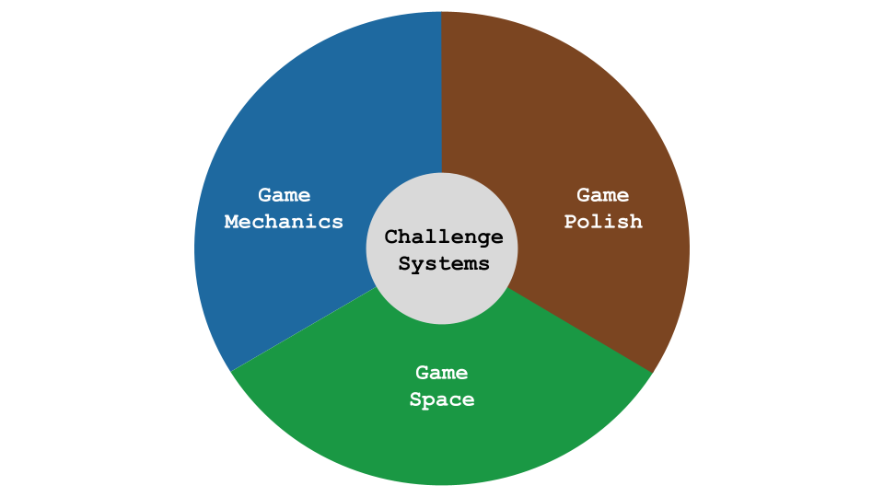
Game Design Themes
This section has explored detail of different themes the game pattern collection.
This structure chosen to present support materials to participants mirrors and potentially reinforces the framework used initially to analyse game elements. While the process of games analysis has limited research for novice game makers, it is not the the field of learning text coding. Similarly this outcome of theming the patterns by function and and difficulty to help build community game making activity and knowledge aligns with the work by Holopainen and colleagues on the use of pattern collections to help structure game making for adults <Do Zotero Refresh: [@holopainen2007teaching]>.

3. Facilitator conflict addressing the Play Paradox
NOTE - MOVE THIS TO TWO? OR TO ONE? SO END WITH TWO WHICH CREATES A TRANSITION TO THE NEXT CHAPTER EFFECTIVELY.
This section addresses my interventions to resolve the play paradox between learner expression and choice and the curricular contents. CHECK IS THIS PREVIOUSLY EXPLORED?
I adapted and extended resources to suit use in more formal learning environments, e.g. particularly a secondary computing classroom.
This conflict provoked me to create resources which could serve to pull participants towards more curricular goals. However, for these learners I did not introduce the resources consistently. This inaction on my part has been is helpful to provide a clearer the focus of this study on the possibilities of informal spaces.
SIGNPOSTING WHY THIS SECTION IS USEFUL HERE

Using Physical Maps of Missions as Game Design Patterns - COMPRESS
I printed out a large-scale colour map of a coastal landscape stylised in a way that mirrored a map used for navigation in a quest-themed computer game. As learners traced a trail between the different island/missions they had visited, the map provoked learners to reflect on their journey and progress. However, this approach may be too labour and time intensive for many class environments.
The game pattern missions were represented as different islands . Learners took time to create and personalise a movable marker representing themselves. When learners selected their next mission, they moved their counter to the relevant island. Thus learners had to be intentional about their next goal and were implicitly encouraged to stick to it. They also kept a track of the missions that they had completed by tracing a trail as they progressed.
In addition the colourful, physical and visual representation served to encourage a sense of community and peer learning. When moving the counter on the map I prompted them to reflect on the coding concepts or other learning dimensions that they had been working with.
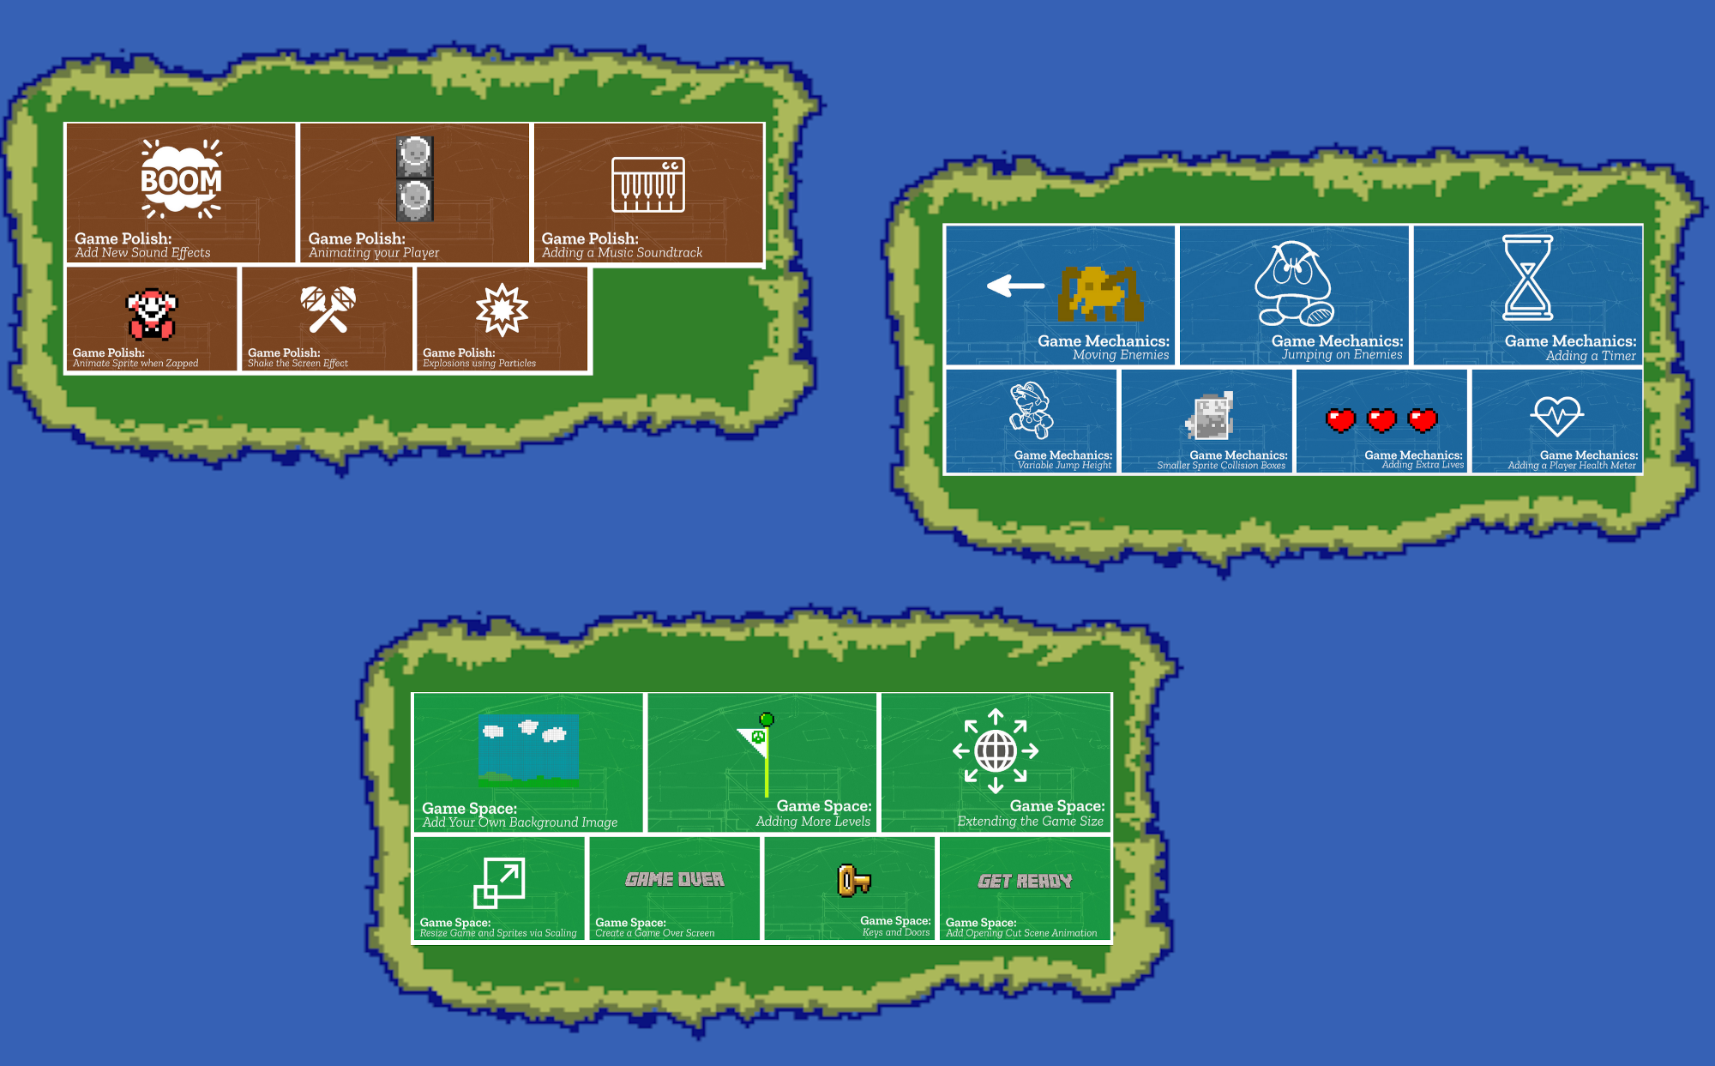 learning islands Missions as Islands
REPLACE WITH 360 OF MAPS
Lack of reflection and moments to reinforce what is being learnt. To support younger coders unsure what to do next or who struggle to stay on task, I sought to create another kind of map to help them navigate their game making journey.
Learners take on features which are too advanced or complex for their current coding level. The use of a physical map on which GDP were arranged aimed to communicate which patterns were more complicated to implement. Starting patterns limited the maximum complexity of missions and present patterns to encourage learners to start with ones that involve simple code changes but return a large change in terms of gameplay experience.
I have de-prioritised Maps as an area of study in this thesis partly this is due to it well explored in other research []FIND SOURCES, and partly as the implementation was patchy as I concentrated on more narrative and in person reflection (see later chapter on Methods)
MOVE LATER? FINAL CHAPTER? It is of value to out like key tensions in the design that maps have the potential to address in more formal teaching environments. I am currently investigating replicating the use of maps process using online tools to reduce complexity and preparation time. This theme is also explored later in this section.

Learning Dimensions Map
In learning environments where there is a lot of choice assessing learners via observation is beneficial. Rather than deciding what you want to teach and testing students on that area, you can map the learning happening in an authentic activity.
When researching hands-on tinkering in Science museums Bevan and Petrich <Do Zotero Refresh: [-@petrich_it_2013]> worked with educators to examine video footage of families interacting with exhibits to make a structured list of the learning they observed. The resulting map of learning dimensions included underlying science concepts but also contained more general skills and helping behaviours involved in exploratory learning processes.
// REWRITE FOLLOWING
One of the outcomes of my research was to extract some of the concepts and practices that learners engaged with when making games from hours of recorded material. While some are common to existing Computational Thinking frameworks others, including systems thinking concepts, are more unique to game making. Table 4.x. shows my resulting map of learning dimensions for the 3M game making model.
Coding Concepts | Systems Patterns | Design Practices
Sequences | Systems Elements | Goal Setting
Variables | Systems Dynamics | Being Incremental and Iterative
Logic | Reinforcing Feedback Loops | Developing Vocabulary
Loops | Balancing Feedback Loops | Web Navigation
Arrays |  | Problem Solving
Creating Functions |  | Version Control
Change Listener |  | Debugging
Input Event |  | Reusing and Remixing
This process of mapping such frameworks may be overly time-consuming for many full-time teachers. However, teachers may also use and adapt existing maps and frameworks based on their own classroom experience to help their observation of students. Because these frameworks can also help students to navigate their own learning journey the effort serves a double purpose.

NOTES ON TENSIONS WHICH THIS LEARNING MAP HAS POTENTIAL TO ADDRESS
THIS SECTIONS NEEDS DEVELOPMENT
Teacher stress if they are not able to support a very diverse set of features demanded by students working on diverse kinds of games.-
Limit the type of game to one kind. Offer a significant but limited menu of missions that users can add. Offer written and visual support documents which learners can access independently of facilitators
Facilitators may need to justify learning happening and struggle to see this in-situ if unfamiliar with the game making process. This may restrict openness of activities to better assess and support learning. A map of learning dimensions flexibly linked to main missions/patterns can be used by both learners and facilitators.
tension adapting resources to a curriculum environment There were some additional changes in the way that design patterns were presented to learners mirroring design patterns on other domains including: name; need ; related patterns. In addition related concepts in computational thinking and design processes which are promoted as part of the recent computing curriculum were included and linked to a learning dimensions map.
In addition, material which mapped and explained learning dimensions including design skills and computational concepts were included in the participant support resources.
Addition of a Game Challenge section
I wanted to explore the possibility to use this model to explore systems thinking. There is precedent to do this in GSM.
It was driven in a response to meaningful missions which helped guide a focus on game play.
I created such missions (outlined in Methods chapter) Added game design patterns based on challenge - find source Schnell & GSM literature (their terminology is Game elements) And then updated the learning map to highlight potential concepts to be learned.
Systems concepts are embedded in many games but the process of direct teaching of such systems can be complex and interrupt and distract from other design activities.
Systems related missions were designed. (If so not clearly tested) Challenge section in particular mirrors systems concepts.
Extra missions which highlight game challenge and user experience may help learners to explore systems concepts within the game context

Limits to the learning dimensions map in an informal setting
This map was designed to link with particular conceptions of learning whilst still retaining a sense of the uniqueness of the affordances of this design. The settings are, CT in school curriculums, systems thinking, design approaches. These align broadly with a STEM approach. The rationale behind this is that Game Making commonly aligns with these curriculum areas and they are particularly suited to explore via iterative game making.
The process of developing the learning dimensions map was helpful for me as a researcher in that it helped decided to keep the focus on this study on more informal and organically evolving processes. This emerging perspective also developed as I read underlying ontological approaches to the socio cultural understandings of learning which problematise the separate of the content to be learned
While I attempted to resolve this by adopting Bevan and al’s observational approach, the process of making this more relevant and recognisable for UK teachers arguably drew me off course. This theme is explored in detail in the next two chapters.

Conclusion

Summary of barriers exposed in this study
A summary (table or text) of the barriers and tensions exposed in interviews and in journal observations and in feedback from participants. Perhaps linking to appendix.
Return to this table https://docs.google.com/document/d/1DRgpgIUfq5XIktYy-lX4WlviUDnffNc0v8SOeLGgHho/edit or this one https://docs.google.com/document/d/18HrRPPx0-fj3PXVJTAf2dzYNTBSYGikpV_U0hu46r2c/edit
NOTE - THIS IS NEEDED FOR LATER CHAPTERS

Discussion on the emergent (and mutual) nature of the design (and reseach?) process.
As explored in chapter x , the process of this chapter is in line with (participantory design and DBR) perspectives approaching research with an open remit to see what tensions come into focus in a particular setting.
This allows a subsequent refocusing of research to explore these emerging issues in more depth.
The most significant manifestation of this process is in the evolved of the learning design and resources.
Resources had with concrete additions from parents, PGCE students, Edlab students, University colleagues and with more indirect ongoing feedback from young people and their parents.
With guidance, PGCE students created printable resources that highlighted particular key lines of code and variables that had a high impact on the game experiences. These include changing gravity, altering the player speed, background colour of the game and the game layout of the platforms, hazards and food to collect. This approach was more prescriptive than I would have adopted, however it worked well. I then made a connection to UMC literature.
NOTE - INSERT RESPONSE FROM COMMENTS FROM CATHY.
The particular nature of the setting is significant. It holds promise to generate resources more generally. Something explored in conclusion.

Link to next chapter
This chapter has dealt with the evolution of design in initial phases and responses to learner experience to resolve tensions. A key focus of this chapter has been relatively micro - barriers to computer coding and use of particular software - drawing on and aligning with the HCI literature and existing work which exposes problems of learning programming syntax.
Pivot to next chapter,
- This chapter is limited in the video data and close exploration of the
- In analysis of data from video other more social factors were given priority - based on the key interests of this study
- Returning to Rogoff’s 2 lenses, while this as focused on a personal, the next is social and the one after is more cultural in nature.
Chapter six explores the delivery and start to explore the impact of the process drama used and emerging community processes.
As explored in literature review the possibility to change and to play with identity is important in the work of Gee and ITO, who explore the role of the design of games and the surrounding communities that build up around games to support an nurture the development of player identities. The process is shown to have beneficial effects in supporting the creative process. In a similar vein, drama processes like the mantle of the expert are designed and enacted by facilitators in ways which allow participants to draw on their existing knowledge and encourages them to put this into practice in fictional scenarios.

