
St. Michael and All Angels Churchyard - Connections with Nature
1 Welcome to the church of St Michael and All Angels. In 2022 the Parochial Church Council (PCC) decided, with the encouragement of our Parish Priest, that the church should take up the challenge set by Justin Welby, the Archbishop of Canterbury, when he said that "responding to climate change is an essential part of our responsibility to safeguard God’s creation”. An Eco Group was set up to advise the PCC on how things might be changed for the better at a local level at this church. Since that time many small actions have taken place which all added up to our receiving the A Rocha Eco Church Silver Award. This trail takes you on a short journey to see those changes and what effect they have on our small corner of the world.



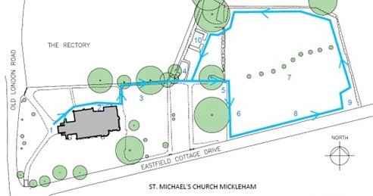
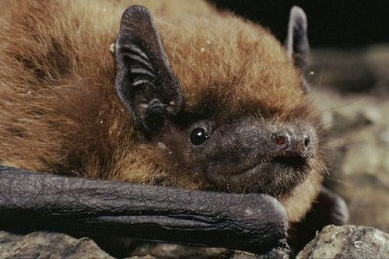
2 We have discovered that bats really do inhabit the belfry! Four species, Serotine, Common Pipistrelle, Soprano Pipistrelle and Brown Long-Eared all inhabit the church and have been recorded both flying about in the church and also emerging from the roof at dusk - the uneven nature of the tiles make for small irregular holes through which the bats easily pass. These tiny mammals (pipistrelles weigh about 5 grams, the weight of a twenty pence piece) are a highly protected species and we count ourselves fortunate that they seem to like our place.

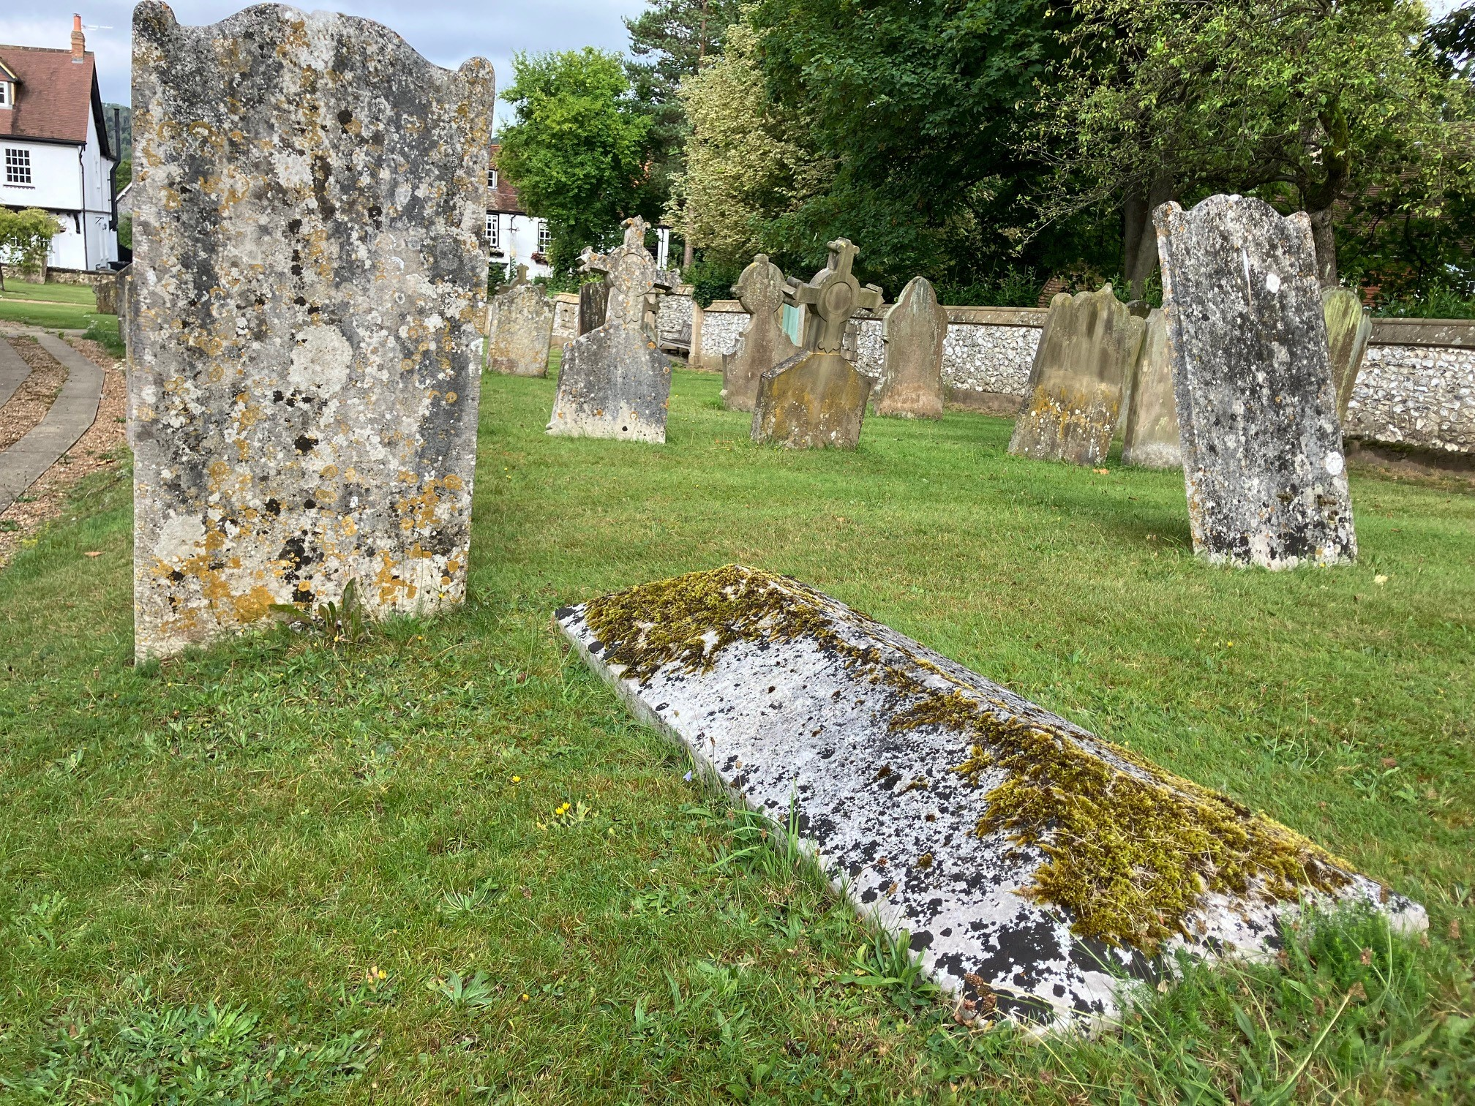
3 The churchyard that surrounds the church is full of ancient graves with their headstones and tombs. These features of great character and age have accumulated lichens which are plants formed of a symbiotic relationship between a fungus and algae. In all a staggering 251 species of lichen have been found in the churchyard, some, those found on elm trees for instance are no longer here, but it is still an important site for these organisms. The area to the rear of the church is only mowed twice a year to allow plants to flower, set seed and provide nectar and pollen for insects.

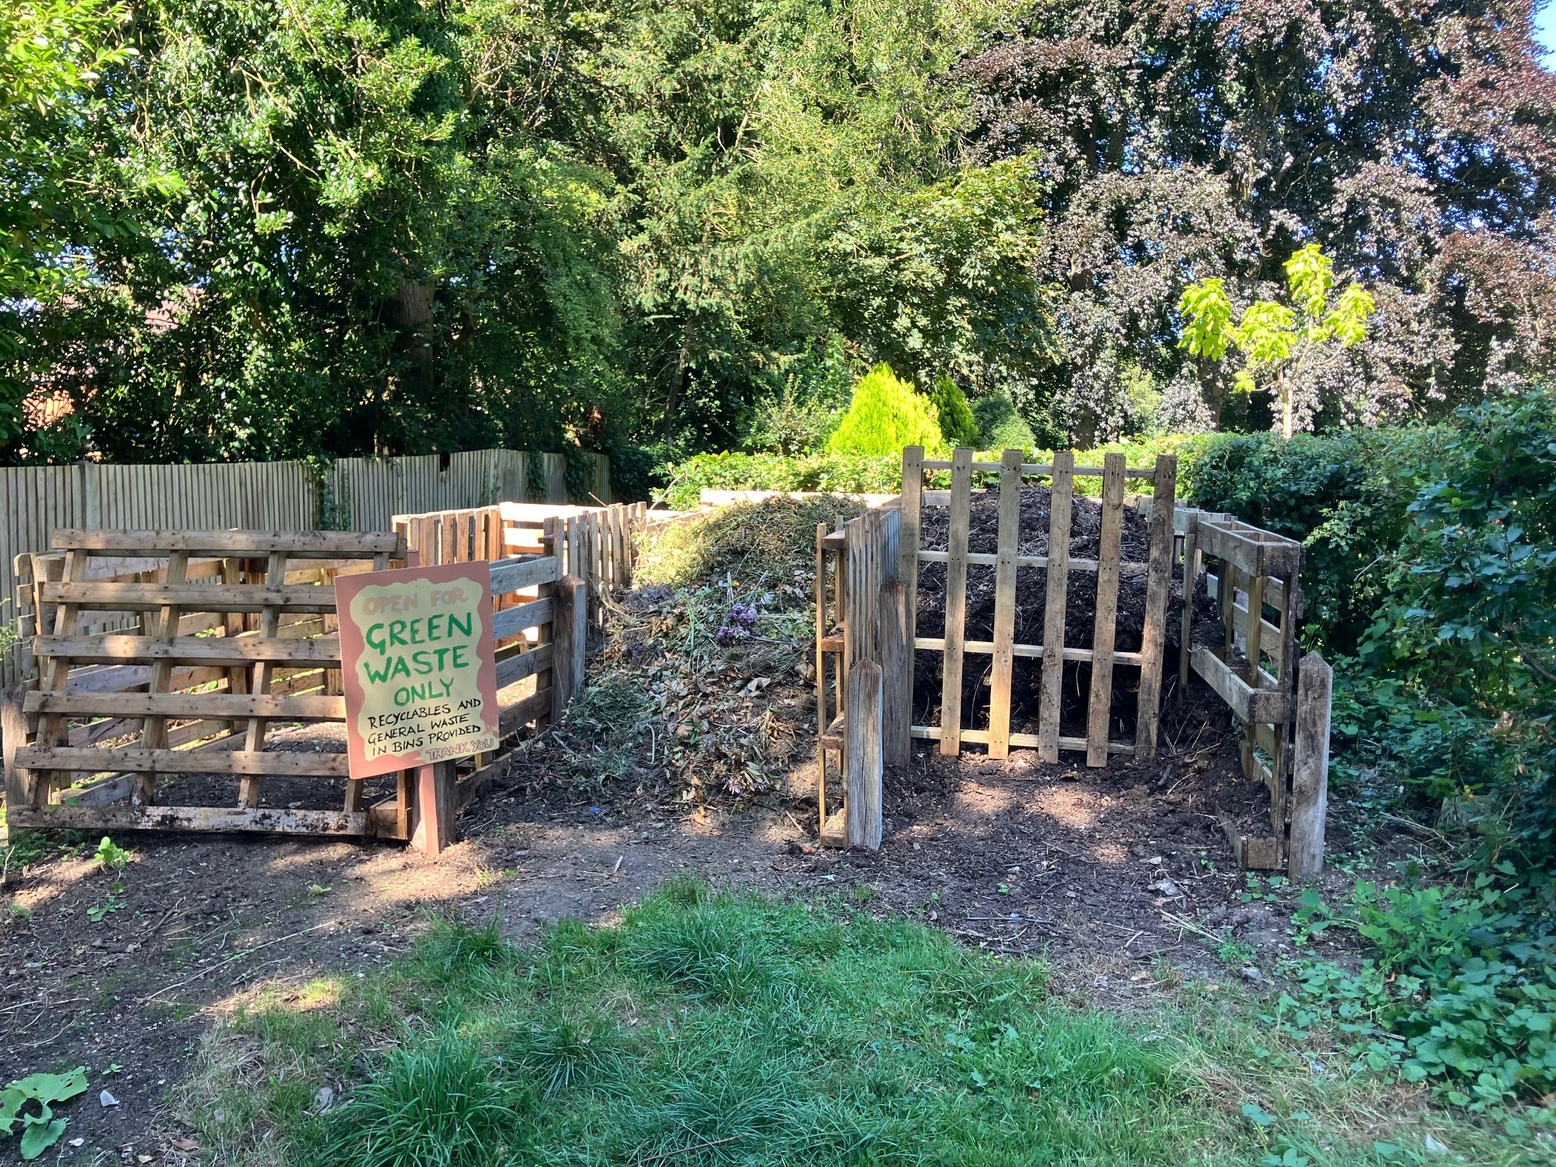
4 The compost area has been reorganised, so that all green waste can be turned into good soil and then returned to areas within the churchyards. You can see one bay that’s almost ready to be distributed and one bay that is still being filled. The empty bay is waiting to be filled. We have bins for recyclables and general waste. We have tried to phase out plastics as much as possible, for instance we no longer use the foam called Oasis made of bonded plastic beads used to hold stems in flower arranging. Instead, all our flower arrangers have been trained to use crumpled chicken wire to hold stems in place - a simple but effective alternative.

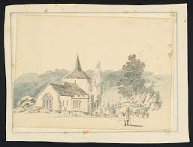
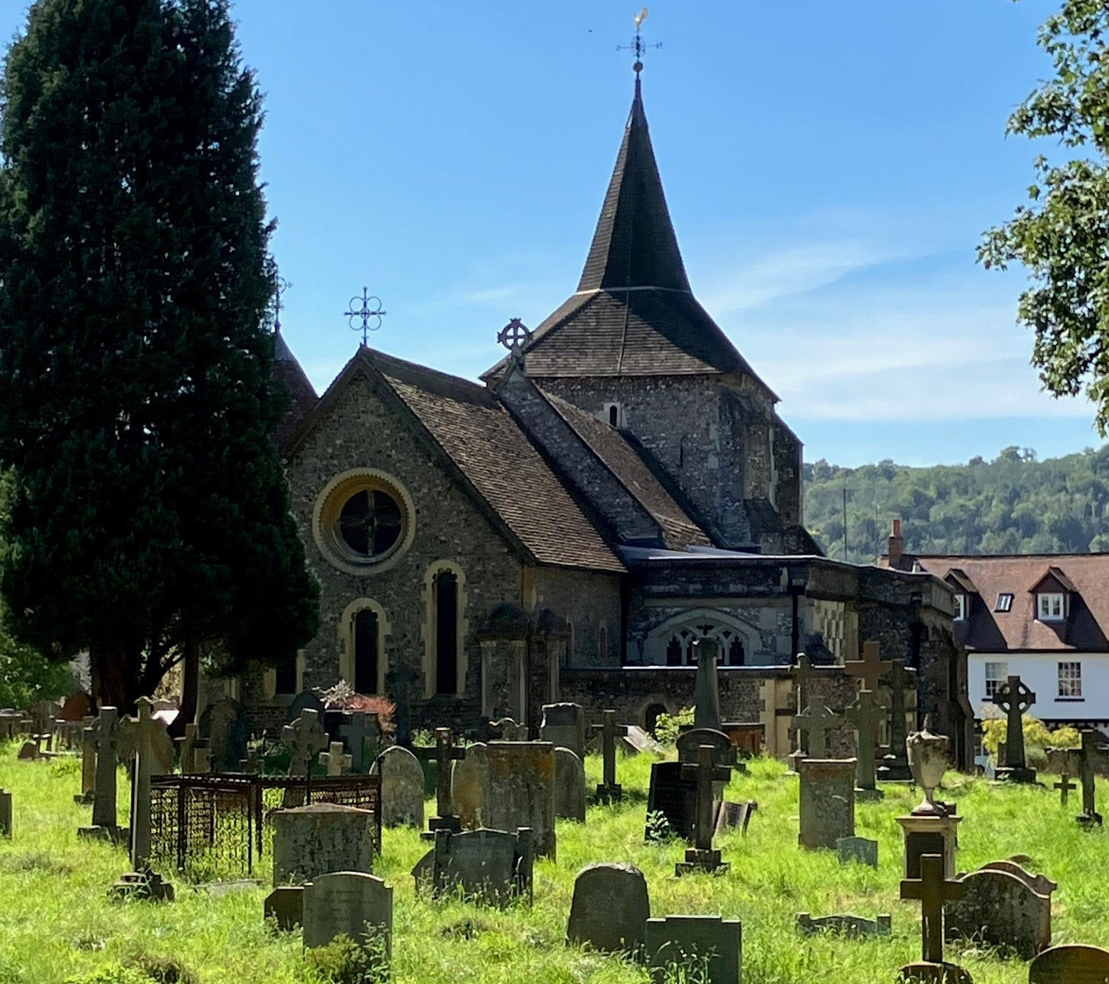
5 The church and churchyard have always been popular with visitors and sometime in c1796, the great painter J M W Turner sketched Mickleham Church from about where this bench sits. It is described by the Tate as 'pencil and grey and grey-blue wash on white wove paper’.

6 A small orchard of fruit trees was planted in the winter of 2022/23. All native British cultivated, it’s a mixture of apple, pear, damsons, quince and medlar. The cages are to protect the young trees from wild deer who tend to strip the bark when very hungry and also when shedding the velvet from their antlers - known as ‘fraying’.

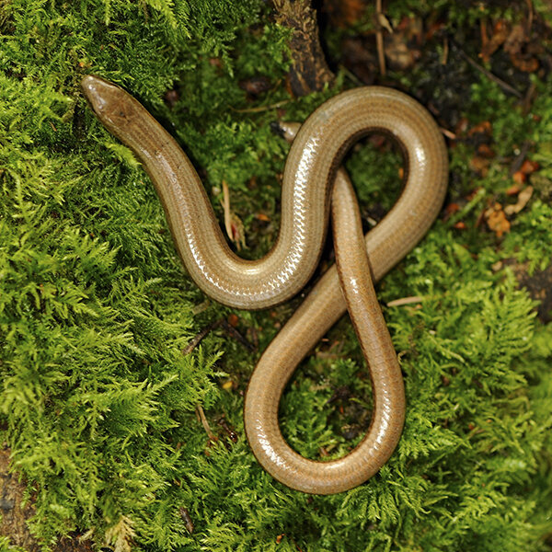
7 This area is the new churchyard, which extends the burial area. We have a policy here of mowing and raking up on a three year cycle - one area is mowed each year in rotation. The raking up is very important to remove the smothering thatch after it has been mowed and expose bare areas into which seeds of flowers may germinate. The grasses are dominant in this area at present, but we hope that our policy will gradually lessen them, and flowers increase. The two areas left unmown each year provide shelter for small mammals and allow insects in particular to complete their lifecycles undisturbed. The whole churchyard has a great number of slow worms present - these golden snake-like creatures are actually legless lizards and mainly eat slugs, worms and some insects.

8 The hedges around the new churchyard have all been recently planted and will form ‘green corridors’ along which mammals and birds will pass. In time they will be a great natural asset.

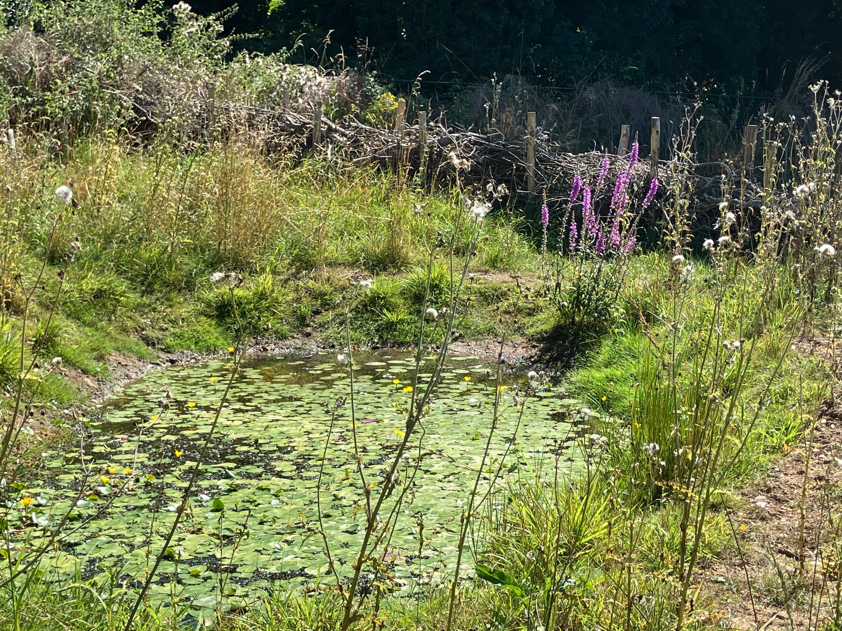
9 The seasonal pond was created this March and is already a haven for dragonflies, damselflies and pond insects such as the pond skater which by virtue of its widely spread legs and water repellent hairs actually walks on water - a very apt creature for a church! Water is essential for all life and this pond also supports birds and we even spotted a fox coming to drink one day. The pond will be filled solely with rainwater and may dry out in hot summers - this occurs naturally in the wild and animals and plants are adapted to this ’seasonality’.

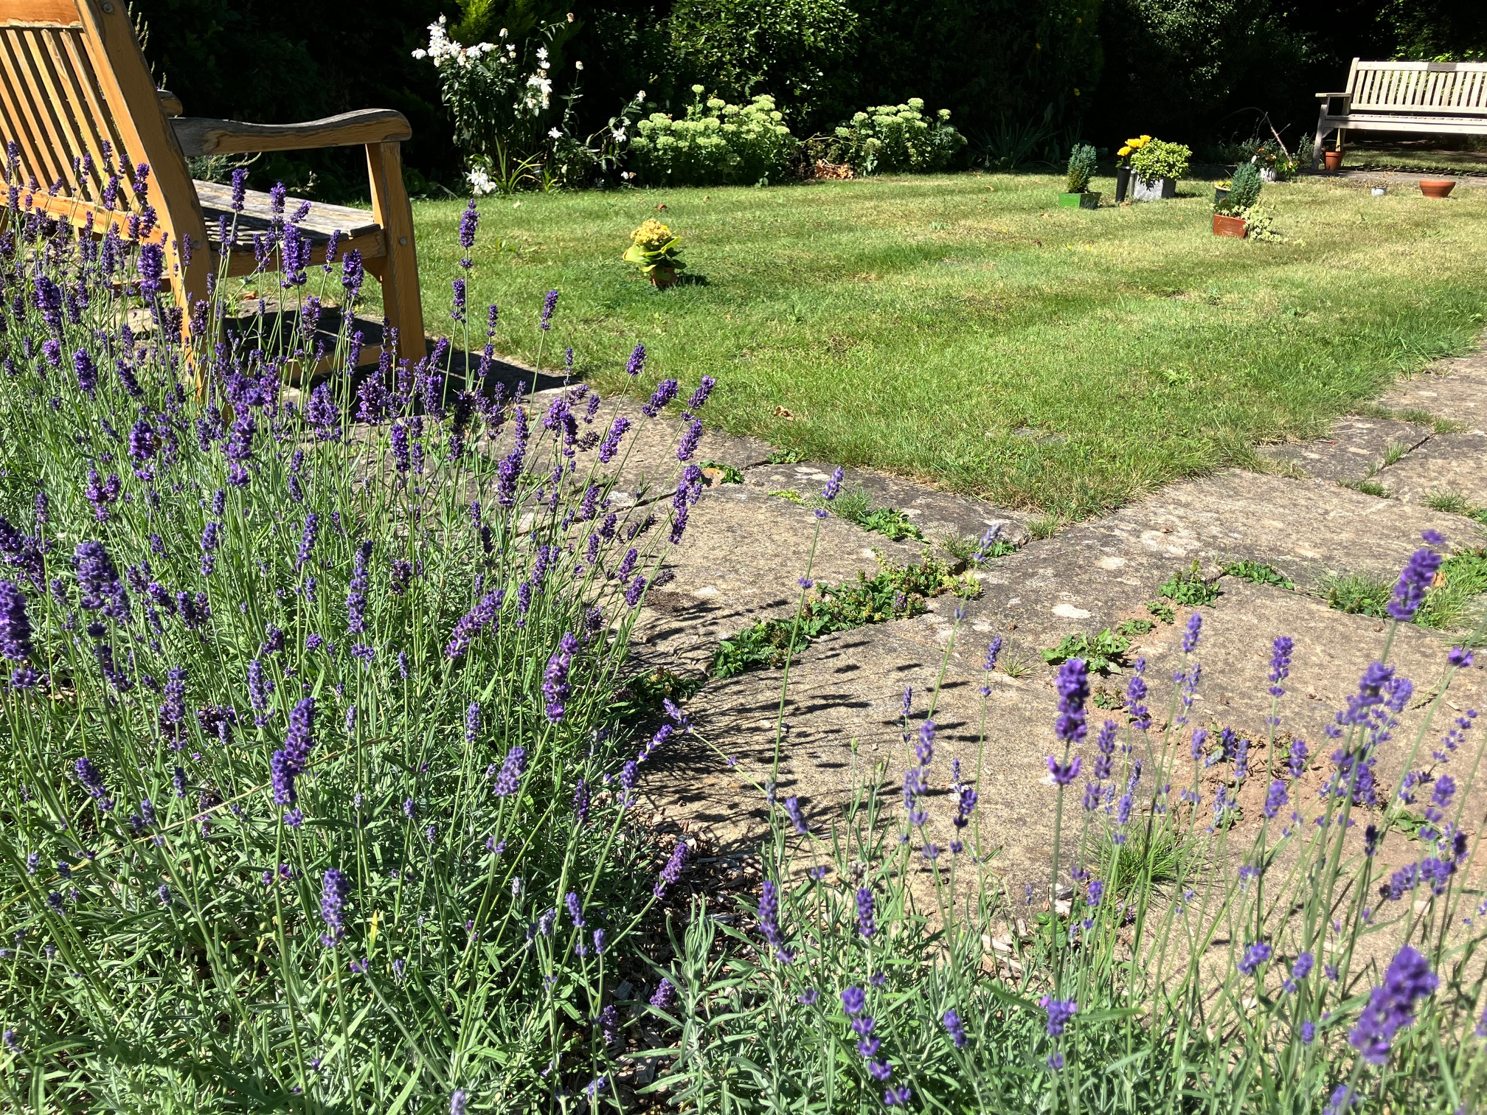
10 The Garden of Remembrance in which ashes are interred has been planted round with Lavender and Rosemary which will provide a regular source of nectar for insects during the summer. The low box hedge which formerly bordered the garden sadly succumbed to box blight and caterpillars. We will keep the plants trimmed and shaped to frame the formal and reflective nature of the Garden. We have phased out the use of herbicides in the churchyards and replaced the control of plants where needed with a weed burner - this is highly effective and is used to keep the paving slabs free of encroachment.

Thank you for your time, we hope you have enjoyed this short tour.
For more information, please contact churchwardens@micklehamchurch.org.uk
Printed on recycled paper

