Creating Beauty, Sustainably
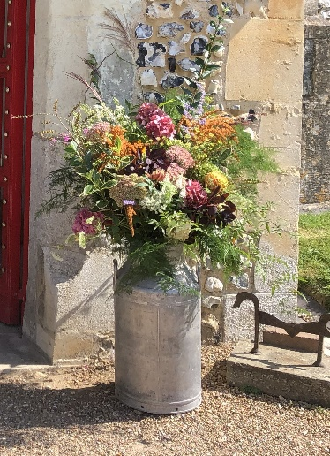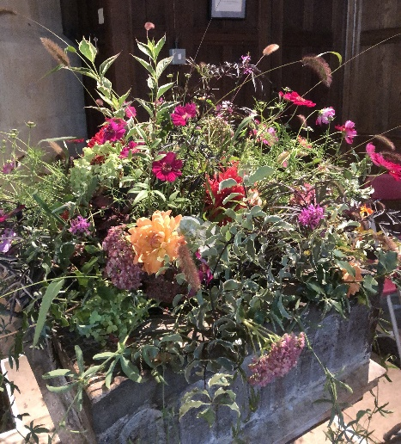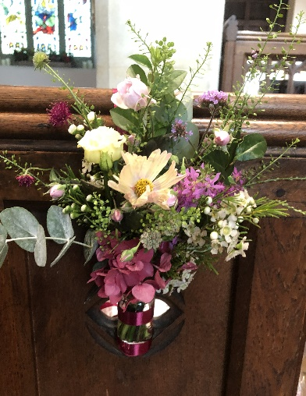
The parish of St. Michael and All Angels embraces sustainable church flowers, meaning that for our regular and occasional services we encourage the sourcing and use of seasonal, local flowers and foliage, and eliminating the use of floral foam.

Flowers are an integral part of many life events; they have a language of their own and, if arranged sensitively, will enhance the overall event experience for everyone, whether they are noticed or not.

It is important to this parish and church community that we keep to a minimum the environmental impact of all our services and events, therefore we encourage a mindfulness towards that impact with everything that is used including all flowers and their design.

We are pleased that you have chosen to hold an event in this beautiful church and would request that no floral foam (brand name Oasis) is used in the arrangement of your flowers. Flowers do best arranged in water; for a variety of sustainable mechanics to support the stems, see the website of Sustainable Church Flowers https://suschurchflowers.com/ which has lots of photographs and videos to instruct and inspire, and which explains why the use of floral foam is so harmful.

Increasingly, flower suppliers and floral creators are willing to have conversations about sustainability, including the provenance and airmiles of their produce. In making these enquiries you play an important part in highlighting the environmental impact that the floral industry has, and you help create a conversation open to positive change.

If you would like to discuss church flowers for a special occasion or find out more about local providers please email Alison Wood at flowers@micklehamchurch.org.uk or telephone her on 01372 376443.

N.B. The use of flowers in church during the seasons of Advent and Lent is discouraged. If you are planning a wedding during either of these seasons, please ask your Wedding Co-ordinator for more details about what might be appropriate.

