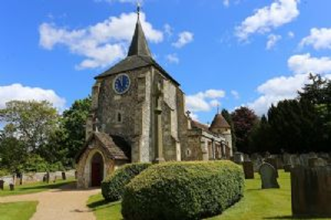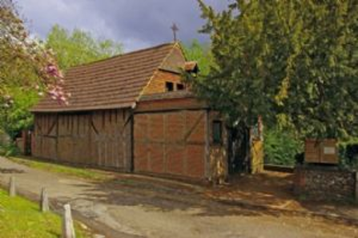
The following Policy was agreed by the Parochial Church Council (PCC) in September 2026

1. Purpose and welcome
St. Michael and All Angels church, Mickleham, gladly welcomes enquiries about baptism for children and adults. Baptism is a significant step in the Christian faith and marks a person’s welcome into the life of the Church. This policy sets out how baptism requests will normally be considered, prepared for and arranged.

2. Who may be baptised
Baptism will normally be available to those who live in the parish, belong to the church, regularly worship here, are on the electoral roll, or have another recognised connection with the parish or church. Where someone does not meet these normal criteria, the clergy may consider the request where there is a strong pastoral reason. Where appropriate, the consent of the candidate’s own parish priest or incumbent may be obtained.

3. Preparation
All candidates, and in the case of children their parents or carers, will be offered appropriate preparation before the baptism. Preparation should help those involved understand the meaning of baptism, the promises made in the service, and the place of baptism within Christian faith and the worshipping life of the church.
Parents or carers bringing a child for baptism should be able to make the baptism promises with integrity. Godparents are welcome to take part in preparation where this is possible.

4. Baptism of children
For the baptism of a child, parents or carers will be involved in both the preparation and the baptism service. Before a baptism is arranged, St. Michael’s expects the family to attend several church services so that they can become familiar with, and connected to, the worshipping life of the church.

5. Godparents and supporters
Godparents are chosen by the parents or carers and must be baptised. The usual expectation is that there will be three godparents (ideally two of the same sex as the child), with flexibility where appropriate. The minimum number is two and we suggest a maximum of 6. If someone chosen to support the child is not baptised, they may be included as a sponsor or may consider baptism themselves before the service.

6. Baptism of adults and older candidates
Adults and older candidates seeking baptism will receive preparation suited to their circumstances. Where appropriate, baptism may be linked with preparation for confirmation. Two or more sponsors may be chosen.

7. When and where baptisms take place
Baptisms take place during the main Sunday morning service, usually during the All-Age Worship service (held on the first Sunday of the month), so that the adult or child being baptised may be welcomed by our church family. Other times may be arranged where there is good pastoral or practical reason, but only with the agreement of the clergy. Under these circumstances it is expected that the baptised person or child would be welcomed at the main Sunday service on a separate occasion.

8. Thanksgiving or blessing
Where baptism is not possible, not desired, or not yet the right step, the church may offer a service of thanksgiving or blessing. This provides an opportunity to give thanks, pray for the child or candidate, and mark the occasion without the baptismal promises.

9. Booking and pastoral responsibility
Initial enquiries and bookings should be made through the parish clergy or parish baptism officer. The clergy are responsible for agreeing arrangements, ensuring that preparation takes place, and deciding how any exceptional circumstances should be handled.

10. Ongoing welcome and support
After baptism, the church will continue to welcome and support the person baptised and their family through worship, teaching, pastoral care and appropriate information about church activities. Families and candidates are encouraged to remain part of the worshipping life of the church.

Dated: September 2026

