Name:Vishal Chauhan
Prn:2020BTECS00090
SUB:Ai-Ml
Ass-8
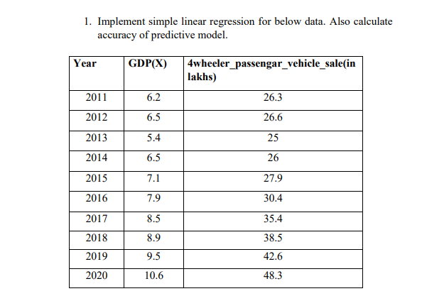

from sklearn.metrics import mean_squared_error
import numpy as np

class Simple_Linear_Regression():

"""
Class to calculate simple regression
"""

def __init__(self, X, Y):
"""
Constructor:
Args :
X (list) : input value of feature
Y (list) : corresponding output values of feature.

"""
self.input = np.array(X)
self.output = np.array(Y)

self.mean_x = sum(self.input)/len(self.input)
self.mean_y = sum(self.output)/len(self.output)

self.mean_sq_x = np.dot(self.input, self.input)/len(self.input)
self.mean_xy = np.dot(self.input, self.output)/len(self.input)

self.a1 = (self.mean_xy - self.mean_x*self.mean_y) / \
((self.mean_sq_x) - (self.mean_x)**2)

self.a0 = self.mean_y - self.a1*self.mean_x

def calculate(self, x):
"""
Main Method:
Args:
x (float) : value of feature
Return:
output value of class y(float)
"""
return round((self.a1 * x + self.a0), 2)

# inputs = [6.2, 6.5, 5.4, 6.5, 7.1, 7.9, 8.5, 8.9, 9.5, 10.6]
# outputs = [26.3, 26.6, 25, 26, 27.9, 30.4, 35.4, 38.5, 42.6, 48.3]

inputs = [1, 2, 3, 4, 5]
outputs = [1.2, 1.8, 2.6, 3.2, 3.8]

x = 3
slr = Simple_Linear_Regression(inputs, outputs)
print("Predicted value of :", x, " is =", slr.calculate(x))

predicted_output = [slr.calculate(inputs[i]) for i in range(len(inputs))]
# mean_squared_error(Y_true,Y_pred)
print("error:", mean_squared_error(outputs, predicted_output))
print("accuracy:", 100-(mean_squared_error(outputs, predicted_output)*100))

OUTPUT:
Predicted value of : 3 is = 2.52
error: 0.002400000000000004
accuracy: 99.76

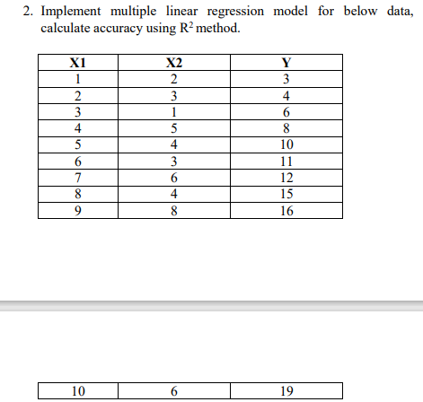
import numpy as np

class multiple_linear_regression():

def __init__(self, X, Y):

self.input = np.array(X)
self.output = np.array(Y)

new_inputs = np.insert(self.input, 0, 1, axis=1)

self.theta = np.matmul(np.matmul(np.linalg.pinv(np.matmul(np.transpose(
new_inputs), new_inputs)), np.transpose(new_inputs)), self.output)
print(self.theta)

def calculate(self, x1, x2):
answer = self.theta[0] + self.theta[1]*x1 + self.theta[2]*x2
print(round(answer))

inputs = [[1, 2], [2, 3], [3, 1], [4, 5], [
5, 4], [6, 3], [7, 6], [8, 4], [9, 8]]
outputs = [3, 4, 6, 8, 10, 11, 12, 15, 16]

mlr = multiple_linear_regression(inputs, outputs)
mlr.calculate(9, 8)

OUTPUT:
[ 1.20380273 1.71657754 -0.0855615 ]
16

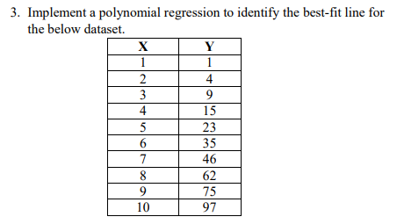
# Here is a more elegant and scalable solution, imo. It'll work for any nxn matrix and you may find use for the other methods.
# Note that getMatrixInverse(m) takes in an array of arrays as input. Please feel free to ask any questions
import numpy as np
import matplotlib.pyplot as plt
import sys

from sklearn.linear_model import LinearRegression
from sklearn.metrics import mean_squared_error, r2_score
from sklearn.preprocessing import PolynomialFeatures

def zeros_matrix(rows, cols):
A = []
for i in range(rows):
A.append([])
for j in range(cols):
A[-1].append(0.0)

return A
# # Taking a 3 * 3 matrix
# A = np.array([[6, 1, 1],
# [4, -2, 5],
# [2, 8, 7]])

def mulAB(A, B, result):
# iterating by row of A
for i in range(len(A)):
# print("i", A[i])

# iterating by column by B
for j in range(len(B[0])):
# print("j", B[j])

# iterating by rows of B
for k in range(len(B)):
result[i][j] += A[i][k] * B[k][j]

return result

x = np.array([1, 2, 3, 4, 5, 6, 7, 8, 9, 10])
# x = x.reshape(-1, 1)
# y = np.array((1, 4, 9, 15, 23, 35, 46, 62, 75, 97), ndmin=2)
y = np.array([1, 4, 9, 15, 23, 35, 46, 62, 75, 97])
# y = y.reshape(10)

Matrix_X = zeros_matrix(3, 3)
row = 3
col = 3
for i in range(row):
for j in range(col):
Matrix_X[i][j] = 0 # firsly initilised as zero
if i == 0 and j == 0:
Matrix_X[i][j] = len(x)
else:
power_of_x = i+j
summation_x_to_power_of_i_plus_j = 0
for val in x:
summation_x_to_power_of_i_plus_j = summation_x_to_power_of_i_plus_j + \
pow(val, power_of_x)
Matrix_X[i][j] = summation_x_to_power_of_i_plus_j

# Calculating the inverse of the matrix
# print(np.linalg.inv(A))
Inv_Matrix_X = np.linalg.inv(Matrix_X)

# for i in range(row):
# for j in range(col):
# print(Matrix_X[row][col])

Matrix_Y = zeros_matrix(3, 1)

def summation_y(y):
sum = 0
for val in y:
sum += val
return sum

def summation_xy(x, y):
sum = 0
for i in range(len(x)):
sum = sum+(y[i]*x[i])
return sum

def summation_x_square_y(x, y):
sum = 0
for i in range(len(x)):
sum = sum+(y[i]*(pow(x[i], 2)))
return sum

Matrix_Y[0][0] = summation_y(y)
Matrix_Y[1][0] = summation_xy(x, y)
Matrix_Y[2][0] = summation_x_square_y(x, y)

# --------------------------------
result = [[0],
[0],
[0]]

Ans_as_all_coefficient = mulAB(Inv_Matrix_X, Matrix_Y, result)
# print(Matrix_X)
# print(Inv_Matrix_X)
# print(Matrix_Y)
print(Ans_as_all_coefficient)

# for i in range(len(Ans_as_all_coefficient)):
# for j in range(len(Ans_as_all_coefficient[0])):
# print(Ans_as_all_coefficient[i][j])
print("best fit line will be:[a0+a1x+a2x^2]:", str(Ans_as_all_coefficient[0][0]) +
" + " + str(Ans_as_all_coefficient[1][0])+" *x + "+str(Ans_as_all_coefficient[2][0])+" *x^2")

OUTPUT:
[[0.6666666666671972], [-0.34242424242438574], [0.9848484848484915]]
best fit line will be:[a0+a1x+a2x^2]: 0.6666666666671972 + -0.34242424242438574 *x + 0.9848484848484915 *x^2

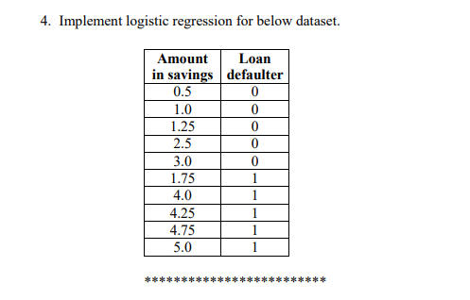
import numpy as np
import math

class Logistic_Regression():

"""
Class to calculate simple regression
"""

def __init__(self, X, Y):
"""
Constructor:
Args :
X (list) : input value of feature
Y (list) : corresponding output values of feature.

"""
self.input = np.array(X)
self.output = np.array(Y)

self.mean_x = sum(self.input)/len(self.input)
self.mean_y = sum(self.output)/len(self.output)

self.mean_sq_x = np.dot(self.input, self.input)/len(self.input)
self.mean_xy = np.dot(self.input, self.output)/len(self.input)

self.a1 = (self.mean_xy - self.mean_x*self.mean_y) / \
((self.mean_sq_x) - (self.mean_x)**2)

self.a0 = self.mean_y - self.a1*self.mean_x

def sigmoid(self, x):
return 1/(1 + math.e**(-(self.a0 + self.a1*x)))

def calculate(self, x):
if (self.sigmoid(x) >= 0.5):
return 1
else:
return 0

def log_fun(self, input):
# squares = [x*x for x in range(11)]

# lst = [self.calculate(val) for val in self.input]
lst = []

for value in input:
lst.append(self.calculate(value))
return lst

input = np.array([0.5, 1.0, 1.25, 2.5, 3.0, 1.75, 4.0, 4.25, 4.75, 5.0])
output = np.array([0, 0, 0, 0, 0, 1, 1, 1, 1, 1])

def my_accuracy(lst1, lst2):
count_yes = 0
for i in range(len(lst1)):
if lst1[i] == lst2[i]:
count_yes = count_yes+1
return (count_yes)/len(lst1)

# model.score(input, output)
# print("score:", model.score(input, output))

x = 7
myObj = Logistic_Regression(input, output)
# print("Predicted value of ", x, " is ", slr.calculate(x))
pred_ans = myObj.log_fun(input)
print(myObj.log_fun(input))
print("accuracy:", my_accuracy(pred_ans, output))

OUTPUT:
[0, 1, 1, 1, 1, 1, 1, 1, 1, 1]
accuracy: 0.6

