TY CSE AY-2022-23 Sem-I
Artificial Intelligence and Machine Learning Lab
Assignment No 5 Due date- 12/10/2022

- Represent knowledge in below different forms

a) Logical Representation.

Formalize the following sentences using propositional logic:

1. “If Davide comes to the party then Bruno and Carlo come too”
2. “Carlo comes to the party only if Angelo and Bruno do not come”
3. “Davide comes to the party if and only if Carlo comes and Angelo doesn’t come”
4. “If Davide comes to the party, then, if Carlo doesn’t come then Angelo comes”
5. “Carlo comes to the party provided that Davide doesn’t come, but, if Davide comes, then Bruno doesn’t come”
6. “A necessary condition for Angelo coming to the party, is that, if Bruno and Carlo aren’t coming, Davide comes”
7. “Angelo, Bruno and Carlo come to the party if and only if Davide doesn’t come, but, if neither Angelo nor Bruno come, then Davide comes only if Carlo comes”

Formalize the following arguments and verify whether they are correct:
1. “If Carlo won the competition, then either Mario came second or Sergio came third. Sergio didn’t come third. Thus, if Mario didn’t come second, then Carlo didn’t win the competition.”
2. “If Carlo won the competition, then either Mario came second or Sergio came third. Mario didn’t come second. Thus, if Carlo won the competition, then Sergio didn’t come third.”
3. “If Carlo won the competition, then Mario came second and Sergio came third. Mario didn’t come second. Thus Carlo didn’t win the competition.”

Define appropriate language and formalize the following sentences using FOL formulas.

1. Bill has at least one sister.
2. Bill has no sister.
3. Bill has at most one sister.
4. Bill has (exactly) one sister.
5. Bill has at least two sisters.
6. Every student takes at least one course.
7. Only one student failed Geometry.
8. No student failed Geometry but at least one student failed Analysis.
9. Every student who takes Analysis also takes Geometry.

b) Semantic Networks

- Consider the semantic network given below, identify different sentences that can be inferred from below representation.

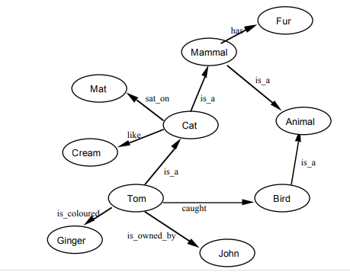

c) Production Rules

Consider the following system of rules and facts, where the variable x stands for a patient, “red_spots(x)” stands for “patient x has red spots”, and so forth.

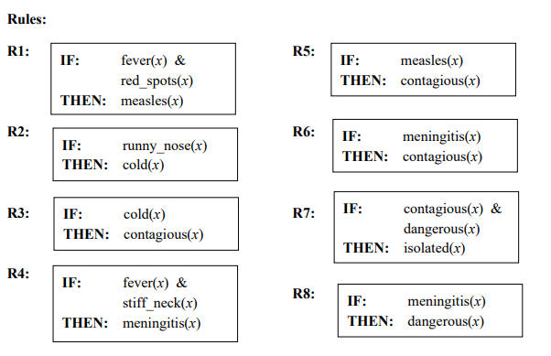

Initial facts: runny_nose(mary)
stiff_neck(john)
fever(john)
red_spots(mary)
fever(mary)

What can be derived from this knowledge base by forward reasoning? Explain your answer in detail.

d) Frame Representation.

- Create a frame of the person Ram who is a doctor. He is of 40. His wife name is Sita. They have two children Babu and Gita. They live in 100 kps street in the city of Delhi in India. The zip code is 756005.

- Create a frame of the person Akash who has a white maruti car of LX-400 Model. It has 5 doors. Its weight is 225kg, capacity is 8, and mileage is 15 km /lit.





