**Vishal Chauahn**

**2020BTECS00090**

**T8 batch**

**SET lab**

**Assignment 3**

**Module 3- Study of Project Management Tool (Jira)**

* **Create a project (give name of your project) in Jira, use template as Scrum and add your team members into this project**

To create a project in Jira, you will need to access the Jira platform and log in to your account. From there, you can click on the "Create project" button and choose the Scrum template. You can then give your project a name, add a description if desired, and invite your team members to join the project.

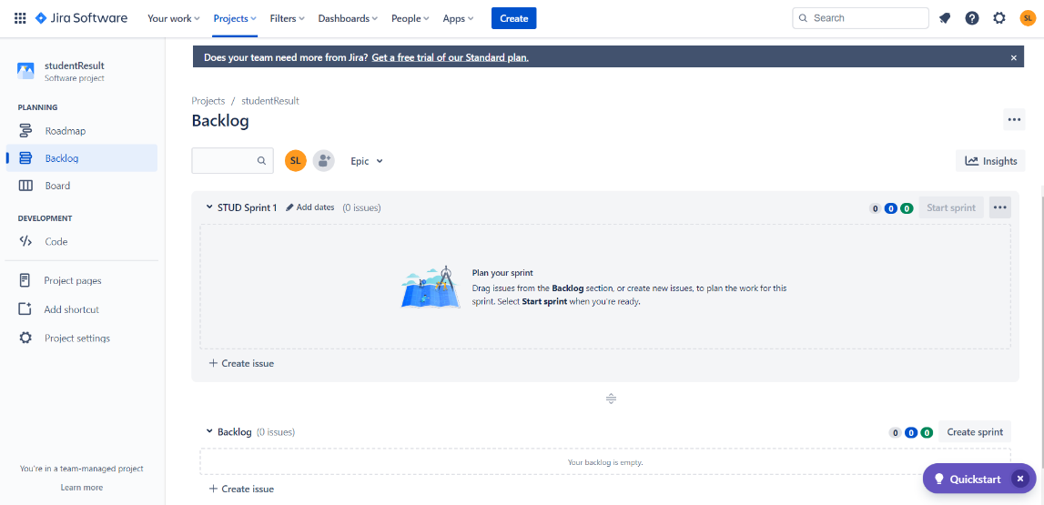

* **Create an Epic into above project (main requirement of your project, e.g Creating a web application for student result generation).**

To create an Epic, you can click on the "Epics" panel in your project and select "Create Epic." Enter the main requirement of your project in the title field and add a description if needed.

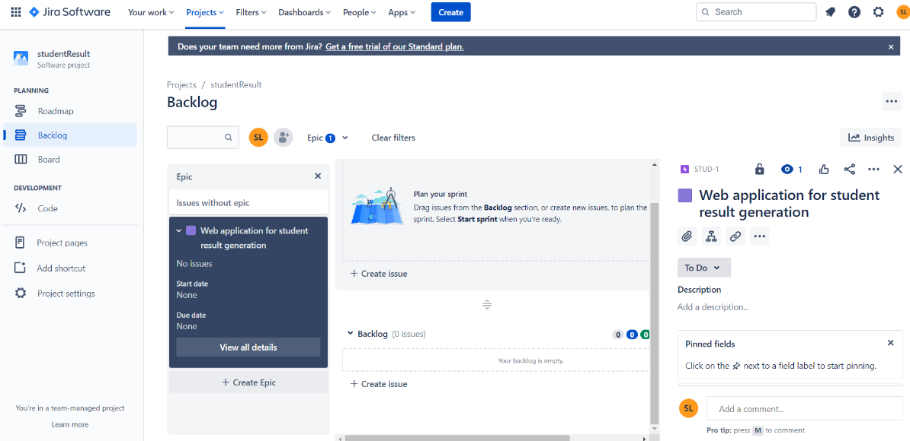

* **Create at least 5 user stories with respect to above epic for your project.**

To create user stories, click on the "Issues" panel and select "Create issue." Choose the "Story" issue type and enter a brief description of the user story in the title field. Repeat this step for at least 5 user stories.

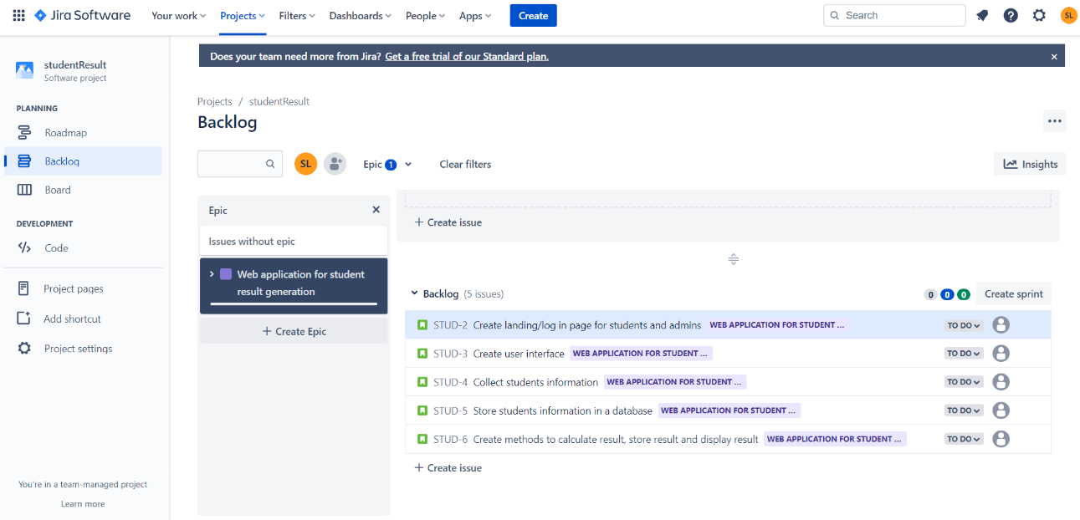

* **Create at least 2 subtasks for every user story. Assign user stories to your team members.**

To create subtasks for each user story, click on the user story you want to add a subtask to, select "Create task," and enter a brief description of the subtask in the title field. Repeat this step for each user story. Assign each user story to a team member by clicking on the "Assignee" field and selecting the appropriate team member.

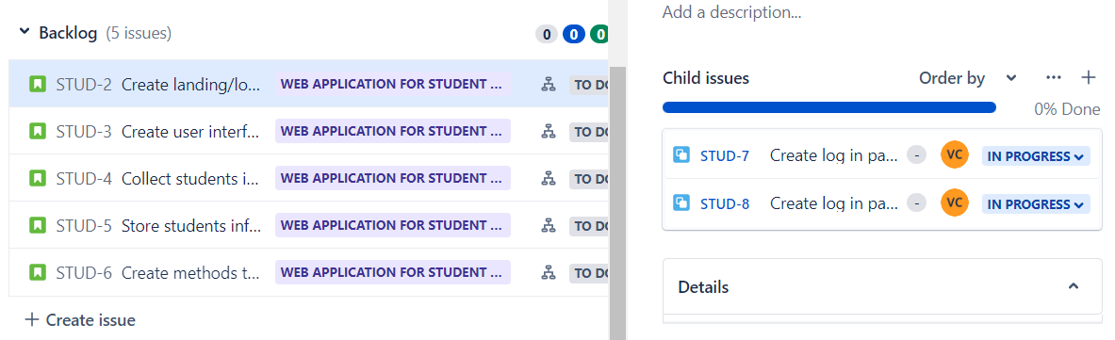

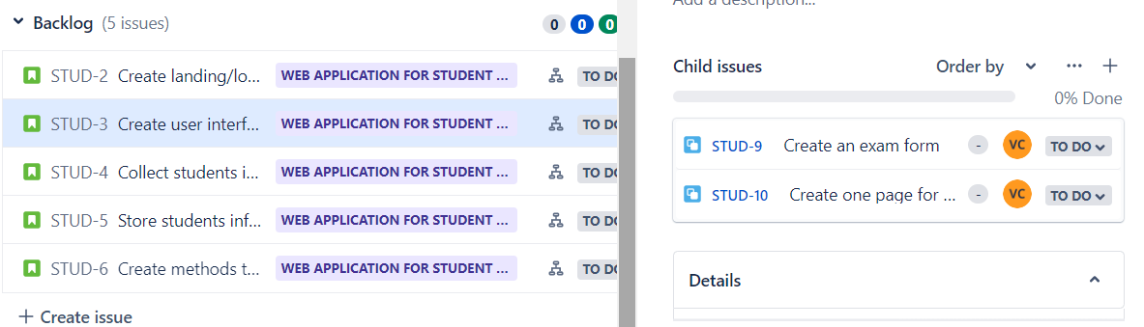

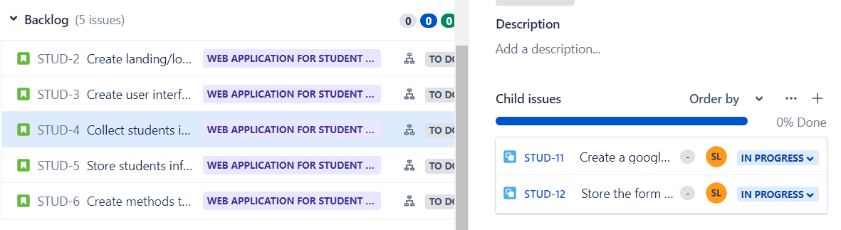

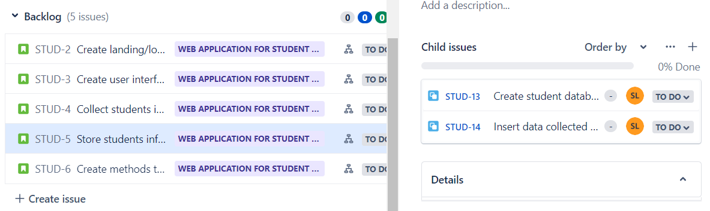

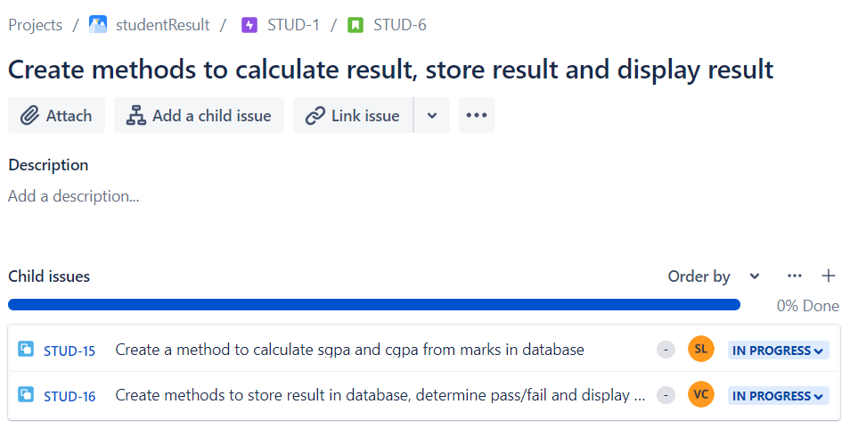

* **Create sprints for every use stories and prioritize them according to your tasks. Assign time period for every user story.**

To create sprints, you can click on the "Backlog" panel and select "Create sprint." Enter a name for the sprint, select the start and end dates, and choose the user stories you want to include in the sprint. Prioritize the user stories by dragging and dropping them in the order you desire. Assign a time period for each user story by clicking on the "Estimate" field and entering the estimated time.

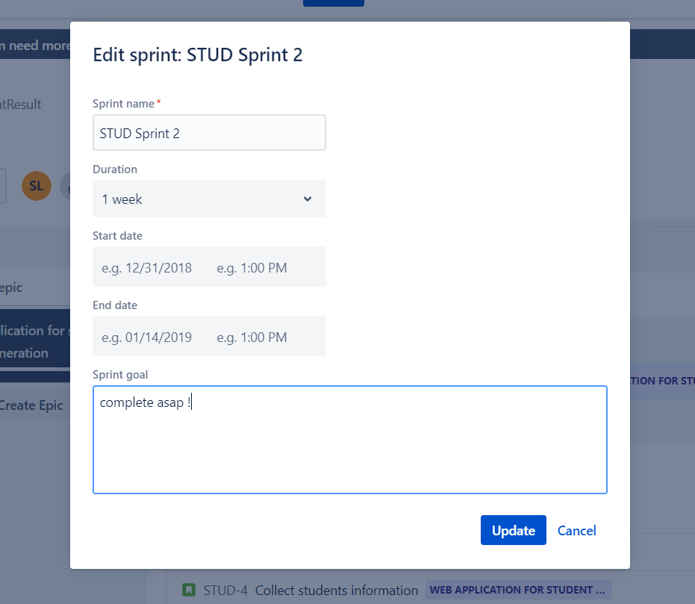

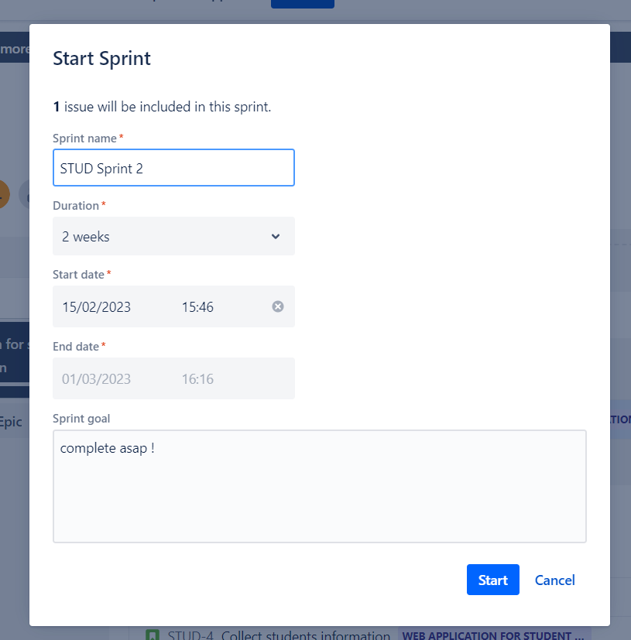

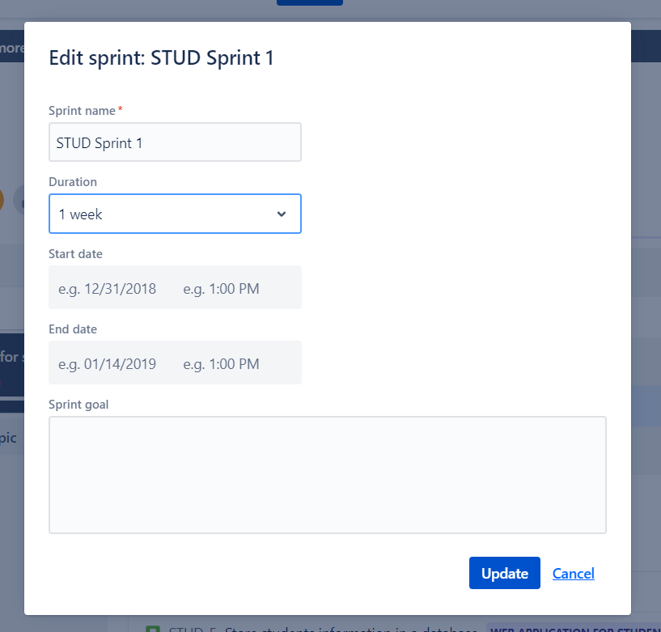

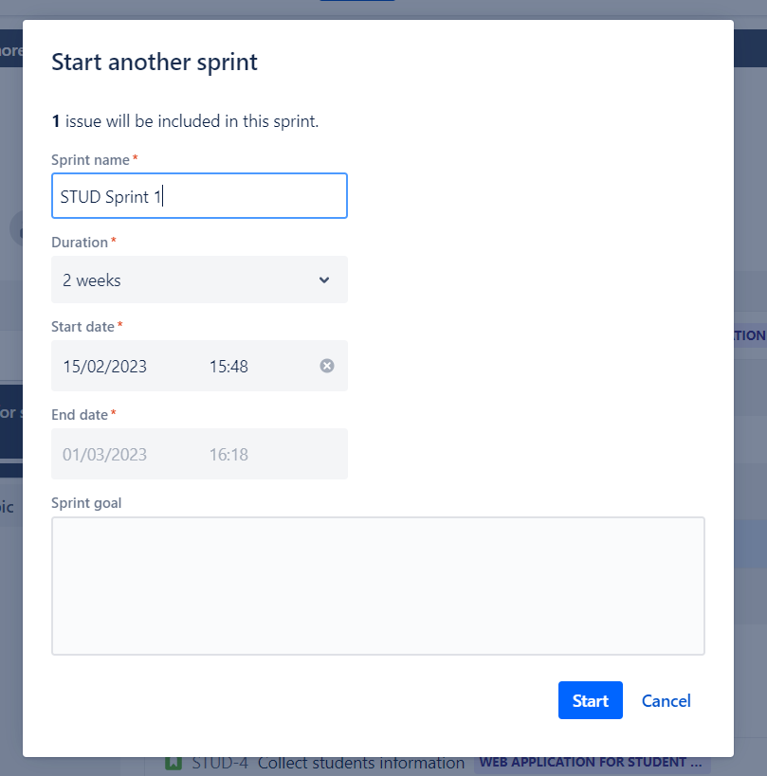

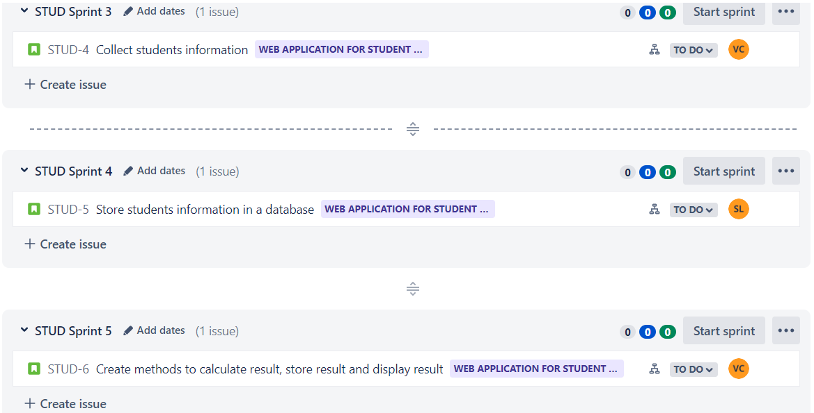

* **Update the status of some user stories as To Do, In Progress or Completed according to sprints (add appropriate comments).**

To update the status of user stories, you can click on the user story and select "Edit." Change the status to "To Do," "In Progress," or "Completed" and add appropriate comments in the "Comment" field.

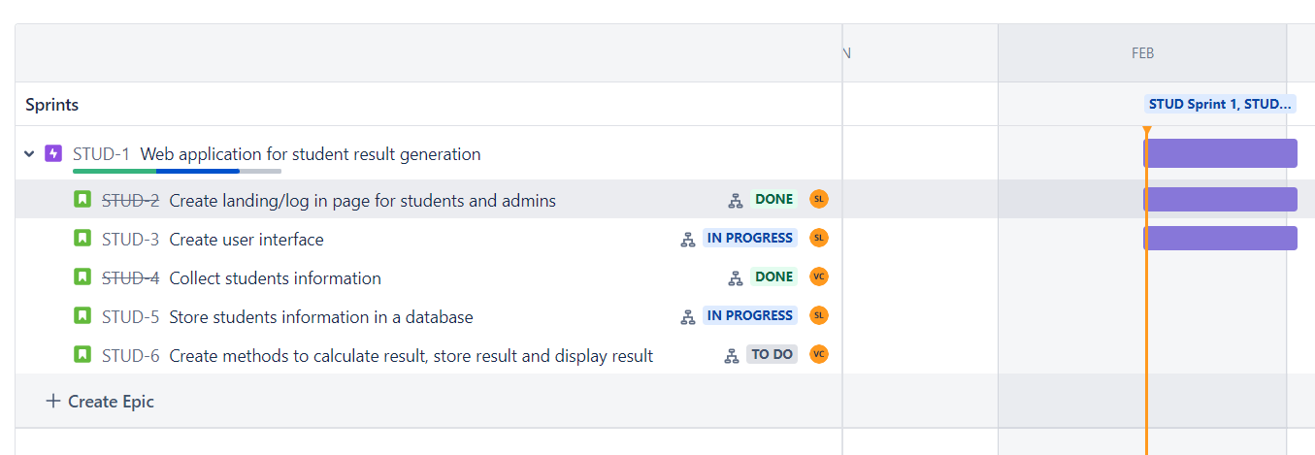

* **Create a bug/issue for respective user story and epic and assign to respective member.**

To create a bug or issue, click on the "Issues" panel and select "Create issue." Choose the appropriate issue type (e.g. "Bug") and enter a brief description of the issue in the title field. Assign the issue to a team member by clicking on the "Assignee" field and selecting the appropriate team member.

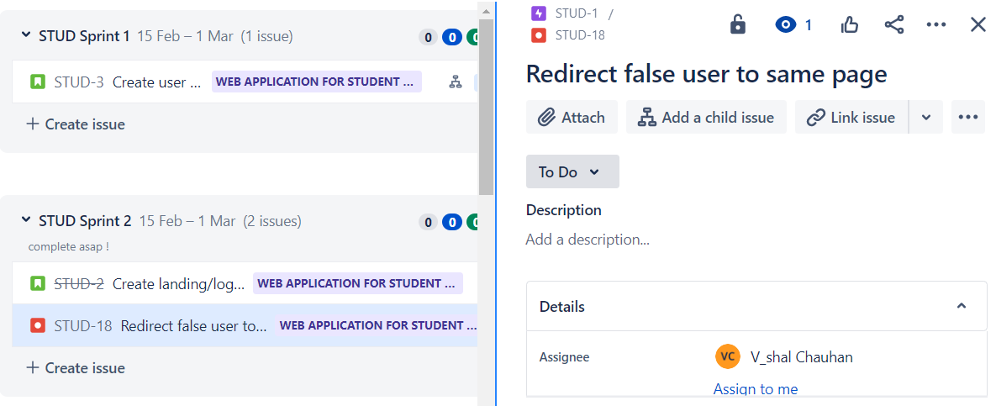

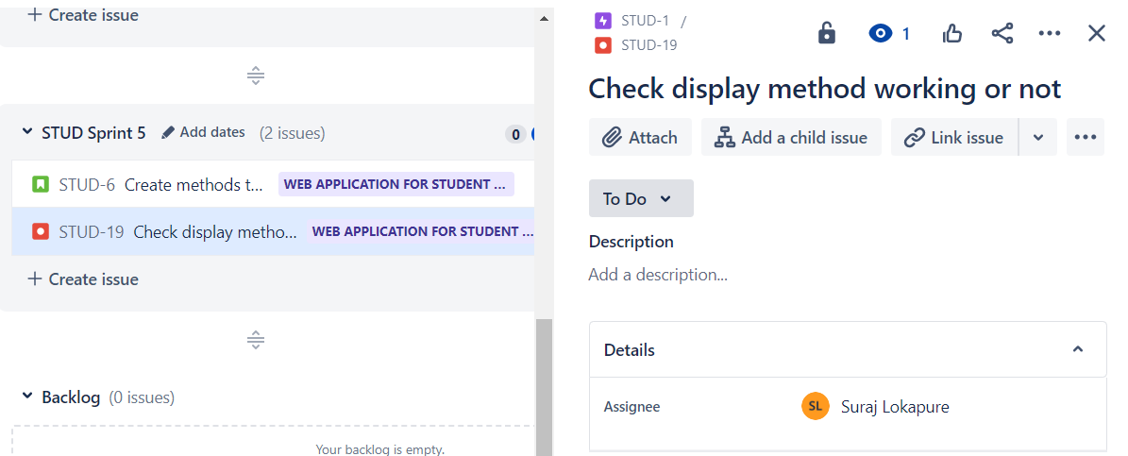

* **Display reports (Burnup chart, Burndown chart) w.r.t your created project.**

To display reports, you can access the "Project pages" panel and choose the report you want to view The report will display information and data related to your project, including sprint progress, user story status, and more.

