**Software Engineering Tools Lab**

**Assignment No-8**

**PRN: 2019BTECS00090**

**Name: Vishal Chauhan**

**Batch: T8**

----------------------------------------------------------------------------------------------------

# Q 1. What are the prerequisites for installing the TestLink tool.

Before installing the TestLink tool, you need to ensure that your system meets the following prerequisites:

1. Web server software: TestLink requires a web server software to be installed, such as Apache or Microsoft IIS.
2. PHP: TestLink is built on PHP, so you need to ensure that the appropriate version of PHP is installed on your system. The recommended version of PHP for TestLink is 7.2 or later.
3. Database software: TestLink requires a database to store its data. The supported database software includes MySQL, PostgreSQL, and Microsoft SQL Server.
4. Database server client software: You also need to ensure that the appropriate client software is installed for your database server. For example, if you are using MySQL, you need to ensure that the MySQL client software is installed on your system.
5. Web browser: To access and use the TestLink tool, you need a modern web browser such as Google Chrome, Mozilla Firefox, or Microsoft Edge.
6. Operating system: TestLink can be installed on various operating systems, including Windows, Linux, and macOS. Ensure that your system meets the requirements for your chosen operating system.

TestLink is an open-source web-based test management tool that is used to manage and track software testing efforts. It is widely used by software development teams to plan, manage, and execute test cases for software applications. Here are some reasons why TestLink tool is used:

1. Test planning and management: TestLink provides a centralized platform for managing the testing process, including test planning, test case creation, test execution, and tracking defects.
2. Collaboration: TestLink allows multiple users to collaborate on testing activities, including test case creation, execution, and tracking.
3. Customization: TestLink provides a highly customizable platform that allows users to create custom test case templates, test plans, and reports.
4. Integration: TestLink can be integrated with other software testing tools such as JIRA, Bugzilla, and Selenium, to streamline the testing process and improve productivity.
5. Reporting: TestLink provides a variety of reports and metrics to track testing progress, identify trends, and analyze test results.
6. Automation: TestLink provides the ability to automate test cases and generate automated test results, which can help save time and increase testing coverage.

Overall, TestLink is a comprehensive test management tool that helps software development teams to streamline the testing process, increase efficiency, and improve the overall quality of software applications.

Q 2. Install TestLink tool on your machine (Provide screen shots for successful installation and login)

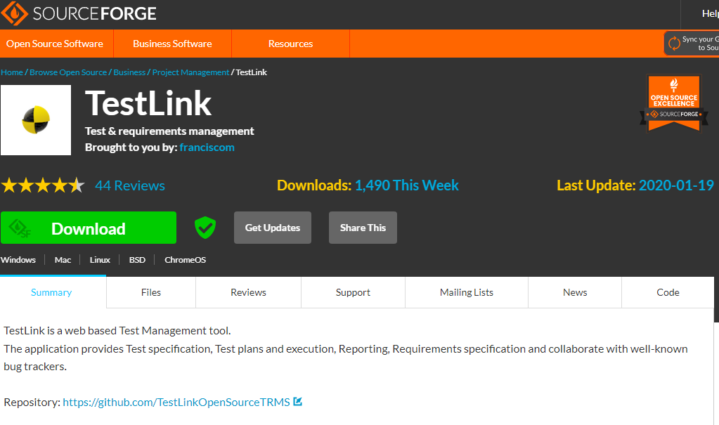

Step 2 − Now unzip the downloaded .tar file and rename the folder name as TestLink.

Step 3 − Go to XAMPP folder where it is installed and navigate to htdocs folder. Place the TestLink folder here as shown in the following screenshot.

Step 4 − Go to TestLink package and open “config.inc.php” file, update path “$tlCfg→log_path” and “$g_repositoryPath” as below −

$tlCfg→log_path = ‘D:/xampp/htdocs/testlink/logs/’;

$g_repositoryPath = ‘D:/xampp/htdocs/testlink/upload area/’;

Step 5 − Now open a browser and type <http://localhost/Testlink> in the navigation bar and press Enter. It will display the installation page of TestLink.

Step 6 − Click New Installation.

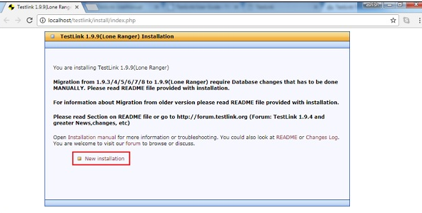

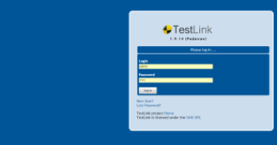

Q 3. Using TestLink tool create multiple test cases (at least 10) on any application/project that you have implemented.

Perform below tasks

1. Create New test project as SETProject

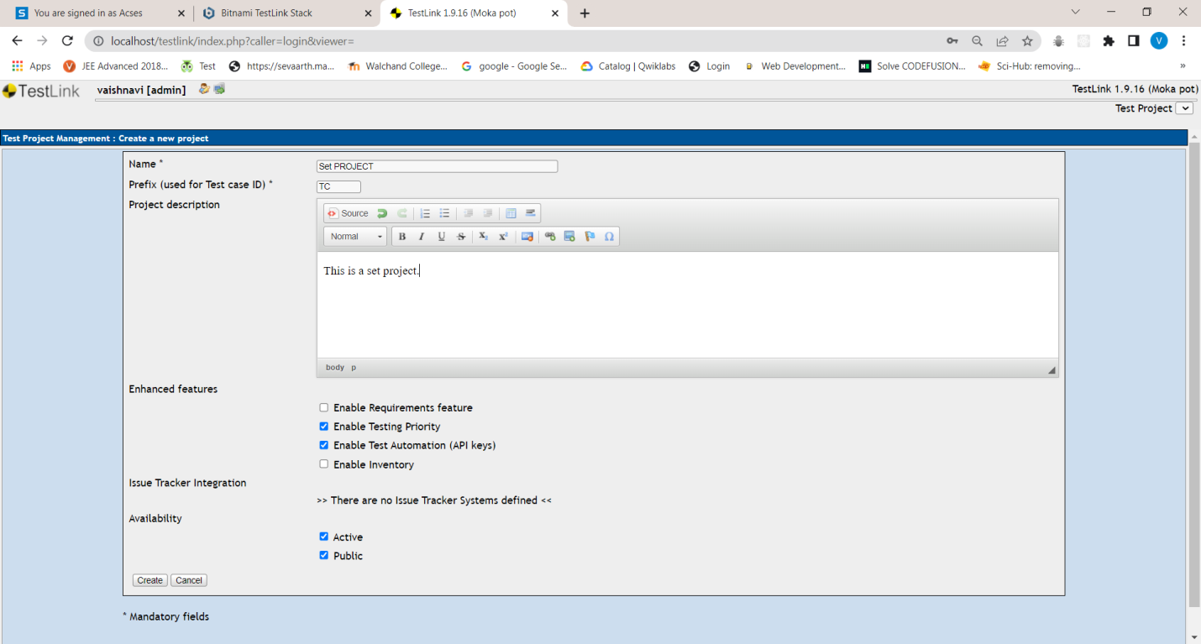

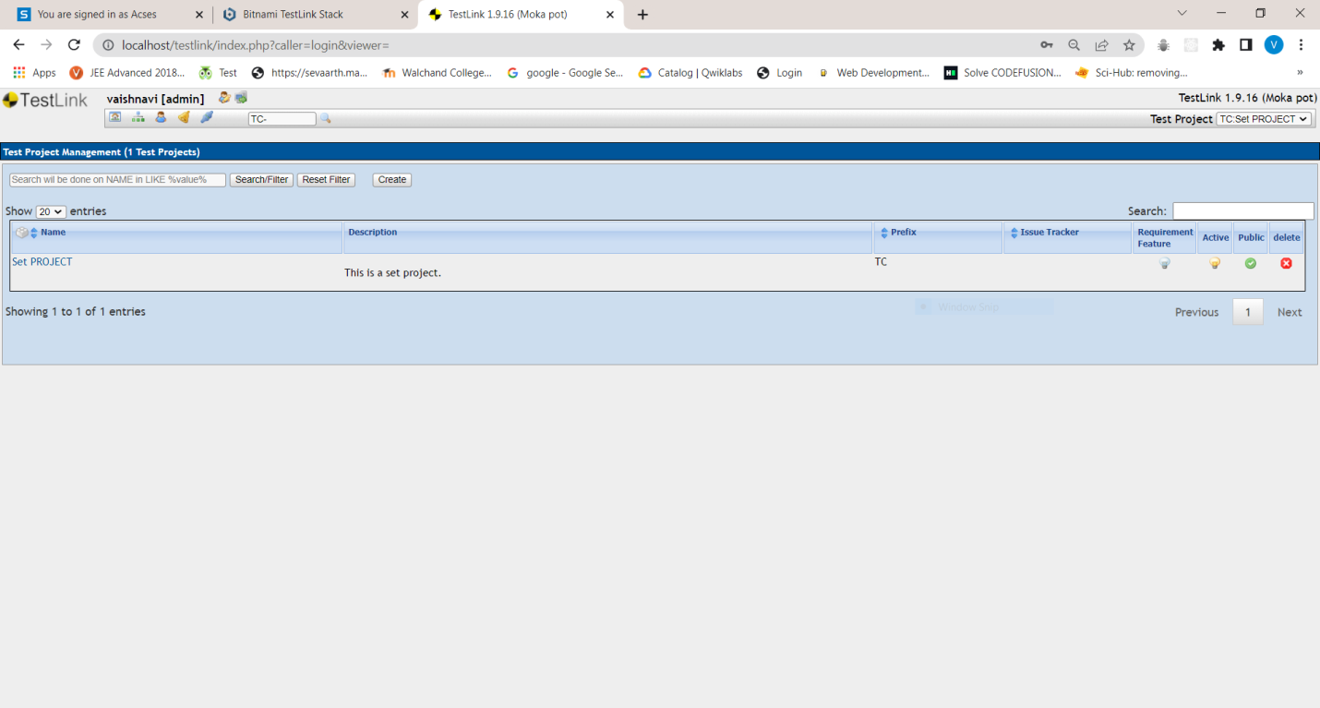

1. Create a test plan as SETProjectTestPlan

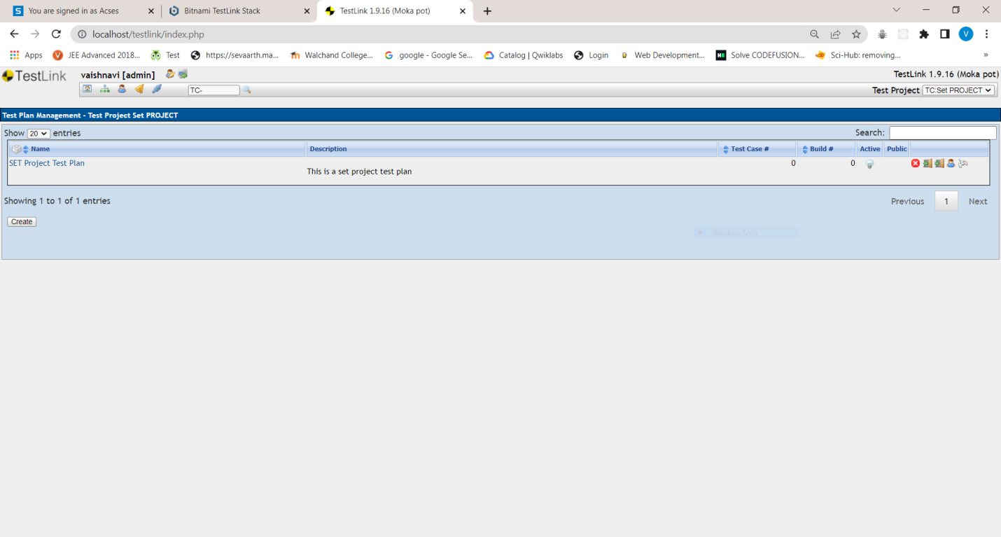

1. Create a build as SETProjectBuild

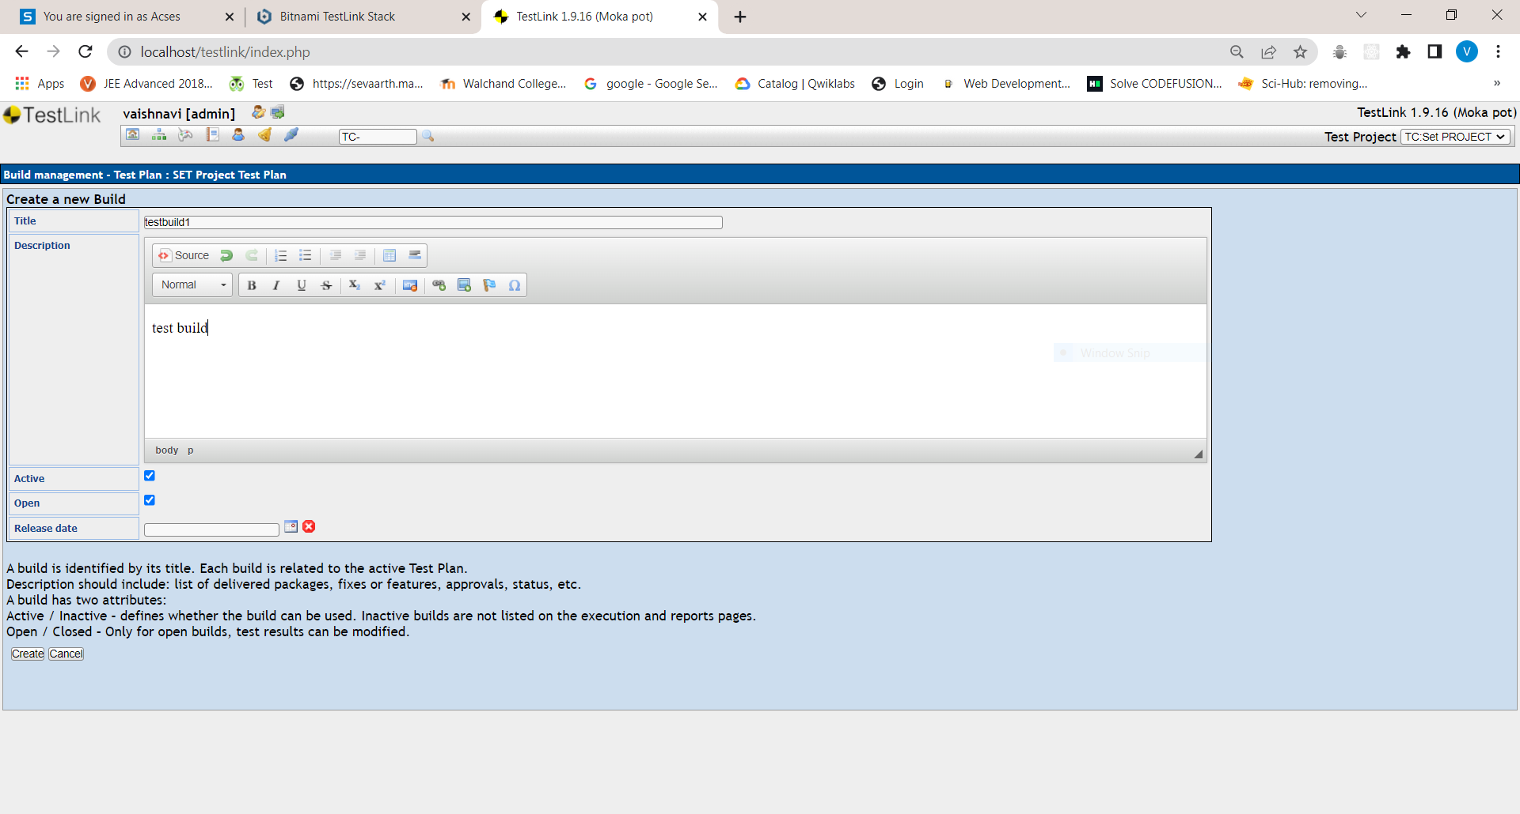 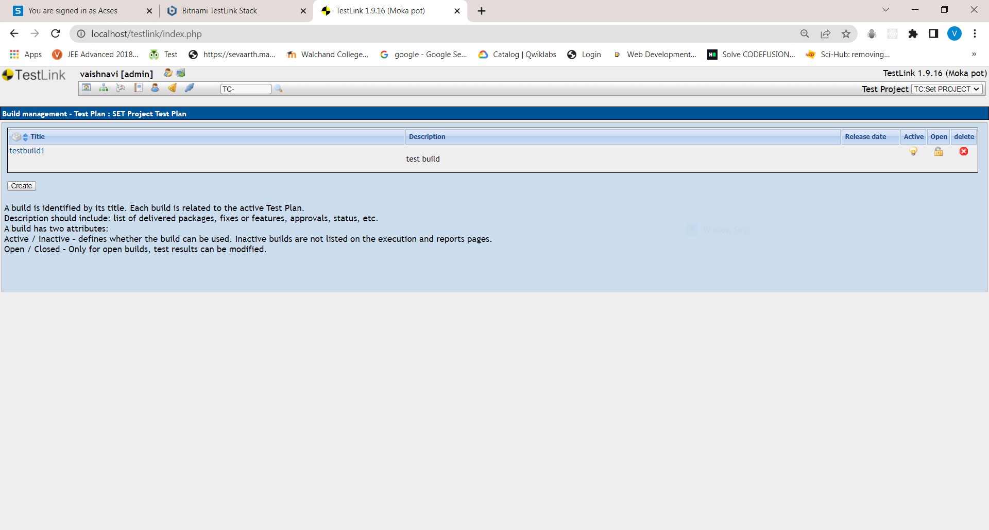

1. Create test suite as Test Suite 1 under SETProject

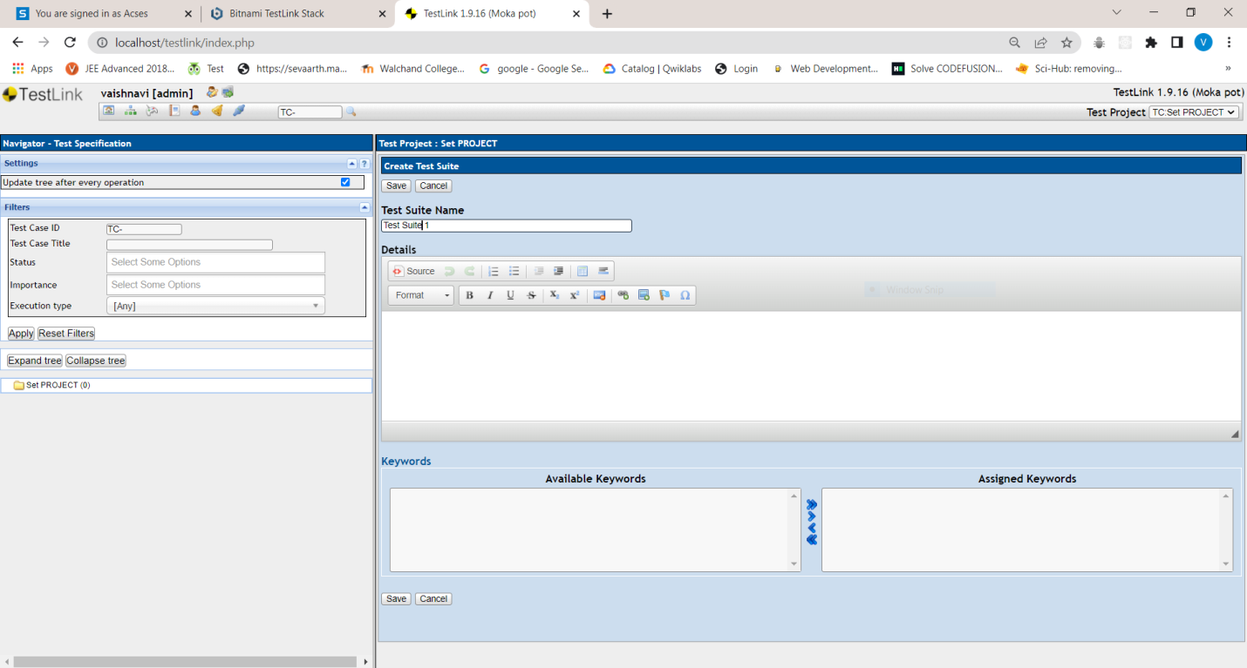 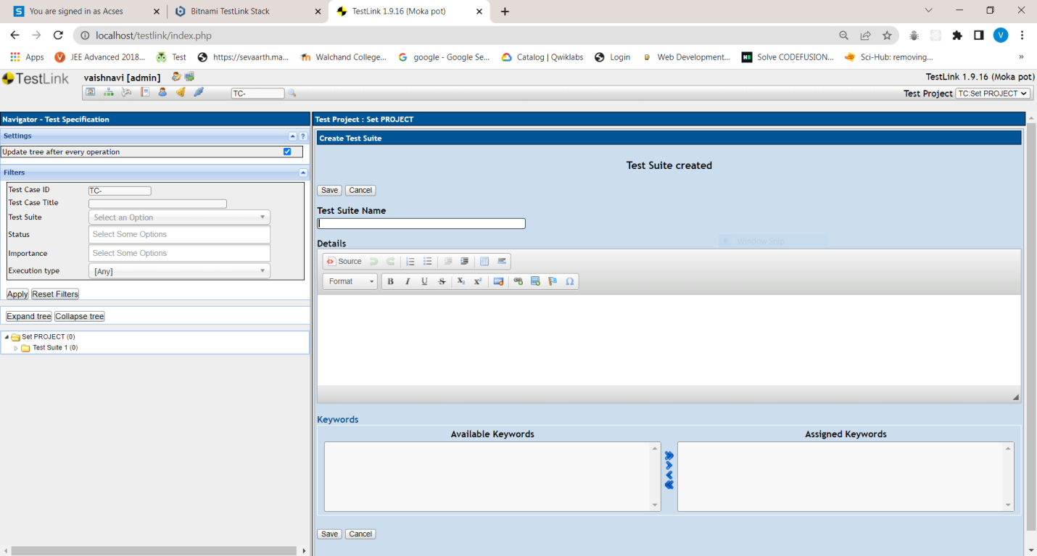

1. Create Test cases in TestLink Tool

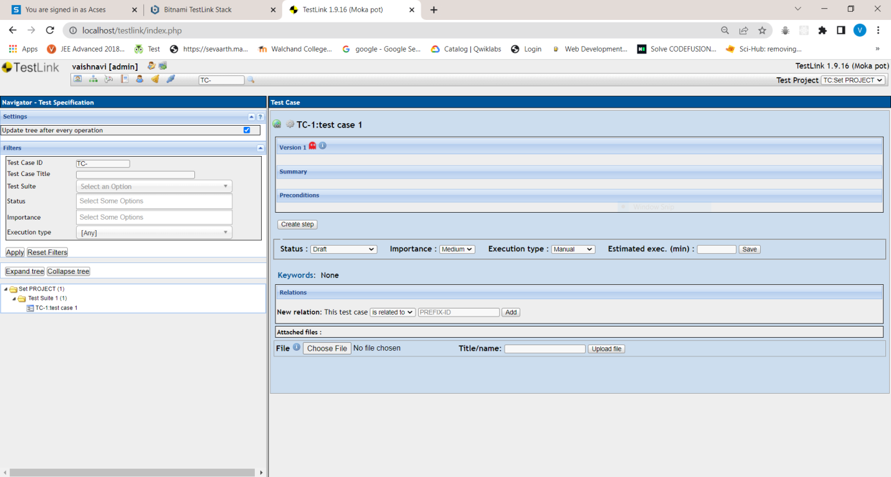

1. Assigncreated Test Cases to the test plan SETProjectTestPlan

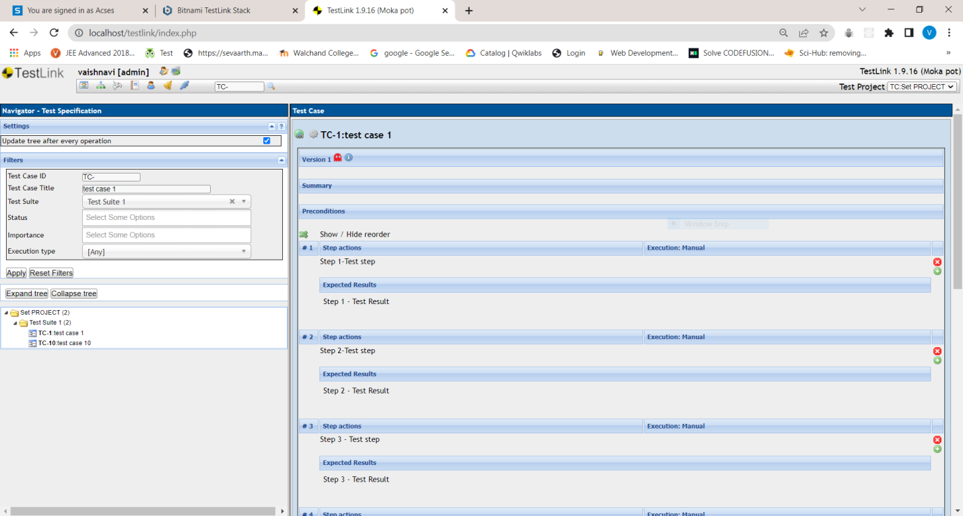

1. Create different roles as given below in the TestLink

| S No. | Role | Test Cases | Test Metrics |
| --- | --- | --- | --- |
| 1. | Guest | View | View |
| 2. | Tester | Execute | View |
| 3. | Senior Tester | Edit & Execute | View |
| 4. | Leader & Admin | Edit & Execute | Edit & Execute |

1. Write a requirements in TestLink
2. Executetest cases
3. Generate a test report in excel format.

*Note- Use the document for reference https://github.com/sdpwce/SETAssignment/Testlink TMT.pdf